**Shiny Application SOP**

**Taylor Stewart**

**3/31/16**

**R Basics:**

* Open the project file (lebs_western_basin_app.Rproj) first to eliminate working directory issues.
* Capitalization, format consistency, and spelling are very important!!!!!!!!!!
* shinyapps will not upload the app without current, up-to-date packages
* Maintain consistent column names between years/seasons
* Report time in military time
* Report coordinates in decimal degrees

**R Data Updates:**

1. **Effort**
   1. Open data_prep/WB_Effort.xlsx
   2. Open the western basin file for the desired year; either
      1. F:/Western Basin Forage/” year”/”season”/trawl
      2. F:/Western Basin Forage/”year”/”season”/life_stages
   3. Copy the appropriate columns into the bottom of data_prep/WB_Effort.xlsx
   4. Use the Proper() function to capitalize the species names in Excel
   5. Make sure species names are completely spelt out (no shorthand)
   6. Make sure size classes follow the same format (All Capital Letters)
      1. Use find and replace with match case selected
   7. Fill in the appropriate day, month, year and season columns for the new data
   8. Save and close file
2. **Length-Weight:**
   1. Open data/WB_LengthWeight.csv
   2. Open western basin trawl length weight file for the desired year
      1. F:/Western Basin Forage/
   3. Copy the appropriate columns into the bottom of data/WB_LengthWeight.csv
   4. Use the Proper() function to capitalize the species names in Excel
   5. Make sure species names are completely spelt out (no shorthand)
   6. Fill in the appropriate day, month, year and season columns for the new data
      1. Effort tab in trawl file
   7. Save and close file

Troubleshoot: Make sure NA values are blank in the data file. An NA value will be read into R as a character and change the structure of the variable. A blank value will get read into R as an NA and maintain the integrity of the remaining variable structure. NA values are filtered out in the global.r script.

1. **Standardized Catch:**
   1. Open data_prep/WB_CatchHA.csv
   2. Open western basin CPH file for the desired year
   3. Copy the appropriate columns into the bottom of data_prep/WB_CatchHA.csv
   4. Use the Proper() function to capitalize the species names
   5. Make sure species names are completely spelt out (no shorthand)
   6. Change the life stages so that they are spelt out (a1 = Age_1, etc)
      1. Use find and replace with match case selected
   7. Open data_prep/WB_Effort.xlsx
   8. Copy effort data to fill in the appropriate columns
   9. Save and close catch file
2. **Catch (Counts):**
   1. Open data_prep/WB_CatchCounts.csv
   2. Open western basin trawl catch file for the desired year
      1. F:/Western Basin Forage/
   3. Copy the appropriate columns into the bottom of data_prep/WB_CatchCounts.csv
   4. Use the Proper() function to capitalize the species names in Excel
   5. Make sure species names are completely spelt out (no shorthand)
   6. Make sure size classes follow the same format (All Capital Letters)
      1. Use find and replace with match case selected
   7. Fill in the appropriate day, month, year and season columns for the new data
   8. Save and close file

**R Data Manipulation**

1. **Standardized Catch**
   1. Open data_prep/shiny_catch_lifestages.R
   2. Run code
   3. A new file will automatically be saved as data/WB_Catch.csv

**NOTE:** If preparing Spring data, zeros for all species/serials need to be entered for Autumn (Paste the data from data_prep/WB_CatchHA_zero_autumn.xlsx into data/WB_CatchperHA.csv). The data being copied will work without errors as long as no new species have been added. If preparing Autumn data, delete the zero values pasted during zero prep.

1. **Expanded Length Frequency (Bootstrap):**
   1. Make sure to have LW and Count data input completed
   2. Begin by running data_prep/shiny_lw_catch_QAQC.R to check for errors
   3. Proceed only if no errors are found or after all errors are corrected
   4. Open data_prep/shiny_lw_bootstrap.R
   5. Change year and season variables (lines 11 & 12)
   6. Run code
   7. If an error occurs, try traceback() to find out more info
   8. If no errors occur, a new file will automatically be saved as data/WB_ExpandedLengths.csv
2. **Water Quality:**
   1. Make sure to have the exported, raw YSI files (one Excel Files; multiple tabs) in the data_prep/WQ_raw folder
   2. Change the file name to be consitent with the other files
   3. Open data_prep/shiny_wq.R
   4. Change the inputs for lines 15, 16, 19, 22 & 54 to current year, season, and file paths
   5. Run code
   6. A new file will be automatically be saved as data_prep/WQ_Summaries/WB_”year”_”season”_WQ_Summary.xlsx
   7. Copy the appropriate columns into the bottom of data/WB_WaterQuality.csv
   8. Fill in the appropriate day, month, year and season columns for the new data
   9. Save and close file

**R Shiny Application Update:**

1. **Shinyapps.io**
   1. Login
      1. UN: [rkraus@usgs.gov](mailto:rkraus@usgs.gov)
      2. PW: Great.Lakes_
   2. Tokens
      1. Tokens are used to link Rstudio to shniyapps.io
      2. If not already linked, click “+ Add Token” under the Account/Token page
      3. Follow instructions provided
2. **Republish App**
   1. Open Rstudio and the western basin project
   2. Open server.R, ui.R, and global.R
   3. If all application files are open the commands will change to the following

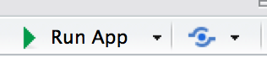

* 1. Run app and check for errors
  2. Click the blue symbol to the right of the “Run App” button to publish

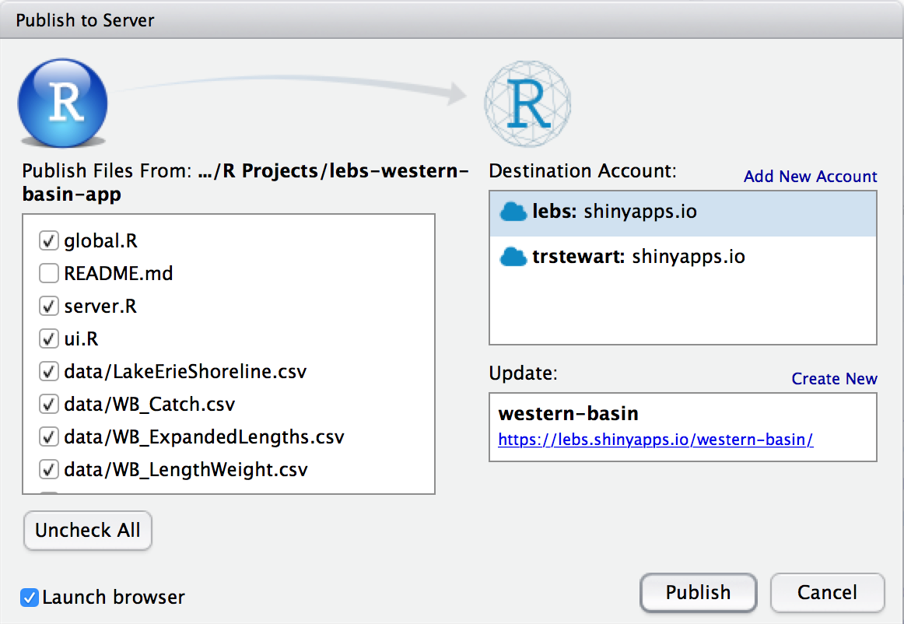

* 1. Uncheck all files except the three scripts, five data files, and all contents in the www folder.
  2. Click “Publish” to sent to server