United States Department of the Interior



U.S. GEOLOGICAL SURVEY

Lake Erie Biological Station

NASA/Plum Brook Station

6100 Columbus Avenue

Sandusky, OH 44870

PH: (419)625-1976 ! FAX: (419)625-7164

22 February 2016

Dr. Weidel,

Enclosed are the modified versions of the datasets supporting our data record entitled “Lake Erie Fish Community Data.” The datasets were modified based upon your suggestions and our further proofing of the record. Each change to the datasets or our rationale for not making changes suggested are detailed below in comment-by-comment format. We hope that you will find our edits both easy to follow and acceptable.

Please contact me if you have any questions or concerns related to the metadata record or our response to the suggestions.

Respectfully,

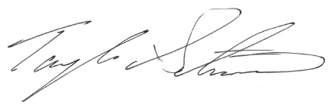

Taylor R. Stewart  
Fisheries Technician, Lake Erie Biological Station  
Great Lakes Science Center, USGS

**Responses to Data Reviewer’s Comments**

Comment 1) Upon the reviewer’s suggestion, a single column naming format was select and integrated throughout all files. A description and units for all variables can be found within the metadata record. Changes were made to satisfy the reviewer’s suggestion.

Comment 2) Effort data (day, month, fishing depth, trawl wingspread, area swept, and hectares swept) were added to the catch dataset to provide data needed to calculate density (number per hectare) and biomass (kilogram per hectare).