**Aircrypto - Technical Document**

**Step - 1:** Install Visual Studio Code

**<https://code.visualstudio.com/download>**

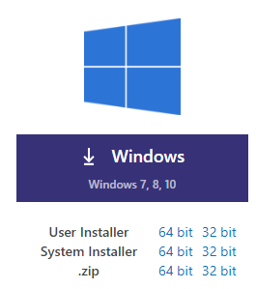

**Step-2:** NodeJS download and install nodeJS which includes npm

**<https://nodejs.org/en/download/>**

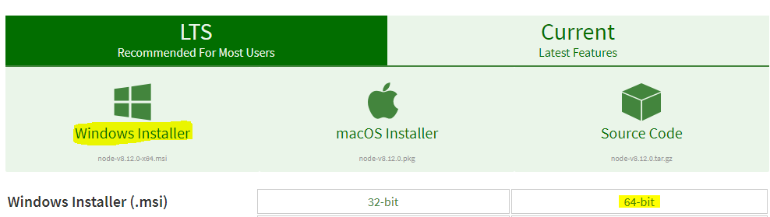

**Step-3:** NodeJS for details

**<https://docs.npmjs.com>**



**Step -4: Download the AIRCRYPTO application from GITHUB.**

**<https://github.com/lakeba-solutions>**



**Step - 5: Open the folder in Visual studio code**

**Step - 6: Install npm and nodeJs as follows**

**$ npm install**

**Step - 7:** To create a **package.json** with version if not exists execute the command **npm init** for example as shown below



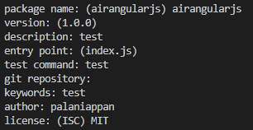

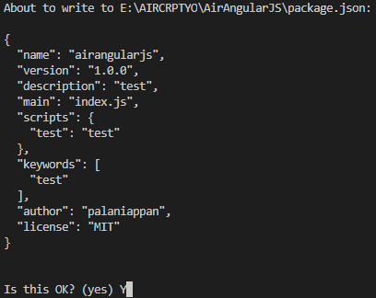

# **Step - 8:** Update a Package version

**npm version <update_type>**

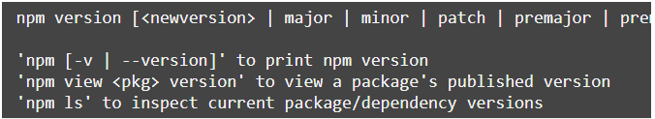

**Or**

# Update a Package version manually in both files Package.json & package-lock.json.

**Step-9:** If required execute the command **npm outdated** which will list all the packages need to update with latest version.

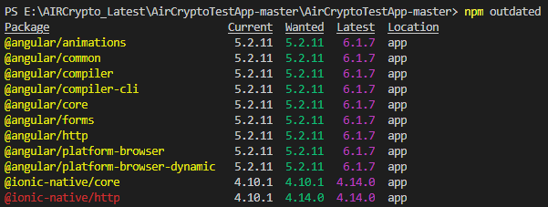

**Step - 10:** If required execute the command **npm Updated** which will update all the packages to the latest version to verify again execute the command **npm outdated.**

**Step - 11:** Execute the command **npm publish.**

**Step-12: verify by login npm portal with desired credentials and try to install as follow in test application.**

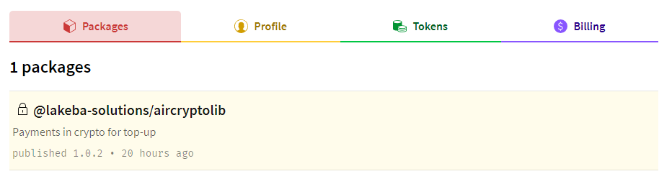

**Step-13:** To install the AircryptoLib you have to login with credentials as shown below

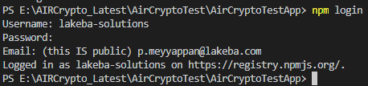

**Step-14:** Execute the command to install the published latest package and verify the same in Package.json with version number.

**$ npm i @lakeba-solutions/aircryptolib**

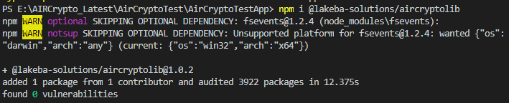

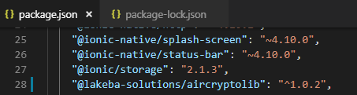

**Step-15:** AirCryptoTestApp application is designed usign ionic. We need to install ionic as follows.

**$ npm install -g ionic cordova**

**Step - 16:** Execute the TestApp using below command

**$ ionic serve**

