Multi-objective Optimization aided Visualization of Graphs related to Business Process Management
Abstract. A problem of drawing aesthetically looking graphs is considered. We focus on graphs related to management of business processes. Vertices of a graph are visualized as rectangles (flow objects), and edges are visualized as rectangular connectors (sequence flow). A particular problem of aesthetic drawing is considered where location of vertices is fixed, and the lines representing the edges should be drawn. The latter problem is restated as a graphs oriented multi-objective combinatorial optimization problem. The generally recognized criteria of aesthetic presentation, such as the general length of lines, the number of crossings, and the number of bends, are considered as the objectives to be minimized. The attitude of the potential users of the supposed algorithms towards the relative importance of the considered criteria is elicited by a psychological experiment. The elicited information is used in the development of domain-specific multi-objective optimization algorithms. We propose for that problem a version of the metaheuristics of ant colony optimization. The efficiency is evaluated experimentally using randomized test problems of different complexity.
Keywords: visualization of graphs, multi-objective optimization, psychological experiment, business process diagrams.
1 Introduction
Problem of graph drawing attracts many researchers, and plenty of publications on that subjects are available. Nevertheless special cases of that problem frequently cannot be solved by straightforward application of the known methods and algorithms. In the present paper we consider a particular problem of drawing graphs where criteria of aesthetics are crucial. Such problems are interesting with relation to the drawing of business processes diagrams. We state the problem as a multi-objective optimization problem where aesthetic criteria are optimized. Although importance of criteria of aesthetics to perception of information presented by graphs is thoroughly investigated, multi-objective optimization aided visualization algorithms, to our best knowledge, have not been proposed in, at least, open literature.
The Business Process Diagrams (BPD) are widely used in business process management. The Business Process Modeling Notation (BPMN) is accepted as a standard for drawing the Business Process Diagrams (BPD) [1]. According to the general opinion, the aesthetic attractiveness of the drawing of a BPD is especially important since the aesthetic layouts are also most informative and practical [2]. The graph drawing aesthetics is comprehensively discussed, e.g. in [3], [4], [5]. However, the criteria of the aesthetic attractiveness not always guarantee the informativeness of the diagrams drawn; we cite [4]: “Few algorithms are designed for a specific domain, and there is no guarantee that the aesthetics used for generic layout algorithms will be useful for the visualization of domain-specific diagrams”. In the present paper we consider a particular problem of drawing diagrams of business processes of SME: the algorithms of drawing the aesthetically pleasing sequence flows are considered assuming the flow objects fixed. The research is aimed at the substantiation of the algorithms supposed for including into a relatively simple and not expensive software package oriented not only to the consultants of business management but also to the managers of SMEs [6]. The original problem is reduced to a problem of the combinatorial multi-objective optimization. We start with the analysis of the attitude of the potential users of the supposed algorithms towards the relative importance of the widely acceptable criteria of BPD aesthetics. The latter are used as the objectives of the multi-objective optimization problem which formalizes the problem of BPD drawing as an optimization problem. For the general discussion on the synergy of optimization and visualization we refer to [7]. The stated multi-objective optimization problem related to BPD drawing is tackled by a version of the algorithm based on the ant colony metaheuristics.
2 An original problem of visualization
In the present paper a particular problem of graph drawing is considered which is related to drawing of BPDs. Aesthetically pleasing lines, which represent the sequence flow, should be drawn assuming the fixed location of the flow objects. The problem of drawing is restated as a combinatorial multi-objective problem where the objectives correspond to the criteria usually used to assess the aesthetics of a BPD. The developed algorithms are supposed to be used interactively where the flow objects are located by a human user. We are going to continue this research and to develop an algorithm for the aesthetic re-location of the flow objects.
To enable a user completely percept the information, presented by the observable part of the BPD, the sub-charts which comprise up to 30 shapes, are drawn. A navigation tool aids a user to specify the sub-chart of interest. The more detailed information concerning the specified flow objects can be extracted by telescoping. To denote the flow objects in the considered diagrams, the notation of BPMN, namely the rectangles, the rhombs, and the circles, is used where these shapes represent the processes, the gateways, and the events correspondingly. The shapes are located in the pool lanes. The sequence flow is represented by the lines constituted of orthogonal line segments. BPD can be augmented by the data objects and the data flows. An example of the diagrammatic visualization of a business process is presented in Fig. 1.
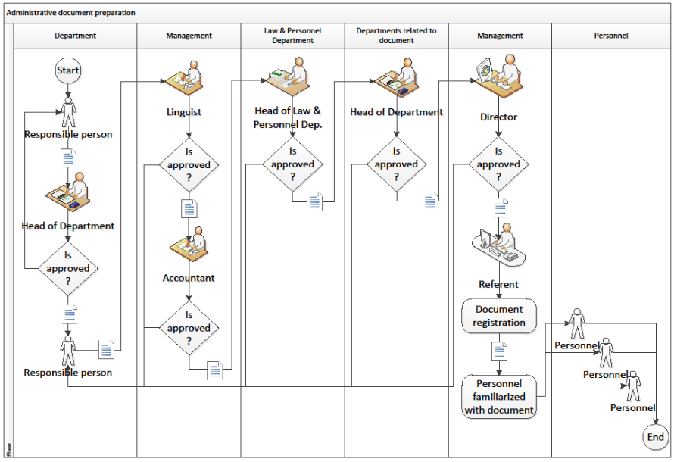
Fig. 1. An example of BPD
As the main criteria of aesthetics considered in the literature, e.g. in [8], [2], [9], [10], are: the total length of connectors, the number of crossings, the number of bends, the uniformity of the distribution of shapes in the area of the drawing, and the compatibility of the process sub-flows with the generalized top-down and left-right direction. However, the influence of these criteria to the perception of the information presented by the considered BPD is different, and depends on the user of the BPD. To implement a visualization method, which ensures the effective perception of a BPD, the attitude of potential users towards the listed above criteria is important. We propose to elicit the generalized attitude of a group of the potential users by means of a psychological experiment. Subsequently the elicited information supplements the statement of the optimization problem which solution is used to specify the drawing of the orthogonal connectors.
3 A brief overview of single-objective algorithms aimed at similar problems
In the present paper we focus on the problem of the sequence flow visualization. Therefore the differences of the flow objects can be ignored, and a single rectangular shape is used below to represent the flow objects. The visualization of graphs, where vertices are drawn as rectangles connected by piecewise vertical and horizontal lines, is commonly used. As the examples, Entity Relationship and UML diagrams can be mentioned among others. The problem of drawing graphs, with the rectangular images of vertices, and with the edges composed of the pieces of vertical and horizontal lines, is considered in many papers. Depending on a supposed application area, the algorithms should satisfy different requirements. Some algorithms, efficient from the point of view of general complexity theory, are described by [11], and [12]. A comprehensive review of algorithms oriented to the routing of paths for nets on the chip layout to interconnect the pins on the circuit blocks or pads at the chip boundary is presented in [13]. The general purpose routing algorithms are classified in three groups, namely, the maze, line-search, and A*-search groups. Since those algorithms are based on general graph-searching techniques they can be adapted to the specific requirements of both global and detailed routing problems. Different versions of those algorithms are proposed and investigated with the focus on the asymptotic complexity estimates and on the application in the chip design. However, from the point of view of the BPD drawing, the criteria of aesthetics prevail the criteria important in technological applications emphasized in [13]. In a recent paper by Wybrow et al [14] a brief review of the available algorithms and software, for the construction of orthogonal connectors, is presented from the point of view of the requirements similar to those stated above. The experimental testing performed by these authors has shown that some of the available software packages, although provide the automatic orthogonal connector routing, produce the routes which may overlap other objects in the diagram. Popular software packages, Microsoft Visio 2007, and Concept Draw Pro5, provide the object-avoiding orthogonal connector routing, but in both cases the aesthetic criteria, such as minimizing distance or number of segments, are not taken into account. We cite the conclusion made in the introduction of [14]: ”in all current tools that we are aware of, automatic routing of orthogonal connectors uses ad-hoc heuristics that lead to aesthetically unpleasing routes and unpredictable behavior”. Agreeing with the latter conclusion as well as with the remarks cited in the Introduction we find the developing of new domain-specific algorithms reasonable.
4 The description of the psychological experiment
The relative importance of the aesthetic criteria of BPD can be different for the different groups of professionals involved in the design and maintenance of business processes. We are interested in the attitude towards these criteria of the potential users of the algorithms in development. Therefore the pool of participants of the psychological experiments was selected from the master degree students in Business Informatics and in Applied Informatics, and of the businessmen who are professionals in information technology. The students have heard courses in software engineering, information systems, and data visualization at Vytautas Magnus University. These courses include themes on the visualization aesthetics, drawing of UML and CASE related diagrams as well as the business process modeling. The description of the assignments to the participants was in Lithuanian. For the repeating the experiment with a different pool of participants only minor revision would be sufficient to take into account education, practical skills, interests, and the other characteristics of the group of the respondents considered.
The psychological experiment is designed to elicit information on the relative importance of the criteria frequently used to evaluate the aesthetics and comprehensibility of BPD. Three criteria are considered: the total length of connectors, the number of crossings, and the compatibility of the process sub-flows with the generalized top-down and left-right direction. The criterion number of bends can be a priori accepted the most important one as it follows from [10], [15], [5]. The criterion of the uniformity of the distribution of shapes in the area of the drawing is not included into consideration since the shapes are supposed to be located by the human users. The goal of the psychological experiment is to rank the considered criteria and to evaluate their relative importance quantitatively.
4.1 The application domain
The process model used is of the type of models of administrative document preparation in a business enterprise. The document preparation process is maintained by the structure of the enterprise: the law and personnel department, the management, the department responsible for document preparation, the other departments related to the documents and personnel. The structure of the enterprise is represented by the swimlanes of the BPD. The example of BPD is presented in Fig. 1.
4.2 The design of BPD for testing
The attitude of the participants towards the importance of the aesthetic criteria considered is analyzed using the results of the psychological experiment where the participants evaluated the esthetics of the specially drawn BPD. Following [4] the test diagrams have been drawn to represent three levels of the aesthetic appeal of BPD with respect to the criterion of interest:
– low – the reading and understanding of the process model becomes difficult, i.e., a lot of connector crossings puzzles perception of the BPD;
– middle – the process model is conceived without substantial difficulties but some effort is needed and some irritation related to the criterion considered is not avoided, i.e., the connector crossings somewhat disturb the perception of the considered business process;
– high – excellence with respect to the criterion of interest, i.e., BPD without of the unavoidable crossings of connectors.
One of the test diagrams is presented in the Fig. 1 where the criteria are of the following levels: crossings – high, length – middle, compatibility of sub – flows – middle.
4.3 The implementation
The psychological experiment consists of two stages of 20 minutes duration.
The purpose of the first stage is to acquaint the participants of the experiment with the business process whose various BPDs are evaluated at the second stage. The respondents are given description of the business process and are asked to draw the BPD in the standard notations. All respondents have understood the business process properly since their drawings were correct.
At the second stage the participants are asked to evaluate the readability and comprehensibility of the received drawings with respect to the aesthetic criteria. Seven BPDs have been prepared for the experiment. Six of them represented either low or high level of the expressiveness of one of criteria, while the other two criteria were at the middle level of expressiveness. One drawing presented a BPD where all criteria were at the middle level of expressiveness. Each respondent has received six drawings of the former type and three drawings of the latter type. Nine drawings represent three levels of expressiveness of all three criteria considered. The diagrams have been presented to the respondents in the random order. The respondents have been asked to evaluate the comprehensibility and aesthetics of each BPD paying special attention to the criterion which level of expressiveness was represented by that BPD. The evaluation should be performed in scale between 0 and 1, where 1 means very good and 0 means very bad.
5 Results of the psychological experiment
The results of the psychological experiment consist of three lists where the assessments are related to three criteria of interest. Every list contains the assessments of three BPDs by 19 respondents. For example, the i-th line of the list related to the connector crossings (0.3 0.6 0.8) means that the i-th respondent has assessed the BPD of the low level of aesthetic appeal by the grade 0.3 in the scale between 0 and 1. The next numbers mean the grades of the BPDs of the middle and high level of aesthetic appeal correspondingly.
The attitude of a respondent towards the relative importance of two criteria is elicited by comparison of grades given to the pairs of BPDs of the same level. Let us assume that the grades given to BPDs with respect to the criteria C₁ and C₂ are (c₁₁, c₁₂, c₁₃) and (c₂₁, c₂₂, c₂₃) correspondingly. The inequality c₁₁ < c₂₁ is interpreted as one yes-vote for C₁ as the criterion of the higher importance than C₂. The inequalities c₁₂ < c₂₂ and c₁₃ > c₂₃ have the same interpretation. Such a binary relation formalizes the notion that bad and medium expression levels of the most important criteria are graded worse than those of the least important criteria. The latter normally are graded rather permissively. The excellent alternatives of the most important criteria, contrary, are graded by higher grades than the excellent alternatives of the least important criteria.
The binary relation of importance among the criteria is defined according to the sums of yes-votes: C₁ C₂ denotes that C₁ has got more yes-votes than C₂ implying that C₁ has been evaluated as more important than C₂. The application of that concept of ranking to the results of the psychological experiment implies the following result
the number of bends the number of crossings ∼
the compatibility of sub − flows = the length of connectors,

Table 1. Results of psychological experiment on BPD aesthetics
Points | Intensity of importance | Percentage of yes-votes
1 | Insignificant | 50% – 60%
2 | Modest | 61% – 70%
3 | Strong | 71% – 80%
4 | Very strong | 81% – 90%
5 | Extreme | 91% –100%

where the a priory assessment of the criterion the number of bends as the most important one is taken into account. To assess the relative importance of the considered criteria quantitatively we apply the method proposed by T.Saaty (see, [16], [17]) for the Analytic Hierarchy Process (AHP). That method requires to represent the pairwise comparison of the importance of criteria as the ratio judgments. The five point scale is used to evaluate quantitatively the relative intensity of the importance of the criterion of the higher importance against the less important alternative. The evaluation is based on the percentage of the yes-votes collected according to the scale described by Table 1.
The matrix of the results of pairwise comparisons should include also the ratio judgments of less important alternatives against the more important ones; that part of the matrix is filled by the reciprocals of known symmetric elements. The matrix of the ratio judgments, which summarizes the results of the psychological experiments, and the weights of the criteria computed by the method used in AHP are presented below
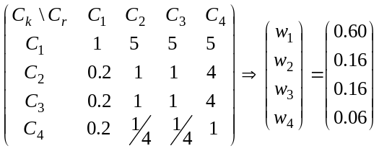 | (1)

where the following notations for the criteria are used: C₁ – the number of bends, C₂ – the number of crossings, C₃ – the compatibility of sub-flows, C₄ – the total length of the connectors. The algorithmic evaluation of the quantitative value of the criterion C₃ for the given BPD is difficult. Therefore, the number of criteria in the statement of the multi-objective optimization problem is limited by three: C₁, C₂, C₄. The weights of these criteria are computed similarly to those in (2)
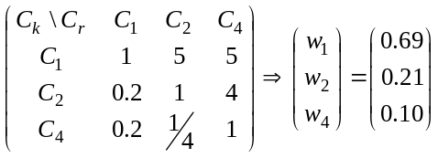 | (2)

The relatively large weight of the criterion number of bends is implied by its extreme intensity of importance set a priori. Such an evaluation is based on the widely recognized opinion substantiated, e.g. in [10], [15], [5]. It seems reasonable, however, to evaluate the weight of this criterion by a future psychological experiment equally with the other criteria.
6 The proposed algorithm
Let us specify the data which defines the problem of the visualization of a sequence flow. A usual for graph presentation data structure can be used here however the following specifics should be taken into account. The rectangle shapes are located at the nodes of a quadratic mesh. The segments of the orthogonal connectors can stretch along the borders of the pool lines and in the passages which are orthogonal to these lines, and interpose between the cells of the mesh. An example presented in Fig. 2 illustrates the permissible ways for routing: a connector starts at the point on the contour of the shape of origin and reaches the point on the contour of the destination shape, interconnecting only the neighboring thick points.
The construction of a desirable connector is a combinatorial optimization problem. The algorithms for the construction of the connectors optimal with respect to a single objective are discussed in Section 2. However, the formal involvement of all three criteria by a modification of a known, e.g. the shortest path type, graph algorithm seems difficult.
Let us start with the general comments on the validating the algorithm selection for a multi-objective optimization problem. The multi-objective algorithms of the type of the classical mathematical programming are efficient for the problems where the objective functions satisfy requirements very restrictive from the point of view of applications [18]. The stochastic algorithms are appropriate for single objective global optimization of the objective functions with various irregularities as discussed e.g. in [19]. The special case of stochastic algorithms, namely the evolutionary algorithms, is appropriate for solution of various applied problems of multi-objective optimization as shown in [20]. Therefore a stochastic metaheuristic algorithm seems appropriate for the development of an algorithm for the problem considered. The ant colony optimization (ACO) algorithms are especially oriented to search for short paths in complicated graphs [21], [22]. ACO algorithms are also efficient in solving bi-criteria traveling sales person problem as shown in the recent paper [23]. Following the arguments above we have developed two versions of ACO specified for the considered problem.
The first version differs from the standard version in the amount of pheromone placed on the path traveled by the ant:
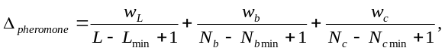 | (3)

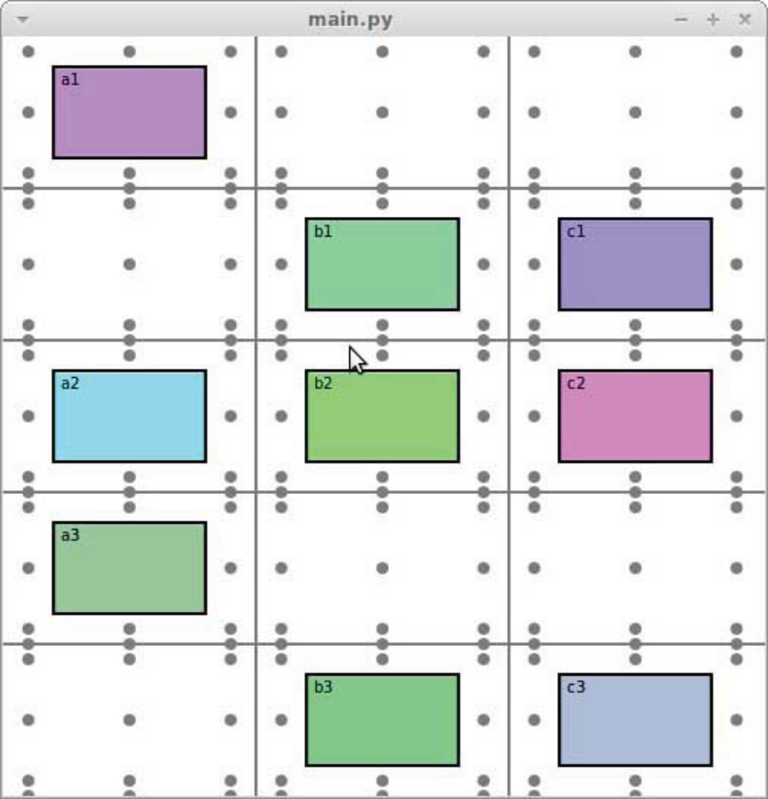
Fig. 2. A graphical illustration of data for solving the routing problem.
where L, N_{b}, N_{c} denote the total length, number of bends, and number of crossings of the considered connectors correspondingly; w with an index denotes weight of the corresponding criterion; min in the index denotes the current minimal value of the corresponding criterion. Below we present a description of the algorithm.
- Mark each edge of the graph with a pheromone value equal to 1. In this way, at the start, all paths are equally likely to be chosen. It is possible to set pheromone values to something other than one at the start. For example we could use some other algorithm, or even ACO itself, maybe with different parameters, to generate a set of paths, and use those paths to modify pheromone values in advance, thus giving the algorithm a head start. Then, the ant colony optimization algorithm could be used to fine tune these paths by, say, emphasizing reduction in the number of bends or crossings.
- Generate 10 random paths using the procedure outlined below.
  - In the beginning the path consists of the starting vertex only.
  - Generate successors for the last vertex in path.
  - Assign probabilities to each successor by taking pheromone values for edges going from the current vertex to the successor. Normalize these probabilities to add to one.
  - Select one of the successors at random according to the probability distribution generated in step (c).
  - Attach the selected successor to path.
  - If the new vertex is the final one then terminate.
  - Go to step (b).
- For each edge in path add Δpheromone to pheromone value of that edge.
- For each edge in the graph multiply the pheromone value by 0.9, which simulates pheromone evaporation. In this way the paths that are the shortest, have the least bends and least intersections with other paths will tend to be used most since they will get the highest pheromone values. The other paths will have their pheromone values constantly reduced until it reaches levels so low that almost no ant will choose them.
- Repeat from step 2 a specified number of times. In the experiments the number of times was set to 500. However values of 200 or even lower were found to be sufficient for the paths to settle.
The second version of the algorithm is developed implementing ideas of the Pareto Ant Colony Optimization (P-ACO) [24]. Here it is aimed at constructing a Pareto optimal set of paths in a graph, taking into account several criteria. As shown in [23] similar algorithm is efficient to solve bi-objective TSP problems.
A path is considered as a sequence of vertices. In the problems with weighted graphs, the sum of weights in the path can be considered as one of the path criteria. The algorithm uses pheromone matrices τ^{k}, k=1,…,K, where K denotes the number of objectives. The values of matrix elements τ^{k}_{ij} define the pheromone quantity corresponding to k-th objective placed on the edge connecting vertices i and j. These matrices are updated during the search, and they guide the ants along the edges of the graph. Different ants choose their way in the graph with different regard to the objectives. The algorithm is described below.
- Initialize the pheromone matrix τ^{k}, placing on every edge the same quantity of pheromone, however ratio of pheromone quantity corresponding to different objectives (τ^{k}_{ij}/ τ^{h}_{ij}) is equal to the ratio of weights in (2).
- A specified number of paths n is generated. Each path should be taken by a single ant. Paths are generated as described below:
              - An ant computes a vector of weights p = (p₁, . . . , p_{k}) for every objective. Value p_{i}, is chosen from uniform random distribution. These random weights serve to place emphasis on different objectives. This allows different ants to explore paths that are better in regards to some particular objective.
              - If ant is at a node i, the next node is computed using formula (4), where Ω is the set of nodes directly reachable to from node i, q₀ is parameter of the algorithm, q is a random number from uniform distribution, η_{ij} is a priori attractiveness of edge from i to j, and α, β are parameters of the algorithm which evaluate importance of a priori knowledge or the pheromone matrix values:
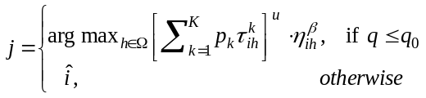 | (4)

where signifies a node in Ω chosen using the probabilities calculated using formula (5):
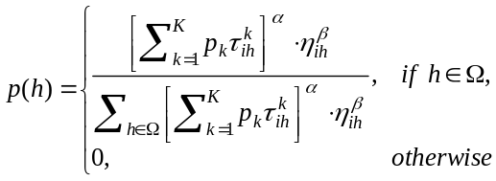 | (5)

              - Each ant, while travelling through edge 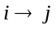 updates the pheromone values in each of the matrices. The update formula is τ ^{k} _{ij} (1-ρ)τ ^{k} _{ij} +ρτ₀, where ρ is evaporation rate. Parameter ρ is usually set to a value close to 0.1; this update function brings the pheromone value closer to initial value τ₀.
- After all ants have finished their run two best ants are selected, separately for each objective k, i.e. two ants which found the smallest values of objectives. Then the pheromone matrices are updated using the following formula
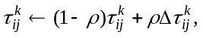

where
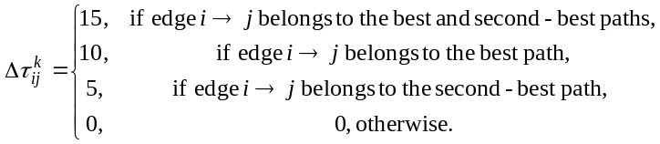

- The current ants’ solution is appended to the candidate set of Pareto optimal solutions if it is not dominated by the solutions in the stored candidate set. If it dominates some of the stored solutions, the latter are discarded.
- This process is repeated from step 2 for a fixed number of iterations.
7 Computational experiment
The proposed algorithm is implemented in C++, and its performance is evaluated experimentally. The statistics of the criteria of the constructed connectors is collected by the solution of randomly generated test problems. The locations of shapes are generated at the nodes of the rectangular mesh randomly with the uniform distribution. The randomly selected pairs of shapes are required to be connected. The size of the mesh is 3×5. The number of shapes is 6, 8, and 10, representing problems of increasing complexity. The mean values and standard deviations of the considered criteria are computed using the data of m = 100 solved test problems which are generated randomly as described above. The result of the solution of a particular problem is random since the ACO algorithm is randomized. Therefore, the optimization is repeated k = 100 times for each test problem.
The results of the experiments with the first version of ACO show that the most important criterion, namely the number of bends, for the medium dense diagrams can be reasonably improved by choosing the high value of the corresponding weight. The found values of the other two criteria are not sensitive with respect to the weights, and they are near optimal. The last lines in the tables present the results where 2/3 of cells are occupied by shapes. In the latter case only few indeed rational connectors are possible, and similar solutions are found with rather arbitrary values of weights.
Table 2. The mean values and standard deviations of the criteria of connectors found by the first version of ACO using the following weights: w_{L} = 0.1, w_{b} = 0.69, w_{c} = 0.21
k | L (means) | L (std) | N_{b} (means) | N_{b} (std) | N_{c} (means) | N_{c} (std)
6 | 7.832 | 3.092 | 9.825 | 3.856 | 1.437 | 1.594
8 | 10.103 | 3.512 | 12.622 | 3.838 | 3.451 | 3.610
10 | 12.680 | 3.704 | 15.770 | 4.307 | 5.483 | 4.763

Table 3. The mean values and standard deviations of the criteria of connectors found by the first version of ACO using the following weights: w_{L} = w_{b} = w_{c} = 0.33
k | L (means) | L (std) | N_{b} (means) | N_{b} (std) | N_{c} (means) | N_{c} (std)
6 | 7.871 | 3.143 | 11.958 | 5.084 | 1.369 | 1.505
8 | 10.050 | 3.593 | 15.165 | 5.344 | 3.003 | 3.075
10 | 12.631 | 3.721 | 16.771 | 5.102 | 5.166 | 4.532

The second version of ACO is more sophisticated. Here an ant chooses the direction to move from every node taking into account partial information on the objectives accumulated for all edges. Therefore different ants find sub optimal paths with respect to different objectives. The combination of parts of such paths is indeed more advantageous in constructing non-dominated solutions than combination of parts of paths which are sub-optimal with respect to a weighted sum of objectives. It could be expected that the more complete information about objectives implies the improvement of solutions with respect to the most important objective. The results of Table 4 show that the expectation was exceeded: the solutions are improved with respect to all objectives. The results of our experiments corroborate the conclusion of [23] on efficiency of the second version of ACO algorithm (called Pareto Ant Colony Optimization in [24]) for the solution of multi-objective graph optimization problems.
Table 4. The mean values and standard deviations of the criteria of connectors found by the second version of ACO.
k | L (means) | L (std) | N_{b} (means) | N_{b} (std) | N_{c} (means) | N_{c} (std)
6 | 6.562 | 2.214 | 7.572 | 2.451 | 1.402 | 1.598
8 | 8.639 | 2.552 | 10.710 | 2.818 | 2.380 | 2.410
10 | 10.965 | 2.755 | 13.912 | 3.267 | 3.880 | 2.883

Both versions of ACO algorithm find the solution in time negligible from a human user point of view.
8 Conclusions
A problem of aesthetical drawing of rectangular connectors, representing edges of special graphs, is re-stated as a combinatorial multi-objective optimization. The relative importance of the criteria of aesthetics is assessed by the results of a psychological experiment. A version of ant colony optimization algorithm is adapted to the considered problem and its efficiency is evaluated by the solution of a set of randomly generated test problems. The preliminary investigation in the present paper shows that the further development of the proposed methods is promising with respect to application in drawing of business process diagrams for small-medium enterprises.
9 Acknowledgements
The support by the Agency for Science, Innovation and Technology (MITA) trough the grant Nr.31V-145 is acknowledged.
References
1. Owen, M., Jog, R.: BPMN and Business Process Management, http://www.bpmn.org, 1-27 (2003)
2. Battista, G.D., Eades, P., Tamassia, R., Tollis, I.G.: Graph Drawing, Algorithms for the Visualisation of Graphs. Prentice Hall (1999)
3. Bennett, Ch., Ryall, J., Spalteholz, L., Gooch, A.: The Aesthetics of Graph Visualization. In: Cunningham, D. W., Meyer, G., Neumann, L.(eds.) Computational Aesthetics in Graphics, Visualization, and Imaging, pp. 1–8. (2007).
4. Purchase, H.C., McGill, M., Colpoys, L., Carrington, D.: Graph drawing aesthetics and the comprehension of UML class diagrams: an empirical study. In Proceedings of the 2001 Asia-Pacific symposium on Information visualisation, 9, pp. 129–137 (2001)
5. Purchase, H.C.: Metrics for Graph Drawing Aesthetics. Journal of Visual Languages & Computing, 13, 501–516 (2002)
6. ORGSOFT, http://www.orgsoft.lt
7.
8. Purchase, H.C., Carrington, D., Allder, J. A.: Empirical evaluation of aesthetics based graph layout. Empirical Softw. Eng., 7(3), 233–255 (2002)
9. Kaufmann, M., Wagner, D.: Drawing Graphs: Methods and Models. Springer (2001)
10. Taylor, M., Rodgers, P.: Applying graphical design techniques to graph visualisation. In Proceedings of the 9th International Conference on Information Visualisation, IV05, pp. 651–656. (2005)
11. Yang, C-D., Lee, D., Wong, C.: Rectilinear Path Problems among Rectilinear Obstacles Revisited. SIAM J. Comput., 24, pp. 457-472 (1995)
12. Lee, D., Yang, C., Wong, C.: Rectilinear paths among rectilinear obstacles. Discrete Applied Mathematics, 70(3), 185-216 (1996)
13. Chen, H.-Y., Chang, Y.-W.: Global and Detailed Routing. In:Wang, L.-T., Chang, Y.-W., and Cheng, K.-T. (eds.) Electronic Design Automation: Synthesis, Verification, and Testing. pp. 687-749. Elsevier/Morgan Kaufmann (2008)
14. Wybrow, M., Marriott, K., Stuckey, P.: Orthogonal Connector Routing. Lecture Notes in Computer Science, 5849, pp. 219-231 (2010)
15. Tamassia, R., Battista, G.D., Batini, C.: Automatic graph drawing and readability of diagrams. IEEE Trans. Syst. Man Cybern., 18(1) 61–79 (1988)
16. Farkas, A.: The Analysis of the Principal Eigenvector of Pairwise Comparison Matrices. Acta Polytechnica Hungarica 4(2) (2007)
17. Saati, T.L.: The Analytic Hierarchy Process: Planning, Priority Settings, Resource Allocation. RWS Publications, Pittsburg PA (2001)
18. Miettinen, K.: Nonlinear Multiobjective Optimization, Kluwer Academic Publishers (1999)
19.
20. Deb, K.: Multi-Objective Optimization using Evolutiionary Algorithms. J. Wiley (2009)
21. Colorni, A., Dorigo, M., Maniezzo, V.: Distributed Optimization by Ant Colonies. Actes de la premiere confrence europaenne sur la vie artificielle, pp. 134-142. Elsevier (1991)
22. Dorigo, M., Birattari, M., Stutzle, T.: Ant Colony Optimization. Technical Report No. TR/IRIDIA/2006-023 (2006)
23. Garcia-Martinez, C., Cordon, O., Herrera, F.: A taxonomy and an empirical analysis of multiple objective ant colony optimization algorithms for the bi-criteria TSP. European Journal of Operations Research, 180, 116–148 (2007)
24.Doerner,K., et al: Ant Colony Optimization: A Metaheuristic Approach to Multiobjective Portfolio, Annals of Operations Research, 131 (1-4), 79-99 (2004)

