|  |  |  |  |
| --- | --- | --- | --- |
|  | Existing Space | | |
|  | **Space** | **SF** | **Annually** |
|  | Admin | 2644 | $0.00 |
|  | Bathrooms | 491 | $0.00 |
|  | Conf Rooms | 1951 | $0.00 |
|  | GAT | 390 | $15,000.00 |
|  | Hallway | 2187 | $0.00 |
|  | NWS/Police | 7645 | $216,000.00 |
|  | Storage | 1495 | $0.00 |
|  | Vacant | 4293 | $0.00 |
|  | Total | | $231,000.00 |

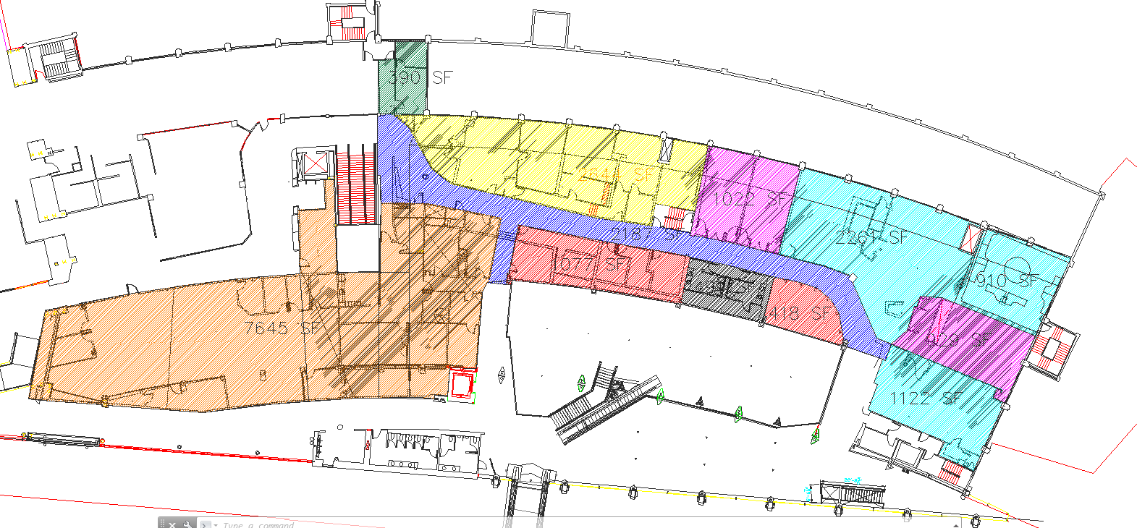

|  |  |  |  |  |
| --- | --- | --- | --- | --- |
|  | Proposed Space | | | |
|  | **Space** | **SF** | **Unit Price** | **Annually** |
|  | Admin | 910 | 0 | $0.00 |
|  | Hallway | 3541 | $53/SF | $187,673.00 |
|  | Retail | 12991 | $53/SF | $688,523.00 |
|  | TSA | 3813 | $51/SF | $194,463.00 |
|  |  | Total | | $1,070,659.00 |

