Homepage
Welcome

Rudgwick Country show is a southern England Country Fair that is well-known one of the largest country fairs in the nation and one of the most visited fairs worldwide.

With all the vehicles and machinery, children’s animal area, craft marquee, food hall, huge autojumble, wild west shoots out shows, acres of the market, machinery displays & on sale in which enriches the popularity of the fair.

Additionally, there are Arena displays, many live demonstrations, a mini beer festival with agricultural music from the new forest yokels; best summer fun for all the family.

Come to the show for sun, fun and cheering while exploring the Steam Engine.

Date: Aug 24 - Aug 26, 2019

Time: 9 am to 6 pm

Location: The Showground, Rudgwick, Nr Horsham, West Sussex

Price: $10 for adults, $5 for children under 16 years and free for children under 5 years

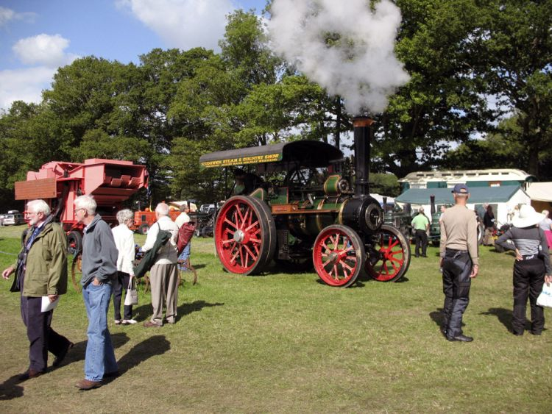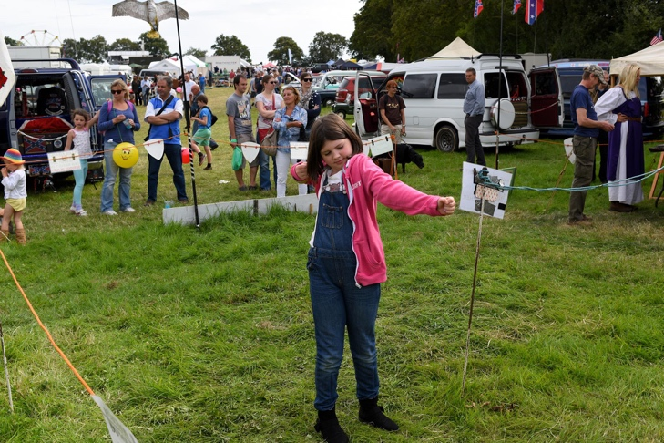
Figure 1 Home page (image of people having fun) Figure 2 Homepage (image of people having fun)
Choose one of above
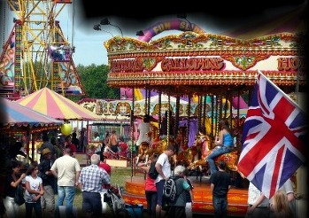
Figure 3 Homepage (image of fair)
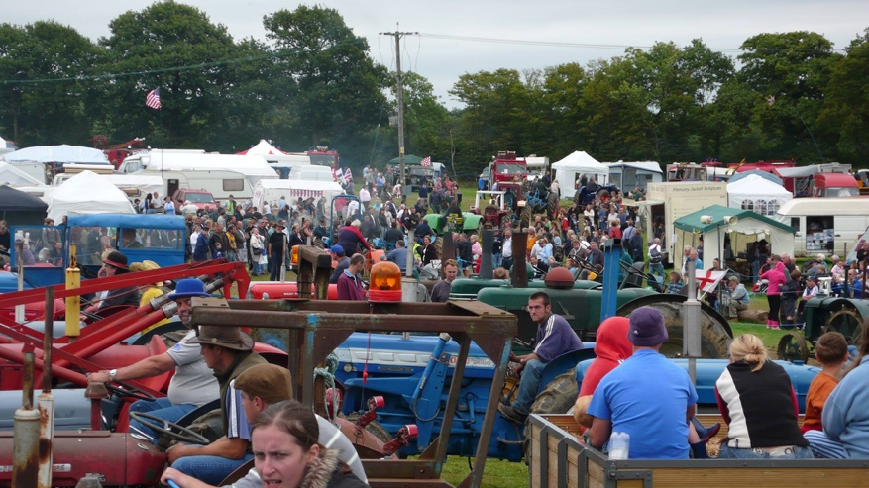
Figure 4 Homepage (image of event)
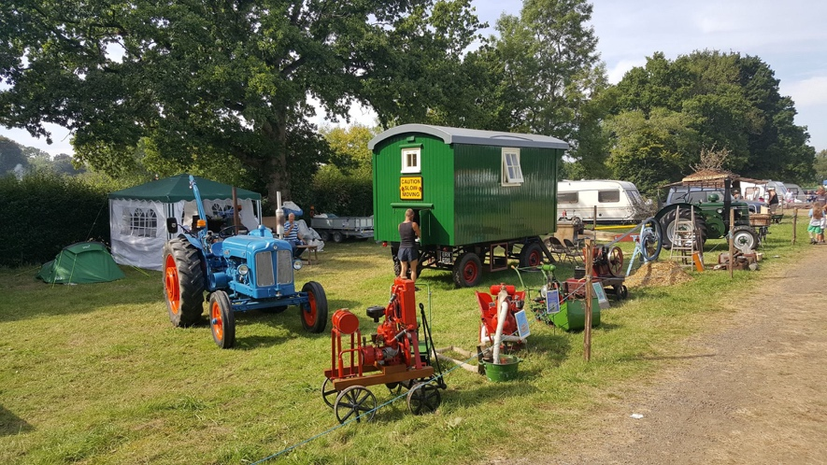
Figure 5 Homepage (image of camping)

Event Page
About Events

The 31st annual Rudgwick Steam & Country Show will be held over the three days of August Bank Holiday Weekend. This year’s show will bring together a wonderful array of the Great British past and present with stunning exhibits, animals, and displays of all kinds from all over the country.

Event Details

Rudgwick Steam and Country Show is our annual end of year event. As well as our Have A Go Archery, our historic friends 'The Wessex Invaders & Settlers Empire' and 'The Far Isles Society' will be on hand to show you what daily life was like in Medieval times and entertain you with cooking demonstrations, armed combat and traditional crafts (subject to availability). This country show has something for everyone to enjoy, the sights and sounds of the beautifully restored vehicles and exhibits of the past pondering around the site. A relaxed and enjoyable day out or weekend away for all the family. Lots more besides us;- Traction engines, ploughing match, vintage tractors & farm machinery, assorted vintage vehicles, large general market, fun fair, food court, beer tent.

Learn and see how things were done in the past with our numerous demonstrations and displays over the spectacular 44-acre site. See and stroke the heavy horses and take a look at our large pet and farm animal sections, ride on the old-time traditional fair. Visit our 6,000 square feet quality Craft Marquee and new Food Hall with homemade cakes and lots more. Sit down and take a break in our 140ft beer marquee with a mini beer festival, while listening to live agricultural music from the New Forest Plonkers or relax in the Tea and Ploughman’s lunch marquee. Enjoy the always amusing animal parades from chickens to shires with an owl fly past. Learn about the magnificent and mighty traction engines at work in our agricultural working sections with tree trunk sawing, threshing and baling demonstrations. See the chainsaw sculptors at work, the rural displays, ferret racing, all the vintage vehicles at work, acres of markets stalls, a large autojumble section plus an action-packed main arena events program. An excellent family fun weekend with something for all ages to enjoy.

Photo gallery

- Steam engines show 2. Farm animals

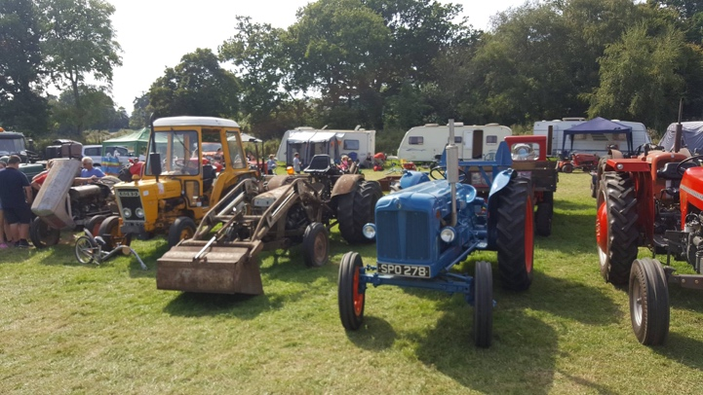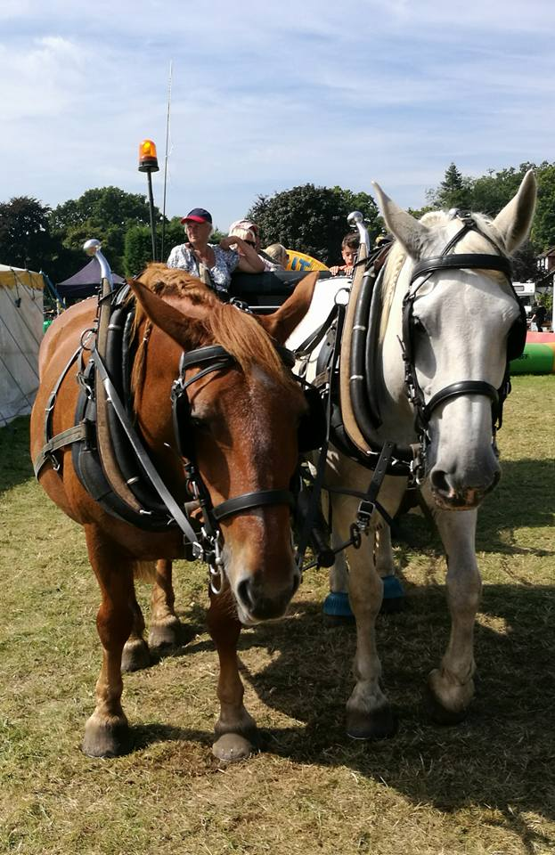

- Traditional fun 4. Beer festival

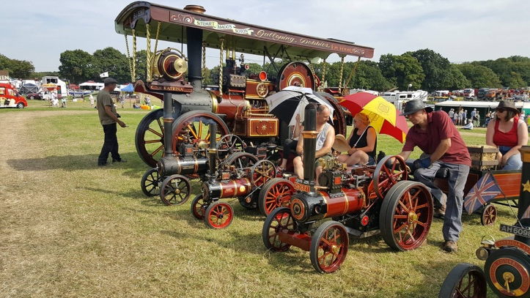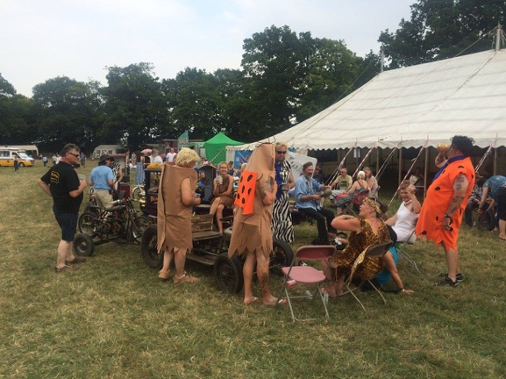

5. Drama performance 6. Music evening

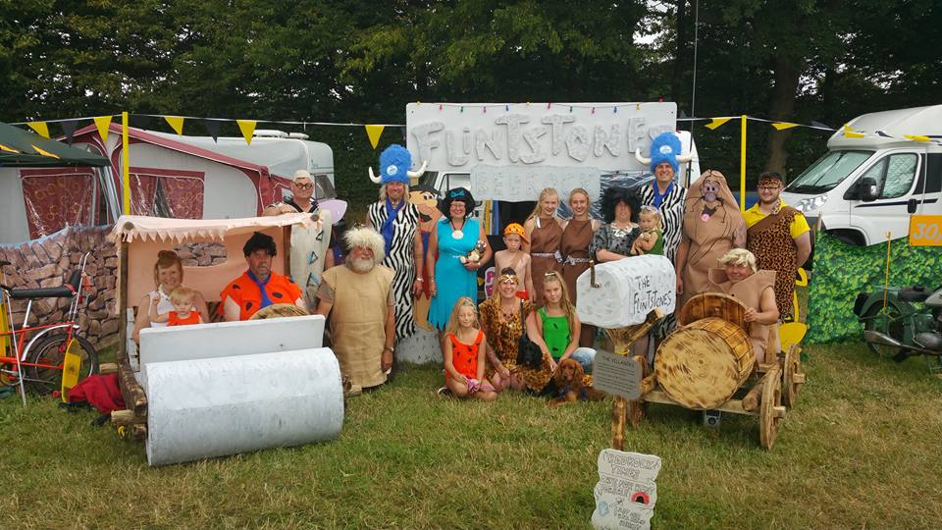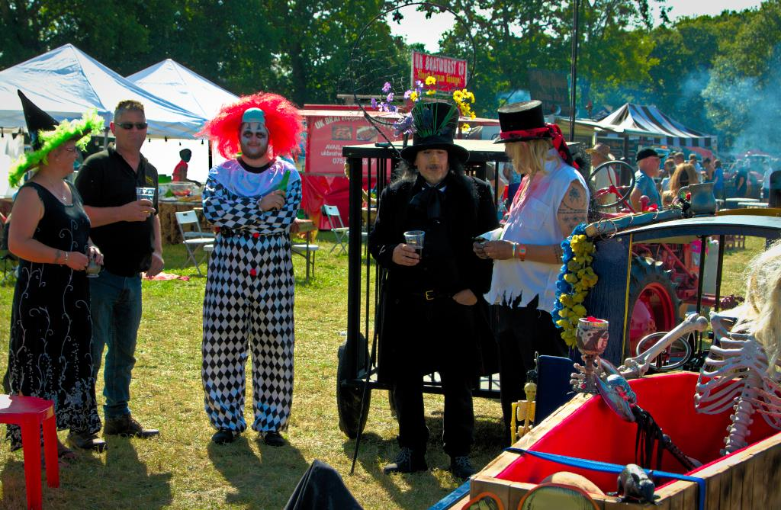

7.Food hall 8. Ride on

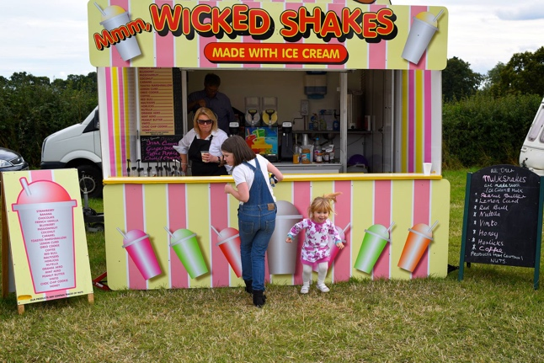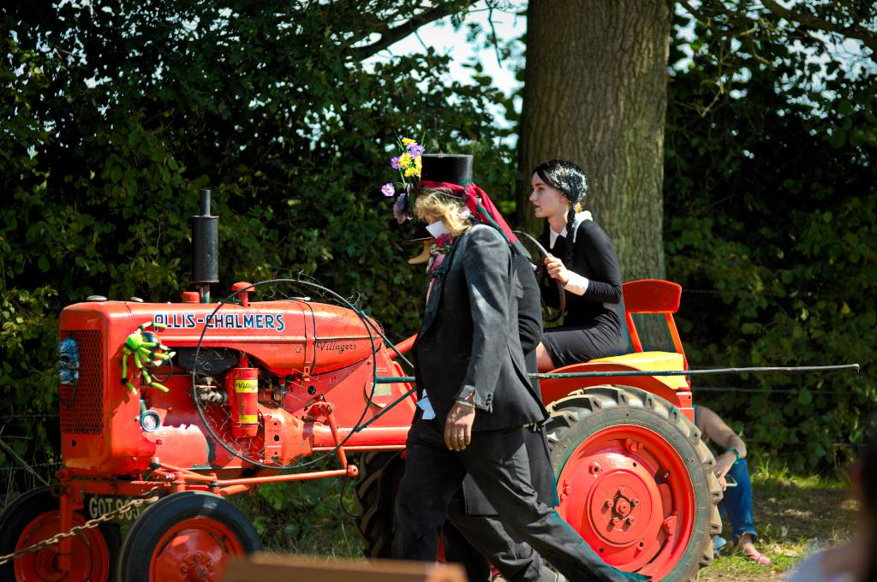

Contact Information
Email: chanaburi1@aol.com
Address:
The Showground, Rudgwick, Nr Horsham,
West Sussex,
RH12 3DF

Image sources

https://www.facebook.com/search/photos/?q=Rudgwick%20Steam%20%26%20Country%20Show&f=AboOkC6n4lgtgEx1mzIRIA8040eS7iYD6I7zcngm2lo7hbAqA3tJuy63z9tUVTgMl2A2y0I7Hg3vxB9tcuU_EohD_qotuIVjOJssVwqBpHxc0zW5MCAkkULE8OrhmdZfaIpzgDyVasE1TBge16PJHshp

https://www.facebook.com/pages/Rudgwick%20Steam%20Show/1006555079430869/photos/

