EXP 4: The string is a sequence of characters placed in double quotes (” “). Performing different operations on string data is called String Handling. Strings are immutable. Whenever a change to a String is made, an entirely new String is created. If we want to store a group of characters we can use a char array. String provides various methods to perform different operations on strings. Using Raptor draw a flowchart to display the total number of characters in the string and returns it.
Workflow:
- Start.
- Declare a string variable str.
- Input the string from the user.
- Calculate the length of the string using Length_of(str).
- Store the result in a variable count.
- Display "Total number of characters = " and count.
- Stop.
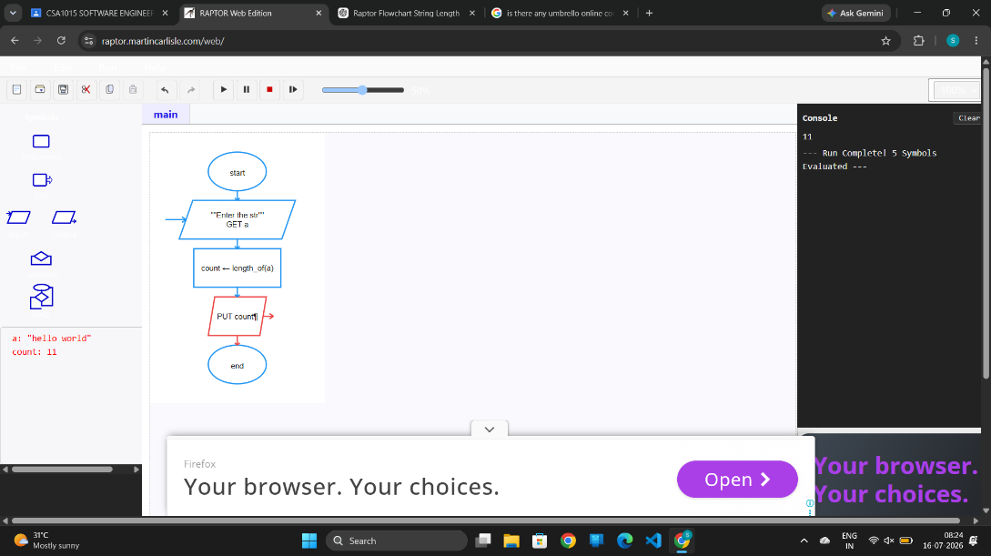

EXP 5: Using Raptor – Draw and validate a flowchart for a given string of lower case English alphabets. One can choose any two characters in the string and replace all the occurrences of the first character with the second character and replace all the occurrences of the second character with the first character. Using Raptor draw and validate the flowchart lexicographically smallest string that can be obtained by doing this operation at most once.
Algorithm
- Start
- Input the string S
- Set best = S
- For each character c1 from 'a' to 'z'
- For each character c2 from c1+1 to 'z'
- Copy S into temp
- Replace every c1 with c2
- Replace every c2 with c1
- Compare temp and best
- If temp is lexicographically smaller
  - best = temp
- Repeat for all character pairs
- Output best
- Stop
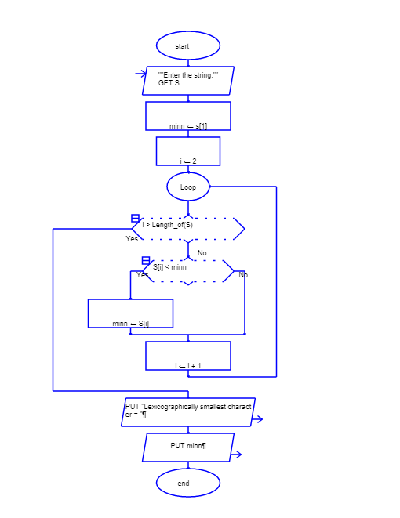
Loop Used
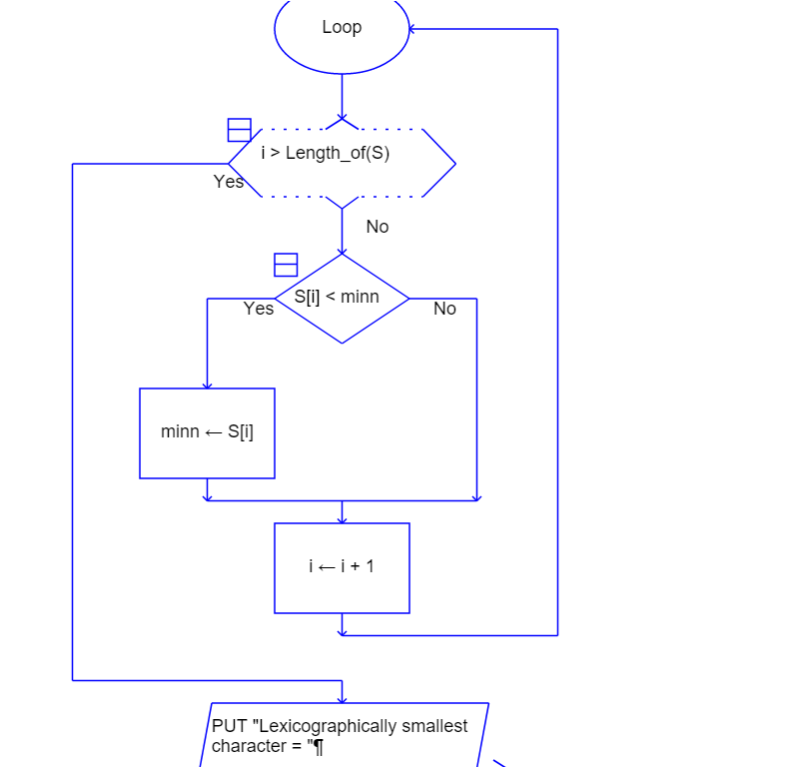
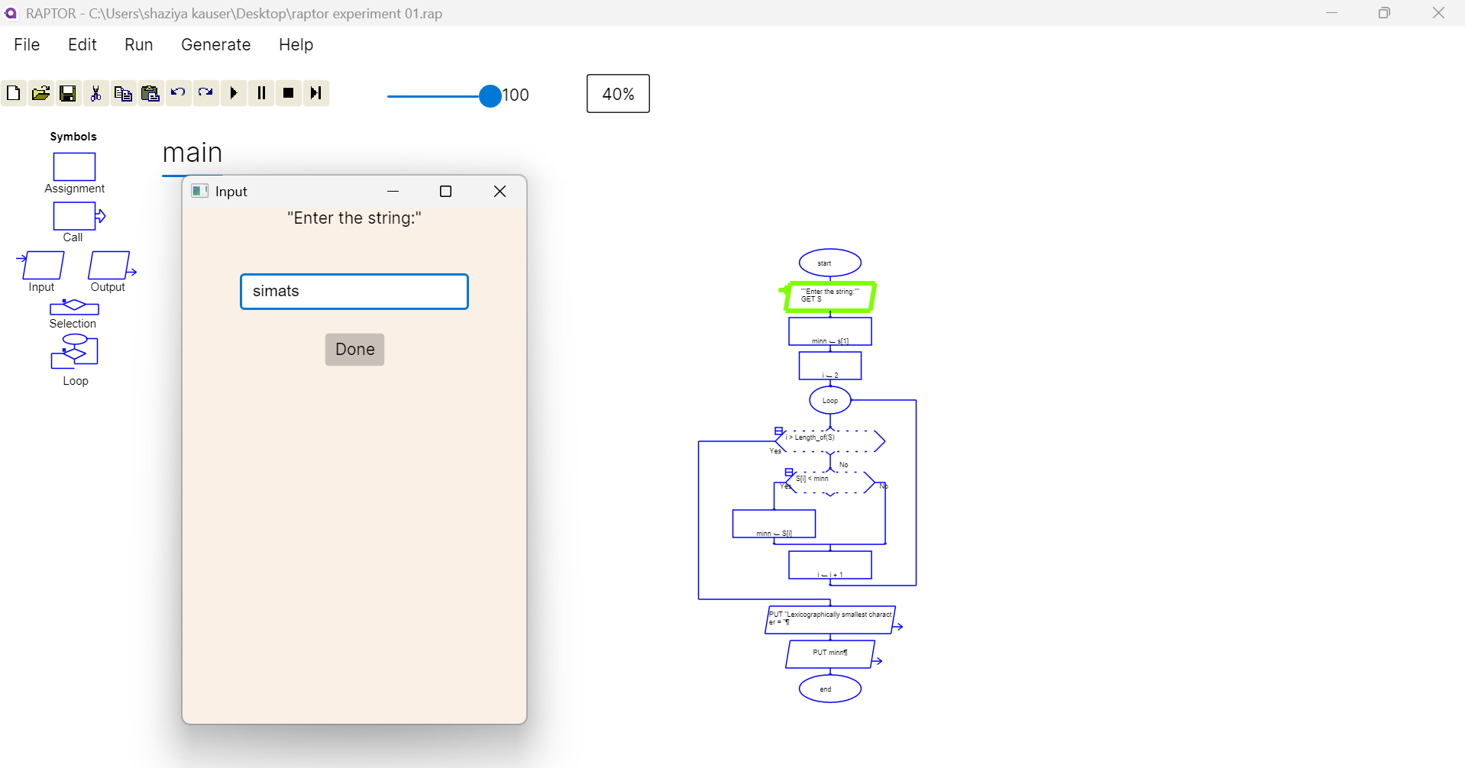
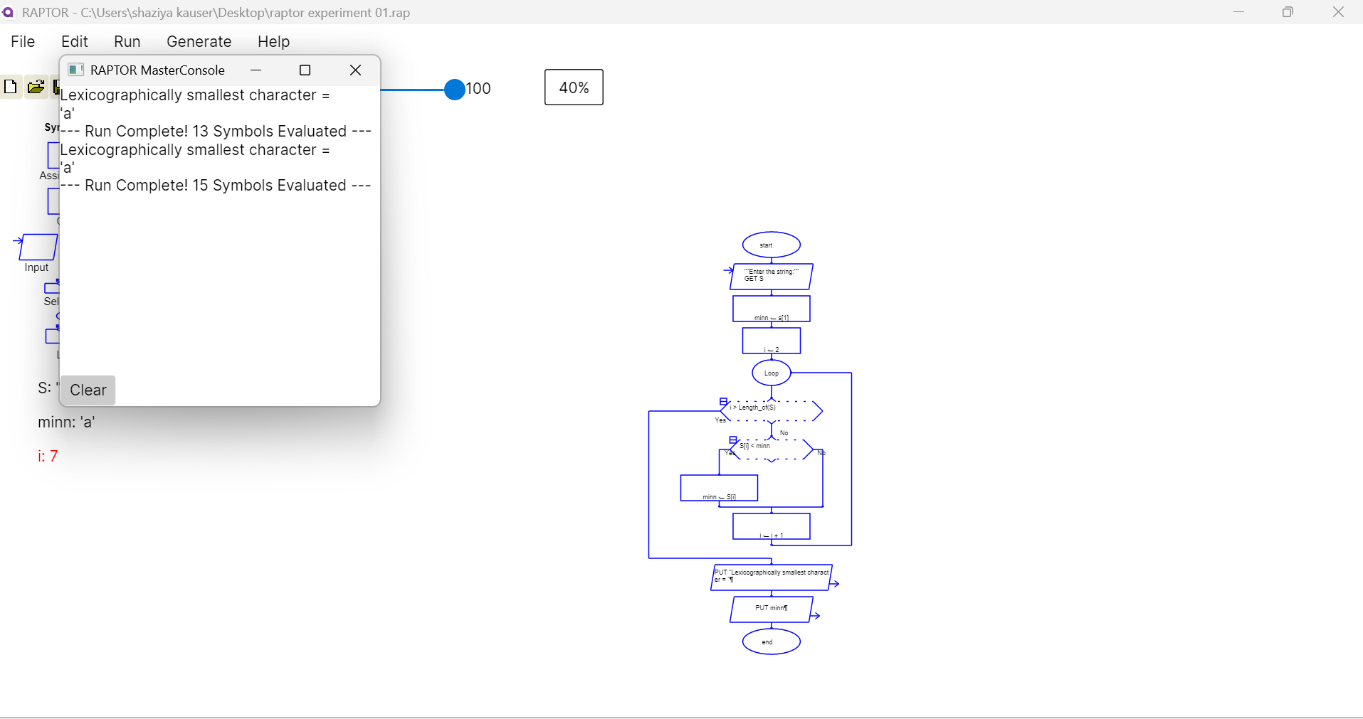

EXP 8: Cyclomatic Complexity in Software Testing is a testing metric used for measuring the complexity of a software program. It is a quantitative measure of independent paths in the source code of a software program. Cyclomatic complexity can be calculated by using control flow graphs or with respect to functions, modules, methods or classes within a software program. Cyclomatic complexity for a flow graph G is V(G)=E-N+2. Cyclomatic complexity is a software metric (measurement), used to indicate the complexity of a program, Cyclomatic complexity = E - N + P where, E = number of edges in the flow graph, N = number of nodes in the flow graph, P = number of nodes that have exit points. Find Cyclomatic Complexity for a graph having number of edges as 17, number of nodes as 13 and number of predicate nodes in the flow graph as 5.

Algorithm: Cyclomatic Complexity
- Start.
- Input the number of edges Ed.
- Input the number of nodes Node.
- Input the number of predicate nodes P.
- Calculate Cyclomatic Complexity using:
  - CC = E − N + 2
  - (or verify using CC = P + 1)
- Display Cyclomatic Complexity = CC.
- Stop.

