Experiment 6 : An online food delivery platform enables customers to browse restaurants, view menus, place food orders, make online payments, and track delivery status. Restaurants use the system to manage their menus and update order status, while delivery agents are responsible for accepting delivery requests and updating delivery progress. Design a Class Diagram, Use case Diagram and Activity Diagram for the Online Food Delivery System showing the relevant classes, their attributes, methods, and relationships.

Class Diagram

Procedure
- Open Umbrello UML Modeller.
- Create a new UML project.
- Select Class Diagram.
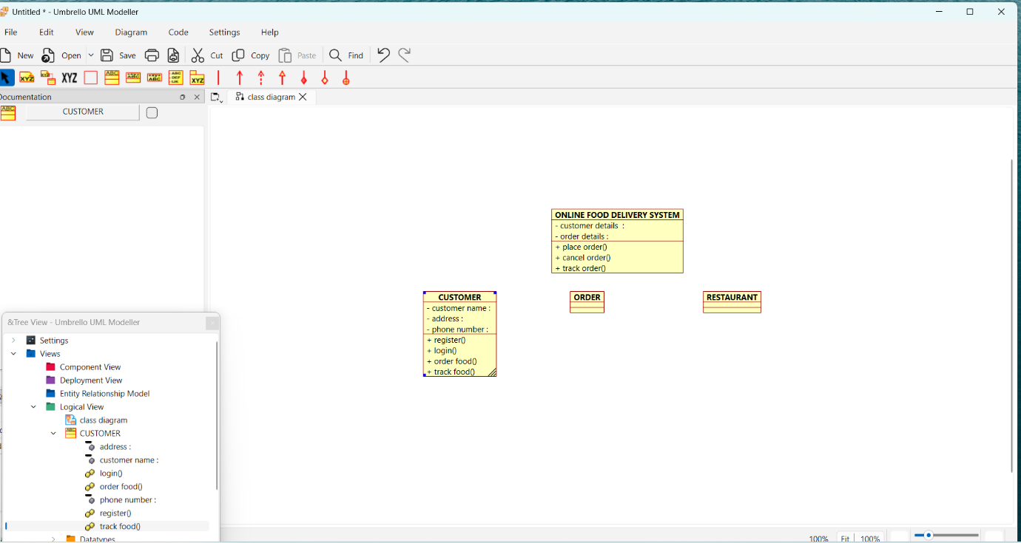
- Create the classes: Customer, Order, Restaurant.
- Add the required attributes and methods to each class.
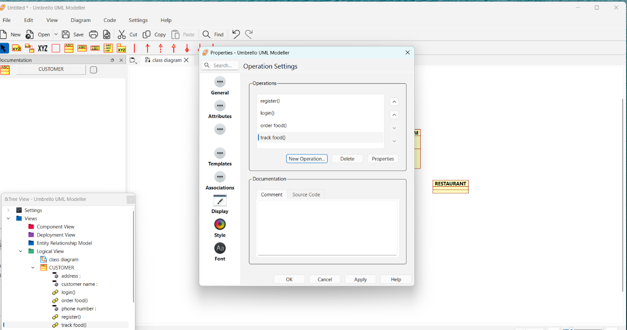
- Connect the classes using association relationships.
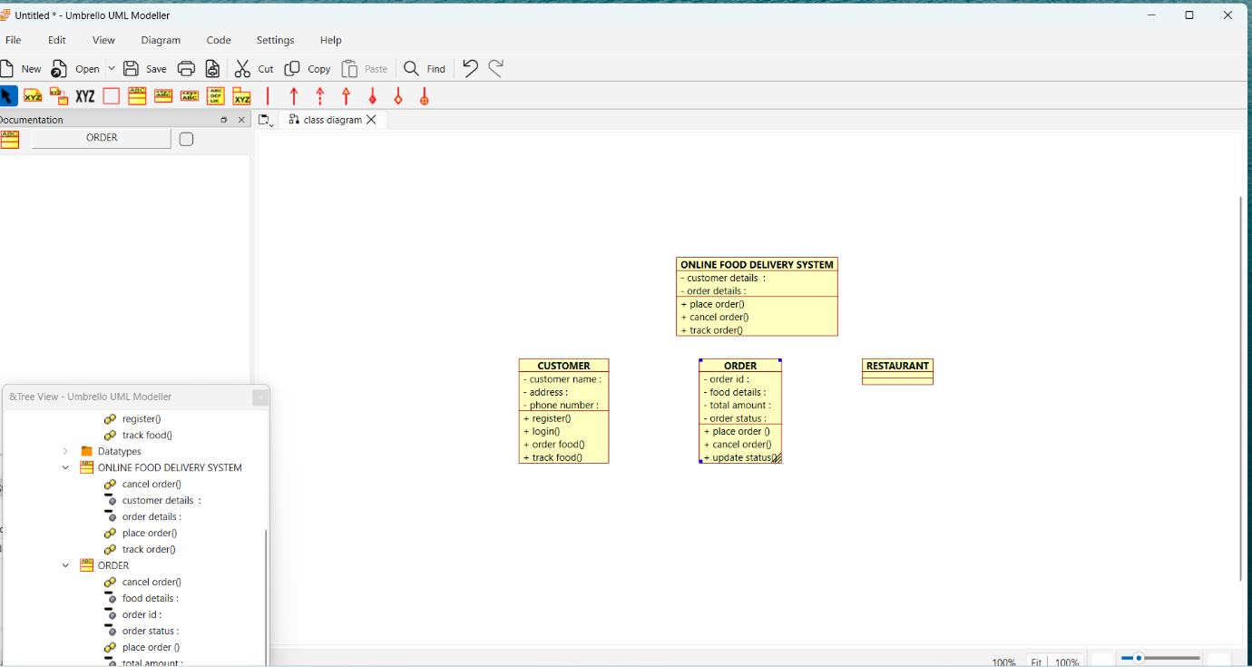
- Arrange the classes neatly.
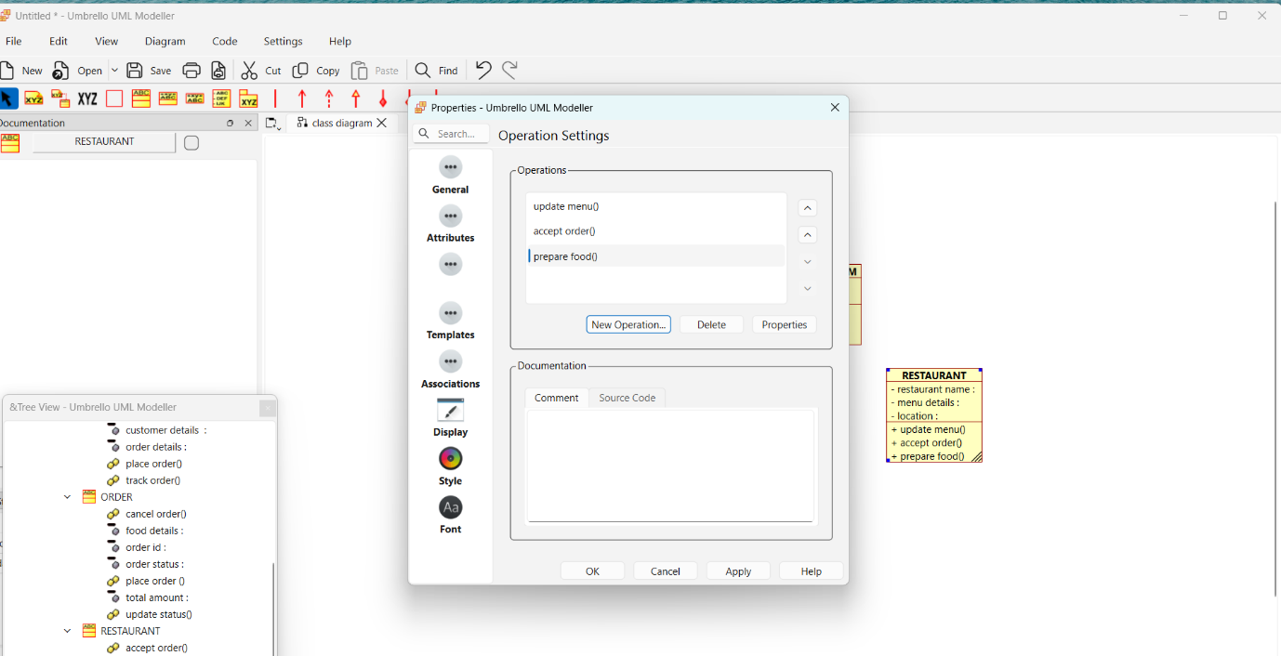
- Save the diagram.
- Verify that the diagram correctly represents the Online Food Delivery System.
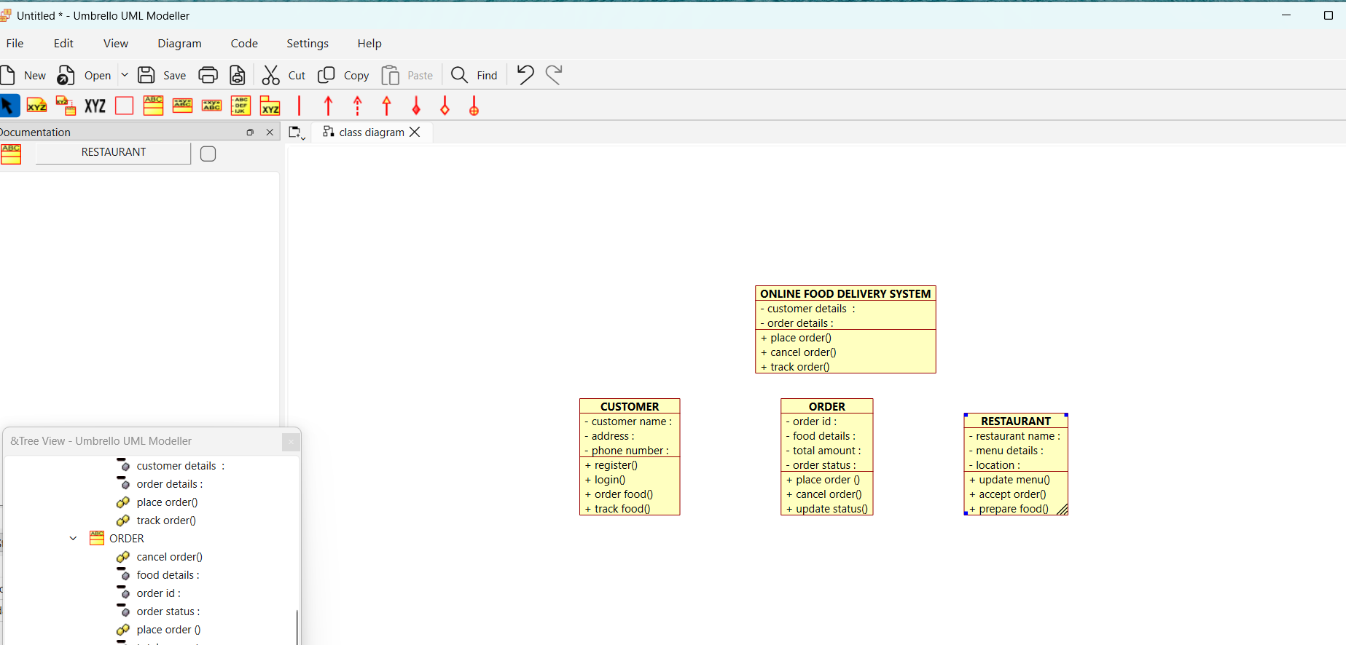
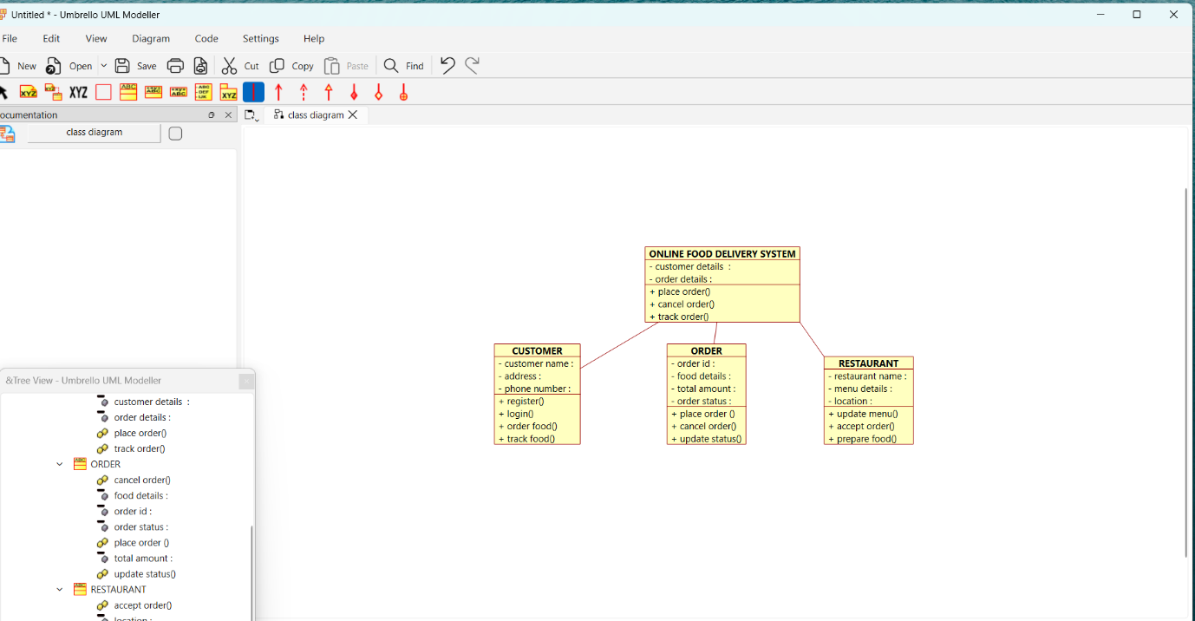
Use Case Diagram :

Procedure
- Open Umbrello UML Modeller.
- Create a new UML project.
- Select Use Case Diagram.
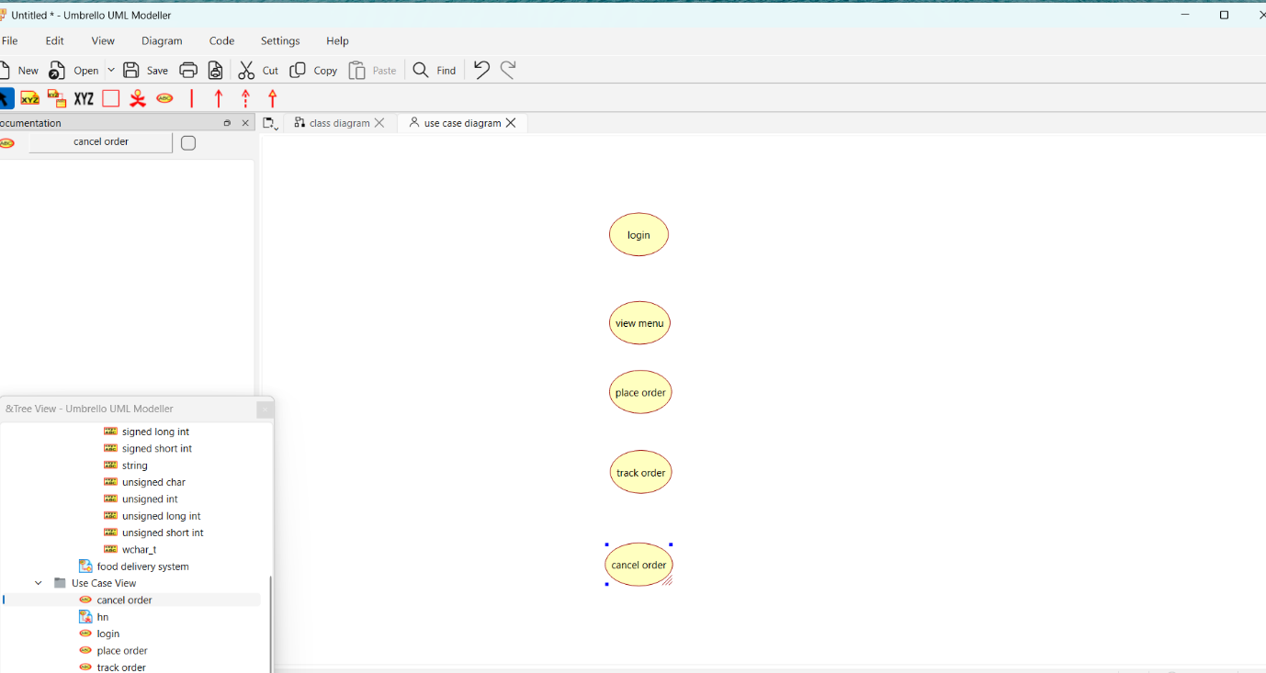
- Add the actors: Customer, Restaurant, and Delivery Agent.
- Create the use cases such as Register/Login, View Menu, Place Order, Make Payment, Track Order, Manage Menu, and Update Delivery Status.
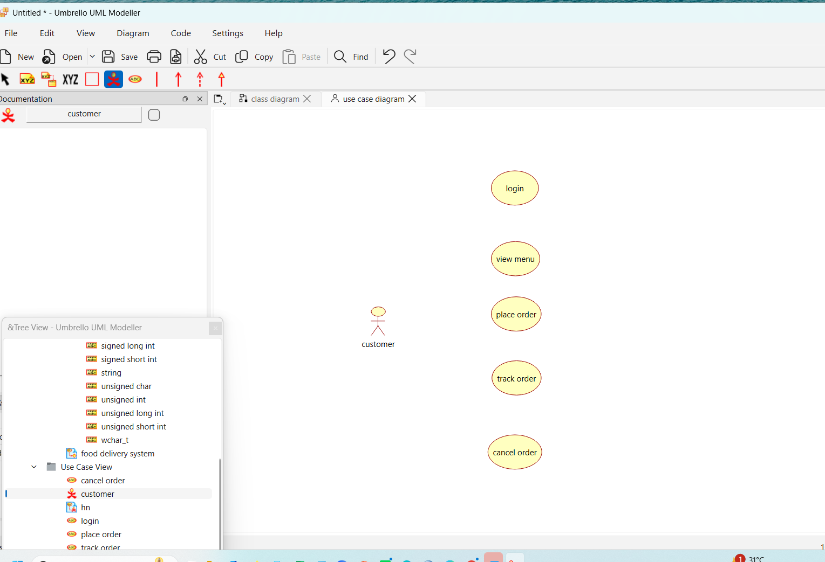
- Connect the actors to the appropriate use cases.
- Arrange the diagram neatly.
- Save the diagram.
- Verify that all user interactions are correctly represented.
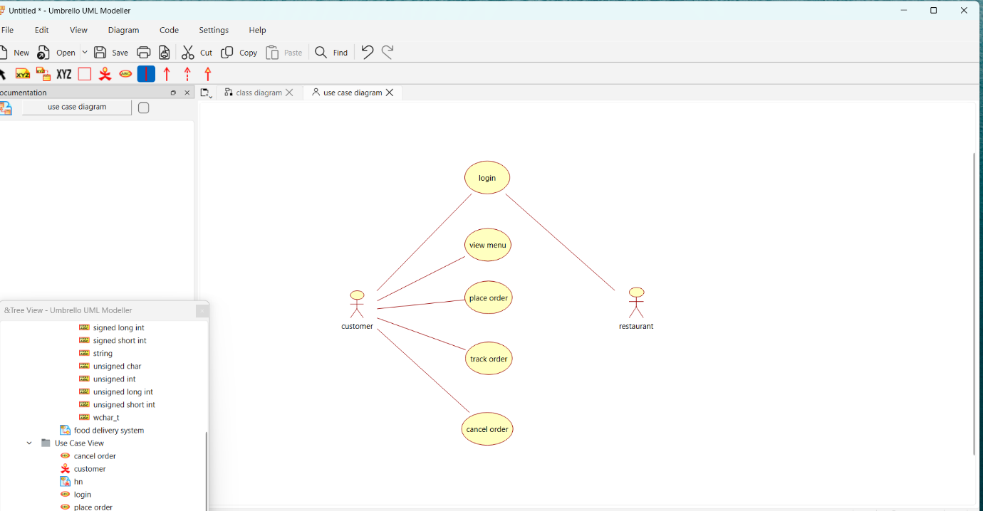

Activity Diagram :

Procedure :
- Open Umbrello UML Modeller.
- Create a new UML project.
- Select Activity Diagram.
- Add the Start node.
- Create the activities: Register/Login, View Menu, Select Food, Place Order, Restaurant Receives Order, Prepare Food, Deliver Food, and Order Completed.
- Connect the activities using control flow arrows.
- Add the End node.
- Arrange the activities in the correct order.
- Save the diagram.
- Verify that the workflow correctly represents the Online Food Delivery System.

Experiment 7 : A college employs a large number of security personnel who are assigned duties at various locations across the campus. Each security person follows a duty schedule that includes date, duty start time, duty end time, and assigned location, ensuring that every campus location is covered. If a security person takes leave, it is recorded manually, and at the end of each month, salaries are calculated based on duties performed and leaves taken. Since manual handling of duty allocation, leave management, and salary calculation is time-consuming and complex, the college plans to develop an Online Security Management System to automate these activities. Develop Class Diagram, Use case Diagram and Activity Diagram to represent the workflow of the Online Security Management System

Procedure for Class Diagram
- Study the problem statement and identify the system requirements.
- Identify the main classes involved in the system, such as Online Security Management System, Security Officer, Security Personnel, Duty Schedule, Leave, and Salary.
- Define the attributes for each class (e.g., personnelId, name, scheduleId, leaveId, salaryId).
- Define the operations (methods) for each class (e.g., assignDuty(), applyLeave(), calculateSalary(), generateReport()).
- Identify the relationships and multiplicities between the classes.
- Draw the class diagram using UML notation in Umbrello.
- Verify that all classes, attributes, operations, and relationships correctly represent the system.
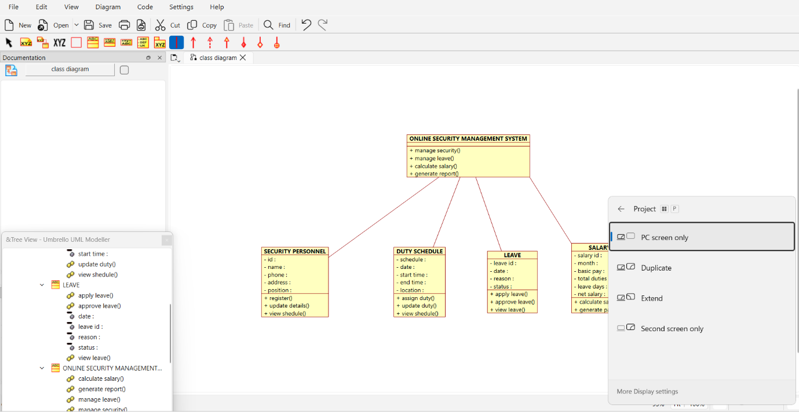

Procedure for Use Case Diagram
- Study the problem statement to understand the system functionalities.
- Identify the actors interacting with the system, such as Security Officer and Security Personnel.
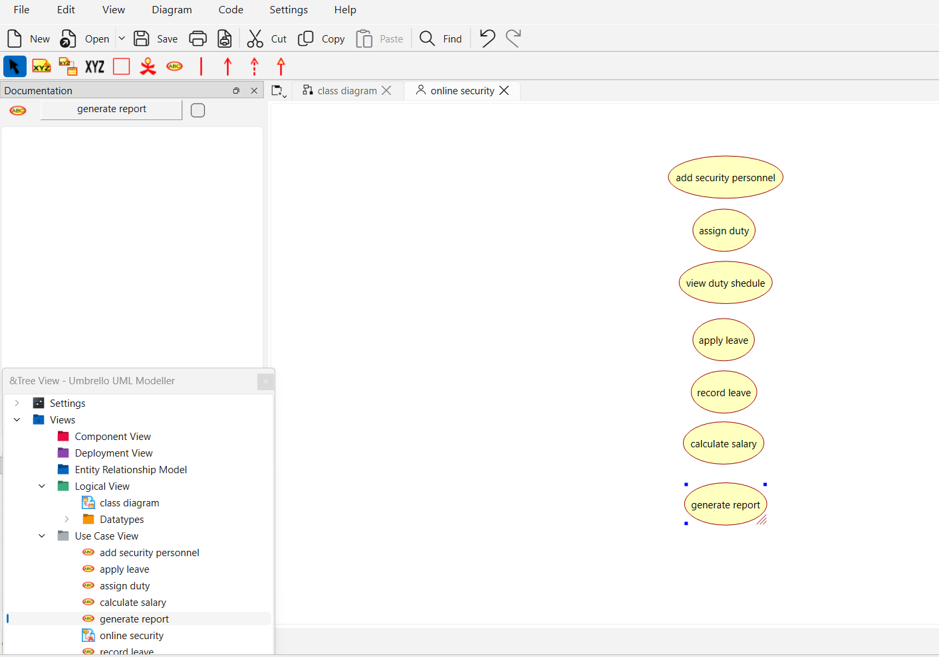
- Identify the use cases performed by each actor.
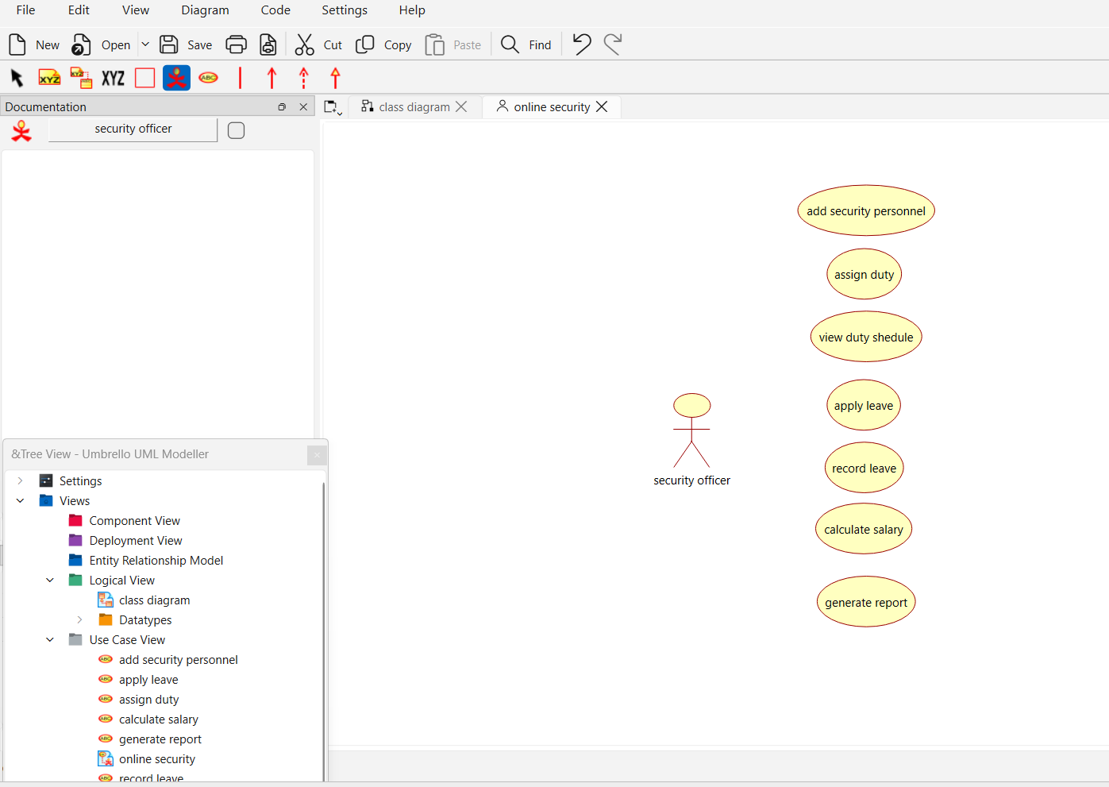
- Draw the system boundary named Online Security Management System. Place all the use cases inside the system boundary.
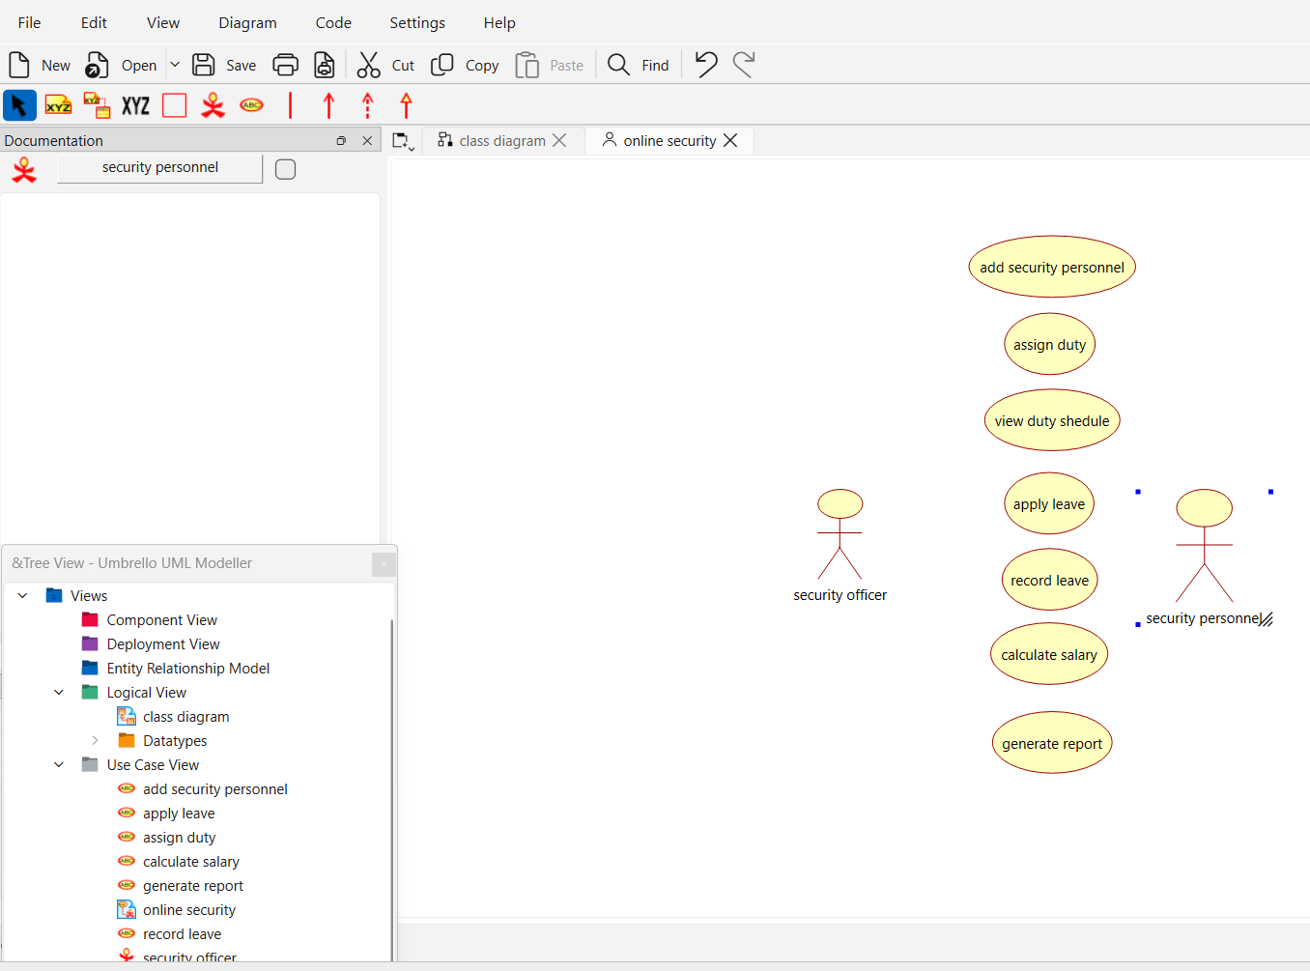
- Connect the actors to their respective use cases using association lines. Verify that all user interactions with the system are represented correctly using UML notation.
