CareerMatch AI — Milestone II
  - Saron Lakew | Individual Final Project | Publish Your Agent

1. Public link and agent update
Public URL: NOT DEPLOYED YET — add the actual Streamlit link after publishing. This document is a working draft until the public URL and live app are checked.
I kept the same CareerMatch AI idea from Milestone I, but I connected three parts: a Profile Agent that reads a resume, a Job Search Agent that loads and filters saved job listings, and a Match Agent that compares skills and explains the results. The tool workflow has a four-call maximum so it cannot run forever. I also added optional Gemini explanations, but those still need a live API key test. All job listings are clearly labeled as fictional examples, not real openings.

Verified demo from my resume
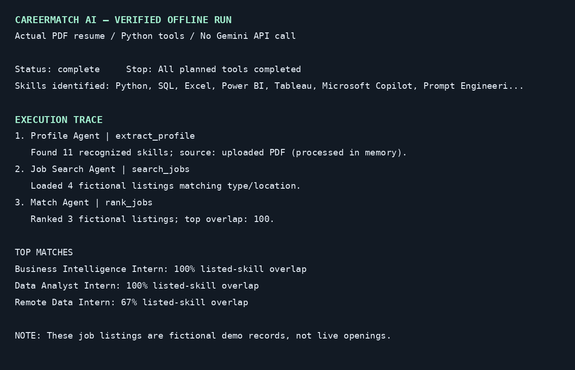
The screenshot above is a rendering of the actual offline run trace, not a screenshot of a live Streamlit deployment. The complete machine-readable trace is included in the project folder.

2. Evaluation results
I ran 12 test cases three times each (36 total runs) against the offline agent. pass@1 means the first run passed. pass^3 means all three runs of the same case passed. The results below are for the Python workflow, not the Gemini API.
Test | Case | pass@1 | pass^3
T01 | Analytics matching | Pass | Pass
T02 | BI requirements | Pass | Pass
T03 | Software matching | Pass | Pass
T04 | Full-time filter | Pass | Pass
T05 | Remote preference | Pass | Pass
T06 | Both job types | Pass | Pass
T07 | No known skills | Pass | Pass
T08 | No interest match | Pass | Pass
T09 | Guard at step one | Pass | Pass
T10 | Guard at step two | Pass | Pass
T11 | Adversarial instruction in skills | Pass | Pass
T12 | Adversarial huge input | Pass | Pass
Overall: 100% pass@1 and 100% pass^3 after the fix.

What failed and what I changed
During my first test, the unusually long skills input failed because the program silently cut it off. I changed it so the program rejects anything over 1,000 characters with a clear error message. After that, I reran the same 12 cases three times each and all passed. I also tested a prompt-injection style input asking for a secret key; the agent treated it as data and did not reveal a key. These tests do not guarantee that every possible input is safe.

3. Governance note
CareerMatch AI reads either a PDF resume or skills someone types in, along with their job type, career interest, and preferred location. The app only pulls out recognized skills and a degree label, and it compares those with a small CSV file of made-up job listings. The app does not save the uploaded resume to disk on purpose. Someone can download their own run results, and the test script saves evaluation results as JSON. If Gemini is turned on, it gets the extracted skills, degree label, and sample job details, not the full resume or contact information.
The human checkpoint is before the agents start: users have to check a box confirming that they understand these are sample jobs and that they will review the results themselves. There is also a separate switch for Gemini before anything is sent outside the app. The app never submits job applications, so the final choice stays with the user. I am responsible for the project and for fixing issues that come up. To limit costs and misuse, I cap the PDF size, manual input length, tool calls, and Gemini output length. For now, the biggest limitations are that the job data is only for a demo, the Streamlit website has not been published yet, and a real Gemini API call has not been tested.

