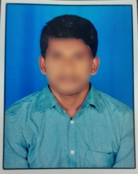**RESUME**

**AVINASH PADALA**

**Email id:** [avinashpdlxx@gmail.com](mailto:avinashpdlxx@gmail.com)

**Mobile No:** 8500XXXX75.

**Address:** H No: 8-145, Ganesh Nagar,

Madhruawada, Visakhapatnam 5300045.

**CAREER OBJECTIVE**

* Obtain a responsible position in an organization with the best capabilities, skills and knowledge.

**ACADEMIC QUALIFICATION:**

* 12th from Narayana Jr College.
* 10th from St Theresa High school.

**PROFESSIONAL SKILLS:**

* Basic knowledge of computer.
* Typing

**WORK EXPERIENCE:**

* Fresher

**PERSONAL DETAILS:**

Father’s Name : Ram Mohan P

Date of birth : 05 April 2002

Gender : Male

Nationality : Indian

Marital Status : Unmarried

Languages Known : English & Telugu

Hobbies : Playing Cricket

Place:

Date:  **Avinash P**