IBM SkillsBuild Data Analytics with AI Academic Internship Program
BharatCares in association with AICTE
PROJECT REPORT
Employee Attrition Risk and Workforce Insights Using Data Analytics and Machine Learning
Domain: Human Resources Analytics
Submitted by
Parth Lakhan
TY B.Sc. IT
Dataset: IBM HR Analytics Employee Attrition & Performance (Kaggle)
Implementation: Python and Jupyter Notebook (Parth_EmployeeAttritionAnalytics.ipynb)

Table of Contents
Abstract
1. Introduction and Background
2. Problem Statement
3. Objectives
4. Project Scope
5. Dataset Source and Description
6. Tools and Technologies
7. System and Methodology Overview
8. Data Cleaning and Preprocessing
9. Exploratory Data Analysis
10. KPIs and Visualizations
11. Machine-Learning Methodology
12. Model Evaluation and Results
13. Key Findings
14. Business Risks and Opportunities
15. Recommendations
16. Limitations and Ethical Considerations
17. Conclusion
18. References

Abstract
Employee attrition raises recruitment costs, disrupts teams and removes experienced people from an organization. This project analyses the IBM HR Analytics Employee Attrition & Performance dataset (1,470 employee records, 35 columns) to find patterns associated with attrition and to build an exploratory machine-learning model. The work was implemented in a single Jupyter Notebook using pandas, NumPy, Matplotlib, Seaborn and scikit-learn.
237 of 1,470 employees (16.1%) were marked as having left. Attrition was uneven: it was 30.5% for employees working overtime versus 10.4% for those who did not, 34.9% for employees in their first year, and 39.8% for Sales Representatives. A Logistic Regression model with balanced class weights, selected by cross-validation on the training data, reached a test ROC-AUC of 0.80, recall of 0.64 and precision of 0.35, compared with zero recall for a majority-class baseline.
The findings are converted into practical recommendations following the sequence Data, Information, Insights, Decisions and Actions. The results are exploratory: they show associations rather than causes, come from a fictional dataset, and must not be used for automatic employment decisions.

1. Introduction and Background
Human Resources (HR) analytics uses data to understand and improve how organizations manage people. One of its most common topics is employee attrition, the rate at which employees leave an organization. When employees leave, the organization may need to spend time and money on recruitment and training, teams lose knowledge and continuity, and remaining staff may carry extra workload.
This project was completed as part of the IBM SkillsBuild Data Analytics with AI Academic Internship Program, conducted by BharatCares in association with AICTE. The program focuses on moving from data fundamentals to practical implementation, including data cleaning, preparation and the use of AI techniques for analytics. The project applies these skills to a realistic business problem in the HR domain.

2. Problem Statement
Employee attrition can increase recruitment costs, disrupt teams, and cause organizations to lose experienced employees. Organizations need to understand workforce patterns, identify employee groups with higher attrition, and use data to guide retention strategies. This project analyses employee data, identifies patterns associated with attrition, builds and evaluates a machine-learning classification model, visualizes important findings, and provides practical recommendations for HR decision-makers.

3. Objectives
- Inspect, validate and clean the employee dataset.
- Calculate attrition KPIs overall and by department, job role, overtime, tenure, age group and satisfaction measures.
- Visualize attrition patterns with clear charts that support business decisions.
- Build a baseline and machine-learning classification models for attrition and evaluate them using precision, recall, F1-score, ROC-AUC and a confusion matrix, not accuracy alone.
- Present a dashboard-style summary and evidence-based recommendations using the Data, Information, Insights, Decisions and Actions framework.

4. Project Scope
In scope: descriptive analytics, exploratory data analysis, KPI calculation, visual analysis and a supervised binary classification model on a public historical dataset, all in one Jupyter Notebook that runs on a typical Windows laptop with free software.
Out of scope: proving cause and effect, estimating financial savings, real-time prediction, building a separate application, and any automated decision about individual employees. The dataset contains no cost data, so no financial benefit is claimed.

5. Dataset Source and Description
The dataset is IBM HR Analytics Employee Attrition & Performance, published on Kaggle: https://www.kaggle.com/datasets/pavansubhasht/ibm-hr-analytics-attrition-dataset. The expected file is WA_Fn-UseC_-HR-Employee-Attrition.csv. It is a fictional dataset created by IBM data scientists for learning and demonstration, so it does not describe real employees.
Verified properties of the file used for the executed analysis: 1,470 rows and 35 columns; 237 records with Attrition = Yes and 1,233 with Attrition = No; no missing values; no duplicate rows. Because the Kaggle site could not be reached from the environment used to run the project, the executed analysis used a copy of the same IBM HR dataset (same shape and attrition counts) obtained from IBM's public GitHub repository. The notebook is written to load the original Kaggle file name and should give the same results with it; the student should re-run it with the Kaggle download to confirm.
Table 1: Dataset column groups
Group | Example columns
Demographics | Age, Gender, MaritalStatus, Education, EducationField, DistanceFromHome
Job information | Department, JobRole, JobLevel, OverTime, BusinessTravel, JobInvolvement
Compensation | MonthlyIncome, DailyRate, HourlyRate, MonthlyRate, PercentSalaryHike, StockOptionLevel
Satisfaction ratings (1-4) | JobSatisfaction, EnvironmentSatisfaction, RelationshipSatisfaction, WorkLifeBalance
Career history | TotalWorkingYears, YearsAtCompany, YearsInCurrentRole, YearsSinceLastPromotion, YearsWithCurrManager, NumCompaniesWorked, TrainingTimesLastYear
Target | Attrition (Yes = left, No = stayed)
Constant / identifier | EmployeeCount, Over18, StandardHours (constant); EmployeeNumber (identifier)

6. Tools and Technologies
Table 2: Tools and technologies
Tool | Purpose
Python 3 and Jupyter Notebook | Single notebook containing the complete project
pandas and NumPy | Loading, cleaning, grouping and calculating KPIs
Matplotlib and Seaborn | Bar charts, count plots, box plots and dashboard layout
scikit-learn | Preprocessing pipeline, train/test split, cross-validation, models, metrics, permutation importance
python-docx | Used to generate this Word report from the executed results

Only free, open-source tools were used. No paid API, API key or Kaggle credentials are required.

7. System and Methodology Overview
The project follows the business intelligence sequence Data, Information, Insights, Decisions, Actions, supported by a standard analytics workflow:
- Load and inspect: read the CSV with a clear error message if it is missing; check shape, data types and statistics.
- Check quality and clean: look for missing values, duplicates, inconsistent values and constant columns.
- Explore and measure: calculate KPIs and attrition rates, and draw charts.
- Model: build a baseline and two classifiers inside a preprocessing pipeline, evaluate on a held-out test set.
- Interpret and recommend: summarize facts, insights, risks, opportunities and actions, and discuss limitations and ethics.

8. Data Cleaning and Preprocessing
Quality checks found the data to be clean: no missing cells, no fully duplicated rows, no duplicated EmployeeNumber values, no age below 18, no non-positive incomes, no record where tenure exceeds total working years, and only the values Yes and No in the Attrition column. Therefore no imputation or record removal was needed and no data values were altered or invented.
The following preparation steps were applied to a copy of the data:
- Removed three constant columns (EmployeeCount, Over18, StandardHours) because they carry no information.
- Created Attrition_Flag (1 = left, 0 = stayed) as the numeric target.
- Created AgeGroup, TenureGroup and IncomeBand (income quartiles) for easier business interpretation.
- Kept EmployeeNumber only as an identifier and excluded it from modelling.

9. Exploratory Data Analysis
The workforce has an average age of 36.9 years, average monthly income of about 6,503 and average company tenure of 7.0 years. Research & Development is the largest department (961 employees), followed by Sales (446) and Human Resources (63). About 28.3% of employees work overtime. Compared with employees who stayed, those who left were on average younger (33.6 versus 37.6 years), earned less (monthly income about 4,787 versus 6,833) and had shorter tenure (5.1 versus 7.4 years).
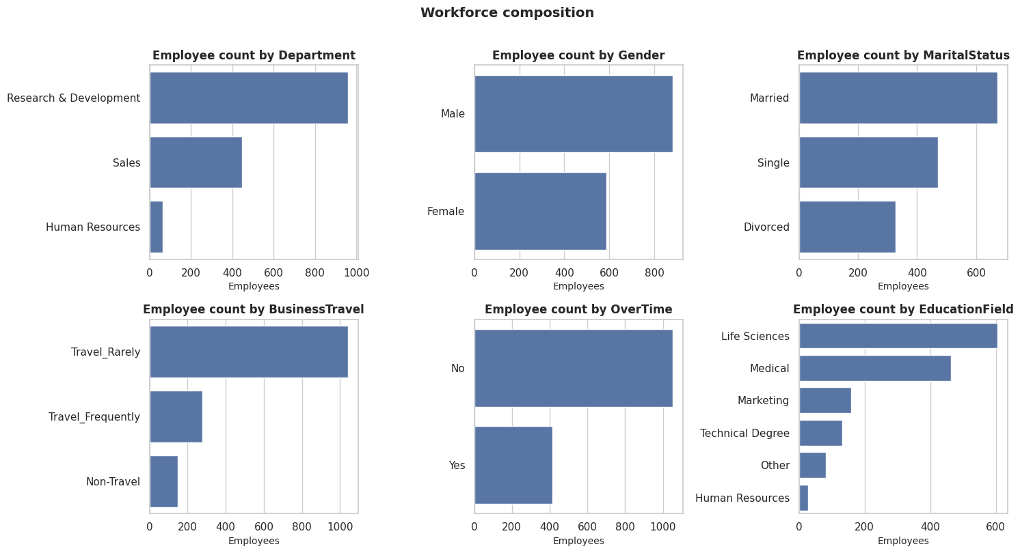
Figure 1: Workforce composition by department, gender, marital status, business travel, overtime and education field (from the notebook).
Figure 1 describes who works in the organization. It matters because raw counts of leavers are misleading when groups differ in size; the analysis therefore compares attrition rates.

10. KPIs and Visualizations
Table 3: Key performance indicators (calculated from the dataset)
KPI | Value
Total employee records | 1,470
Employees who left | 237
Employees who stayed | 1,233
Overall attrition rate | 16.1%
Average job satisfaction (1-4), all / stayed / left | 2.73 / 2.78 / 2.47
Average environment satisfaction (1-4) | 2.72
Average work-life balance (1-4) | 2.76
Employees working overtime | 28.3%
Average years at company | 7.0

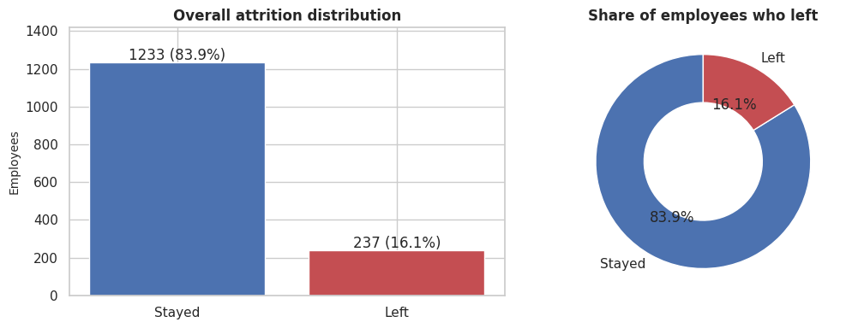
Figure 2: Overall attrition distribution: number and share of employees who stayed or left.
Figure 2 shows that the dataset is imbalanced: 16.1% of employees left. This is the company-wide reference rate for every comparison and is why accuracy alone is a poor model metric.
Table 4: Attrition by job role
Job role | Employees | Left | Attrition rate (%)
Sales Representative | 83 | 33 | 39.8
Laboratory Technician | 259 | 62 | 23.9
Human Resources | 52 | 12 | 23.1
Sales Executive | 326 | 57 | 17.5
Research Scientist | 292 | 47 | 16.1
Healthcare Representative | 131 | 9 | 6.9
Manufacturing Director | 145 | 10 | 6.9
Manager | 102 | 5 | 4.9
Research Director | 80 | 2 | 2.5

Table 5: Attrition by department
Department | Employees | Left | Attrition rate (%)
Sales | 446 | 92 | 20.6
Human Resources | 63 | 12 | 19.0
Research & Development | 961 | 133 | 13.8

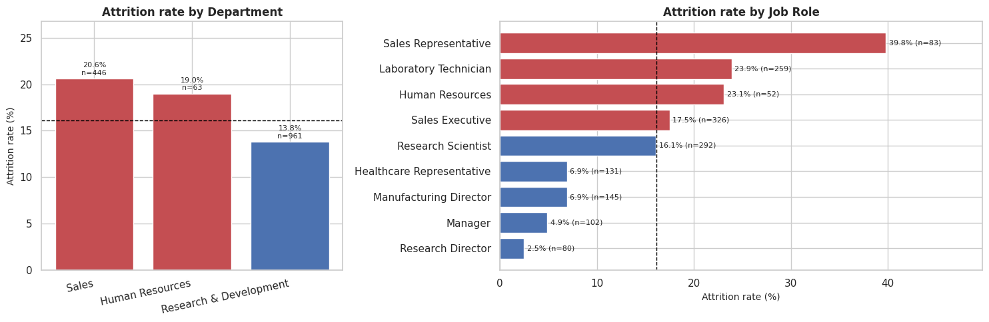
Figure 3: Attrition rate by department and by job role (red bars are above the 16.1% company rate).
Figure 3 shows where attrition is concentrated. Sales (20.6%) is above the company rate and Research & Development (13.8%) is below it. By role, Sales Representatives (39.8%, 83 employees) have the highest rate, followed by Laboratory Technicians (23.9%) and Human Resources staff (23.1%, only 52 employees, so less stable). Senior roles such as Research Director (2.5%) and Manager (4.9%) have the lowest rates. For HR this suggests targeting role-specific retention work rather than one company-wide policy.
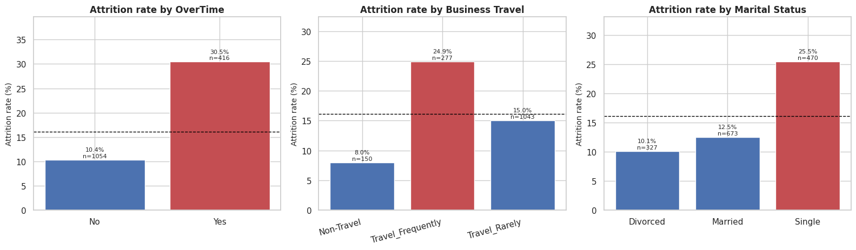
Figure 4: Attrition rate by overtime, business travel and marital status.
Figure 4 shows that employees working overtime left at 30.5% versus 10.4% for those who did not, about 2.9 times higher. Frequent travellers (24.9%) left more often than non-travellers (8.0%), and single employees (25.5%) more often than married (12.5%) or divorced (10.1%) employees. Overtime and travel are work conditions that management can influence, which makes them practical levers. The overtime gap was also seen in every department (Sales 37.5% versus 13.8%, Research & Development 27.3% versus 8.6%, Human Resources 29.4% versus 15.2%).
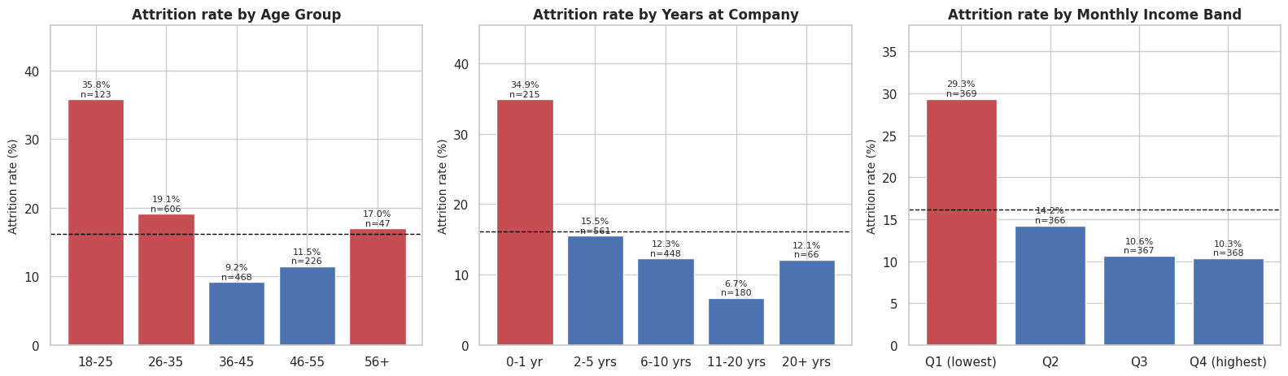
Figure 5: Attrition rate by age group, years at company and monthly income band.
Figure 5 shows the employee life-cycle effect. Attrition is 35.8% for ages 18-25 and 9.2% for ages 36-45; it is 34.9% in the first year at the company and 6.7% for 11-20 years; and it is 29.3% in the lowest income quartile versus 10.3% in the highest. Age, tenure, job level and income overlap, so these charts should not be read as independent causes.
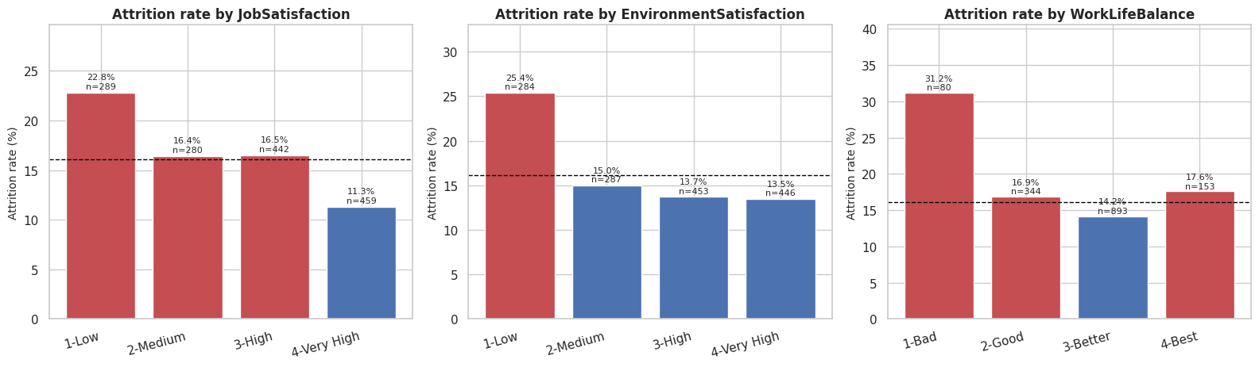
Figure 6: Attrition rate by job satisfaction, environment satisfaction and work-life balance rating.
Figure 6 shows that lower ratings are generally linked to higher attrition: employees with job satisfaction 1 (low) left at 22.8% versus 11.3% at rating 4, and work-life balance rating 1 shows 31.2% (only 80 employees). Satisfaction surveys could therefore act as early-warning signals.
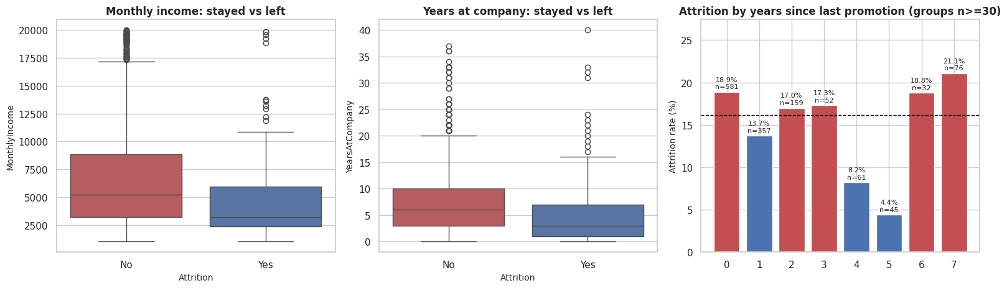
Figure 7: Monthly income and years at company for employees who stayed and left, and attrition by years since last promotion.
Figure 7 compares typical income and tenure of leavers and stayers. Leavers have lower median income and shorter tenure. The right-hand chart shows attrition by years since last promotion for groups with at least 30 employees.
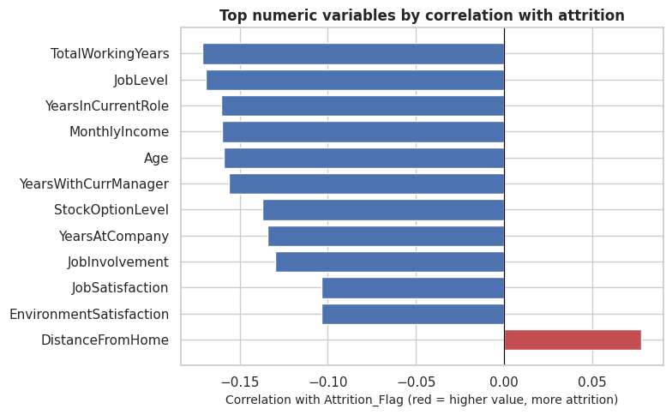
Figure 8: Numeric variables most correlated with attrition (red = higher value goes with more attrition).
Figure 8 shows that most of the strongest numeric associations are negative: higher total working years, job level, years in the current role, monthly income, age, years with the current manager, stock option level and satisfaction ratings go with lower attrition. The only positive association among the top variables is distance from home (longer distance, slightly more attrition). All correlations are modest (about -0.17 to +0.08) and do not prove causation.

11. Machine-Learning Methodology
Problem type: binary classification, with the actual Attrition column (converted to 1 = left, 0 = stayed) as the target.
- Leakage prevention: Attrition, Attrition_Flag, EmployeeNumber and the derived group columns (AgeGroup, TenureGroup, IncomeBand) were removed from the features. 30 features remained: 7 categorical and 23 numeric.
- Splitting: 80% training (1,176 rows, 190 leavers) and 20% test (294 rows, 47 leavers), stratified on the target, random_state = 42.
- Preprocessing: a scikit-learn ColumnTransformer inside a Pipeline: StandardScaler for numeric columns (including ordered 1-4 rating scales) and OneHotEncoder for text columns. Because the pipeline is fitted only on training data, no information leaks from the test set.
- Class imbalance: handled with class_weight set to balanced so that mistakes on leavers cost more during training. This avoids creating synthetic records and needs no extra library. Evaluation uses precision, recall, F1-score and ROC-AUC rather than accuracy alone.
- Models: a DummyClassifier baseline (always predicts the majority class), Logistic Regression, and Random Forest (300 trees, minimum 3 samples per leaf).
- Model selection: 5-fold stratified cross-validation on the training set only, using ROC-AUC, so the test set stays untouched. The cross-validation ROC-AUC (mean ± standard deviation) was 0.500 for the baseline, 0.827 ± 0.028 for Logistic Regression and 0.813 ± 0.035 for Random Forest, so Logistic Regression was selected.
- Interpretation: permutation importance on the test set (15 repeats), which shows how much ROC-AUC falls when a single original feature is shuffled.

12. Model Evaluation and Results
All values below were measured on the held-out test set of 294 employees (47 leavers).
Table 6: Test-set performance of the compared models
Model | Accuracy | Precision | Recall | F1-score | ROC-AUC
Baseline (majority class) | 0.840 | 0.000 | 0.000 | 0.000 | 0.500
Logistic Regression (selected) | 0.752 | 0.349 | 0.638 | 0.451 | 0.803
Random Forest | 0.840 | 0.500 | 0.234 | 0.319 | 0.786

The baseline reaches 84% accuracy only because most employees stayed, yet it finds none of the leavers (recall 0). This shows why accuracy alone is misleading. Logistic Regression finds 64% of the actual leavers with a precision of 35%; Random Forest has higher precision (0.50) but finds only 23% of leavers. Logistic Regression has the best ROC-AUC (0.80) and best F1-score, so it is the preferred model here for screening.
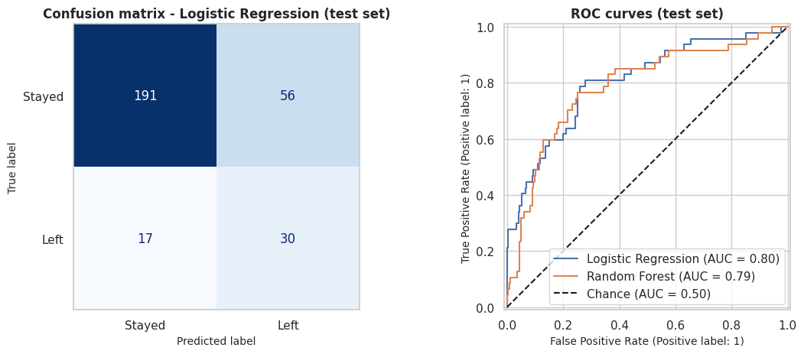
Figure 9: Confusion matrix of the selected model and ROC curves of the two classifiers (test set).
Table 7: Confusion matrix, Logistic Regression, test set
 | Predicted: Stayed | Predicted: Left
Actual: Stayed | 191 (true negatives) | 56 (false positives)
Actual: Left | 17 (false negatives) | 30 (true positives)

A false positive (56 employees) is an employee flagged as at risk who actually stayed: HR may spend time on unnecessary retention conversations and the employee may feel singled out. A false negative (17 employees) is an employee who left without being flagged: a missed chance to intervene. If the intervention is a low-cost, supportive check-in, tolerating more false positives to catch more leavers can be justified. The notebook shows this trade-off: at a decision threshold of 0.3 the model flagged 134 employees with recall 0.81 and precision 0.28, while at 0.7 it flagged 41 employees with recall 0.45 and precision 0.51.
Table 8: Top six features by permutation importance
Rank | Feature | Permutation importance (drop in ROC-AUC)
1 | OverTime | 0.109
2 | NumCompaniesWorked | 0.027
3 | MaritalStatus | 0.024
4 | YearsSinceLastPromotion | 0.024
5 | BusinessTravel | 0.022
6 | JobSatisfaction | 0.018

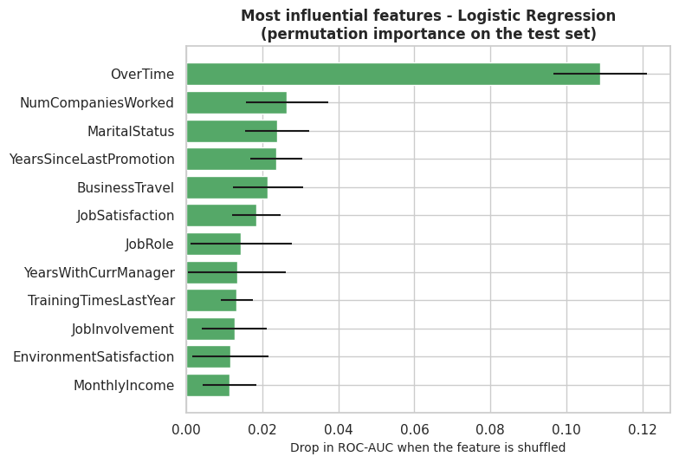
Figure 10: Most influential features of the selected model (permutation importance on the test set).
OverTime is by far the most influential feature, consistent with the exploratory charts. Feature importance shows which variables the model used to separate leavers from stayers; it does not prove that those variables cause attrition. With only 47 leavers in the test set the ranking could change if the data were split differently.
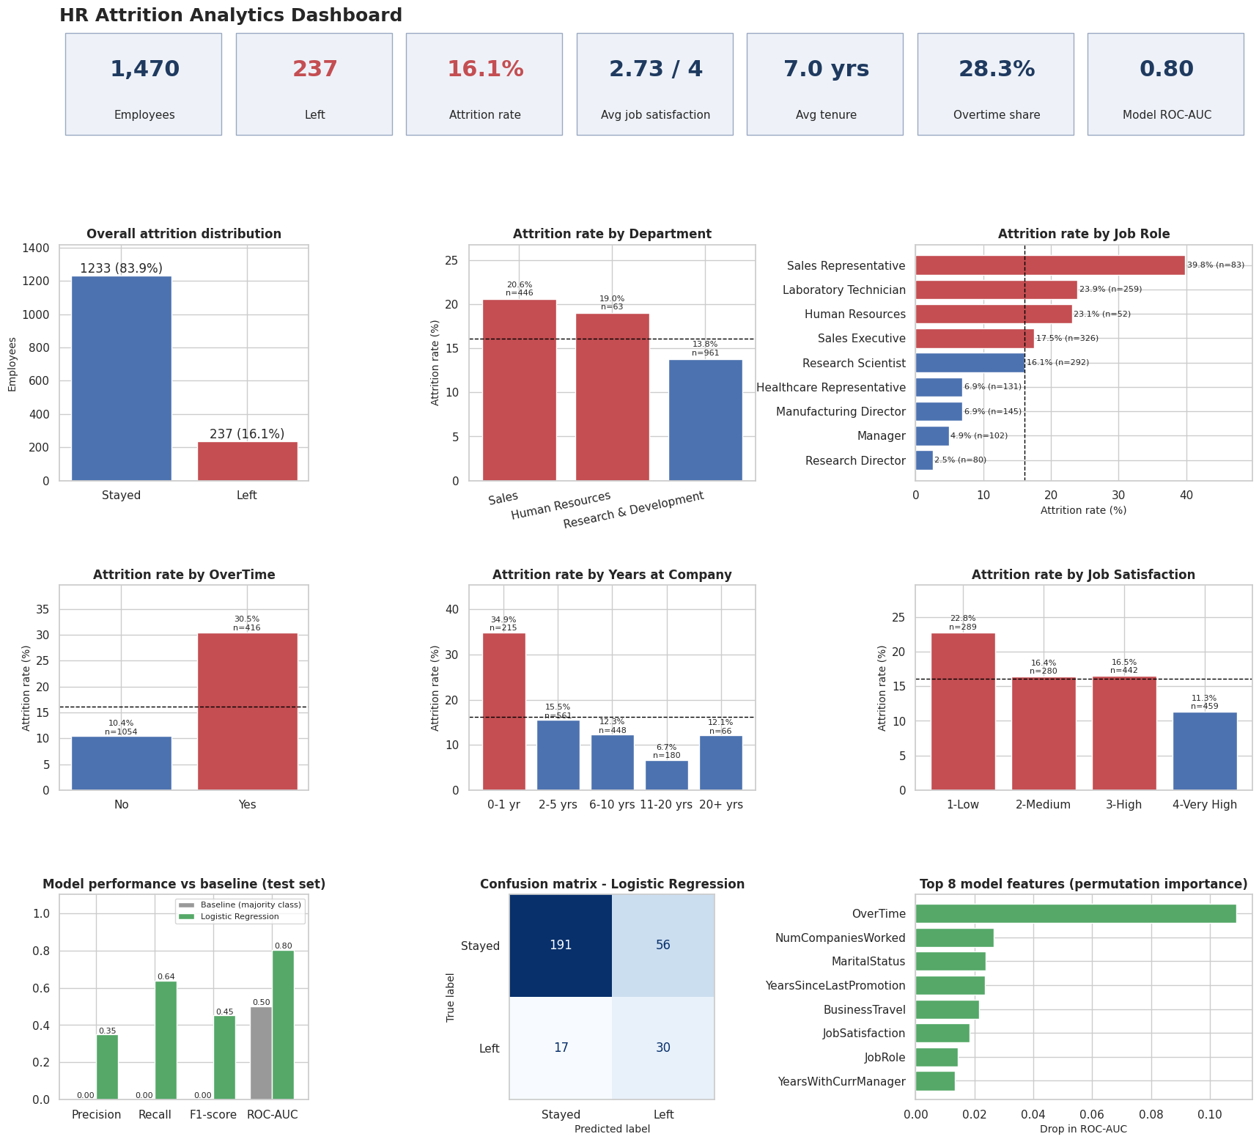
Figure 11: Dashboard-style analytical summary produced in the notebook: KPIs, attrition distribution, department and role comparison, key factors and model performance.

13. Key Findings
- 237 of 1,470 employees (16.1%) left; the dataset is imbalanced.
- Attrition is concentrated: Sales (20.6%) and Sales Representatives (39.8%) are highest; senior roles are lowest.
- Overtime is the strongest factor observed: 30.5% versus 10.4%, in every department, and the top model feature.
- Early-career and early-tenure employees leave most: 35.8% for ages 18-25 and 34.9% for the first year.
- Lower pay and lower level go with higher attrition: 29.3% in the lowest income quartile versus 10.3% in the highest; job level 1 is 26.3%; stock option level 0 is 24.4% versus 9.4% at level 1.
- Frequent travel (24.9%), single marital status (25.5%) and low job satisfaction (22.8% at rating 1) are also associated with higher attrition.
- The selected model (ROC-AUC 0.80, recall 0.64, precision 0.35) clearly beats the baseline but is an imperfect screening aid.

14. Business Risks and Opportunities

Risks
- Workload risk: 416 employees work overtime and 127 of them left; burnout may be involved, but the data cannot confirm reasons.
- Early-career risk: 75 of 215 first-year employees left, wasting recruitment and training effort.
- Concentration risk: a few roles, especially Sales Representative, account for a large share of attrition.
- Model risk: 56 false alarms and 17 missed leavers in the test set; using the model on individuals could be unfair or inaccurate.
- Data risk: fictional single-snapshot data may not match a real organization.

Opportunities
- Low-attrition groups (Research Directors, Managers, long-tenure employees) provide an internal benchmark worth studying.
- Overtime, travel, pay progression and stock-option eligibility are partly controllable, so they are realistic levers for pilots.
- The model can help rank groups by relative risk for planning, not for judging individuals.

15. Recommendations
Each recommendation is linked to evidence. No cost savings or percentage improvements are claimed because the dataset has no cost data; the recommendations should be tested through pilots.
Table 9: Recommendations and supporting evidence
# | Recommended action | Evidence from this project
1 | Review overtime and workload practices; pilot limits or time off in high-overtime teams. | 30.5% vs 10.4% attrition; gap in all departments; top model feature.
2 | Strengthen onboarding and first-year support (mentor, 30/90/180-day check-ins, stay interviews). | 34.9% first-year attrition; 35.8% for ages 18-25.
3 | Run focused retention reviews for Sales Representatives, Laboratory Technicians and Sales Executives. | 39.8%, 23.9% and 17.5% versus 16.1% overall.
4 | Benchmark entry-level pay, clarify promotion criteria, consider wider stock-option eligibility. | 29.3% in the lowest income quartile; 24.4% at stock option level 0. Income, level and age overlap.
5 | Review travel rotation and run short satisfaction pulse surveys as early warnings. | Frequent travel 24.9% vs 8.0%; job satisfaction 1 = 22.8% vs 11.3% at 4.
6 | Use the model only as an aggregate, supportive planning aid with human review and fairness checks. | ROC-AUC 0.80, recall 0.64, precision 0.35; 56 false positives and 17 false negatives in 294 test employees.

16. Limitations and Ethical Considerations

Limitations
- The dataset is fictional and a single snapshot, so timing of departures and real-world context are unknown.
- Charts, correlations and feature importance show association, not causation.
- Only 237 employees left (47 in the test set), and some groups are small, so rates and metrics can change with a different split.
- Only two models were compared with limited tuning and no external validation.
- Reasons for leaving, manager quality, labour-market conditions and costs are not in the data.
- The executed analysis used IBM's GitHub copy of the dataset because Kaggle could not be accessed; it should be re-run with the Kaggle download.

Ethical considerations
- Model results are exploratory and must not be used for automatic employment decisions or to label individuals.
- Age, gender and marital status are sensitive; decisions based on them could be discriminatory. A real deployment needs fairness review, legal and privacy compliance, and transparency to employees.
- Predictions can be wrong in both directions, so human judgement and a supportive rather than punitive use of results are essential.
- Employee data should be handled with consent, access control and data minimisation.

17. Conclusion
This project turned raw HR records into information, insights and actions. Attrition affected 16.1% of employees but was far from uniform: it was highest among employees working overtime, those in their first year, younger and lower-paid employees, frequent travellers and sales-related and laboratory roles. A Logistic Regression model with balanced class weights identified 30 of the 47 actual leavers in the test set, with ROC-AUC 0.80, clearly better than a baseline that finds none, though precision is modest. The most practical next steps are to review overtime, improve first-year support, run focused retention reviews for the highest-attrition roles and examine entry-level pay and progression, then measure the results through pilots. The project also showed the importance of evaluating imbalanced classification with several metrics and of describing findings as associations rather than causes.

18. References
- IBM HR Analytics Employee Attrition & Performance dataset, Kaggle: https://www.kaggle.com/datasets/pavansubhasht/ibm-hr-analytics-attrition-dataset
- IBM SkillsBuild Data Analytics with AI Academic Internship Program, BharatCares with AICTE, 2026 (masterclass materials).
- pandas documentation: https://pandas.pydata.org/docs/
- scikit-learn documentation: https://scikit-learn.org/stable/
- Matplotlib documentation: https://matplotlib.org/stable/ and Seaborn documentation: https://seaborn.pydata.org/

