Software Requirements Specification
Aptivra
Career Development and Evidence-Based Recruitment
26 October 2026
Prepared by
Vishesh: Registration No. 2312391
Haji Lakhir: Registration No. 2312436
Supervisor: Sir Asif Khalid
BS Computer Science
Faculty of Computing and Engineering Sciences
SZABIST University, Karachi Campus
Full two-semester prototype specification

Contents
1. Introduction 4
1.1 Purpose 4
1.2 Document Conventions 4
1.3 Intended Audience and Reading Suggestions 4
1.4 Product Scope 5
1.5 References 6
2. Overall Description 7
2.1 Product Perspective 7
2.2 Product Functions 7
2.3 User Classes and Characteristics 8
2.4 Operating Environment 9
2.5 Design and Implementation Constraints 9
2.6 User Documentation 10
2.7 Assumptions and Dependencies 10
3. External Interface Requirements 11
3.1 User Interfaces 11
3.2 Hardware Interfaces 11
3.3 Software Interfaces 12
3.4 Communications Interfaces 13
4. System Features 14
4.1 Accounts and workspaces 15
4.2 Vacancies and role catalogue 21
4.3 Controlled CV processing 26
4.4 Evidence comparison 29
4.5 Independent preparation 33
4.6 Optional preparation history 37
4.7 Applications, referrals and review 41
4.8 Recruitment assessments 50
4.9 Interview coordination 56
4.10 Notifications and job alerts 59
4.11 Plans and usage allowances 61
4.12 Privacy, internal audit and analytics 65
5. Other Nonfunctional Requirements 72
5.1 Performance Requirements 72
5.2 Safety Requirements 72
5.3 Security Requirements 73
5.4 Software Quality Attributes 74
5.5 Business Rules 75
6. Other Requirements 78
Appendix A: Glossary 79
Appendix B: Analysis Models 81
B.1 System context and trust boundaries 81
B.2 State and evidence models 81
B.3 Requirement traceability and semester gates 84
B.4 Integrated acceptance scenarios 86
Appendix C: To Be Determined List 88
Appendix D: Current prototype user interfaces 92
D.1 Public access and account screens 93
D.2 Employer workspaces and vacancies 99
D.3 Candidate preparation and document intake 103

Revision History
Version / date | Prepared by | Change and approval state
1.3 / 26 Oct 2026 | Vishesh and Haji Lakhir | Adds current local UI screenshots, clarifies browser-test status and diagram permissions/storage, and retains the whole-project use cases and requirement identifiers. Supervisor review remains pending.
Sir Asif Khalid’s approval is pending. Implementation and test acceptance have not been established by this document.

1. Introduction

1.1 Purpose
This Software Requirements Specification (SRS) defines the intended behavior and acceptance conditions for Aptivra, a hosted career-preparation and evidence-based recruitment platform. It covers the complete two-semester FYP prototype and will guide implementation and testing. The specified features include work that has yet to be implemented.
The scope follows the revised proposal [R1], the university template [R2] and the assignment example [R3]. The team’s latest delivery decision is to use localhost for interim demonstrations and deploy the browser service later. The supervisor must review that schedule change; it does not change the intended online product.

1.2 Document Conventions
“Shall” identifies a requirement. C01 to C12 identify the twelve proposal capabilities; UC identifiers identify individual actor goals; FR identifiers identify functional requirements; NFR identifiers identify nonfunctional requirements; BR identifiers identify business rules. IDs remain unique throughout the document. A1 to A8 and B1 to B8 are semester work packages, not additional features.
High priority denotes a core correctness, security or workflow obligation. Medium priority denotes supporting work that remains in the final scope. Priority does not indicate implementation status. In the Status column, “Pending” means pending full verification and acceptance, not necessarily unimplemented. Local results in Appendix C apply only to their stated scope. Supervisor approval remains pending.
Appendix C lists unresolved parameter values, their owners and closure conditions under TBD identifiers. Response times, accuracy percentages, uptime and free-hosting commitments require supporting measurements or agreements before they can be confirmed. Section 4 follows the supplied use-case and requirement-table structure, including successful and unsuccessful postconditions.
Body and table text use Times New Roman, 12 point, with 1.2 line spacing and one-inch margins. Main headings are 16-point bold and subheadings 14-point bold. The contents page uses internal document headings; no linked external content is required.

1.3 Intended Audience and Reading Suggestions
Vishesh (2312391) and Haji Lakhir (2312436) will use this document for implementation, test design and scope control. Supervisor Sir Asif Khalid and the FYP panel should review the boundaries, actor permissions, use cases, unresolved decisions and acceptance conditions before submission.
Candidates and prospective employer reviewers can read Sections 1 to 2 and the relevant Section 4 use cases. Developers should also read interfaces, business rules and state models. Testers should begin with the IDs and traceability/acceptance scenarios in Appendix B, then check the applicable functional and nonfunctional requirements. Operators need the privacy, expiry, deployment and recovery conditions.

1.4 Product Scope
A candidate can choose a supported target role, inspect CV evidence, practice privately and obtain learning guidance without a current vacancy. Approved companies and genuine startup teams can publish requirements, receive application snapshots, request optional assessments, coordinate interviews and record human decisions. Authorized internal reviewers can inspect sources/referrals, decision history and descriptive recruitment reports.
Aptivra targets early-career candidates and smaller teams hiring interns or junior staff. Evaluation is bounded to frontend development, backend development and data analysis, with English documents/guidance. The application is independent of university systems; candidates and employers use a browser rather than install models or desktop software.
Payroll, attendance, employee management, personality classification, mandatory aptitude fallback, proctoring, executable coding tests, credential/background verification, external job scraping, native apps, video-call provision and live billing are excluded. University/ZABDesk integration is a possible later opportunity, not an FYP dependency. Referral reporting cannot automatically establish nepotism, causal fairness or hiring merit.

1.5 References
[R1] Vishesh and Haji Lakhir. Aptivra: Career Development and Evidence-Based Recruitment, FYP Proposal. Revised 10 October 2026; startup-setting-only correction 20 October 2026. Supplied baseline file: Aptivra FYP Proposal Updated.docx.
[R2] SRS_Template (2025).pdf, supplied university assignment template. Includes Karl E. Wiegers’s 1999 template attribution and permission to use, modify and distribute. Structure adapted; explanatory placeholders are not requirements.
[R3] Sign Up UseCase Example.pdf and the supplied Google Classroom assignment screenshots, “Software Requirement Specifications and Use Case Example,” Abid Ali, posted/edited 5 October; displayed deadline 26 October 2026, 11:59 PM. These establish table/format and advisor-review instructions, not Aptivra’s business rules.
[R4] OWASP Foundation. File Upload Cheat Sheet. Accessed 20 October 2026. https://cheatsheetseries.owasp.org/cheatsheets/File_Upload_Cheat_Sheet.html
[R5] OWASP Foundation. Authorization Cheat Sheet. Accessed 20 October 2026. https://cheatsheetseries.owasp.org/cheatsheets/Authorization_Cheat_Sheet.html
[R6] OWASP Foundation. LLM Prompt Injection Prevention Cheat Sheet. Accessed 20 October 2026. https://cheatsheetseries.owasp.org/cheatsheets/LLM_Prompt_Injection_Prevention_Cheat_Sheet.html
[R7] Laravel. Deployment, Laravel 13.x documentation. Accessed 20 October 2026. Exact deployment versions remain TBD-04. https://laravel.com/framework/docs/13.x/deployment
[R8] Laravel. Queues, Laravel 13.x documentation. Accessed 20 October 2026. Used for the queued-work interface, not as a performance guarantee. https://laravel.com/framework/docs/13.x/queues
[R9] European Commission. Use ESCO. Accessed 20 October 2026. Vocabulary/resource input, not a recruitment test bank. https://esco.ec.europa.eu/en/use-esco

2. Overall Description

2.1 Product Perspective
Aptivra is a new, self-contained web platform with two related but separately authorized journeys: private candidate preparation and employer recruitment. The SRS does not claim to invent CV matching or outperform established products. Its focus is traceable evidence, optional employer assessments, disclosed retention and accountable human review.
The browser interface connects through React/Inertia to one Laravel-led application. PostgreSQL stores related records and version references; CV binaries remain in private storage. Database-backed Laravel jobs invoke a restricted Python/document-processing component and server-controlled model inference. A background worker is software, not a human auditor. Internal-review users remain distinct human actors.

2.2 Product Functions
Capability | Summary
C01: Accounts and workspaces | One account can be used for private candidate preparation and authorized employer work. Email ownership, organization approval and organization membership are separate checks.
C02: Vacancies and role catalogue | Approved employers define their vacancy criteria. Candidates can browse published jobs or choose one of three supported preparation role families without a live vacancy. Verified users can report vacancy concerns for manual administrative review.
C03: Controlled CV processing | Supported documents enter private quarantine before scanning and constrained extraction. Processing status is independent of recruitment suitability.
C04: Evidence comparison | Comparisons describe what a specific CV version supports against a specific criteria version. They do not predict employment or silently equate a parser miss with a missing skill.
C05: Independent preparation | Candidates can obtain preparation feedback without a job listing and take private practice without a CV. Advice draws on supported evidence, reviewed role information and learning resources.
C06: Optional preparation history | History is an explicit, bounded choice. A candidate can retain two CV/report versions and compare changes in documented evidence under consistent settings.
C07: Applications, referrals and review | Candidates submit vacancy-specific snapshots. Employers review retained evidence, record sources/referrals and make attributable decisions, including an employer-recorded Hired outcome.
C08: Recruitment assessments | Employers may request vacancy-specific MCQ or written tests. Server-side attempts and versioned marking preserve the difference between test performance and CV evidence.
C09: Interview coordination | The platform coordinates interview times, stores an external meeting link and records interview status. Video conferencing is outside its scope.
C10: Notifications and job alerts | In-app notifications communicate authorized workflow changes. Opt-in alerts match preferences against vacancies actually published on Aptivra.
C11: Plans and usage allowances | Demonstration entitlements enforce the proposed pilot allowances without collecting money. Usable work, retries and accepted applications have explicit counting rules.
C12: Privacy, internal audit and analytics | Privacy rules govern each storage purpose. Authorized internal reviewers inspect recorded recruitment activity and source/outcome summaries without claiming to detect hidden influence or independently verify employment.
Section 4 details the twelve capabilities; Appendix B maps them to semester delivery. Authentication, organization permissions, audit and expiry apply throughout development, including the workflows built before charts and paid-plan demonstrations.

2.3 User Classes and Characteristics
User class | Responsibilities and access boundary
Visitor | Browse approved open vacancies and product/retention information; must register and verify email for protected features.
Candidate | Own preparation, practice, optional history and submitted applications. May also hold an employer membership, but that does not grant self-grading or unrelated records.
Organization owner | Create/manage the employer workspace, membership/ownership and entitlements; perform authorized recruitment actions. Cannot approve their own organization as a platform administrator.
Recruiter / hiring decision-maker | Manage permitted vacancies, application reviews, invitations/interviews and recorded outcomes within the organization. Decision rights must be explicitly granted.
Assigned reviewer / grader | Inspect assigned applications and grade authorized written attempts; cannot grade their own attempt or assume owner/administrator powers.
Authorized internal reviewer / exception approver | Inspect permitted audit/source reports and decide authorized required-stage exceptions. Reporting access and approval rights are separate permissions, not unrestricted access to all personal data.
Platform administrator / operator | Approve/suspend workspaces, review vacancy reports and maintain the platform under limited permissions. No automatic right to private preparation or to make organizational hiring decisions.
Email delivery, scanning, the queue/runner and model inference are supporting software services. The human user classes are listed above. Authorized users record referrer declarations and their basis; the FYP does not require a separate referrer portal or account role.

2.4 Operating Environment
Users access Aptivra through a supported browser. Development and interim demonstrations may use the team’s localhost instance; internet access is needed for the later hosted service and external resources. Users do not need to install a model, database or desktop application. The supported browser and viewport matrix must be finalized under TBD-04.
The team currently develops and demonstrates on Windows. The intended hosted environment supports Laravel/PHP, PostgreSQL, private storage, the queue/scheduler, scanning, OCR/conversion and model execution. Host capacity and platform compatibility require deployment testing under TBD-03 and TBD-04.
Local integration precedes deployment. The team will pin component versions and verify host resources, workload, encrypted storage and key handling before hosted acceptance (TBD-03 and TBD-04). A successful localhost demonstration does not establish production capacity or complete the final online-delivery requirement.

2.5 Design and Implementation Constraints
The agreed foundation is React/Inertia, PHP/Laravel, PostgreSQL and specialized Python processing. Node/Vite builds browser assets; a second Node backend, FastAPI service or MongoDB instance is not required by the agreed design. Laravel owns permissions, workflow transitions and database writes.
Open-source components and licence-reviewed server model weights are preferred. Qwen3-4B-Instruct-2507 with an appropriate llama.cpp runtime is a proposal candidate, not an already selected or proven deployment. Fine-tuning is optional, justified by labelled errors/compute, and cannot delay the core workflow. Foundation-model training is excluded.
Real CVs are not sent to external AI services by default. No paid inference/CV-parsing API is required for the core prototype. Hosting, storage, backups and verification email still require a feasible resource arrangement; no perpetual free tier or confirmed sponsor is assumed.
Chart.js is the proposed open-source charting default. CanvasJS remains conditional on supervisor direction and licence approval. Charts display backend-calculated authorized metrics; neither library decides hiring.

2.6 User Documentation
Delivery includes a candidate guide for one-off reports, private practice, history and data choices; an employer guide for vacancies, reviews, referrals, assessments/interviews and reports; and an administrator/operator runbook for approval, configuration, deployment, backup restoration and privacy cleanup.
The team will also supply source/migrations, safe seed fixtures, the dependency/model/content licence manifest, configuration examples without secrets, automated test instructions and measured limitations. The manual must explain that declared referrals and employer-reported hires are not independent verification. Documentation will be in English and delivered with the hosted prototype/source package.

2.7 Assumptions and Dependencies
The two-student team will supply fictional demonstration employers/CVs and original or licensed, reviewed questions/resources. Real participant data requires separate consent. Ordinary uploads do not authorize research/model training, and a user study or employer pilot depends on the availability of consenting participants.
Verification and password recovery depend on an approved email-delivery arrangement. Delivery failure must remain recoverable and cannot activate the account. No requirement for routine application-update email/SMS is implied by account verification.
A suitable hosting arrangement is required before final online delivery, not before the agreed interim localhost demonstrations. Dependency licences, processing limits and supervisor-reviewed decisions remain necessary. Unsupported inputs and worker/model outages require defined states. University portal access, confidential institutional data and employer partnerships are not dependencies.

3. External Interface Requirements

3.1 User Interfaces
Interface area | Required information and behavior
Account entry | Registration, verification/resend, sign-in/out, recovery and settings. Present candidate/employer workspace choices without suggesting two separate account identities.
Candidate preparation | Supported-role selection, private upload/processing status, evidence report/corrections, practice, learning resources, download and explicit optional-history controls.
Candidate applications | Effective vacancy criteria, submission snapshot/retention notice, receipt/status, invitations, result release, interview details and withdrawal.
Employer workspace | Organization status/membership, versioned vacancy intake, authorized application directory, source-linked evidence, referral declarations, review tasks/decisions, assessments/interviews and allowances.
Internal review | Permission-scoped audit history, required-stage exceptions, source/outcome cohort filters, counts/definitions and readable alternatives to charts.
Administration/privacy | Organization approval/suspension, vacancy-report review/status, authorized export/deletion requests and operator-visible cleanup/service failure states.
Appendix D records the supplied local prototype screens. They illustrate current interfaces; the requirements in this section also cover planned functionality not yet shown.
Forms must have labels, server-validated error messages and clear pending/success/failure states. Actions must recheck permissions even if their buttons are hidden. Evidence and assessment labels must remain distinguishable. Confirmation screens must explain destructive actions and separate retention purposes. Detailed final visual design may change without altering these requirements.

3.2 Hardware Interfaces
The FYP has no direct specialist hardware interface. File selection/download uses normal browser facilities; server storage, CPU and optional GPU are infrastructure resources. Interview links do not require Aptivra camera/microphone integration. Hardware requirements and resource ceilings are based on the measured host under TBD-03, not the candidates’ laptops.

3.3 Software Interfaces
Connection | Inputs, outputs and boundary
Browser ↔ Laravel/Inertia | Authenticated session/CSRF-protected requests, allowlisted form data and JSON/page responses. Server policies and versions remain authoritative.
Laravel ↔ PostgreSQL | Parameterized relational writes/queries, transactions, uniqueness and foreign-key references for accounts, memberships, documents, versions, applications, attempts and events. CV binaries are not database blobs by default.
Laravel ↔ private storage | Opaque generated file IDs and purpose/expiry metadata; authorized file handlers rather than public CV paths. Downloads recheck ownership/retention.
Queue ↔ restricted Python runner | The runner receives structured operation/document IDs, an allowed format and resource limits. It returns structured state, page coverage, passages, fields/flags and a safe error code. Laravel validates schema/provenance/expiry before saving. The interface exposes no arbitrary shell or database tool.
Document tools | ClamAV clean/infected/unavailable/error decision; pypdf/python-docx native extraction; restricted LibreOffice conversion and PDFium rendering/Tesseract OCR. Tool failure is not a clean/ready result.
Server inference / embeddings | Only authorized untrusted content and reviewed resources under bounded schemas/actions. Model output cannot authorize writes, hiring, rejection or messages; exact weights/runtime/settings remain TBD-04.
Email-delivery service | Account-bound verification/recovery messages and delivery-failure state. Secrets remain on the server; delivery does not itself establish verified ownership. Provider terms/configuration remain TBD-01.
Reviewed content / charts | Versioned ESCO-informed vocabulary and reviewed learning links/question banks; Laravel-calculated report data rendered by Chart.js and readable tables. No live ESCO or CanvasJS subscription is assumed.
Interface implementations and installed versions must be recorded in the dependency manifest. Queue supervision/retries follow the selected Laravel mechanism [R8]. Meetings use stored external links; a conferencing-provider API is outside the required interface. There is no live billing interface in the FYP.

3.4 Communications Interfaces
The public application uses HTTPS with authenticated browser sessions for private records and state-changing requests protected against CSRF. In-app updates may use ordinary request/polling behavior; WebSockets and SMS are not required. The internal application/worker/database channels are restricted to approved host/network identities.
Verification/recovery delivery uses the selected provider’s authenticated secure transport. No real CV text or assessment answer key is included in account email. Links/tokens must be account-bound, expiring and validated by Laravel; arbitrary user-supplied meeting/resource URLs must not become server-side fetch instructions.
Canonical timestamps and participant-visible time zones support interview deadlines and assessment timing. The report month-boundary time zone and performance/transfer limits are documented before acceptance (TBD-03/TBD-09); no unmeasured transfer-rate guarantee is asserted.

4. System Features
The twelve feature groups below specify the approved scope through goal-level use cases and uniquely identified functional requirements. The use cases follow the supplied tabular structure. Each protected action rechecks account authorization, record purpose/expiry and applicable allowance. Organizational actions additionally check membership/assignment and organization status; independent preparation relies on candidate ownership without employer membership. Buttons and notifications do not grant authorization.
Section 4 states required behavior for the complete project. “Pending” does not mean that no code exists: Appendix C records the local checks reported by the team. Alternate and exception flows are required behavior. Workers and models are supporting software; they do not make human recruitment decisions. Semester allocation appears in each feature group and Appendix B.
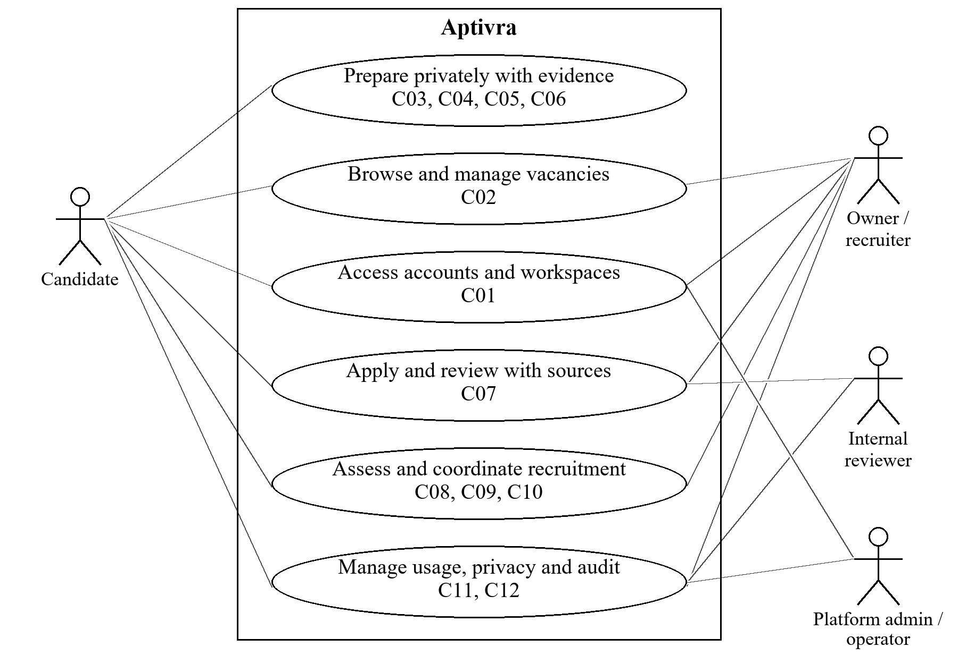
Figure 4.0. Whole-project use-case overview (aggregated goals).
Figures 4.1 to 4.12 show individual use-case IDs. An association means that a role participates in the goal; the table’s preconditions determine which actions are permitted. Lines do not show execution order. Internal queues, marking code and models remain inside the system boundary.

4.1 Accounts and workspaces

4.1.1 Description and Priority
One account can be used for private candidate preparation and authorized employer work. Email ownership, organization approval and organization membership are separate checks.
Priority: High. Delivery: FYP-I; hardening in FYP-II. Scope reference: C01 [R1].
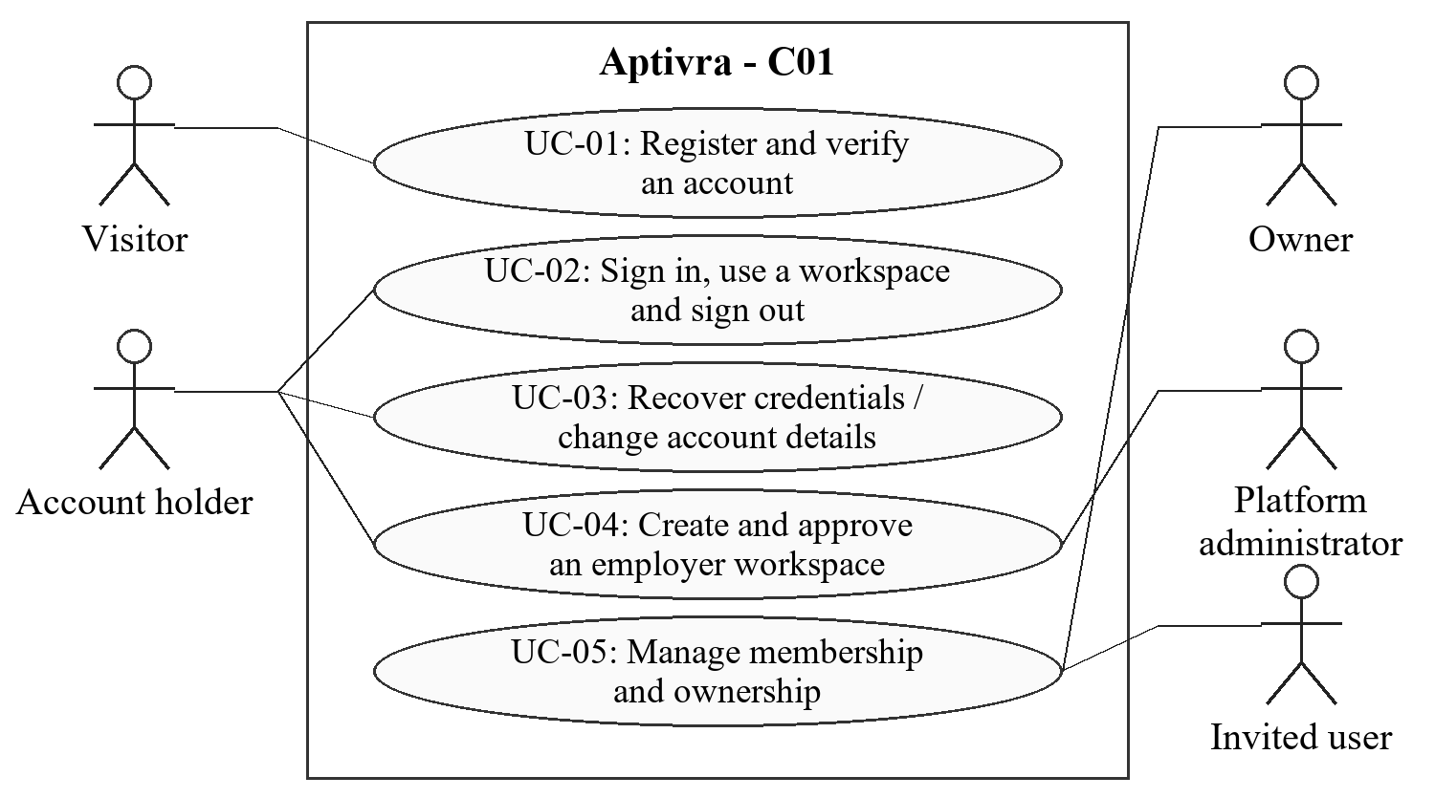
Figure 4.1. C01 actor goals (UC-01, UC-02, UC-03, UC-04, UC-05).

4.1.2 Stimulus/Response Sequences

UC-01: Register and verify an account
Use Case Name: UC-01: Register and verify an account
Description: Create an account whose email ownership can be verified.
Actors: Visitor; email-delivery service
Goal: Create an account whose email ownership can be verified.
Preconditions: The visitor is signed out and can receive email at the supplied address.
Basic Course of Events / Main Flow
User Action / Trigger (Step 1): Open Sign Up and enter name, email, password and confirmation.
System Response: Display the required fields, password rules and privacy notice; validate the request on the server.
User Action / Trigger (Step 2): Submit valid details for an unused email address.
System Response: Create an unverified account with a password hash and send a time-limited verification link; do not grant protected processing or recruitment access.
User Action / Trigger (Step 3): Open the valid verification link.
System Response: Verify the token and its account/email binding, mark email ownership verified, and direct the user to sign in. After sign-in, offer candidate preparation or an employer workspace.
Alternate Flow: Invalid fields receive specific validation feedback. An expired link can be replaced through a rate-limited resend action; an existing account is directed to sign-in/recovery without creating a duplicate.
Exception Flow: If saving fails, no account is committed. If delivery fails after saving, retain the unverified account and offer a safe resend; never mark it verified merely because delivery was attempted.
Postconditions: A verified account exists, or an unverified account remains with a recoverable delivery/verification state; protected access remains blocked until verification.

UC-02: Sign in, use a workspace and sign out
Use Case Name: UC-02: Sign in, use a workspace and sign out
Description: Access only the workspaces and records permitted to the account.
Actors: Registered candidate or employer user
Goal: Access only the workspaces and records permitted to the account.
Preconditions: An account exists; protected actions additionally require verified email and current permissions.
Basic Course of Events / Main Flow
User Action / Trigger (Step 1): Enter credentials on Sign In.
System Response: Validate credentials and apply rate limits; return a non-disclosing error for a failed attempt.
User Action / Trigger (Step 2): Choose candidate preparation or an available organization.
System Response: Regenerate the authenticated session and load only authorized workspace data. An unverified user receives verification/resend options instead of protected features.
User Action / Trigger (Step 3): Select Sign Out.
System Response: Invalidate the session and prevent subsequent protected requests with that session.
Alternate Flow: A candidate may also join an organization without opening a second account. Removed membership or suspended organization status limits access according to the requested action, even if an old page remains open.
Exception Flow: Session or database failure produces a safe error without granting access. Reauthentication is requested when the session has expired.
Postconditions: A valid authorized session is active, or the user is signed out; no workspace choice overrides server permissions.

UC-03: Recover credentials and change account details
Use Case Name: UC-03: Recover credentials and change account details
Description: Recover account access or update the account without bypassing identity checks.
Actors: Account holder; email-delivery service
Goal: Recover account access or update the account without bypassing identity checks.
Preconditions: A recovery request may start while signed out; profile/password changes require the account holder to be authenticated.
Basic Course of Events / Main Flow
User Action / Trigger (Step 1): Request password recovery, or open the account settings while signed in.
System Response: Return a generic recovery acknowledgement, or show the account settings and any required current-password confirmation.
User Action / Trigger (Step 2): Follow a valid recovery link or submit an authorized change.
System Response: Validate the token or current password, apply the password policy, and save only allowlisted profile fields.
User Action / Trigger (Step 3): Complete the change and sign in again when required.
System Response: Invalidate the consumed recovery token; invalidate affected sessions after password recovery. An email change requires verification of the replacement address before protected use resumes.
Alternate Flow: Invalid, expired or consumed recovery links do not reset the password. Recovery/resend requests are rate-limited. A changed email cannot be used to bypass the account-level report ledger.
Exception Flow: Delivery or persistence failure leaves the previous credentials/contact state usable where possible and reports a recoverable error; secrets are not included in logs.
Postconditions: The authorized change is recorded, or the original state is retained; an unverified replacement email does not inherit verified status.

UC-04: Create and approve an employer workspace
Use Case Name: UC-04: Create and approve an employer workspace
Description: Establish a workspace that can publish jobs only after administrative approval.
Actors: Verified user; platform administrator
Goal: Establish a workspace that can publish jobs only after administrative approval.
Preconditions: The creator has a verified account. The administrator uses a separately authorized account; new users cannot grant themselves administrator privileges.
Basic Course of Events / Main Flow
User Action / Trigger (Step 1): Submit an organization/team name and the minimum onboarding information requested by the published policy.
System Response: Create a pending workspace and owner membership together; display the pending state.
User Action / Trigger (Step 2): Administrator reviews the workspace request.
System Response: Show the submitted information to the administrator without exposing private candidate preparation.
User Action / Trigger (Step 3): Administrator approves, declines or suspends the workspace with a reason.
System Response: Record actor, time, reason and resulting status. Permit publication only for approved workspaces; enforce suspension on existing vacancies as well as new ones.
Alternate Flow: A genuine unregistered startup team may be approved; approval is platform permission, not certification of legal registration. A declined request can be corrected and resubmitted under the review policy.
Exception Flow: If workspace/member creation fails, roll back both records. A non-admin approval attempt is denied without a status change.
Postconditions: A traceable onboarding decision exists; a pending, declined or suspended workspace cannot publish or accept new applications.

UC-05: Manage team membership and ownership
Use Case Name: UC-05: Manage team membership and ownership
Description: Assign organization permissions without granting access to another organization or exceeding the plan allowance.
Actors: Organization owner; invited verified user
Goal: Assign organization permissions without granting access to another organization or exceeding the plan allowance.
Preconditions: The owner is authorized for the target organization; the proposed membership fits the workspace allowance or an approved demonstration upgrade.
Basic Course of Events / Main Flow
User Action / Trigger (Step 1): Invite a user or propose a role/ownership change.
System Response: Validate the organization, intended account, permitted role and reviewer-seat allowance.
User Action / Trigger (Step 2): The invited account accepts, or the owner confirms an authorized change.
System Response: Create/update the membership transactionally and record the event; candidates cannot assign roles through their own application fields.
User Action / Trigger (Step 3): Remove access or transfer ownership when needed.
System Response: Recheck permissions on later requests and queued work. Prevent a last owner leaving unless ownership is transferred or explicit workspace closure is completed.
Alternate Flow: The same account may belong to more than one workspace, but permissions remain organization-specific. An invitation does not grant rights before valid acceptance.
Exception Flow: A duplicate acceptance is idempotent. Last-seat races, unauthorized role changes or removal of the sole owner are rejected without a partial membership change.
Postconditions: The authorized membership change is stored with history, and the workspace retains a responsible owner or an explicit closed state.

4.1.3 Functional Requirements
Req. ID | Description | Priority | Status
FR-C01-001 | The system shall maintain one account identity for candidate and employer uses and require a unique normalized email address; selecting a workspace shall not create a separate identity. | High | Pending
FR-C01-002 | The system shall store password hashes, validate confirmation and enforce the published password policy; it shall not store or return plaintext passwords. | High | Pending
FR-C01-003 | The system shall require verified email before document processing, private practice, report generation, applications or employer recruitment actions; public vacancy browsing shall remain available without sign-in. | High | Pending
FR-C01-004 | The system shall issue account-bound, expiring verification/recovery tokens, reject invalid or consumed tokens and rate-limit token issuance and authentication attempts. | High | Pending
FR-C01-005 | The system shall create an organization and its initial owner atomically, keep it pending until an authorized administrative decision, and record decision actor, time and reason. | High | Pending
FR-C01-006 | The system shall deny vacancy creation, editing, publication and new application intake for a suspended organization; historical access shall require retained membership, record authorization and unexpired data. | High | Pending
FR-C01-007 | The system shall enforce owner, recruiter, assigned reviewer and internal-review permissions at the server for each organization; being an administrator shall not automatically disclose private preparation. | High | Pending
FR-C01-008 | The system shall enforce reviewer-seat allowances, prevent unauthorized role escalation and require ownership transfer or explicit workspace closure before a sole owner account is closed. The role-based seat-counting rule shall be published under TBD-09 before allowance acceptance. | High | Pending

4.2 Vacancies and role catalogue

4.2.1 Description and Priority
Approved employers define their vacancy criteria. Candidates can browse published jobs or choose one of three supported preparation role families without a live vacancy. Verified users can report vacancy concerns for manual administrative review.
Priority: High. Delivery: FYP-I. Scope reference: C02 [R1].
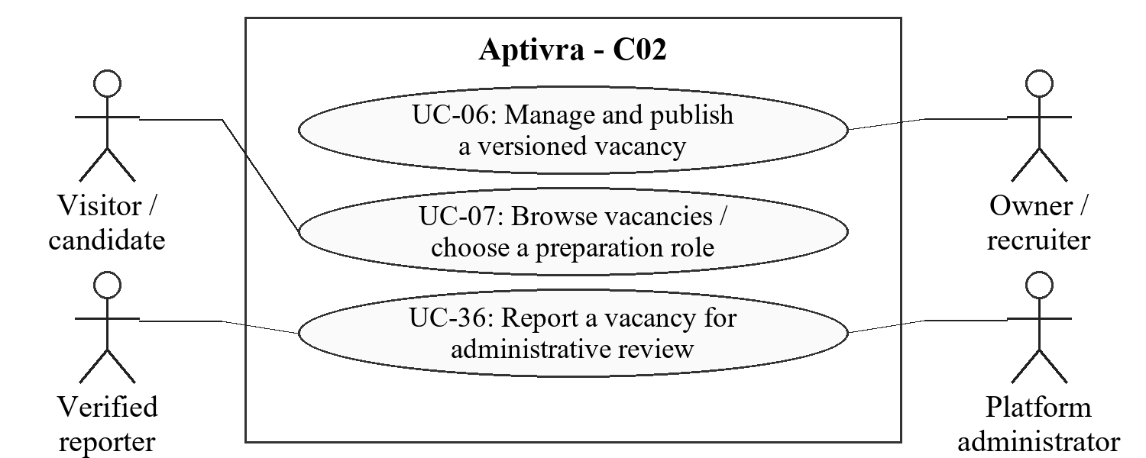
Figure 4.2. C02 actor goals (UC-06, UC-07, UC-36).

4.2.2 Stimulus/Response Sequences

UC-06: Manage and publish a versioned vacancy
Use Case Name: UC-06: Manage and publish a versioned vacancy
Description: Publish clear requirements while preserving earlier versions.
Actors: Organization owner or recruiter
Goal: Publish clear requirements while preserving earlier versions.
Preconditions: The organization is approved and the user has vacancy-management permission. Starting a new campaign/publication additionally requires its allowance; closing intake or editing a retained campaign does not require an unused new-campaign slot.
Basic Course of Events / Main Flow
User Action / Trigger (Step 1): Create or edit a vacancy title, description, role family and required/preferred criteria.
System Response: Validate the fields and save a new draft criteria version without overwriting an earlier version.
User Action / Trigger (Step 2): Review the draft and publish it.
System Response: Atomically make that version the effective public version and record publication, subject to organization status and campaign rules.
User Action / Trigger (Step 3): Close intake or prepare a later revision.
System Response: Stop new submissions when closed; keep accepted applications and issued tests available within retention. An unpublished edit does not alter the effective public version.
Alternate Flow: A stale edit receives a version-conflict response. Reopening within a campaign does not reset its deadline or allowance. A materially new intake requires a new campaign/entitlement.
Exception Flow: A failed save/publish rolls back the operation. Repeated requests cannot accidentally publish two campaigns or create conflicting effective versions.
Postconditions: A consistent draft/published/closed vacancy state exists; submitted applications retain the effective criteria version used at submission.

UC-07: Browse vacancies or choose a preparation role
Use Case Name: UC-07: Browse vacancies or choose a preparation role
Description: Find a published vacancy or select an evaluated preparation role.
Actors: Visitor or candidate
Goal: Find a published vacancy or select an evaluated preparation role.
Preconditions: Public browsing needs no account. Preparation actions require verified sign-in.
Basic Course of Events / Main Flow
User Action / Trigger (Step 1): Browse jobs or open the supported-role catalogue.
System Response: Show only approved, open, published vacancies for intake and identify the three evaluated families: frontend development, backend development and data analysis.
User Action / Trigger (Step 2): Open a vacancy or select a target role.
System Response: Show the effective criteria version and required/preferred requirements, or the curated preparation criteria version.
User Action / Trigger (Step 3): Choose Apply or Prepare.
System Response: Require verified sign-in for the selected protected action; allow role preparation even if no vacancy exists for that role.
Alternate Flow: A job closed during browsing cannot accept a later submission. Unsupported roles are labelled outside the evaluated scope rather than receiving an invented validated assessment.
Exception Flow: If catalogue or vacancy data cannot be loaded, show unavailable/retry status rather than substitute a different vacancy or criteria version.
Postconditions: The user has inspected a public vacancy or chosen a supported role; no application is created merely by viewing a page.

UC-36: Report a vacancy for administrative review
Use Case Name: UC-36: Report a vacancy for administrative review
Description: Report a concern about a published vacancy and obtain an attributable administrative review outcome.
Actors: Verified user reporting a vacancy; authorized platform administrator
Goal: Report a concern about a published vacancy and obtain an attributable administrative review outcome.
Preconditions: The reporter has a verified account and can identify the published vacancy. Administrative review requires platform moderation permission; it does not grant access to private candidate preparation.
Basic Course of Events / Main Flow
User Action / Trigger (Step 1): Submit a vacancy report with a non-empty reason.
System Response: Validate the vacancy and report request, record the reporter, vacancy version, reason, time and Open state, and apply configured rate limits. A report does not automatically suspend an employer or reject applicants.
User Action / Trigger (Step 2): An authorized administrator inspects the report.
System Response: Show the reported vacancy/version and necessary report details under moderation permission; exclude private CV/practice data.
User Action / Trigger (Step 3): The administrator records the review outcome with a reason.
System Response: Record actor, time, reason and Reviewed state. Where warranted, use the existing workspace suspension controls to stop new intake; otherwise record no action. Preserve existing application/retention rules and show the reporter the permitted status.
Alternate Flow: A vacancy closed after reporting may still be reviewed while its report is retained. Duplicate logical submissions return one report. The administrator may conclude that no action is needed; a declaration is not proof of wrongdoing.
Exception Flow: Invalid/unauthorized reports are refused without creating public accusations. A failed save leaves no partial report or suspension decision. Expired report data is inaccessible.
Postconditions: An owned report acknowledgement or authorized review outcome exists. Moderation details follow the bounded supporting-record retention policy under TBD-06.

4.2.3 Functional Requirements
Req. ID | Description | Priority | Status
FR-C02-001 | The system shall allow authorized owners/recruiters of approved organizations to create vacancies with a title, description, supported job family and individually labelled required/preferred criteria. | High | Pending
FR-C02-002 | The system shall retain immutable criteria versions and distinguish an editable draft from the effective published version; updating a draft shall not silently change the public vacancy. | High | Pending
FR-C02-003 | The system shall publish, close and revise vacancies using atomic version checks; concurrent stale edits shall be serialized or rejected as conflicts without inconsistent pointers. | High | Pending
FR-C02-004 | The system shall expose only the effective published version for open intake and bind each accepted application to that version at submission. | High | Pending
FR-C02-005 | The system shall provide public browsing of approved open Aptivra vacancies and preparation criteria for the three evaluated role families; it shall not scrape external job platforms. | High | Pending
FR-C02-006 | The system shall close new intake when the vacancy, organization, campaign deadline or application allowance disallows it, without cancelling previously accepted applications or issued tests. | High | Pending
FR-C02-007 | The system shall let verified users report a published vacancy with a non-empty reason and inspect their permitted report status. Authorized administrators shall record a reasoned manual outcome and, where warranted, use existing workspace suspension controls. Reports shall not automatically establish wrongdoing or expose private CV/practice data; supporting-report retention shall be disclosed under TBD-06. | High | Pending

4.3 Controlled CV processing

4.3.1 Description and Priority
Supported documents enter private quarantine before scanning and constrained extraction. Processing status is independent of recruitment suitability.
Priority: High. Delivery: FYP-I; recovery verification in FYP-II. Scope reference: C03 [R1].
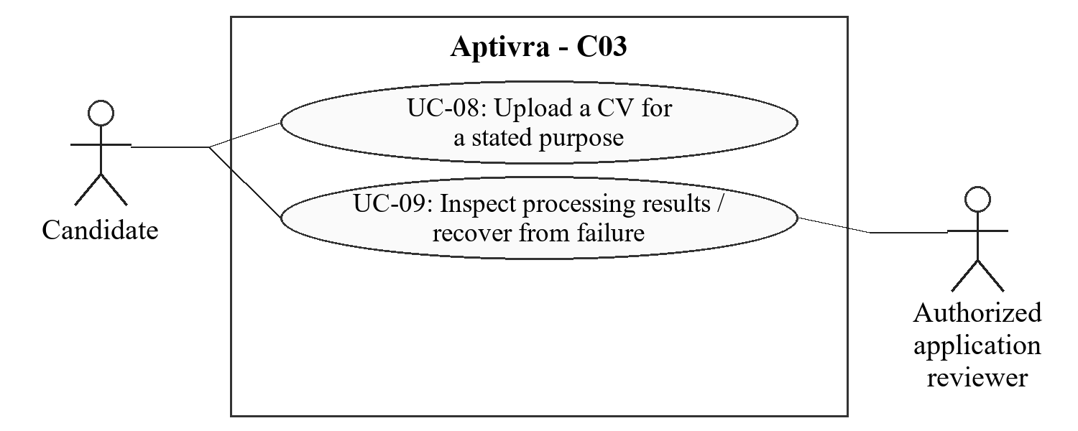
Figure 4.3. C03 actor goals (UC-08, UC-09).

4.3.2 Stimulus/Response Sequences

UC-08: Upload a CV for a stated purpose
Use Case Name: UC-08: Upload a CV for a stated purpose
Description: Submit a supported document under a disclosed storage purpose and limit.
Actors: Verified candidate
Goal: Submit a supported document under a disclosed storage purpose and limit.
Preconditions: The candidate selects one-off preparation or a recruitment submission path and sees its retention notice; required allowance is available.
Basic Course of Events / Main Flow
User Action / Trigger (Step 1): Select a PDF or non-macro DOCX file and confirm the stated purpose.
System Response: Show supported formats, configured limits and retention; validate authorization and content/format/size checks on the server.
User Action / Trigger (Step 2): Confirm the upload.
System Response: Assign an opaque document identifier, store privately in quarantine and create a bounded processing operation with its owner, purpose and expiry.
User Action / Trigger (Step 3): Open the processing status.
System Response: Show queued/scanning/extracting/clarification/ready/failure status from stored operation data, not a simulated success timer.
Alternate Flow: Unsupported, encrypted, macro-enabled, corrupt or oversized files receive an actionable rejection/failure. An identical retried upload operation does not duplicate charges or committed effects.
Exception Flow: An incomplete upload or scanner outage remains non-clean and cannot proceed to ordinary analysis. Hard processing deadlines and cleanup apply under TBD-02.
Postconditions: A private, purpose-bound operation exists or a defined rejection is returned; no unverified file is presented as clean.

UC-09: Inspect processing results or recover from failure
Use Case Name: UC-09: Inspect processing results or recover from failure
Description: Obtain traceable extracted evidence or a clear reason why it is unavailable.
Actors: Candidate; authorized application reviewer
Goal: Obtain traceable extracted evidence or a clear reason why it is unavailable.
Preconditions: The requester is authorized for the unexpired document; extraction is allowed only after a clean scanner result.
Basic Course of Events / Main Flow
User Action / Trigger (Step 1): Request the document status/result.
System Response: Run bounded native extraction, page rendering/OCR and page-coverage checks; retain document/conversion version and passage references.
User Action / Trigger (Step 2): Inspect the returned state.
System Response: Show complete supported evidence, or identify mismatch, partial coverage and unreadable content without automatically accusing or rejecting the candidate.
User Action / Trigger (Step 3): Retry an eligible failed operation or supply a replacement/clarification.
System Response: Reuse the logical operation safely where appropriate; recheck expiry/withdrawal before persisting output and do not silently rewrite submitted snapshots.
Alternate Flow: A native/OCR mismatch enters needs-clarification. A result covering only some pages discloses the gap and cannot support a full-document conclusion.
Exception Flow: Scanner, parser, model or worker failure produces a defined unavailable/failure state. The worker terminates at resource/deadline limits and cannot restore expired/deleted content.
Postconditions: Authorized users see grounded evidence or a defined non-success state; unsafe or expired material is not exposed.

4.3.3 Functional Requirements
Req. ID | Description | Priority | Status
FR-C03-001 | The system shall accept only allowed PDF and non-macro DOCX content within published file/page limits, validate more than the filename extension, and store uploads outside public file access [R4]. | High | Pending
FR-C03-002 | The system shall associate each document and derived artifact with an owner, purpose, version, processing operation and expiry before analysis begins. | High | Pending
FR-C03-003 | The system shall require a verified-clean malware-scanning result before parsing; scanner infection, unavailability or error shall not count as clean. | High | Pending
FR-C03-004 | The system shall run document conversion, rendering, OCR and extraction under configured time, memory, page and network limits without inheriting database credentials or application secrets. | High | Pending
FR-C03-005 | The system shall retain native/OCR provenance, page coverage and passage identifiers; DOCX page references shall identify the conversion version. | High | Pending
FR-C03-006 | The system shall treat mismatches or suspicious instructions as clarification/security-review evidence, not automatic proof of malicious intent or applicant inability. | High | Pending
FR-C03-007 | The system shall expose explicit queued, scanning, extracting, ready, needs-clarification, failed and expired states, with safe user-facing recovery guidance. | High | Pending
FR-C03-008 | The system shall bound retries, preserve logical operation identifiers, clean temporary/derived artifacts and recheck permission/expiry before saving or delivering delayed output. | High | Pending

4.4 Evidence comparison

4.4.1 Description and Priority
Comparisons describe what a specific CV version supports against a specific criteria version. They do not predict employment or silently equate a parser miss with a missing skill.
Priority: High. Delivery: FYP-I. Scope reference: C04 [R1].
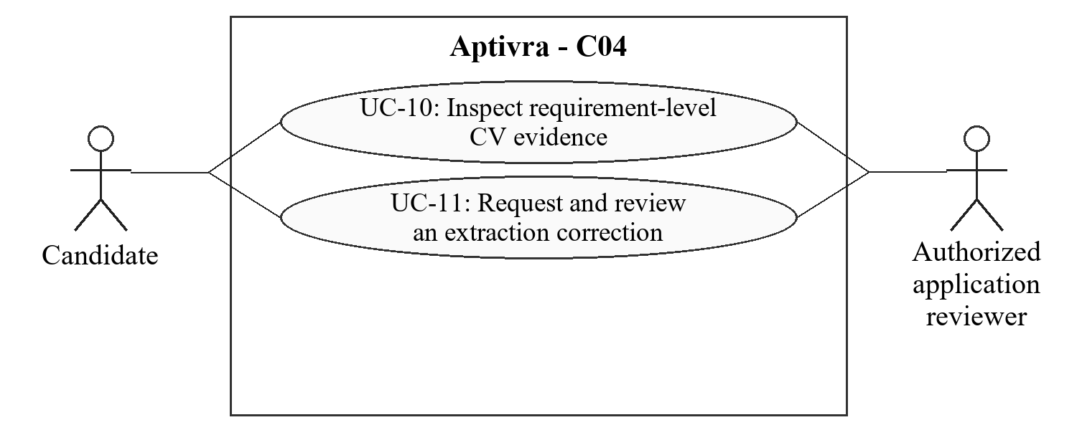
Figure 4.4. C04 actor goals (UC-10, UC-11).

4.4.2 Stimulus/Response Sequences

UC-10: Inspect requirement-level CV evidence
Use Case Name: UC-10: Inspect requirement-level CV evidence
Description: Understand the document support for each requirement.
Actors: Candidate; authorized application reviewer
Goal: Understand the document support for each requirement.
Preconditions: The requester can access the retained document and target criteria version; usable extracted evidence exists.
Basic Course of Events / Main Flow
User Action / Trigger (Step 1): Request comparison for a supported role or submitted vacancy.
System Response: Load the correct document/criteria versions and compare wording using explicit rules with evaluated semantic assistance.
User Action / Trigger (Step 2): Open a requirement result.
System Response: Show evidenced, uncertain or not-shown document support with the supporting passage and coverage limits; keep assessment state separate.
User Action / Trigger (Step 3): Inspect any coverage summary.
System Response: Display required/preferred distinctions, numerator/denominator and criteria version; explain that this is document coverage, not a probability of job success.
Alternate Flow: A missing passage or incomplete page coverage results in uncertainty or an explicit limitation rather than a fabricated reference. No assessment is labelled passed/failed merely from CV wording.
Exception Flow: Invalid model structure, unavailable evidence or a deleted version prevents a confident result and produces a review/unavailable state.
Postconditions: The comparison can be traced to retained evidence and criteria; no automatic hire/reject action occurs.

UC-11: Request and review an extraction correction
Use Case Name: UC-11: Request and review an extraction correction
Description: Correct document interpretation while preserving the original review context.
Actors: Candidate; authorized reviewer
Goal: Correct document interpretation while preserving the original review context.
Preconditions: A retained source and the disputed extracted item are accessible to the actor.
Basic Course of Events / Main Flow
User Action / Trigger (Step 1): Identify an extraction error and cite the visible source passage.
System Response: Record a correction request against the document/version without modifying the original file or deleting earlier output.
User Action / Trigger (Step 2): Review the request and record the supported amendment.
System Response: Retain actor, time, earlier value, revised value and reason; refuse to present a later qualification as content of an earlier CV.
User Action / Trigger (Step 3): Reopen affected comparisons.
System Response: Display the amendment and its effect while preserving earlier recorded decisions and the versions they used.
Alternate Flow: A newly earned qualification is new evidence, not an extraction correction. A disputed amendment remains labelled and can be reviewed; unrelated employers cannot inspect it.
Exception Flow: If source content has expired or a write fails, do not fabricate support or partially overwrite the earlier record.
Postconditions: An attributable amendment or unresolved request exists; historical review evidence is not silently rewritten.

4.4.3 Functional Requirements
Req. ID | Description | Priority | Status
FR-C04-001 | The system shall compare an identified document version with an identified role/vacancy criteria version, preserving required and preferred criterion labels. | High | Pending
FR-C04-002 | The system shall distinguish document evidence status from skill-assessment status and test performance; absence from the CV shall not be stated as proof of inability. | High | Pending
FR-C04-003 | The system shall attach valid document passage references to supported claims and flag uncertain, unsupported or partial extraction instead of inventing evidence. | High | Pending
FR-C04-004 | The system shall label any aggregate as criteria/document coverage, show its denominator and version, and never describe it as hiring probability or a validated employee-quality score. | High | Pending
FR-C04-005 | The system shall record extraction corrections as attributable amendments with earlier values and reasons; later qualifications shall require new evidence rather than rewriting old applications. | High | Pending
FR-C04-006 | The system shall validate AI output and permitted references before display; the model shall not authorize decisions, messages, database writes or unrestricted tools [R6]. | High | Pending
FR-C04-007 | The system shall restrict any AI coordinator to authorized evidence lookup, requirement comparison, reviewed-resource lookup or clarification drafting; Laravel shall validate arguments, record access, action count and outputs under pinned limits. | High | Pending

4.5 Independent preparation

4.5.1 Description and Priority
Candidates can obtain preparation feedback without a job listing and take private practice without a CV. Advice draws on supported evidence, reviewed role information and learning resources.
Priority: High. Delivery: Basic report in FYP-I; practice and full guidance in FYP-II. Scope reference: C05 [R1].
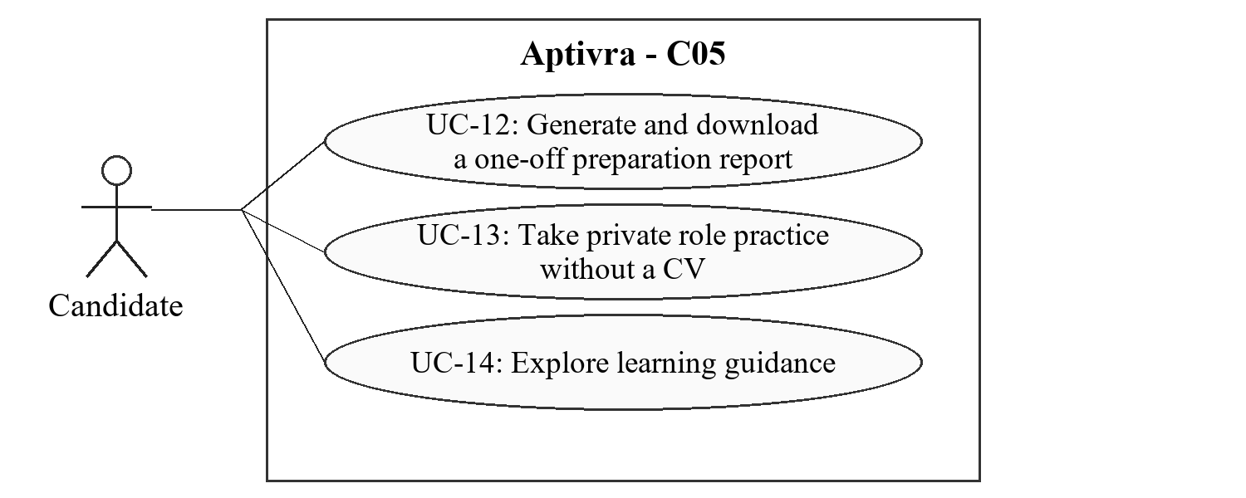
Figure 4.5. C05 actor goals (UC-12, UC-13, UC-14).

4.5.2 Stimulus/Response Sequences

UC-12: Generate and download a one-off preparation report
Use Case Name: UC-12: Generate and download a one-off preparation report
Description: Obtain role-specific CV feedback without applying for a vacancy.
Actors: Verified candidate
Goal: Obtain role-specific CV feedback without applying for a vacancy.
Preconditions: A supported role and usable owned CV are selected; a report credit can be reserved.
Basic Course of Events / Main Flow
User Action / Trigger (Step 1): Request a one-CV/one-role preparation report.
System Response: Show its criteria version, allowance and one-off retention notice; reserve one credit atomically.
User Action / Trigger (Step 2): Wait for the result and inspect evidence.
System Response: Generate supported strengths, missing/uncertain evidence and practical next steps without exposing employer-private information. Consume the credit only on usable delivery.
User Action / Trigger (Step 3): Download the report before expiry.
System Response: Provide an authorized download without another credit charge; do not save permanent history unless the candidate explicitly chooses it.
Alternate Flow: No vacancy is required. Refresh, failed-job retry or a platform extraction correction does not create a second charge. Unsupported roles receive a scope explanation.
Exception Flow: A failed job remains recoverable or releases the reservation with a record; no invented report is delivered to consume a credit.
Postconditions: A private downloadable report exists within its retention, or a recoverable/released-credit failure is recorded.

UC-13: Take private role practice without a CV
Use Case Name: UC-13: Take private role practice without a CV
Description: Practice role-related MCQs without a recruitment application or CV upload.
Actors: Verified candidate
Goal: Practice role-related MCQs without a recruitment application or CV upload.
Preconditions: A supported role and published reviewed practice bank are available.
Basic Course of Events / Main Flow
User Action / Trigger (Step 1): Select private practice for a supported role.
System Response: Present practice questions without asking for a vacancy or CV and identify the bank/version and privacy boundary.
User Action / Trigger (Step 2): Answer and submit the practice questions.
System Response: Validate the owned attempt and mark objective answers on the server against the frozen answer key.
User Action / Trigger (Step 3): Review the practice result and explanations.
System Response: Show correct-answer explanations at the permitted review stage and limited skill-tag feedback; keep the attempt invisible to employer recruitment views.
Alternate Flow: A candidate may repeat according to published practice limits. A weak result describes that attempt only, not general inability. Practice limits are separate from CV-report credits.
Exception Flow: An interruption or abandoned attempt follows published recovery rules and a maximum in-progress lifetime under TBD-08. On reaching that deadline, the system records failure/expiry and applies one-off retention; it does not retain the attempt indefinitely. Duplicate submissions return one logical result.
Postconditions: The candidate receives a private versioned practice result; no employer assessment or application is created.

UC-14: Explore learning guidance
Use Case Name: UC-14: Explore learning guidance
Description: Choose practical learning steps for a supported target role.
Actors: Verified candidate
Goal: Choose practical learning steps for a supported target role.
Preconditions: A target goal/role is selected; owned CV evidence or private practice results are optional inputs.
Basic Course of Events / Main Flow
User Action / Trigger (Step 1): Request guidance for the target role and choose available private inputs.
System Response: Retrieve reviewed role/learning resources and disclose which evidence and criteria version inform the advice.
User Action / Trigger (Step 2): Inspect recommended steps and links.
System Response: Separate evidence presentation issues from unassessed skills or observed practice weaknesses; explain why each next step is suggested.
User Action / Trigger (Step 3): Download or revisit the guidance within its retention.
System Response: Provide the report and source links; require explicit eligible saving for optional longer history.
Alternate Flow: With no CV or practice, provide goal-based reviewed resources and label the limited personalization. ESCO is a vocabulary source, not a question bank or a Pakistan-specific hiring standard [R9].
Exception Flow: Unavailable resources/models produce bounded alternatives or an unavailable explanation, not invented course links or credentials.
Postconditions: The candidate receives traceable preparation suggestions, with no guaranteed employment or verified skill-improvement claim.

4.5.3 Functional Requirements
Req. ID | Description | Priority | Status
FR-C05-001 | The system shall support private preparation for frontend development, backend development and data analysis without requiring a listed vacancy or employer participation. | High | Pending
FR-C05-002 | The system shall generate a one-CV/one-role report from authorized evidence, provide a free download during retention and avoid saving a permanent CV profile by default. | High | Pending
FR-C05-003 | The system shall allow private MCQ practice without uploading a CV and shall maintain a reviewed original/licensed practice bank separate from recruitment banks. | High | Pending
FR-C05-004 | The system shall mark private MCQs on the server, retain the question/version association and restrict unreleased answer-key access; employers shall not obtain private attempts or guidance. Private attempts shall have a bounded in-progress lifetime and recovery policy under TBD-08 before release; completion or failure starts one-off retention. | High | Pending
FR-C05-005 | The system shall retrieve reviewed role/resource records for guidance and identify supporting inputs; it shall not fabricate resource links, credentials or guaranteed learning/hiring outcomes. | High | Pending
FR-C05-006 | The system shall keep CV evidence gaps, unassessed skills and performance on a particular practice attempt distinct in advice and reports. | High | Pending
FR-C05-007 | The system shall apply report-credit reservation, usable-output consumption and retry/correction rules without counting ordinary practice as a completed CV report. | High | Pending

4.6 Optional preparation history

4.6.1 Description and Priority
History is an explicit, bounded choice. A candidate can retain two CV/report versions and compare changes in documented evidence under consistent settings.
Priority: Medium. Delivery: FYP-II. Scope reference: C06 [R1].
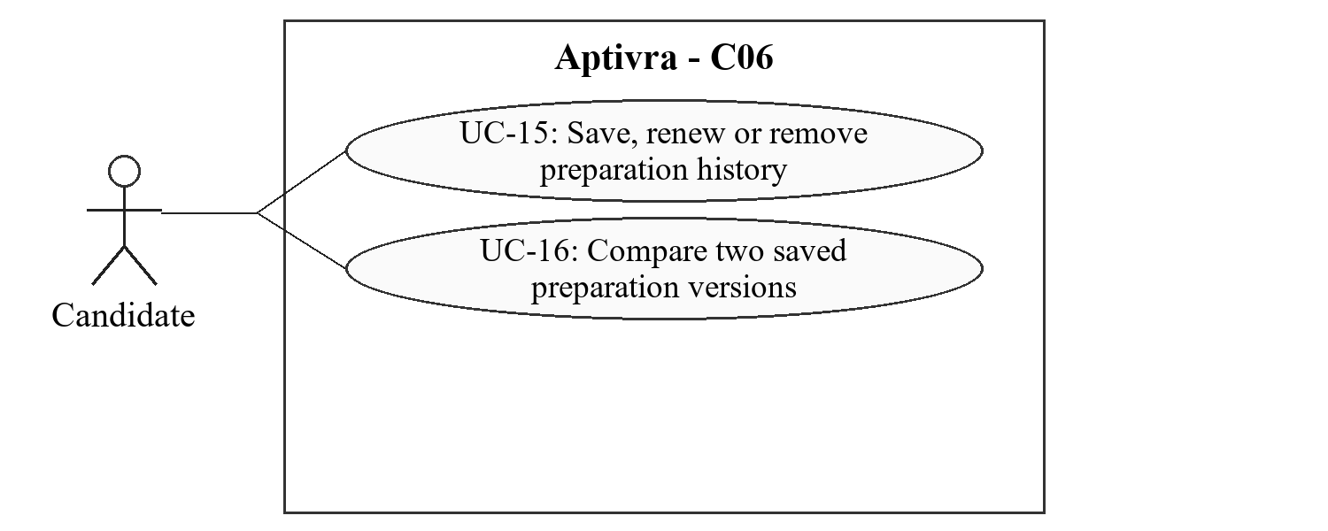
Figure 4.6. C06 actor goals (UC-15, UC-16).

4.6.2 Stimulus/Response Sequences

UC-15: Save, renew or remove preparation history
Use Case Name: UC-15: Save, renew or remove preparation history
Description: Control whether eligible preparation versions remain available beyond one-off retention.
Actors: Verified candidate
Goal: Control whether eligible preparation versions remain available beyond one-off retention.
Preconditions: The candidate is authorized for their own history. Saving/renewal requires an owned unexpired eligible version and the applicable demonstration entitlement. Removing retained history requires ownership/authorization, not an active saving entitlement.
Basic Course of Events / Main Flow
User Action / Trigger (Step 1): Choose Save History and read the retention/entitlement notice.
System Response: Show the two-version maximum and the 90-day expiry that begins with explicit save or renewal.
User Action / Trigger (Step 2): Confirm a save or renewal.
System Response: Persist the authorized version and expiry; if two slots are occupied, require an explicit replacement choice and warning.
User Action / Trigger (Step 3): Remove a saved version or let it expire.
System Response: Revoke access and schedule deletion of that history purpose and derived artifacts; explain any separately retained application snapshot.
Alternate Flow: Page views do not renew the period. An expired/deleted file cannot be offered for reuse. No live payment is collected for demonstration entitlements.
Exception Flow: A failed save/renewal leaves the previous valid slot/expiry state intact. A delayed worker must not recreate removed history.
Postconditions: At most two deliberately saved history versions exist, with disclosed expiry and separate application retention respected.

UC-16: Compare two saved preparation versions
Use Case Name: UC-16: Compare two saved preparation versions
Description: See differences in documented evidence rather than a purported verified increase in skill.
Actors: Verified candidate
Goal: See differences in documented evidence rather than a purported verified increase in skill.
Preconditions: Two owned, unexpired versions and their provenance/settings are available.
Basic Course of Events / Main Flow
User Action / Trigger (Step 1): Select two retained versions for comparison.
System Response: Validate ownership, expiry and compatibility of target criteria/model settings.
User Action / Trigger (Step 2): Request side-by-side feedback.
System Response: Show document passages and added/removed/changed evidence; identify dates, criteria and processing versions.
User Action / Trigger (Step 3): Inspect or download the comparison.
System Response: Label differing settings or regenerate an eligible comparison under consistent settings with consent; do not silently charge for a platform correction.
Alternate Flow: Incompatible results are not presented as a like-for-like improvement score. A report can explain a comparison limitation instead of fabricating progress.
Exception Flow: Expiry/deletion between selection and download blocks the operation; unauthorized versions are never exposed.
Postconditions: A private evidence comparison or a clear compatibility/retention limitation is delivered.

4.6.3 Functional Requirements
Req. ID | Description | Priority | Status
FR-C06-001 | The system shall save preparation history only after explicit candidate action and entitlement confirmation, with no more than two retained CV/report versions. | Medium | Pending
FR-C06-002 | The system shall expire saved history 90 days after explicit saving or renewal; browsing or signing in shall not renew the expiry. | Medium | Pending
FR-C06-003 | The system shall warn and obtain a replacement choice before removing an occupied history slot; saving/renewal shall be atomic. | Medium | Pending
FR-C06-004 | The system shall compare only authorized unexpired versions and display document, criteria and processing provenance; inconsistent settings shall be disclosed or reconciled before like-for-like comparison. | Medium | Pending
FR-C06-005 | The system shall describe changes as documented evidence changes, not verified skill growth or an employment-probability increase. | Medium | Pending
FR-C06-006 | The system shall prevent reuse of expired/deleted history and explain that removing history does not erase a separately retained submitted application. | Medium | Pending

4.7 Applications, referrals and review

4.7.1 Description and Priority
Candidates submit vacancy-specific snapshots. Employers review retained evidence, record sources/referrals and make attributable decisions, including an employer-recorded Hired outcome.
Priority: High. Delivery: FYP-I; full outcome/report checks in FYP-II. Scope reference: C07 [R1].
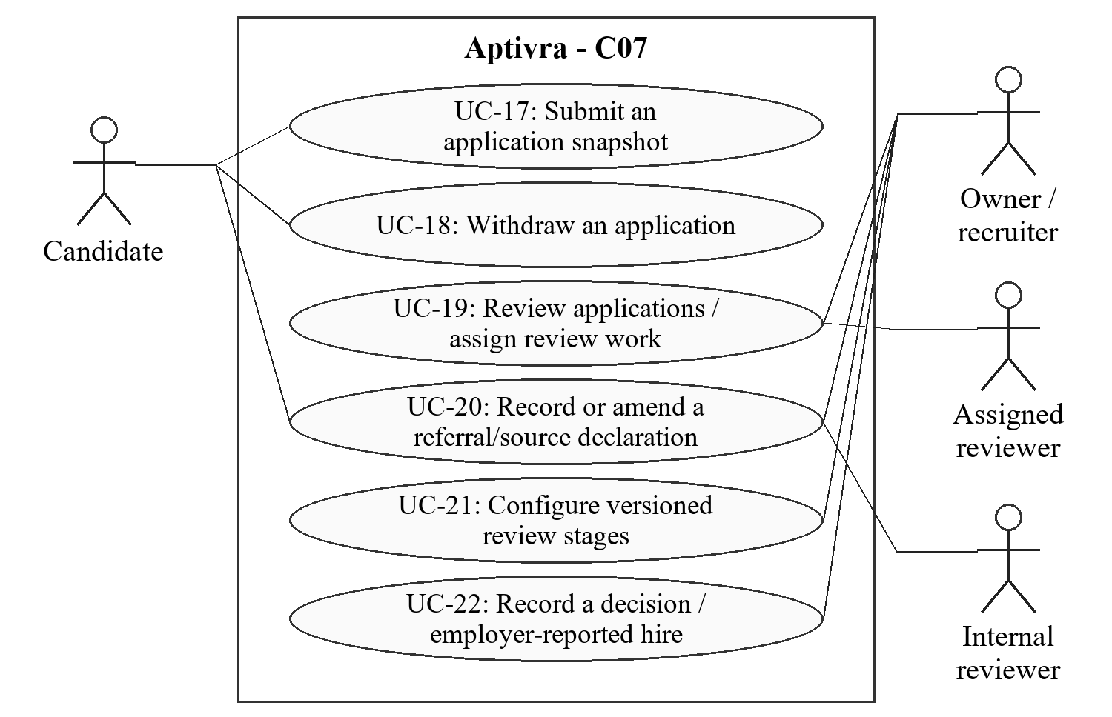
Figure 4.7. C07 actor goals (UC-17, UC-18, UC-19, UC-20, UC-21, UC-22).

4.7.2 Stimulus/Response Sequences

UC-17: Submit an application snapshot
Use Case Name: UC-17: Submit an application snapshot
Description: Apply to an open published vacancy using explicitly chosen evidence.
Actors: Verified candidate
Goal: Apply to an open published vacancy using explicitly chosen evidence.
Preconditions: The organization is approved, intake and allowance are open, and the candidate has a usable authorized CV and application-form fields for submission. Application fields accompany a usable CV; they do not replace the document. Required fields must be identified to the candidate and validated on the server before acceptance.
Basic Course of Events / Main Flow
User Action / Trigger (Step 1): Open the vacancy and choose the CV version and application-form fields to submit.
System Response: Display the effective vacancy criteria, submission details, source declaration options and application-retention notice. Offer reuse only for explicitly saved unexpired evidence.
User Action / Trigger (Step 2): Confirm the application.
System Response: Atomically validate the current published version and available slot, store the submitted CV and application-form fields and criteria snapshot, and assign an application ID.
User Action / Trigger (Step 3): View the acknowledgement and application status.
System Response: Return the accepted version references and receipt; show it in the authorized candidate/employer views without exposing private practice.
Alternate Flow: A changed/closed vacancy requires reconfirmation or rejects submission. A duplicate logical request returns the existing receipt and consumes one slot. An unknown source stays unknown.
Exception Flow: Last-slot races or storage failure roll back incomplete acceptance/reservation. A processing problem is not silently converted into a recruitment rejection.
Postconditions: One accepted application snapshot exists with a source status and version references, or no application/slot commitment is made.

UC-18: Withdraw an application
Use Case Name: UC-18: Withdraw an application
Description: Stop active participation and apply the disclosed withdrawal-retention rule.
Actors: Candidate who owns the application
Goal: Stop active participation and apply the disclosed withdrawal-retention rule.
Preconditions: The application is retained and owned by the signed-in candidate.
Basic Course of Events / Main Flow
User Action / Trigger (Step 1): Open the application and request withdrawal.
System Response: Show the effects on participation, outstanding actions and the retained application snapshot.
User Action / Trigger (Step 2): Confirm withdrawal.
System Response: Record the withdrawal and stop new assessment/interview actions; restrict future worker writes. Start the 30-day withdrawal period only if no earlier closure deadline applies; later withdrawal cannot extend an existing deadline.
User Action / Trigger (Step 3): Review confirmation or request separately allowed data deletion.
System Response: Explain remaining purpose-specific retention and that withdrawal does not restore the employer campaign allowance.
Alternate Flow: Repeated withdrawal requests return the existing withdrawn state. Withdrawal after a recorded outcome is handled as a participation/privacy request without erasing the earlier employer decision.
Exception Flow: A concurrent review/worker operation rechecks withdrawal before committing; failure does not leave contradictory active/withdrawn states.
Postconditions: The withdrawal and its retention consequences are recorded; no automatic rejected outcome is inferred.

UC-19: Review applications and assign review work
Use Case Name: UC-19: Review applications and assign review work
Description: Inspect submitted evidence against the vacancy and record accountable review work.
Actors: Authorized owner/recruiter; assigned reviewer
Goal: Inspect submitted evidence against the vacancy and record accountable review work.
Preconditions: The user has organization/application permission and the application data remains accessible within retention.
Basic Course of Events / Main Flow
User Action / Trigger (Step 1): Open the organization candidate directory and select an application or assigned task.
System Response: Load only retained applications in that organization, with submitted criteria/CV versions and processing limitations.
User Action / Trigger (Step 2): Inspect source passages, released recruitment results and existing authorized notes.
System Response: Keep CV claims, tests, referrals and reviewer judgements visibly separate; exclude private candidate preparation.
User Action / Trigger (Step 3): Record a review note, mark the assigned review completed or recommend shortlisting.
System Response: Store actor, time, relevant versions and reason, including an explicit completion event when the reviewer marks the review completed. A recommendation becomes a decision only when an authorized decision-maker records it.
Alternate Flow: Returning applications are linked only by retained account identity within authorized records, not names or exact-file hashes alone. Missing optional tests do not block review.
Exception Flow: Revoked membership, expired data, self-grading conflicts or another organization ID deny access without leaking the requested record.
Postconditions: The authorized review/task record is retained with its context; earlier notes are amended rather than silently overwritten.

UC-20: Record or amend a referral/source declaration
Use Case Name: UC-20: Record or amend a referral/source declaration
Description: Make application origin and declared referrals visible to authorized reviewers.
Actors: Candidate declaring a source; authorized organization recruiter/internal reviewer
Goal: Make application origin and declared referrals visible to authorized reviewers.
Preconditions: The actor can access the retained application and has permission for the proposed source/referral action.
Basic Course of Events / Main Flow
User Action / Trigger (Step 1): Declare an application source or record a referral/reference.
System Response: Offer public vacancy, employee referral, agency, direct invitation or unknown; collect only necessary referrer identity, relationship and recommendation.
User Action / Trigger (Step 2): Confirm, dispute or correct the record with an explanation.
System Response: Record declared/confirmed/disputed/unconfirmed status, the acting user, time and amendment history. Keep a professional reference a separate type.
User Action / Trigger (Step 3): Inspect the source alongside the review record.
System Response: Show the appropriate disclosure to authorized users without adding competence points or treating a declaration as independent credential verification.
Alternate Flow: A source may remain unknown/unconfirmed. Confirmation describes a recorded organizational confirmation and its basis, not automatic proof of an external relationship. A candidate cannot confirm a declaration as the employer.
Exception Flow: Unauthorized edits or expired source records are rejected; changes must not erase the prior entry or expose another candidate/referrer.
Postconditions: An attributable source/referral declaration or amendment exists, separate from competence evidence and hiring judgement.

UC-21: Configure versioned review stages
Use Case Name: UC-21: Configure versioned review stages
Description: Publish which review stages are required for a vacancy without retroactively changing accepted applications.
Actors: Authorized organization owner or recruiter
Goal: Publish which review stages are required for a vacancy without retroactively changing accepted applications.
Preconditions: The organization is approved and the actor can manage the vacancy; the proposed rules do not require an excluded feature.
Basic Course of Events / Main Flow
User Action / Trigger (Step 1): Choose the vacancy’s review stages and identify optional versus required steps.
System Response: Show supported review, assessment and interview stages. Identify required stages for final selection and the permission/reason needed for an exception. Starting a stage does not require that stage to be completed.
User Action / Trigger (Step 2): Review and publish the configuration with the vacancy version.
System Response: Freeze the required-stage policy and any required assessment reference in the effective published version, visible before candidates apply.
User Action / Trigger (Step 3): Revise the policy for later intake.
System Response: Create a later version; existing applications retain their submitted stage-policy version. Do not retroactively require a new test or label a formerly optional test bypassed.
Alternate Flow: Assessments are optional by default; an employer may explicitly require a job-specific test for the published vacancy. A candidate cannot be their own reviewer, decision-maker, grader or exception approver.
Exception Flow: Unsupported stages, missing required assessment versions or unauthorized edits prevent publication. Concurrent/stale changes use the vacancy version-conflict rules.
Postconditions: A published stage-policy version defines the required checks for final selection; accepted applications retain that version. A failed change leaves the previous valid version unchanged.

UC-22: Record a decision or employer-reported hire
Use Case Name: UC-22: Record a decision or employer-reported hire
Description: Record a recruitment decision and identify reported hires with their recorded application sources.
Actors: Authorized organizational decision-maker other than the applicant
Goal: Record a recruitment decision and identify reported hires with their recorded application sources.
Preconditions: The actor has decision permission for the organization. The application is active and unexpired for a new decision, or still retained for an authorized correction. The guard for the requested transition applies.
Basic Course of Events / Main Flow
User Action / Trigger (Step 1): Inspect application evidence, recruitment results, declared source and required review stages.
System Response: Show the current stage/outcome, submitted policy version, completed required stages and approved exceptions. An omitted optional test is not a bypass.
User Action / Trigger (Step 2): Record a shortlist, next stage, selection, rejection or subsequent employer-recorded Hired outcome, with a reason.
System Response: Validate the action-specific transition and require a non-empty reason. Final selection requires completed mandatory stages or approved exceptions; early rejection does not require later stages. Hired requires an existing selected application and satisfied selection safeguards. Append actor, time, reason and version context.
User Action / Trigger (Step 3): Open the outcome history or an authorized source/outcome report.
System Response: Link the recorded Hired outcome to retained source/referral history. Count a hired application once within selected totals and separately in hired counts; apply cohort and retention rules.
Alternate Flow: An authorized correction preserves the earlier outcome and reason and rechecks safeguards for the effective outcome. A recruiter may reject an active application early with a reason; not undertaking later stages for that rejection is not a required-stage bypass. A referred hire is not labelled unqualified, and a public-source hire is not declared proven merit.
Exception Flow: Concurrent stale decisions receive a conflict/retry response. Failure commits neither a partial outcome nor an inconsistent audit event.
Postconditions: An attributable decision exists. Hired/rejected decisions close the application for ordinary intake actions and start the applicable closure-retention period; history does not prove why a hire occurred.

4.7.3 Functional Requirements
Req. ID | Description | Priority | Status
FR-C07-001 | The system shall accept applications only against an approved open published vacancy and atomically preserve the submitted CV and application-form fields, effective criteria version, candidate account and application identifier. | High | Pending
FR-C07-002 | The system shall permit one accepted application per candidate account and campaign, enforce that business uniqueness as well as logical-request idempotency, and reject over-capacity/closed-intake requests without partial acceptance. | High | Pending
FR-C07-003 | The system shall provide candidate-owned status/withdrawal actions and an organization-scoped candidate directory, assigned review tasks, attributable review-completion events, human shortlisting and recorded review reasons. | High | Pending
FR-C07-004 | The system shall preserve original submission/review context when profiles or extraction amendments change; similar names and matching file hashes shall not establish candidate identity. | High | Pending
FR-C07-005 | The system shall record public-vacancy, employee-referral, agency, direct-invitation or unknown sources and separately typed professional references, with only purpose-necessary details. | High | Pending
FR-C07-006 | The system shall retain source/referral actor, time, confirmation/dispute status, basis and amendment history; it shall neither grant referral competence points nor infer undisclosed influence. | High | Pending
FR-C07-007 | The system shall restrict decisions to authorized organizational users, require a non-empty reason before committing a decision, and store actor, time and relevant evidence/criteria versions as an attributable event. | High | Pending
FR-C07-008 | The system shall support an explicitly labelled employer-recorded Hired outcome and link it to the retained source/referral record for authorized inspection; it shall not claim independent employment verification. | High | Pending
FR-C07-009 | The system shall enforce transition-specific guards: authorized stage entry does not require its own completion; final selection and subsequent Hired recording require completed mandatory stages or approved exceptions. An active application may be rejected early with a reason without completing later stages. Closure/withdrawal/expiry rules remain enforced; expiry and omitted optional tests are not rejection or bypass. | High | Pending
FR-C07-010 | The system shall prevent cross-organization review access and employer access to private practice/history; decision/outcome corrections shall preserve earlier entries and not restart expired retention. | High | Pending
FR-C07-011 | The system shall publish required/optional stage configuration with the effective vacancy version and retain it with each application. Required checks govern final selection, not entry into those same stages; later policy changes shall not apply retroactively. | High | Pending
FR-C07-012 | The system shall deny an applicant access to reviewer, grader, unreleased-key, decision-maker or exception-approval powers over their own application/attempt, even when the account holds an employer role; an authorized non-applicant must perform those actions. | High | Pending
FR-C07-013 | The system shall preserve the one-account/one-campaign application rule after withdrawal or rejection; eligible corrections amend the retained record, while a new campaign permits a new snapshot without rewriting the old application. | High | Pending

4.8 Recruitment assessments

4.8.1 Description and Priority
Employers may request vacancy-specific MCQ or written tests. Server-side attempts and versioned marking preserve the difference between test performance and CV evidence.
Priority: High. Delivery: FYP-II. Scope reference: C08 [R1].
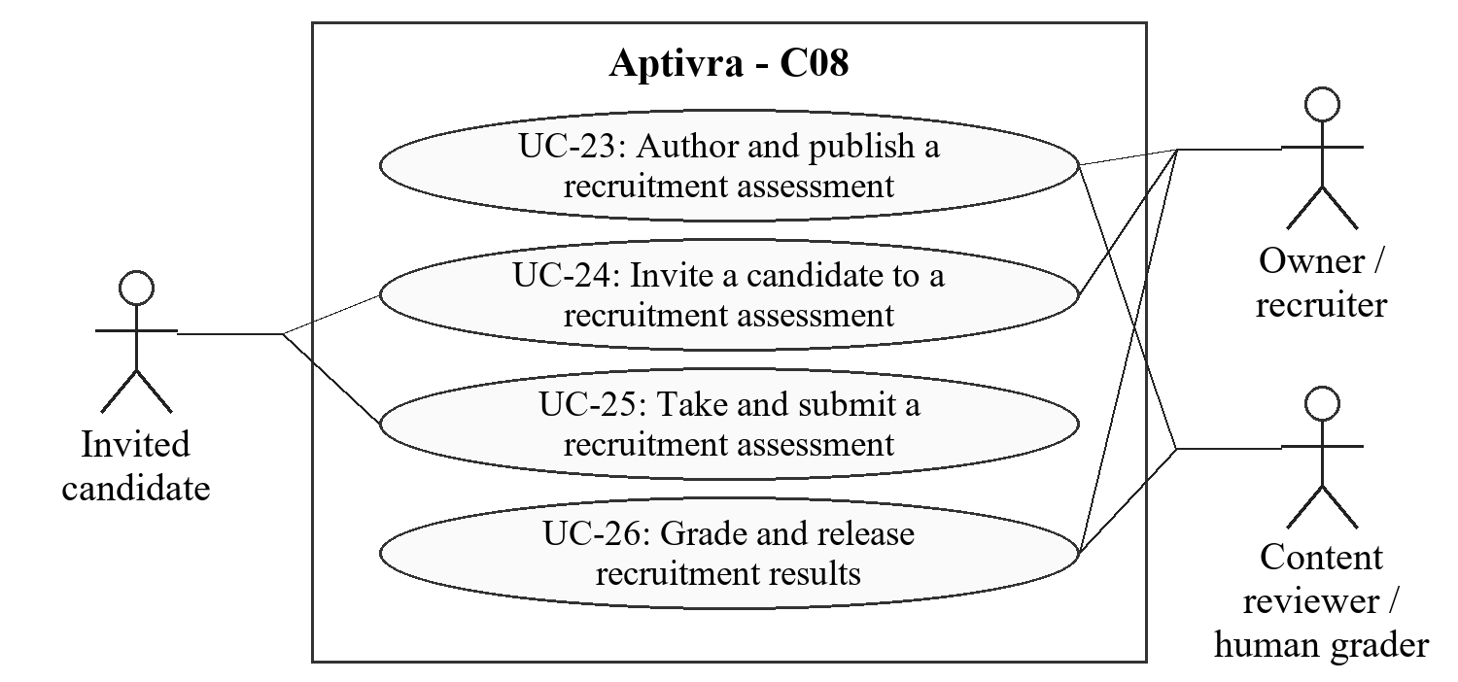
Figure 4.8. C08 actor goals (UC-23, UC-24, UC-25, UC-26).

4.8.2 Stimulus/Response Sequences

UC-23: Author and publish a recruitment assessment
Use Case Name: UC-23: Author and publish a recruitment assessment
Description: Publish job-specific questions and marking rules.
Actors: Authorized owner/recruiter; assigned content reviewer
Goal: Publish job-specific questions and marking rules.
Preconditions: The organization is approved and the author can manage its assessments.
Basic Course of Events / Main Flow
User Action / Trigger (Step 1): Create MCQ/written questions, skill tags and a marking rubric.
System Response: Validate options/answer keys, rubric fields and the permitted question types; store a draft version separate from private practice content.
User Action / Trigger (Step 2): Set attempt duration, allowed attempts and interruption/accommodation rules.
System Response: Require explicit published rules before invitations; show that recruiter authorship is not psychometric validation.
User Action / Trigger (Step 3): Publish the assessment version.
System Response: Freeze the questions, keys, rubric and attempt rules referenced by invitations; future changes create another version.
Alternate Flow: An invalid key/rubric prevents publication. A revised test does not change attempts already invited under an older version. Code execution and proctoring are outside scope.
Exception Flow: Failed publication leaves the prior published version unchanged and does not issue invitations.
Postconditions: A published recruitment assessment is available to authorized inviters; a vacancy’s submitted stage policy determines whether it is required. Answers/keys are not public.

UC-24: Invite a candidate to a recruitment assessment
Use Case Name: UC-24: Invite a candidate to a recruitment assessment
Description: Associate a published test with a particular submitted application.
Actors: Authorized recruiter; invited candidate
Goal: Associate a published test with a particular submitted application.
Preconditions: The application is active/retained and belongs to the organization; the test version and invitation/attempt rules are published.
Basic Course of Events / Main Flow
User Action / Trigger (Step 1): Select the application, assessment version and permitted deadline.
System Response: Validate the actor, application eligibility, version and time-zone display; prevent duplicate logical invitations.
User Action / Trigger (Step 2): Confirm the invitation.
System Response: Create a candidate/application-bound invitation and an in-app notification without exposing the answer key.
User Action / Trigger (Step 3): Candidate opens the invitation.
System Response: Show rules, deadline, attempt allowance and accessibility/accommodation contact before the candidate starts.
Alternate Flow: Where no assessment is required by the submitted vacancy policy, review/interview may proceed without a test. A required test may be invited before completion; final selection requires its completed marking or an approved exception. No personality or aptitude fallback is inserted. Plan/intake closure alone does not cancel issued eligible invitations.
Exception Flow: Withdrawn/expired applications or cancelled/expired invitations cannot start new attempts. Delivery/display failure does not create an extra invitation.
Postconditions: One authorized invitation exists or a defined refusal is returned; the candidate has not yet been graded.

UC-25: Take and submit a recruitment assessment
Use Case Name: UC-25: Take and submit a recruitment assessment
Description: Complete the invited assessment under server-controlled rules.
Actors: Invited verified candidate
Goal: Complete the invited assessment under server-controlled rules.
Preconditions: The invitation belongs to the candidate, is eligible/unexpired and permits another attempt.
Basic Course of Events / Main Flow
User Action / Trigger (Step 1): Start the attempt.
System Response: Freeze its version reference, server start/deadline and allowed questions; return no answer keys or private rubrics that reveal correct answers.
User Action / Trigger (Step 2): Answer questions and save progress.
System Response: Authorize each save and use server time and operation IDs; refresh does not restart the timer or create another attempt.
User Action / Trigger (Step 3): Submit or reach the published time limit.
System Response: Finalize one logical submission using the published timeout/outage rule and retain saved answers with the attempt/version.
Alternate Flow: Resume, retake and accommodation behavior follows the published rules. Late/unauthorized answer changes are refused; an allowed retake is another identifiable attempt, not an overwrite.
Exception Flow: Network/server outage invokes the declared recovery policy. Duplicate submit requests return the same result; incomplete/cancelled work is not silently labelled a genuine skill failure.
Postconditions: A versioned submitted/timed-out/interrupted attempt exists under the disclosed policy, separate from private practice and CV evidence.

UC-26: Grade and release recruitment results
Use Case Name: UC-26: Grade and release recruitment results
Description: Produce and release attributable results without self-grading or hidden model decisions.
Actors: Assigned human grader; authorized recruiter
Goal: Produce and release attributable results without self-grading or hidden model decisions.
Preconditions: A submitted attempt and its frozen key/rubric exist. Deterministic MCQ marking uses an authorized backend process; written grading requires an assigned human who is not the candidate. Result release requires release permission and completed marking, not assignment as the written grader.
Basic Course of Events / Main Flow
User Action / Trigger (Step 1): Grade the submitted attempt.
System Response: Mark MCQs deterministically on the backend; route written answers to the assigned human grader with the published rubric.
User Action / Trigger (Step 2): For written questions, record marks/feedback or an authorized correction; for an MCQ-only test, inspect the computed marks.
System Response: For written grading, validate assignment, mark ranges and permissions; retain grader, time, rubric version and amendments. MCQ-only tests need no human grader. AI assistance cannot finalize written marks.
User Action / Trigger (Step 3): Release results under the published disclosure rules.
System Response: Show the candidate and authorized employer their permitted versioned result/feedback; keep unreleased answer keys and other candidates private.
Alternate Flow: Unsubmitted/cancelled attempts are not graded as completed tests. A result describes this test/version, not general inability or guaranteed job suitability.
Exception Flow: A marking error produces pending-review/unavailable status rather than an invented grade; release fails safely if grading is incomplete.
Postconditions: A traceable grade and explicit release state exist, separate from recruitment decisions and private preparation.

4.8.3 Functional Requirements
Req. ID | Description | Priority | Status
FR-C08-001 | The system shall let authorized employers author MCQ/written assessments with skill tags, correct-answer keys, rubrics and published attempt/outage/accommodation rules. | High | Pending
FR-C08-002 | The system shall version and freeze published questions, rubric and timing rules; invitations and attempts shall retain the exact version used. | High | Pending
FR-C08-003 | The system shall issue application/candidate-bound recruitment invitations and identify whether the assessment is required by the submitted vacancy policy. Review/interview may proceed without an optional test; final selection remains subject to required-stage checks or approved exceptions. | High | Pending
FR-C08-004 | The system shall control attempt timing, autosave, allowed attempts and finalization on the server; refresh and duplicate requests shall not reset time, duplicate attempts or permit late answer changes. | High | Pending
FR-C08-005 | The system shall mark recruitment MCQs deterministically and require assigned human grading of written answers; a candidate shall not grade their own attempt. | High | Pending
FR-C08-006 | The system shall restrict unreleased keys and grading data, record grade amendments, and release only authorized results/feedback after the required marking is complete. | High | Pending
FR-C08-007 | The system shall distinguish cancelled, interrupted, pending-grade and completed results and shall not present a technical failure as assessed inability. | High | Pending
FR-C08-008 | The system shall keep private-practice banks/attempts and recruitment banks/attempts separately authorized; it shall provide neither personality classification, proctoring nor a code-execution judge. | High | Pending
FR-C08-009 | The system shall satisfy a required assessment stage only after an eligible version-bound attempt is submitted and all required MCQ/written marking is finalized, or an authorized stage exception is approved. Candidate result release and analytics submission completion are separate events. | High | Pending

4.9 Interview coordination

4.9.1 Description and Priority
The platform coordinates interview times, stores an external meeting link and records interview status. Video conferencing is outside its scope.
Priority: Medium. Delivery: FYP-II. Scope reference: C09 [R1].
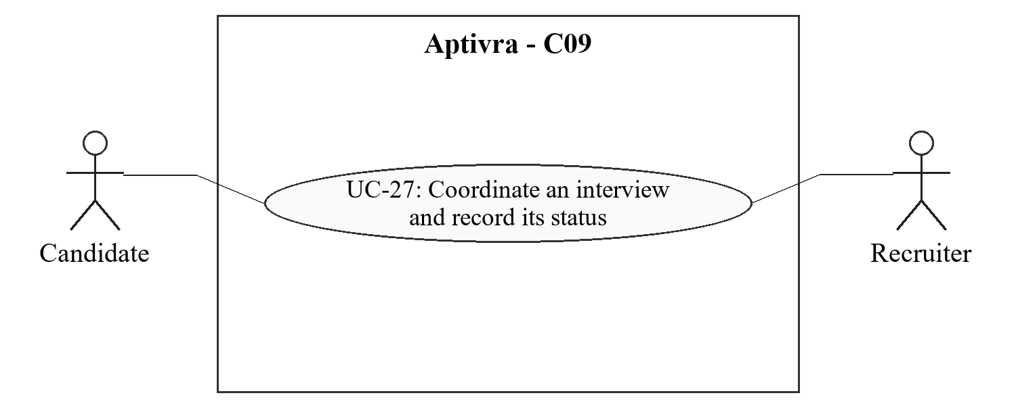
Figure 4.9. C09 actor goals (UC-27).

4.9.2 Stimulus/Response Sequences

UC-27: Coordinate an interview and record its status
Use Case Name: UC-27: Coordinate an interview and record its status
Description: Coordinate an application-linked interview and record its scheduling, participation and completion status.
Actors: Authorized recruiter; applicant
Goal: Coordinate an application-linked interview and record its scheduling, participation and completion status.
Preconditions: The recruiter has permission for the retained, unexpired application. New participation or scheduling requires an active application; scheduling also requires a proposed time and external link. Authorized corrections to earlier interview events may occur on retained closed/withdrawn records without reopening participation or restarting retention.
Basic Course of Events / Main Flow
User Action / Trigger (Step 1): Propose a time, time zone and external meeting link.
System Response: Validate the application, date/time and permitted URL scheme; store a canonical time and display participant-local time-zone labels.
User Action / Trigger (Step 2): Candidate views the appointment and responds through the supported confirmation/request action.
System Response: Show the current appointment details and record the response without granting the candidate recruiter scheduling privileges.
User Action / Trigger (Step 3): Recruiter confirms a change or cancellation.
System Response: Retain appointment-change history and notify authorized participants; prevent an old link/time from appearing as the current meeting.
User Action / Trigger (Step 4): Record Completed or No-show after the interview time.
System Response: Validate a non-applicant recruiter’s permission and the appointment; store the reported event time, recording time, actor, appointment version and note. Only Completed satisfies a required interview stage. Corrections preserve the earlier status and do not restart retention.
Alternate Flow: A candidate can request a change; the recruiter controls the schedule. An authorized non-applicant recruiter records completion or no-show; a scheduled, cancelled or no-show interview does not satisfy a required interview stage. An authorized stage exception remains a separate event. No video-provider API or independent attendance verification is assumed.
Exception Flow: Invalid links, expired applications or persistence failure leave the previous valid appointment unchanged and produce a clear error.
Postconditions: The retained application has a current appointment, cancellation or attributable completed/no-show status, with earlier status changes preserved.

4.9.3 Functional Requirements
Req. ID | Description | Priority | Status
FR-C09-001 | The system shall let authorized recruiters create, reschedule and cancel application-linked interviews and record participant responses or change requests. | Medium | Pending
FR-C09-002 | The system shall store a canonical interview time, display the relevant time zone and retain the current external meeting link and change history. | Medium | Pending
FR-C09-003 | The system shall validate meeting-link schemes, restrict link visibility to authorized participants and avoid server-side fetching of arbitrary supplied URLs. | Medium | Pending
FR-C09-004 | The system shall notify affected users of appointment changes; storing a link shall not be represented as providing video calls or a confirmed external-provider API integration. | Medium | Pending
FR-C09-005 | The system shall let an authorized non-applicant recruiter record interview Completed or No-show with actor, event/recording times, appointment version and note. Scheduled, cancelled and no-show states shall not satisfy required interview completion; attributable corrections preserve history and retention limits. | Medium | Pending

4.10 Notifications and job alerts

4.10.1 Description and Priority
In-app notifications communicate authorized workflow changes. Opt-in alerts match preferences against vacancies actually published on Aptivra.
Priority: Medium. Delivery: FYP-II. Scope reference: C10 [R1].
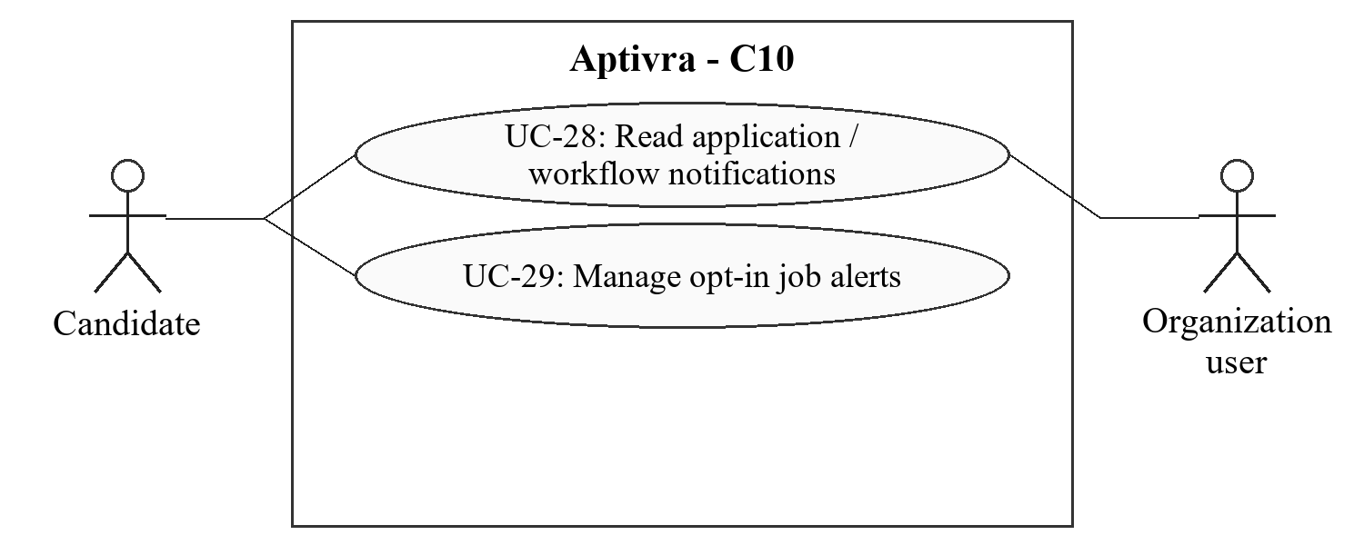
Figure 4.10. C10 actor goals (UC-28, UC-29).

4.10.2 Stimulus/Response Sequences

UC-28: Read application and workflow notifications
Use Case Name: UC-28: Read application and workflow notifications
Description: Receive relevant in-app updates without leaking restricted records.
Actors: Verified candidate or organization user
Goal: Receive relevant in-app updates without leaking restricted records.
Preconditions: An event affecting the account has occurred and the recipient is still authorized to view its permitted detail.
Basic Course of Events / Main Flow
User Action / Trigger (Step 1): Open the notification list.
System Response: Return only recipient-authorized notifications and read/unread status.
User Action / Trigger (Step 2): Open an update about an application, test or interview.
System Response: Recheck record access/expiry before showing details; a stale notification is not an access token.
User Action / Trigger (Step 3): Mark the update read.
System Response: Update only the recipient record and avoid duplicating a notification on an idempotent event retry.
Alternate Flow: An expired/deleted target can show a minimal unavailable notice rather than retained CV/test content. Security notices use their own minimal disclosed retention.
Exception Flow: A delayed notification or event failure is recoverable and does not alter the underlying recruitment decision.
Postconditions: The user sees permitted updates; read state is stored without extending source-data retention.

UC-29: Manage opt-in job alerts
Use Case Name: UC-29: Manage opt-in job alerts
Description: Be notified of relevant future Aptivra vacancies without retaining a CV for that purpose.
Actors: Verified candidate
Goal: Be notified of relevant future Aptivra vacancies without retaining a CV for that purpose.
Preconditions: The candidate can manage their own preferences.
Basic Course of Events / Main Flow
User Action / Trigger (Step 1): Enable alerts and choose supported role, location and experience preferences.
System Response: Explain what is stored and that alerts cover only approved open published Aptivra vacancies.
User Action / Trigger (Step 2): Save preferences.
System Response: Store an explicit opt-in and evaluate eligible new vacancies against the preferences rather than private CV content.
User Action / Trigger (Step 3): Change preferences or disable alerts.
System Response: Apply the change to future matching and revoke alert delivery on opt-out/account closure.
Alternate Flow: No matching jobs is a valid outcome, not a promise to find employment. Alert preferences can exist without saved preparation history.
Exception Flow: An unavailable matching job or failed delivery does not create a fabricated vacancy or a duplicate alert.
Postconditions: An explicit preference/opt-out state exists independently of CV retention.

4.10.3 Functional Requirements
Req. ID | Description | Priority | Status
FR-C10-001 | The system shall create recipient-scoped in-app notifications for application, assessment and interview events and record read status without granting access to the target record. | Medium | Pending
FR-C10-002 | The system shall recheck permissions and expiry when a notification is opened and avoid preserving sensitive deleted content in notification payloads. | Medium | Pending
FR-C10-003 | The system shall provide explicit opt-in role/location/experience preferences and match alerts only to approved open published vacancies on Aptivra. | Medium | Pending
FR-C10-004 | The system shall store alert preferences separately from CVs, stop matching on opt-out/account closure and avoid duplicate event delivery effects. | Medium | Pending
FR-C10-005 | The system shall not require application-update email/SMS delivery for the FYP; the separately approved verification/recovery email service remains an account dependency. | Medium | Pending

4.11 Plans and usage allowances

4.11.1 Description and Priority
Demonstration entitlements enforce the proposed pilot allowances without collecting money. Usable work, retries and accepted applications have explicit counting rules.
Priority: High. Delivery: FYP-II. Scope reference: C11 [R1].
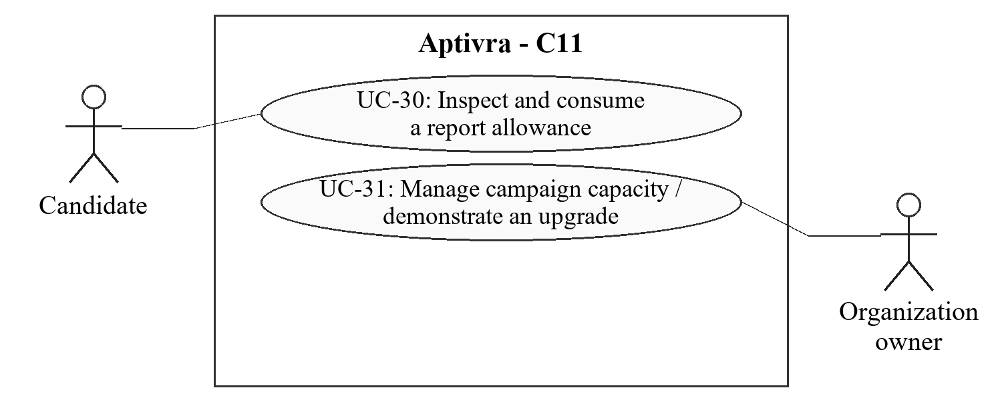
Figure 4.11. C11 actor goals (UC-30, UC-31).

4.11.2 Stimulus/Response Sequences

UC-30: Inspect and consume a report allowance
Use Case Name: UC-30: Inspect and consume a report allowance
Description: Understand available report credits and be charged only for usable delivery.
Actors: Verified candidate
Goal: Understand available report credits and be charged only for usable delivery.
Preconditions: The candidate account and minimal usage ledger are available; published pilot limits apply.
Basic Course of Events / Main Flow
User Action / Trigger (Step 1): Open usage or request a new one-CV/one-role report.
System Response: Show three completed pilot reports per calendar month, reservations and any additional demonstration credits.
User Action / Trigger (Step 2): Confirm processing.
System Response: Reserve credit atomically against the account and logical operation before heavy work starts.
User Action / Trigger (Step 3): Receive a usable report or a failed result.
System Response: Consume one reservation on usable delivery; preserve/release failed work with a record. Downloads, refreshes and platform-error corrections do not consume another credit.
Alternate Flow: Changing an email does not create a fresh account ledger. Historical content may expire while minimal disclosed usage counts remain for their separate purpose.
Exception Flow: Concurrent requests cannot spend the same final credit; an eligible retry cannot create a second debit.
Postconditions: A consistent reserved/consumed/released credit state exists and the candidate can inspect it.

UC-31: Manage campaign capacity and demonstrate an upgrade
Use Case Name: UC-31: Manage campaign capacity and demonstrate an upgrade
Description: Use bounded employer capacity without resetting trials or collecting payments.
Actors: Organization owner
Goal: Use bounded employer capacity without resetting trials or collecting payments.
Preconditions: An approved workspace and its allowance ledger exist.
Basic Course of Events / Main Flow
User Action / Trigger (Step 1): Open the plan/campaign allowance.
System Response: Show one free campaign per organization, one reviewer seat, 25 accepted applications and a 30-day intake window beginning at first publication.
User Action / Trigger (Step 2): Publish another campaign, add capacity or request a demonstration upgrade.
System Response: Require the appropriate entitlement for a second campaign or excess capacity even if the first is not full; show that no payment is being collected.
User Action / Trigger (Step 3): Close/reopen intake or let the plan expire.
System Response: Preserve eligible accepted applications and issued tests within retention, without refunding slots for withdrawal/rejection or resetting the trial by renaming jobs/teams.
Alternate Flow: A campaign is one vacancy intake: editing its criteria does not create fresh capacity. Reopening keeps the original window; a new intake uses another campaign entitlement.
Exception Flow: Last-slot/last-seat races are handled atomically. Failed publication does not consume a second campaign and duplicate acceptance consumes one application slot.
Postconditions: The workspace has a traceable allowance state or an explicit capacity refusal; security, basic audit and referral transparency remain available.

4.11.3 Functional Requirements
Req. ID | Description | Priority | Status
FR-C11-001 | The system shall demonstrate three completed one-CV/one-role candidate reports per calendar month and account-bound reserved/consumed/released credit records, with the month boundary/time zone published. | High | Pending
FR-C11-002 | The system shall debit a report atomically when a validated usable report is committed ready and made accessible to its owner; an actual download is not required. Refresh, download, eligible retry and platform extraction correction shall not cause another debit. | High | Pending
FR-C11-003 | The system shall demonstrate one free campaign per organization with one reviewer seat, up to 25 accepted application submissions and a 30-day intake window from first publication. | High | Pending
FR-C11-004 | The system shall require an upgrade entitlement for a second campaign or capacity beyond the free allowance regardless of unused first-campaign capacity; it shall collect no live payments. | High | Pending
FR-C11-005 | The system shall enforce last-slot/last-credit/last-seat operations atomically with idempotency and uniqueness safeguards; withdrawal or rejection shall not replenish the campaign allowance. | High | Pending
FR-C11-006 | The system shall retain eligible accepted workflows after intake/plan closure, prevent simple job/team renaming from resetting trials and publish a separate minimal trial-ledger retention period. | High | Pending
FR-C11-007 | The system shall include core security, basic audit and referral transparency in trial access and shall neither sell CV data nor offer purchased ranking. | High | Pending

4.12 Privacy, internal audit and analytics

4.12.1 Description and Priority
Privacy rules govern each storage purpose. Authorized internal reviewers inspect recorded recruitment activity and source/outcome summaries without claiming to detect hidden influence or independently verify employment.
Priority: High. Delivery: Access/audit/expiry in FYP-I; complete reports/recovery in FYP-II. Scope reference: C12 [R1].
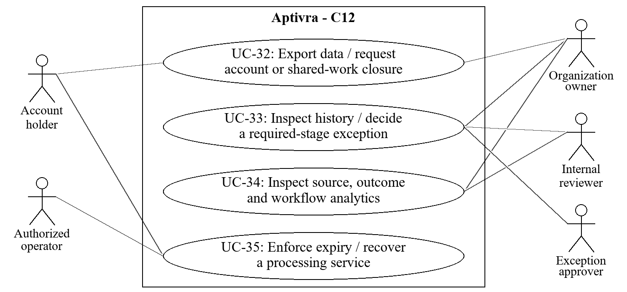
Figure 4.12. C12 actor goals (UC-32, UC-33, UC-34, UC-35).

4.12.2 Stimulus/Response Sequences

UC-32: Export data or close/delete account data
Use Case Name: UC-32: Export data or close/delete account data
Description: Exercise data control without erasing other users’ shared records improperly.
Actors: Verified account holder; authorized organization owner where shared-work closure is involved
Goal: Exercise data control without erasing other users’ shared records improperly.
Preconditions: The requester is authenticated and passes required identity confirmation; relevant retained data and purpose rules can be determined.
Basic Course of Events / Main Flow
User Action / Trigger (Step 1): Request an export, history deletion or account closure.
System Response: Explain the requested scope, ownership and separately retained application/audit purposes; require current-password or equivalent identity confirmation for destructive closure.
User Action / Trigger (Step 2): Confirm the permitted request.
System Response: Export only requester-authorized data, or revoke account/session/alert access and schedule applicable deletion. Handle sole-owner transfer/explicit workspace closure first.
User Action / Trigger (Step 3): Inspect the request acknowledgement.
System Response: State which purpose-specific records remain and their expiry; ensure delayed workers and later restore/access paths enforce deletion.
Alternate Flow: Removing private history does not silently erase an employer-held submitted application. Exports exclude other users’ private notes, answer keys and restricted referrer data.
Exception Flow: An ownership conflict pauses closure for transfer/closure rather than orphaning a workspace. Failed exports do not expose temporary public links.
Postconditions: An authorized export or traceable deletion/closure request exists; access is revoked where required and separately retained records are explained.

UC-33: Inspect recruitment history and approve a stage exception
Use Case Name: UC-33: Inspect recruitment history and approve a stage exception
Description: Examine the recorded procedure and any approved departure from a required stage.
Actors: Authorized organization requester/internal reviewer; authorized exception approver
Goal: Examine the recorded procedure and any approved departure from a required stage.
Preconditions: The actor has the relevant organization/application history or exception permission and the records are unexpired.
Basic Course of Events / Main Flow
User Action / Trigger (Step 1): Submit a required-stage exception request or open a retained application/request.
System Response: Require a non-empty reason when submitting an exception request. Viewing existing history requires only the appropriate access permission and unexpired records. Show actor/action/time/version history, source/referral amendments and decision reasons within that permission.
User Action / Trigger (Step 2): Inspect a required-stage exception request.
System Response: Distinguish required checks for final selection from optional assessments and from early rejection. An omitted optional test or an early rejection is not a bypass.
User Action / Trigger (Step 3): Approve or decline an exception, or record an authorized correction.
System Response: Require approval permission and a non-empty reason before committing approval/decline. Append requester, approver, reason, time and affected stage/version; retain earlier entries. An applicant cannot approve an exception for their own application.
Alternate Flow: Unknown/unconfirmed sources remain visible as such. The platform cannot reveal an undeclared personal connection or prove favoritism from a recorded referral.
Exception Flow: An unauthorized history edit, expired application or another organization ID is denied. A failed decision/exception write cannot leave an approved bypass without its audit event.
Postconditions: A permitted history view or attributable exception decision exists; records are application-level append-only, not claimed immune to a server administrator.

UC-34: Inspect source, outcome and workflow analytics
Use Case Name: UC-34: Inspect source, outcome and workflow analytics
Description: Understand recorded recruitment outcomes, including referred reported hires, with explicit denominators.
Actors: Authorized organization owner or internal reporting reviewer
Goal: Understand recorded recruitment outcomes, including referred reported hires, with explicit denominators.
Preconditions: The reporting permission, cohort definitions and small-group disclosure policy are configured; source data is retained or eligible de-identified aggregates exist.
Basic Course of Events / Main Flow
User Action / Trigger (Step 1): Choose organization-authorized vacancy and submission-date filters.
System Response: Define the cohort and show counts of submitted, pending, withdrawn, unknown/unconfirmed-source and recorded outcome records.
User Action / Trigger (Step 2): Inspect source/stage/outcome counts, review durations, assessment completion and exception/missing-reason summaries.
System Response: Compute metrics in the backend from authorized records. Count selected/Hired applications once in selected totals and show Hired separately as employer-recorded. Exclude cancelled invitations from completion rates; show approved/pending/declined exception counts. Count absent/blank reasons on recorded decisions/exception approvals as integrity warnings, not pending decisions or permission-redacted reasons.
User Action / Trigger (Step 3): Open permitted details or read the accessible summary table.
System Response: Apply record permissions, small-cohort suppression and retention; exclude private preparation and display missing data/metric definitions beside charts.
Alternate Flow: A zero denominator is shown as not applicable, not 0% success. Unknown-source records are not reclassified as non-referred. Comparisons describe recorded cohorts, not causal merit/favoritism.
Exception Flow: If authorized data cannot be computed, show unavailable rather than stale invented numbers. Expired identifiable reports cannot be restored from cached chart data.
Postconditions: A reproducible, permission-scoped descriptive report is shown with explicit counts, definitions and limitations.

UC-35: Enforce expiry and recover a processing service
Use Case Name: UC-35: Enforce expiry and recover a processing service
Description: Keep expired/private records inaccessible through delays, outages and restoration.
Actors: Account holder; authorized operator. The scheduler and worker perform internal automated steps.
Goal: Keep expired/private records inaccessible through delays, outages and restoration.
Preconditions: Purpose-specific expiry and processing deadlines have been configured; restoration occurs in an isolated maintenance state.
Basic Course of Events / Main Flow
User Action / Trigger (Step 1): An expiry deadline occurs, or an operator restarts/restores the service.
System Response: Block expired data at access time and identify due source, derived, queue/cache and report records before ordinary access resumes.
User Action / Trigger (Step 2): The scheduler/worker performs cleanup or recovery.
System Response: Recheck deletion/withdrawal before writes, remove due artifacts and retain only disclosed minimal audit/trial evidence under its separate policy.
User Action / Trigger (Step 3): An authorized user requests the old record or an operator reviews recovery checks.
System Response: Deny expired access, show a minimal explanation and record cleanup/recovery errors without restoring private content.
Alternate Flow: A downloaded candidate report is outside platform deletion control. Necessary historical aggregates require a re-identification check and cannot retain identifiable details simply by being called analytics.
Exception Flow: A failed cleanup is visible to operators; expiry still blocks access. A restored backup cannot enable access to records whose retention has already ended.
Postconditions: Expiry is enforced independently of cleanup success; the service resumes only after required privacy/recovery checks.

4.12.3 Functional Requirements
Req. ID | Description | Priority | Status
FR-C12-001 | The system shall provide purpose-scoped authorized exports and deletion/closure requests, require identity confirmation for destructive closure and disclose separately retained application/audit purposes. | High | Pending
FR-C12-002 | The system shall expire one-off CVs, extracted content, private practice attempts and unsaved reports 24 hours after completion or failure, with download and retention notices shown beforehand. | High | Pending
FR-C12-003 | The system shall retain submitted application snapshots, recruitment attempts/results, referrals and application-specific review history while active and for 30 days after the first closure/withdrawal; later withdrawal shall not extend an existing closure deadline. Unresolved applications shall expire at 90 days after submission followed by 30-day cleanup. | High | Pending
FR-C12-004 | The system shall block expired application access at the 90-day expiry point even during cleanup grace, never label expiry as rejection, and prevent amendments/page views from silently extending retention. | High | Pending
FR-C12-005 | The system shall retain only necessary account/preferences data and review accounts inactive for 12 months for deletion after advance notice; closure shall revoke sessions, alerts and protected access immediately. | High | Pending
FR-C12-006 | The system shall enforce explicit expiry for derived artifacts, caches, queued payloads, backups and minimal security/trial logs and recheck it during access, delayed output, restart and backup restoration. | High | Pending
FR-C12-007 | The system shall record attributable organization-scoped audit events for criteria, submissions, referral amendments, grades, decisions and exceptions, excluding raw CV text/secrets from logs. | High | Pending
FR-C12-008 | The system shall require an authorized approval and non-empty reason before committing an exception to a required final-selection check, preserving requester, approver, time and version context. Omitted optional tests and early rejection shall not be reported as required-stage bypasses. | High | Pending
FR-C12-009 | The system shall compute organization/vacancy/submission-date cohort metrics in Laravel from authorized records. Selection rate shall be current selected-or-Hired applications divided by all accepted submissions in the cohort, including pending/withdrawn records in the denominator; unknown/unconfirmed sources remain visible. | High | Pending
FR-C12-010 | The system shall count Hired as an employer-recorded outcome linked to recorded sources. Selected totals shall count each application’s current effective selected/Hired outcome once, not superseded audit events, without implying verified employment or causal evidence of favoritism. | High | Pending
FR-C12-011 | The system shall count an invitation completed once when at least one of its permitted attempts reaches finalized submitted state under the published rule; retakes do not add invitations. Completion rate shall divide completed non-cancelled invitations by all issued non-cancelled invitations, including pending/expired invitations; zero denominators are not applicable. | High | Pending
FR-C12-012 | The system shall exclude private preparation from employer reports, enforce small-cohort disclosure rules, supply readable tables with charts and remove identifiable reports with expired source records. | High | Pending
FR-C12-013 | The system shall report approved, pending and declined required-stage exception counts and absent/blank reasons on recorded decisions or exception approvals within the authorized cohort. Pending recruitment decisions and permission-redacted reasons shall remain distinct. Missing reasons are integrity warnings, normally zero under enforced validation; they do not authorize reasonless decisions. | High | Pending

5. Other Nonfunctional Requirements
These are acceptance obligations for the complete product. Appendix C records outstanding values and limited local results. The verification methods describe the evidence needed for acceptance; they do not imply that these tests have already passed.

5.1 Performance Requirements
ID / priority | Requirement | Verification method
NFR-PER-01 (High) | The system shall run scanning, OCR and model work outside the interactive web request through bounded queued jobs and expose a stored operation identifier/status. | Verify with a delayed worker fixture; the request returns an operation/status rather than waiting for document completion.
NFR-PER-02 (High) | Before hosted acceptance, the team shall approve a measured workload, interactive-response target, queued completion target, memory ceiling and heavy-task concurrency limit under TBD-03. | Benchmark the intended host with the web application, database, scanner and selected model present; report p50/p95, queue wait, errors and peak total memory.
NFR-PER-03 (High) | The system shall enforce configured file/page/time/memory and queue limits; excess work shall receive a bounded busy/failure response rather than cause an unbounded process. | Run limit-boundary and stalled-tool tests using the approved TBD-02 configuration.
NFR-PER-04 (Medium) | The system shall define review-duration metrics from recorded stage events and disclose missing start/end events rather than fill them with guessed times. | Use timestamped fixtures with missing events and confirm the documented exclusion/count rules.

5.2 Safety Requirements
ID / priority | Requirement | Verification method
NFR-SAF-01 (High) | The system shall not automatically hire/reject candidates, infer demographic traits, declare general inability from missing evidence, or treat a technical outage as a genuine assessment failure. | Test missing-skill, failed-model, unreadable-file and interrupted-attempt cases; verify only permitted states and explanations.
NFR-SAF-02 (High) | The system shall distinguish a security/processing clarification from a suitability decision and require human review for unresolved evidence conflicts. | Use benign extraction-mismatch and safe injection fixtures; verify no automatic candidate accusation or rejection.
NFR-SAF-03 (High) | The system shall label referrals and Hired outcomes as recorded declarations/outcomes and shall not classify candidates as hired through merit or favoritism. | Inspect source/outcome views and known-source fixtures for these forbidden causal conclusions.
NFR-SAF-04 (High) | Destructive account/history/workspace actions shall show their scope and retention consequences, require confirmation and preserve other users’ authorized records. | Exercise sole-owner, shared-workspace, separate-history/application and repeated-deletion scenarios.

5.3 Security Requirements
ID / priority | Requirement | Verification method
NFR-SEC-01 (High) | Every protected request, download, export, report query and queued-result write shall validate the account, record ownership or authorized access, and purpose/expiry. Organization, membership and role/assignment checks shall additionally apply to organizational records/actions. Independent preparation shall not require employer membership; default access shall be denied [R5]. | Run candidate A/B, organization A/B, removed-member, suspended-team, grader and administrator boundary tests.
NFR-SEC-02 (High) | The hosted service shall use HTTPS for credentials and private records, protected session cookies, CSRF defenses for state changes, password hashing and configurable authentication/recovery rate limits. | Inspect deployed configuration and exercise HTTP, invalid-CSRF, bad-session and burst-request cases; exact limits close under TBD-01.
NFR-SEC-03 (High) | Database access shall use parameterized operations and allowlisted writable/filter fields; CV or model text shall never become executable SQL, shell input or unrestricted tool arguments. | Use harmless SQL-like text and disallowed-action fixtures and inspect persistence/action validation.
NFR-SEC-04 (High) | Untrusted CV, vacancy, answer, referral and resource content shall be escaped for display and treated as data by AI components; screening shall not override output/permission validation [R6]. | Test safe prompt/XSS payloads and unsupported model references; verify no tool action or raw HTML execution.
NFR-SEC-05 (High) | Production storage/backups shall use protected access and encryption at rest, keep secrets outside the client/repository/logs, and grant the processing runner no database credentials. | Inspect operator-approved host/runner permissions, encryption/key handling and sanitized environment/log fixtures.
NFR-SEC-06 (High) | Unreleased assessment keys, private practice, employer-private notes and restricted referrer details shall not be included in unauthorized client payloads, exports, chart caches or notifications. | Inspect response bodies and exports with actors lacking each permission, not only hidden interface controls.
NFR-SEC-07 (High) | Production debug output shall be disabled and dependency/runtime versions and security updates shall be recorded before deployment [R7]. | Check deployment manifest, debug-error response and dependency advisories; unresolved release-blocking exposures prevent delivery.
NFR-SEC-08 (High) | Malware scanner, parser or model failure shall fail safely; safe fixtures, not uncontrolled real malware, shall be used for student security tests. | Simulate scanner-down/error/infected and invalid model responses; verify non-clean states and bounded recovery.

5.4 Software Quality Attributes
ID / priority | Requirement | Verification method
NFR-QUA-01 (High) | The system shall retain consistent snapshot, version and audit references through concurrent edits, duplicate requests and worker retries. | Run stale-version, last-slot, duplicate-submit and transaction-failure tests on isolated PostgreSQL fixtures.
NFR-QUA-02 (High) | The system shall recover from worker/server interruption using bounded retries and idempotent operation identifiers without duplicate charges, invitations, grades or decisions. | Restart workers during accepted operations and compare final logical-operation/ledger counts.
NFR-QUA-03 (Medium) | Core candidate/recruiter journeys shall be usable with labelled controls, keyboard navigation, readable tables and clear validation/status messages at the approved browser/viewport matrix. | Run scripted browser journeys and keyboard/manual checks; finalize the matrix in TBD-04.
NFR-QUA-04 (High) | A second team member shall be able to install, migrate, seed, test and restore an isolated instance using versioned instructions without undocumented administrator credentials. | Follow the handover runbook from a clean environment and retain setup/recovery evidence.
NFR-QUA-05 (High) | Extraction/guidance claims shall be evaluated against frozen labelled cases using documented denominators, errors and exclusions; planned scores shall not be presented as achieved accuracy. | Review field/reference/coverage results, safe attack success/false alarms and held-out separation; acceptance bounds close under TBD-05.
NFR-QUA-06 (High) | The application shall be a hosted browser service; candidates and employers shall not install Python, a model, a desktop application or database tools to use it. | Demonstrate both journeys from a separate supported browser/device against the hosted instance.
NFR-QUA-07 (Medium) | Charts shall have equivalent readable data tables, definitions and missing-data labels; a chart-rendering failure shall not change backend metric values. | Compare known-fixture backend totals with chart/table output and disable chart rendering during a test.

5.5 Business Rules
Rule ID | Rule | Operating principle
BR-01 | One account, distinct permissions | A verified account may prepare privately and join employer workspaces. Neither membership nor organization approval is inferred from email verification.
BR-02 | Human decisions | Only authorized organizational users record recruitment decisions, with reasons. AI provides bounded evidence/guidance assistance; it cannot authorize hiring.
BR-03 | Three evaluated families | Frontend development, backend development and data analysis are the evaluated preparation families. Unsupported roles receive an explicit limitation.
BR-04 | Optional hiring tests | Recruiters may include tests. Required stages are checked before final selection or subsequent Hired recording, not before entry into those stages. Early rejection with a reason and omission of optional tests are permitted. No personality/aptitude substitute is inserted.
BR-05 | Referral neutrality | Sources/referrals are separate from competence evidence. Unknown is not non-referred; confirmed describes an attributable recorded confirmation, not platform credential verification.
BR-06 | Reported Hired outcome | Hired is an employer-recorded outcome linked to the application/source history. It does not prove actual employment or that the referral caused the decision.
BR-07 | Coverage, not employment probability | Any coverage summary shows its criterion version and denominator; test results describe the specific attempt/version.
BR-08 | Pilot report allowance | Three completed one-CV/one-role reports per calendar month; reserve first, consume only on usable delivery. Practice is not a CV-report debit.
BR-09 | Employer trial | One free campaign per organization, one reviewer seat and 25 accepted applications over 30 days from first publication; this is not 25 hires.
BR-10 | Campaign identity and upgrades | Criteria edits/reopening do not reset intake/slots. Another campaign or excess capacity needs a demonstration entitlement even if the first is not full. No live payment occurs.
BR-11 | No refund for withdrawal/rejection | Duplicate logical requests consume one slot; later withdrawal/rejection does not replenish lifetime campaign acceptance capacity.
BR-12 | Accepted workflows survive plan closure | Closing intake or plan expiry alone does not cancel eligible accepted applications/tests; purpose retention and withdrawal/expiry still govern access.
BR-13 | One-off versus saved history | One-off preparation lasts 24 hours after completion/failure. At most two explicitly saved CV/report versions last 90 days from save/renewal; page views never renew them.
BR-14 | Application retention | Active applications retain their snapshot/recruitment/referral/review data; the first closure/withdrawal starts 30-day retention, never extended by later withdrawal. Unresolved applications expire at 90 days with access blocked, followed by 30-day cleanup.
BR-15 | Separate deletion purposes | History deletion does not erase a separately retained application. An authorized amendment does not restart retention; source-linked identifiable reports expire with source records.
BR-16 | Account inactivity and closure | Necessary account data only; review for deletion after 12 months of inactivity with advance notice. A sole owner must transfer ownership or explicitly close the workspace.
BR-17 | Pilot commercial boundaries | Security/basic audit/referral transparency remain in trials. Applying, invited tests and released results are free to candidates within retention; rankings cannot be purchased and CV data is not sold.
BR-18 | Research and external processing consent | An upload does not authorize model training, research reuse or sending real CVs to external AI services. Evaluation uses fictional or separately consented/redacted data.

6. Other Requirements
ID | Requirement | Verification
OR-01 | The system shall preserve relational ownership/version constraints and separate account, organization, document, application, attempt, source/referral and audit purposes. | Review migrations, uniqueness/foreign keys and purpose-bound expiry tests.
OR-02 | The prototype shall use English documents/guidance and publish supported role/file/browser limits. Other languages/occupations shall not be claimed validated without evaluation. | Inspect notices and unsupported-input fixtures.
OR-03 | The team shall retain licence/source/attribution records for software, models and question/learning content; no unapproved paid service shall be a core dependency. | Review the versioned manifest and provider approvals under TBD-03/TBD-04.
OR-04 | Evaluation shall use original fictional or separately consented/redacted data; upload consent shall not authorize training/research reuse. | Inspect fixture provenance, volunteer consent and partition records; absence of a volunteer study is reported honestly.
OR-05 | The delivery shall include the hosted prototype, source, migrations, safe fixtures, model/prompt/settings manifest, setup/recovery instructions, test evidence and user guide. | Reproduce the candidate, employer and internal-review journeys using the handover package.
OR-06 | Supervisor review shall precede assignment submission; the SRS shall remain a draft until a genuine approval decision is recorded. Changes to this baseline shall have a version, reason and affected requirement IDs. | Check the revision/approval record; do not prefill an unreceived approval.
The prototype retention durations are project policies, not claims of statutory compliance. Applicable production legal obligations and any later institutional integration require separate review. No production security certification, psychometric validation or credential/employment verification is promised.

Appendix A: Glossary
Term | Meaning
Application snapshot | The submitted CV and application-form fields and effective vacancy criteria retained for a particular application; later profile changes do not rewrite it.
Audit event | An attributable record of actor, action, time and relevant versions; not proof of all off-platform influence.
Campaign | One vacancy intake with a publication start, intake deadline and lifetime acceptance allowance. Reopening is not a fresh trial.
Coverage | How many identified criteria are supported by the document evidence under a stated version; not hiring probability.
CV | Curriculum vitae; a candidate-supplied document containing claims that may require clarification or assessment.
Declared / confirmed / disputed / unconfirmed | Source/referral record statuses. Confirmed records include an authorized actor and recorded basis; they are not automatic background verification.
Employer-recorded Hired | An authorized employer report of hiring, linked to an application. The platform does not independently verify employment or the cause of the decision.
Expiry / cleanup | Expiry blocks access at the deadline; cleanup removes due artifacts. A cleanup delay does not make expired data accessible.
FR / NFR / BR / UC | Functional requirement / nonfunctional requirement / business rule / use case. C01-C12 are capability IDs, not semester work-package counts.
Idempotency | Repeating the same logical operation does not duplicate its committed effect, such as a charge, submission or grade.
MCQ / OCR | Multiple-choice question / optical character recognition.
Organization / tenant | An employer/team workspace whose authorized records are isolated from other workspaces.
Private preparation | Candidate-only practice, feedback and optional history that is not automatically included in employer applications or reports.
Professional reference / referral | A professional reference supplies a recommendation; a referral records an introduction/source. Neither directly adds competence points.
Quarantine | Private storage for an uploaded document before checks establish whether processing may proceed.
RPO / RTO | Recovery point objective / recovery time objective; exact prototype targets remain TBD-06.
Required stage / optional test | An employer-configured check that must be completed or excepted before final selection / an assessment not required by the submitted vacancy policy. Stage entry and early rejection follow their own guards.
Source-linked evidence | An extracted claim tied to a retained document/conversion version and passage/page reference.
TBD | To be determined; a decision tracked in Appendix C. A local part may be resolved while later parameters or acceptance tests remain open.
Unassessed / not shown | Unassessed means no relevant skill assessment has occurred. Not shown means the specified CV does not provide the evidence; neither proves inability.
Unresolved application | An application still active without recorded closure or withdrawal. Shortlisted/selected applications awaiting a final outcome remain subject to the 90-day unresolved expiry.

Appendix B: Analysis Models
These models describe the planned system. The context model identifies people and software boundaries, while the state tables constrain implementation. The traceability table connects capabilities to use cases, requirements, semesters and acceptance evidence. Current repository behavior requires separate verification.

B.1 System context and trust boundaries
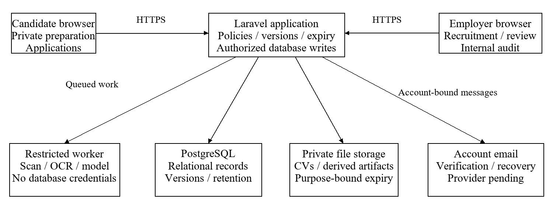
Figure B1. Planned system context. Employers receive only submitted application evidence and authorized reports; candidate-only preparation is not shared.
The model/runner cannot authorize decisions or database writes. Laravel performs action/argument checks. The database, private storage and workers are server-operated components; the email service and external meeting website are distinct integrations. User browsers never need the processing toolchain installed.

B.2 State and evidence models
Record / state | Allowed behavior and invariant
Account: unverified → verified | Only a valid email-bound token verifies ownership. Unverified accounts can use verification/recovery actions, not protected processing/recruitment.
Organization: pending → approved; declined/suspended | Authorized administrator decisions include reasons. Suspended organizations cannot publish/edit or take new applications; separately permitted historical reads still require retention/membership.
Vacancy: draft → open → closed | One effective published criteria version supports intake. A draft revision stays separate; closure stops new applications, not accepted workflows. Publication/edit races require transactional/version control.
Document: queued → scanning → extracting | Only a clean scan enables parsing. Needs-clarification, failed and expired are non-success paths. Ready requires disclosed coverage; model/parser/scanner failure is never fabricated success.
Application: submitted / review / assessment / interview | Stages describe workflow, not competence. Stage entry does not require its own completion. Final selection/Hired checks require completed mandatory stages or approved exceptions; early rejection with a reason and omission of optional tests remain permitted.
Outcome: pending / selected / Hired / rejected | Selected is an employer decision, not verified employment. Hired is separately labelled employer-recorded, counted once within selected totals, and linked to source history. Hired/rejected close ordinary recruitment activity.
Participation: withdrawn / expired / closed | Withdrawal stops new participation. Unresolved applications expire at day 90 with access blocked; expiry is not rejection. Closure/withdrawal ordinarily starts 30-day retention; amendments do not restart it.
Source: declared / confirmed / disputed / unconfirmed | Unknown remains unknown. Confirmation has a recorded actor/basis. A status correction retains the earlier entry and does not change competence coverage.
Attempt: invited → in progress → submitted | Server time and frozen versions govern the attempt. Cancelled, interrupted and timed-out states follow published rules. MCQ marking and manual written grading precede explicit release.
Credit: available → reserved → consumed/released | Consume on usable report delivery. Duplicate logical requests/retries have one effect; failure is recoverable or releases the reservation without an invented report.
Privacy: accessible → expired → purged | Access-time checks enforce expiry before physical purge. Separately retained applications/history/logs have their own disclosed purpose and cannot restore expired personal content.
Application transitions below constrain ordinary actions. Stage, recruitment outcome and candidate participation are recorded separately: a later withdrawal does not erase an earlier employer decision. Selected applications awaiting closure/hiring remain unresolved for the 90-day expiry rule. A retained terminal record may receive an attributable correction, but no correction reopens expired data or restarts retention.
From | Action / actor | To | Guard / invariant
Submitted | Assigned non-applicant reviewer opens review | Under review | Current organization/assignment permission; retained data.
Under review / shortlisted | Authorized non-applicant records a next stage | Shortlisted / assessment / interview | Active, authorized application and valid stage/invitation. Entry does not require that same stage to be complete.
Assessment / interview | Authorized non-applicant resumes review or coordinates another stage | Under review / assessment / interview | Active record and action permission; incomplete required checks remain visible and do not authorize final selection.
Any active stage | Authorized non-applicant records selection | Selected | Submitted mandatory policy satisfied: recorded review completion, submitted/final-marked required assessment and Completed required interview, as applicable, or approved exceptions. Candidate result release is separate.
Selected, still active | Authorized non-applicant records a reported hire | Hired | Selection safeguards remain satisfied; record employer-reported outcome and reason, close ordinary recruitment and start closure retention.
Any active stage, including selected | Authorized non-applicant records early/final rejection | Rejected | Non-empty reason and decision permission. Later tests/interviews need not be completed; their omission for rejection is not a bypass. Close ordinary recruitment.
Any active stage | Candidate withdraws, or unresolved deadline occurs | Withdrawn / expired | Withdrawal is candidate-controlled; at 90 days unresolved data access stops. Neither means automatic rejection.
Retained closed / withdrawn record | Authorized correction of an earlier event | Amended effective record; closure persists | Preserve actor/time/value and recheck decision/selection safeguards where relevant; no new participation or retention restart.
Expired / purged | Ordinary view/edit/download or delayed worker write | Denied | A restored backup, stale link or old job cannot revive access.
Metric definitions: selection rate = distinct current selected-or-Hired applications / all accepted submissions in the filtered cohort. Rejected, pending and withdrawn submissions remain in that denominator. Hired counts are shown separately by recorded source; unknown/unconfirmed sources are not silently treated as non-referrals. Superseded outcomes remain in history but are not counted as extra applications. Stage, participation and outcome counts may overlap and must not be summed as if they were disjoint categories. Assessment completion counts each non-cancelled invitation once after any permitted attempt is finalized submitted; retakes add attempts, not invitations. Show pending/expired/cancelled counts and treat zero denominators as not applicable.

B.3 Requirement traceability and semester gates
Capability / Section 4 | Use cases / requirements | Semester / acceptance evidence
C01 / 4.1 | UC-01 to UC-05; FR-C01-001 to FR-C01-008 | FYP-I; hardening in FYP-II. Register/verify; approve workspace; enforce roles, suspension and last-owner rules.
C02 / 4.2 | UC-06 to UC-07, UC-36; FR-C02-001 to FR-C02-007 | FYP-I. Publish/edit/close criteria; browse effective versions; reject stale/concurrent conflicts.
C03 / 4.3 | UC-08 to UC-09; FR-C03-001 to FR-C03-008 | FYP-I; recovery verification in FYP-II. Upload a fictional PDF/DOCX file; inspect statuses, references, mismatch and scanner/outage limits.
C04 / 4.4 | UC-10 to UC-11; FR-C04-001 to FR-C04-007 | FYP-I. Inspect cited passages, uncertainty and an attributable correction without rewriting earlier review.
C05 / 4.5 | UC-12 to UC-14; FR-C05-001 to FR-C05-007 | Basic report in FYP-I; practice and full guidance in FYP-II. FYP-I: one-off target-role report without vacancy. FYP-II: no-CV private practice and reviewed guidance.
C06 / 4.6 | UC-15 to UC-16; FR-C06-001 to FR-C06-006 | FYP-II. Explicitly save/renew two versions; show compatible comparison and expiry/replacement behavior.
C07 / 4.7 | UC-17 to UC-22; FR-C07-001 to FR-C07-013 | FYP-I; full outcome/report checks in FYP-II. Submit snapshot; record referral and decision reason/history in FYP-I; verify reported-hire linkage in FYP-II.
C08 / 4.8 | UC-23 to UC-26; FR-C08-001 to FR-C08-009 | FYP-II. Author/invite/attempt/mark/release with private keys, frozen versions and outage/retake rules.
C09 / 4.9 | UC-27; FR-C09-001 to FR-C09-005 | FYP-II. Schedule, reschedule, cancel and record interview completion/no-show, using an external meeting link.
C10 / 4.10 | UC-28 to UC-29; FR-C10-001 to FR-C10-005 | FYP-II. Open authorized updates; opt in/out of preference-based alerts with no retained-CV dependency.
C11 / 4.11 | UC-30 to UC-31; FR-C11-001 to FR-C11-007 | FYP-II. Demonstrate 3-report and 1-campaign/seat/25-application limits, last-slot races and no live billing.
C12 / 4.12 | UC-32 to UC-35; FR-C12-001 to FR-C12-013 | Access/audit/expiry in FYP-I; complete reports/recovery in FYP-II. FYP-I: access/audit/expiry. FYP-II: known-answer source/outcome/exception metrics and restoration tests.
FYP-I covers C01 to C04, C07, basic C05 and initial C12 controls. FYP-II completes practice/guidance, C06 and C08 to C11, and extended C12. Basic referrals and decision history remain FYP-I work. The eight work packages per semester are schedule groupings, not eight product capabilities. Interim demonstrations use localhost under the team’s current plan; final online delivery remains required, subject to supervisor review of timing.

B.4 Integrated acceptance scenarios
Scenario | Procedure and required evidence
AT-01: Account / organization boundary | Register, test an expired verification link, verify correctly, create a pending organization, deny publication, approve it and publish. Report the vacancy, verify permitted report status and administrative handling, suspend the organization and deny another edit/publish. Repeat access checks as outsider/reviewer; a report alone must not cause suspension.
AT-02: One-off preparation | Choose a supported role with no vacancy, upload a fictional CV, inspect references/correction, obtain a report and download it. Test scanner-down/corrupt/partial-page cases and verify no fabricated readiness or duplicate debit.
AT-03: Private practice boundary | Use a verified candidate account with no employer membership to take practice without a CV and inspect owned guidance. Then test an employer membership on the same account and another employer account: neither organizational role may fetch private attempts/results or include them in reports.
AT-04: Snapshot / referral / Hired | Apply with version 1, update optional history later, and verify the application still references the original. Declare/confirm/amend a referral; record an authorized Hired outcome and inspect actor/reason/source linkage. Test an unknown source and a disputed referral separately.
AT-05: Optional tests / grading | Review an application with no required test and another with a required versioned MCQ/written assessment. Allow invitation before completion, block premature selection, test early rejection with a reason, refresh/retry at deadline, deny self-grading/key access, finalize grading and release the permitted result. For a required interview, distinguish scheduled/cancelled/no-show from Completed and test the approved-exception path.
AT-06: Allowance concurrency | Race two requests for the last report credit/application slot, retry the accepted logical request, withdraw/reject an application and rename/reopen a campaign. Verify one effect and no allowance reset/refund.
AT-07: Privacy / recovery | Expire one-off/history/application fixtures, request old links, withdraw during work and restore a backup containing expired records. Verify access blocks and late workers do not recreate data; distinguish history deletion from separate application retention.
AT-08: Audit / analytics | Use known counts with selected/Hired/rejected/pending/withdrawn and unknown/unconfirmed sources. Verify distinct totals, zero denominator, cancelled invitations/retakes, approved/pending/declined exceptions and missing-reason warnings. Distinguish pending decisions and redacted reasons from missing reasons; test small groups and another organization’s reports.
AT-09: Hosted handover | From a separate supported browser/device, complete candidate preparation, employer review and internal reporting. Reproduce clean setup/seed/admin provisioning and recovery from the runbook; retain measured limits, failed cases and unresolved acceptance decisions.
These are integrated acceptance scenarios. The team has reported narrower local checks for account verification, upload/scanning, its development environment and CV expiry (Appendix C). Those checks do not establish that every scenario or requirement has passed. Acceptance requires results from the implemented workflows, including failure and permission tests.

Appendix C: To Be Determined List
The decision log covers the complete project. The team reports that local parts of TBD-01, TBD-02, TBD-04 and TBD-06 have been tested. Those local results are recorded separately from the remaining decisions. TBD-03 is deferred to deployment, TBD-05 is planned for weeks 9 to 12, and TBD-07 to TBD-09 belong to later work. An open item does not remove a feature from scope. Before a dependent release, the owner must record the value, reason, review and test evidence; future implementation is not evidence of completion.

TBD-01: Account-security configuration
Status: Local verification accepted by the team; remaining configuration open.
Recorded local result / decision: Local evidence: the team reports successful registration, disposable-address rejection, signed-link verification and dashboard access. Verification links were inspected through development logging; this is not evidence of real email delivery. The team reports a 10-minute idle-session setting. Record expiry, reset, rate-limit and session regression results before broader acceptance.
Remaining decision: Open decisions: live email provider/credentials, token lifetimes, password and resend/authentication/vacancy-report limits not established by those local checks.
Owner: Vishesh with supervisor review
Closure condition: Before protected pilot use; production email delivery must be checked before public registration.

TBD-02: File/worker limits
Status: Local upload, queue and scanning path accepted by the team; extraction and resource limits open.
Recorded local result / decision: Local evidence: the team reports PDF/DOCX intake, a PostgreSQL-backed queued scan, ClamAV returning a clean result and the document moving from quarantine. A clean scan permits processing; it does not prove that a document is safe or that all extraction cases work.
Remaining decision: Open decisions: enforced file/page/archive-expansion limits, OCR mismatch and coverage rules, processing/temp-file deadlines, memory/time/network ceilings and retry limits. These require boundary and failure tests.
Owner: Vishesh and Haji
Closure condition: Intake checks before accepting uploads; extraction/OCR limits during weeks 9 to 12 and before evidence-processing acceptance.

TBD-03: Hosted capacity and performance
Status: Deferred to the deployment phase; not resolved.
Recorded local result / decision: Current decision: localhost is the team’s intended environment for FYP-I demonstrations and initially FYP-II. The final product remains a hosted browser service. Supervisor review of the revised timing is pending.
Remaining decision: Open decisions: provider/funding, total memory, supported workload and heavy-job concurrency, response/completion/queue-wait targets, and operating cost cap.
Owner: Both students and supervisor
Closure condition: Select and benchmark the intended host before final online deployment; no month-one cloud prerequisite is asserted.

TBD-04: Version/browser/model manifest
Status: Local development baseline accepted by the team; complete release manifest open.
Recorded local result / decision: Local evidence: the team reports Windows 11, PHP 8.3, PostgreSQL 16, Node 24 and ClamAV 1.5.4 operating locally. These reported versions are not a guarantee of hosted compatibility. Exact application/package versions must come from the retained lockfiles and runtime checks.
Remaining decision: Open decisions: reproducible full dependency manifest, tested browsers/viewports, processing-library versions, selected model/quantization/runtime/prompt hashes, coordinator limits and content licences. Freeze experimental settings before evaluation.
Owner: Both students
Closure condition: Complete local setup/browser evidence before integrated evaluation; finalize hosting-specific values before deployment.

TBD-05: Evaluation acceptance thresholds
Status: Planned for weeks 9 to 12; acceptance thresholds remain open.
Recorded local result / decision: Current decision: develop extraction and comparison criteria during the parser/evidence work. No accuracy or usability percentage is claimed achieved.
Remaining decision: Open decisions: extraction/reference coverage, allowed false alarms/attack success, guidance rubric and task/usability acceptance bounds. Choose thresholds using development cases, then freeze them before examining held-out results.
Owner: Both students with supervisor
Closure condition: Before held-out evaluation cases are opened; retain failed, unreadable and uncertain cases in the results.

TBD-06: Supporting-record retention/recovery
Status: Local CV expiry/deletion checks accepted by the team; supporting-record and recovery policies open.
Recorded local result / decision: Local evidence: Vishesh reports that the local CV expiry/deletion behavior was tested. The earlier shared note also records an expiry label; a displayed timestamp alone would not demonstrate deletion. The agreed final one-off policy remains 24 hours after completion or failure, not a universal 24-hour deadline after upload.
Remaining decision: Open decisions: security/trial-log and vacancy-report retention, backup expiry, cleanup interval, inactive-account notice period and recovery point/time objectives. Local CV deletion does not close these distinct policies.
Owner: Vishesh with supervisor
Closure condition: Before non-fixture personal data is stored and before backup/recovery acceptance. Verify access denial, delayed jobs and restored expired data.

TBD-07: Reporting disclosure and event definitions
Status: Planned for later analytics work; not resolved.
Recorded local result / decision: Current decision: reports must retain explicit cohort/denominator definitions and unknown/unconfirmed counts. No numeric suppression threshold has been approved.
Remaining decision: Open decisions: small-cohort threshold, referrer-field permissions, stage-duration start/end events, missing-event exclusions and retained aggregate re-identification checks.
Owner: Both students with supervisor
Closure condition: Before the analytics pilot or release; verify known-answer fixtures, organization boundaries and disclosure behavior.

TBD-08: Assessment and accommodation defaults
Status: Planned for recruitment-assessment work; not resolved.
Recorded local result / decision: Current decision: publish the rules for each assessment before issuing invitations. No universal 45-minute duration, single attempt or 30-second autosave interval is imposed.
Remaining decision: Open decisions: default duration, attempts, autosave/recovery, timeout, release visibility, retakes and accommodations. Written answers require authorized human grading. This also includes the maximum in-progress lifetime and recovery rules for standalone private practice before that feature is released.
Owner: Haji with supervisor
Closure condition: Before invitations are issued; test interrupted, resumed, timed-out, accommodated and duplicate attempts and grade release. Finalize private-practice lifetime/recovery rules before releasing private practice.

TBD-09: Demonstration entitlements and time boundaries
Status: Planned for allowance demonstrations; not resolved.
Recorded local result / decision: Current decision: retain the agreed three-report monthly candidate allowance and the one-campaign/one-reviewer/25-application/30-day employer trial. No live payment or fixed price is included.
Remaining decision: Open decisions: calendar-month time zone, month-crossing reservations, additional-credit/history entitlement catalogue and demonstration capacity values. Define which owner, recruiter, assigned-reviewer and internal-review roles consume a reviewer seat, how combined roles count, and whether the owner is included.
Owner: Both students with supervisor
Closure condition: Before the allowance demonstration; test last-credit/slot/seat races and month-end completion without a double debit.

Appendix D: Current prototype user interfaces
The following screens were supplied by the team from its local prototype on 26 October 2026. They show visible interface states, not complete acceptance-test evidence. Overlapping screenshots are omitted. Later features remain specified in Section 4 even when no current screen is available.
The current upload screen says that role analysis is a later release. Its “24 hours after upload” wording differs from the intended one-off retention rule in BR-13 and FR-C12-002, which starts after completion or failure. That UI wording must be reconciled before acceptance. The displayed 5 MB setting does not close the remaining file/worker limits in TBD-02.
Private practice remains inaccessible to employers, including when a candidate separately submits an application. Only the chosen application snapshot belongs in the employer workflow. Optional starter-kit controls in a screenshot do not make additional authentication methods mandatory.

D.1 Public access and account screens
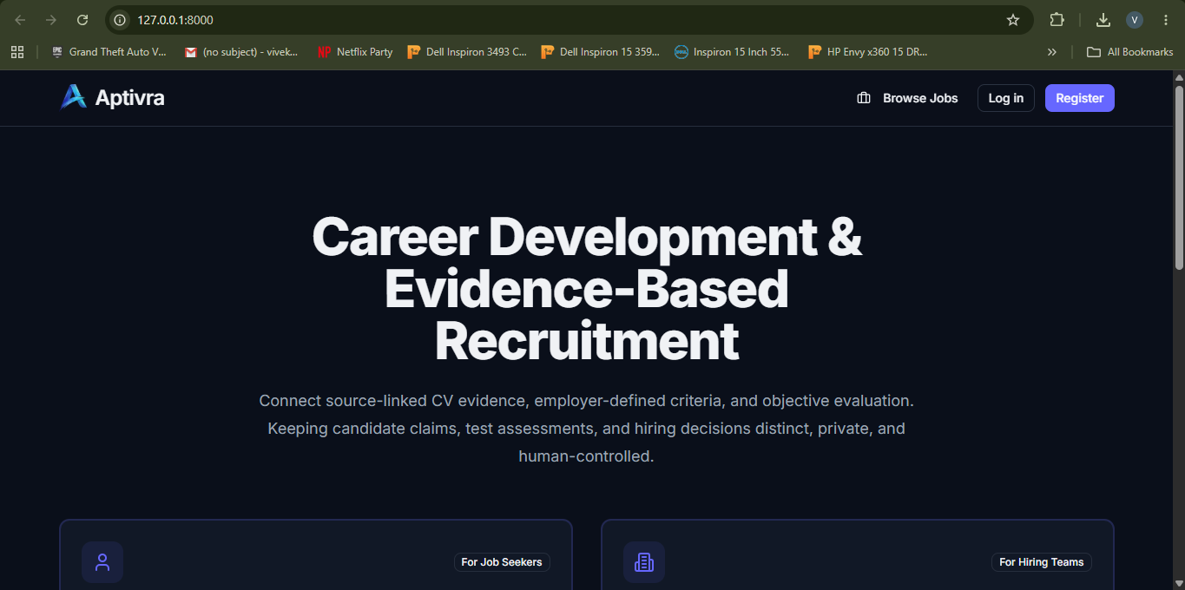
Figure D1. Public landing page. Public entry points for vacancy browsing, sign-in and registration.

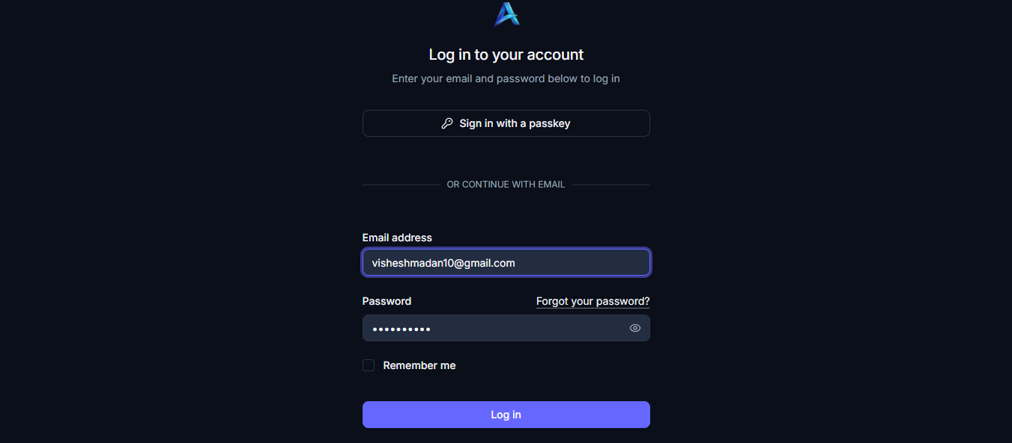
Figure D2. Login form. Email/password login with the password masked; optional starter-kit controls are visible.

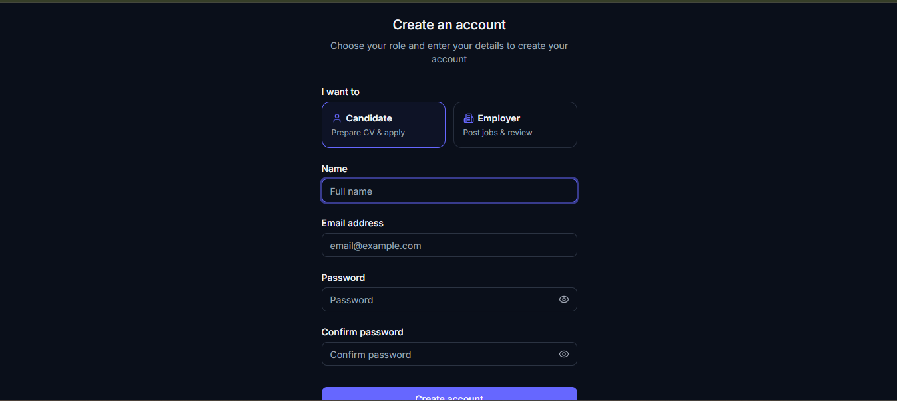
Figure D3. Registration form, upper view. Candidate/employer selection and account-detail fields. The lower controls continue in Figure D4.

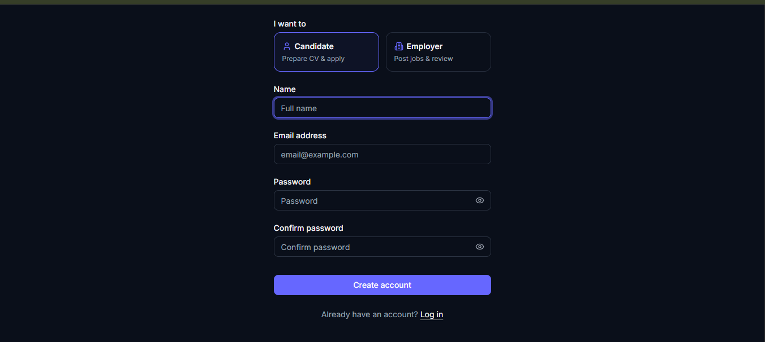
Figure D4. Registration form, lower view. Password confirmation, account creation and the link back to login.


Figure D5. Email-verification notice. The current prototype requests verification through an emailed link and offers resend/logout actions.

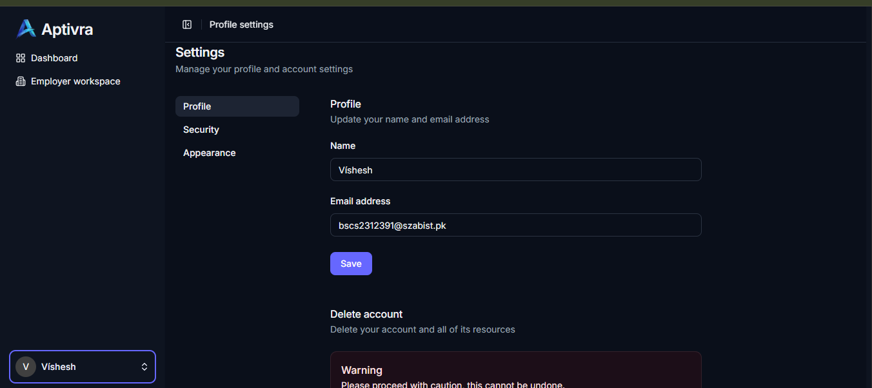
Figure D6. Profile settings. Name/email editing and the account-deletion warning in the current settings screen.

D.2 Employer workspaces and vacancies
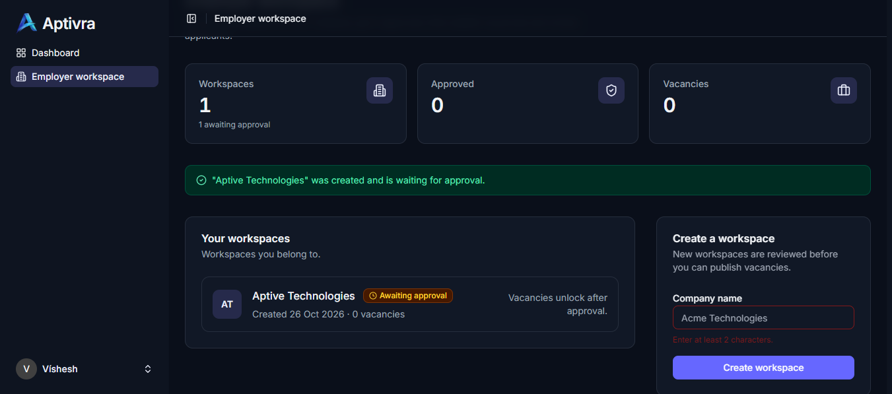
Figure D7. Employer workspace awaiting approval. A newly created workspace is shown pending approval, with vacancy access restricted in the interface.

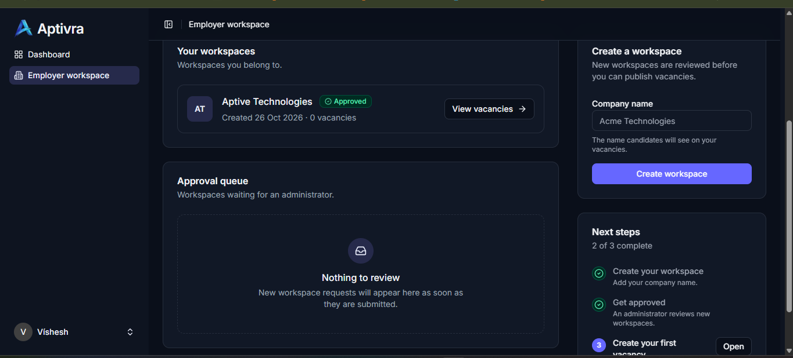
Figure D8. Approved employer workspace. The example workspace shows an approved state and access to its vacancy list.

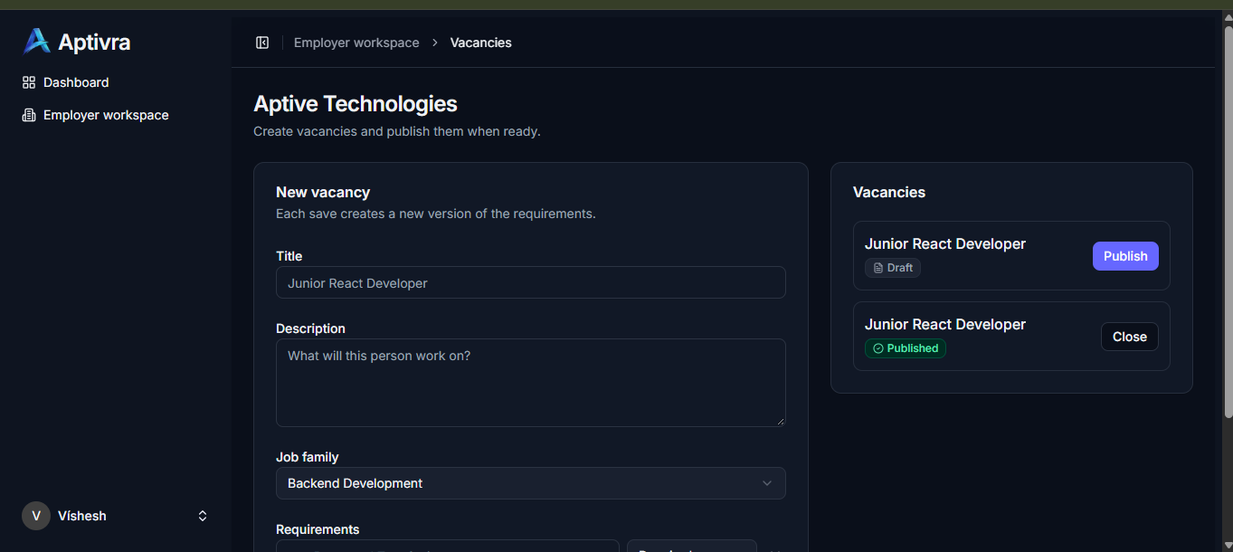
Figure D9. Vacancy management. The current form and example draft/published vacancy states; sample entries are demonstration data.

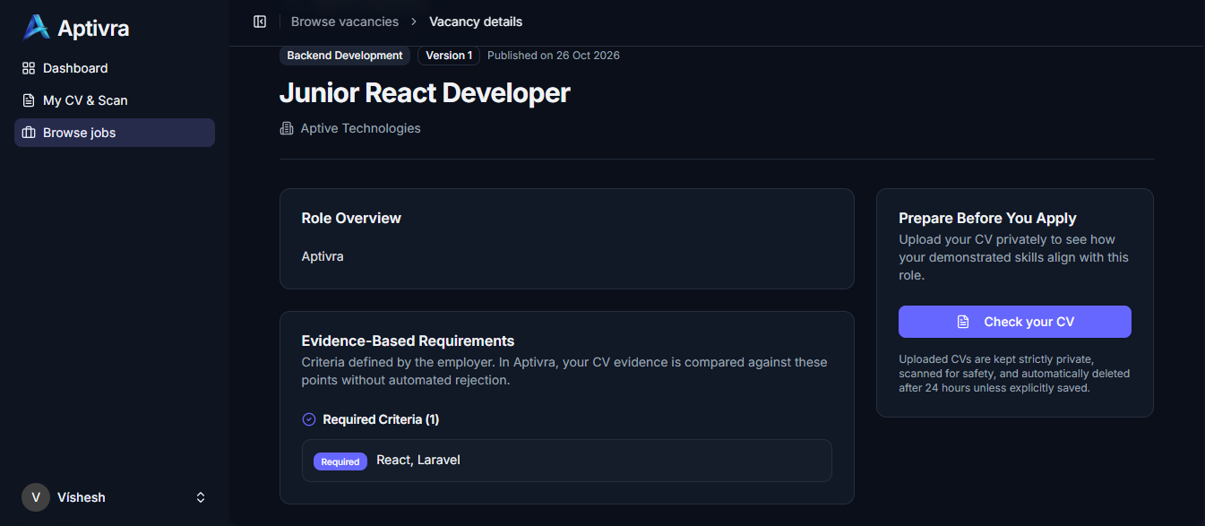
Figure D10. Candidate vacancy view. A published sample vacancy, criteria and the CV-check entry point; this is not evidence that role analysis is complete.

D.3 Candidate preparation and document intake
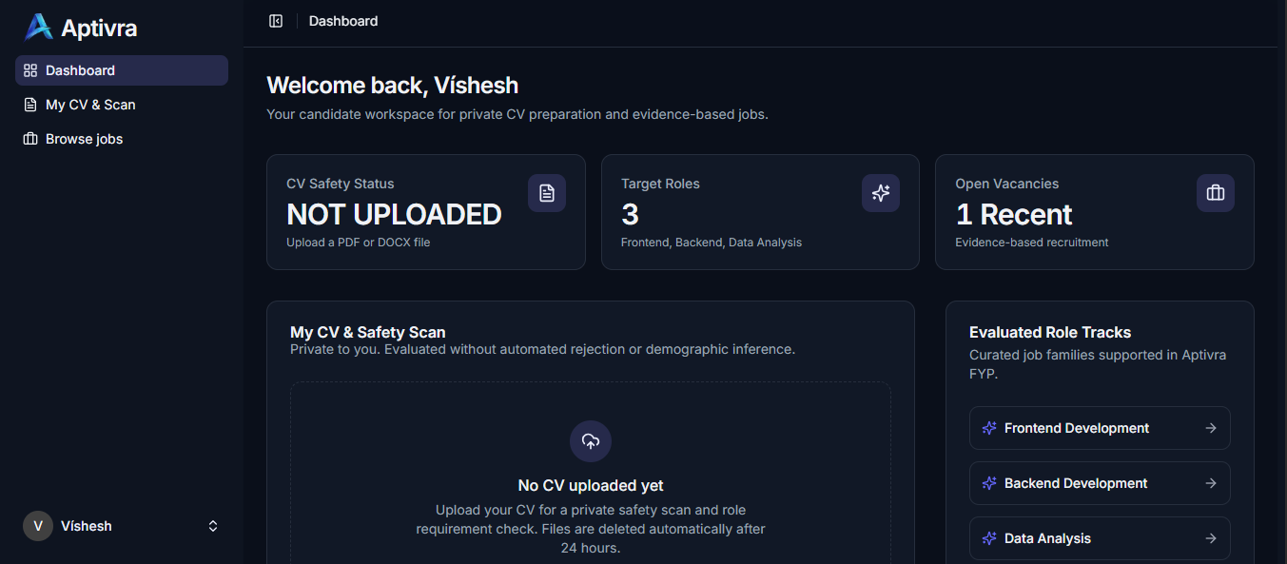
Figure D11. Candidate dashboard. The empty-CV state, three target families and vacancy navigation.

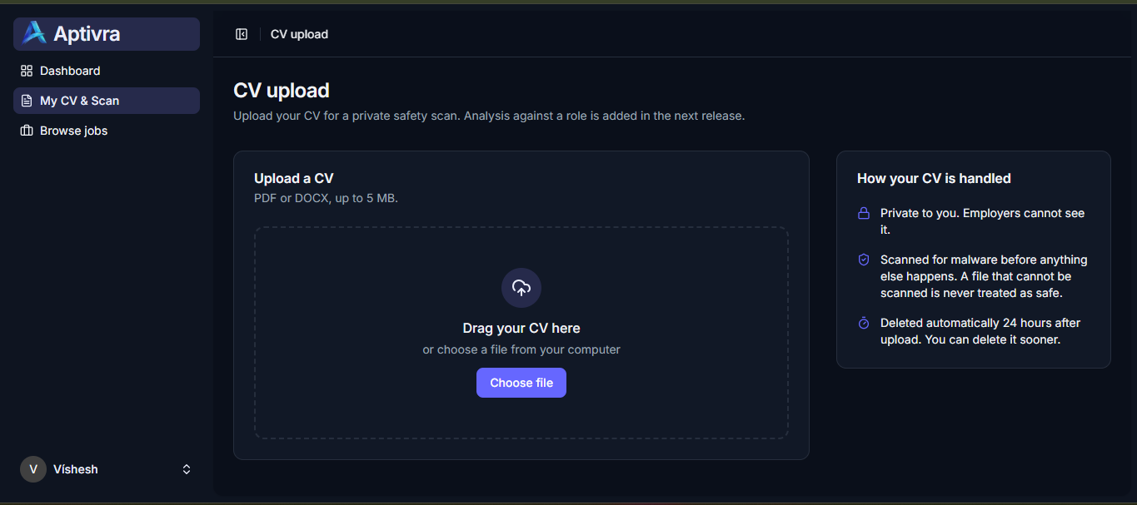
Figure D12. Private CV upload. PDF/DOCX selection and a displayed 5 MB limit. The screen explicitly defers role analysis to a later release.

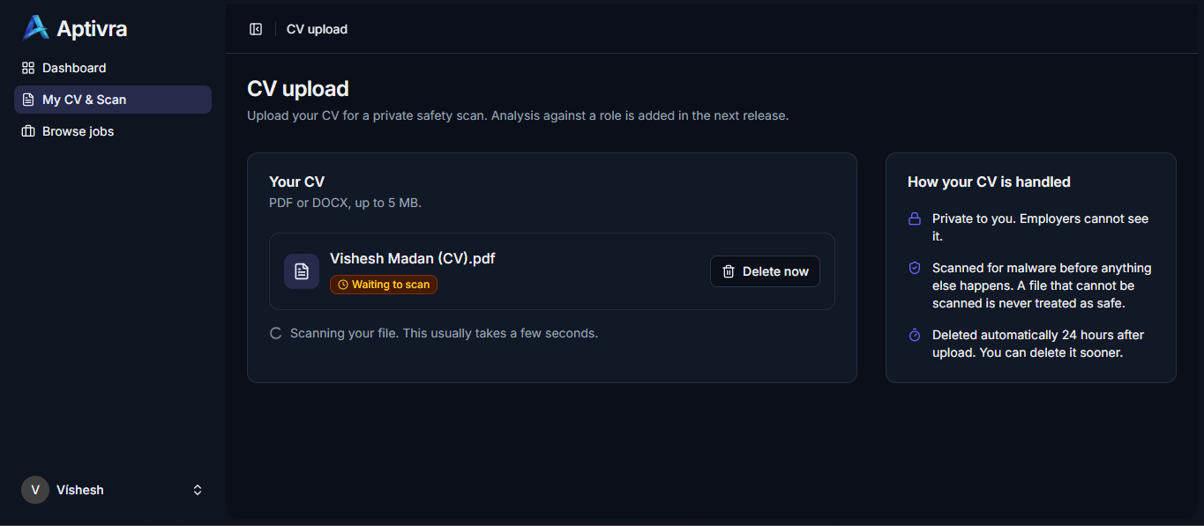
Figure D13. CV waiting for a safety scan. The uploaded file is shown waiting to scan, with a deletion action and processing status.

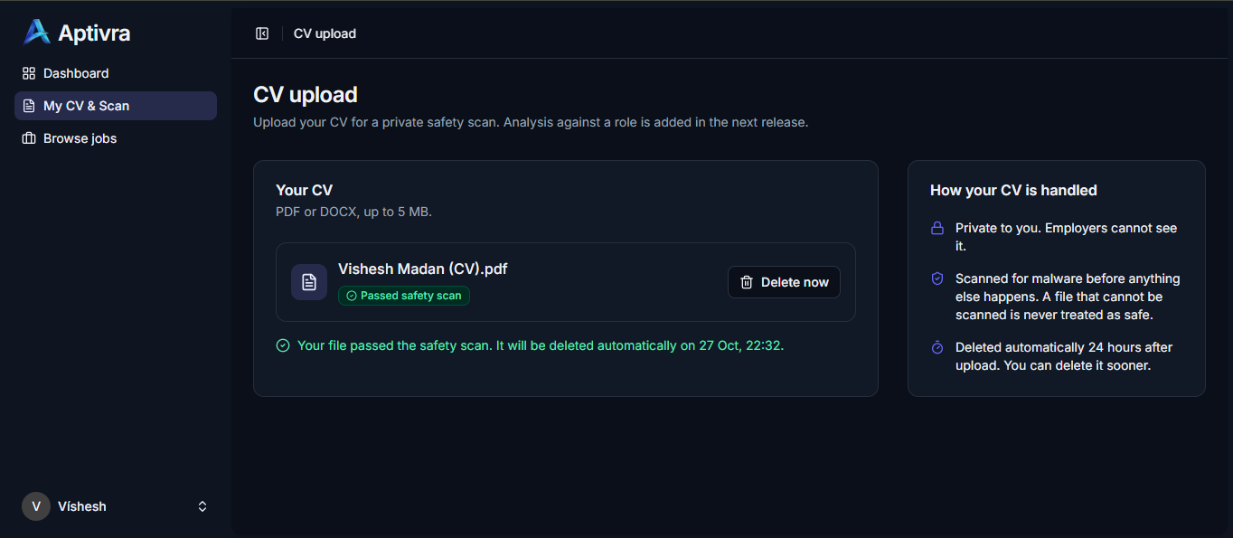
Figure D14. CV safety-scan result. The interface reports a passed scan and a scheduled deletion time; it does not demonstrate a completed purge.

