**FRONT PAGE**

**TABLE OF CONTENTS**

**1.SOFTWARE**

|  |  |  |
| --- | --- | --- |
| **S.NO** | **NAME** | **PAGE NO** |
| **1** | **Main Screen** |  |
| **2** | **Vehicle Entry Screen** |  |
| **3** | **Vehicle Reentry Screen** |  |
| **4** | **Parameter Settings**  4.1 Parameter Settings Main Screen  4.2 Code Settings Screen  4.3 Header Settings Screen  4.4 Other Settings Screen |  |
| **5** | **Settings**  5.1 Settings Main Screen  5.2 Comm Port Settings Screen  5.3 User Settings Screen |  |
| **6** | **Report Screen** |  |

**Main Screen**

In the main screen there is a weight display, a table which shows the recent 10 data and a Virtual Keyboard enable/disable option. It also has a series of buttons which is used to navigate throughout the application.

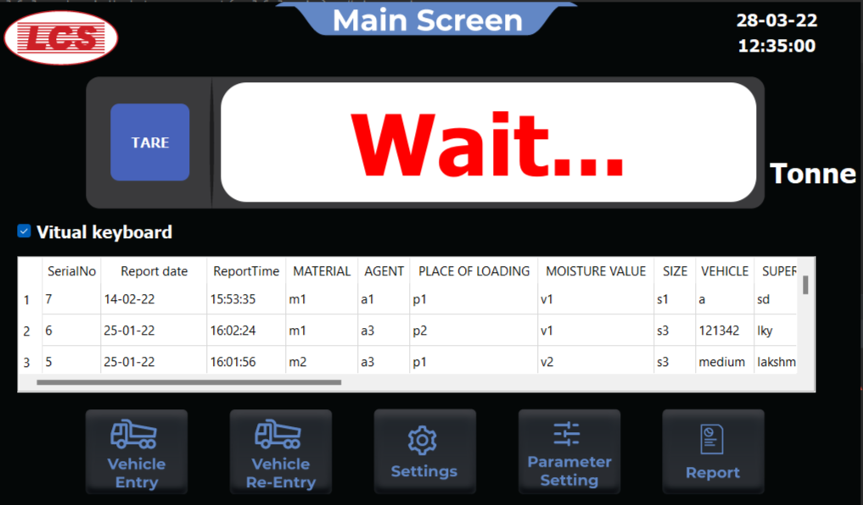

**Vehicle Entry**

In this page the details regarding the vehicles will be entered and it will be stored in a data base. Also the parameters in this page is customizable which will be explained briefly in page no:<page number> . And if you need a receipt printout you just have to tick the checkbox.

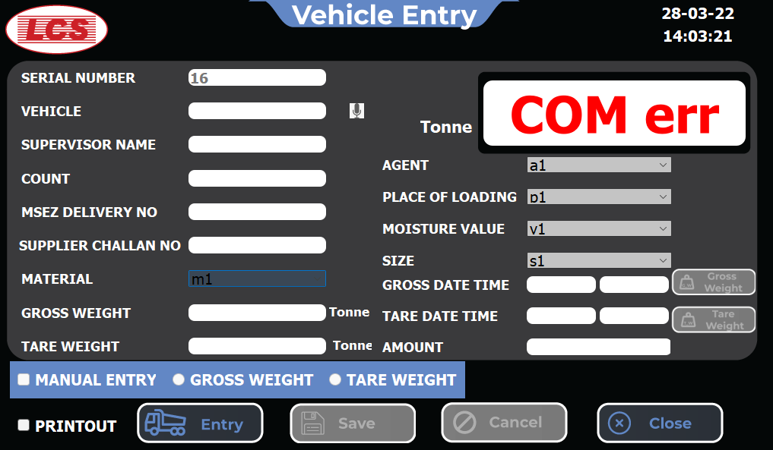

**Vehicle Reentry**

This page is used when vehicle returns with materials after loading. Using Serial number or Vehicle number the details of the vehicle at the entry will be retrieved and it will be used for the Net weight and amount calculation and if you need a receipt printout you just have to tick the checkbox.

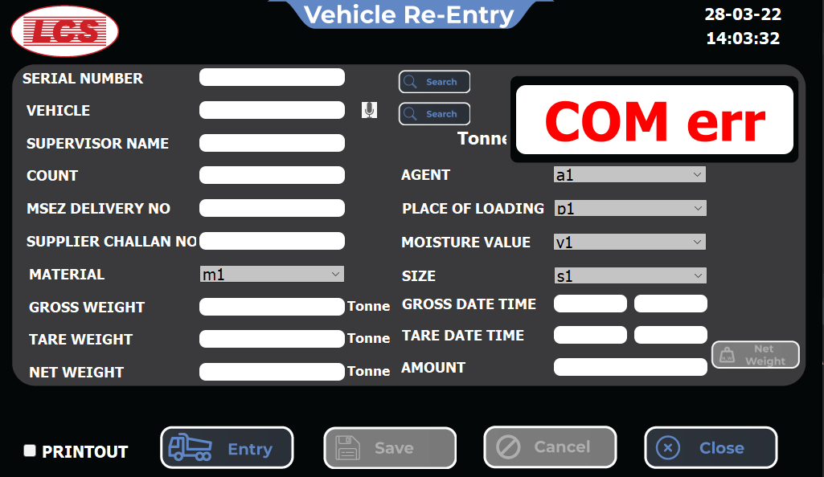

**Parameter Settings**

Parameter Settings is used to customize various parameters accordingly. It has 3 sub pages which has different set of parameters.

**Parameter Settings Main Page**

This is the main page of the parameters settings which has a series of button to navigate to its subpages.

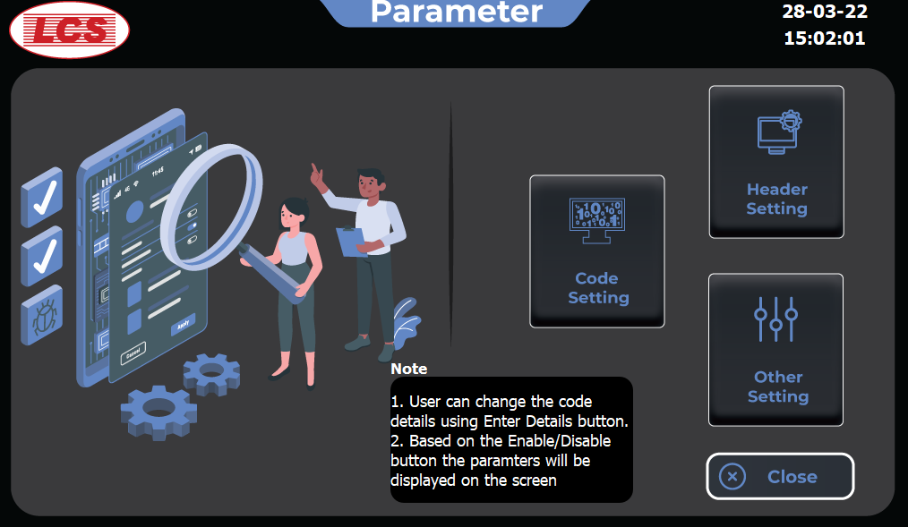

**Code Settings Page**

In this page code parameters can be customized. You can change the name, enable or disable the code parameters. Using the **Enter Details** button you can set the options to be available at the drop-down during entry/reentry page.

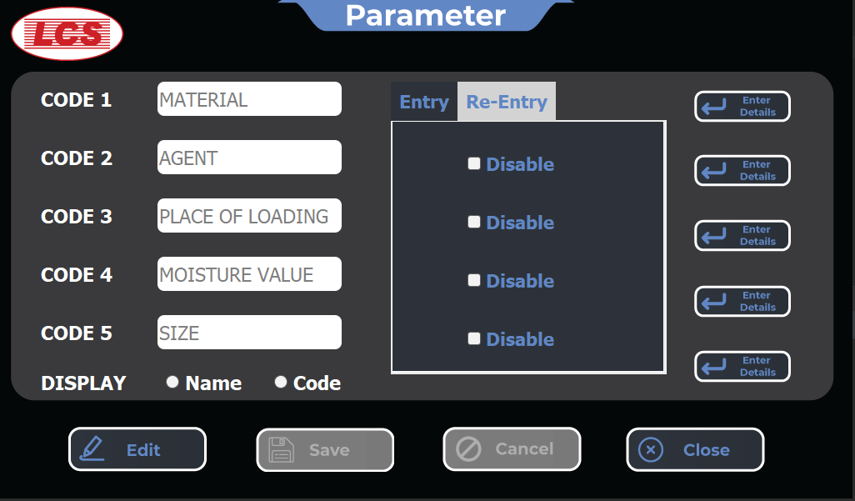

**Enter Details Page**

Using this page, you can either edit the code and name of the items or you can create a new item using **Create button** after giving code and name click **Add button** the new item will be added to the dropdown as well as it will shown in the table.

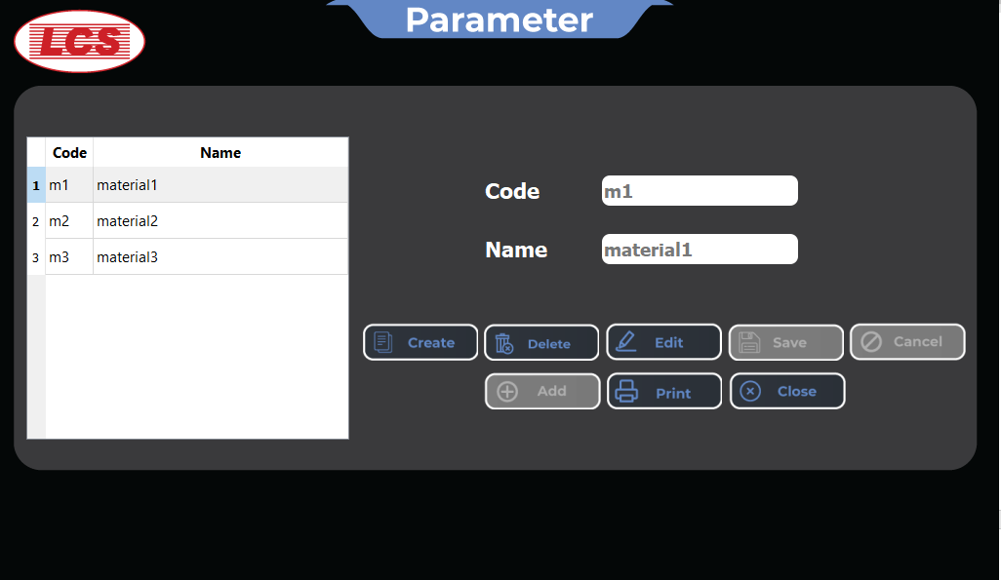

**Header Settings Page**

In this page Header parameters can be customized. You can change the name, enable or disable the Header parameters.

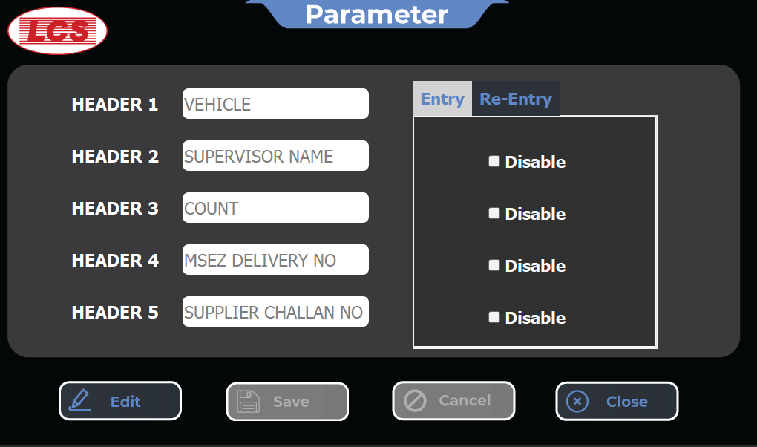

**Other Settings Page**

In this page, for the set of parameters you can use enable or disable options and also you can change the unit of the weight

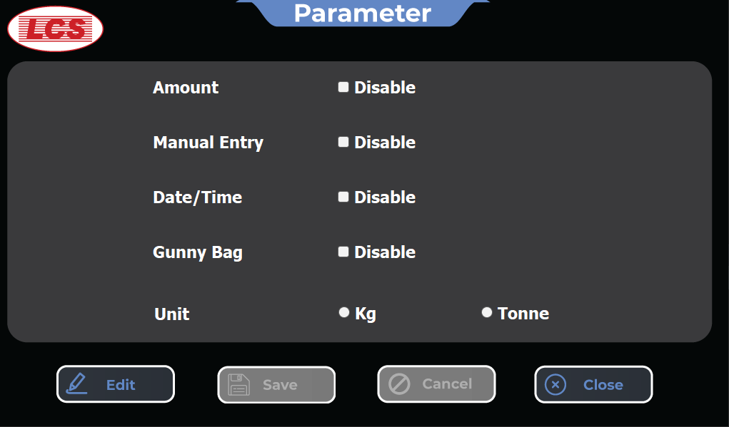

**Settings Page**

Settings page is used for setting comm port as well as changing user account details. It has two subpages.

**Settings Main Page**

This is the main page of the settings menu and it has buttons which is used to navigate to its subpages.

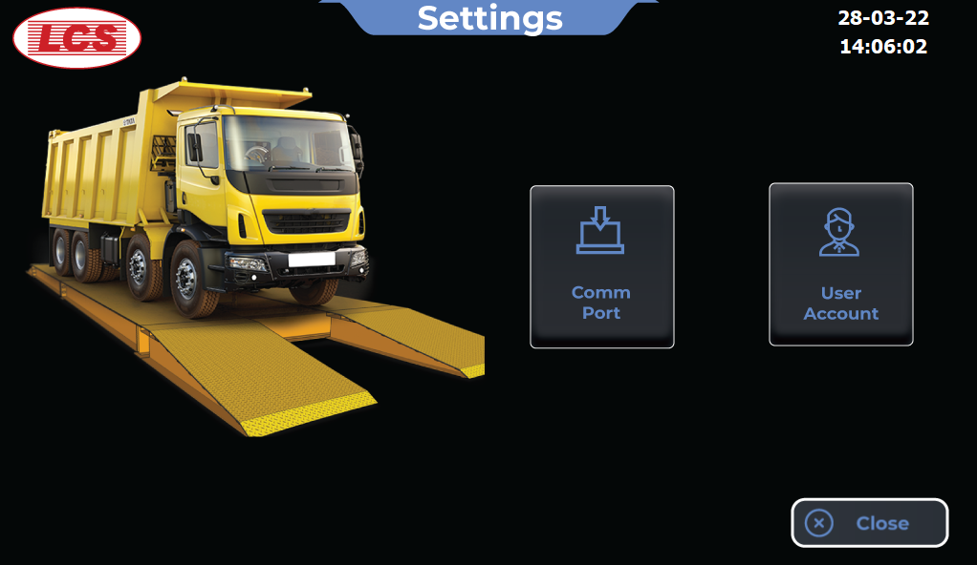

**Communication Port Settings Page**

This page allows user to select the comport at which weight transmitter or Printer is connected and set the baud rate accordingly.

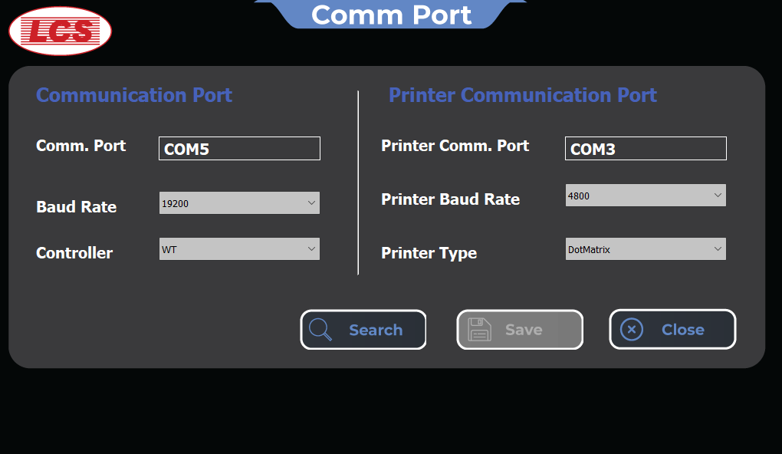

**User Account Settings Page**

Using this page you can change admin credentials for login.

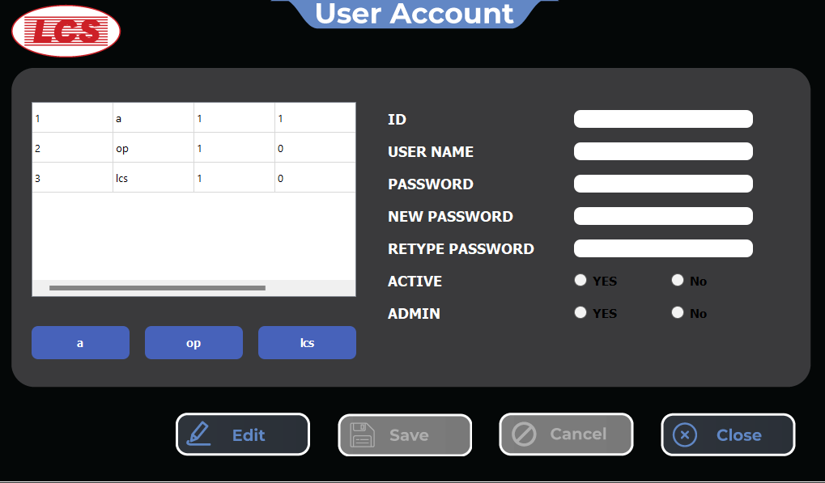

**Report Page**

This page allows users to generate daily and monthly reports with a variety of customization options such as sorting by code parameters and header parameters.

They can save the information as a pdf or excel file and print it as needed directly from the application.

