1.

public class EX01 {  
 public static void main(String args[] ) {  
 String str = new String("Welcome to Java Programming.");  
 System.*out*.println("length of String: " + str.length());  
 }  
}

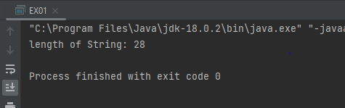

2.

public class Ex02 {  
 public static void main(String args[]) {  
// String str1 = new String("Welcome to Java Programming.");  
// String str2 = new String("");  
 String hi = "Hi, ";  
 String mom = "mom.";  
  
 System.*out*.println(hi.concat(mom));  
 }  
}

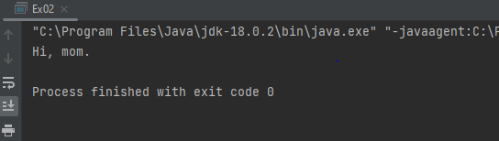

3.

public class EX03 {  
 public static void main(String args[]) {  
 String fullName = "Banneheka Mudiyanselage Lakindu Banula Sirimewan Banneheka";  
 String[] myName = fullName.split(" ");  
 for (int i = 0; i < myName.length; i++) {  
 String s = myName[i];  
 System.*out*.print(s.charAt(0)+ " ");  
 }  
 }  
}

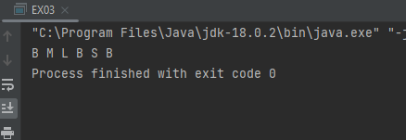

4.

public class Ex04 {  
 public static void main(String args[]) {  
 String str = "Sample Text";  
 for (int i = str.length(); i > 0; i--) {  
 System.*out*.print(str.charAt(i-1));  
 }  
 }  
}

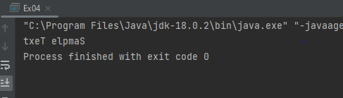

5.

public class Ex05 {  
 public static void main(String args[]) {  
 String str1 = "Banana";  
 String str2 = "Apple";  
 System.*out*.println(str1.compareTo(str2) < 0? str1 + ", " + str2 : str2 + ", " + str1);  
  
 }  
}

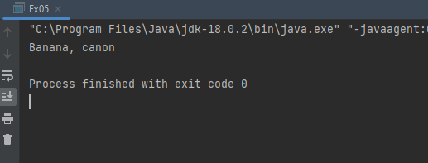

6.

public class Ex06 {  
 public static void main(String args[]) {  
 String original ="software";  
 StringBuilder result = new StringBuilder("hi");  
 int index =original.indexOf('a');// index = 5  
 result.setCharAt(0, original.charAt(0)); // result = si  
 result.insert(1, original.charAt(4));// result = swi  
 result.append(original.substring(1, 4)); // result = swioft  
 result.insert(3, (original.substring(index, index+2) + "")); // result = swiaroft  
 System.*out*.println(result);  
 }  
}

result = swiaroft

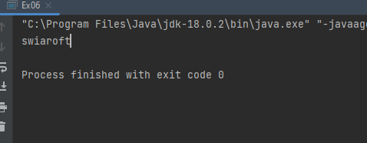

7.

public class Ex07 {  
 public static void main(String args[]) {  
 String firstName = "Kamala";  
 String middleName = "Sugarcane";  
 String lastName = "Perera";  
 int age = 20;  
  
 StringBuilder password = new StringBuilder(" ");  
 password.setCharAt(0, firstName.toLowerCase().charAt(0));  
 password.append(middleName.toLowerCase().substring(0, 2));  
 password.append(lastName.toLowerCase().substring(lastName.length()-3,lastName.length()-1));  
 password.append(age * 100);  
  
 System.*out*.println("Password: " + password);  
  
 }  
}

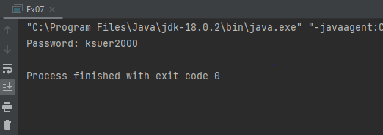

8.1.

public class Ex08 {  
 public static void main(String[] args) {  
 String str = "I'm a JaVa PrOgRaMmEr";  
 int mCount = 0;  
  
 for(int i = 0; i < str.length(); i++){  
 if(str.charAt(i) == 'm' || str.charAt(i) == 'M') {  
 if (mCount >= 3) {  
 System.*out*.print(str.charAt(i));  
 }  
 mCount++;  
  
 } else {  
 System.*out*.print(str.charAt(i));  
 }  
 }  
 }  
}

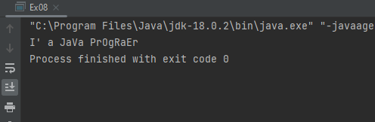

8.2.

public class EX08_02 {  
 public static void main(String[] args) {  
 String str = "ICS 102: Introduction to Computing I";  
 String courseName = str.substring(0,3);  
 String courseNumber = str.substring(4,7);  
 String courseDescription = str.split(":")[1];  
  
 System.*out*.println("Course Name: " + courseName);  
 System.*out*.println("Course Number: " + courseNumber);  
 System.*out*.println("Course Description: " + courseDescription);  
 }  
}

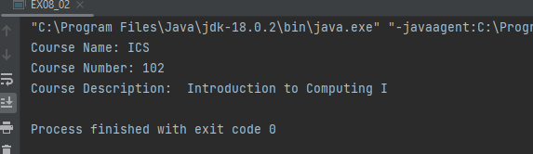

8.3.

public class Ex08_03 {  
 public static void main(String[] args){  
 String stu1 = "Niroshan Perera";  
 String stu2 = "Kamal Alwi";  
  
 System.*out*.println("First Student: " + stu1.split(" ")[0] + " " + stu2.split(" ")[1]);  
 System.*out*.println("Second Student: " + stu2.split(" ")[0] + " " + stu1.split(" ")[1]);  
  
 }  
}

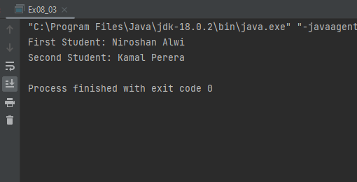

9.

public class Ex09 {  
 public static void main(String[] args) {  
 int[] Num = {40,28,10,81,23,45,47,18,76,64};  
 int sum = 0;  
  
 for(int i = 0; i < Num.length; i++){  
 System.*out*.print(Num[i] + ", ");  
 sum += Num[i];  
 }  
  
 System.*out*.println("Using For each: ");  
 for (int number: Num) {  
 System.*out*.print(number + ", ");  
 }  
 System.*out*.println("\nSum: " + sum);  
  
 }  
}

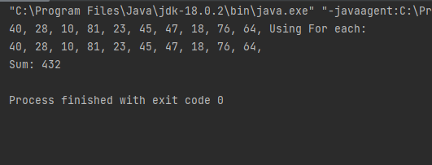

10.

public class Ex10 {  
 public static void main(String[] args) {  
 double [] [] weights = {{54.5, 50, 48}, {43, 56.5, 67, 65.5,59}, {45, 55, 63, 45.5, 54.5}, {66, 49.5,  
 56}};  
 double sum = 0;  
  
 for(int i = 0; i < 4; i++){  
 for(int j = 0; j < weights[i].length; j++) {  
 sum += weights[i][j];  
 }  
 System.*out*.println("avg "+ i + " : " + sum/weights[i].length);  
 sum =0;  
  
 }  
  
 }  
}

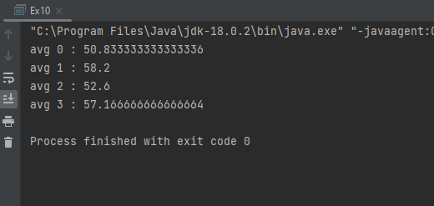

11.

public class Ex11 {  
 public static void main(String[] args) {  
 String[][] names = {{"Amali","Thilina","Vihara"},{"Kamal"},{}};  
 System.*out*.println("Seat No | Student");  
 for(int i = 0; i < names.length; i++){  
 for(int j =0; j < names[i].length; j++) {  
 System.*out*.println((i+1)+""+(j+1)+" | "+ names[i][j]);  
 }  
 }  
  
 }  
}

