Power Before Hours: Facility Limits, Embodied Carbon, and the Redundancy Dividend in Carbon-Aware Workload Shifting
Naveen Kumar Lakkaram
Independent researcher
Preprint, November 2026

Abstract
Carbon-aware schedulers cut cloud emissions by moving flexible work to hours and places with cleaner electricity. Upper-bound studies of this idea evaluate each job in isolation, which implicitly lets all shifted work pile into the same low-carbon hours. A data centre cannot do that: its grid draw is bounded by the electrical plant (utility service, transformers, switchgear, UPS and generators). We first reproduce the trace-driven analysis of Sukprasert et al. (EuroSys 2024) from its released data for 123 grid zones, matching 27 of 30 numeric claims, and report three discrepancies. We then show that reaching the published temporal upper bound requires the median facility to draw 13x its mean power in a single hour; with a realistic 20% power headroom only 36% of the ideal saving survives. Using the dual variables of a compact linear program we compute, to our knowledge for the first time across many grids, the shadow carbon price of facility capacity: one extra kW of headroom saves 228 kg CO2/yr in the median zone. Comparing this against embodied-carbon factors we derive from manufacturer Environmental Product Declarations shows that electrical headroom repays its embodied carbon in under a year in almost every zone, whereas CPU servers bought to absorb shifted work pay back within their lifetime in only 23% of zones. Tier redundancy (N+1, 2N) offers this headroom for free: using the spare path for sheddable work closes 36-73% of the gap to the ideal, and maintenance and failures erode almost none of it. Finally, measurements of LLM inference on an Apple M4 Pro GPU show that batching cuts energy per token by 4.4x for 1.5x more power, a larger lever than temporal shifting. All code, data and a secure interactive explorer are released.
Keywords: carbon-aware computing, data-centre power provisioning, workload shifting, embodied carbon, redundancy, LLM inference energy.

1 Introduction
Data-centre electricity demand is growing quickly, driven in large part by AI, and operators have committed to aggressive emission targets. One prominent response is carbon-aware workload shifting: delaying flexible batch work to hours when grid electricity is cleaner, or moving it to cleaner regions [1, 2, 5, 8]. Sukprasert et al. [1] recently bounded the benefits of this idea across 123 grid zones and found them far smaller than commonly assumed. Their temporal analysis, however, optimises every job independently: each job is free to run in the cleanest hours of its window regardless of how many other jobs choose the same hours. The authors note that resource limits would reduce the savings further, but do not quantify that effect.
Gap. A data centre is an electrical facility before it is a computer. Its grid draw is capped by the rating of its utility service, substation transformers, switchgear and UPS, and, for tier-rated sites, by the generator plant that must back the critical load. Google's carbon-intelligent compute system already enforces hourly capacity caps on flexible work in production [2, 15], and CarbonFlex [4] studies contention among jobs in a cluster. What is missing is a cross-grid answer to three facility-level questions: how much of the ideal carbon saving survives a realistic power cap; what one additional kilowatt of capacity is worth in carbon; and whether that kilowatt is worth building once its embodied carbon is counted.
Insight. The capped scheduling problem has a structure that makes these questions cheap to answer exactly. When all flexible work has the same slack, earliest-deadline-first coincides with FIFO, so feasibility reduces to bounds on cumulative work served. The optimisation becomes a linear program with one variable per hour, and its dual variables price facility capacity in grams of CO2. Combined with embodied-carbon factors from equipment declarations, these shadow prices turn an operations question into a design question.
This paper makes the following contributions:
- A clean-room reproduction of the EuroSys'24 analysis [1] that matches 27 of 30 checked claims, with three documented discrepancies, including a spatial metric that treats departed work as zero-carbon (Sec. 3).
- A power-capped formulation of temporal shifting, an exact cumulative-flow LP that is 25-170x smaller than the per-arrival transportation LP and provably equivalent to it, and a 123-zone map of how much of the ideal saving survives each level of headroom (Sec. 4).
- The shadow carbon price of capacity and the first embodied-carbon payback analysis of headroom built for carbon shifting, using factors derived from transformer, UPS, generator and server declarations (Sec. 5).
- The redundancy dividend: using N+1 and 2N spare capacity as zero-embodied-carbon headroom for sheddable work, evaluated with maintenance and random failures, plus a negative result for carbon-aware maintenance scheduling (Sec. 6).
- Measurements of GPU power, throughput and energy per token versus LLM batch size, and of UPS-battery carbon arbitrage (Secs. 7-8), plus robustness to three years of traces and to forecast error (Secs. 4.3, 5.3).
- An open artifact: tested code (44 tests), all data, and a hardened interactive web explorer (Sec. 11).

2 Background

2.1 Grid carbon intensity and workload flexibility
The average carbon intensity of grid electricity (g CO2eq/kWh) varies by hour with the mix of generators serving demand and differs by an order of magnitude between regions [1, 19]. Batch work such as ML training, analytics and simulation tolerates delay (deferrability) and pausing (interruptibility); interactive work does not [1]. We follow [1] in using average rather than marginal intensity, as required by the GHG Protocol for Scope 2 reporting.

2.2 The electrical plant of a data centre
Power enters through a utility service and medium-voltage switchgear, is stepped down by transformers, conditioned by UPS systems with batteries for ride-through, and backed by diesel generators. Facilities are provisioned for peak demand plus redundancy; average draw is well below the provisioned rating [10], and operators increasingly oversubscribe power to recover the difference [3, 11]. Redundancy is described by topology: N+1 adds one spare module to the N needed for the critical load; 2N duplicates the entire power path. The spare capacity is idle except during maintenance or a failure.

3 Reproduction of Sukprasert et al.
We re-implemented the analysis without executing the original code: the artifact [19] was read for reference only. The released hourly traces for 2022 were preprocessed identically (back-fill then forward-fill over 2020-2022). For temporal shifting, a job of length J arrives at every hour and may start anywhere within its slack S (deferral, a minimum-sum contiguous window) or run in its J cheapest hours (interruption). Our vectorised implementation (sliding windows, partial sorts, and a heap for the one-year case) replaces a 50-process loop. A unit test checks it against a line-by-line port of the original loop, including its end-of-year clipping and its definition of one-year slack as 'until the end of the year'. The full reproduction runs in about 20 s on a laptop.
Table 1. All numeric claims checked (30). g = g CO2eq per job-hour or per kWh as in [1].
Source | Claim | Paper | Ours | Unit
§3.1.3 | Global average carbon intensity | 368.39 | 368.38 | g/kWh
§4.1 | Share of zones with mean CI > 400 | 46 | 45.53 | %
§4.1 | Max/min ratio of zone mean CI | 40 | 59.73 | x
§1 | Share of zones with daily CV < 0.1 ('>70%') | 70 | 49.59 | %
§5.1.1 | Greenest zone mean CI (Sweden) | 16 | 15.9 | g/kWh
Fig 7a | Deferral saving, 1 h job, 1-year slack | 154 | 153.94 | g
Fig 7a | Deferral saving, 168 h job, 1-year slack | 70 | 69.89 | g
Fig 7b | Deferral saving, 1 h job, 24 h slack | 57 | 57.38 | g
Fig 7b | Deferral saving, 168 h job, 24 h slack | 3 | 2.89 | g
Fig 8a | Extra saving from interruption, 168 h job, 1-year slack | 43 | 42.47 | g
Fig 8b | Extra saving from interruption, 24 h job, 24 h slack (peak) | 18.4 | 18.36 | g
Fig 9a | Deferral, 168 h job, 1-year slack (% of baseline) | 19 | 18.94 | %
Fig 9a | Interruption adds, 168 h job, 1-year slack | 11 | 11.56 | %
Fig 9b | Defer+interrupt, 168 h job, 24 h slack | 3 | 2.71 | %
Fig 10a | Equal job mix, 1-year slack, global | 135 | 134.87 | g
Fig 10b | Azure job mix, 1-year slack | 100 | 100.61 | g
Fig 10c | Google job mix, 1-year slack | 112 | 111.91 | g
Fig 10d | Equal mix, 24 h slack | 31 | 32.32 | g
Fig 10d | Equal mix, 1-year slack | 127 | 134.87 | g
Fig 5a | Global, infinite capacity | 352 | 352.48 | g
Fig 5a | Europe, infinite capacity | 281 | 281.24 | g
Fig 5a | Asia, infinite capacity | 556 | 555.84 | g
Fig 5b | Global, 50% idle capacity | 190 | 189.72 | g
Fig 5b | Asia, 50% idle capacity (artifact metric) | 556 | 555.84 | g
Fig 6b | Max extra from inf-migration over 1-migration (<10) | 10 | 7.88 | g
Fig 5c | Global reduction at 50% idle | 51.5 | 51.5 | %
Fig 5c | Global reduction at 99% idle | 95.68 | 95.68 | %
Fig 6a | 250 ms SLO, infinite capacity | 92.5 | 92.5 | %
Fig 6a | 250 ms SLO, 50% utilisation | 45.7 | 45.5 | %
Fig 6a | 50 ms SLO, 50% utilisation | 31 | 31.11 | %

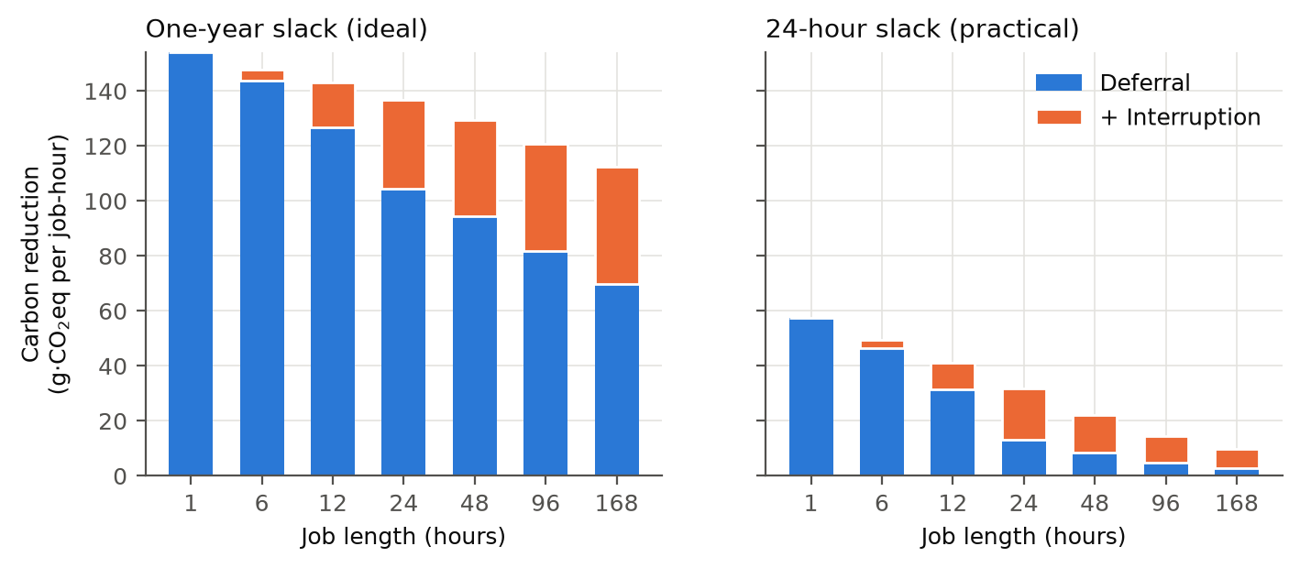
Figure 1. Reproduced carbon reduction per job-hour from deferral and interruption (cf. Figs. 7-8 of [1]).
Discrepancies. (i) Figure 10(d) reports 127 g for the equal-mix, one-year-slack case, but Figure 10(a) reports 135 g for the same quantity. The artifact computes both identically and yields 134.9 g, which suggests the 127 g comes from an earlier run. (ii) Two descriptive statistics in §1 and §4.1 do not match their stated definitions. The share of zones with mean daily coefficient of variation below 0.1 is 49.6% (the paper says 'more than 70%'; a threshold of 0.15 gives 74%), and the max/min ratio of zone means is 60x across all zones and 51x across cloud zones (the paper says 40x). (iii) In the capacity-constrained spatial analysis, the artifact scores a grouping by subtracting the mean intensity of member data centres that receive work; when no member receives any, a NaN becomes 0, as if departed work ran at zero carbon. Charging each origin the intensity where its work actually lands changes Asia at 50% idle capacity from 556 to 387 g, and the Americas at infinite capacity from 380 to 364 g. Global results and all qualitative conclusions of [1] are unaffected.

4 Power-Capped Temporal Shifting

4.1 Model
Normalise power to the facility's mean IT load. Each hour, a share φ of energy is flexible, pre-emptible work that must finish within S hours of arrival; the remaining 1-φ is inflexible. Grid draw in hour t may not exceed a cap C_t. C_t - 1 is the headroom: it is set by the electrical plant and drops during maintenance. With y_t the flexible work served in hour t and c_t the carbon intensity, the scheduler solves
minimise Σ_t c_t · y_t subject to 0 ≤ y_t ≤ C_t − (1 − φ), A(t − S) ≤ Y_t ≤ A(t) ∀t (1)
where Y_t = Σ_{u≤t} y_u is cumulative service and A(t) = φ(t+1) is cumulative arrivals. Lemma. Because every arrival has the same relative deadline, earliest-deadline-first and FIFO coincide, so a profile y can serve every arrival within its window if and only if the cumulative bounds in (1) hold. Necessity is immediate. For sufficiency, serve arrivals FIFO: the lower bound ensures that by the end of hour t all arrivals from hour t-S are complete. Formulation (1) has one variable per hour (8,760 per zone-year) with banded constraints, compared with 8,760·(S+1) variables in the per-arrival transportation LP. HiGHS solves it in about 50 ms. Tests confirm that it equals the brute-force LP on random instances (relative error < 1e-7), and that with C = ∞ it reproduces the 1-hour-job result of [1] (57.4 g per flexible kWh at 24 h slack), so the published bound is the C → ∞ limit of our model.

4.2 Results
We sweep all 123 zones × φ ∈ {25, 50, 75%} × S ∈ {24, 168} h × 14 cap levels (10,332 LPs; 78 s on 14 cores). The ideal requires an absurd power spike: with φ = 0.5 and 24 h slack, the uncapped optimum concentrates a day's flexible work in the cleanest hour, so the median facility peaks at 13x its mean load (85x with weekly slack). Realistic headroom keeps only part of the saving (Table 2, Fig. 2). The median zone needs +34% headroom to keep half its ideal 24 h saving and +125% to keep 80%; with weekly slack the median zone does not reach 80% even at 4x capacity, so additional slack is useful only if there is power to use it. Variable, low-carbon grids gain most from small headroom (South Australia reaches 6.0% with 5% headroom), while flat fossil grids gain little at any headroom (India-West: 5.1% even uncapped). 3 zones have constant traces and are excluded from the headroom-needed statistics.
Table 2. Global mean over 123 zones, φ = 0.5. Share kept = ratio of mean savings.
Headroom above mean load | +10% | +20% | +50% | +100% | ∞
Share of ideal kept, 24 h slack | 23% | 36% | 58% | 76% | 100%
Facility CO2 reduction, 24 h slack | 2.3% | 3.5% | 5.4% | 6.8% | 8.8%
Share of ideal kept, 168 h slack | 17% | 26% | 44% | 59% | 100%
Facility CO2 reduction, 168 h slack | 2.9% | 4.4% | 6.9% | 9.0% | 14.4%

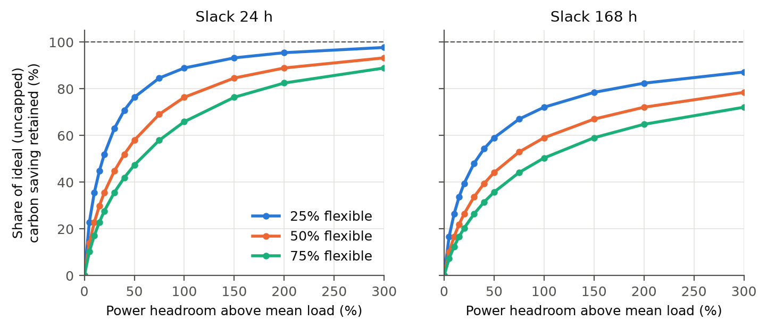
Figure 2. Share of the ideal (uncapped) carbon saving retained as power headroom grows, for three flexible shares and two slacks.

4.3 Forecast error under a cap
Schedulers act on forecasts. We optimise schedules on noisy forecasts and charge them the true intensity. The forecasts carry autocorrelated multiplicative errors (AR(1), ρ = 0.9) calibrated to a target MAPE (123 zones, 3 seeds; the schedule stays feasible, so it can never beat perfect information). Uncapped, forecast error costs 0.8-2.9% of emissions at 5-15% MAPE, consistent with the estimate in [1] for CarbonCast-level errors [9]. As a share of the achievable saving the loss is large (9-36%), because hourly variation is small relative to the error. Caps and forecast error compound almost independently at realistic error levels: with +20% headroom, the facility keeps 35-38% of the equally mis-forecast uncapped saving, against 36% with perfect forecasts. Only at 30% MAPE does the cap act as a hedge (keeping 52%). Capped schedules spread work over many hours instead of betting on the predicted minimum, so they lose a smaller share of their saving when forecasts are poor.
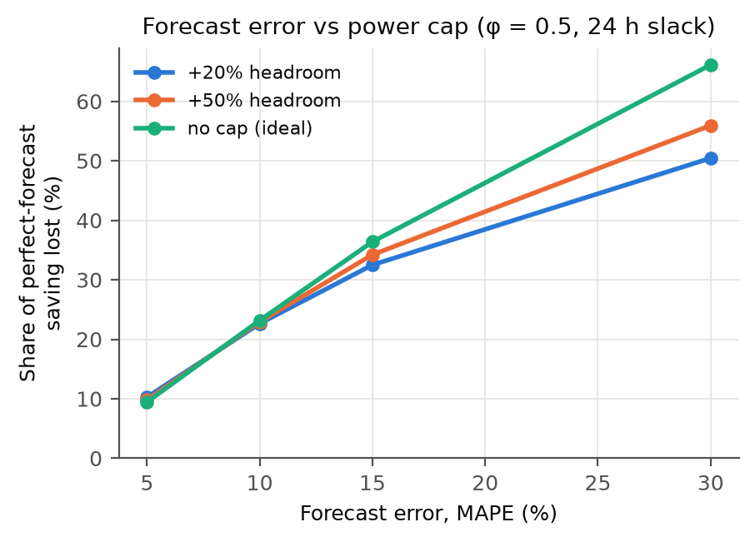
Figure 3. Share of the perfect-forecast saving lost versus forecast error, for two caps and no cap.

4.4 Real facilities: Google power traces
To ground the headroom axis in real data, we use Google's public PowerData2019 traces [29]: 5-minute power utilisation of 57 power domains in May 2019. The domains run at a median 70% of their power capacity (52-78%), so real facilities have about +42% headroom above mean load. At each domain's real headroom, carbon-aware shifting keeps a median 54% of the ideal saving (44-75%; 120 grids, φ = 0.5, 24 h slack). The daily load shape barely matters. We lay each real hour-of-week shape over every grid at all 24 daily alignments, which bounds the effect without assuming a time zone. With the fleet-median shape, the worst alignment loses 1.4% of the saving; with the most diurnal domain (21% daily swing), 5.9%. Averaged over alignments, the result equals the flat-load model used elsewhere. One caveat: utilisation includes floor cooling, and the documented meaning of the trace's bad-data flag contradicts the data, so we treat the 24 rows flagged True as bad.
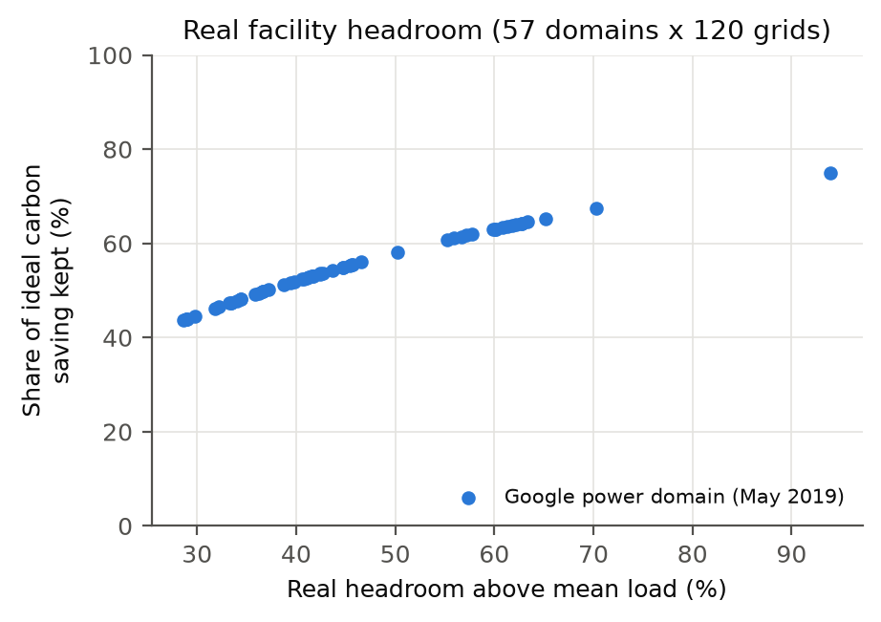
Figure 4. Share of the ideal saving kept at each Google power domain's real headroom (pooled over 120 grids).
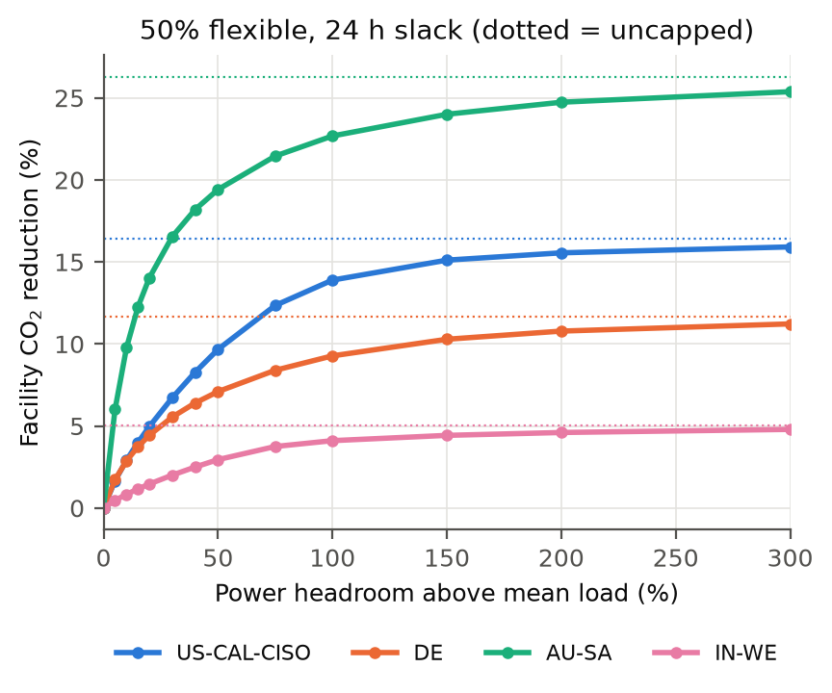
Figure 5. Facility-level reduction versus headroom for four grids (φ = 0.5, 24 h slack); dotted lines mark the uncapped ideal.

5 The Carbon Price of a Kilowatt

5.1 Shadow prices
Let λ_t ≥ 0 be the dual variable of the hourly capacity constraint in (1). Raising capacity by one unit in hour t lowers emissions by λ_t, so Σ_t λ_t is the annual carbon value of one additional kW of headroom at a facility with 1 kW mean load (equivalently, grams per year per kW of added capacity). We verify the duals against finite differences (within 2%), and check that they are non-negative and vanish when the cap does not bind. For the median zone at 24 h slack, one extra kW saves 346 kg/yr at 10% existing headroom, 228 kg/yr at 20%, 112 kg/yr at 50% and 48 kg/yr at 100%. The first kilowatts are the most valuable.

5.2 Embodied carbon of headroom
We found no peer-reviewed per-kW embodied-carbon factors for data-centre electrical plant, so we derive them from manufacturer EPDs (cradle-to-gate, A1-A3) and server product carbon footprints [20-26]. Table 3 lists the factors. A key observation is that sheddable, deferrable work does not require UPS or generator backup: on a grid outage it is postponed, not lost. Headroom for carbon shifting can therefore be grid-only (transformer plus switchgear), roughly five times cheaper in embodied carbon than fully backed capacity.
Table 3. Embodied carbon per kW of capacity (kg CO2eq/kW) derived for this study.
Component | Low | Central | High | Basis
transformer | 8 | 18 | 18 | [20, 21] 2.5 MVA cast resin; 16/20 MVA oil
switchgear | 0 | 10 | 20 | no primary EPD found; sensitivity range
ups | 17 | 40 | 74 | [24] ABB MegaFlex, DPA 250; Schneider Galaxy VX
ups battery | 9 | 10 | 12 | Li-ion 54-69 kg/kWh × 10 min (secondary)
generator | 66 | 71 | 76 | [22, 23] Cummins QSK95; mtu 10V1600
cpu servers | 1200 | 2000 | 3100 | [25] Dell R650, R760; 0.35 kW assumed draw
gpu servers | 234 | 470 | 700 | [26] HGX H100 baseboard ×2 (assumed)

Table 4. Carbon payback of building headroom for shifting at 20% existing headroom, φ = 0.5, 24 h slack. *Savings decline 3%/yr with grid decarbonisation.
Headroom build | Embodied kg/kW | Life (y) | Median payback (y) | Zones repaid in life*
Grid-only electrical | 28 | 25 | 0.1 | 98%
Fully backed electrical | 150 | 25 | 0.7 | 93%
GPU servers | 470 | 5 | 2.1 | 79%
CPU servers | 2,000 | 5 | 8.8 | 23%

Uncertainty. We propagate the embodied-carbon uncertainty with a 5,000-draw Monte Carlo. Each component factor is drawn from its EPD range, CPU-server draw from 0.25-0.5 kW, the GPU full-server multiplier from 1.5-3x, lifetimes from 20-30 y (electrical) and 4-6 y (servers), and a decline in savings from 0-5%/y. The build ordering held in 100% of draws. At +20% headroom, electrical builds repay in 92-98% of zones in every draw, while CPU servers repay in a median 23% (90% interval 1-52%) and reach a majority of zones in only 5% of draws.
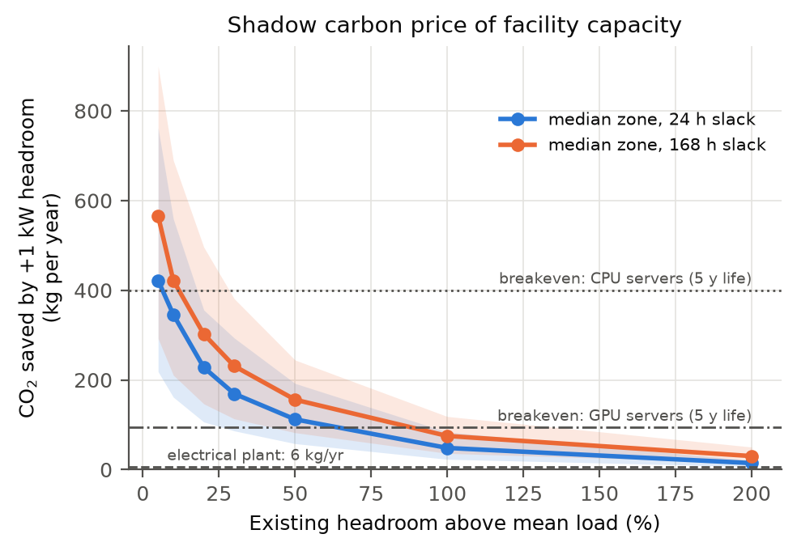
Figure 6. Shadow carbon price of facility capacity (median and interquartile range over zones) with embodied-carbon breakeven levels per build option.
Finding: build power, not servers. Electrical headroom repays its embodied carbon within months in almost every zone. CPU servers bought only to absorb shifted work pay back within a five-year life in just 23% of zones; GPU servers, with far lower embodied carbon per watt, do so in 79%. Carbon-aware shifting should therefore use idle compute that already exists, and a power-constrained operator gains most by adding electrical headroom.

5.3 Robustness across years
We repeat the facility analysis for 2020 and 2021 (φ = 0.5, 24 h slack; the 120 zones with non-constant traces). Table 5 shows that the headline results are stable. Per-zone shadow prices rank-correlate at Spearman 0.93-0.97 between years, so a ranking of where capacity is most valuable carries over from one year to the next. The carbon value of capacity is rising: the median shadow price grew 17% from 2020 to 2022. Three years is too short to establish a trend, but the direction is notable. It runs opposite to the observation in [1] that the relative benefit of carbon-aware scheduling shrinks as grids decarbonise: as grids become more variable, headroom becomes more valuable.
Table 5. Robustness of the facility findings across three years of traces.
Metric | 2020 | 2021 | 2022
Share of ideal kept, +20% headroom | 36.7% | 36.0% | 35.6%
Share of ideal kept, +50% headroom | 58.7% | 58.0% | 58.0%
Shadow price of capacity, median (kg/kW-yr) | 198 | 217 | 232
CPU servers repaid within life | 15% | 18% | 23%
Gap to ideal closed by N+1 | 35% | 35% | 36%
Gap to ideal closed by 2N | 72% | 72% | 73%

5.4 What drives the value of capacity?
Lemma (affine invariance). In (1) the total work served is fixed and the feasible set does not depend on c. So for c' = a + b·c with b > 0 the optimal schedule is unchanged, and savings and shadow prices scale exactly by b. The level of intensity is irrelevant; only its absolute swings matter. The data confirm this. Across 120 zones and three years, the shadow price of capacity has Spearman correlation 0.993 with the daily standard deviation of intensity, against 0.55 with its mean and 0.48 with the coefficient of variation, the relative-variability indicator used in [1]. One public statistic predicts the carbon value of capacity: value ≈ 4.83·σ^1.12 kg CO2 per kW-year (R² = 0.96). The change in value from 2020 to 2022 follows the change in σ (ρ = 0.97) and not the change in mean (ρ = -0.01); the median σ grew 15%, which explains the rising value in Sec. 5.3. Decarbonisation therefore raises the value of capacity only if it widens swings, as solar and wind do, and lowers it if it relies on steady sources.
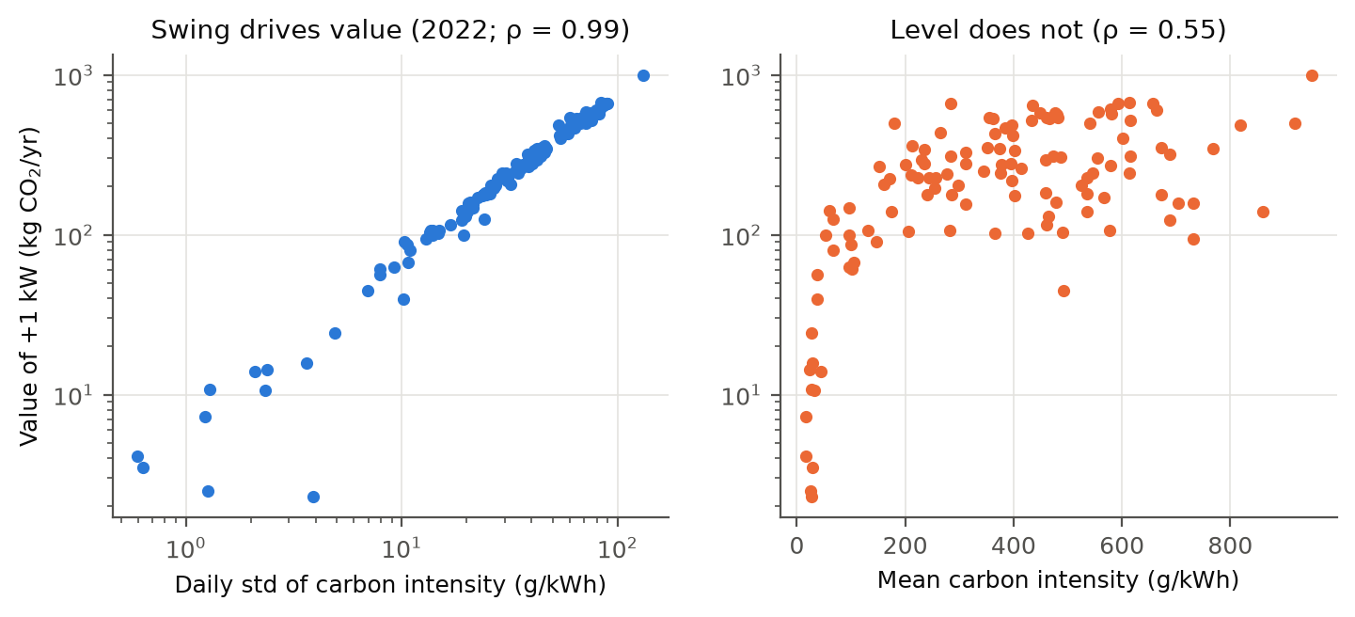
Figure 7. Value of one extra kW versus the daily standard deviation (left) and the mean (right) of grid carbon intensity, 2022.

5.5 Where should the next kilowatt go?
We take a cloud's real regions: the 32 GCP regions whose grids are in the dataset, with measured inter-region latency [19]. Each region hosts a facility at Google's real 70% utilisation (Sec. 4.4) with half its load flexible. An hourly migration LP moves flexible work to any region within a latency limit, subject to destination capacity. Its capacity duals give each region's spatial shadow price, which we compare with the temporal shadow price from (1). With a 100 ms limit, migration cuts fleet emissions by 18.5%. Spatial and temporal flexibility want capacity in different places. One extra kW in Quebec is worth 2,943 kg CO2/yr as a destination, 22x the median temporal value (137 kg), but only 1.5 kg for time shifting on its flat grid. Spatial value tracks low mean intensity (Spearman -0.84 at 100 ms, -0.97 at 250 ms); temporal value tracks daily variability (0.58). The two rankings are negatively correlated (-0.39 to -0.15). Siting for carbon therefore depends on the workload: build where the grid is clean if work can migrate, and where it is variable if work must stay (latency, data residency). This complements capacity-shifting and mesoscale studies by the same community [4, 28]. Caveat: under marginal accounting, extra load in a hydro-exporting region may displace exports, so marginal emissions there can far exceed the average.
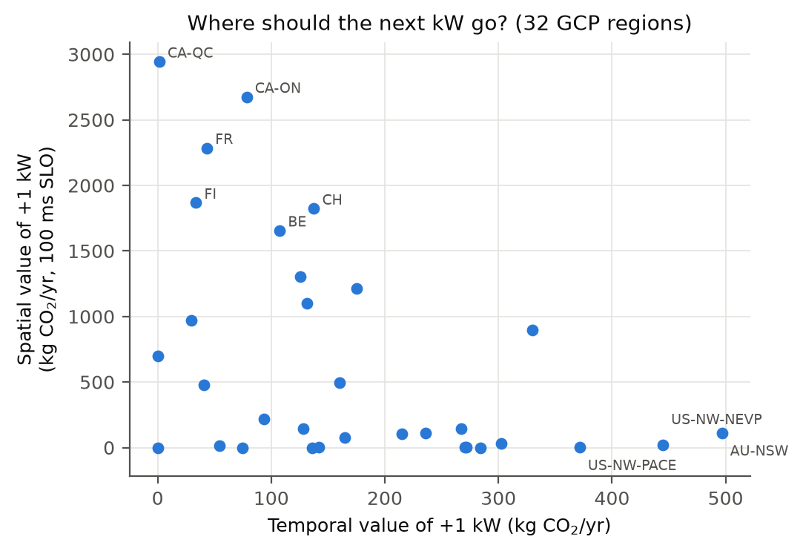
Figure 8. Spatial (migration, 100 ms) versus temporal value of one extra kW in 32 GCP regions.

6 The Redundancy Dividend
Tier-rated facilities already own idle electrical capacity. Flex [3] showed that this reserve can host software-redundant work and be reclaimed within seconds when a failure occurs. We apply the idea to carbon: deferrable work may use the redundant capacity, and when a path is down the facility falls back to its design capacity 1/u, where u is design utilisation (mean load / critical capacity). We model two 24 h maintenance windows per year and Poisson failures (0.5/yr, exponential repair with an 8 h mean), averaged over 10 random seeds per zone. Maintenance is placed either at random or in the window with the lowest summed shadow price (carbon-aware maintenance).
Table 6. Facility CO2 reduction, mean of 123 zones, φ = 0.5, 24 h slack. Ideal (uncapped) = 8.76%.
u | Capacity for flexible work | Cap (×mean) | No outages | Random maint. | Carbon-aware maint. | Gap closed
0.50 | design only | 2.00 | 6.83% | 6.83% | 6.83% | –
0.50 | N+1 (N=4) | 2.50 | 7.49% | 7.49% | 7.49% | 34%
0.50 | 2N | 4.00 | 8.20% | 8.20% | 8.20% | 71%
0.65 | design only | 1.54 | 5.52% | 5.52% | 5.52% | –
0.65 | N+1 (N=4) | 1.92 | 6.67% | 6.67% | 6.67% | 36%
0.65 | 2N | 3.08 | 7.88% | 7.87% | 7.88% | 73%
0.80 | design only | 1.25 | 3.90% | 3.90% | 3.90% | –
0.80 | N+1 (N=4) | 1.56 | 5.61% | 5.61% | 5.61% | 35%
0.80 | 2N | 2.50 | 7.49% | 7.48% | 7.49% | 74%

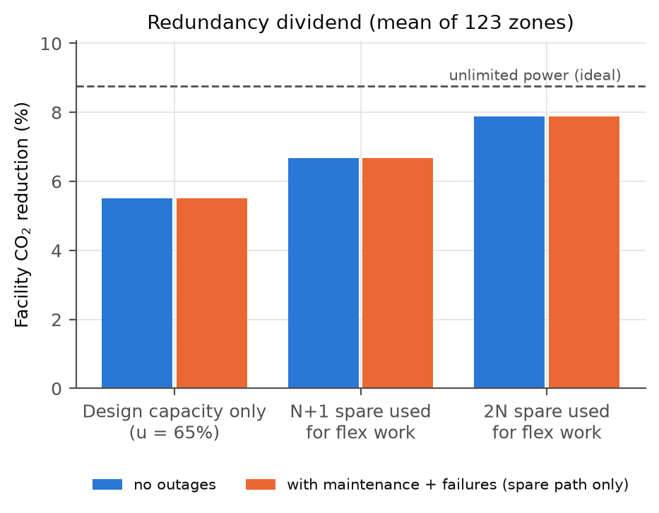
Figure 9. Redundancy dividend at 65% design utilisation.
Finding: redundancy is free carbon headroom, and outages barely matter. Using the N+1 spare raises the facility reduction from 5.5% to 6.7% and the 2N spare to 7.9% at u = 0.65, at zero embodied cost. Maintenance and failures cost under 0.01 percentage points, because the LP simply routes work around short windows within its slack. Carbon-aware maintenance recovers 90-100% of that loss; the effect is real but negligible. We report this as a negative result: it is not worth optimising.

7 Can UPS Batteries Shift Carbon?
We solve a cyclic battery-dispatch LP behind a flat load (90% round-trip efficiency, grid draw limited by the cap). A UPS sized for 10 minutes of ride-through and fully cycled every day cuts emissions by only 0.19% on average (0.9% in the best zone), and by 0.10% if half its energy must stay in reserve. Even a dedicated 4-hour battery averages 3.5% (best zone 15.8%), less than half-flexible load with 50% headroom (5.4%).
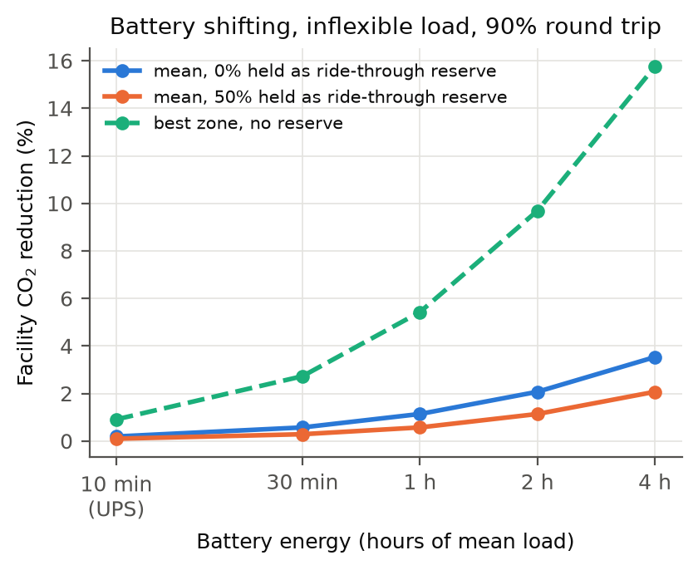
Figure 10. Facility CO2 reduction from carbon-optimal battery dispatch versus battery size.

8 Measured LLM Inference Energy versus Batch Size
AI inference is the fastest-growing flexible load, and batch size is its main efficiency control. We measured two 4-bit Qwen2.5 instruct models [17] (1.5B and 7B) on an Apple M4 Pro with a 20-core GPU, using MLX [18]. B distinct prompts were decoded together with concurrency forced to B (mlx-lm otherwise silently caps it at 32), generating 128 tokens each for at least 6 s per point, with three repeats. GPU, chip (CPU+GPU+DRAM) and system power were sampled every 100 ms with macmon [27], which reads the IOReport counters used by powermetrics without root privileges. We report chip energy as the headline metric because system power drifted upward with temperature and background activity during the run.
Table 7. Mean of 3 repeats; chip-power coefficient of variation across repeats ≤ 8.4%.
Model (4-bit) | Batch | Tokens/s | GPU W | Chip W | Chip mJ/token
Qwen2.5-1.5B | 1 | 198 | 15.3 | 19.7 | 99
Qwen2.5-1.5B | 8 | 604 | 25.4 | 26.9 | 45
Qwen2.5-1.5B | 32 | 1,292 | 28.5 | 29.5 | 23
Qwen2.5-1.5B | 128 | 1,392 | 30.7 | 31.5 | 23
Qwen2.5-7B | 1 | 53 | 18.2 | 20.2 | 377
Qwen2.5-7B | 8 | 149 | 28.4 | 28.9 | 194
Qwen2.5-7B | 32 | 318 | 31.2 | 31.9 | 100
Qwen2.5-7B | 128 | 326 | 32.1 | 32.9 | 101

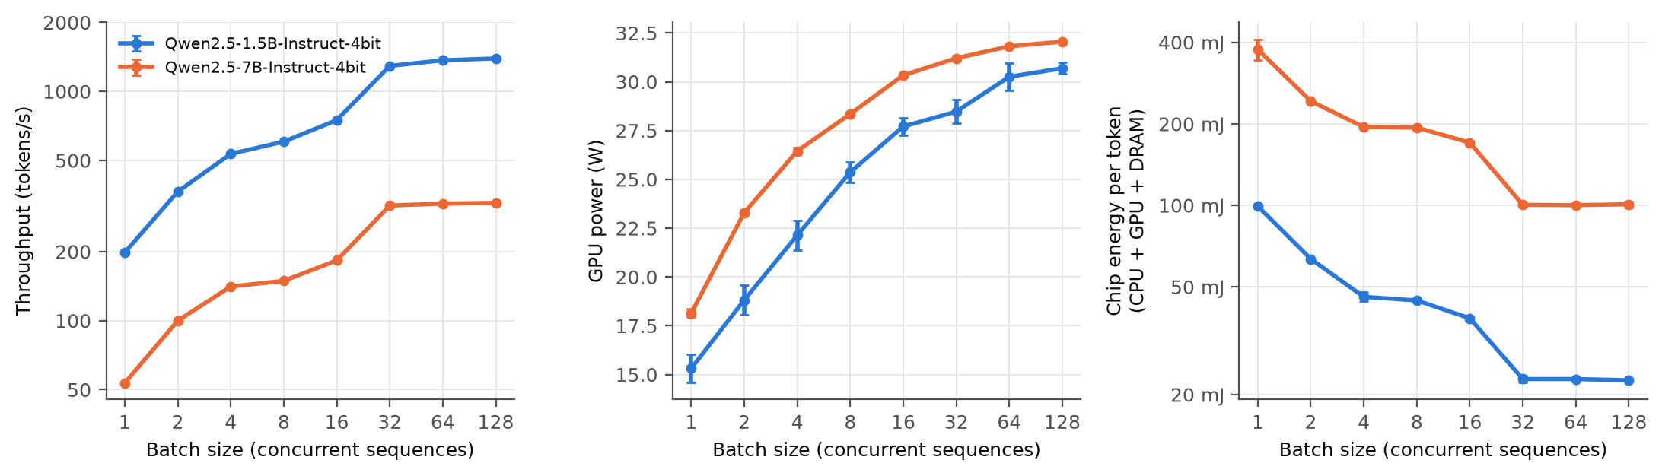
Figure 11. Throughput, GPU power and chip energy per token versus batch size on an Apple M4 Pro.
Batching is cheap in power. From batch 1 to 32, throughput of the 1.5B model rises 6.5x while chip power rises 1.5x, cutting energy per token 4.4x (3.8x for 7B). The GPU saturates near batch 32: beyond it, decode throughput grows by less than 10% (1,616 to 1,770 tokens/s for 1.5B), and GPU power plateaus at 31-32 W. Gains are uneven, with a flat step from 4 to 8 and a 1.7-1.9x jump from 16 to 32, consistent with (but not shown to be caused by) kernel-selection thresholds in MLX's quantised matrix multiplication. Implication: under a power cap, running inference at its efficient batch size delivers about 4x more tokens per joule within the same watts, a larger lever than temporal shifting (Sec. 4). Only work beyond the saturation point needs to compete for headroom. This complements carbon-aware inference designs such as EcoServe [13] and power oversubscription for LLM clusters [11].

8.1 Does batch size need to follow the grid?
Each sequence's time per output token is B / throughput(B), so larger batches trade latency for energy. Under a yearly mean latency budget we compare the best static batch mix with a carbon-aware hourly mix that uses small, fast batches in clean hours and large, efficient ones in dirty hours. The hourly-mix LP has a single coupling constraint, so we solve it exactly by Lagrangian bisection: each hour picks the batch minimising c_t·e(B) + λ·lat(B), and the optimum is a convex combination of the two schedules either side of λ (tested equal to the full LP). Across 120 grids, static batching at the efficient size cuts CO2 by 41-71% versus batch 1; carbon-aware timing adds only 1.6-4.8% (pooled), up to 24% in very variable grids such as Uruguay. Batch for efficiency first; following the grid is second-order. The measurements also show that batch sizes 8 and 16 are dominated by 32, which halves energy per token for nearly the same per-token latency
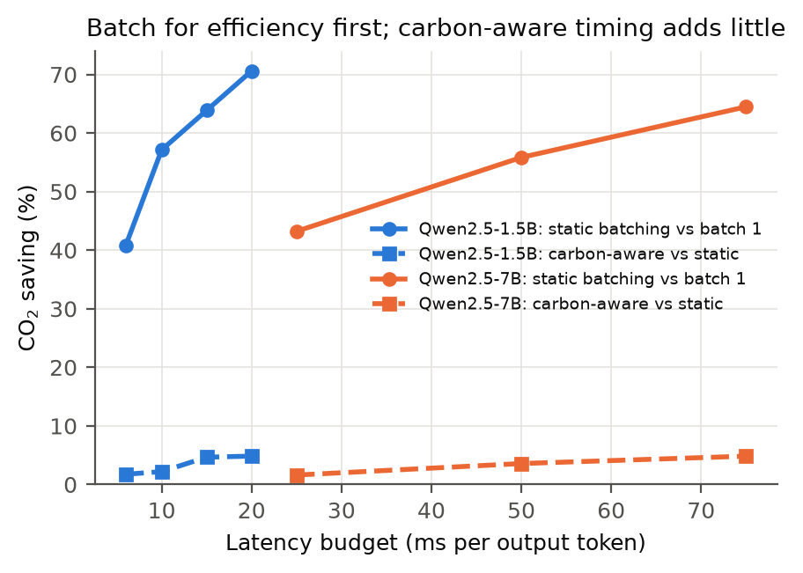
Figure 12. CO2 saving from static batching (vs batch 1) and the additional saving from carbon-aware time-varying batching.

9 Related Work
Carbon-aware shifting. Temporal shifting was evaluated for specific regions and workloads [8] and bounded across 123 zones [1]. CarbonScaler [5] exploits elasticity, CarbonFlex [4] provisions and schedules clusters, and Ecovisor [6] and the virtual energy system vision [14] expose energy and carbon to applications. CarbonCast [9] provides the forecasts such schedulers need. Google's carbon-intelligent compute system [2] and its probabilistic extension [15] enforce hourly capacity caps in production. We add a cross-grid quantification of how the cap level bounds the saving, and price capacity in carbon.
Power provisioning. Fan et al. [10] showed that real clusters draw well below their aggregate nameplate, motivating oversubscription. Flex [3] eliminates reserved power by shedding software-redundant work on failures, and POLCA [11] oversubscribes LLM inference clusters. These works use headroom to host more servers; we use it to save carbon, and show that tier redundancy is effective carbon headroom.
Embodied carbon. ACT [12] models the embodied carbon of computing hardware, and Carbon Explorer [7] co-designs capacity, renewables and storage for carbon-aware data centres. To our knowledge no prior work derives embodied carbon per kW of data-centre electrical plant from equipment declarations, or weighs it against the operational value of headroom for workload shifting.

10 Discussion, Limitations and Threats to Validity
- Average vs. marginal intensity. Like [1], we use average intensity; marginal signals can rank hours differently.
- Forecasts. The main results assume perfect forecasts and are upper bounds. Sec. 4.3 shows that synthetic AR(1) errors at CarbonCast-level MAPE cost 1-3% of emissions and leave the cap penalty nearly unchanged; real forecast errors may be structured differently.
- Fluid flexible work. Long jobs are not infinitely divisible, which lowers savings below our bounds; migration and checkpoint overheads are ignored. Real diurnal load shapes change results by at most 6% (Sec. 4.4).
- Embodied factors. One or two EPDs per component; switchgear has no primary source; server factors rest on assumed average draws. Conclusions are robust because the gap between electrical plant and CPU servers is an order of magnitude.
- Redundancy model. Fleet-average failure parameters; partial-module failures and cooling redundancy are not modelled; shedding is assumed instantaneous, as in [3].
- GPU measurements. One laptop-class SoC and two small quantised models; they show the shape of the batch curve, not data-centre accelerator values.
- Grid evolution. Savings shrink as grids decarbonise [1]; payback results include a 3%/yr decline sensitivity.

11 Artifact
The repository contains the library (data loading, temporal and spatial bounds, capped LP with duals, battery LP, embodied factors with sources, redundancy model, sudo-free power sampler), experiment scripts that write every number in this paper to CSV, 44 unit and integration tests (including equivalence to the original loop and to brute-force LPs), and an interactive explorer. The explorer is a FastAPI service with strict input validation, rate and concurrency limits, a body-size limit, a strict Content-Security-Policy, and no runtime model inference. This document is generated by scripts/build_paper.py from the result files.

12 Conclusion
Carbon-aware workload shifting is bounded not only by grid variability but by the power plant of the facility doing the shifting. Realistic headroom preserves a fraction of the published upper bounds. Pricing capacity in carbon shows that the first kilowatts of headroom are valuable and cheap in embodied carbon, that the redundancy tier-rated facilities already own is free carbon headroom, and that buying servers just to shift work rarely pays off. For AI inference, batching to the hardware's efficient point beats shifting in time. Together these results argue for carbon-aware schedulers that see watts, not only hours: the natural next step is an Ecovisor-style interface [6] that exposes both the carbon signal and the facility's power budget to applications.

Acknowledgements
We thank the authors of [1] for releasing their code and data, and Electricity Maps for the underlying carbon-intensity data (ODbL).

References
[1] T. Sukprasert, A. Souza, N. Bashir, D. Irwin, P. Shenoy. On the Limitations of Carbon-Aware Temporal and Spatial Workload Shifting in the Cloud. In Proc. EuroSys, 2024. arXiv:2306.06502.
[2] A. Radovanović, R. Koningstein, et al. Carbon-Aware Computing for Datacenters. arXiv:2106.11750, 2021.
[3] C. Zhang, A. G. Kumbhare, I. Manousakis, et al. Flex: High-Availability Datacenters With Zero Reserved Power. In Proc. ISCA, 2021.
[4] W. A. Hanafy, L. Wu, D. Irwin, P. Shenoy. CarbonFlex: Enabling Carbon-aware Provisioning and Scheduling for Cloud Clusters. arXiv:2505.18357, 2025.
[5] W. A. Hanafy, Q. Liang, N. Bashir, D. Irwin, P. Shenoy. CarbonScaler: Leveraging Cloud Workload Elasticity for Optimizing Carbon-Efficiency. Proc. ACM Meas. Anal. Comput. Syst. (SIGMETRICS), 2023. arXiv:2302.08681.
[6] A. Souza, N. Bashir, J. Murillo, W. Hanafy, Q. Liang, D. Irwin, P. Shenoy. Ecovisor: A Virtual Energy System for Carbon-Efficient Applications. In Proc. ASPLOS, 2023.
[7] B. Acun, B. Lee, F. Kazhamiaka, K. Maeng, U. Gupta, M. Chakkaravarthy, D. Brooks, C.-J. Wu. Carbon Explorer: A Holistic Framework for Designing Carbon Aware Datacenters. In Proc. ASPLOS, 2023.
[8] P. Wiesner, I. Behnke, D. Scheinert, K. Gontarska, L. Thamsen. Let's Wait Awhile: How Temporal Workload Shifting Can Reduce Carbon Emissions in the Cloud. In Proc. Middleware, 2021. arXiv:2110.13234.
[9] D. Maji, P. Shenoy, R. K. Sitaraman. CarbonCast: Multi-Day Forecasting of Grid Carbon Intensity. In Proc. BuildSys, 2022.
[10] X. Fan, W.-D. Weber, L. A. Barroso. Power Provisioning for a Warehouse-sized Computer. In Proc. ISCA, 2007.
[11] P. Patel, E. Choukse, C. Zhang, Í. Goiri, B. Warrier, N. Mahalingam, R. Bianchini. POLCA: Power Oversubscription in LLM Cloud Providers. arXiv:2308.12908, 2023.
[12] U. Gupta, M. Elgamal, G. Hills, G.-Y. Wei, H.-H. S. Lee, D. Brooks, C.-J. Wu. ACT: Designing Sustainable Computer Systems with an Architectural Carbon Modeling Tool. In Proc. ISCA, 2022.
[13] Y. Li, Z. Hu, E. Choukse, R. Fonseca, G. E. Suh, U. Gupta. EcoServe: Designing Carbon-Aware AI Inference Systems. arXiv:2502.05043, 2025.
[14] N. Bashir, T. Guo, M. Hajiesmaili, D. Irwin, P. Shenoy, R. Sitaraman, A. Souza, A. Wierman. Enabling Sustainable Clouds: The Case for Virtualizing the Energy System. In Proc. SoCC, 2021. arXiv:2106.08872.
[15] A. Hall, F. Micheli, G. Belgioioso, A. Radovanović, F. Dörfler. Carbon-Aware Computing for Data Centers with Probabilistic Performance Guarantees. arXiv:2410.21510, 2024.
[16] W. Kwon, Z. Li, S. Zhuang, et al. Efficient Memory Management for Large Language Model Serving with PagedAttention. In Proc. SOSP, 2023.
[17] Qwen Team. Qwen2.5 Technical Report. arXiv:2412.15115, 2024.
[18] A. Hannun, J. Digani, A. Katharopoulos, R. Collobert. MLX: Efficient and Flexible Machine Learning on Apple Silicon. https://github.com/ml-explore/mlx, 2023.
[19] Electricity Maps. Historical carbon-intensity data (hourly, 2020-2022), ODbL; as released with [1] at https://github.com/umassos/decarbonization-potential (Zenodo 10790855).
[20] Trafo Elettro S.r.l. Environmental Product Declaration, 2500 kVA cast-resin transformers TES-R2-2. EPDItaly1073 rev. 04 (EN 15804+A2).
[21] ABB T&D S.p.A. Environmental Product Declaration, Large Distribution Transformer 16/20 MVA (ONAN/ONAF). S-P-00056.
[22] Cummins Inc. Environmental Product Declaration, QSK95 Series Open Diesel Generator Set. EPD-IES-0025774:003, 2026.
[23] Rolls-Royce Power Systems. Environmental Product Declaration, containerized diesel generator set mtu 10V1600 DS500. EPD-IES-0017705:002, 2025.
[24] Schneider Electric. PEP ecopassport ENVPEP2311001_V2, Galaxy VX UPS (A1-A3), 2024; ABB MegaFlex DPA and DPA 250 S4 UPS EPDs (PEP ecopassport / INIES), via OneClick LCA.
[25] Dell Technologies. Product Carbon Footprint, PowerEdge R650 (2022); Life Cycle Assessment, PowerEdge R760.
[26] NVIDIA. HGX H100 Product Carbon Footprint Summary (cradle-to-gate), 2024.
[27] vladkens. macmon: sudoless performance monitoring CLI for Apple Silicon. https://github.com/vladkens/macmon.
[28] L. Wu, W. A. Hanafy, A. Souza, K. Nguyen, J. Harkes, D. Irwin, M. Satyanarayanan, P. Shenoy. CarbonEdge: Leveraging Mesoscale Spatial Carbon-Intensity Variations for Low Carbon Edge Computing. In Proc. HPDC, 2025. arXiv:2502.14076.
[29] V. Sakalkar, V. Kontorinis, D. Landhuis, S. Li, D. De Ronde, T. Blooming, A. Ramesh, J. Kennedy, C. Malone, et al. Data Center Power Oversubscription with a Medium Voltage Power Plane and Priority-Aware Capping. In Proc. ASPLOS, 2020. Traces: Google PowerData2019, https://github.com/google/cluster-data (CC-BY 4.0).

