TECHNICAL ARCHITECTURE & MIGRATION GUIDE
IBM ODWEK 10.5 and AFP2PDF
on WebSphere Liberty for OpenShift
Container image design • Liberty Operator • GitOps • operations • cutover

Recommended target
One application container per pod: Liberty + ODWEK 10.5 native runtime + AFP2PDF + application WAR
Two or more stateless replicas, connected to the existing CMOD server

Document | Value
Status | Draft implementation blueprint
Prepared for | Middleware / OpenShift / Security / Application teams
Version | 1.0
Date | 2026-09-02
Primary decision | Use a versioned ODWEK+AFP2PDF Liberty base image and a thin application image
Important Confirm IBM support, license entitlement, AFP2PDF distribution terms, exact 10.5 fix pack, Java level, base-image compatibility, and silent-installer response values before production.

Document purpose and scope
This guide defines a production-oriented migration from a traditional Liberty-hosted ODWEK application to Red Hat OpenShift. The Content Manager OnDemand (CMOD) server remains external during the first migration phase. Every OpenShift pod runs the Liberty JVM, the ODWEK Java/native runtime, AFP2PDF, and the application WAR in the same application container.
The design deliberately separates the reusable middleware runtime from the application release. IBM installation media is consumed only in a controlled image-build pipeline; it is never downloaded by a running pod and is never committed to Git.

In scope
- Target logical and deployment architecture
- ODWEK 10.5 and AFP2PDF image build pattern
- WebSphere Liberty Operator custom resource
- Configuration, secrets, TLS, storage and OpenShift security
- GitOps and CI/CD lifecycle
- Observability, health, scaling, capacity and resilience
- Migration waves, test plan, cutover, rollback and operating model

Out of scope
- Migration of the CMOD library server, database or storage manager
- Exact IBM installer response-file keys, which must come from the entitled media/readme
- Application source-code changes beyond required integration and health endpoints
- Selection or procurement of AFP2PDF licensing

Executive recommendation
Decision Build one internally governed base image containing Liberty, the complete supported ODWEK 10.5 Linux installation, AFP2PDF, native dependencies and standard fonts. Build a thin application image from that base with server.xml and the WAR. Deploy only the application image through the Liberty Operator.

Design choice | Recommendation | Reason
Pod composition | Single application container | ODApi.jar loads native libraries through JNI and AFP2PDF expects local programs/configuration.
Image pattern | Versioned middleware base + thin app image | Separates IBM runtime patching from WAR releases and improves provenance.
CMOD location | Keep existing CMOD external initially | Reduces migration blast radius and allows parallel validation.
Replicas | Minimum 2 across failure domains | Removes a single application-pod dependency.
State | Stateless pods; emptyDir for transform work | Allows replacement and horizontal scaling.
Secrets | External secret provider or approved Secret injection | No passwords or private keys in Git or images.
Traffic cutover | Weighted/canary where available | Supports controlled rollback.

Assumptions and required confirmations
Area | Working assumption | Confirm before build
CMOD/ODWEK | Version 10.5 | Exact fix pack and interoperability with CMOD server.
Liberty | Current enterprise-approved Liberty container | Exact Liberty edition, tag and Java version supported by the application and ODWEK.
OpenShift | Operator-based deployment | OCP version, Liberty Operator channel/version, SCC and network policy standards.
AFP2PDF | Linux media and entitlement exist | Container-use entitlement, installer behavior, fonts/resources, version compatibility.
Registry/artifacts | Internal registry and JFrog-like repository | Repository paths, credentials, retention and promotion process.
Identity | Arbitrary non-root UID required | Writable paths and group-0 permissions pass SCC admission.
CMOD network | Pods can reach CMOD endpoint | DNS, ports, firewall, TLS trust and connection limits.
Support gate IBM documents ODWEK on supported Linux and Liberty container patterns separately. Obtain written confirmation for the exact ODWEK 10.5 fix pack + AFP2PDF + Liberty/Java + UBI/OpenShift combination if your support policy requires explicit certification.

Current and target architecture

Current-state pattern
Consumer / browser
Load balancer or web tier
Liberty server + ODWEK + AFP2PDF on a long-lived host
External CMOD server
The current host combines runtime, application and transform installation. Configuration drift and host-local state can make recovery dependent on restarting the JVM or rebuilding the host.

Target logical architecture
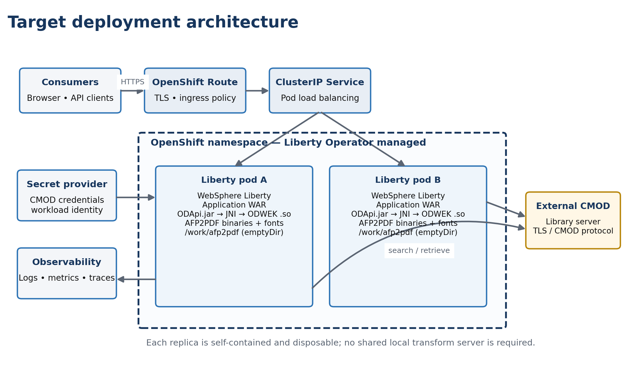
Figure 1. Target OpenShift deployment showing traffic flow, pod composition, replica isolation, and external dependencies.

Trust boundaries and flows
Flow | Protocol | Authentication / trust | Control
Client → Route | HTTPS | Enterprise TLS; app authentication | TLS policy, rate limit, access logs
Route → Liberty | HTTP or re-encrypted HTTPS | Cluster trust | Prefer re-encrypt where required
Liberty/ODWEK → CMOD | CMOD protocol/TCP; TLS if configured | CMOD account and trust material | Egress policy, secret injection, timeout
Pod → secret provider | Provider-specific TLS | Workload identity/service account | Least privilege and audit
CI → artifact repository | HTTPS | Build credential | Read only for IBM media
CI → image registry | HTTPS | Robot/service account | Immutable digest and signing

Container composition and filesystem contract
Path | Owner / source | Writable? | Purpose
/opt/ibm/wlp | Liberty base image | No | Liberty runtime
/opt/ibm/ondemand/V10.5 | ODWEK installer | No | ODWEK Java/native runtime
/opt/ibm/afp2pdf | AFP2PDF installer | Mostly no | Transform binaries, resources and standard fonts
/config | Application image / mounted config | Only required subpaths | server.xml, apps and Liberty config
/work/afp2pdf | emptyDir | Yes | Per-pod transform workspace
/logs or stdout | Runtime | Prefer stdout | Application diagnostics
/dumps | Optional emptyDir/PVC/object collection | Yes | JVM dumps when enabled
Non-root rule A pod may run with an arbitrary UID. Files needed at runtime should be readable by group 0, and only explicitly writable directories should use group-write permissions. Do not make the entire image tree world-writable.

Image strategy and software supply chain

Two-image lifecycle
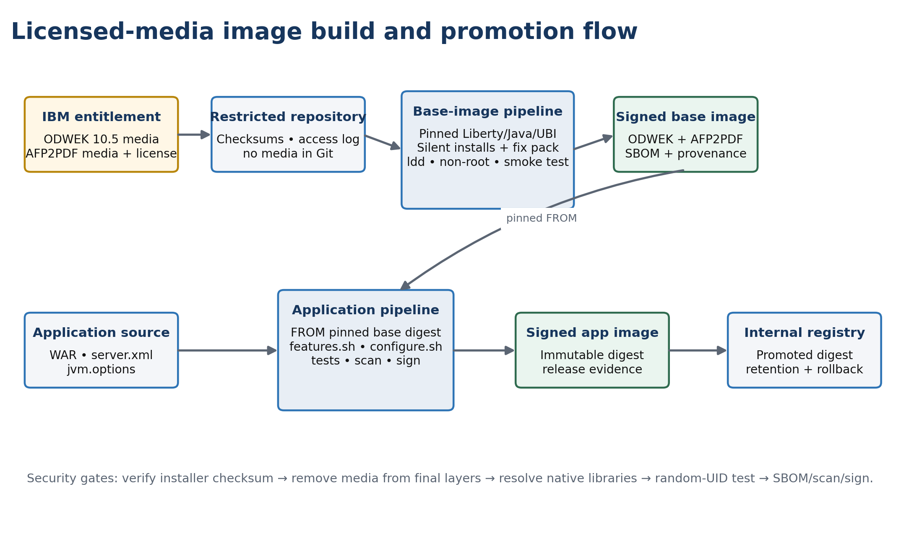
Figure 2. Controlled use of licensed IBM media and separation of middleware-base and application-image release lifecycles.

Licensed media handling
- Download CMOD/ODWEK 10.5 and AFP2PDF Linux media through the organization’s IBM entitlement process.
- Verify checksums and capture part number, version, fix pack, license evidence and download date.
- Upload media to a restricted binary repository. Grant read access only to the controlled base-image build identity.
- Exclude media, response files containing sensitive values, and extracted IBM binaries from Git and developer workstations.
- Use an ephemeral CI workspace. Delete installer payloads in the same build layer after a successful installation.
- Publish an SBOM, vulnerability report, signature, provenance statement and compatibility manifest with the image.

Suggested repository layout
odwek-platform/
base-image/
Containerfile
scripts/install-odwek.sh
scripts/install-afp2pdf.sh
scripts/verify-runtime.sh
response/odwek-response.template
compatibility.yaml
app-image/
Containerfile
config/server.xml
config/jvm.options
deploy/
base/
overlays/dev/
overlays/test/
overlays/prod/
tests/
smoke/ resilience/ performance/

Image version contract
Element | Example | Rule
Base image tag | 10.5.0.10-afp2pdfX-liberty25-java8-ubi9-r3 | Human-readable; never the sole production selector.
Base digest | sha256:<digest> | Pin in application build.
Application tag | 2.4.1-build173 | Release traceability.
Deployment reference | registry/.../odwek-app@sha256:<digest> | Immutable promotion.
Labels | source, revision, created, licenses, base digest | OCI metadata for audit.

Base image build: detailed procedure

Reference Containerfile
# REFERENCE PATTERN — replace placeholders after validating entitled media
ARG LIBERTY_IMAGE=registry.example.com/approved/websphere-liberty:<pinned-tag>
FROM ${LIBERTY_IMAGE}
USER 0
ARG ODWEK_MEDIA
ARG AFP2PDF_MEDIA
COPY ${ODWEK_MEDIA} /tmp/install/odlinux.bin
COPY ${AFP2PDF_MEDIA} /tmp/install/afp2pdf-media
COPY response/odwek-response.txt /tmp/install/
COPY scripts/ /usr/local/sbin/
RUN /usr/local/sbin/install-odwek.sh && /usr/local/sbin/install-afp2pdf.sh && /usr/local/sbin/verify-runtime.sh && rm -rf /tmp/install && chgrp -R 0 /opt/ibm/ondemand /opt/ibm/afp2pdf && chmod -R g=u /opt/ibm/ondemand /opt/ibm/afp2pdf && find /opt/ibm -type d -exec chmod g-s {} +
ENV ODWEK_HOME=/opt/ibm/ondemand/V10.5 \
AFP2PDF_HOME=/opt/ibm/afp2pdf \
LD_LIBRARY_PATH=/opt/ibm/ondemand/V10.5/www:/opt/ibm/ondemand/V10.5/lib64
USER 1001
Installer caution Generate and test the response file from the actual 10.5 installer. IBM requires a response file for silent installation/license acceptance. Do not invent property names from examples.

Build script responsibilities
Stage | Required behavior | Failure condition
Fetch | Authenticated download, checksum verification | Missing or mismatched checksum
Install ODWEK | Run supported silent installer; retain log | Nonzero return or expected component absent
Apply fix pack | Use IBM-provided update method | Installed level differs from declared level
Install AFP2PDF | Run supported Linux installer | Executable/resources/config template absent
Verify native links | Use ldd/readelf where permitted | Unresolved shared library
Permissions | Arbitrary-UID read; minimal writable paths | Runtime needs root or broad write
Sanitize | Remove media, cache and credentials | Media/secret remains in layer
Attest | SBOM, scan, sign, provenance | Policy gate fails

Build-time verification examples
test -f /opt/ibm/ondemand/V10.5/www/api/ODApi.jar
find /opt/ibm/ondemand/V10.5 -name 'libars3wapi64.so' -print -quit | grep .
test -x /opt/ibm/afp2pdf/<validated-executable>
ldd /opt/ibm/ondemand/V10.5/<validated-path>/libars3wapi64.so | tee /tmp/ldd.out
! grep -q 'not found' /tmp/ldd.out
test "$(id -u)" != 0

Application image and Liberty configuration

Thin application Containerfile
FROM registry.example.com/middleware/liberty-odwek-afp2pdf@sha256:<base-digest>
ARG VERBOSE=false
COPY --chown=1001:0 config/server.xml /config/
COPY --chown=1001:0 config/jvm.options /config/
RUN features.sh
COPY --chown=1001:0 build/odwek-app.war /config/apps/odwek-app.war
RUN configure.sh

Reference server.xml
<server description="ODWEK application">
<featureManager>
<feature>servlet-4.0</feature>
<feature>mpHealth-4.0</feature>
<feature>monitor-1.0</feature>
</featureManager>
<httpEndpoint id="defaultHttpEndpoint" host="*" httpPort="9080" httpsPort="9443"/>
<library id="odwekLib">
<fileset dir="/opt/ibm/ondemand/V10.5/www/api" includes="ODApi.jar"/>
<!-- Pin exact support JAR names for the installed ODWEK fix pack. -->
<fileset dir="/opt/ibm/ondemand/V10.5/<validated-jar-dir>"
includes="<exact-gson>,<exact-log4j-api>,<exact-log4j-core>"/>
</library>
<webApplication id="odwek-app" location="odwek-app.war" contextRoot="/odwek">
<classloader commonLibraryRef="odwekLib"/>
</webApplication>
</server>
The Liberty shared-library paths must be verified against the installed fix pack. Avoid broad *.jar patterns in production because duplicate logging, JSON or application libraries can create class-loader conflicts.

AFP2PDF integration
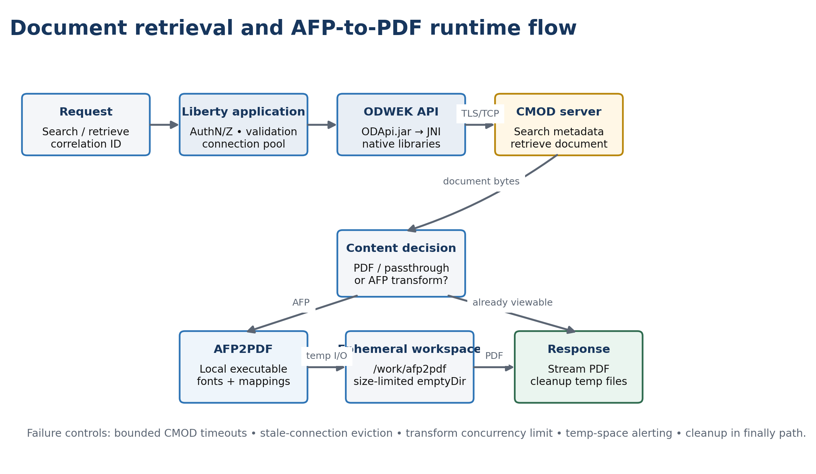
Figure 3. End-to-end request path, including the conditional local AFP2PDF transform and ephemeral workspace.
- Set the ODWEK AFP2PDF installation directory to /opt/ibm/afp2pdf using the application’s supported ODConfig mechanism.
- Mount afp2pdf.ini and environment-specific mapping files read-only when operational changes must not require an image rebuild.
- Bake approved standard fonts into the base image; mount only governed customer-specific resources when required.
- Use /work/afp2pdf for temporary conversion data and clean request artifacts after completion.
- If AllObjects is required for large-object AFP content, validate memory, temp-space and latency impact under load.

OpenShift and Liberty Operator design

Namespace objects
Object | Purpose
WebSphereLibertyApplication | Owns application deployment, service and operational settings
ConfigMap | Non-secret endpoint and transform settings
Secret / external secret | CMOD credentials and TLS materials
ServiceAccount | Workload identity and least-privilege access
NetworkPolicy | Restricts ingress and egress
PodDisruptionBudget | Maintains availability during voluntary disruption
Route | North-south exposure
ServiceMonitor/telemetry config | Metric collection where available

Reference WebSphereLibertyApplication
apiVersion: liberty.websphere.ibm.com/v1
kind: WebSphereLibertyApplication
metadata:
name: odwek-app
spec:
applicationImage: registry.example.com/apps/odwek-app@sha256:<digest>
replicas: 2
serviceAccountName: odwek-app
expose: true
env:
- name: CMOD_HOST
valueFrom: {configMapKeyRef: {name: odwek-config, key: cmod-host}}
- name: CMOD_USER
valueFrom: {secretKeyRef: {name: odwek-runtime, key: username}}
- name: CMOD_PASSWORD
valueFrom: {secretKeyRef: {name: odwek-runtime, key: password}}
volumeMounts:
- name: afp-work
mountPath: /work/afp2pdf
- name: afp-config
mountPath: /etc/afp2pdf
readOnly: true
volumes:
- name: afp-work
emptyDir: {sizeLimit: 10Gi}
- name: afp-config
configMap: {name: afp2pdf-config}
readinessProbe:
httpGet: {path: /health/ready, port: 9080}
initialDelaySeconds: 20
periodSeconds: 10
timeoutSeconds: 3
failureThreshold: 6
livenessProbe:
httpGet: {path: /health/live, port: 9080}
initialDelaySeconds: 60
periodSeconds: 20
timeoutSeconds: 3
failureThreshold: 3
resources:
requests: {cpu: "1", memory: 2Gi, ephemeral-storage: 2Gi}
limits: {cpu: "2", memory: 4Gi, ephemeral-storage: 12Gi}
affinity: <spread replicas across nodes/zones>
Schema validation Operator CR fields vary by installed operator version. Validate this reference against the cluster’s WebSphereLibertyApplication CRD before commit.

ConfigMap and secret reference
apiVersion: v1
kind: ConfigMap
metadata: {name: odwek-config}
data:
cmod-host: cmod.example.internal
cmod-port: "<port>"
---
# Prefer an ExternalSecret or platform-approved secret injection object.
# Do not commit a Secret containing base64-encoded production credentials.

Security architecture
Control area | Implementation
Container user | Non-root, arbitrary UID compatible, no privilege escalation
Linux capabilities | Drop ALL; add none unless vendor requirement is documented
Filesystem | Read-only root where compatible; writable emptyDir only for work/dumps
Secrets | External provider, short-lived where possible, rotation tested
TLS | Trusted ingress certificate and validated CMOD trust chain
Network | Default-deny; allow route ingress, DNS, CMOD egress and required telemetry only
Image trust | Digest pinning, signing, admission policy, SBOM and scan gates
RBAC | Dedicated service account; no broad namespace roles
Data handling | Treat retrieved documents and temporary PDFs as sensitive; erase promptly
Logging | No document contents, passwords, tokens or session identifiers

Example network policy intent
Ingress: allow only OpenShift ingress/controller namespaces to application port.
Egress: allow cluster DNS, approved CMOD host/port, secret provider and telemetry endpoints.
Deny: all other ingress and egress by default.
Implementation note: standard Kubernetes NetworkPolicy selects pods/namespaces; use your CNI or egress firewall controls for stable external CIDR/FQDN requirements.

Runtime state, storage and AFP2PDF capacity
The application pods should be disposable. Use emptyDir for transform work unless a documented recovery requirement demands persistence. A PVC shared by all replicas can create security, locking and cleanup problems and should not be the default.
Data | Storage | Retention | Sizing driver
AFP input/intermediate/PDF | emptyDir | Delete after request; pod lifetime maximum | Largest document × expansion factor × concurrency
Liberty temp | emptyDir or container ephemeral | Pod lifetime | Concurrent requests
JVM dumps | Dedicated emptyDir/PVC or collection agent | Incident policy | Heap size × dump types
Logs | stdout/stderr | Central platform policy | Traffic and trace level
Fonts/config | Image or read-only ConfigMap | Versioned | Resource bundle size

Initial sizing method
Do not use the sample resource values as final sizing. Baseline with production-like AFP documents, concurrent retrievals and CMOD latency. Measure p50/p95/p99 conversion time, peak RSS, CPU seconds per conversion, temporary bytes, GC pause, active ODWEK sessions and error recovery.
work_size ≈ concurrent_transforms × largest_input_size × measured_expansion_factor × safety_factor
heap_target = measured_live_set + concurrency_headroom + GC_headroom
replicas = max(availability_minimum, ceil(peak_arrival_rate / safe_per_pod_throughput))

Health checks, connection pooling and recovery
Design priority A liveness endpoint must not restart pods merely because CMOD is briefly unavailable. Readiness can remove a pod when it cannot safely serve traffic; liveness should prove only that Liberty and its request-processing loop remain healthy.

Check | What it proves | Dependency | Action
Startup | Liberty/app initialized and native libraries load | Local runtime only | Hold traffic during startup
Liveness | JVM/event loop can respond | No CMOD call | Restart only on local deadlock/failure
Readiness | Pod has capacity and critical configuration | Optional cached CMOD status | Remove from Service endpoints
Synthetic business check | Login/search/retrieve/transform works | Full CMOD + AFP2PDF path | Alert; do not run at probe frequency

ODWEK pool requirements
- Set connection creation, borrow, socket/read and validation timeouts; no unbounded waits.
- Validate connections before use or after an idle threshold.
- Evict stale/idle connections and cap maximum lifetime.
- Invalidate a connection on network/protocol failure; never return it to the pool.
- Use bounded retries with jitter only for idempotent operations.
- Expose pool active/idle/waiter/exhaustion metrics and CMOD error categories.
- Test CMOD host black-hole behavior, not only clean connection refusal.
- Verify recovery without restarting Liberty after CMOD returns.
This area is especially important given the previously observed “timeout waiting for idle object” and hung-thread behavior. The acceptance criterion is automatic recovery after CMOD interruption, with bounded user-facing failures and no manual JVM restart.

Availability, scaling and performance
Mechanism | Recommendation | Caution
Replicas | At least 2 | Confirm CMOD/session capacity before scaling.
Topology spread | Across nodes and zones where available | Do not make scheduling impossible with overly strict rules.
PDB | minAvailable: 1 for two replicas | PDB does not protect against node failure.
HPA | CPU plus queue/latency metric when available | AFP conversion can be CPU and ephemeral-storage intensive.
Session design | Prefer stateless or shared external session state | Avoid sticky sessions as the only correctness mechanism.
Graceful shutdown | Stop new traffic, drain in-flight transforms | Set termination grace to measured worst-case or cancel safely.
CMOD protection | Per-pod and global concurrency cap | HPA can otherwise overload the back end.

Observability and operational telemetry
Signal | Examples | Alert / use
Golden signals | Rate, errors, latency, saturation | SLO and incident detection
JVM | Heap, GC, threads, CPU, native memory | Leak, pressure and hung-thread diagnosis
ODWEK | Login/search/retrieve latency, error class, pool stats | CMOD dependency health
AFP2PDF | Conversions, duration, failures, bytes, temp usage | Transform capacity and faulty resources
Platform | Restarts, OOMKill, evictions, throttling, volume use | Pod health and resource tuning
Build | Image digest, SBOM, vulnerability and base versions | Release provenance

Logging standards
- Emit structured logs with timestamp, severity, pod, correlation ID, operation, duration and sanitized error category.
- Propagate a correlation ID from ingress through ODWEK calls and AFP2PDF work.
- Keep normal logs on stdout/stderr; enable ODWEK trace only for bounded diagnostic windows.
- Redact credentials, query values that contain sensitive data, document content and generated PDF paths.
- Define automatic dump and trace collection before a pod is replaced.

GitOps and CI/CD architecture
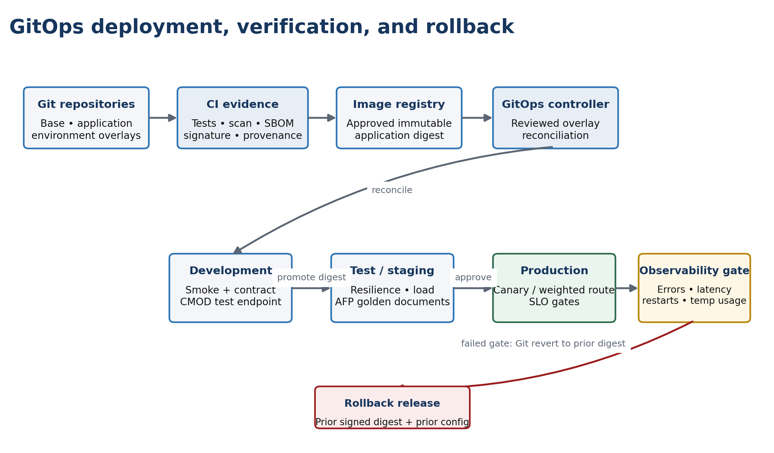
Figure 4. Digest-based GitOps promotion with environment verification gates and rollback to a prior signed release.

Pipeline stages
Stage | Trigger | Key gates | Output
Base build | ODWEK/AFP2PDF/Liberty/Java/UBI update | Checksum, install, ldd, non-root, scan, license record | Signed base digest
App build | WAR or server config change | Tests, features.sh, configure.sh, smoke scan | Signed app digest
Dev deploy | Manifest PR merge | CRD schema, policy, secret refs | Running dev release
Integration | Deployment healthy | CMOD search/retrieve, AFP conversion, recovery | Evidence bundle
Promotion | Approval and passed evidence | Digest unchanged, config diff reviewed | Prod overlay update
Rollback | Failed SLO/health gate | Prior digest/config available | Git revert or rollout

Migration work plan
Phase | Activities | Exit criteria
0. Discovery | Inventory versions, paths, JARs, .so dependencies, fonts, INI files, CMOD endpoints, pools and traffic. | Signed inventory and support matrix.
1. Foundation | Install Operator, namespaces, registry access, secrets integration, policies and observability. | Sample Liberty app passes platform controls.
2. Base image | Install ODWEK/AFP2PDF in CI; verify native runtime and arbitrary UID. | Signed, scanned base digest.
3. App image | Add server.xml/WAR; externalize configuration. | Local/container smoke tests pass.
4. Dev pilot | Deploy one replica to existing CMOD; functional tests. | Login/search/retrieve/AFP→PDF success.
5. Resilience | Two replicas; network faults, pod kill, node drain and CMOD recovery. | No manual JVM restart; bounded failure.
6. Performance | Load, soak and large-object tests; tune pools/resources. | Capacity and SLO evidence approved.
7. Production | Canary/weighted cutover, monitor, then complete traffic shift. | Stable observation window.
8. Decommission | Retain rollback window; remove old endpoint and secrets. | Formal operational acceptance.

Detailed validation plan

Functional
- Authenticate and log out
- Search by every supported criterion
- Retrieve AFP, PDF, text and representative large-object documents
- Convert AFP to PDF with standard and application-specific mappings
- Validate fonts, overlays, images, page count and visual fidelity
- Exercise authorization failures, missing documents and malformed inputs
- Validate concurrent sessions and multiple replicas

Failure and recovery
- Delete a pod during active traffic; confirm retry/drain behavior
- Block CMOD packets to simulate an unresponsive host; confirm timeout
- Restore CMOD connectivity; confirm pool replaces stale connections automatically
- Restart CMOD cleanly; confirm pods recover without restart
- Fill AFP work volume near limit; confirm controlled failure and cleanup
- Inject corrupt AFP and missing font/map resources
- Rotate CMOD credentials and certificates
- Drain a node and validate PDB/topology behavior

Performance and soak
Test | Measure | Pass criterion
Baseline retrieval | p50/p95/p99, CPU, memory | Meets agreed SLO at normal load
AFP conversion mix | Duration by size/type, temp bytes | Capacity model validated
Burst | Queueing, rejection, pool wait | Bounded wait; no cascading failure
Soak 8–24h | Heap/native growth, files, sessions | No sustained leak or exhaustion
Scale out/in | CMOD load, errors, drain | No unsafe scale-in; back end protected
Large object | Memory/temp amplification | Within limits with safety margin

Cutover and rollback runbook

Pre-cutover checklist
- Production image digest, SBOM, scan and signature approved
- IBM support/licensing confirmation recorded
- Production secrets and CMOD trust validated
- Capacity, resilience and recovery tests passed
- Dashboards, alerts and on-call runbook ready
- Prior platform remains available and data-compatible
- DNS/route/load-balancer rollback mechanism rehearsed
- Change record and business validation owners confirmed

Cutover sequence
- Freeze unrelated releases and record current configuration/digests.
- Deploy production pods without external traffic; run internal smoke and synthetic tests.
- Shift a small canary percentage or selected consumer group.
- Observe errors, p95 latency, AFP conversion quality, pool saturation, CMOD load and pod resources.
- Increase traffic in approved steps; pause at each observation gate.
- Complete traffic shift, retain old platform warm for the agreed rollback window.
- Close migration only after soak, business sign-off and operational handover.

Rollback triggers and action
Trigger | Immediate action | Rollback
Sustained error or latency SLO breach | Stop further traffic increase | Return route/LB weight to old platform
AFP visual corruption | Disable affected path; preserve sample/evidence | Route all conversion traffic back
CMOD pool exhaustion/non-recovery | Protect CMOD and cap concurrency | Restore old platform; investigate offline
Security or secret exposure | Revoke/rotate and isolate | Rollback image/config and open incident
Resource instability | Scale cautiously only within CMOD capacity | Revert digest/config if not rapidly correctable

Operational runbook
Symptom | First checks | Safe response
Readiness failing | App logs, CMOD reachability, pool metrics, config mount | Remove traffic; do not restart-loop blindly
Liveness restart | Thread/JVM/dump evidence, OOMKill, node pressure | Collect evidence; correct local failure
AFP conversion slow | CPU throttle, work usage, document size, fonts/maps | Limit concurrency; preserve sanitized sample
Pool timeout | Active/idle/waiters, CMOD network, stale validation | Fail fast; invalidate stale sessions; protect back end
Ephemeral storage high | Active jobs, orphaned temp files, request sizes | Stop admission if needed; cleanup safely
Native library error | LD_LIBRARY_PATH, image digest, ldd result | Rollback image; do not hot-patch pod

Roles and responsibilities
Role | Accountability
Middleware/Liberty | Base compatibility, Liberty configuration, ODWEK runtime, pool and JVM tuning
Application team | WAR, health endpoints, stateless behavior, functional and error handling
OpenShift platform | Operator, namespaces, SCC, routes, storage, observability and availability controls
Security/PKI | Secrets, certificates, image policy, vulnerability exceptions and audit
CMOD team | Endpoint, version compatibility, account, capacity and server-side monitoring
DevSecOps | CI, artifact media access, SBOM, signing, scanning and GitOps promotion
Business/test owners | Representative documents, conversion-fidelity and acceptance sign-off

Key risks and mitigations
Risk | Impact | Mitigation
Unsupported version combination | Vendor support gap | Written compatibility confirmation; pinned tested matrix.
Native dependency missing | Pod fails at runtime | ldd/build smoke gate and startup validation.
AFP2PDF license/media misuse | Legal/compliance exposure | Restricted repository and entitlement review.
Arbitrary UID incompatibility | Admission/runtime failure | Non-root CI test under random UID.
Stale CMOD connections | Hung requests and restart dependency | Validation, eviction, bounded timeouts and fault tests.
Transform temp exhaustion | Eviction/service failure | Size limit, cleanup, concurrency guard and alerts.
HPA overloads CMOD | Back-end cascade | Global concurrency ceiling and CMOD capacity gate.
Font/mapping drift | Incorrect PDFs | Version resources, visual golden tests and checksum.
Secrets in Git/image/logs | Credential exposure | External injection, scanning, redaction and rotation.

Implementation checklist
- Exact ODWEK fix pack recorded
- AFP2PDF version/media/license recorded
- Approved Liberty/Java/UBI matrix recorded
- Installer response generated from actual media
- Base build runs without interactive steps
- No licensed media remains in final layers
- Native libraries resolve cleanly
- Random-UID runtime test passes
- WAR loads ODApi.jar from intended classloader
- AFP2PDF conversion passes golden-document comparison
- Secrets and TLS are externalized
- Default-deny network policy tested
- Liveness independent of CMOD
- Readiness and synthetic checks separated
- CMOD outage recovers without pod restart
- Two replicas tolerate pod/node disruption
- Load/soak capacity approved
- Cutover and rollback rehearsed
- Runbook and ownership accepted

Appendix A — Compatibility manifest template
application: odwek-app
application_version: <version>
odwek:
version: 10.5.0.<fixpack>
media_checksum: sha256:<checksum>
afp2pdf:
version: <version>
media_checksum: sha256:<checksum>
liberty:
version: <version>
edition: <edition>
java:
vendor: IBM Semeru or approved vendor
major: <8|11|17|21>
base_os: <UBI version>
operator:
channel: <channel>
csv: <installed CSV>
openshift: <version>
validated_date: <date>
evidence: <test-report links>

Appendix B — Architecture decision records
ADR | Decision | Status
ADR-001 | Run Liberty, ODWEK and AFP2PDF in one application container per pod. | Recommended
ADR-002 | Maintain a reusable, versioned middleware base image. | Recommended
ADR-003 | Keep CMOD external during phase 1. | Recommended
ADR-004 | Use ephemeral per-pod AFP transform workspace. | Recommended
ADR-005 | Use digest-based GitOps promotion. | Recommended
ADR-006 | Separate liveness from CMOD dependency health. | Recommended
ADR-007 | Require automatic stale-connection recovery without JVM restart. | Acceptance gate

Appendix C — Source references
- IBM CMOD 10.5: Setting up the ODWEK development environment: https://www.ibm.com/docs/en/cmofm/10.5.0?topic=applications-setting-up-development-environment
- IBM CMOD 10.5: Silently installing Content Manager OnDemand: https://www.ibm.com/docs/en/cmofm/10.5.0?topic=multiplatforms-silently-installing-content-manager-ondemand
- IBM CMOD 10.5: Installing Content Manager OnDemand software on Linux: https://www.ibm.com/docs/en/cmofm/10.5.0?topic=servers-installing-content-manager-ondemand-software-linux
- IBM Liberty: Creating application images: https://www.ibm.com/docs/en/was-liberty/core?topic=container-creating-application-images
- IBM Liberty Operator: WebSphereLibertyApplication custom resource: https://www.ibm.com/docs/en/was-liberty/core?topic=resources-webspherelibertyapplication-custom-resource
- IBM CMOD 10.5: Configuring the afp2pdf.ini file: https://www.ibm.com/docs/en/cmofm/10.5.0?topic=legacy-configuring-afp2pdfini-file
- Red Hat OpenShift documentation: https://docs.redhat.com/en/documentation/openshift_container_platform/
Reference note: IBM documentation is authoritative for the installed product/fix pack. Validate current pages and entitled-media readmes at implementation time. Sample YAML and Containerfiles in this guide are implementation patterns, not substitutes for the installed Operator CRD or vendor installer documentation.

