**JSP**

* 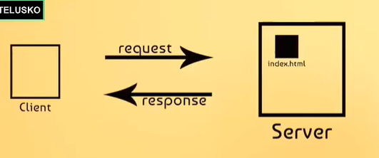
* If client is asking for a static page then it will provide it.
* If its asking for a dynamic page then server needs to build in at runtime and return it to client. How do server handles it ?  
  servlets : java file which takes the request from java client on the internet and it can process the request and provides response in the format of html page.
* App servers like Tomcat, Glassfish, jboss and websphere can also act as web servers.
* 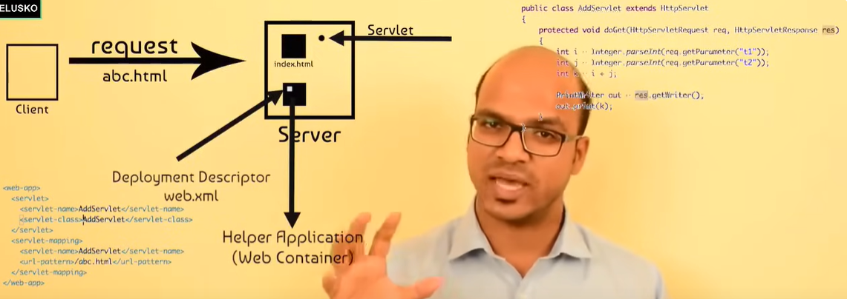

**MAY 27, 2024**  
  
Created tomcat server and able to launch html page on the server in STS.

**May 28,2024**

**Topics on how to send data from a form to servlet and display data ?  
how to call one servlet from another servlet ?**

TO make your class a servlet you need to extend **HttpServlet.**  
service() is the method which belongs to servlet lifecycle.  
to configure your page to particular servlet calls use below is the web.xml file.  
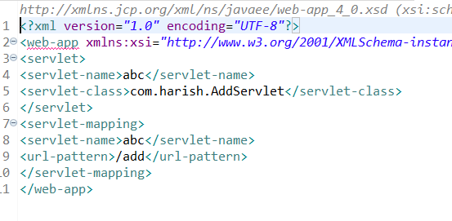  
here AddServlet is the class.

is the class.  
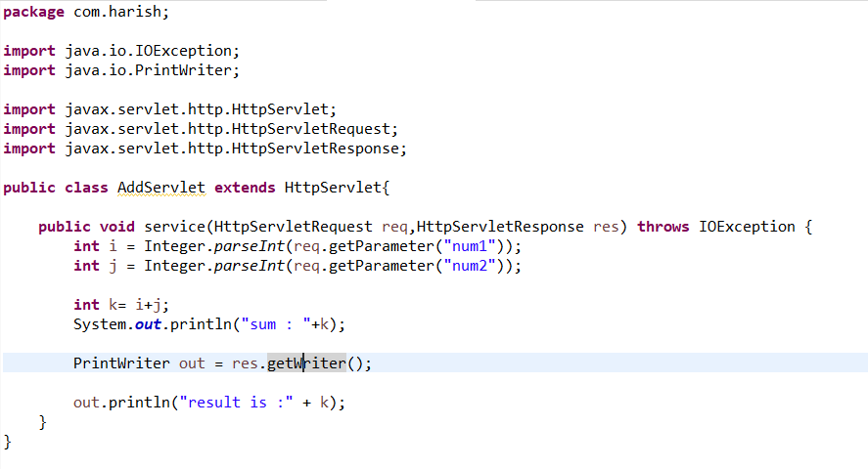

How can we call this from html page ?  
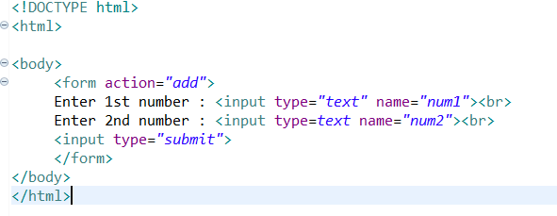

When click on submit it will search for add in web.xml and map it to servlet accordingly.

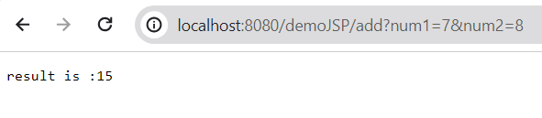

By default it used **get** from HTTP methods. We can use post as well.  
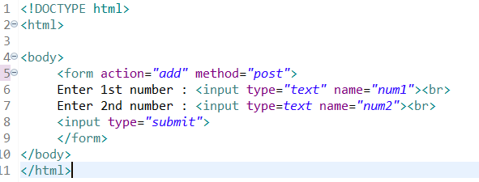

If your servlet wants to use only post/get then you can use doPost()/doGet() instead of service() method.

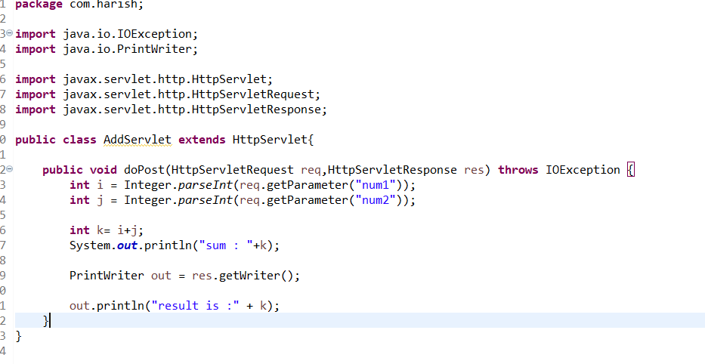

We can call a server inside another server using   
1.request dispatcher  
2.Redirect

**SessionManagement** : for sending data from one server to another server.

1.Reqeust dispatcher – for passing data from one server to another.  
  
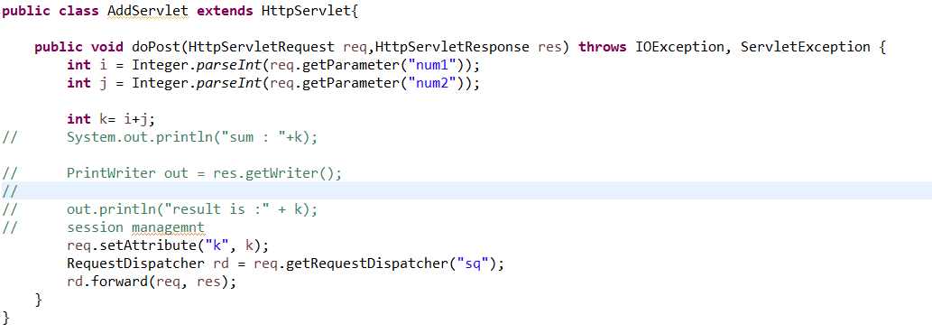

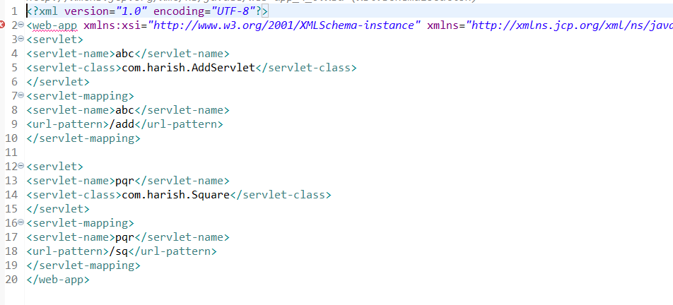

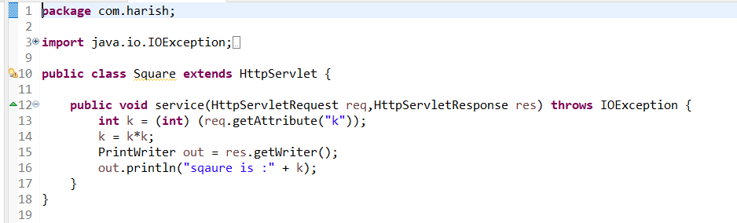\

**May 29, 2024**   
Seen demo on sendredirect() and ways to pass data from one servlet to another servlet.  
  
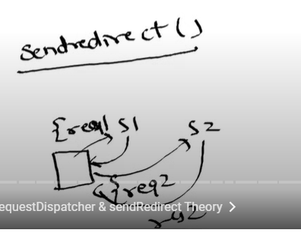

Demo on sendredirect

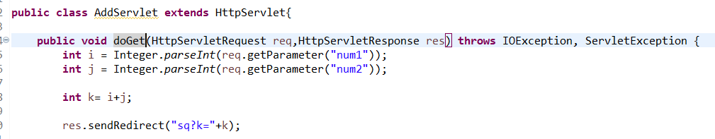

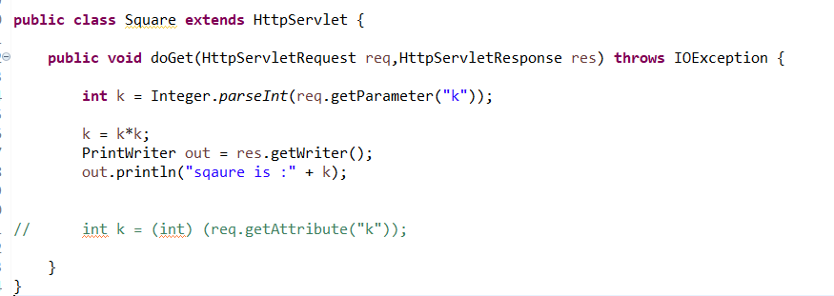

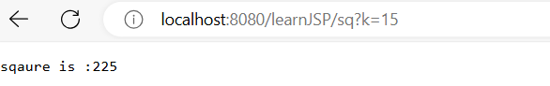

Ways to pass data from one servlet to another servlet is :

1.Url redirect  
2.Http Session  
3.Cookies

In the above code we used URL redirect in addServlet file.  
  
**Demo on Http Session :**

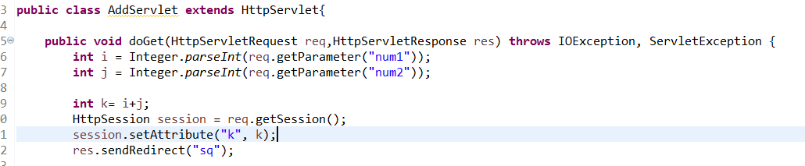

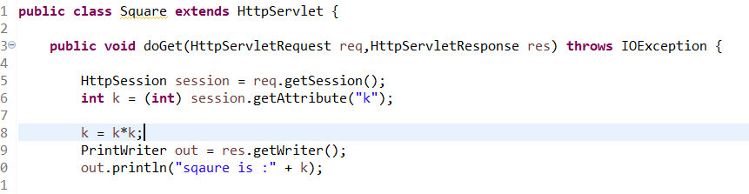

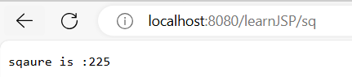

Demo using Cookies

