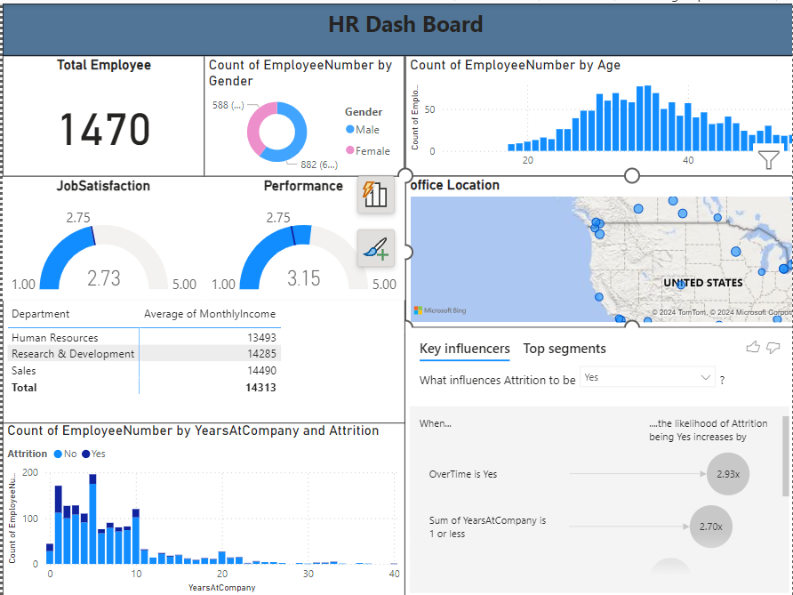
HR
1. Introduction
This personal project aimed to enhance HR reporting capabilities by leveraging the advanced features of Power BI. The project focused on creating a comprehensive, interactive HR dashboard that would provide insights into various HR metrics, such as reasons for employee turnover, performance ratings, and other key indicators. The project was designed to guide users through the create visuals, and perform analyses.
2. Project Objectives
The primary objectives of this project were:
- To enable easy creation of visualizations for HR data.
- To load load Data from Excel to Power BI.
- To create specific reports on reasons for quitting, performance ratings, and turnover analysis.
- To develop an interactive HR dashboard that brings together these reports into a cohesive and user-friendly interface.
3. Project Scope
The scope of this project encompassed the following tasks:
- Loading and preparing HR Data .
- Creating detailed reports on key HR metrics.
- Performing turnover analysis to identify patterns and trends.
- Designing an interactive HR dashboard that consolidates all the reports.
4. Methodology
The project was executed in several phases, each building on the previous one to ensure a structured and comprehensive approach. The methodology involved the following steps:
- Data Collection: Gathering HR data from Free Online Data source .
- Data Preparation: Cleaning and transforming the data to ensure it was suitable for analysis.
- AI Integration: Applying AI capabilities within Power BI to generate insights and enhance data visualizations.
- Report Creation: Developing reports focused on specific HR metrics like turnover rates and performance ratings.
- Dashboard Development: Bringing together the reports into an interactive dashboard.
5. Project Phases
Data Loading and Preparation
The first phase involved loading HR data from different sources into Power BI. This included employee records, performance reviews, and exit interview data. The data was then cleaned, formatted, and integrated into a single model for analysis.
Report Creation
Reports were created to address specific HR questions:
- Reasons for Quitting: Analysis of exit interview data to identify common reasons for employee turnover.
- Performance Rating: Visualization of employee performance ratings across different departments and time periods.
- Turnover Analysis: Detailed analysis of turnover rates, including identification of high-risk groups and predictive modelling.
Turnover Analysis
A focused analysis was conducted to understand the factors contributing to employee turnover.
Dashboard Development
The final phase involved developing an interactive HR dashboard in Power BI. This dashboard integrated all the reports into a single interface, allowing users to explore the data dynamically. Filters and drill-down features were added to enhance interactivity and user experience.
6. Challenges and Solutions
During the project, several challenges were encountered:
- Sampling Bias: Free HR datasets may not be representative of a broader population, especially if they are collected from specific sectors, regions, or types of organizations. This can lead to biased insights that don't generalize well.
- Data Source Bias: The source of the data might introduce bias, especially if it comes from surveys or platforms that cater to specific types of employees (e.g., tech workers), skewing results.
- Dashboard Performance: Ensuring the dashboard was responsive and performed well with large datasets required optimization of data models and visuals.
Results and Findings
The project successfully demonstrated the use of AI in Power BI to enhance HR reporting and analysis. Key findings included:
- Identification of the top reasons for employee turnover.
insights into performance rating distributions across diff The interactive HR dashboard provided a user-friendly platform for HR professionals to explore and analyse data, leading to more informed decision-making. Different departments.

Conclusion
This project showcased the potential of Power BI, particularly its AI capabilities, to revolutionize HR reporting and analysis. By following the structured approach outlined in this report, HR teams can leverage Power BI to gain deeper insights into their data, improve reporting accuracy, and make data-driven decisions.

