BIG BANG THEORY – ASSEMBLY CODE

SHELDON1

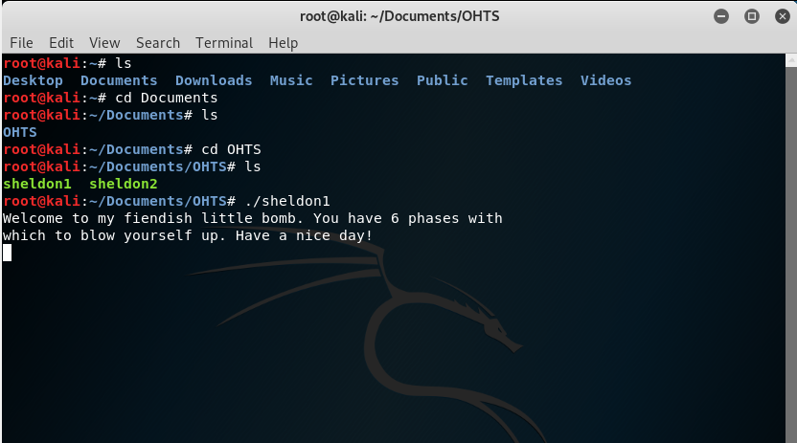

Figure 1: Accessing sheldon1

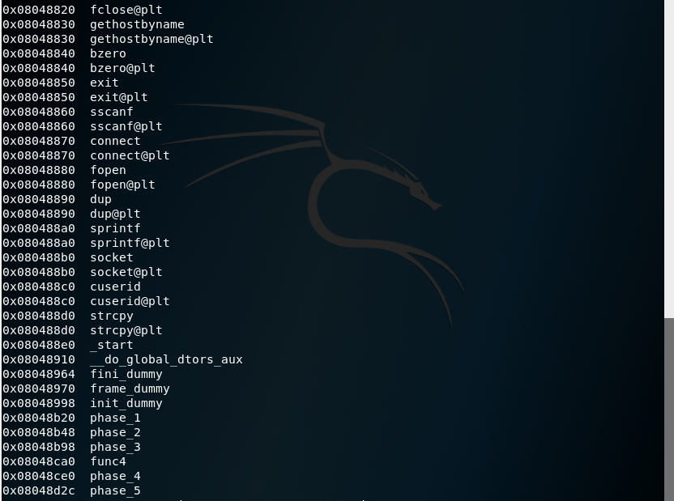

Figure 2: Info functions is able to show the different phases identified

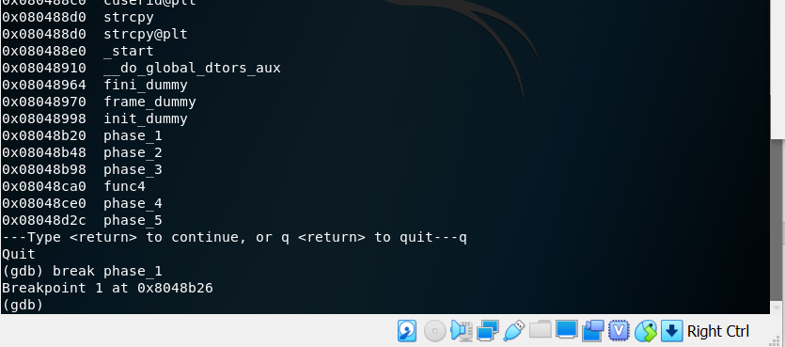

Figure 3: Adding break point at phase_1

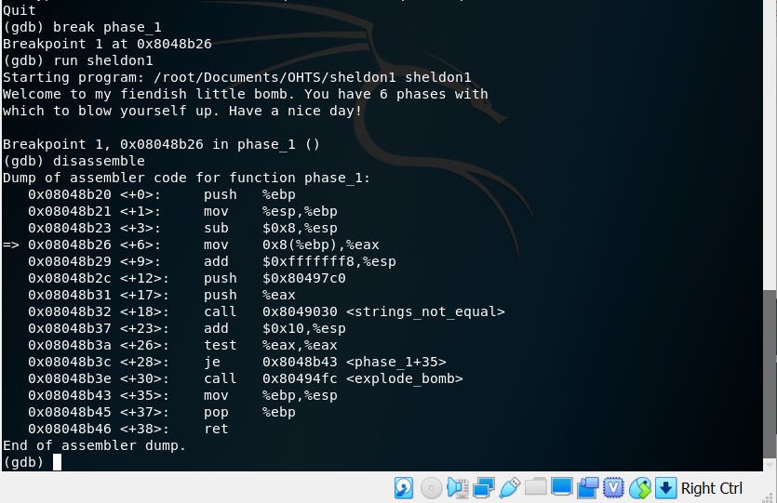

Figure 4: Running sheldon1 and disassembling it