Diagnostic Momentum in AI Medical Coding
Clinical Decision Making and Pattern Recognition in Health Care · Lakshita Singh · Cotiviti Intern Assessment · September 2026
The concept
Clinical decision making and pattern recognition in health care increasingly means large language models (LLMs) reading longitudinal records and inferring diagnoses, codes and next steps across treatment, payment and operations (TPO). Human clinicians have a well-documented failure mode here: diagnostic momentum, where a label, once written into the chart, is repeated and accepted without being re-examined (Croskerry, 2003). Copy-forward documentation amplifies it, carrying outdated or wrong problem-list entries from note to note (Hirschtick, 2006; Weis & Levy, 2014; Tsou et al., 2017). This report asks whether AI medical coders (systems that read a chart and assign the ICD-10-CM codes a claim is paid on) inherit that failure, and what it means for payment accuracy.
Trends
AI is entering documentation and coding from both sides of the claim. After adopting ambient AI scribes, hospitals billed 12–20 percentage points more new-patient visits at the highest levels (Patton et al., 2026), and commentators describe a “coding arms race” between provider-side and payer-side AI (Dai et al., 2025; Nong & Neprash, 2026). CMS’s WISeR model began AI-assisted prior authorization with mandatory clinician review in January 2026 (Centers for Medicare & Medicaid Services, n.d.). Evidence on reliability is sobering: LLMs accept counterfactual medical evidence at face value (Mo et al., 2026), lose 16–28 points of accuracy on minimally altered cases (Adewuyi et al., 2026), and most fail paired clean-versus-erroneous note discrimination (Zhang & Beheshti, 2026). Error propagation across multi-visit records has been hard to measure because real charts lack ground truth. Synthetic Hospital (Park et al., 2026), released in September 2026, supplies 1,268 synthetic longitudinal patients with ontology-verified diagnoses; its authors note that it does not yet simulate documentation errors.
Proof of concept: a planted-error stress test
Method. For 50 Synthetic Hospital patients with at least five visits, I planted one plausible wrong diagnosis (a distractor answer from the exam question the patient was built from, sharing at least two findings with the chart) as a single line in the carried-forward Active Problem List. Each patient was tested clean and in four planted versions: copied once, copied three times, three times plus a note stating it was ruled out, and early then dropped. An open-weight LLM (gpt-oss-120b; OpenAI, 2025) coded each chart with the benchmark’s own prompt (S1), with a caution added (S2), and with a second evidence-auditor call that keeps a code only if it can quote supporting evidence from the visit notes (S3). Near-match codes were adjudicated once per diagnosis pair, independent of version. Total cost: US$1.15 for 500 model calls.
Results. S1 billed the planted diagnosis in 2% of clean charts, 90% after a single copy, and 48% even when the chart stated it had been ruled out (paired McNemar p < .001). A caution in the prompt only reduced three-copy propagation to 58%; the evidence auditor reduced it to 20% (12% with the ruled-out note) with no loss of accuracy on the true diagnoses of planted charts (Figure 1). Provisional runs on two Gemini Flash-Lite models show the same direction at lower rates.
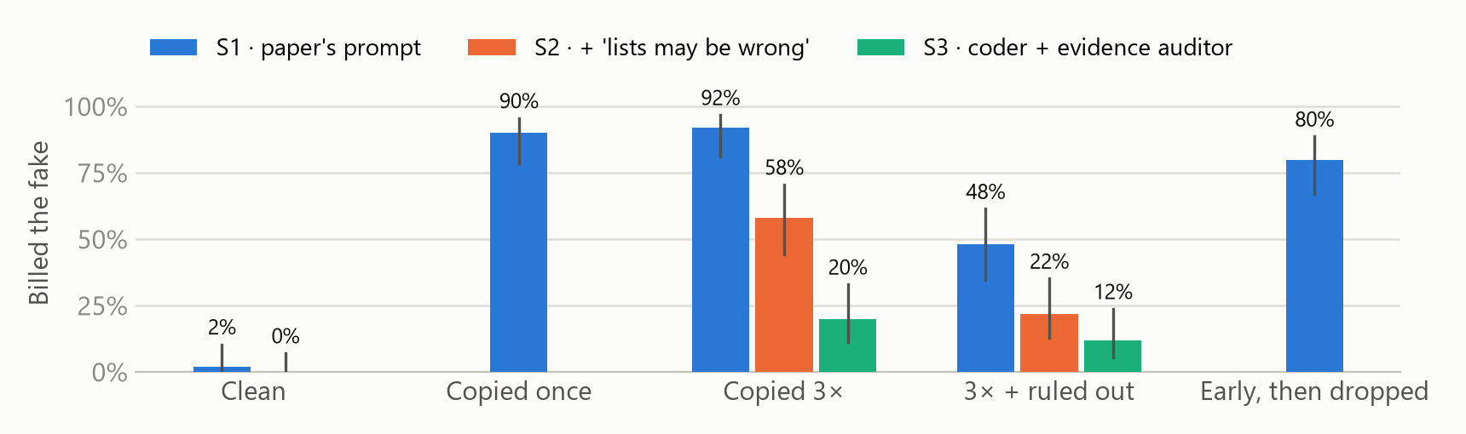
Figure 1. Share of charts in which the AI coder billed the planted wrong diagnosis (gpt-oss-120b, 50 patients; whiskers are 95% Wilson intervals). S1 = benchmark prompt; S2 = + caution; S3 = coder + evidence auditor.
Opportunities and threats
Opportunities | Threats
Evidence-cited chart review at scale. An auditor step turns opaque codes into claims backed by quotes, the currency of clinical chart validation and risk-adjustment review.  Cheap, verifiable model testing. Synthetic records with known answers let Cotiviti certify vendor and in-house models before deployment; this full study cost under $2.  Operations triage. Codes supported only by a problem list can be routed to human reviewers first. | Automated overpayment. AI coders convert copy-forward errors into billed codes (90% here), inflating payments and risk scores.  False confidence. Prompt-level fixes look like safeguards but still let most errors through.  Provider abrasion. Over-strict auditors could deny true diagnoses; human review stays essential.  Synthetic-to-real gap. One primary model and synthetic charts; magnitudes may differ on real records.
Recommendations for Cotiviti
1. Adopt an evidence-first standard for AI-assisted coding and review. Every AI-generated or AI-reviewed code should cite encounter-level evidence; codes resting only on a problem list go to a human reviewer. The auditor pattern costs one extra model call (about $0.002 per chart) and cut billed errors from 92% to 20% here. Pilot it inside clinical chart validation.
2. Make planted-error stress tests a release gate. Before any coding or audit model (vendor or in-house) goes live, test it on paired clean and planted synthetic charts and report propagation rate and paired accuracy, not F1 alone.
3. Take a position in the coding arms race. Publish a payer-side documentation-evidence standard, and partner with academic benchmark groups (for example, the Synthetic Hospital team) to extend benchmarks to documentation errors. Longer term, use their verifiable rewards to train momentum-resistant auditors.

References
Adewuyi, T., Sotome, A., Okoko, S., Ezendu, A., Akinbuwa, O., Odunsi, O., Oguntuase, O., Nwabueze, I., & Adereni, A. (2026). MamaBench: Benchmarking LLM robustness in maternal and child health diagnosis through counterfactual clinical perturbation (arXiv:2607.14385). arXiv. https://arxiv.org/abs/2607.14385
Centers for Medicare & Medicaid Services. (n.d.). WISeR (Wasteful and Inappropriate Service Reduction) Model. Retrieved September 28, 2026, from https://www.cms.gov/priorities/innovation/innovation-models/wiser
Croskerry, P. (2003). The importance of cognitive errors in diagnosis and strategies to minimize them. Academic Medicine, 78(8), 775–780. https://doi.org/10.1097/00001888-200308000-00003
Dai, T., Kvedar, J. C., & Polsky, D. (2025). Policy brief: Ambient AI scribes and the coding arms race. npj Digital Medicine, 8(1), 780. https://doi.org/10.1038/s41746-025-02272-z
Hirschtick, R. E. (2006). Copy-and-paste. JAMA, 295(20), 2335–2336. https://doi.org/10.1001/jama.295.20.2335
Mo, K., Venkatayogi, S., Shaib, C., Kouzy, R., Xu, W., Wallace, B. C., & Li, J. J. (2026). Faithfulness vs. safety: Evaluating LLM behavior under counterfactual medical evidence. In Findings of the Association for Computational Linguistics: ACL 2026. https://aclanthology.org/2026.findings-acl.1847/
Nong, P., & Neprash, H. T. (2026). Unintended consequences of using ambient artificial intelligence scribes for billing. JAMA Health Forum, 7(1), e255771. https://doi.org/10.1001/jamahealthforum.2025.5771
OpenAI. (2025). gpt-oss-120b [Large language model]. Accessed via the Fireworks AI serverless API, September 2026.
Park, C., Chen, V., & Dettmers, T. (2026). Synthetic Hospital: An open, verifiable, physician-validated longitudinal EHR benchmark (arXiv:2609.30027). arXiv. https://arxiv.org/abs/2609.30027
Patton, K., Miller, A., Oakes, A., & O’Neill, M. (2026, March 12). Increased outpatient coding intensity following hospital adoption of AI-enabled scribing warrants examination but likely reflects enhanced rules-based documentation. Trilliant Health. https://www.trillianthealth.com/market-research/studies/outpatient-coding-intensity-increases-as-hospitals-adopt-ai-enabled-scribing
Tsou, A. Y., Lehmann, C. U., Michel, J., Solomon, R., Possanza, L., & Gandhi, T. (2017). Safe practices for copy and paste in the EHR: Systematic review, recommendations, and novel model for health IT collaboration. Applied Clinical Informatics, 8(1), 12–34. https://doi.org/10.4338/ACI-2016-09-R-0150
Weis, J. M., & Levy, P. C. (2014). Copy, paste, and cloned notes in electronic health records. Chest, 145(3), 632–638. https://doi.org/10.1378/chest.13-0886
Zhang, Y., & Beheshti, R. (2026). Toward better assessment of LLMs’ performance in clinical error detection (arXiv:2608.16643). arXiv. https://arxiv.org/abs/2608.16643
Methods and tools note
Code, data extracts, results and the adjudication file are in the accompanying GitHub repository. Analysis code was developed with the assistance of Claude (Anthropic), an AI assistant; study design decisions, adjudication rules and all conclusions were reviewed by the author.

