**GIT Assignment 3**

**Step – 1**

initialize a new Git repository - **'web-api'.**

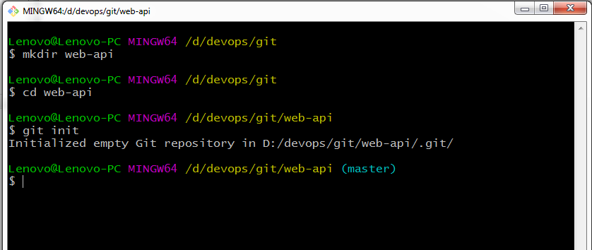

**Step – 2**

Once this new repository – **web-api** is created,

create a mark down file called **'README.md'** that contains "Web-API v1" text.

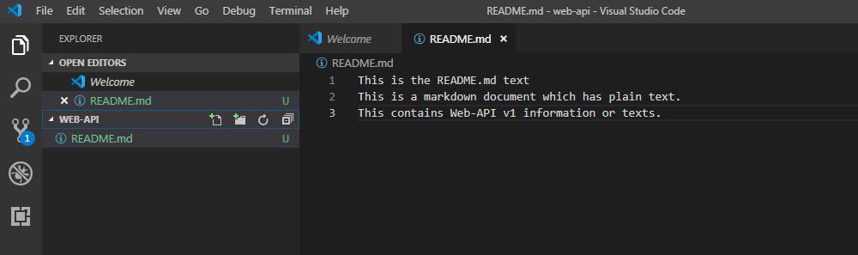

**Step – 3**

Must **Add** the README.md file to the repository and **commit** the changes to the repository.

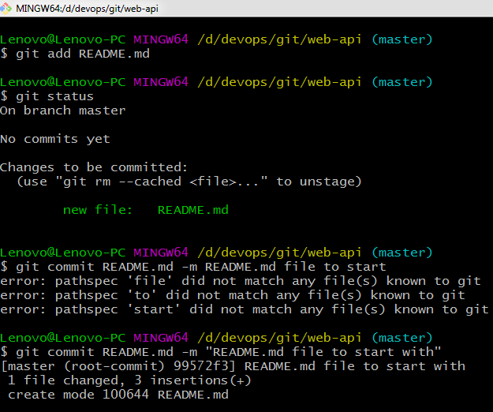

**Step – 4**

Confirm that the default branch is up-to-date with no changes to commit. Can be checked using **git status** command as shown in above screenshot. Then turn it back over to the team for their use.

Can use **git push** and push it to the github specified server where the specific repository kept by the team.

For reference –

Here I have moved it to my github , assuming it has been specified by the developing team.

Also Master branch is clear without anything to commit and is turned over to the team for further commits of files and codes.

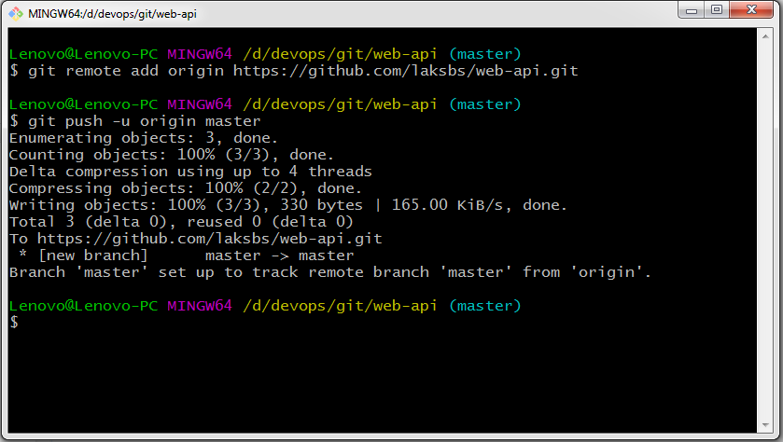

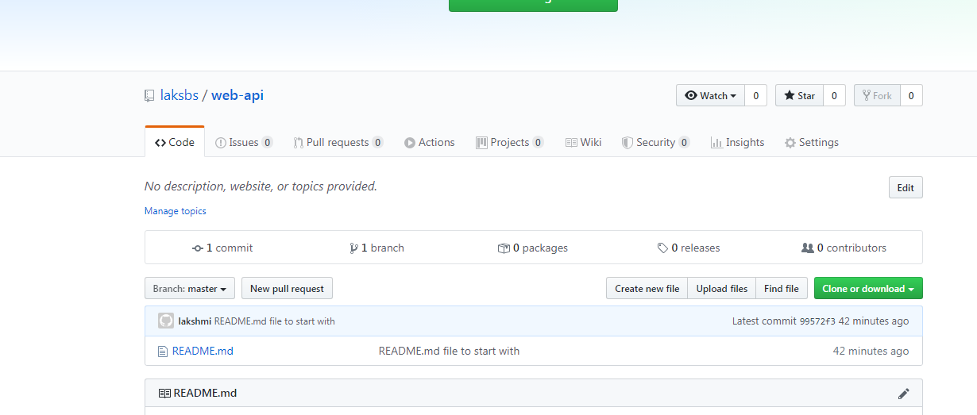

OR

Directly with the given credentials and server details,

Empty repository naming web-api can be created there and README.md file can be created inside it directly by clicking – “Get started by [creating a new file](https://github.com/laksbs/web-api/new/master) “

Which appears once the empty repository is created.