**GIT Assignment 4**

**Step – 1**

Create a branch named as **'fix-readme'** to make changes

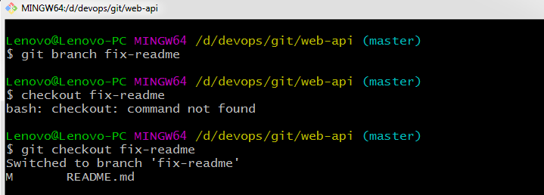

**Step – 2**

Log into the central server used for maintaining the git repository for the web-api, which is located in the home directory, and correct the spelling within the file.

Before editing –

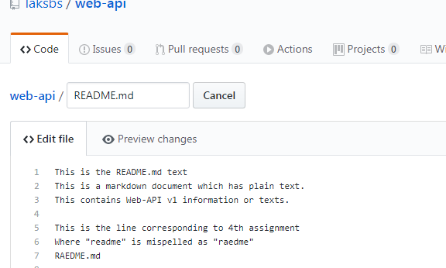

After editing -

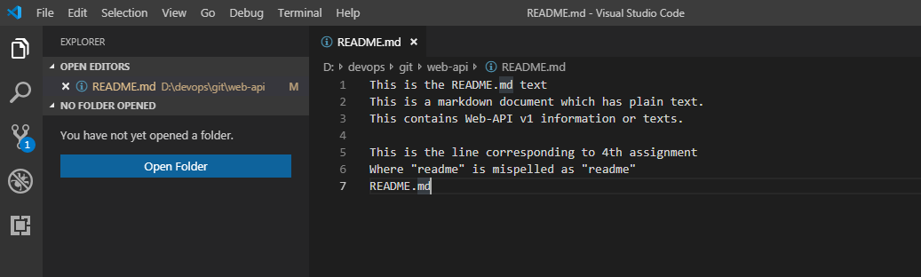

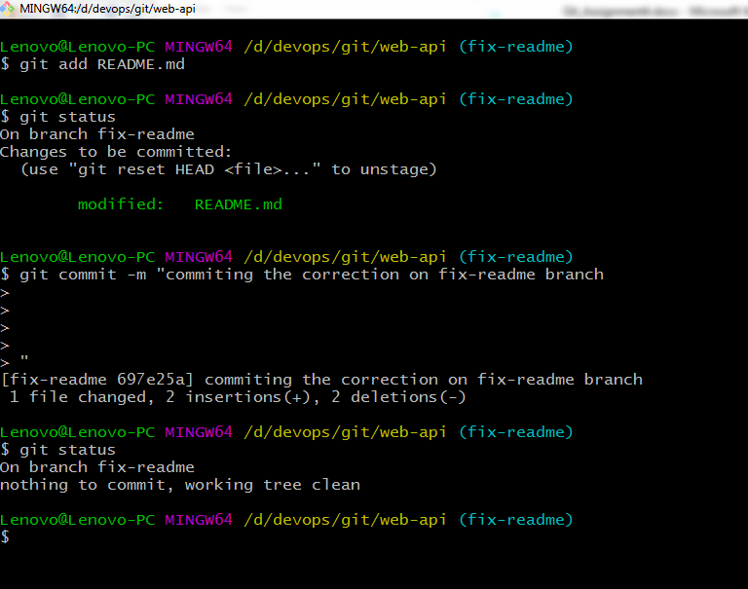

**Step – 3**

Now merge the corrected file back into the master branch once finished.

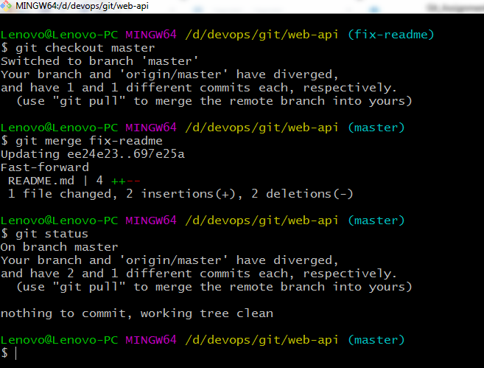

**Step – 4**

Do not remove the branch, once task is completed. To show the branch not deleted use git branch to list all the branches.

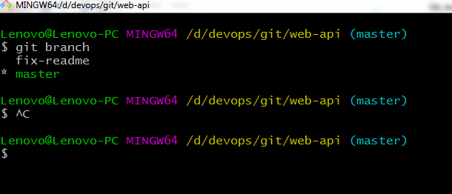

**Step – 5**

After all the above is done must hand the system over to the lead developer for approval. So push the changes to github and allow the changes to reflect.

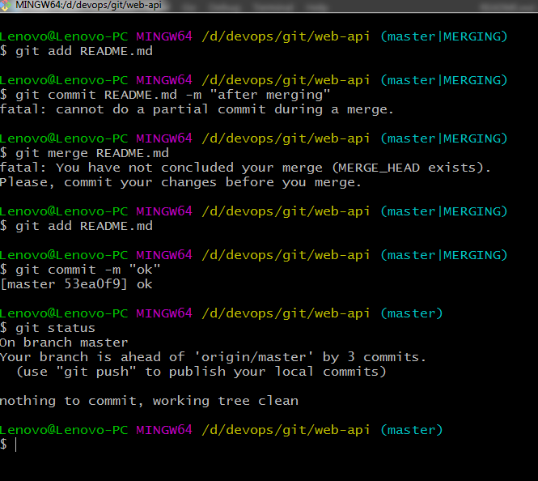

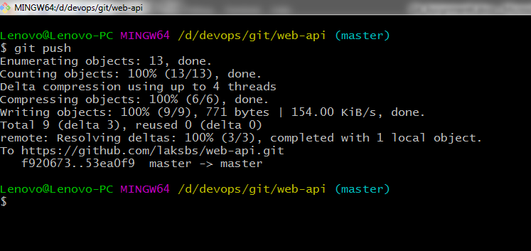

Final changes reflected –

