INDIVIDUAL PROJECT REPORT
Review 1 — Problem Identification & Proposal (24/8/2026)

AI-Driven Edge–Cloud Network for Cyclone Prediction and Resilient Ocean Telemetry

Student | Register No. | Team No. | My role
Anvay Sharma | 24BCE0824 | ________ | Edge gateway and edge intelligence (classification, satellite image analysis, ML models)

Team: Laksh Ahuja (24BDS0212), Anvay Sharma (24BCE0824), Sreehari (24BDS0417). Repository: https://github.com/laksh-ahuja06/AI-DRIVEN-EDGE-CLOUD-NETWORK

Summary
Our project is a cyclone-monitoring network that must work over slow, lossy links. In this report I explain the problem from the point of view of the network edge: deciding at the gateway which data is urgent, and reducing heavy satellite images to the information that actually matters before they consume the backbone. I present the evidence, the literature I surveyed, our proposed solution and my plan.

1. Problem Statement
Edge devices in a cyclone-monitoring network forward everything they receive, in arrival order and at full size, so a multi-megabyte satellite image or a routine reading can delay the one packet that shows a storm is intensifying.
• Why it matters: the earlier a dangerous trend is recognised, the more time there is to warn and evacuate.
• Who is affected: fishing communities and coastal residents, and meteorological and disaster agencies that depend on near-real-time data.
• If unsolved: a threshold-only system gives zero warning before a threshold is crossed, and raw images can saturate the link for many minutes.

Objectives of My Part
Objective | Measurable success criterion
Classify every packet at the gateway as CRITICAL or NORMAL | No breach of 60 km/h / 990 hPa missed
Warn before thresholds are crossed using the trend of readings | Positive lead time in test scenarios
Cut satellite data sent over the backbone | > 95 % fewer bytes than the raw frame
Gateway that never crashes on bad input | Malformed packets counted and dropped
Fair, repeatable evaluation of every model | Held-out scenarios and a simple baseline for each

2. Evidence the Problem is Real
Table 1: Evidence that the problem is real
Source | Published fact | Why it matters for my part
India Meteorological Department [1] | India has a coastline of about 7,500 km; the 1999 Odisha super cyclone caused about 10,000 deaths. | The scale of exposure makes early warning valuable.
WMO Atlas 1970–2019 [2] | Tropical cyclones are among the leading causes of human and economic losses from weather, climate and water extremes. | Losses justify investing in faster, smarter edge decisions.
Engineering estimate (our calculation) | A 4-band 16-bit frame at 512 × 512 pixels is 2,097,152 bytes; lossless compression typically removes only a fraction of that for noisy imagery. | Sending images unprocessed is not viable; edge analysis must cut data volume by orders of magnitude.

3. Literature Survey
Table 2: Literature survey (15 articles)
# | Author / Year | Method used | Result | Limitation
1 | Dvorak, 1975 [3] | Analyst reads cloud patterns in satellite images | Global operational standard | Subjective; needs experts
2 | Velden et al., 2006 [4] | 30-year review of the Dvorak technique | Documents accuracy and pitfalls | No automation for edge devices
3 | Olander & Velden, 2007 [5] | Advanced Dvorak Technique (objective, IR) | Automated intensity estimates | Runs centrally on full images
4 | Pradhan et al., 2018 [6] | Deep CNN on IR imagery | Learned intensity estimation | Needs GPU and large labelled data
5 | Chen et al., 2019 [7] | CNN using multi-channel satellite data | Improved intensity estimates | Heavy model; central processing
6 | Chen et al., 2020 [8] | Review of ML in cyclone forecasting | Maps ML methods to forecast tasks | No network or edge aspect
7 | Denby & Lucia, 2020 [9] | Orbital edge computing on nanosatellites | Process imagery where it is captured | Space segment, not ground stations
8 | Giuffrida et al., 2022 [10] | On-board DNN filters cloudy images (Φ-Sat-1) | Saves downlink by discarding useless data | Cloud screening only, not storm features
9 | Hochreiter & Schmidhuber, 1997 [11] | LSTM recurrent network | Learns long time dependencies | Generic; needs a framework
10 | Lim & Zohren, 2021 [12] | Survey of deep time-series forecasting | Compares RNN, attention, hybrids | Not edge-constrained
11 | Chen & Guestrin, 2016 [13] | Gradient-boosted trees (XGBoost) | Strong tabular classifier | Less transparent than linear models
12 | Shi et al., 2016 [14] | Edge computing vision | Motivates edge analytics | No algorithms
13 | Mao et al., 2017 [15] | Mobile edge computing survey | Offloading decisions at the edge | Cellular focus
14 | Shelby et al., 2014 [16] | CoAP protocol | Compact messages for constrained devices | No content-aware priority
15 | Blake et al., 1998 [17] | DiffServ traffic classes | Class-based forwarding | Static classification

Gap: image-based cyclone analysis (Dvorak, ADT, CNNs) runs centrally on full images, and on-board satellite AI so far only screens out cloudy frames. Network classification uses fixed rules on current values. Nobody we found extracts storm features at the ground station and sends only those, or uses the trend of a sensor's readings at the gateway to raise priority before a threshold is crossed. These two ideas are my contribution to the project.

4. Proposed Solution Form
Form: coding and modelling. The edge gateway and the edge-AI functions are software by nature. We will first build a rule-based gateway (thresholds on wind and pressure) so the pipeline can be verified, then add lightweight models that can run on a laptop or a Raspberry Pi. A hardware-first approach was rejected because the decisions at the edge must be tested on many storm scenarios, which only simulation provides.
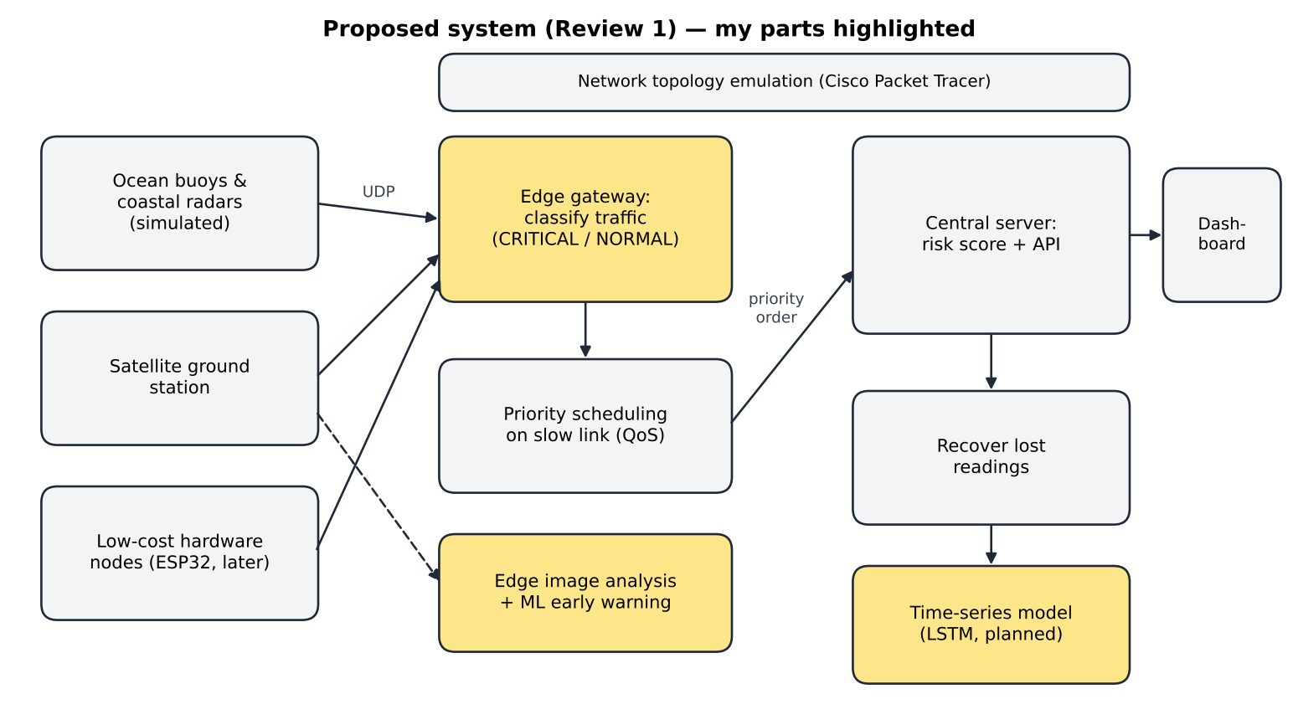
Figure 1: Proposed block diagram; my parts (gateway classification, edge image analysis, ML / LSTM) are highlighted

Planned Method for My Part
Component | Planned method
Gateway | Two threads — receiver and forwarder — joined by a priority queue; threshold rule first so the pipeline can be verified.
Early warning | Features from the last few readings (pressure falling, wind rising, distance to the thresholds) fed to a small, explainable classifier.
Satellite images | Extract the cues forecasters use — cold cloud tops, symmetry, an eye — at the ground station and send only those numbers.
Evaluation | Compare every model with a simple baseline on scenarios it has not seen.

5. Initial Technical Feasibility
Table 3: Feasibility of my part
Area | Status
Skills I have | Python, NumPy, basic machine learning (regression, classification), threading
Skills I must learn | Image processing on multi-band data, recurrent networks (LSTM) and how to train them, evaluating models fairly (held-out data, baselines)
Tools needed / access | Python, NumPy, Matplotlib (free); laptop CPU is enough for small models; real satellite imagery from public portals (MOSDAC) later
Risks | No labelled satellite data (mitigation: synthetic frames with known intensity); ML may raise false alarms (mitigation: keep the threshold rule as a safety floor); deep-learning frameworks may be too heavy for edge devices

Table 4: Risk register for my part
Risk | Likelihood | Impact | Mitigation
No labelled satellite images | High | High | Synthetic frames with known storm intensity
ML classifier raises false alarms | Medium | Medium | Keep the threshold rule as a safety floor
Deep-learning frameworks too heavy for the edge | Medium | Medium | Prefer small NumPy models
Gateway crashes on bad packets | Medium | High | Validate every packet before use

6. Team Role Split and Timeline to Review 2
Table 5: Team role split
Member | Role | Specific tasks (R1 → R3)
Laksh Ahuja (24BDS0212) | Central server, dashboard & network QoS | Prediction server and REST API, live dashboard, priority scheduling on the slow link, cyclone simulation model, demo launcher, automated testing
Anvay Sharma (24BCE0824) | Edge gateway & edge intelligence | Gateway classification and forwarding, satellite image analysis at the edge, ML early-warning classifier, LSTM implementation, evaluation and logs
Sreehari (24BDS0417) | Sensing layer, hardware & data recovery | Sensor-node and satellite-station simulators, packet-loss model, reconstruction of lost readings, model training data, ESP32 hardware nodes

My role is the intelligence at the edge: the gateway that classifies and forwards each packet, and the models that let it recognise danger early and shrink satellite data.
Table 6: My weekly plan from Review 1 to Review 2
Week | Dates | My milestone | Deliverable / check
1 | 25–31 Aug | Define CRITICAL / NORMAL classes and thresholds with the team; design the gateway threads (receiver + forwarder) | Design note and agreed record format
2 | 1–7 Sep | Implement the gateway: UDP receive, threshold classification, priority queue | Gateway forwards packets in priority order
3 | 8–14 Sep | Alert mode (throttle normal traffic during an alert); integration with sensors and server; literature study for the ML classifier | Gateway shown in the Review 2 demo

R1 Video Plan
Segment | What I show
Problem and evidence (1.5 min) | Face + screen; IMD / WMO evidence and the problem statement
Literature gap (1.5 min) | Face + screen; literature table and the gap
Proposed solution and feasibility (2 min) | Face + screen; block diagram and feasibility table
My role and timeline (1 min) | Face + screen; role table and weekly plan

References
[1] India Meteorological Department, "Cyclone eAtlas" and Regional Specialised Meteorological Centre (Tropical Cyclones) reports, New Delhi. [Online]. Available: https://rsmcnewdelhi.imd.gov.in
[2] World Meteorological Organization, WMO Atlas of Mortality and Economic Losses from Weather, Climate and Water Extremes (1970–2019), WMO-No. 1267, Geneva, 2021.
[3] V. F. Dvorak, "Tropical cyclone intensity analysis and forecasting from satellite imagery," Monthly Weather Review, vol. 103, no. 5, pp. 420–430, 1975.
[4] C. Velden et al., "The Dvorak tropical cyclone intensity estimation technique: A satellite-based method that has endured for over 30 years," Bull. Amer. Meteor. Soc., vol. 87, no. 9, pp. 1195–1210, 2006.
[5] T. L. Olander and C. S. Velden, "The Advanced Dvorak Technique: Continued development of an objective scheme to estimate tropical cyclone intensity using geostationary infrared satellite imagery," Weather and Forecasting, vol. 22, no. 2, pp. 287–298, 2007.
[6] R. Pradhan, R. S. Aygun, M. Maskey, R. Ramachandran, and D. J. Cecil, "Tropical cyclone intensity estimation using a deep convolutional neural network," IEEE Trans. Image Processing, vol. 27, no. 2, pp. 692–702, 2018.
[7] B.-F. Chen, B. Chen, H.-T. Lin, and R. L. Elsberry, "Estimating tropical cyclone intensity by satellite imagery utilizing convolutional neural networks," Weather and Forecasting, vol. 34, no. 2, pp. 447–465, 2019.
[8] R. Chen, W. Zhang, and X. Wang, "Machine learning in tropical cyclone forecast modeling: A review," Atmosphere, vol. 11, no. 7, art. 676, 2020.
[9] B. Denby and B. Lucia, "Orbital edge computing: Nanosatellite constellations as a new class of computer system," in Proc. ACM ASPLOS, 2020.
[10] G. Giuffrida et al., "The Φ-Sat-1 mission: The first on-board deep neural network demonstrator for satellite Earth observation," IEEE Trans. Geoscience and Remote Sensing, vol. 60, 2022.
[11] S. Hochreiter and J. Schmidhuber, "Long short-term memory," Neural Computation, vol. 9, no. 8, pp. 1735–1780, 1997.
[12] B. Lim and S. Zohren, "Time-series forecasting with deep learning: A survey," Philosophical Transactions of the Royal Society A, vol. 379, art. 20200209, 2021.
[13] T. Chen and C. Guestrin, "XGBoost: A scalable tree boosting system," in Proc. ACM KDD, 2016, pp. 785–794.
[14] W. Shi, J. Cao, Q. Zhang, Y. Li, and L. Xu, "Edge computing: Vision and challenges," IEEE Internet of Things Journal, vol. 3, no. 5, pp. 637–646, 2016.
[15] Y. Mao, C. You, J. Zhang, K. Huang, and K. B. Letaief, "A survey on mobile edge computing: The communication perspective," IEEE Communications Surveys & Tutorials, vol. 19, no. 4, pp. 2322–2358, 2017.
[16] Z. Shelby, K. Hartke, and C. Bormann, "The Constrained Application Protocol (CoAP)," IETF RFC 7252, 2014.
[17] S. Blake, D. Black, M. Carlson, E. Davies, Z. Wang, and W. Weiss, "An architecture for differentiated services," IETF RFC 2475, 1998.

