INDIVIDUAL PROJECT REPORT
Review 2 — Design, Development & Progress (14/9/2026)

AI-Driven Edge–Cloud Network for Cyclone Prediction and Resilient Ocean Telemetry

Student | Register No. | Team No. | My role
Anvay Sharma | 24BCE0824 | ________ | Edge gateway and edge intelligence

Team: Laksh Ahuja (24BDS0212), Anvay Sharma (24BCE0824), Sreehari (24BDS0417). Repository: https://github.com/laksh-ahuja06/AI-DRIVEN-EDGE-CLOUD-NETWORK

Summary
Since Review 1 I built the edge gateway of our prototype: it receives every sensor packet, classifies it as CRITICAL or NORMAL against cyclone thresholds, forwards critical packets first through a priority queue, and throttles normal traffic while a cyclone alert is active. This report covers the gateway's design, the working code, my design choices, feasibility, the problems I found by testing it, and my contribution.

1. Detailed Design
The gateway has two threads (Figure 1). The receiver reads UDP port 9001, decodes the record, classifies it and pushes (priority, order, record) into a priority queue. The forwarder takes the highest-priority record and sends it to the server on port 9002; while an alert is active, each NORMAL packet waits 0.5 s first. The alert switches on with any CRITICAL packet and clears after 10 s without one.
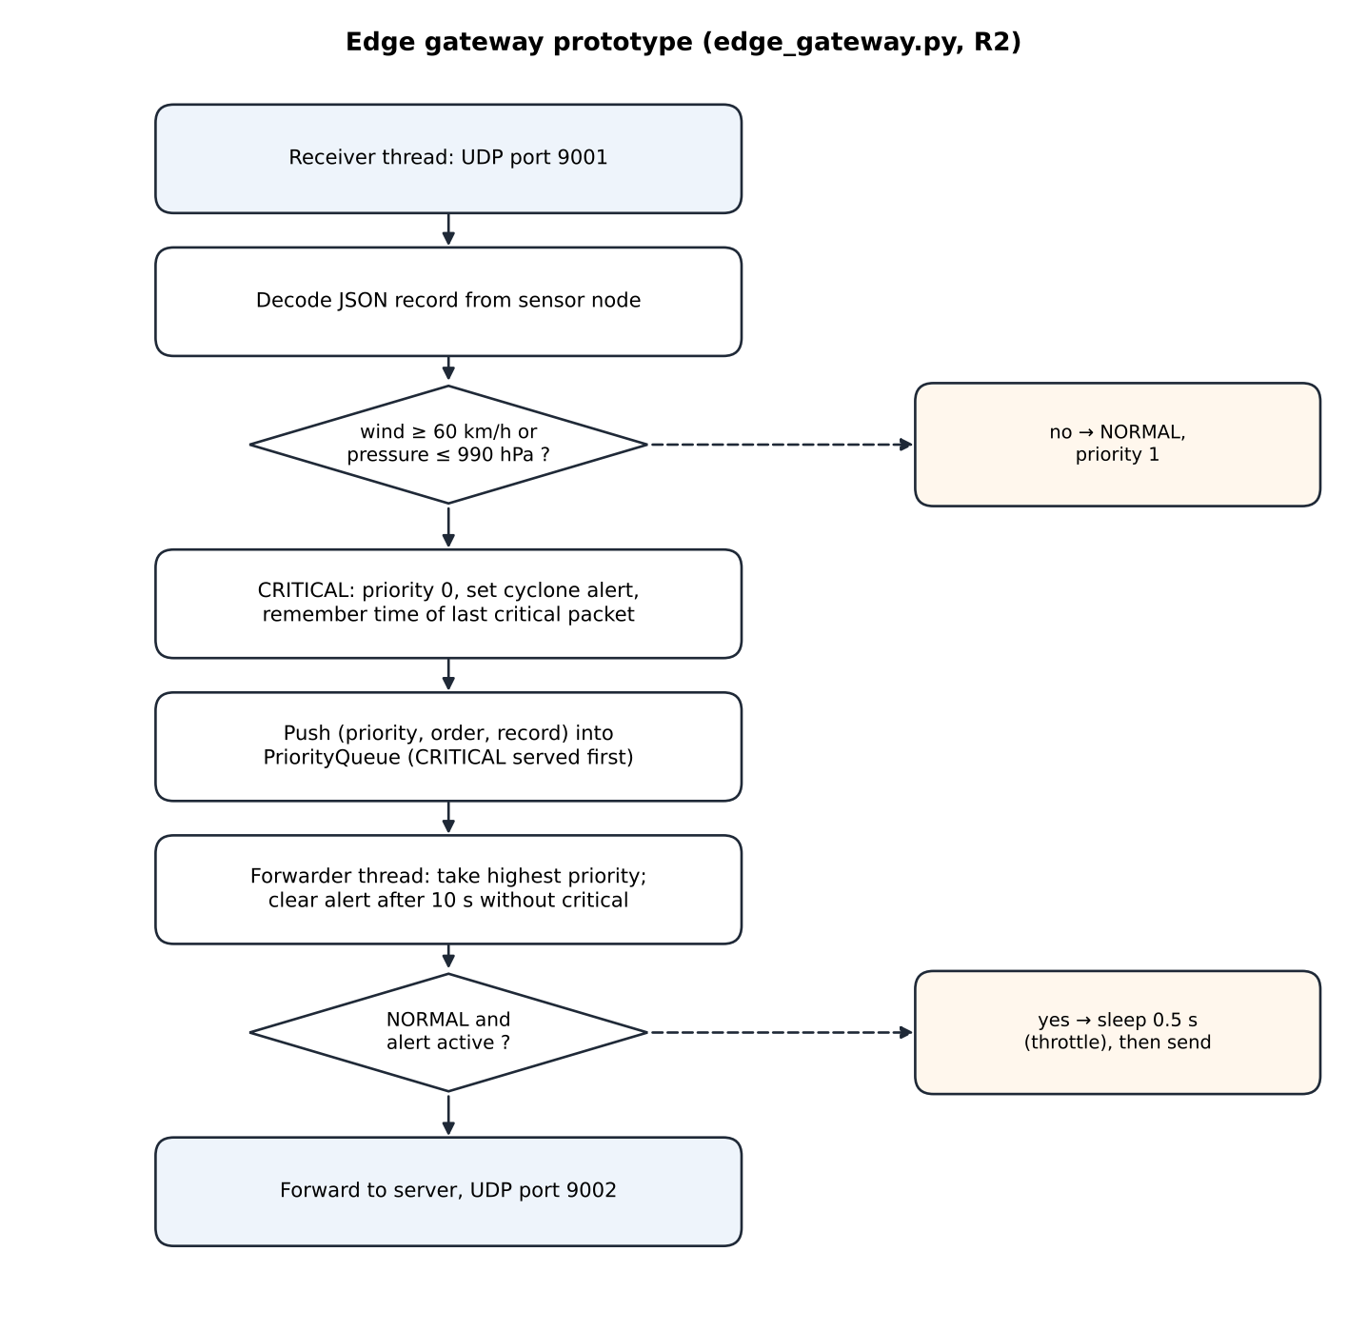
Figure 1: Flowchart of my edge gateway (prototype)
Table 1: Labelled parameters of my module
Parameter | Value | Meaning
SENSOR_TO_GATEWAY_PORT | 9001 (UDP) | Input from sensor nodes
GATEWAY_TO_SERVER_PORT | 9002 (UDP) | Output to the central server
WIND_CRITICAL_THRESHOLD | 60 km/h | CRITICAL if wind ≥ this
PRESSURE_CRITICAL_THRESHOLD | 990 hPa | CRITICAL if pressure ≤ this
Priority | 0 = CRITICAL, 1 = NORMAL | Lower value served first; insertion order breaks ties
ALERT_HOLD_SECONDS | 10 s | Alert stays on this long after the last CRITICAL packet
Throttle | 0.5 s per NORMAL packet | Applied only while the alert is active

2. Actual Working Progress since Review 1
• Code committed: edge_gateway.py (101 lines) and the classify_traffic() rule in common.py, commit 82bcb8a.
• Running: the gateway receives from three nodes and forwards in priority order; the log shows the alert switching on and NORMAL packets being throttled.
• Studied for the next phase: trend-based ML classification and satellite feature extraction (literature from Review 1).
def classify_traffic(record):
if record["wind"] >= WIND_CRITICAL_THRESHOLD or record["pressure"] <= PRESSURE_CRITICAL_THRESHOLD:
return TRAFFIC_CRITICAL
return TRAFFIC_NORMAL

# forwarder thread
_priority, _order, record = pq.get()
if record["traffic_class"] != TRAFFIC_CRITICAL and cyclone_alert.is_set():
time.sleep(0.5) # reserve bandwidth for critical traffic
sock.sendto(encode(record), (HOST, GATEWAY_TO_SERVER_PORT))

To produce dated evidence for this report, the Review 2 prototype (repository commit 82bcb8a, 16/9/2026) was re-run unchanged with three sensor nodes for 60 seconds; the logs are in docs/reports/evidence/r2_prototype/. The team's original 12-second test reported 66 packets received, 11 reconstructed and 2 critical, with overall risk 100 and the alert active.
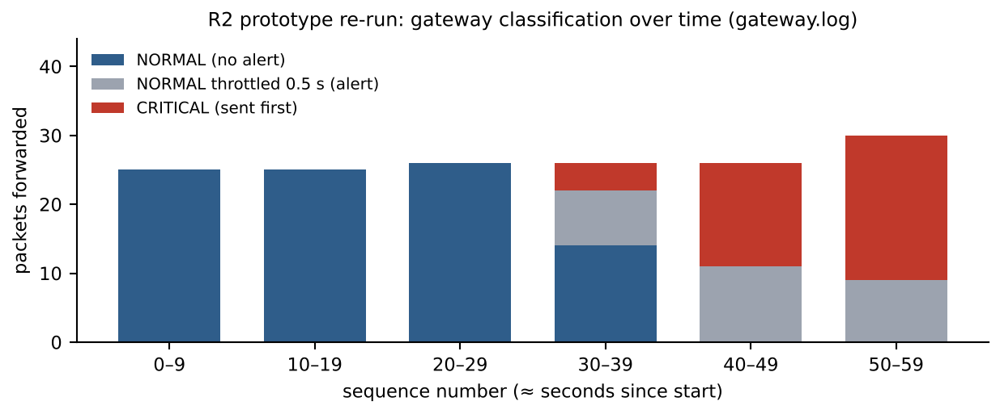
Figure 2: Classification over time in the re-run (from my gateway's log)
In the re-run the gateway forwarded 160 packets: 42 CRITICAL packets were sent immediately, and 28 NORMAL packets were throttled during the alert.
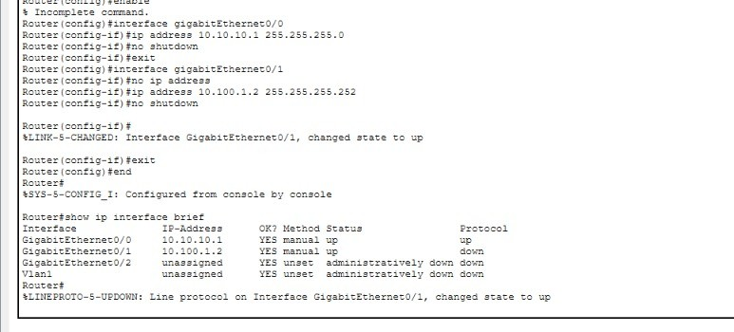
Figure 3: Ocean-side router of the team's Packet Tracer topology (joint work); this is the edge of the network where my gateway sits
Completion: about 40 % of my planned scope. Done: gateway pipeline, threshold classification, priority forwarding, alert mode. Remaining: input validation, an ML early-warning classifier, satellite image feature extraction, an LSTM for missing data, and a proper evaluation.
Table 2: Test runs performed on my module
Test run | Setup | Observation
Team test, 12 s, 2 nodes | Gateway between sensors and server | 2 packets classified CRITICAL once wind > 60
Re-run, 60 s, 3 nodes | Prototype commit 82bcb8a | 160 forwarded; 42 CRITICAL sent first; 28 NORMAL throttled
Robustness test | One non-JSON datagram to port 9001 | Receiver thread died; later packets ignored
Alert-hold check | Code review of the forwarder loop | Alert can be stale after a silent period

3. Justification of Design Choices
Table 3: Comparison of alternatives for my module
Choice | Option | Accuracy / quality | Compute & power | Ease | Decision
Classifier | Threshold rule | Exact on breaches; no early warning | Negligible | Very easy | Chosen now
 | Logistic regression on trends | Can warn before breach | Very low | Easy | Next phase
 | Deep network | Possibly best | High; needs GPU/data | Hard | Rejected
Forwarding | FIFO queue | Critical waits behind others | Low | Easiest | Rejected
 | Fixed bandwidth cap per class | Wastes capacity when idle | Low | Easy | Rejected
 | Priority queue | Critical first, adapts instantly | Low | Easy | Chosen
Language | Python threads | Fast enough at our rates | Runs on laptop / Pi | Easy | Chosen

4. Updated Feasibility
Table 4: Economic picture for my part
Aspect | Review 1 estimate | Now (Review 2) | Reason
Software cost | ₹0 | ₹0 | Python standard library only
Edge hardware | Laptop or Raspberry Pi | Laptop; Pi optional (lab) | Gateway uses < 1 % CPU
ML compute | Possibly GPU | CPU only | Lightweight models chosen to fit the edge

Social: earlier recognition of danger directly benefits people who must evacuate. Environmental: choosing small CPU models instead of GPU training keeps energy use low, and prioritising data avoids wasteful retransmissions on remote links.

5. Problems Encountered and How I Adapted
Table 5: Problems in my module
Problem | How I diagnosed it | What I changed | Result
A malformed packet stopped the gateway | Sent a non-JSON datagram while testing: the receiver thread raised an exception in decode() and died; later valid packets were ignored | Added a validation step to the design (check fields and ranges, count and drop bad packets) | To be implemented next; logged as the top fix
NORMAL packets delayed even on an idle link | Log showed 28 NORMAL packets each waiting 0.5 s during the alert although the queue was empty; a fixed sleep ignores real link capacity | Plan a capacity-based scheduler (token bucket) instead of a fixed sleep | Behaviour understood; redesign scheduled
Alert state can be stale | Code review: the alert is cleared only before the forwarder blocks on the queue, so a NORMAL packet arriving after a long silence is still throttled | Re-check the alert after every dequeue in the redesign | Identified before it affected a demo

Plan from Review 2 to Review 3
Week | Planned work
15–21 Sep | Input validation and capacity-based forwarding in the gateway
22–28 Sep | Trend-based ML classifier (logistic regression) with the rule as safety floor
29 Sep–5 Oct | Satellite feature extraction; LSTM implementation in NumPy
6–9 Oct | Evaluation harness, results tables, trained models in the repository

6. Individual Contribution Evidence
Table 6: Division of work
Tasks I did | Tasks done by teammates
Edge gateway: receiver and forwarder threads, priority queue | Laksh: central server, REST API, dashboard, startup fix
CRITICAL / NORMAL rule (classify_traffic) and alert mode | Sreehari: sensor-node simulator and gap interpolation
Robustness testing of the gateway (malformed input, throttling) | Team: shared record format, Packet Tracer topology

• Code: edge_gateway.py and classify_traffic() in common.py, commit 82bcb8a (https://github.com/laksh-ahuja06/AI-DRIVEN-EDGE-CLOUD-NETWORK).
• Logs: gateway.log and crash_gw.log in docs/reports/evidence/r2_prototype/.
[Insert here: screenshot of my own commits / work log and a photo or screen recording of me testing. Note: the team's early commits were pushed from one shared GitHub account, so the file-level split above is the record of who wrote what.]

R2 Video Plan
Segment | What I show
Design walkthrough (2 min) | Face + screen; flowchart and parameter table
Live progress with my own work on screen (2 min) | Face + screen; code running and the logs
One problem and its solution (1 min) | Face + screen; the problem table and the evidence log
Updated cost and my contribution (1 min) | Face + screen; cost table and the division-of-work table

