INDIVIDUAL PROJECT REPORT
Review 1 — Problem Identification & Proposal (24/8/2026)

AI-Driven Edge–Cloud Network for Cyclone Prediction and Resilient Ocean Telemetry

Student | Register No. | Team No. | My role
Laksh Ahuja | 24BDS0212 | ________ | Central server, dashboard, network QoS, cyclone simulation and testing

Team: Laksh Ahuja (24BDS0212), Anvay Sharma (24BCE0824), Sreehari (24BDS0417). Repository: https://github.com/laksh-ahuja06/AI-DRIVEN-EDGE-CLOUD-NETWORK

Summary
This report states the problem our team is solving, the evidence that it is real, what earlier work has tried, and the solution we propose. My own focus is the back half of the system: how cyclone telemetry should be prioritised on a slow link, and how a central server should turn incomplete data into a reliable cyclone-risk picture on a live dashboard.

1. Problem Statement
During a cyclone, ocean buoys and coastal stations must push their readings over slow, unreliable links, so the most important readings arrive late or not at all — exactly when forecasters and coastal residents need them most.
• Why it matters: cyclone warnings save lives only if they are timely; stale or missing pressure and wind data delays evacuation decisions.
• Who is affected: coastal and island communities and fishers on India's east coast, and the district disaster-management officials who order evacuations.
• If unsolved: a monitoring network treats a routine battery report and a falling-pressure alarm equally; under congestion, critical readings queue behind unimportant data, and gaps from packet loss leave the dashboard blank or wrong during the critical hours.

Objectives of My Part
Objective | Measurable success criterion
Server keeps a per-node history and detects every missing sequence number | 100 % of gaps detected in test runs
Fused cyclone-risk output and alert available through an API | /predict answers in < 1 s; alert at risk ≥ 60
Critical readings forwarded ahead of routine traffic on a slow link | Critical latency well below normal traffic under load
Live dashboard that shows estimated vs measured data | Updates at least every 2 s
Network topology emulated with routing | End-to-end ping buoy → server succeeds

2. Evidence the Problem is Real
Table 1: Evidence that the problem is real
Source | Published fact | Why it matters for my part
India Meteorological Department [1] | India has a coastline of about 7,500 km; the 1999 Odisha super cyclone caused about 10,000 deaths. | A large exposed population depends on timely data from coastal sensors.
WMO Atlas 1970–2019 [2] | Tropical cyclones are among the leading causes of human and economic losses from weather, climate and water extremes. | The cost of a late warning is measured in lives and livelihoods.
Engineering estimate (our calculation) | One 4-band, 16-bit satellite frame of 512 × 512 pixels is about 2.1 MB; on a 9.6 kbps satellite backhaul that alone would take roughly half an hour to send. | Shows why the network must decide what to send first — the core of my QoS work.

3. Literature Survey
Table 2: Literature survey (15 articles)
# | Author / Year | Method used | Result | Limitation
1 | Shi et al., 2016 [3] | Edge computing vision paper | Defines edge tier, motivates local processing | No concrete scheduling policy
2 | Satyanarayanan, 2017 [4] | Cloudlet / edge architecture | Lower latency and backhaul load | General purpose; no disaster focus
3 | Mao et al., 2017 [5] | Survey of mobile edge computing | Taxonomy of offloading and resource allocation | Cellular setting; not lossy marine links
4 | Bonomi et al., 2012 [6] | Fog computing for IoT | Argues for a layer between devices and cloud | Position paper; no evaluation
5 | Al-Fuqaha et al., 2015 [7] | IoT protocol survey | Compares MQTT, CoAP and others | No prioritisation by event severity
6 | Xu et al., 2019 [8] | Review of marine IoT monitoring | Catalogues ocean sensing systems | Little on congestion or data gaps
7 | Blake et al., 1998 [9] | DiffServ class-based QoS | Scalable per-hop priority | Classes fixed in advance
8 | Floyd & Jacobson, 1993 [10] | Random early detection | Keeps queues short | Drops are blind to importance
9 | Shreedhar & Varghese, 1996 [11] | Deficit round-robin | Fair sharing in O(1) | Fairness, not urgency
10 | Lantz et al., 2010 [12] | Mininet emulation | Realistic networks on one laptop | Tool only
11 | Banks & Gupta, 2014 [13] | MQTT 3.1.1 standard | Lightweight publish/subscribe | QoS levels about delivery, not urgency
12 | Holland, 1980 [14] | Analytic hurricane wind/pressure profile | Standard parametric storm model | Not a monitoring system
13 | Pradhan et al., 2018 [15] | CNN on satellite images | Automatic intensity estimation | Central, compute-heavy
14 | Che et al., 2018 [16] | RNN for series with missing values | Better predictions despite gaps | Offline; not a live server
15 | Chen et al., 2020 [17] | Review of ML for cyclone forecasting | Surveys ML forecast models | Focus on models, not data delivery

Gap: networking work (DiffServ, RED, DRR) prioritises traffic by fixed rules, edge papers stay at the level of vision, and cyclone ML work assumes the data has already arrived. No work we found ties network priority to the live cyclone risk computed at the server, while also repairing missing readings and showing what was estimated. My part of the project targets exactly this link between risk and the network.

4. Proposed Solution Form
Form: coding and modelling. We will build the system as software — simulated sensor nodes, an edge gateway and a central server — plus a network topology in Cisco Packet Tracer. Fabrication or a product first would be wrong for this problem: we cannot deploy buoys at sea, and the hard part is the behaviour of the network under congestion and loss, which software lets us measure and repeat. Low-cost hardware nodes can be added later without changing the software design.
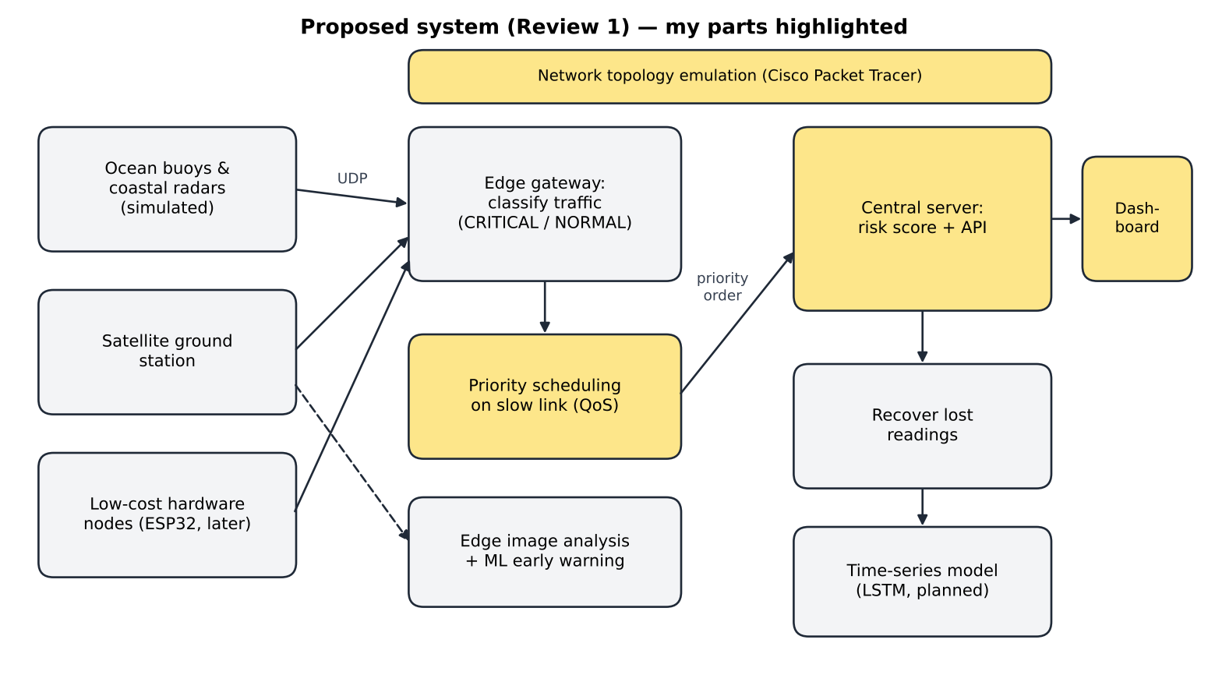
Figure 1: Proposed block diagram; my parts (server, dashboard, QoS, network emulation) are highlighted

Planned Method for My Part
Component | Planned method
Central server | Python FastAPI service with a background UDP listener; per-node ring buffer of recent readings; sequence-number tracking to detect gaps; risk score from wind and pressure; REST endpoints.
Dashboard | Single HTML page that polls the API and highlights CRITICAL nodes and estimated values.
QoS on the slow link | Start with a priority queue (critical first); later model the link capacity explicitly so that urgent data never waits behind routine data.
Simulation and testing | A cyclone scenario for the sensors, Packet Tracer for routing, and scripted end-to-end runs so every result can be repeated.

5. Initial Technical Feasibility
Table 3: Feasibility of my part
Area | Status
Skills I have | Python, sockets and basic networking, HTML/JavaScript, Git
Skills I must learn | FastAPI web framework, queueing / QoS theory (token bucket), Cisco Packet Tracer routing (OSPF), writing automated tests with pytest
Tools needed / access | Python 3, FastAPI, uvicorn (free); Cisco Packet Tracer (free with NetAcad account); own laptop — all available
Risks | No real buoy data (mitigation: physics-based simulation); timing bugs between threads; scope creep if every feature is attempted before Review 2

Table 4: Risk register for my part
Risk | Likelihood | Impact | Mitigation
Thread timing bugs between listener and API | Medium | High | Start threads in framework hooks; test end to end
No real buoy data | High | Medium | Physics-based simulation; real archives later
Packet Tracer cannot run our Python code | High | Low | Use it for routing; run code on loopback / Mininet
Scope creep before Review 2 | Medium | Medium | Weekly milestones; baseline first

6. Team Role Split and Timeline to Review 2
Table 5: Team role split
Member | Role | Specific tasks (R1 → R3)
Laksh Ahuja (24BDS0212) | Central server, dashboard & network QoS | Prediction server and REST API, live dashboard, priority scheduling on the slow link, cyclone simulation model, demo launcher, automated testing
Anvay Sharma (24BCE0824) | Edge gateway & edge intelligence | Gateway classification and forwarding, satellite image analysis at the edge, ML early-warning classifier, LSTM implementation, evaluation and logs
Sreehari (24BDS0417) | Sensing layer, hardware & data recovery | Sensor-node and satellite-station simulators, packet-loss model, reconstruction of lost readings, model training data, ESP32 hardware nodes

My role is distinct: everything from the moment a packet leaves the gateway — scheduling, the server, the dashboard — plus the simulation and tests that prove it works.
Table 6: My weekly plan from Review 1 to Review 2
Week | Dates | My milestone | Deliverable / check
1 | 25–31 Aug | Agree the telemetry record format with the team; build the Packet Tracer topology (routers, subnets, OSPF) | Ping from a buoy PC to the prediction server succeeds
2 | 1–7 Sep | Server skeleton: UDP listener, per-node storage, risk score | Server receives packets from the gateway
3 | 8–14 Sep | REST endpoints and first dashboard; end-to-end test with teammates' modules | Working prototype demonstrated at Review 2

R1 Video Plan
Segment | What I show
Problem and evidence (1.5 min) | Face + screen; IMD / WMO evidence and the problem statement
Literature gap (1.5 min) | Face + screen; literature table and the gap
Proposed solution and feasibility (2 min) | Face + screen; block diagram and feasibility table
My role and timeline (1 min) | Face + screen; role table and weekly plan

References
[1] India Meteorological Department, "Cyclone eAtlas" and Regional Specialised Meteorological Centre (Tropical Cyclones) reports, New Delhi. [Online]. Available: https://rsmcnewdelhi.imd.gov.in
[2] World Meteorological Organization, WMO Atlas of Mortality and Economic Losses from Weather, Climate and Water Extremes (1970–2019), WMO-No. 1267, Geneva, 2021.
[3] W. Shi, J. Cao, Q. Zhang, Y. Li, and L. Xu, "Edge computing: Vision and challenges," IEEE Internet of Things Journal, vol. 3, no. 5, pp. 637–646, 2016.
[4] M. Satyanarayanan, "The emergence of edge computing," Computer, vol. 50, no. 1, pp. 30–39, 2017.
[5] Y. Mao, C. You, J. Zhang, K. Huang, and K. B. Letaief, "A survey on mobile edge computing: The communication perspective," IEEE Communications Surveys & Tutorials, vol. 19, no. 4, pp. 2322–2358, 2017.
[6] F. Bonomi, R. Milito, J. Zhu, and S. Addepalli, "Fog computing and its role in the Internet of Things," in Proc. MCC Workshop on Mobile Cloud Computing, 2012, pp. 13–16.
[7] A. Al-Fuqaha, M. Guizani, M. Mohammadi, M. Aledhari, and M. Ayyash, "Internet of Things: A survey on enabling technologies, protocols, and applications," IEEE Communications Surveys & Tutorials, vol. 17, no. 4, pp. 2347–2376, 2015.
[8] G. Xu, Y. Shi, X. Sun, and W. Shen, "Internet of Things in marine environment monitoring: A review," Sensors, vol. 19, no. 7, art. 1711, 2019.
[9] S. Blake, D. Black, M. Carlson, E. Davies, Z. Wang, and W. Weiss, "An architecture for differentiated services," IETF RFC 2475, 1998.
[10] S. Floyd and V. Jacobson, "Random early detection gateways for congestion avoidance," IEEE/ACM Trans. Networking, vol. 1, no. 4, pp. 397–413, 1993.
[11] M. Shreedhar and G. Varghese, "Efficient fair queuing using deficit round-robin," IEEE/ACM Trans. Networking, vol. 4, no. 3, pp. 375–385, 1996.
[12] B. Lantz, B. Heller, and N. McKeown, "A network in a laptop: Rapid prototyping for software-defined networks," in Proc. ACM HotNets, 2010.
[13] A. Banks and R. Gupta (Eds.), "MQTT Version 3.1.1," OASIS Standard, 2014.
[14] G. J. Holland, "An analytic model of the wind and pressure profiles in hurricanes," Monthly Weather Review, vol. 108, no. 8, pp. 1212–1218, 1980.
[15] R. Pradhan, R. S. Aygun, M. Maskey, R. Ramachandran, and D. J. Cecil, "Tropical cyclone intensity estimation using a deep convolutional neural network," IEEE Trans. Image Processing, vol. 27, no. 2, pp. 692–702, 2018.
[16] Z. Che, S. Purushotham, K. Cho, D. Sontag, and Y. Liu, "Recurrent neural networks for multivariate time series with missing values," Scientific Reports, vol. 8, art. 6085, 2018.
[17] R. Chen, W. Zhang, and X. Wang, "Machine learning in tropical cyclone forecast modeling: A review," Atmosphere, vol. 11, no. 7, art. 676, 2020.

