INDIVIDUAL PROJECT REPORT
Review 1 — Problem Identification & Proposal (24/8/2026)

AI-Driven Edge–Cloud Network for Cyclone Prediction and Resilient Ocean Telemetry

Student | Register No. | Team No. | My role
Sreehari | 24BDS0417 | ________ | Sensing layer (sensor and satellite simulators, hardware nodes) and recovery of lost data

Team: Laksh Ahuja (24BDS0212), Anvay Sharma (24BCE0824), Sreehari (24BDS0417). Repository: https://github.com/laksh-ahuja06/AI-DRIVEN-EDGE-CLOUD-NETWORK

Summary
A cyclone-monitoring network is only as good as the data its sensors deliver. In this report I describe the problem from the sensing side: realistic sensor readings, the lossy links they travel over, and how lost readings can be recovered. I present the evidence, the 15 articles I studied, the proposed solution and my plan up to Review 2.

1. Problem Statement
Ocean buoys and coastal stations lose packets in bursts when storms bring rain fade and interference, so the monitoring centre receives gaps in the very readings that show a cyclone intensifying.
• Why it matters: the pressure trend is a key sign of intensification; a gap hides it.
• Who is affected: forecasters who interpret the data, and coastal communities whose warnings depend on it.
• If unsolved: dashboards show missing or stale values during the storm, and models that need continuous data cannot run.

Objectives of My Part
Objective | Measurable success criterion
Realistic sensor readings with a storm that arrives and passes | Wind > 60 km/h and pressure < 990 hPa only during the storm
Packet loss that matches real marine links | Configurable loss rate; bursts of consecutive losses
Record the true value of every reading, even lost ones | Ground-truth file for every test run
Recover lost readings better than simple methods | Lower error than holding the last value
Low-cost hardware node sending the same message format | ≤ ₹1,000 per node

2. Evidence the Problem is Real
Table 1: Evidence that the problem is real
Source | Published fact | Why it matters for my part
India Meteorological Department [1] | India has a coastline of about 7,500 km; the 1999 Odisha super cyclone caused about 10,000 deaths. | Coastal sensing covers a long, exposed coastline.
WMO Atlas 1970–2019 [2] | Tropical cyclones are among the leading causes of human and economic losses from weather, climate and water extremes. | Data gaps during storms have real human cost.
Engineering estimate (our calculation) | Low-power long-range radio (LoRa) offers only about 0.3–50 kbps [5]; marine links also suffer correlated (bursty) loss [8]. | Sensor data must be compact and the receiver must cope with bursts of lost packets.

3. Literature Survey
Table 2: Literature survey (15 articles)
# | Author / Year | Method used | Result | Limitation
1 | Al-Fuqaha et al., 2015 [3] | Survey of IoT technologies | Protocols and architectures for sensors | General, not marine
2 | Xu et al., 2019 [4] | Review of marine IoT monitoring | Ocean sensing platforms and links | Data loss handling not addressed
3 | Raza et al., 2017 [5] | LPWAN overview | Range vs data rate trade-offs | No recovery of lost data
4 | Augustin et al., 2016 [6] | LoRa measurements | Long range at low throughput | Duty-cycle limits
5 | Jouhari et al., 2019 [7] | Underwater sensor network survey | Challenges of marine communication | Underwater focus
6 | Gilbert, 1960 [8] | Two-state burst-noise channel | Models clustered errors | Theory only
7 | Elliott, 1963 [9] | Error rates on burst channels | Practical channel parameters | Not for IoT telemetry
8 | Che et al., 2018 [10] | GRU-D with missing-value decay | Better results with gaps | Offline clinical data
9 | Cao et al., 2018 [11] | Bidirectional RNN imputation | State-of-the-art gap filling | Needs whole series; heavy
10 | Yoon et al., 2018 [12] | GAN-based imputation (GAIN) | Imputes without full data | Complex to train
11 | Lim & Zohren, 2021 [13] | Deep time-series forecasting survey | Forecasting model families | No real-time telemetry
12 | Holland, 1980 [14] | Hurricane pressure profile | Realistic storm pressure field | Needs storm parameters
13 | Chen et al., 2019 [15] | CNN on satellite channels | Intensity from imagery | Large data and compute
14 | Denby & Lucia, 2020 [16] | Orbital edge computing | Process data where captured | Space segment only
15 | Shelby et al., 2014 [17] | CoAP for constrained devices | Compact sensor messaging | No gap recovery

Gap: imputation methods (GRU-D, BRITS, GAIN) work offline on complete datasets with heavy frameworks; marine IoT reviews describe links but not recovery; burst-loss channel models are rarely used to test sensor systems realistically. My part will generate realistic readings and loss, record the truth so recovery can be measured, recover lost readings online, and design low-cost nodes that send the same data.

4. Proposed Solution Form
Form: coding and modelling first, low-cost fabrication later. Simulated sensor nodes and a simulated satellite station give us unlimited, repeatable storm scenarios with known ground truth, which is essential for measuring recovery. Once the software works, ESP32 nodes with a pressure sensor will replace the simulator using the same message format. A product design was rejected because the scope is a proof of concept, not a manufactured device.
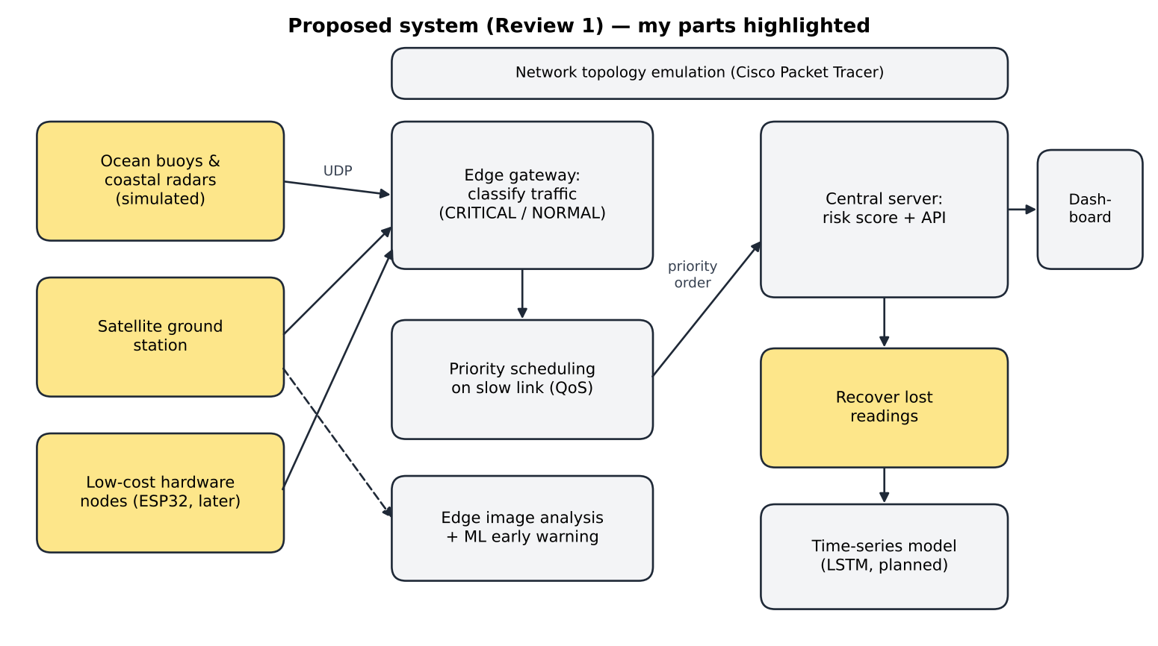
Figure 1: Proposed block diagram; my parts (sensors, satellite station, hardware nodes, recovery of lost readings) are highlighted

Planned Method for My Part
Component | Planned method
Sensor simulator | One reading per second with a sequence number, compact JSON over UDP, and a configurable loss probability.
Storm and loss models | Begin with a ramp, then a physical wind/pressure profile; begin with random loss, then a burst-loss channel.
Recovery of lost readings | Linear interpolation as the baseline, then a learned time-series model evaluated against recorded ground truth.
Hardware | ESP32 with a BMP280 pressure/temperature sensor sending the same JSON as the simulator.

5. Initial Technical Feasibility
Table 3: Feasibility of my part
Area | Status
Skills I have | Python, basic electronics, Arduino programming, statistics
Skills I must learn | Burst-loss channel modelling, time-series reconstruction, ESP32 Wi-Fi/UDP programming, I²C sensors
Tools needed / access | Python (free); Arduino IDE (free); ESP32 + BMP280 sensor (about ₹500 per node, college lab may lend); laptop
Risks | No real buoy data (mitigation: physics-inspired simulation); hardware parts delayed (mitigation: software first); recovery may not beat simple interpolation

Table 4: Risk register for my part
Risk | Likelihood | Impact | Mitigation
Hardware parts delayed or faulty | Medium | Medium | Software simulator first; borrow from lab
Simulated data too unrealistic | Medium | High | Use published storm profiles and burst-loss models
Recovery no better than interpolation | Medium | Medium | Report honestly; keep interpolation as fallback
Pressure reads wrong indoors (altitude) | High | Medium | Convert station pressure to sea level

Initial cost estimate for hardware (R1): about ₹2,000–2,500 for two nodes including breadboards and cables; software costs nothing.

6. Team Role Split and Timeline to Review 2
Table 5: Team role split
Member | Role | Specific tasks (R1 → R3)
Laksh Ahuja (24BDS0212) | Central server, dashboard & network QoS | Prediction server and REST API, live dashboard, priority scheduling on the slow link, cyclone simulation model, demo launcher, automated testing
Anvay Sharma (24BCE0824) | Edge gateway & edge intelligence | Gateway classification and forwarding, satellite image analysis at the edge, ML early-warning classifier, LSTM implementation, evaluation and logs
Sreehari (24BDS0417) | Sensing layer, hardware & data recovery | Sensor-node and satellite-station simulators, packet-loss model, reconstruction of lost readings, model training data, ESP32 hardware nodes

My role is the beginning of the data path and its repair: what the sensors send, how it gets lost, and how we recover it.
Table 6: My weekly plan from Review 1 to Review 2
Week | Dates | My milestone | Deliverable / check
1 | 25–31 Aug | Sensor-node simulator: readings, sequence numbers, configurable loss | Node sends JSON over UDP; LOST lines printed
2 | 1–7 Sep | Cyclone scenario (wind rises, pressure falls) and gap-filling baseline on the server | Missing sequence numbers are filled and marked
3 | 8–14 Sep | Integration test with gateway and server; hardware parts list | Prototype shown at Review 2; component list ready

R1 Video Plan
Segment | What I show
Problem and evidence (1.5 min) | Face + screen; IMD / WMO evidence and the problem statement
Literature gap (1.5 min) | Face + screen; literature table and the gap
Proposed solution and feasibility (2 min) | Face + screen; block diagram and feasibility table
My role and timeline (1 min) | Face + screen; role table and weekly plan

References
[1] India Meteorological Department, "Cyclone eAtlas" and Regional Specialised Meteorological Centre (Tropical Cyclones) reports, New Delhi. [Online]. Available: https://rsmcnewdelhi.imd.gov.in
[2] World Meteorological Organization, WMO Atlas of Mortality and Economic Losses from Weather, Climate and Water Extremes (1970–2019), WMO-No. 1267, Geneva, 2021.
[3] A. Al-Fuqaha, M. Guizani, M. Mohammadi, M. Aledhari, and M. Ayyash, "Internet of Things: A survey on enabling technologies, protocols, and applications," IEEE Communications Surveys & Tutorials, vol. 17, no. 4, pp. 2347–2376, 2015.
[4] G. Xu, Y. Shi, X. Sun, and W. Shen, "Internet of Things in marine environment monitoring: A review," Sensors, vol. 19, no. 7, art. 1711, 2019.
[5] U. Raza, P. Kulkarni, and M. Sooriyabandara, "Low power wide area networks: An overview," IEEE Communications Surveys & Tutorials, vol. 19, no. 2, pp. 855–873, 2017.
[6] A. Augustin, J. Yi, T. Clausen, and W. M. Townsley, "A study of LoRa: Long range & low power networks for the Internet of Things," Sensors, vol. 16, no. 9, art. 1466, 2016.
[7] M. Jouhari, K. Ibrahimi, H. Tembine, and J. Ben-Othman, "Underwater wireless sensor networks: A survey on enabling technologies, localization protocols, and Internet of Underwater Things," IEEE Access, vol. 7, pp. 96879–96899, 2019.
[8] E. N. Gilbert, "Capacity of a burst-noise channel," Bell System Technical Journal, vol. 39, no. 5, pp. 1253–1265, 1960.
[9] E. O. Elliott, "Estimates of error rates for codes on burst-noise channels," Bell System Technical Journal, vol. 42, no. 5, pp. 1977–1997, 1963.
[10] Z. Che, S. Purushotham, K. Cho, D. Sontag, and Y. Liu, "Recurrent neural networks for multivariate time series with missing values," Scientific Reports, vol. 8, art. 6085, 2018.
[11] W. Cao, D. Wang, J. Li, H. Zhou, L. Li, and Y. Li, "BRITS: Bidirectional recurrent imputation for time series," in Proc. NeurIPS, 2018.
[12] J. Yoon, J. Jordon, and M. van der Schaar, "GAIN: Missing data imputation using generative adversarial nets," in Proc. ICML, 2018.
[13] B. Lim and S. Zohren, "Time-series forecasting with deep learning: A survey," Philosophical Transactions of the Royal Society A, vol. 379, art. 20200209, 2021.
[14] G. J. Holland, "An analytic model of the wind and pressure profiles in hurricanes," Monthly Weather Review, vol. 108, no. 8, pp. 1212–1218, 1980.
[15] B.-F. Chen, B. Chen, H.-T. Lin, and R. L. Elsberry, "Estimating tropical cyclone intensity by satellite imagery utilizing convolutional neural networks," Weather and Forecasting, vol. 34, no. 2, pp. 447–465, 2019.
[16] B. Denby and B. Lucia, "Orbital edge computing: Nanosatellite constellations as a new class of computer system," in Proc. ACM ASPLOS, 2020.
[17] Z. Shelby, K. Hartke, and C. Bormann, "The Constrained Application Protocol (CoAP)," IETF RFC 7252, 2014.

