INDIVIDUAL PROJECT REPORT
Review 1 — Problem Identification & Proposal (24/8/2026)

AI-Driven Edge–Cloud Network for Cyclone Prediction and Resilient Ocean Telemetry

Student | Register No. | Team No. | My role
Anvay Sharma | 24BCE0824 | ________ | Edge gateway and edge intelligence (classification, satellite image analysis, ML models)

Team: Laksh Ahuja (24BDS0212), Anvay Sharma (24BCE0824), Sreehari (24BDS0417). Repository: https://github.com/laksh-ahuja06/AI-DRIVEN-EDGE-CLOUD-NETWORK

Summary
Our project is a cyclone-monitoring network that must work over slow, lossy links. In this report I explain the problem from the point of view of the network edge: deciding at the gateway which data is urgent, and reducing heavy satellite images to the information that actually matters before they consume the backbone. I present the evidence, the literature I surveyed, our proposed solution and my plan.

1. Problem Statement
Edge devices in a cyclone-monitoring network forward everything they receive, in arrival order and at full size, so a multi-megabyte satellite image or a routine reading can delay the one packet that shows a storm is intensifying.
• Why it matters: the earlier a dangerous trend is recognised, the more time there is to warn and evacuate.
• Who is affected: fishing communities and coastal residents, and meteorological and disaster agencies that depend on near-real-time data.
• If unsolved: a threshold-only system gives 0 s of warning before a threshold is crossed, and one raw 2 MB image saturates a 9.6 kbps link for about half an hour.

Objectives of My Part
Objective | Measurable success criterion
Classify every packet at the gateway as CRITICAL or NORMAL | No breach of 60 km/h / 990 hPa missed
Warn before thresholds are crossed using the trend of readings | Positive lead time in test scenarios
Cut satellite data sent over the backbone | > 95 % fewer bytes than the raw frame
Gateway that never crashes on bad input | Malformed packets counted and dropped
Fair, repeatable evaluation of every model | Held-out scenarios and a simple baseline for each

2. Evidence the Problem is Real
Table 1: Evidence that the problem is real
Source | Published fact / figure | Why it matters for my part
WMO Atlas 1970–2019 [1] | Storms caused about 577,000 deaths worldwide in 1970–2019 and were the most common cause of economic damage among weather hazards. | The cost of recognising danger late is very high, so even minutes of extra warning matter.
Chen et al., 2019 [2] | The Dvorak method is subjective and gives inconsistent estimates; their CNN needed 1,097 storms of training data and reached an 8.39 kt error. | Accurate image analysis exists but is heavy and central; the edge needs a light version.
Engineering estimate (our calculation) | A 4-band 16-bit 512 × 512 frame is 2,097,152 bytes; a record of about 200 bytes of storm features is roughly 10,000 times smaller. | Sending features instead of images is what makes satellite data usable on a slow link.

3. Literature Survey
Table 2: Literature survey (15 articles, 2018–2022)
# | Author / Year | Method used | Result | Limitation
1 | Olander & Velden, 2019 [3] | Advanced Dvorak Technique update | Objective intensity from IR images | Runs centrally on full images
2 | Pradhan et al., 2018 [4] | Deep CNN on IR imagery | Learned intensity estimation | Needs GPU and labelled data
3 | Chen et al., 2019 [2] | CNN on IR + microwave channels | 8.39 kt error on 2017 storms | Heavy model; central
4 | Wimmers et al., 2019 [5] | Deep learning on passive microwave | Intensity from microwave images | Depends on polar passes
5 | Rüttgers et al., 2019 [6] | GAN on satellite image sequences | 6-h track forecast, ≈96 km error | Large training set; GPU
6 | Denby & Lucia, 2020 [7] | Orbital edge computing | Process imagery where captured | Space segment, not ground
7 | Giuffrida et al., 2022 [8] | On-board DNN cloud screening | Discards cloudy frames, saves downlink | Cloud screening only
8 | Chen & Ran, 2019 [9] | Review of deep learning at the edge | Techniques to fit DL on edge devices | Mostly video, not sensors
9 | Wang et al., 2020 [10] | Edge computing + DL survey | Inference and training at the edge | No disaster use case
10 | Ray, 2022 [11] | Review of TinyML | ML on microcontrollers | Tools still immature
11 | Banbury et al., 2021 [12] | MLPerf Tiny benchmark | Fair comparison of tiny models | Benchmark, not application
12 | Van Houdt et al., 2020 [13] | Review of the LSTM model | Formulation, training, uses | Generic; framework-based
13 | Lim & Zohren, 2021 [14] | Survey of deep time-series forecasting | Compares RNN, attention, hybrids | Not edge-constrained
14 | Rudin, 2019 [15] | Case for interpretable models | Simple models for high-stakes use | Position paper
15 | Grinsztajn et al., 2022 [16] | Benchmark: trees vs DL on tables | Simple models often win on tabular data | No time-series focus

Gap: image-based cyclone analysis (ADT, CNNs, GANs) runs centrally on full images, and on-board satellite AI so far only screens out cloudy frames. Edge-AI reviews show how to fit models on small devices but not for disaster telemetry, and interpretability work argues for simple models where lives are at stake. Nobody we found extracts storm features at the ground station and sends only those, or uses the trend of a sensor's readings at the gateway to raise priority before a threshold is crossed. These two ideas are my contribution to the project.
Foundational methods we also build on (not counted in the 15): the Dvorak cloud-pattern technique [17] and the original LSTM [18].

4. Proposed Solution Form
Form: coding and modelling. The edge gateway and the edge-AI functions are software by nature. We will first build a rule-based gateway (thresholds on wind and pressure) so the pipeline can be verified, then add lightweight models that can run on a laptop or a Raspberry Pi. A hardware-first approach was rejected because the decisions at the edge must be tested on many storm scenarios, which only simulation provides.
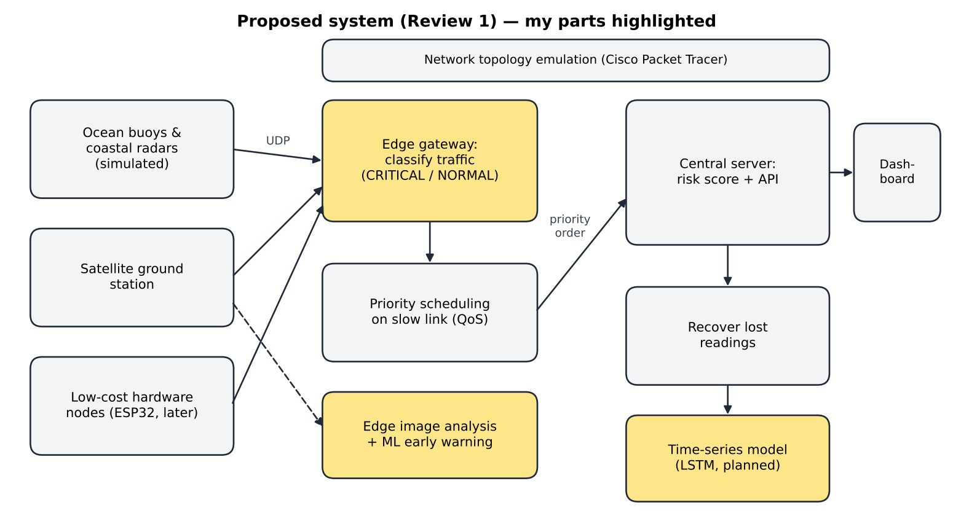
Figure 1: Proposed block diagram; my parts (gateway classification, edge image analysis, ML / LSTM) are highlighted

Planned Method for My Part
Component | Planned method
Gateway | Two threads — receiver and forwarder — joined by a priority queue; threshold rule first so the pipeline can be verified.
Early warning | Features from the last few readings (pressure falling, wind rising, distance to the thresholds) fed to a small, explainable classifier.
Satellite images | Extract the cues forecasters use — cold cloud tops, symmetry, an eye — at the ground station and send only those numbers.
Evaluation | Compare every model with a simple baseline on scenarios it has not seen.

5. Initial Technical Feasibility
Table 3: Feasibility of my part
Area | Status
Skills I have | Python, NumPy, basic machine learning (regression, classification), threading
Skills I must learn | Image processing on multi-band data, recurrent networks (LSTM) and how to train them, evaluating models fairly (held-out data, baselines)
Tools needed / access | Python, NumPy, Matplotlib (free); laptop CPU is enough for small models; real satellite imagery from public portals (MOSDAC) later
Risks | No labelled satellite data (mitigation: synthetic frames with known intensity); ML may raise false alarms (mitigation: keep the threshold rule as a safety floor); deep-learning frameworks may be too heavy for edge devices

Table 4: Risk register for my part
Risk | Likelihood | Impact | Mitigation
No labelled satellite images | High | High | Synthetic frames with known storm intensity
ML classifier raises false alarms | Medium | Medium | Keep the threshold rule as a safety floor
Deep-learning frameworks too heavy for the edge | Medium | Medium | Prefer small NumPy models
Gateway crashes on bad packets | Medium | High | Validate every packet before use

6. Team Role Split and Timeline to Review 2
Table 5: Team role split and interfaces
Member | Responsibility | Interface with the gateway (my module)
Anvay Sharma (24BCE0824) — me | Edge gateway, classification, satellite analysis, ML models | Receive, check and label every packet; decide what leaves the edge first; shrink satellite data
Sreehari (24BDS0417) | Sensor and satellite simulators, hardware nodes, gap recovery | Upstream of me: sends JSON readings to my UDP port 9001
Laksh Ahuja (24BDS0212) | Prediction server, dashboard, link QoS, testing | Downstream of me: my forwarder sends to his server on UDP port 9002

My role is the intelligence at the edge: the gateway that classifies and forwards each packet, and the models that let it recognise danger early and shrink satellite data.
Table 6: My weekly plan from Review 1 to Review 2
Week | Dates | My milestone | Deliverable / check
1 | 25–31 Aug | Define CRITICAL / NORMAL classes and thresholds with the team; design the gateway threads (receiver + forwarder) | Design note and agreed record format
2 | 1–7 Sep | Implement the gateway: UDP receive, threshold classification, priority queue | Gateway forwards packets in priority order
3 | 8–14 Sep | Alert mode (throttle normal traffic during an alert); integration with sensors and server; literature study for the ML classifier | Gateway shown in the Review 2 demo

R1 Video Plan
Segment | What I show
Problem and evidence (1.5 min) | Face + screen; the WMO loss figures and why late detection is costly
Literature gap (1.5 min) | Face + screen; papers on satellite intensity estimation and edge AI; the edge gap
Proposed solution and feasibility (2 min) | Face + screen; the gateway and edge-analysis blocks I will build
My role and timeline (1 min) | Face + screen; my three-week gateway plan

References
[1] World Meteorological Organization, WMO Atlas of Mortality and Economic Losses from Weather, Climate and Water Extremes (1970–2019), WMO-No. 1267, Geneva, 2021.
[2] B.-F. Chen, B. Chen, H.-T. Lin, and R. L. Elsberry, "Estimating tropical cyclone intensity by satellite imagery utilizing convolutional neural networks," Weather and Forecasting, vol. 34, no. 2, pp. 447–465, 2019.
[3] T. L. Olander and C. S. Velden, "The Advanced Dvorak Technique (ADT) for estimating tropical cyclone intensity: Update and new capabilities," Weather and Forecasting, vol. 34, no. 4, pp. 905–922, 2019.
[4] R. Pradhan, R. S. Aygun, M. Maskey, R. Ramachandran, and D. J. Cecil, "Tropical cyclone intensity estimation using a deep convolutional neural network," IEEE Trans. Image Processing, vol. 27, no. 2, pp. 692–702, 2018.
[5] A. Wimmers, C. Velden, and J. H. Cossuth, "Using deep learning to estimate tropical cyclone intensity from satellite passive microwave imagery," Monthly Weather Review, vol. 147, no. 6, pp. 2261–2282, 2019.
[6] M. Rüttgers, S. Lee, S. Jeon, and D. You, "Prediction of a typhoon track using a generative adversarial network and satellite images," Scientific Reports, vol. 9, art. 6057, 2019.
[7] B. Denby and B. Lucia, "Orbital edge computing: Nanosatellite constellations as a new class of computer system," in Proc. ACM ASPLOS, 2020.
[8] G. Giuffrida et al., "The Φ-Sat-1 mission: The first on-board deep neural network demonstrator for satellite Earth observation," IEEE Trans. Geoscience and Remote Sensing, vol. 60, 2022.
[9] J. Chen and X. Ran, "Deep learning with edge computing: A review," Proceedings of the IEEE, vol. 107, no. 8, pp. 1655–1674, 2019.
[10] X. Wang, Y. Han, V. C. M. Leung, D. Niyato, X. Yan, and X. Chen, "Convergence of edge computing and deep learning: A comprehensive survey," IEEE Communications Surveys & Tutorials, vol. 22, no. 2, pp. 869–904, 2020.
[11] P. P. Ray, "A review on TinyML: State-of-the-art and prospects," Journal of King Saud University – Computer and Information Sciences, vol. 34, no. 4, pp. 1595–1623, 2022.
[12] C. Banbury et al., "MLPerf Tiny benchmark," in Proc. NeurIPS Datasets and Benchmarks Track, 2021.
[13] G. Van Houdt, C. Mosquera, and G. Nápoles, "A review on the long short-term memory model," Artificial Intelligence Review, vol. 53, no. 8, pp. 5929–5955, 2020.
[14] B. Lim and S. Zohren, "Time-series forecasting with deep learning: A survey," Philosophical Transactions of the Royal Society A, vol. 379, art. 20200209, 2021.
[15] C. Rudin, "Stop explaining black box machine learning models for high stakes decisions and use interpretable models instead," Nature Machine Intelligence, vol. 1, pp. 206–215, 2019.
[16] L. Grinsztajn, E. Oyallon, and G. Varoquaux, "Why do tree-based models still outperform deep learning on typical tabular data?" in Proc. NeurIPS Datasets and Benchmarks Track, 2022.
[17] V. F. Dvorak, "Tropical cyclone intensity analysis and forecasting from satellite imagery," Monthly Weather Review, vol. 103, no. 5, pp. 420–430, 1975.
[18] S. Hochreiter and J. Schmidhuber, "Long short-term memory," Neural Computation, vol. 9, no. 8, pp. 1735–1780, 1997.

