INDIVIDUAL PROJECT REPORT
Review 2 — Design, Development & Progress (14/9/2026)

AI-Driven Edge–Cloud Network for Cyclone Prediction and Resilient Ocean Telemetry

Student | Register No. | Team No. | My role
Laksh Ahuja | 24BDS0212 | ________ | Central server, dashboard, network QoS, cyclone simulation and testing

Team: Laksh Ahuja (24BDS0212), Anvay Sharma (24BCE0824), Sreehari (24BDS0417). Repository: https://github.com/laksh-ahuja06/AI-DRIVEN-EDGE-CLOUD-NETWORK

Summary
Since Review 1 I designed and built the central prediction server of our prototype: the UDP listener, per-node storage, risk scoring, the REST API and a live dashboard, and I worked on the team's Packet Tracer topology. The prototype runs end to end with my teammates' sensor nodes and gateway. This report shows the design, the working code, why I chose this design, the updated feasibility, the problems I hit and how I solved them, and my contribution.

1. Detailed Design
Input → process → output: input is a JSON record forwarded by the gateway over UDP port 9002 (node, seq, time, wind, temp, pressure, traffic_class); process checks the sequence number, fills gaps using the team's interpolation function, computes a risk score and stores the record; output is three REST endpoints and an HTML dashboard (Figure 2). Figure 1 shows where my modules sit in the whole prototype.
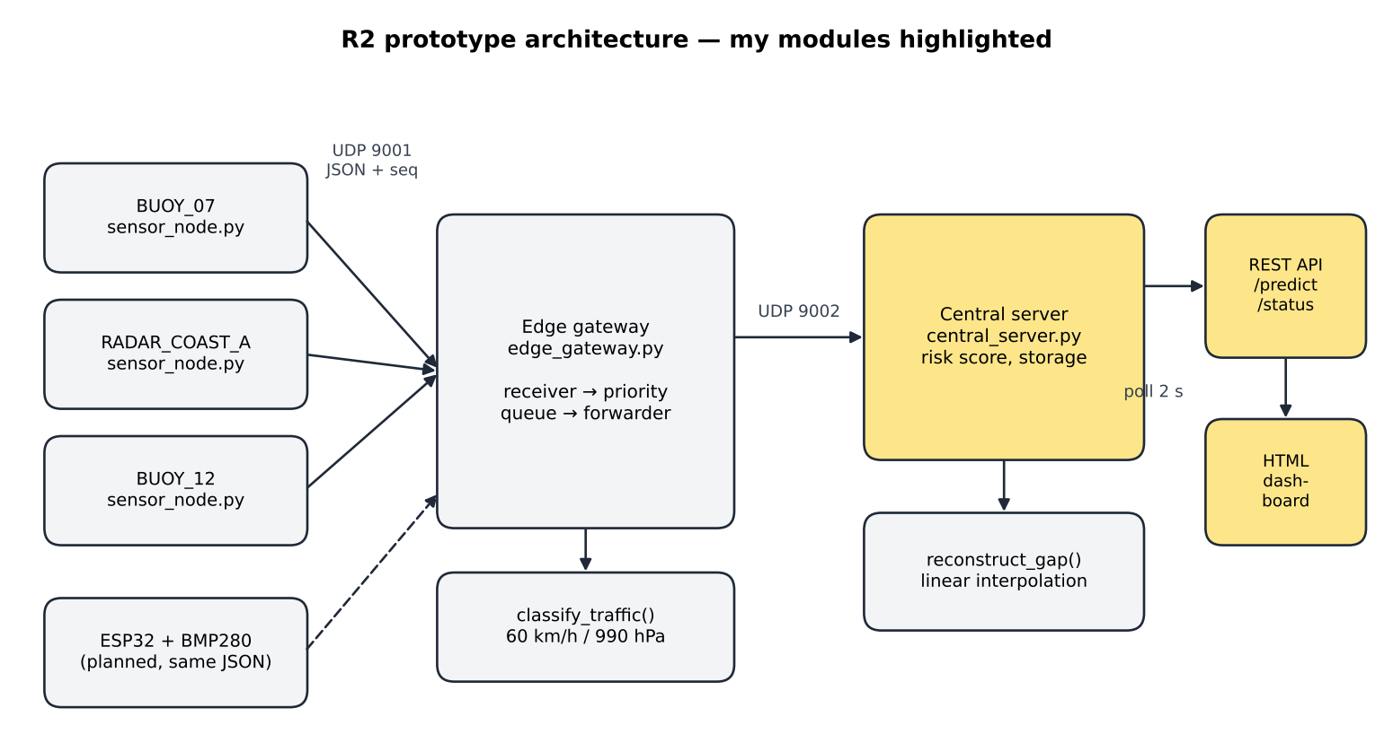
Figure 1: Architecture of the R2 prototype; my modules (server, API, dashboard) are highlighted
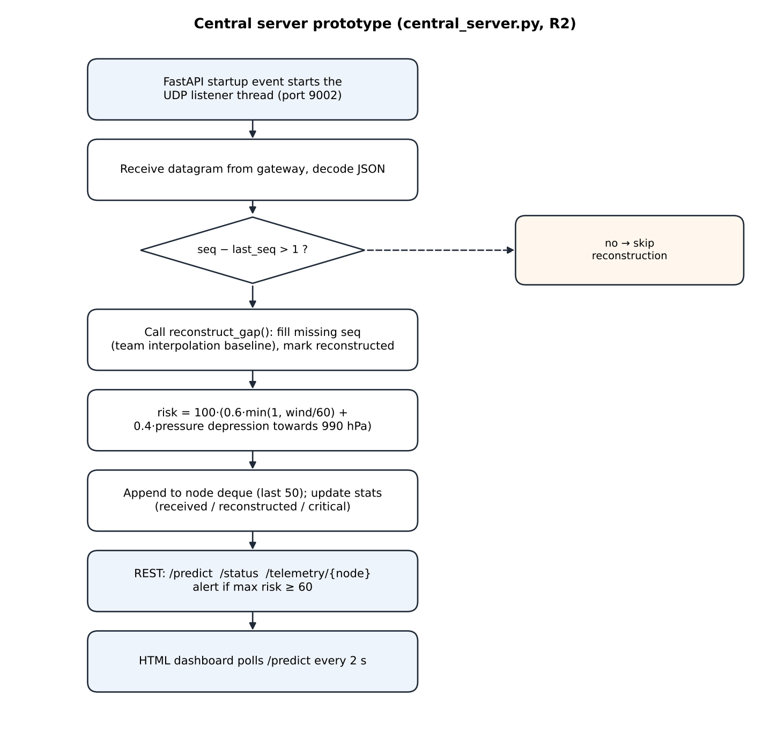
Figure 2: Flowchart of my central server (prototype)
Table 1: Labelled parameters of my module
Parameter | Value | Meaning
GATEWAY_TO_SERVER_PORT | 9002 (UDP) | Where the gateway sends packets
HISTORY_LEN | 50 | Readings kept per node (deque)
WIND_RISK_THRESHOLD | 60 km/h | Wind at which the wind part of risk saturates
PRESSURE_RISK_THRESHOLD | 990 hPa | Pressure at which the pressure part saturates
Risk formula | 100·(0.6·w + 0.4·p) | w = min(1, wind/60); p = depression from 1013 towards 990 hPa
Alert rule | max node risk ≥ 60 | Shown in /predict and on the dashboard
Dashboard refresh | 2 s polling | Fetches /predict

2. Actual Working Progress since Review 1
• Code committed: central_server.py (189 lines, including the reconstruct_gap() function written by Sreehari), in repository commit 82bcb8a.
• Running: server, gateway and sensors run together; endpoints /predict, /status, /telemetry/{node} and the dashboard work.
• Network: the team's Packet Tracer topology is complete with OSPF routing; a ping from BUOY-01 to the prediction server succeeds (Figure 4).
The heart of the server is short; this is the startup fix and the prediction endpoint:
@app.on_event("startup")
def start_listener():
threading.Thread(target=udp_listener, daemon=True).start()

@app.get("/predict")
def predict():
with lock:
latest = {node_id: dq[-1] for node_id, dq in telemetry_store.items() if dq}
overall = max(rec["risk"] for rec in latest.values())
return {"overall_risk": overall, "alert": overall >= 60, "nodes": latest}

I re-ran my server, unchanged from repository commit 82bcb8a (16/9/2026), with three sensor nodes for 60 seconds to capture dated logs (docs/reports/evidence/r2_prototype/). In our original 12-second team test my /status endpoint reported 66 packets received, 11 reconstructed and 2 critical, and /predict returned an overall risk of 100 with the alert on.
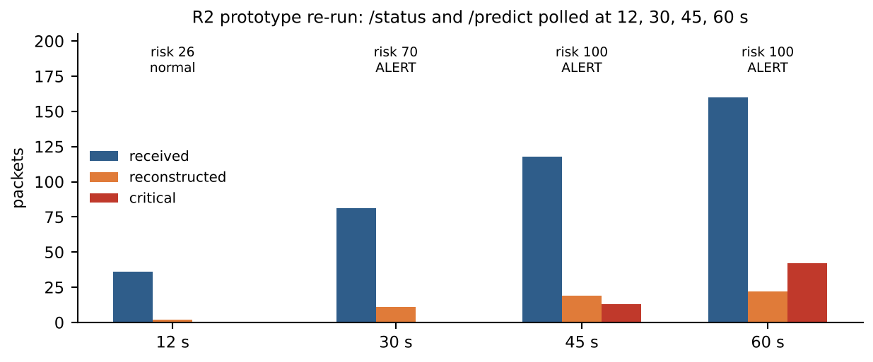
Figure 3: My server's /status and /predict during the prototype re-run
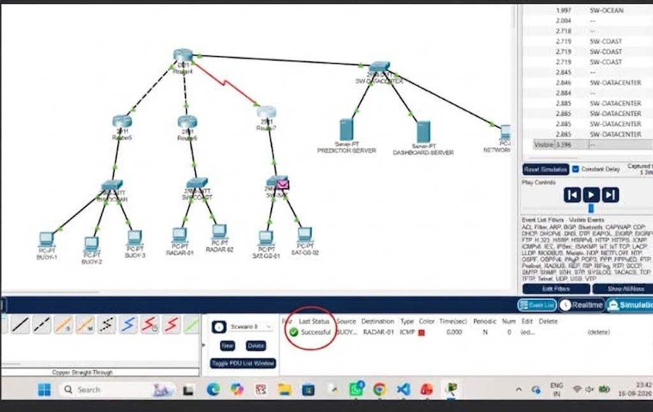
Figure 4: The team's Packet Tracer topology (joint work); the data-centre side hosts my prediction and dashboard servers
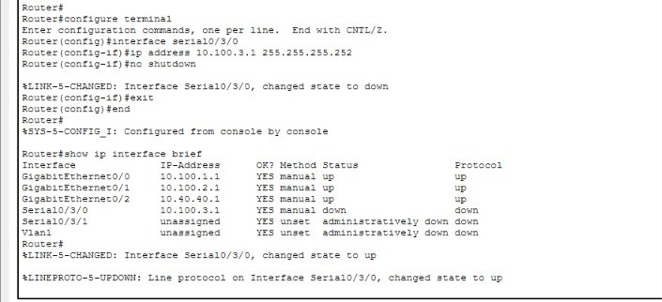
Figure 5: Core router configuration (show ip interface brief) linking the WAN to the data centre
Completion: about 40 % of my planned scope. Done: server pipeline, risk score, REST API, polling dashboard, topology. Remaining: priority scheduling on a bandwidth-limited link, a learned model for missing data (with Sreehari and Anvay), real-time updates over WebSocket, a realistic cyclone model, and automated tests.
Table 2: Test runs performed on my module
Test run | Setup | Observation
Team test, 12 s, 2 nodes | Server + gateway + BUOY_07, RADAR_A | 66 packets, 11 reconstructed, 2 critical; risk 100, alert on
Startup test | Sensors started before the listener | /predict empty → fixed with startup event
Re-run, 60 s, 3 nodes | Prototype commit 82bcb8a | 160 received, 22 reconstructed, 42 critical; alert at ≈30 s
Robustness test | One non-JSON datagram to port 9002 | Listener thread died; /status stayed at 0 received
Packet Tracer | ping BUOY-01 → 10.40.40.10 | Successful end to end over OSPF

3. Justification of Design Choices
Table 3: Comparison of alternatives for my module (cost, accuracy, availability, power, ease of use)
Choice | Option | Cost | Accuracy / fit | Availability | Power | Ease of use | Decision
Web framework | Flask | Free | Works; background thread needs care | pip, mature | Light | Very easy | —
 | Django | Free | Too large for a small API | pip, mature | Heavier | Heavy setup | —
 | FastAPI | Free | Startup hooks for the UDP thread; auto API docs | pip, open source | Light | Easy | Chosen
Transport | TCP | ₹0 | Retransmits hide the loss we study; adds delay | Built into OS | Extra radio time | Easy | —
 | MQTT broker | ₹0 | Good later; extra hop | Mosquitto, free | Broker always on | Extra service | —
 | UDP datagrams | ₹0 | Loss visible and measurable | Built into OS | Least radio time | Easy | Chosen
Dashboard | Polling 2 s | ₹0 | Up to 2 s stale | Any browser | Small repeated requests | Simplest | Chosen now
 | WebSocket push | ₹0 | Instant updates | Needs extra package | Fewer requests | Moderate | Next phase
Hosting | Own laptop | ₹0 | Enough for demos | Available now | Laptop only | Easy | Chosen
 | Cloud VM | ≈US$5–10 / month | Public URL | Needs payment card | Data centre | Moderate | Later

4. Updated Feasibility
Table 4: Economic picture for my part
Aspect | Review 1 estimate | Now (Review 2) | Reason for change
Software cost | ₹0 | ₹0 | All tools open source
Server hosting | Own laptop | Own laptop; a small cloud VM later ≈ US$5–10 / month | Needed only for a public demo
Effort | 3 weeks for prototype | On schedule | Startup race fixed in one day

Social: coastal and island communities often have the worst connectivity, so a server that keeps a usable picture despite missing data supports fairer disaster response. Environmental: no new hardware is needed for the server tier, and avoiding retransmissions saves energy at the remote end.

5. Problems Encountered and How I Adapted
Table 5: Problems in my module
Problem | How I diagnosed it | What I changed | Result
/predict returned empty data at first | Server log showed the listener starting after sensors had begun sending; the thread was started at import time | Start the UDP listener in FastAPI's startup event | Data appears immediately; fixed
Processes started from separate shells failed silently | Background processes lost their working directory, so imports failed | Launch the server, gateway and sensors from one script | All components start reliably; fixed
One malformed packet stopped the server receiving | Sent a non-JSON datagram during testing: the listener thread raised an exception and died; /status then showed 0 packets received | Input validation and exception handling planned for the next phase | Workaround: restart; fix scheduled
Gaps can only be repaired after the next packet | Found while reviewing the logs: a gap is known only when a later sequence number arrives | Plan real-time estimates for overdue packets | Design limitation recorded

Plan from Review 2 to Review 3
Week | Planned work
15–21 Sep | Token-bucket QoS scheduler with critical reserve; FIFO baseline for comparison
22–28 Sep | Server hardening: validation, late/duplicate packets, real-time estimates for overdue packets
29 Sep–5 Oct | WebSocket dashboard; physics-based cyclone model; one-command launcher
6–9 Oct | Automated test suite; measurements for the final report

6. Individual Contribution Evidence
Table 6: Division of work
Tasks I did | Tasks done by teammates
Central server: UDP listener, storage, risk score, alert rule | Anvay: edge gateway (classification, priority queue, alert throttling)
REST API (/predict, /status, /telemetry) and HTML dashboard | Sreehari: sensor-node simulator and the reconstruct_gap() interpolation used by my server
Startup race fix; single-script launch; end-to-end test runs | Team: shared record format (common.py), Packet Tracer topology

• Code: central_server.py at commit 82bcb8a (https://github.com/laksh-ahuja06/AI-DRIVEN-EDGE-CLOUD-NETWORK).
• Logs: server.log, api.log and crash_srv.log in docs/reports/evidence/r2_prototype/.
[Insert: dated screenshot of my terminal running central_server.py with /predict open in the browser, and my GitHub commit list. Our early commits went through one shared account, so the file split above is the record of who wrote what.]

R2 Video Plan
Segment | What I show
Design walkthrough (2 min) | Face + screen; the architecture and my server flowchart
Live progress with my own work on screen (2 min) | Face + screen; server + API running, /predict in the browser
One problem and its solution (1 min) | Face + screen; the startup-race fix and the malformed-packet crash
Updated cost and my contribution (1 min) | Face + screen; my cost table and division of work

