INDIVIDUAL PROJECT REPORT
Review 2 — Design, Development & Progress (14/9/2026)

AI-Driven Edge–Cloud Network for Cyclone Prediction and Resilient Ocean Telemetry

Student | Register No. | Team No. | My role
Sreehari | 24BDS0417 | ________ | Sensing layer, hardware and recovery of lost data

Team: Laksh Ahuja (24BDS0212), Anvay Sharma (24BCE0824), Sreehari (24BDS0417). Repository: https://github.com/laksh-ahuja06/AI-DRIVEN-EDGE-CLOUD-NETWORK

Summary
Since Review 1 I built the sensor-node simulator of our prototype and the function that fills gaps left by lost packets, and I prepared the hardware parts list. The sensor nodes generate a cyclone scenario, drop packets to emulate a lossy marine link, and the server repairs the missing sequence numbers. This report covers the design, the working code, my choices, updated costs, the problems I found and my contribution.

1. Detailed Design
Sensor node: every second the node increments its sequence number, updates wind, temperature and pressure (a small random walk in calm weather; after --cyclone-after seconds wind rises and pressure falls), builds a compact JSON record and, unless the loss draw says the packet is lost, sends it to the gateway. Gap filling: when the server sees a jump in sequence numbers, my reconstruct_gap() linearly interpolates each variable between the readings before and after the gap and marks the result as reconstructed (Figure 2). Figure 1 places my modules in the whole prototype.
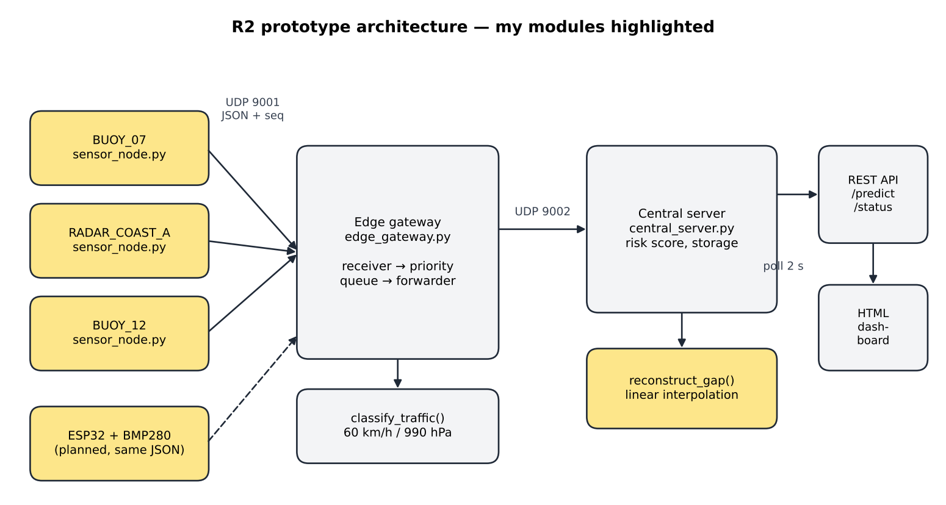
Figure 1: Architecture of the R2 prototype; my modules (sensor nodes, gap filling, planned ESP32 node) are highlighted
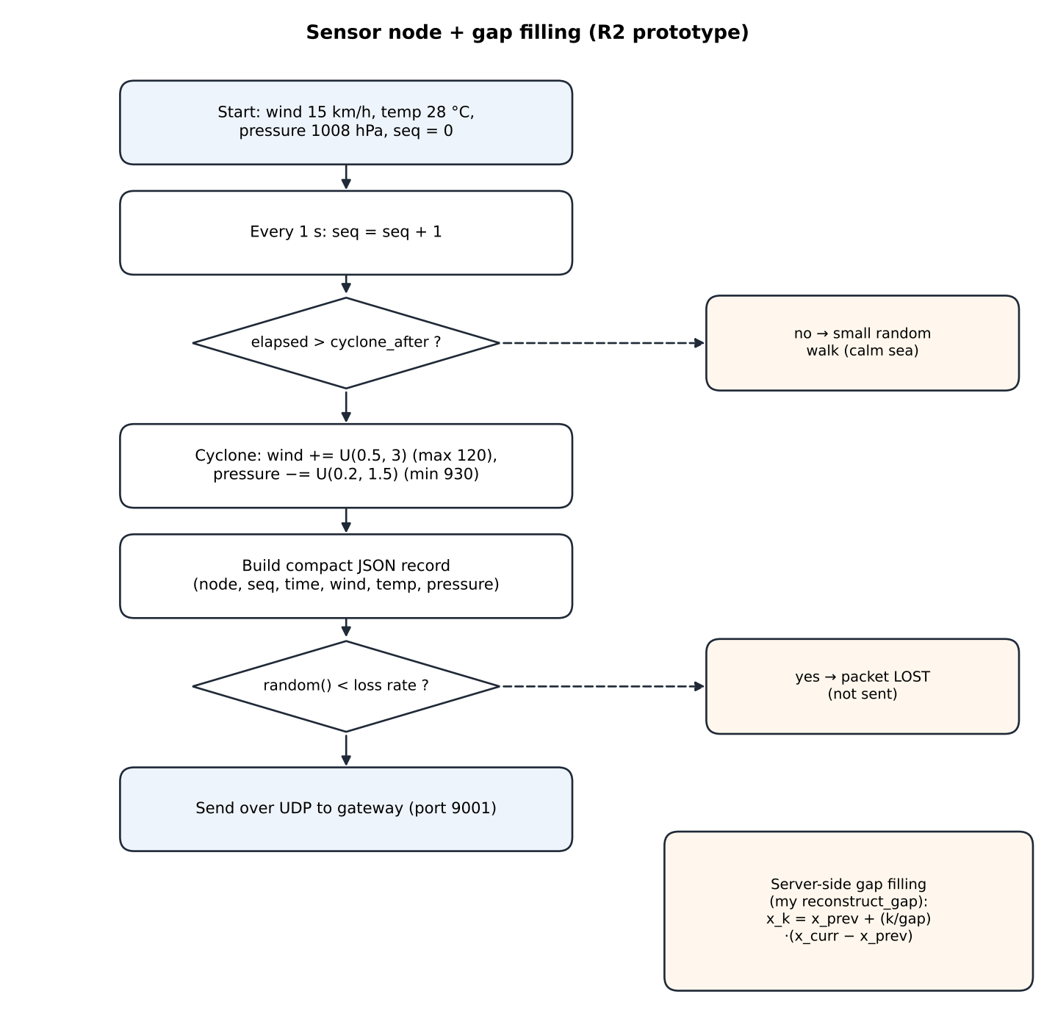
Figure 2: Flowchart of my sensor node and gap filling (prototype)
Table 1: Labelled parameters of my module
Parameter | Value | Meaning
--interval | 1 s | Time between readings
--loss | 0.08 default (0.10–0.15 in tests) | Probability that a packet is dropped
--cyclone-after | 20 s default | When the storm starts in the scenario
Calm walk | wind ±1, pressure ±0.5, temp ±0.2 per step | Natural variation
Cyclone ramp | wind +0.5…3 (max 120), pressure −0.2…1.5 (min 930) | Approaching storm
Interpolation | x_k = x_prev + (k/gap)·(x_curr − x_prev) | Estimate for missing reading k

2. Actual Working Progress since Review 1
• Code committed: sensor_node.py (68 lines) and reconstruct_gap() in central_server.py, commit 82bcb8a.
• Running: three simulated nodes (BUOY_07, RADAR_COAST_A, BUOY_12) with different loss rates and cyclone start times feed the gateway; the server marks filled readings as reconstructed.
• Hardware: parts list prepared (ESP32 + BMP280 per node); purchase planned after the software interface is fixed. The circuit is designed (Figure 3) so that the node sends exactly the same JSON as the simulator.
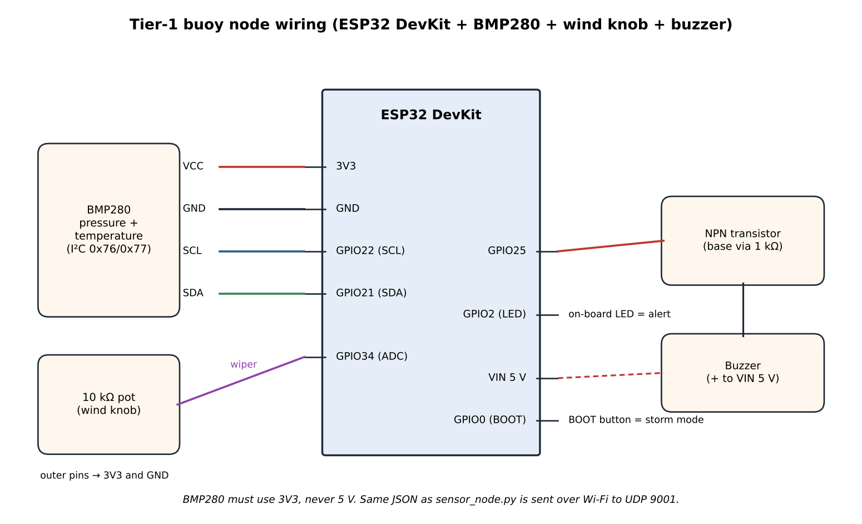
Figure 3: Circuit diagram of the planned ESP32 buoy node (BMP280 on I²C, potentiometer as wind input, buzzer and LED for local alert)
if random.random() < loss_rate:
print(f"[{node_id}] seq={seq:05d} LOST (simulated link loss)")
else:
sock.sendto(encode(record), (HOST, SENSOR_TO_GATEWAY_PORT))

def reconstruct_gap(node_id, prev_record, curr_record):
gap = curr_record["seq"] - prev_record["seq"]
for i in range(1, gap):
frac = i / gap # linear interpolation for each variable

To check my nodes I re-ran the Review 2 prototype (commit 82bcb8a, no changes) with BUOY_07, RADAR_COAST_A and BUOY_12 for 60 seconds; their logs (buoy_07.log, radar.log, buoy_12.log) are in docs/reports/evidence/r2_prototype/. In the original 12-second team test, the server filled 11 readings lost by my two nodes using reconstruct_gap().
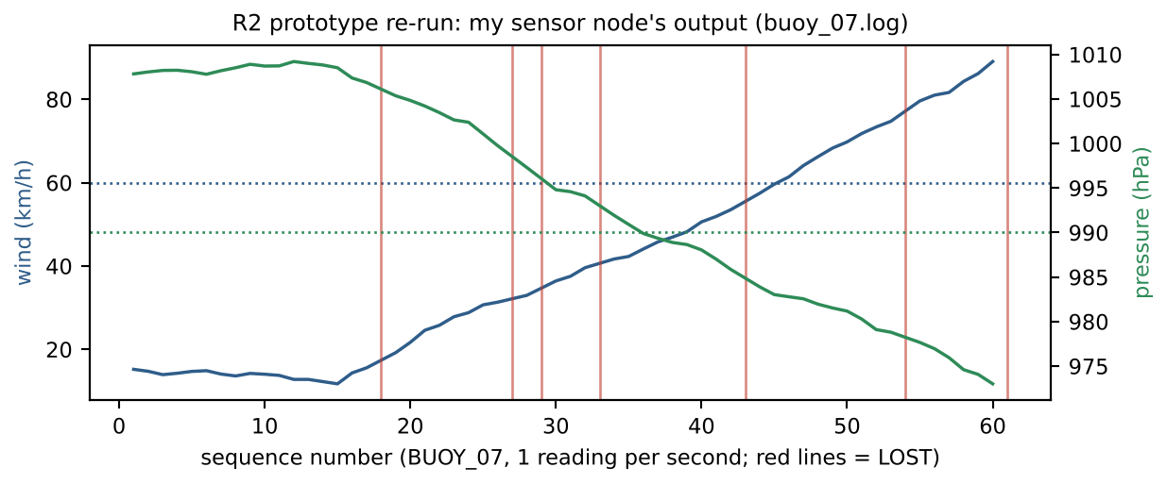
Figure 4: Output of my sensor node in the re-run; red lines mark lost packets
In the re-run my three nodes lost 22 packets in total; the server filled them using my function (22 reconstructed in /status at 60 s).
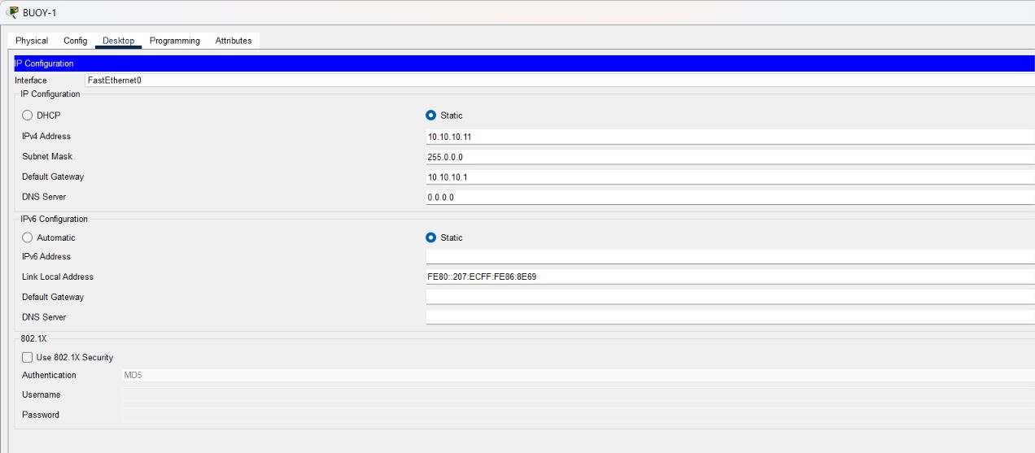
Figure 5: BUOY-1 end device in the team's Packet Tracer topology (joint work); it represents my sensor nodes in the routed network
Completion: about 40 % of my planned scope. Done: sensor simulator, cyclone scenario, loss emulation, interpolation baseline, parts list. Remaining: realistic storm physics and bursty loss, ground-truth logging, a learned reconstruction model, a satellite-station simulator, and the ESP32 nodes.
Table 2: Test runs performed on my module
Test run | Setup | Observation
Team test, 12 s, 2 nodes | BUOY_07 (15 % loss), RADAR_A (10 %) | 11 lost packets filled by interpolation
Re-run, 60 s, 3 nodes | Prototype commit 82bcb8a | 22 packets lost, all 22 reconstructed by the server
Burst analysis | Runs of LOST lines in the logs | Longest run 2 packets — losses too scattered
Storm-shape check | 300 simulated steps of the node logic | Wind fixed at 120, pressure at 930 after ≈100 s
Unit check of reconstruct_gap() | Gap 10 → 13 | Values correct, timestamps wrong (all 12:00:03)

3. Justification of Design Choices
Table 3: Comparison of alternatives for my module (cost, accuracy, availability, power, ease of use)
Choice | Option | Cost | Accuracy / fit | Availability | Power | Ease of use | Decision
Data source | Simulated nodes | ₹0 | Controllable; true values known | Instant | None | Easiest | Chosen now
 | Recorded buoy archives | ₹0 | Real, but loss not controllable | Public portals (registration) | None | Needs cleaning | Later
 | ESP32 hardware nodes | ≈₹800 / node | Real sensors, real Wi-Fi loss | Local shops / online | ≈0.5 W sending; deep sleep | Build effort | Next phase
Gap filling | Hold last value | ₹0 | Poor when values change fast | Trivial | Negligible | Trivial | Rejected
 | Linear interpolation | ₹0 | Good baseline; needs next reading | Own code | Negligible | Easy | Chosen now
 | LSTM / GRU-D | ₹0 | Can learn storm dynamics | Own NumPy code | Training on laptop CPU | Needs training | Next phase
Micro-controller | Arduino Uno + ESP8266 | ≈₹700 | Works | Common | Two boards | Extra wiring | Rejected
 | ESP32 | ≈₹400 | Wi-Fi built in | Very common | Deep sleep available | Arduino IDE | Planned
Pressure sensor | BMP280 | ≈₹120 | ±1 hPa absolute | Very common | Very low | I²C, 4 wires | Planned
 | BME280 | ≈₹350 | Adds humidity | Common | Very low | I²C, 4 wires | Rejected (cost)

4. Updated Feasibility
Table 4: Economic picture for my part
Aspect | Review 1 estimate | Now (Review 2) | Reason for change
Two hardware nodes | ₹2,000–2,500 | ₹1,600–2,200 | BMP280 (≈₹120) chosen instead of BME280; a potentiometer replaces a commercial anemometer for demos
Software | ₹0 | ₹0 | Python and Arduino IDE are free
Purchase status | — | Not yet bought | Waiting until the message format is final

Social: low-cost nodes would let local bodies and colleges densify coastal monitoring. Environmental: ESP32 boards are reusable and can sleep between readings; small packets mean less radio energy.

5. Problems Encountered and How I Adapted
Table 5: Problems in my module
Problem | How I diagnosed it | What I changed | Result
Simulated losses are unrealistically scattered | Counted runs of LOST lines in the re-run logs: 22 losses, the longest run only 2 packets; real storm links lose packets in bursts | Plan a two-state burst-loss (Gilbert–Elliott) model | Problem quantified; model chosen
The simulated cyclone never passes | Simulated 300 steps of my node's logic: wind stays at 120 km/h and pressure at 930 hPa after about 100 s, so the alert can never clear | Plan a storm that approaches, passes and recedes (physical wind/pressure profile) | Needed to test alert clearing
Reconstructed readings had the wrong time | Unit check of reconstruct_gap(): readings 11 and 12 both got 12:00:03, the time of packet 13 | Mark them as estimates of their own sequence slot; correct time stamping planned | Bug found before it affected results
Cannot measure how good the gap filling is | Lost readings are never recorded anywhere, so there is no truth to compare with | Plan a ground-truth log written by each node, including lost readings | Enables error measurement next phase

Plan from Review 2 to Review 3
Week | Planned work
15–21 Sep | Physics-based storm (approach, pass, recede) and burst-loss channel
22–28 Sep | Ground-truth logging; satellite-station simulator
29 Sep–5 Oct | Learned reconstruction model and training pipeline
6–9 Oct | ESP32 firmware and hardware guide; LoRa option

6. Individual Contribution Evidence
Table 6: Division of work
Tasks I did | Tasks done by teammates
Sensor-node simulator: readings, sequence numbers, cyclone ramp, loss emulation | Laksh: central server, REST API, dashboard
reconstruct_gap() interpolation used by the server | Anvay: edge gateway classification and priority forwarding
Hardware parts list and cost estimate; loss and gap analysis of the logs | Team: shared record format, Packet Tracer topology

• Code: sensor_node.py and reconstruct_gap() in central_server.py, commit 82bcb8a (https://github.com/laksh-ahuja06/AI-DRIVEN-EDGE-CLOUD-NETWORK).
• Logs: buoy_07.log, buoy_12.log, radar.log and server.log in docs/reports/evidence/r2_prototype/.
[Insert: dated screenshot of three sensor_node.py terminals showing LOST lines, and the hardware parts list or shop quotation. My later commits will be pushed from my own GitHub account.]

R2 Video Plan
Segment | What I show
Design walkthrough (2 min) | Face + screen; the architecture, my sensor flowchart and the circuit diagram
Live progress with my own work on screen (2 min) | Face + screen; three nodes running with LOST lines; filled gaps in /status
One problem and its solution (1 min) | Face + screen; scattered losses and the wrong-timestamp bug
Updated cost and my contribution (1 min) | Face + screen; hardware cost table and division of work

