- Data Sampling:
Step 1: Down-sample the majority class
- Omit many of the majority class examples from the training data to make the dataset more balanced
Step 2: Upweight the down-sampled class
- Down-sampling introduces “predictive bias” by showing the model an artificial world where the classes are more balanced than the real world
- To solve this, we “upweight” the loss in the majority class by the factor by which we have down-sampled the majority class
Idea Reference: https://developers.google.com/machine-learning/crash-course/overfitting/imbalanced-datasets
- Transactional Graph Construction (using Pytorch-geometric):
- Splitting of the dataset into train-test-validation temporally so that future information is not leaked during the training
- Performed SMOTE-like oversampling by duplicating fraud transactions with slight noise in training dataset keeping validation and test dataset intact to increase the number of fraud transactions in the training dataset

- Graph Transformers Model (i.e. GAT model):
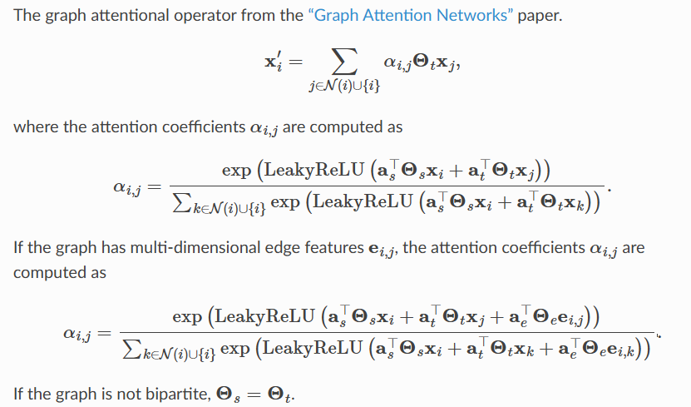
Link to the paper on GAT : https://arxiv.org/pdf/1710.10903
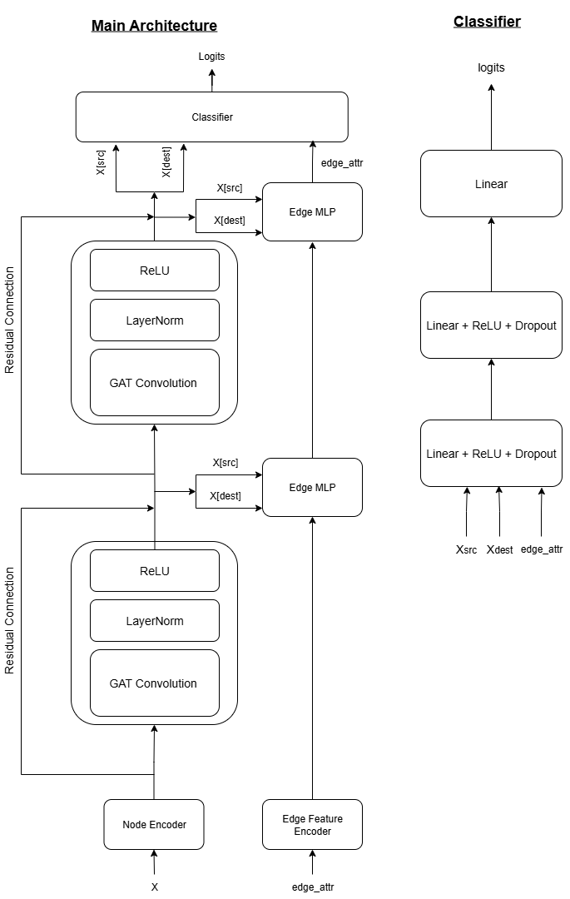
Training:
- BCE Loss = $-[pos_{weight}*y*log(p)+(1-y)*log(1-p)]$
Where:
y = true label(0 or 1)
p = predicted probability
$pos_{weight}$ = $class_count[0] / class_count[1]$

- Focal Loss = $-[ α * (1-p)^ γ * log(p)]$
Where:
α (alpha): Balances positive/negative examples $(=1 - (fraud_count) / total)$
γ (gamma): Focuses learning on hard examples $(=2)$
p: Model's confidence for the correct class

- BCE with logits = $\left\{\begin{aligned} log\left(1 + exp\left(-logit\right)\right)=log⁡(sigmoid\left(+logit\right)), & target=1 \\ log\left(1 + exp\left(+logit\right)\right)=log⁡(sigmoid\left(-logit\right)), & target=0\end{aligned}\right.$

- Total Loss = 0.7 * Focal Loss + 0.3 * BCE Loss

Evaluation:
- ROC-AUC curve (Receiver Operating Characteristic Area under the curve):
- Curve of TPR(true positive rate) vs FPR(false positive rate)
- $TPR = TP / (TP + FN)$, $FPR = FP / (FP + TN)$
- Ideally, TPR should be 1 and FPR should be 0
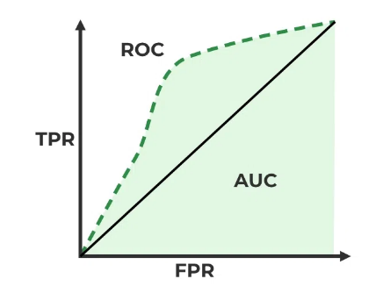

- $Precision = TP / (TP + FP)$
- $Recall = TP / (TP + FN)$
- $F1-Score = (2 * Precision * Recall) / (Precision + Recall)$

Further Improvements (for detection of directed subgraph patterns) :
- Port Numbering
- Ego IDs
- Reverse Message Passing
Points:
- Visualization of most of the fraud transactions (1:4) and neighbors around it (i.e. 2 hops and 3 hops)
- Same as Point (1) while sampling the non-fraud transactions
- GPU from the department
- List of transactions classified as fraud

