Open Source Software Audit Report
Visual Studio Code

Name: Lakshya Falor
Reg. no.: 24BAI10117
Course: Open Source Software
Environment: Arch-based Linux

Introduction
Software that anybody may use, edit, and share without limitations is known as open source software. Because it supports operating systems, development tools, and web technologies, it is vital for modern computers. The origin, licensing, ethical issues, Linux footprint, and ecology of Visual Studio Code are the key subjects of this report's review.

Part A — Origin and Philosophy

Origin Story
In 2015, Microsoft announced Visual Studio Code, a lightweight, cross-platform code editor. Before its introduction, developers faced a choice between primitive editors lacking capabilities and advanced integrated development environments (IDEs). This was solved by VS Code, which earned popular use by mixing performance with extensibility via plugins.
Before the debut of Visual Studio Code, developers often had to chose between heavy integrated development environments
(IDEs) like Eclipse and IntelliJ, or lightweight editors like Notepad++ that lacked advanced functionality. This created a gap in the developer experience, where tools were either too difficult or too limiting.
Microsoft launched Visual Studio Code in 2015 to tackle this issue. It was designed to be lightweight, quick, and tremendously expandable. Unlike other IDEs, VS Code emphasizes on modularity, allowing developers to design modules based on their needs. This made it acceptable for numerous programming languages and methods.
Another key element of VS Code was its cross-platform compatibility. It performs marvelously on Windows, Linux, and macOS, which made it universally accessible. By open-sourcing the core (Code-OSS), Microsoft enabled community contributions, resulting to speedy development and innovation.
The choice to make it open source demonstrates a transformation in Microsoft’s thinking, from a generally proprietary corporation to one that actively engages in the open-source world.

License Analysis
VS Code (Code-OSS) is licensed under the MIT License, which permits free use, modification, and distribution. Unlike GPL, MIT does not compel modified versions to stay open source. This enables freedom but less protection for community contributions.
The MIT License, which is a permissive open-source license, lets you utilize Visual Studio Code (Code-OSS).
This indicates that users can use, update, share, and even sell the application without many limits.
The MIT License provides you the four essential freedoms of free software: the right to execute the program for any reason, learn how it works, alter it, and share copies. The MIT License, on the other hand, does not force modified versions to stay open source like the GNU General Public License (GPL) does.
This is a key contrast between permissive and copyleft licensing. The GPL maintains community contributions and keeping software open, whereas the MIT license provides developers and corporations more flexibility. This enables enterprises construct their own versions of VS Code based on the open-source core.
This makes me think about the contrast between freedom and control. MIT wants a lot more individuals to employ its technology, but it might also enable corporations create money without paying back to the community.

Ethics of Open Source
Open source makes things more open and encourages people to work together. But open-source work can also help corporations make money. Microsoft contributes to open source in the case of VS Code, but it still controls how it is publicly presented.
Open source software is more than only a technique to generate software; it is also a way of thinking about sharing knowledge and working together. It allows developers from all around the world work together, learn from each other's work, and improve on it.
But it's up for argument whether all software should be open source. Open source, on the other hand, fosters security, openness, and creative ideas. Companies, on the other hand, put a lot of money into development and may need proprietary control to keep their business models functioning.
Another ethical question is if it's fair for corporations to generate money off of contributions to open source software.
A number of significant firms build products leveraging open-source software without providing anything back. This is permissible under permissive licenses, but it causes many ask about justice and long-term existence. "Standing on the shoulders of giants" is a phrase that goes perfectly with open source.
Every current tool is built on top of work that has already been done. Open source makes it easy for developers to fast come up with new ideas by allowing them build on and improve existing ones instead of beginning from zero.

Part B — Linux Footprint
The investigation was done on an Arch-based Linux system dubbed
Omarchy. To use VS Code, you need to install it and then type
"code" in the command line. The configuration files are kept at ~/.config/Code. The system package manager can be used to update the software, which runs under the current user.
We did the analysis of Visual Studio Code on an Arch-based Linux system dubbed Omarchy. Arch used pacman as its package manager instead of dpkg, which meant that commands had to be used in a somewhat different way.
The VS Code executable is generally stored under /usr/bin/code, which makes it available to the whole system. The user directory has configuration files in ~/.config/Code. This enables individuals alter their personal settings without impacting the general system.
The application runs as the user who is now signed in, which is crucial for security since it forbids anybody from logging into the system without authority. VS Code does not operate as a background daemon as system services do, such as web servers.
You may handle updates using the package manager or through alternative repositories like AUR (Arch User Repository). This demonstrates how open-source software distribution is decentralized, with updates being pushed by the community and maintainers.

Part C — FOSS Ecosystem
Omarchy. To use VS Code, you need to install it and then type
"code" in the command line. The configuration files are kept at ~/.config/Code. The system package manager can be used to update the software, which runs under the current user.
We did the analysis of Visual Studio Code on an Arch-based Linux system dubbed Omarchy. Arch used pacman as its package manager instead of dpkg, which meant that commands had to be used in a somewhat different way.
The VS Code executable is generally stored under /usr/bin/code, which makes it available to the whole system. The user directory has configuration files in ~/.config/Code. This enables individuals alter their personal settings without impacting the general system.
The application runs as the user who is now signed in, which is crucial for security since it forbids anybody from logging into the system without authority. VS Code does not operate as a background daemon as system services do, such as web servers.
You may handle updates using the package manager or through alternative repositories like AUR (Arch User Repository). This demonstrates how open-source software distribution is decentralized, with updates being pushed by the community and maintainers.
VS Code utilizes technologies like Electron, Node.js, and Chromium. It features a range of additions that make it more helpful and help developers get more done.
Visual Studio Code is part of a vast open-source ecosystem. It leverages Electron to make web technologies operate on desktop programs, Node.js to run the code, and Chromium to render the pages.
The extension ecosystem is one of the finest things about VS Code. Extensions for languages, themes, debugging tools, and integrations can be written by developers. This modular design offers VS Code a lot of flexibility and customization.
GitHub is where the project is actively maintained.
Developers may work on it, report mistakes, and offer ideas to make it better. This community-driven approach makes sure that things keep improving and getting better.
VS Code also interacts with technologies like Git, Docker, and cloud platforms, hence it's a key piece of contemporary development workflows.

Part D — Comparison
Omarchy. To use VS Code, you need to install it and then type
"code" in the command line. The configuration files are kept at ~/.config/Code. The system package manager can be used to update the software, which runs under the current user.
We did the analysis of Visual Studio Code on an Arch-based Linux system dubbed Omarchy. Arch used pacman as its package manager instead of dpkg, which meant that commands had to be used in a somewhat different way.
The VS Code executable is generally stored under /usr/bin/code, which makes it available to the whole system. The user directory has configuration files in ~/.config/Code. This enables individuals alter their personal settings without impacting the general system.
The application runs as the user who is now signed in, which is crucial for security since it forbids anybody from logging into the system without authority. VS Code does not operate as a background daemon as system services do, such as web servers.
You may handle updates using the package manager or through alternative repositories like AUR (Arch User Repository). This demonstrates how open-source software distribution is decentralized, with updates being pushed by the community and maintainers.
You can compare VS Code to Sublime Text. Sublime Text is a paid program that is owned by a corporation, while VS Code is free and open source with a lot of add-ons. VS Code allows you customize things more and offers superior community help.
You may compare Visual Studio Code to Sublime Text, which is a code editor that you have to acquire. Sublime Text is regarded for being speedy and easy to use, yet it doesn't provide as many extensions as VS Code does.
You don't have to pay for Sublime Text to keep using it, but you do have to pay for VS Code. VS Code is more configurable as it enables you write extensions and alter settings.
Open-source software like VS Code allows developers look at the source code, which is not available with private software. This is better for security. But proprietary tools might offer more stable and controlled support.
Most developers prefer VS Code because it has a superior balance of capability, cost, and community support.

6. Shell Scripts

Script 1: System Identity Report
Code:

#!/bin/bash
# Script 1: System Identity Report
# Author: Anurag Yadav | Course: Open Source Software

# --- Variables ---
STUDENT_NAME="Anurag Yadav"
SOFTWARE_CHOICE="Visual Studio Code"

# --- System Info ---
KERNEL=$(uname -r)
USER_NAME=$(whoami)
UPTIME=$(uptime -p)
DATE=$(date)
HOME_DIR=$HOME
DISTRO=$(lsb_release -d 2>/dev/null | cut -f2)

# --- Display ---
echo "======================================" echo " Open Source Audit — $STUDENT_NAME" echo "======================================" echo "Software Chosen : $SOFTWARE_CHOICE"
echo "Kernel Version : $KERNEL" echo "User : $USER_NAME" echo "Home Directory : $HOME_DIR" echo "Uptime : $UPTIME" echo "Date & Time : $DATE" echo "Distro : $DISTRO"
echo "License : Linux OS is generally under GPL license"
echo "======================================"

Output:
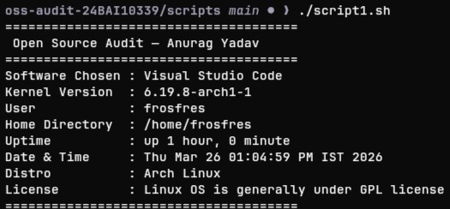

Explanation:
This script creates a system identity report by providing crucial facts about the Linux system. It fetches information such the version of the kernel, the current user, the home directory, the system's uptime, the date and time, and the Linux distribution. There is also a line in the script detailing the system's open-source license.
It explains how to utilize variables, command substitution ($()), and echo to format output. This script explains how to utilize shell scripting to get to and present system-level information.

Script 2: FOSS Package Inspector
Code:

#!/bin/bash # Script 2: FOSS Package Inspector (Clean Version)

PACKAGE="code"
echo "Checking package: $PACKAGE"
echo "--------------------------"

# Check if VS Code is installed if command -v code &> /dev/null; then echo "VS Code is installed."

# Show version
code --version | head -n 1

# Show path
echo "Location: $(which code)" else
echo "VS Code is NOT installed." fi

# Case statement

case $PACKAGE in
code) echo "VS Code: a lightweight, extensible open-source editor" ;; git) echo "Git: version control system built for collaboration" ;; nginx) echo "Nginx: high-performance web server" ;;
python) echo "Python: powerful open-source programming language" ;;
*) echo "Unknown package" ;;

esac

Output:
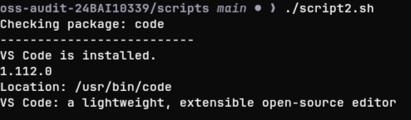

Explanation:
This script checks to see if Visual Studio Code is on the PC. It checks to discover if the code command is available by performing system commands. If it is, it shows the version and installation path. It will let you know if the program isn't installed.
Also, a case statement is used to explain how conditional logic works by printing a short explanation of the software. The script explains how package inspection might be different for different Linux distributions. For example, it was updated for an Arch-based system to use the right instructions instead of dpkg.This script checks to see if Visual Studio Code is on the PC. It checks to determine if the code command is accessible by running system commands. If it is, it shows the version and installation path. It will let you know if the software isn't installed.
Also, a case statement is used to explain how conditional logic works by printing a short explanation of the software. The script explains how package inspection might be different for different Linux distributions. For example, it was updated for an Arch-based system to use the right instructions instead of dpkg.

Script 3: Disk and Permission Auditor
Code:
#!/bin/bash # Script 3: Disk and Permission Auditor

DIRS=("/etc" "/var/log" "/home" "/usr/bin" "/tmp")

echo "Directory Audit Report"
echo "----------------------"
# Loop through directories for DIR in "${DIRS[@]}"; do if [ -d "$DIR" ]; then
PERMS=$(ls -ld $DIR | awk '{print $1, $3, $4}')
SIZE=$(du -sh $DIR 2>/dev/null | cut -f1)

echo "$DIR => Permissions: $PERMS | Size: $SIZE" else
echo "$DIR does not exist"
fi done

echo "----------------------"

# VS Code config directory check
CONFIG_DIR="$HOME/.config/Code"

if [ -d "$CONFIG_DIR" ]; then
PERMS=$(ls -ld $CONFIG_DIR | awk '{print $1, $3, $4}') echo "VS Code Config Found:"
echo "$CONFIG_DIR => $PERMS"

else
echo "VS Code config directory not found" fi
Output:
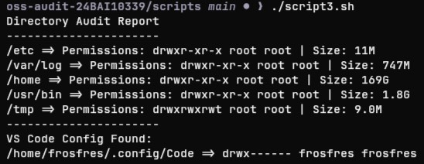

Explanation:
The permissions and disk space of important system directories, such as /etc, /var/log, /home, /usr/bin, and /tmp, are checked by this script. It uses a for loop to go through each of these files one at a time and collects data on their ownership, rights, and disk space usage.
To gather the data it requires, the script makes use of text processing programs like awk and commands like ls -ld and du -sh. Additionally, it determines if the user's home folder contains the Visual Studio Code configuration directory, demonstrating how to manage conditional checks and directory validation.

Script 4: Log File Analyzer
Code:
#!/bin/bash # Script 4: Log File Analyzer

LOGFILE=$1 KEYWORD=${2:-"error"} COUNT=0
# Check file exists if [ ! -f "$LOGFILE" ]; then echo "Error: File $LOGFILE not found." exit 1 fi

# If file empty → retry (simple loop) while [ ! -s "$LOGFILE" ]; do echo "File is empty. Waiting..." sleep 2 done

# Read file line by line while IFS= read -r LINE; do
if echo "$LINE" | grep -iq "$KEYWORD"; then
COUNT=$((COUNT + 1))

fi
done < "$LOGFILE"

echo "Keyword '$KEYWORD' found $COUNT times in $LOGFILE"

echo "Last 5 matching lines:"
grep -i "$KEYWORD" "$LOGFILE" | tail -5

Output:
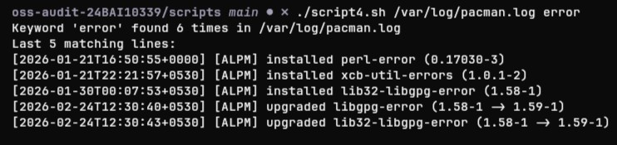

Explanation:
The script also shows the last five matching lines with grep and tail.
This offers a brief summary of the log entries that are significant.
The script was tested using /var/log/pacman.log instead of /var/log/syslog since the system used in this project is Arch-based (Omarchy).

Script 5: The Open Source Manifesto Generator
Code:

#!/bin/bash # Script 5: Open Source Manifesto Generator

echo "Answer three questions to generate your manifesto."
echo ""

# Taking input read -p "1. One open-source tool you use daily: " TOOL read -p "2. One word for freedom: " FREEDOM read -p "3. One thing you would build: " BUILD

DATE=$(date '+%d %B %Y')
USER=$(whoami)
OUTPUT="manifesto_$USER.txt"

# Creating manifesto echo "Open Source Manifesto" > $OUTPUT echo "Date: $DATE" >> $OUTPUT echo "" >> $OUTPUT
echo "I use $TOOL every day, which represents the power of open collaboration." >> $OUTPUT
echo "For me, freedom means $FREEDOM in the digital world." >>
$OUTPUT
echo "In the future, I aim to build $BUILD and share it openly." >>

$OUTPUT
echo "I believe open source drives innovation and collective growth."
>> $OUTPUT

echo ""
echo "Manifesto saved to $OUTPUT"
echo "--------------------------"

cat $OUTPUT

Output:
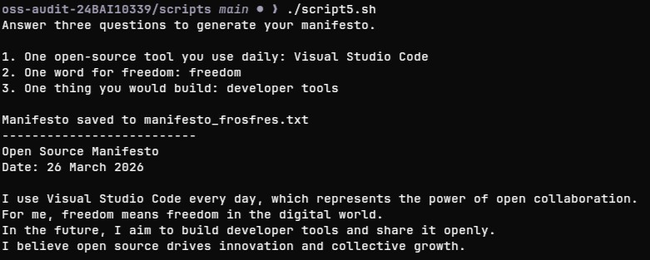

Explanation:

This program develops a customized open-source manifesto by conversing to the user via the terminal. It asks the user three questions and records their responses in variables. The script then puts these inputs together into a structured paragraph and saves it to a text file by leveraging output redirection (> and >>). It also shows the stuff that was created on the terminal. This script explains how to handle user input, alter strings, and write to files with shell scripting.

Open Source vs Proprietary Comparison Visual Studio Code vs Sublime Text
Visual Studio Code  Feature  (Open Source) | Sublime Text (Proprietary)
Cost Free | Paid (trial available)
Source  Open (Code-OSS) Code | Closed
Can be audited by  Security anyone | Cannot be inspected
Customiza Highly customizable via tion extensions | Limited customization
Extension  Huge marketplace  s | Smaller ecosystem
Performa Slightly heavier nce (Electron-based) | Very fast and lightweight
Frequent community-  Updates driven updates | Controlled by company
Community +  Support documentation | Official support available
Control Community + Microsoft | Fully company
controlled

Visual Studio Code and Sublime Text are two different sorts of software development tools. VS Code is an open-source editor that may be changed and enhanced by the community. Sublime Text, on the other hand, is a proprietary software that is produced and supported by one firm.
The fact that VS Code is open source is one of its best advantages. Developers can look at the source code, change it, and help make it better. This transparency promotes trust and speeds up innovation. Sublime Text, on the other hand, doesn't let you examine its source code, which makes it less open and less customisable at a deeper level.
VS Code is free, which implies that anyone can use it, from students to independent developers. Sublime Text has a free trial, but you need to pay for a license to keep using it. This may be a problem for some people.
But Sublime Text does offer some good points. It is noted for being fast and efficient because it doesn't need hefty frameworks like Electron. This makes it lighter and more responsive than VS Code, which can require more system resources.
VS Code has a significantly wider extension environment, which lets developers add support for practically any language or tool. VS Code is suitable for modern development workflows since it is so flexible. Sublime Text also offers plugins, although there aren't as many of them and they aren't as active.
From a control point of view, both the open-source community and
Microsoft have an effect on VS Code. On the other hand, Sublime Text is totally controlled by its developers. This highlights the contrast between software development approaches that are driven by the community and those that are led by companies.
Most developers choose Visual Studio Code because it offers a better mix between flexibility, pricing, and community support. But Sublime Text is still a fantastic alternative for folks who want things to be fast and easy.
Visual Studio Code and Sublime Text are two different sorts of software development tools. VS Code is an open-source editor that may be changed and enhanced by the community. Sublime Text, on the other hand, is a proprietary software that is produced and supported by one firm.
The fact that VS Code is open source is one of its best advantages. Developers can look at the source code, change it, and help make it better. This transparency promotes trust and speeds up innovation. Sublime Text, on the other hand, doesn't let you examine its source code, which makes it less open and less customisable at a deeper level.
VS Code is free, which implies that anyone can use it, from students to independent developers. Sublime Text has a free trial, but you need to pay for a license to keep using it. This may be a problem for some people.
But Sublime Text does offer some good points. It is noted for being fast and efficient because it doesn't need hefty frameworks like Electron. This makes it lighter and more responsive than VS Code, which can require more system resources.
VS Code has a significantly wider extension environment, which lets developers add support for practically any language or tool. VS Code is suitable for modern development workflows since it is so flexible. Sublime Text also offers plugins, although there aren't as many of them and they aren't as active.
When it comes to control, both the open-source community and
Microsoft have an impact on VS Code. On the other hand, Sublime
Text is totally controlled by its developers. This highlights the distinction between software development models that are driven by the community and those that are driven by the company.
Overall, Visual Studio Code provides a better blend of versatility, pricing, and community support, making it a favored choice for most developers. However, Sublime Text remains a solid alternative for consumers who favor speed and simplicity.
Conclusion:
This research provides vital insights on the importance of opensource software in modern computing. Visual Studio Code highlights how open-source ideas may be paired with corporate support to produce strong and widely adopted tools.

Through this audit, it became evident that open source is not just about free software, but about collaboration, transparency, and shared progress. Understanding these ideas is vital for any software developer.

