AR523: Robot Manipulators
Assignment 2: Force-Controlled Writing & Haptic Material Identification
This assignment focuses on force control for robotic manipulators -- making a robot regulate contact force, not just position. It is divided into two parts:
- Part A: Analytical derivation and hand computation of the admittance and impedance control laws.
- Part B: Simulation-based implementation using PyBullet, applied first to a force-controlled writing task and then to haptic material identification.
Students are expected to develop an understanding of the underlying mathematical formulation and then validate their results through simulation.
Students may refer to the following for learning PyBullet: PyBullet Official Documentation. A skeleton Python code is provided to help you get started (utils.py and main.py in the starter/ folder). There might be errors in the skeleton code, which is expected to be resolved by yourself.
Part A: Derivation of the Force Control Laws
In Part A, you will derive both control laws analytically and work through one numeric example by hand before implementing anything in simulation.
Section-I
- Starting from the Cartesian impedance control law τ = Jᵀ(-Ke - Bė) + g(q), derive the steady-state relationship between commanded penetration and contact force for a rigid environment (Hooke's law, F = K × penetration). State clearly what assumptions your derivation relies on.
- Starting from the admittance control law M ẍc + B ẋc = Fmeasured - Fdesired, derive the steady-state condition and show that it implies Fmeasured = Fdesired regardless of the environment's actual stiffness (unlike impedance control).
- Choose a target contact force Fdesired and a normal-axis stiffness K (justify your choice of K with one or two sentences). Compute by hand the virtual penetration required to achieve Fdesired under impedance control.
- For a chosen virtual mass M, compute the critical damping B = 2ζ√(KM) for ζ = 1 (critically damped) and for ζ = 0.5 (underdamped). Briefly describe how you would expect the two to behave differently on contact.
- Submit the complete derivation and calculations for this section in handwritten form.

Part B: Force-Controlled Writing and Material Identification using PyBullet
In this part, you will implement and demonstrate admittance control, impedance control, and haptic material identification using PyBullet.
Section-I: Admittance Control
- Implement the admittance control law in AdmittanceController.step() (see the starter/ skeleton code).
- Using it, hold the end-effector at a fixed point and regulate contact force to a chosen Fdesired (“pen-down force calibration”). Plot measured vs. desired force over time and report force-tracking RMSE and settling time.
- Extend the task to write a short word (any combination of A-Z) in simple block letters at constant contact force, lifting the pen between disconnected strokes. Plot the traced (x, y) path -- it should be recognizable as the word.
Section-II: Impedance Control
- Implement the impedance control law in CartesianImpedanceController.compute() (see the starter/ skeleton code).
- Repeat the pen-down force calibration task from Section-I using impedance control instead, with a fixed virtual penetration setpoint computed from your Part-A derivation. Report the same metrics for direct comparison.
- Repeat the word-writing task from Section-I using impedance control.
Section-III: Analysis and Comparison
- Prepare a written comparison between admittance and impedance control using both the calibration and writing results from Section-I and Section-II: which tracked force more accurately? Which responded faster? Does one produce a more legible traced word?
Section-IV: Haptic Material Identification
- Three material samples of unknown (to your controller) stiffness are placed on the table. Using your impedance controller, press into each sample to the same commanded target pose and record the resulting steady-state contact force.
- Estimate an approximate contact stiffness K̂ = Fsteady / commanded_penetration for each sample.
- Implement classify_material() (see the starter/ skeleton code) to classify each sample as soft / medium / hard against thresholds you choose, and report a table of estimated K̂ alongside your classification.
- Discuss: your probe's own compliance is effectively in series with each material's stiffness, so K̂ will always read below the true stiffness. What does this imply about choosing a probe stiffness if you needed to distinguish materials stiffer than the ones tested here?
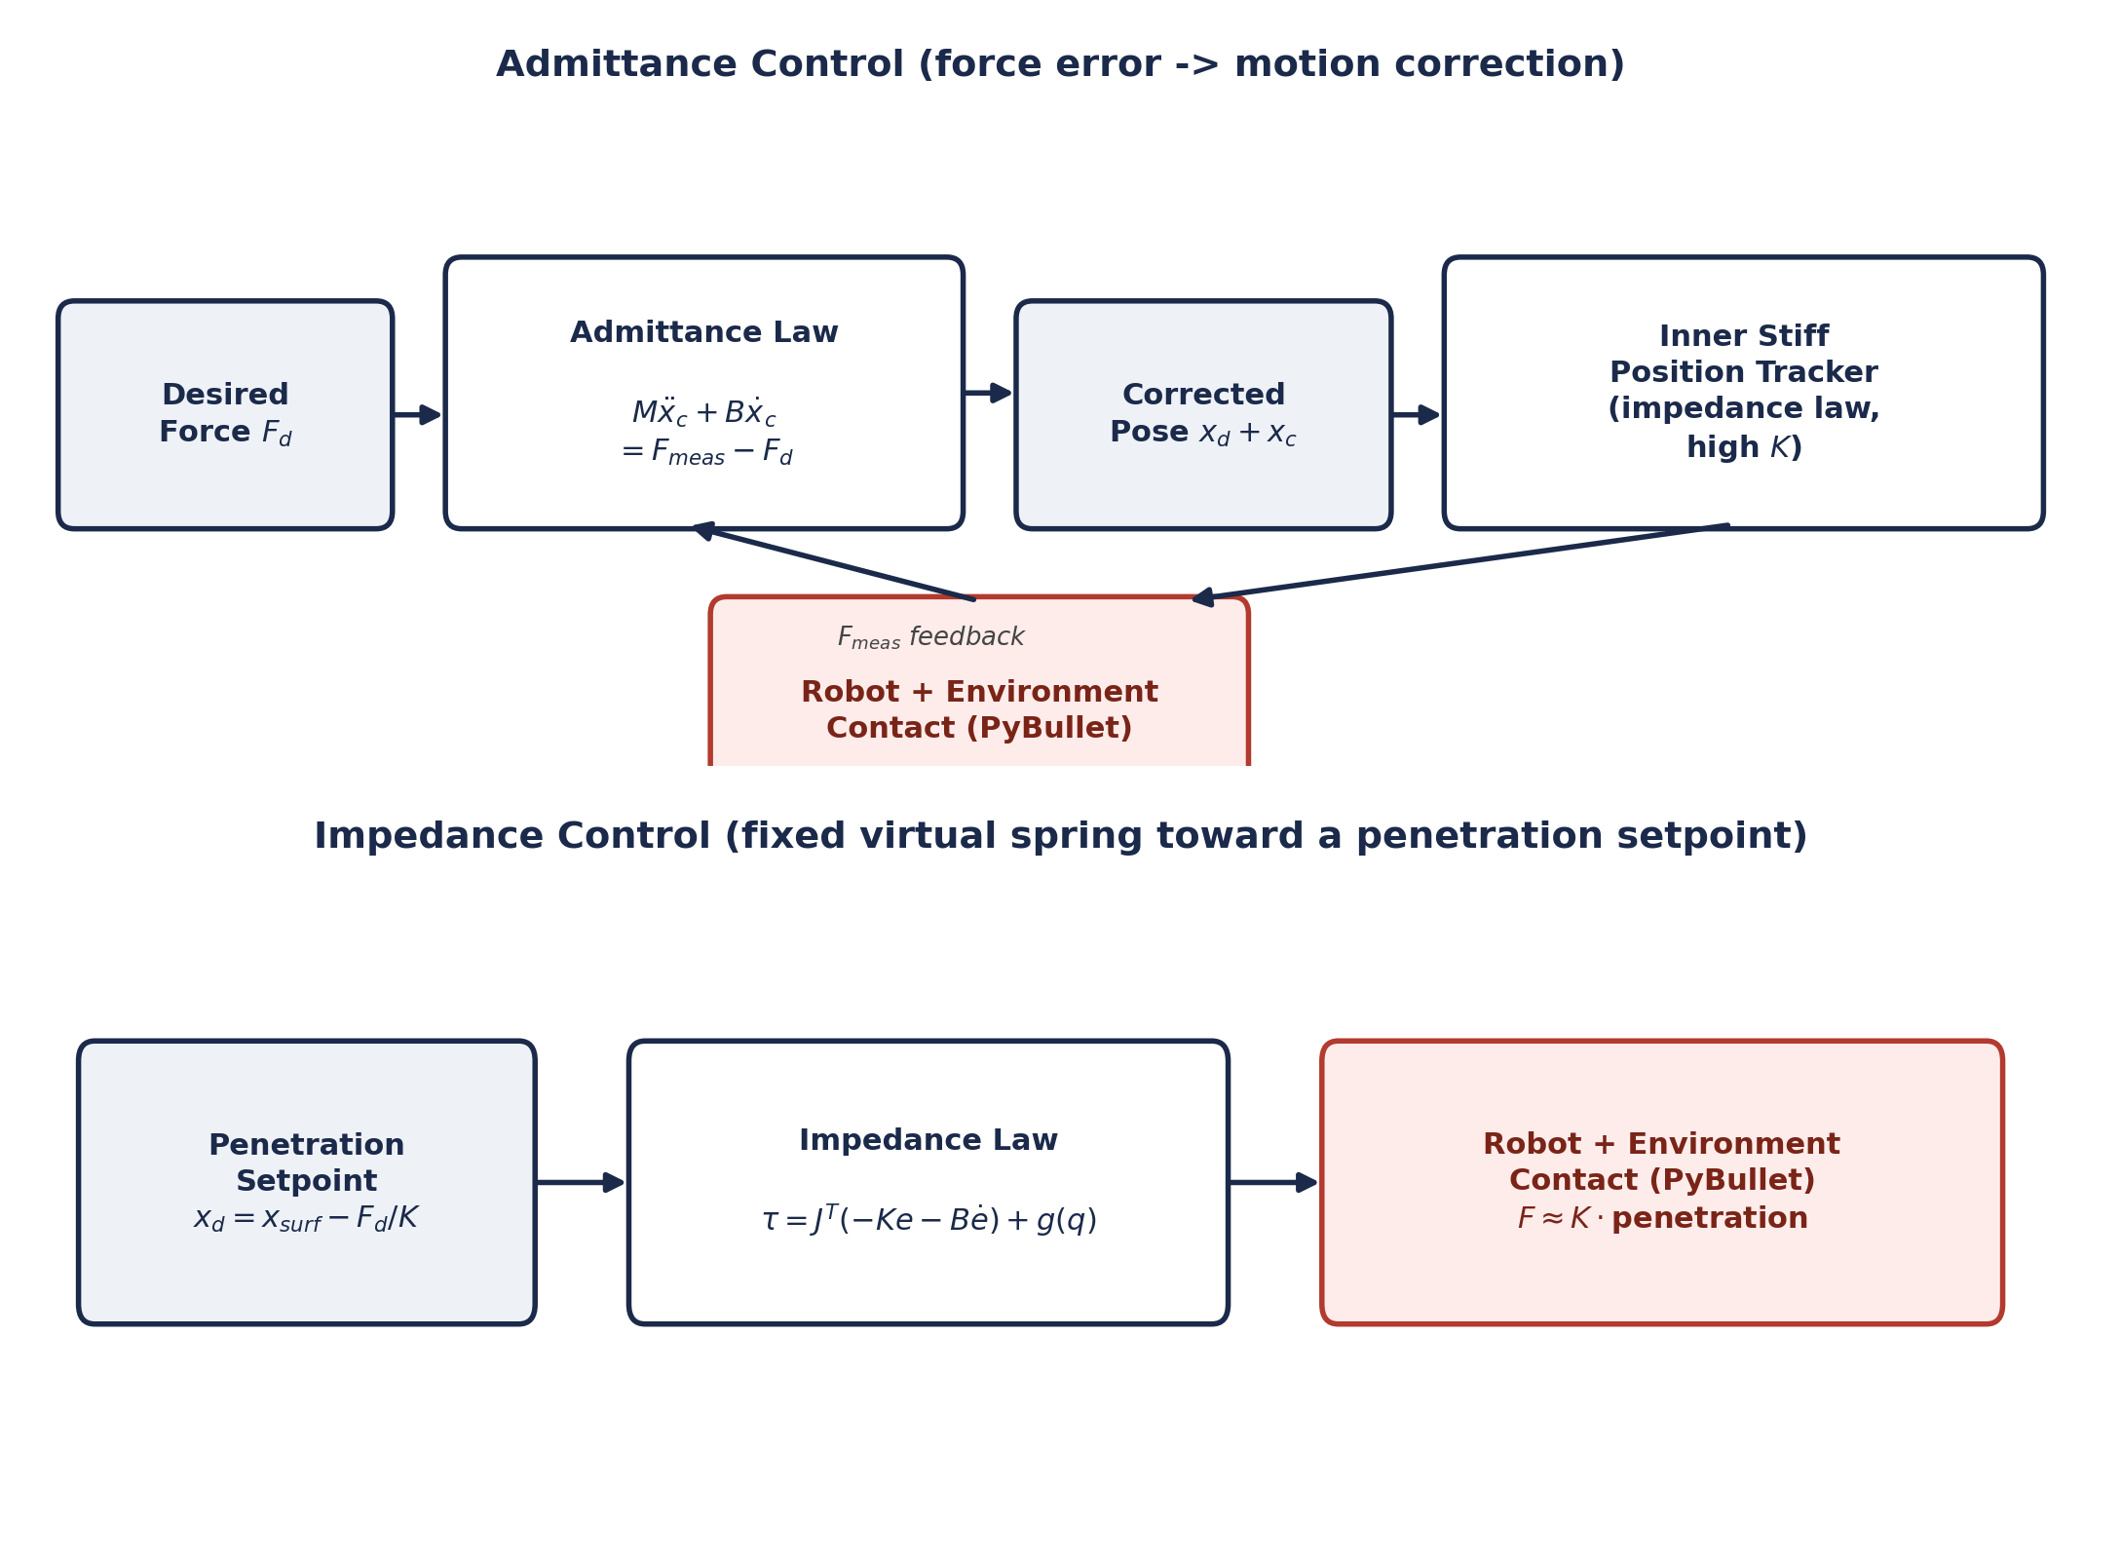
Figure 1. Admittance control (top) regulates force through an outer mass–damper correction feeding a stiff inner position tracker. Impedance control (bottom) regulates force directly by choosing a fixed virtual-spring penetration setpoint.
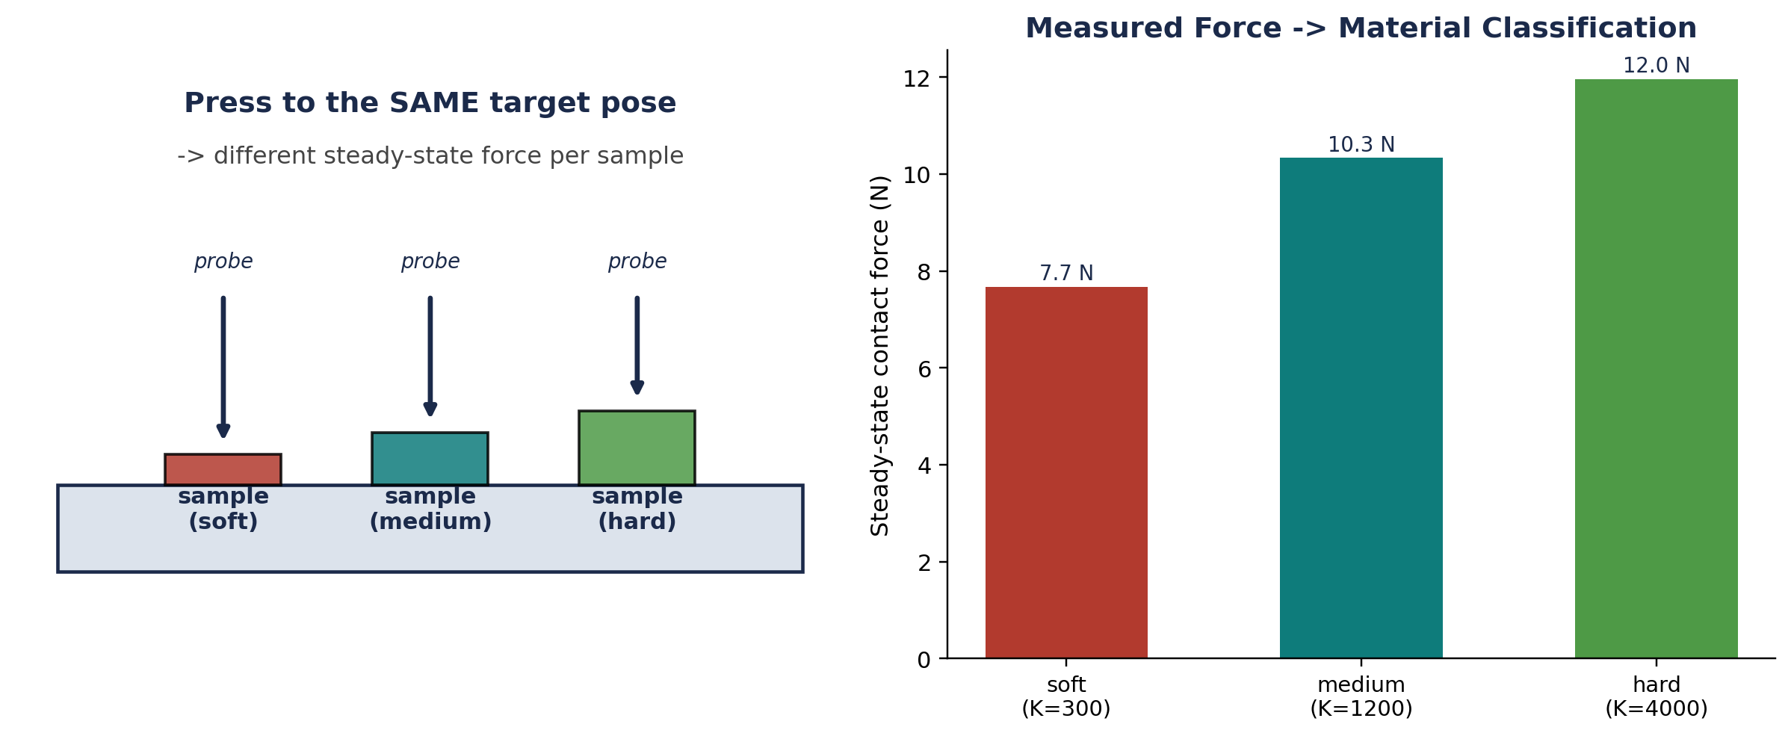
Figure 2. Every material sample is probed to the SAME commanded pose, so the resulting steady-state force alone is a monotonic signature of stiffness.
Extra Credit
Extra credit is optional and assessed on top of full marks for Parts A and B. Pick at most two.
- Extend Section-IV to a full loading-curve stiffness estimate (linear regression of force vs. penetration depth over a controlled quasi-static press) instead of a single steady-state point.
- Extend your writing controller to handle a non-planar surface -- estimate the local surface normal and regulate force along it rather than assuming a fixed world axis.
- Implement online adaptation of the virtual mass, damping, or stiffness based on contact conditions.

Setup
- Python 3.8+
- PyBullet -- install with pip install pybullet
- NumPy, Matplotlib
Instructions:
- This assignment is to be done individually or in pairs. The choice is yours.
- Please submit it on google form as a single zip file named <A2_StudentID>.zip or <A2_StudentID1_StudentID2>.zip. The zip file should contain a scan copy of handwritten notes (Part A), python files, and running instructions.
- The submission deadline is 11:59 PM IST on [DATE TBD]. Late submission will incur a daily 10% score adjustment for up to two days.
- Your first submission within the prescribed time period is final. Please do not ask for replacing the files later (e.g., on account of any incorrect upload). Such tampering beyond the submission time is not fair to other students in class who submit on time.
- The assignment must be done only from your own original efforts. Do not use any existing implementation/report from online sources. Do not violate the academic honesty code.
- Please write your implementation without use of AI code generators (e.g., GPT). Taking assistance from such tools will take away the opportunity to deeply understand the working of the algorithms. Hence, it is important to do this exercise on your own. A standard AI code generated solution will be part of automated code similarity checking. Submissions that resemble similarity beyond acceptance to standard AI-generated code will be flagged and treated as external assistance beyond your own effort.
Acknowledgement:
Thanks TA [TA Name] ([TA email]) for his/her help in preparing this assignment! You may reach out to him/her in case of any doubts.

