**STACK OVERFLOW**

**DEVELOPER SURVEY 2019**

**Lakshay Madhok**

# OUTLINE

* Executive Summary
* Introduction
* Methodology
* Results
* Visualization – Charts
* Dashboard
* Discussion
* Findings & Implications
* Conclusion
* Appendix

# EXECUTIVE SUMMARY

* Data contextualization and analysis goal.
* Methodology description.
* Data gathering.
* Data analysis.
* Data visualizations.
* Results presentation supported with graphs and trends.
* Discussion of overall findings and implications regarding the results previously exposed.
* Final conclusions of the carried out research.

# INTRODUCTION

* Stack Overflow’s annual Developer Survey is the largest and most comprehensive survey of people who code around the world.
* Results don’t represent everyone in the developer community evenly.
* Nearly 90,000 developers.
* Trends to predict where the developers are going.
* Characterization of developers around the globe.

# METHODOLOGY

* Collect survey data & explore its content
* Web Scraping
* APIs.
* Request library.
* Data Wrangling
* Exploratory data analysis
* Analyzing data distribution.
* Handling outliers.
* Correlations.
* Data Visualization
* Highlight distribution of data, relationships, the composition and comparison of data.
* Dashboards

# RESULTS



# PROGRAMMING LANGUAGE TRENDS

Current Year Next Year

**PROGRAMMING LANGUAGE TRENDS - FINDINGS & IMPLICATIONS**

Findings Implications

* JavaScript seems to keep as • Possible developers migration leading language. from JavaScript to TypeScript.
* Python fastest-growing.
* Great interest in TypeScript

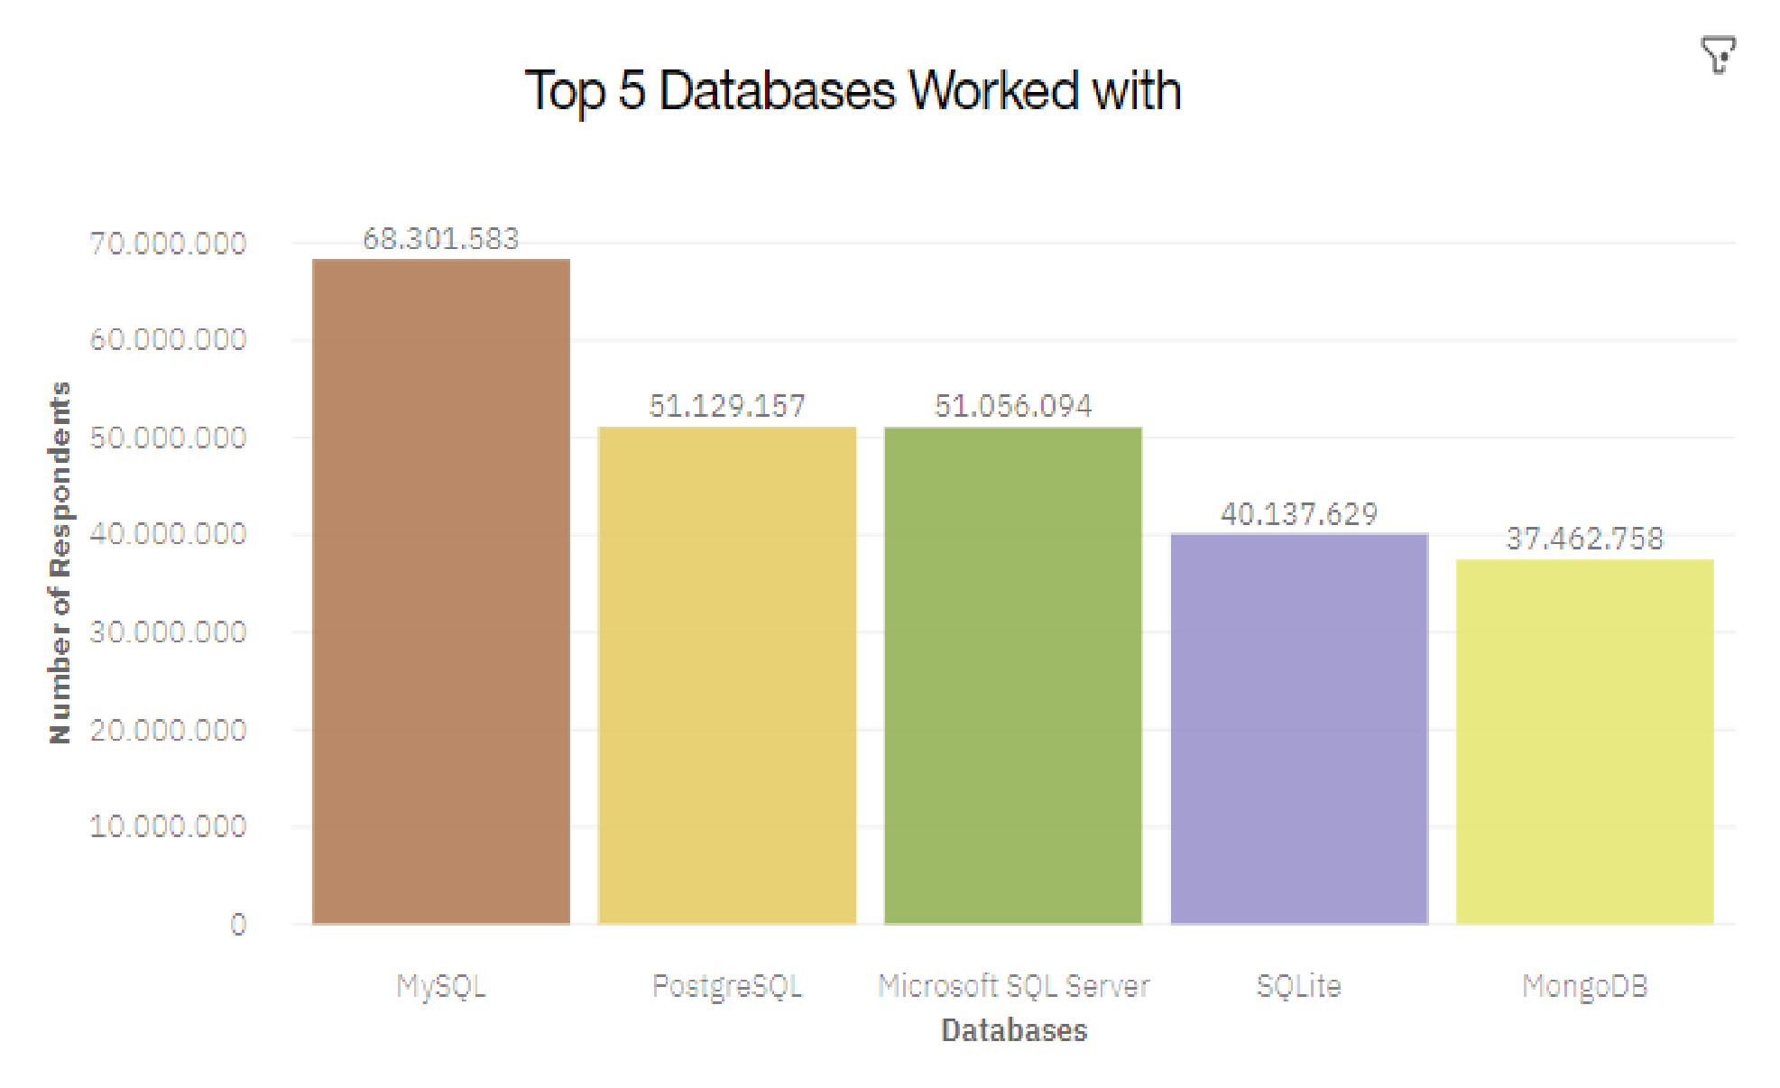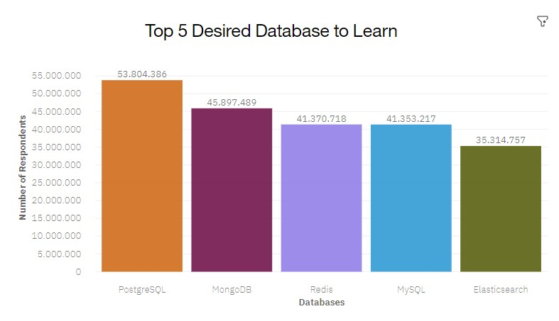**DATABASE TRENDS** Current Year Next Year

# DATABASE TRENDS - FINDINGS & IMPLICATIONS

Findings Implications

* MySQL as most used database. • Microsoft SQL Server and SQLite
* Lack of interest in Microsoft SQL losing ground in the market.

Server and SQLite. • PostgreSQL and MongoDB

* Increasing interest in PostgreSQL establishment in the market.

and MongoDB.

# DASHBOARD

[https://dataplatform.cloud.ibm.com/da shboards/380a93e5-f4a1-4e4d-98414966b65d676b/view/4c21e17d12b36af](https://dataplatform.cloud.ibm.com/dashboards/380a93e5-f4a1-4e4d-9841-4966b65d676b/view/4c21e17d12b36af74bfcc0e407cf7a0f7d35250fbabb8456d6d77b490a327397f33b1590c87c1d5b89130561a5bf110acc)

[74bfcc0e407cf7a0f7d35250fbabb8456d](https://dataplatform.cloud.ibm.com/dashboards/380a93e5-f4a1-4e4d-9841-4966b65d676b/view/4c21e17d12b36af74bfcc0e407cf7a0f7d35250fbabb8456d6d77b490a327397f33b1590c87c1d5b89130561a5bf110acc)

[6d77b490a327397f33b1590c87c1d5b8](https://dataplatform.cloud.ibm.com/dashboards/380a93e5-f4a1-4e4d-9841-4966b65d676b/view/4c21e17d12b36af74bfcc0e407cf7a0f7d35250fbabb8456d6d77b490a327397f33b1590c87c1d5b89130561a5bf110acc)

[9130561a5bf110acc](https://dataplatform.cloud.ibm.com/dashboards/380a93e5-f4a1-4e4d-9841-4966b65d676b/view/4c21e17d12b36af74bfcc0e407cf7a0f7d35250fbabb8456d6d77b490a327397f33b1590c87c1d5b89130561a5bf110acc)

# CURRENT TECHNOLOGY USAGE

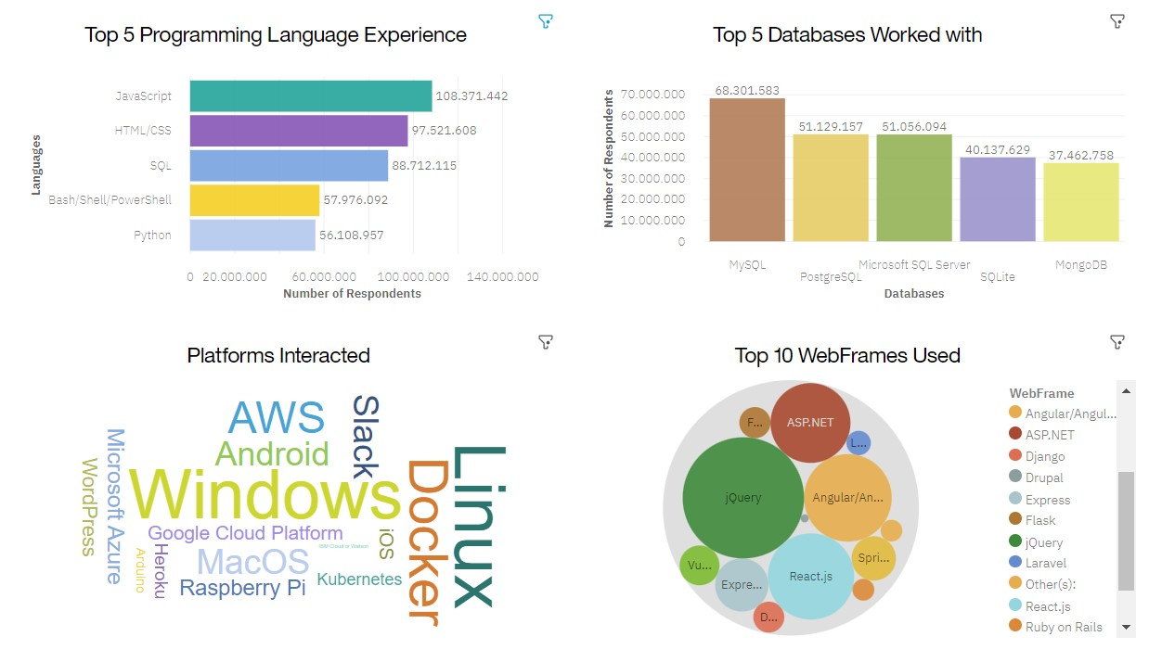

# FUTURE TECHNOLOGY TREND

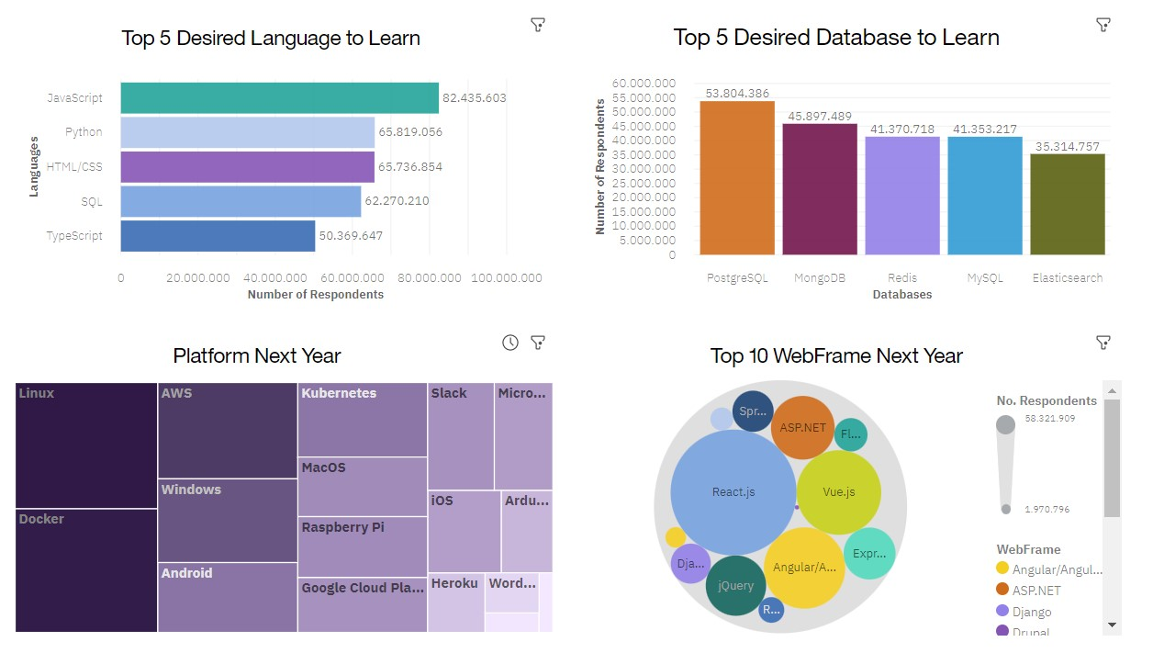

# DEMOGRAPHICS

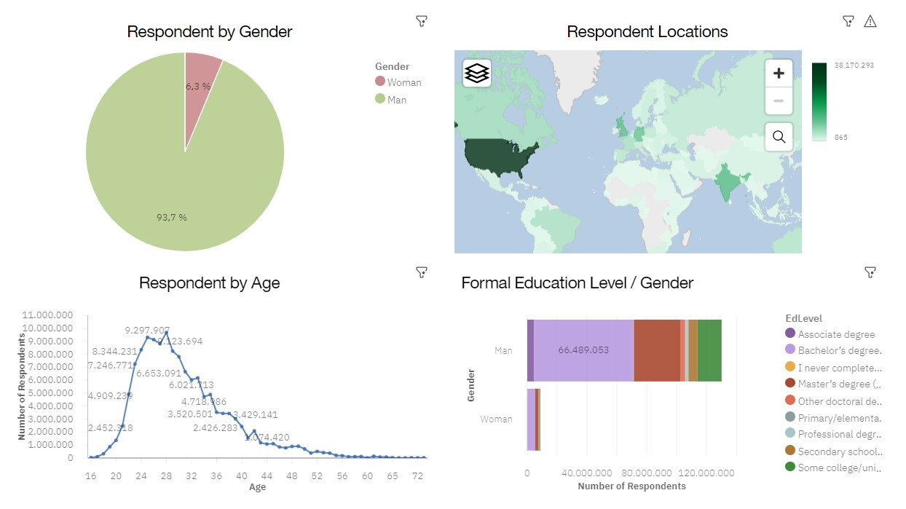

# DISCUSSION



# OVERALL FINDINGS & IMPLICATIONS

Findings

* JavaScript widely used and TypeScript getting popular.
* Over 90% young male developers.
* Developers mostly located in developed countries.

Implications

* JavaScript and TypeScript web frames gaining followers.
* Global polarization of developers location and gender.
* Young developers without postgrad studies on its majority.

# CONCLUSION

* Developers are people with very marked characteristics.
* A good idea of popularity trends of different tools, platforms and languages can be obtained.
* There is a job to be done to spread accessibility of this labor market to countries in development.

# APPENDIX



# AGE DISTRIBUTION BOXPLOT

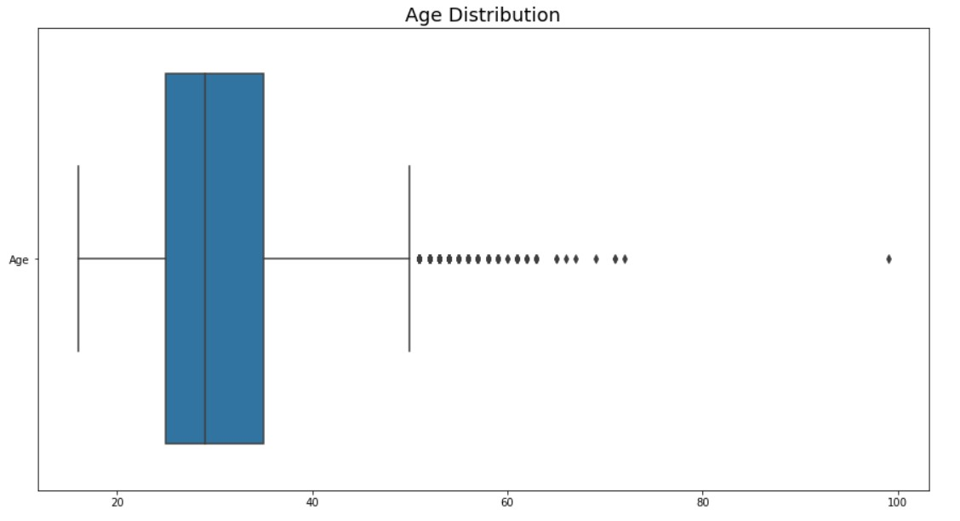

# JOB POSTINGS

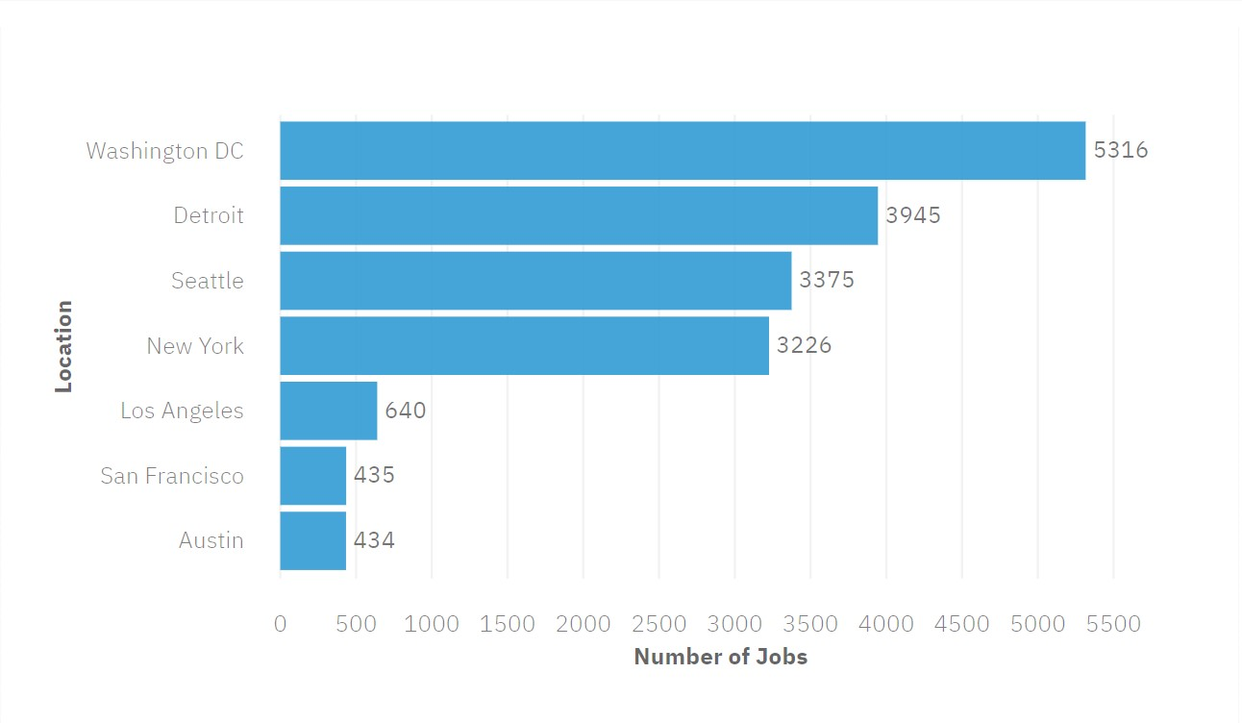

# POPULAR LANGUAGES

