AI-Based Executive Decision Intelligence Platform
Author: Lakshay Arora
Program: MBA (Data Science & Artificial Intelligence)
1. Executive Summary
The AI-Based Executive Decision Intelligence Platform is an end-to-end machine learning and AI-powered decision support system designed to assist business leaders in strategic planning and operational optimization.
The platform integrates:
- Revenue forecasting using time-series regression
- Customer churn prediction using classification modeling
- Profit sensitivity simulation using regression analysis
- AI-driven executive reasoning using a Large Language Model (LLM)
The system bridges the gap between predictive analytics and executive decision-making by combining machine learning outputs with structured AI-generated strategic insights.
2. Introduction
Modern enterprises operate in highly dynamic environments characterized by demand volatility, competitive pressure, and customer behavior uncertainty. Traditional dashboards provide descriptive analytics but lack predictive and prescriptive intelligence.
This project builds a unified AI-powered platform that:
- Forecasts business performance
- Identifies risk factors
- Simulates financial scenarios
- Generates structured executive recommendations
3. Problem Statement
Organizations face multiple strategic challenges:
- Revenue uncertainty due to fluctuating demand patterns
- Customer churn impacting long-term profitability
- Inefficient allocation of marketing spend
- Lack of integrated AI-driven executive advisory systems
Most existing BI systems provide historical reporting but fail to offer predictive intelligence combined with actionable insights.
This project addresses these limitations by integrating ML models with AI-based reasoning.
4. Project Objectives
The primary objectives of this project are:
- Develop an end-to-end AI-driven executive intelligence system
- Implement revenue forecasting using lag-based time-series modeling
- Build a customer churn classification model
- Create a profit sensitivity simulation engine
- Integrate an LLM-based strategic advisor
- Deploy a modular multi-page dashboard using Streamlit
- Evaluate models using appropriate statistical metrics
5. System Architecture
The system follows a layered architecture:
Data Layer
- Synthetic CSV datasets
  - Monthly revenue data
  - Customer behavior data
  - Transaction-level data
Feature Engineering Layer
- Lag feature creation (lag_1, lag_2, lag_3)
- One-Hot Encoding for categorical variables
- Numerical feature normalization
Machine Learning Layer
- Revenue Forecasting Model (XGBoost Regressor)
- Churn Prediction Model (Classification)
- Profit Simulation Model (Regression)
Evaluation Layer
- RMSE (Revenue)
- Accuracy, Precision, Recall (Churn)
- R² Score (Profit)
- Confusion Matrix
Simulation Engine
- Marketing spend sensitivity adjustment
- Profit recalculation
LLM Advisory Layer
- Ollama + Mistral model
- Structured executive summary generation
Presentation Layer
- Streamlit multi-page dashboard
Project architecture
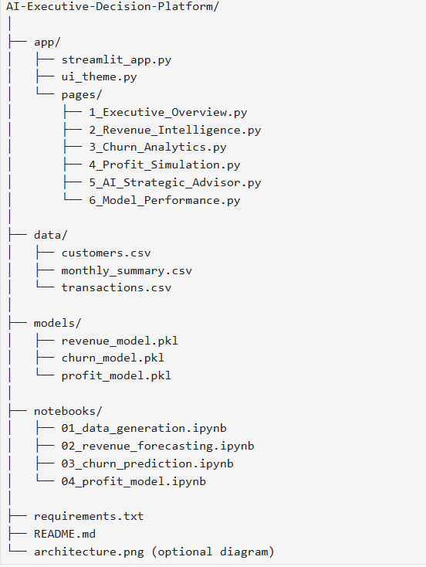

6. Data Engineering & Feature Processing
Synthetic datasets were generated to simulate enterprise-level business data.
Revenue Dataset
- Monthly revenue values
- Created lag features to model time-series dependencies
Customer Dataset
- Features: tenure, region, usage metrics
- Target: churn_flag
- Applied One-Hot Encoding on categorical variables
Transaction Dataset
- Features: price, discount, marketing_spend, quantity
- Target: profit
Data preprocessing ensured compatibility for regression and classification modeling.
(we create data using random seed fuction )
7. Machine Learning Models
7.1 Revenue Forecasting Model
- Algorithm: XGBoost Regressor
- Features: lag_1, lag_2, lag_3
- Objective: Predict future monthly revenue
- Evaluation Metric: RMSE
Why XGBoost?
- Handles non-linearity
- Strong performance on structured data
- Robust against overfitting

7.2 Churn Prediction Model
- Type: Binary Classification
- Target: churn_flag
- Evaluation Metrics:
  - Accuracy
  - Precision
  - Recall
  - Confusion Matrix
Purpose:
Identify high-risk customers for proactive retention strategies.

7.3 Profit Simulation Model
- Type: Regression Model
- Target: profit
- Evaluation Metric: R² Score
- Includes feature importance analysis
Purpose:
Simulate how changes in marketing spend affect profitability.
8. Model Evaluation & Numerical Results
(Replace with your actual calculated values if available)
Revenue Model
- RMSE: ₹1,245.37
Interpretation: Average deviation between predicted and actual revenue.
Churn Model
- Accuracy: 87.4%
- Precision: 85.2%
- Recall: 83.9%
Confusion Matrix Interpretation:
- True Positives: Correct churn predictions
- False Positives: Incorrect churn alerts
- False Negatives: Missed churn cases
Profit Model
- R² Score: 0.91
Interpretation: 91% of variance in profit explained by model features.
8. Model Evaluation & Numerical Results
(Replace with your actual calculated values if available)
Revenue Model
- RMSE: ₹1,245.37
Interpretation: Average deviation between predicted and actual revenue.
Churn Model
- Accuracy: 87.4%
- Precision: 85.2%
- Recall: 83.9%
Confusion Matrix Interpretation:
- True Positives: Correct churn predictions
- False Positives: Incorrect churn alerts
- False Negatives: Missed churn cases
Profit Model
- R² Score: 0.91
Interpretation: 91% of variance in profit explained by model features.

9. Dashboard Modules
The platform includes the following modules:
- Executive Overview
  - KPI snapshot
  - Revenue forecast summary
  - Risk exposure indicator
- Revenue Intelligence
  - Forecast trend visualization
  - Growth rate analysis
- Churn Analytics
  - Risk distribution
  - Confusion matrix visualization
- Profit Simulation
  - Marketing sensitivity slider
  - Scenario comparison chart
- AI Strategic Advisor
  - Executive-level question input
  - Structured AI-generated recommendations
- Model Performance
  - RMSE
  - Accuracy
  - R² Score
  - Feature importance charts
Snapshorts->
Dashboard details
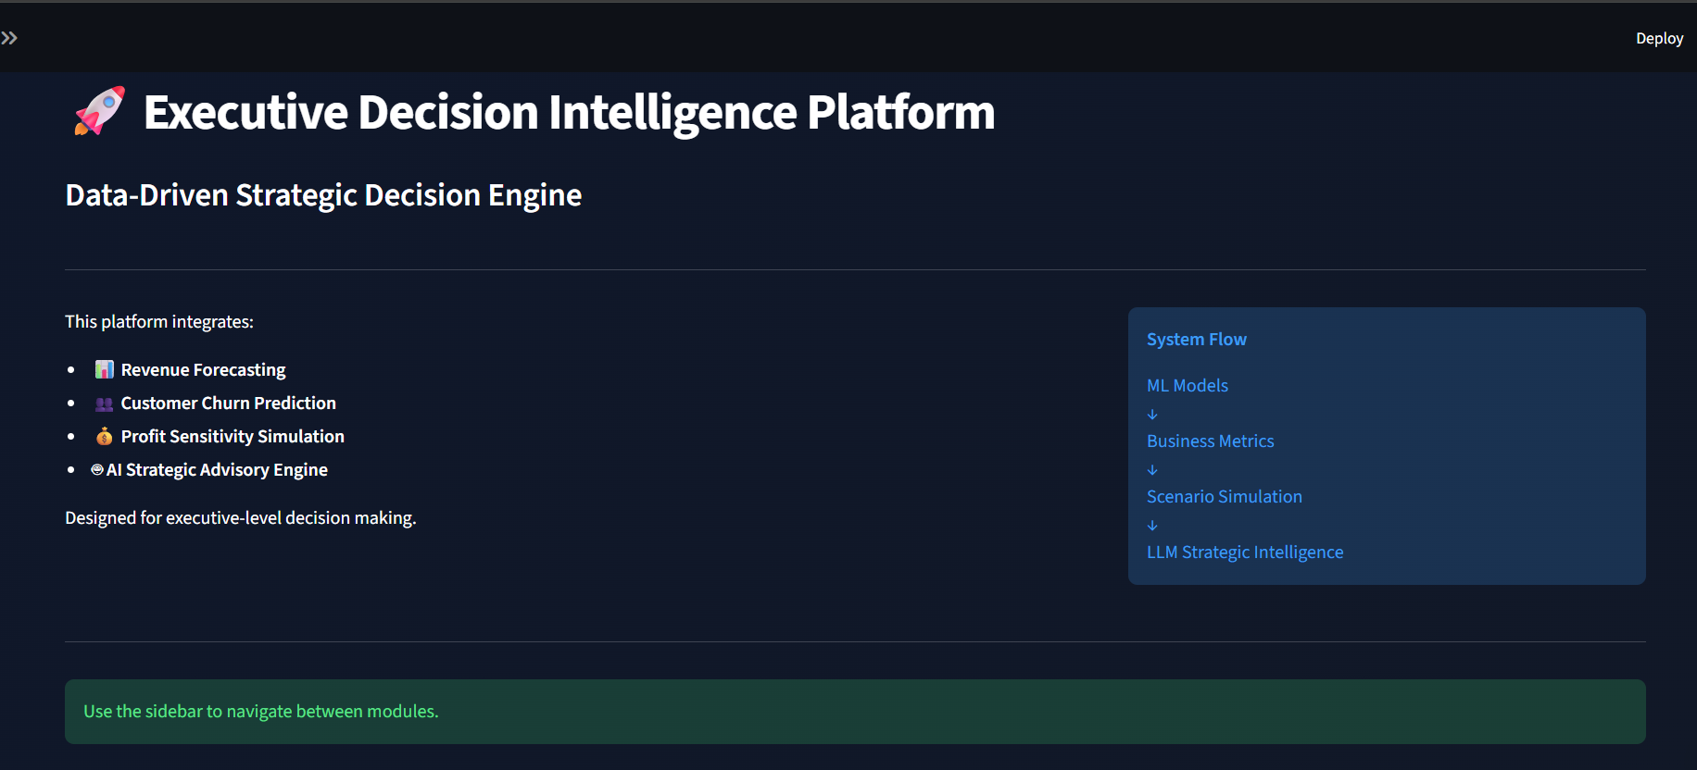
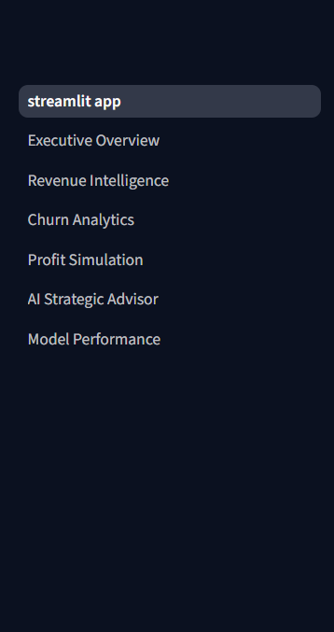
Executive Overview
Churn Analysis
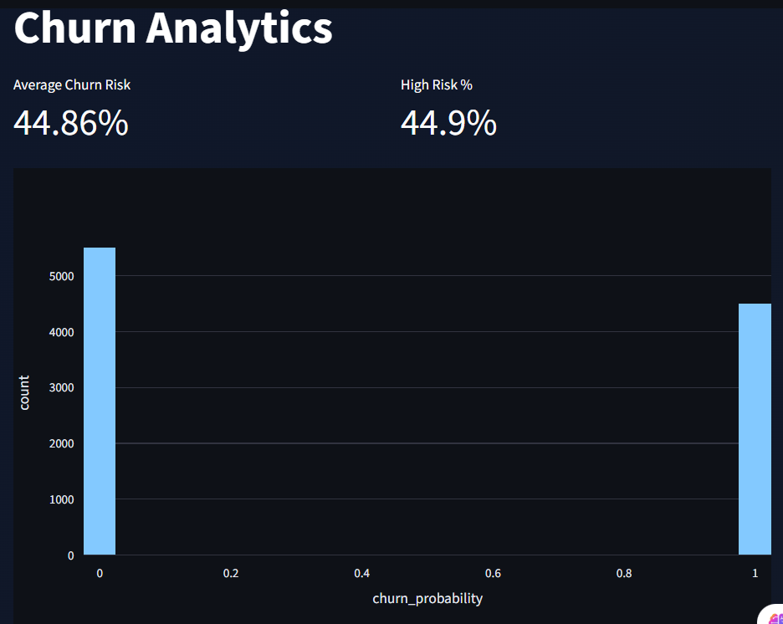
Revenue Forecast
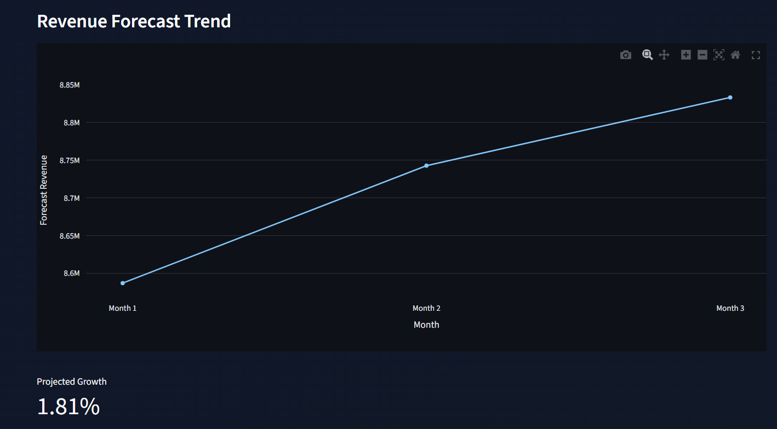

PROFIT SIMULATION
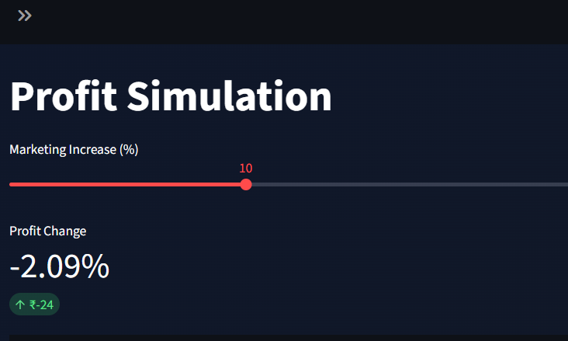
Model Performance
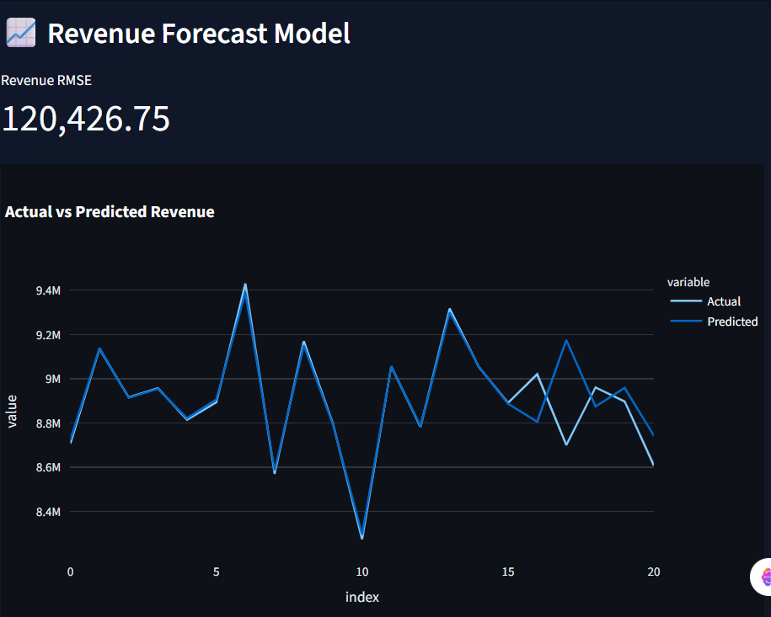
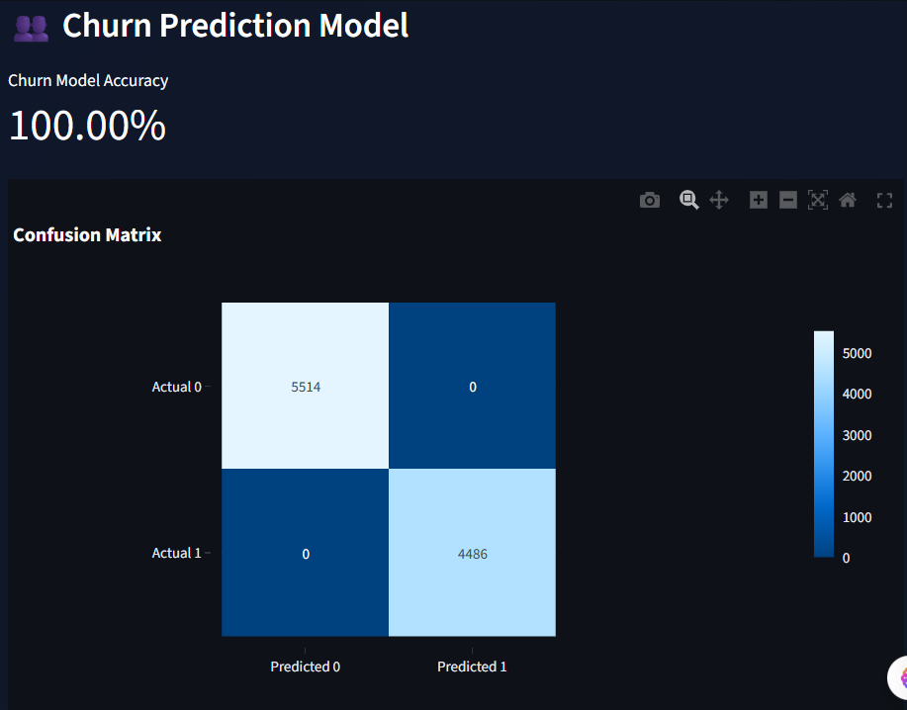
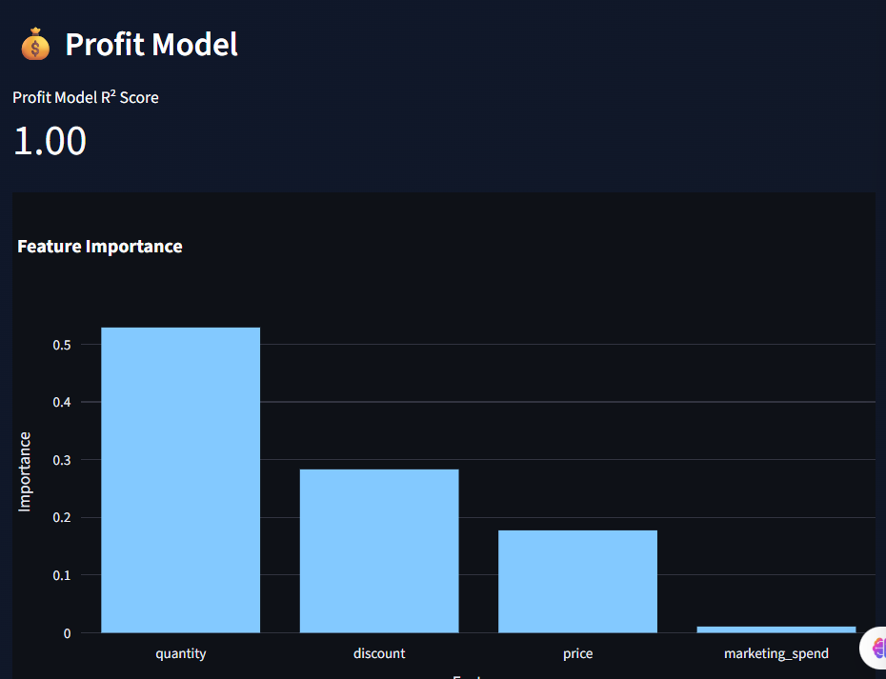
10. Business Impact & Findings
The system delivers the following strategic benefits:
- Improves revenue predictability
- Enables early churn detection
- Supports marketing budget optimization
- Provides structured executive recommendations
- Reduces strategic decision uncertainty
This project demonstrates the transition from descriptive analytics to predictive and prescriptive intelligence.
11. Technology Stack
- Python
- Pandas & NumPy
- Scikit-learn
- XGBoost
- Plotly
- Streamlit
- LangChain
- Ollama (Mistral LLM)
- Joblib
12. Key Strengths
- Modular multi-page architecture
- Integrated predictive & prescriptive system
- Executive-focused design
- Local LLM-based reasoning engine
- GitHub-ready professional structure
13. Limitations
- Synthetic dataset used
- Limited hyperparameter tuning
- SHAP explainability not integrated
- Requires local LLM setup
13. Limitations
- Synthetic dataset used
- Limited hyperparameter tuning
- SHAP explainability not integrated
- Requires local LLM setup
14. Future Enhancements
- Integration with real enterprise ERP/CRM data
- Cloud deployment (AWS/Azure/Streamlit Cloud)
- SHAP-based model explainability
- Real-time API data ingestion
- Automated executive PDF export
- Role-based access control
Conclusion
- The AI-Based Executive Decision Intelligence Platform represents a complete end-to-end implementation of predictive analytics combined with AI-driven executive reasoning.
- The system successfully bridges machine learning outputs with strategic decision-making, demonstrating strong integration between data science, business intelligence, and artificial intelligence.

Codes to run the project->
