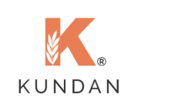

Web VAPT
Vulnerability Assessment & Penetration Testing Report

For
Kundan Minerals & Metals

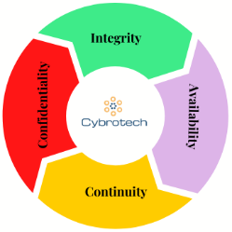
Cybrotech Digiventure Private Limited,
101, Siddharth Chambers, Aurobindo Marg, Hauz Khas, New Delhi 110016
011-41828996, +91 81780 82027
https://cybrotech.us, cxo@cybrotech.in

Document Control
Document Title | Kundan Minerals & Metals
Document ID | Kundan Minerals & Metals VAPT-001
Information Classification | Confidential - Restricted
Current Version No. | 1.0
Report Date

Reviewers
Name | Title | Date | Signature
Abhishek Kumar | Assistant Consultant

Approvers
Name | Title | Date | Signature
Anuj Agarwal | Director

Confidentiality:
This document is covered by NDA between Cybrotech Digiventure Pvt. Ltd. and Kundan Minerals & Metals Pvt. Ltd. and is marked as sensitive and confidential.

Disclaimer:
Cybrotech Digiventure Pvt. Ltd. will not be liable in respect of any losses arising out of any event or events beyond our reasonable control. Any business/reputational/financial losses, including unconditional loss of or damage to profits, income, revenue, use, production, anticipated savings, business, contracts, commercial opportunities or otherwise arising because of use/misuse of this report by anyone would not be responsibility of Cybrotech. The gaps / vulnerabilities / findings / observations and their recommendations/ solutions provided in this report are based on the current scenario and are void of any warranty expressed or implied. These observations / findings / recommendations are based on the inputs (interviews, documents and other artefacts) provided by various team members and stakeholders of Kundan Minerals & Metals Pvt. Ltd.
We do not hold any responsibility for the accuracy and correctness of such sources and solely rely on the Kundan Minerals & Metals Pvt. Ltd. for the same. This is a not forensic examination of impugned resources and are not fit for legal purposes and representation before legal forums.

Copyright & Trademarks etc.:
This document is copyright of Cybrotech Digiventure Pvt. Ltd. All IPRs of respective parties are acknowledged and are used only for representation purposes.

CONTENT

Executive Summary
- Intended Audience
- Assessment Objectives
- Assessment Scope
- Assessment Methodology
- Owasp Top 10 & sans 25

Detailed Performed Report
1) Assessment Result Summary

1. Executive Summary
This summary report is produced by Cybrotech Digiventure Pvt. Ltd. on the basis of Web Vulnerability Assessment & Penetration Testing carried out for Kundan Minerals & Metals Pvt. Ltd.as on Date Mention Web Vulnerability Assessment & Penetration Testing was carried out for below Web.

Web Address: - https://www.kundanrefinery.in/

Intended Audience:

This document is primarily meant for the management of Kundan Minerals & Metals Pvt. Ltd...

Assessment Objectives:
The Web Vulnerability Assessment and Penetration Testing for Kundan Minerals & Metals Pvt. Ltd. this VAPT was requested by the management of Kundan Minerals & Metals Pvt. Ltd. the purpose of this activity is to discover the vulnerabilities in the Kundan Minerals & Metals Pvt. Ltd. owned Web, defined in the scope of this report, and to indicate the subsequent risk level associated with the vulnerabilities. The objectives of this vulnerability assessment and penetration test are:
  - To investigate whether or not an attacker could penetrate the application being evaluated.
  - To determine the likelihood that an attacker could compromise the “specific Application under evaluation” with limited knowledge and restricted access.
  - To provide evidence that verifies the possibility of exploiting the vulnerabilities found, as well as the scope of these vulnerabilities.
  - To determine the strengths and weaknesses of the security measures implemented within the production systems.

Assessment Scope:

The security assessment is done on the following controls:
    - Authentication
    - Authorization
    - Session Management
    - Input Validation
    - Error Handling

The following was not part of this assessment:
    - Denial of Service by exhausting system resources
    - Social Engineering

Assessment Methodology:

A hybrid approach is followed to perform the assessment that is a combination of tools is used to discover the wide range of vulnerabilities. Additionally, the assessment being adaptive in nature allows us to control the assessment methodology as per the application functionality to focus on the critical areas of the application. Our assessment approach is aligned to the OWASP Top 10 & Sans 25.

The attack vectors are controlled as per the assessment needs and the attack selection ensures maximum coverage of the application. The following diagram represents the assessment approach:
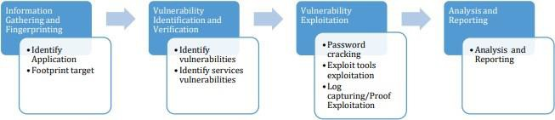

The scan/audit type determines what type of testing has been done for the Web in scope: The vulnerabilities discovered are associated with a risk level that indicates how critical the vulnerability is and helps the application team to prioritize the vulnerabilities and choose an appropriate mitigation approach.

- Risk Rating:

The risk rating for each finding in this report is based on the Impact and Exploit factor of the vulnerability. Here is a guide to interpreting the Risk Rating.

Risk Rating | Explanation
CRITICAL  9.0-10 | Vulnerability was discovered that has been rated as critical. It is recommended that corrective actions are implemented urgently. This category of risk should be monitored closely by management.
HIGH  7.0-8.9 | Vulnerability was discovered that has been rated as important. It is recommended that corrective actions must be implemented within a short term.
MEDIUM  4.0-6.9 | Vulnerability was discovered that has been rated as of medium criticality. It is recommended that corrective actions should be part of on-going security maintenance of the system.
LOW  0.1-3.9 | Vulnerability was discovered that has been rated as of low criticality. Owners should consider whether to apply corrective measures as part of routine maintenance tasks or to accept the risk.
INFO  0-0 | A finding was discovered that had been rated as of informational value which should be addressed in order to meet industry best practice.

2. Detailed Performed Report

The detailed Performed report is primarily meant for application team, developers and technical teams. It provides relevant information required for the mitigation of the vulnerabilities. This section also mentions other information, such as vulnerability category, risk and remediation recommendations.

One single table with one Ref ID mentions one instance of the vulnerability found. However, it cannot be assumed that the vulnerabilities mentioned below are the only vulnerabilities present in the application. Several other instances of similar vulnerabilities may exist in different areas of the application. It is recommended to consider the whole application rather than the instances mentioned in this report.

The document briefly describes how to approach for the mitigation of a specific vulnerability. The implementation approach or methods for the mitigation of the vulnerabilities could vary based on the operating system, technology and type of devices used, therefore the mitigation should be done based on the best approach available for the operating system, technology or the type of device used. It is recommended that the remediation team should test all such remediation steps in the test environment before implementing them in production. We expect the remediation team to do their own due-diligence and analysis before implementing any recommendations for mitigation of vulnerabilities.

Assessment Results Summary

It was identified as Kundan Minerals & Metals Pvt. Ltd.- scope. Web is not secured with Three High, Four Medium risk vulnerabilities.

Ref ID | Risk | Vulnerability | Category | Status
1 | Medium | Strict Transport Security (HSTS) | Security Misconfiguration | Open
2 | Low | Link manipulation (DOM-based) | Injection | Open
3 | Medium | Web Cache Poisoning | Identification and Authentication Failures | Open
4 | High | Client-Side Desync | Identification and Authentication Failures | open

1. Strict transport security not enforced

Medium
Ref Id | 1
CVE Score | 5.0
Category | Security Misconfiguration
Affected Item | https://admin.kundanrefinery.in/
Vulnerability Description | The issue "Strict Transport Security Not Enforced" falls under OWASP A06:2021 -Vulnerable and Outdated Components and OWASP A07:2021 - Identification and Authentication Failures, depending on the context.

PoC –
Vulnerability Description

Security headers like Strict-Transport-Security (HSTS), Content Security Policy (CSP), and X-Frame-Options are essential for preventing attacks like Man-in-the-Middle (MitM), Clickjacking, and XSS. If missing, users and sensitive data can be exposed to potential attacks.

Step 1: Check HTTP Response Headers
- capture a request to the target website.
- Analyze the HTTP Response Headers
- Look for missing security headers
- If the headers are absent, the application is vulnerable.

Impact:
- Man-in-the-Middle Attacks: Without HSTS, attackers can intercept traffic and perform SSL stripping.
- Clickjacking Attacks: Lack of X-Frame-Options allows embedding in malicious iframes.
- Content-Type Sniffing Attacks: Without X-Content-Type-Options: nosniff, browsers may interpret files incorrectly, leading to XSS.

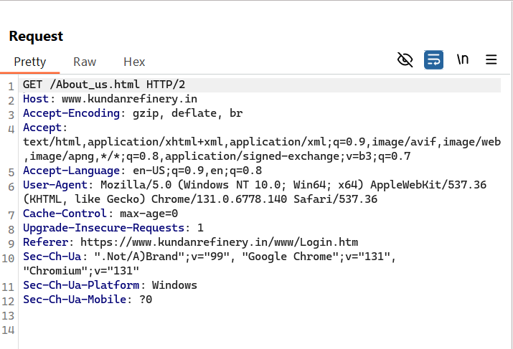

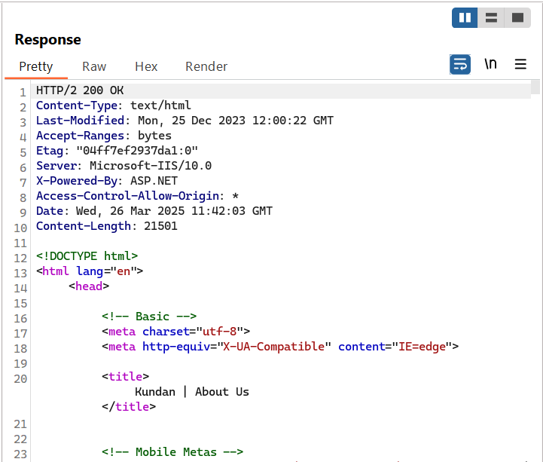

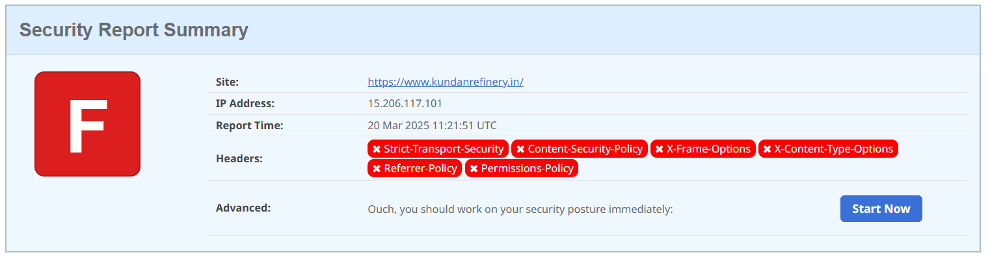

2. Link manipulation (DOM-based)

Low
Ref Id | 1
CVE Score | 3.0
Category | Injection
Affected Item | https://www.kundanrefinery.in  /www/Login.htm  /www/Orders.htm  /www/Trades.htm  /www/Trades_History.htm
Vulnerability Description | The affected web pages on kundanrefinery.in allow JavaScript (the code running on your browser) to dynamically change the links on the webpage based on the website address (URL).  This means an attacker can modify where links take you or change the destination of forms you submit. If you visit a specially crafted link, the attacker can redirect you to a fake website or steal your login credentials.

PoC –
Steps:
- Attackers can create a malicious link and trick you into clicking it. When you visit the link:

- The website modifies the target of important buttons and forms using the attacker's input.

- Instead of going to the actual login or order page, you are sent to a fake website that looks real but is controlled by the attacker.

- If you enter your username and password, the attacker steals your credentials.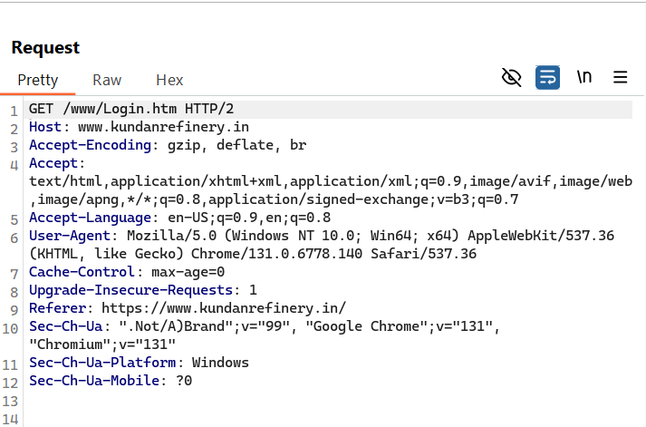

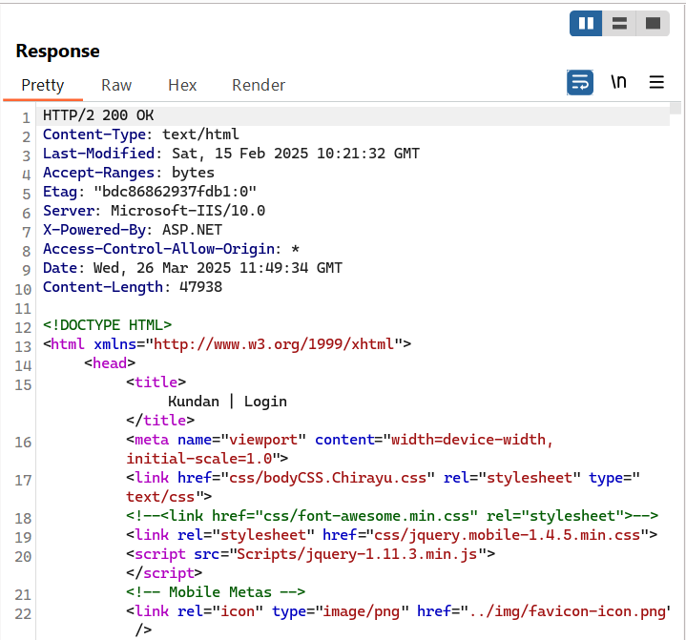

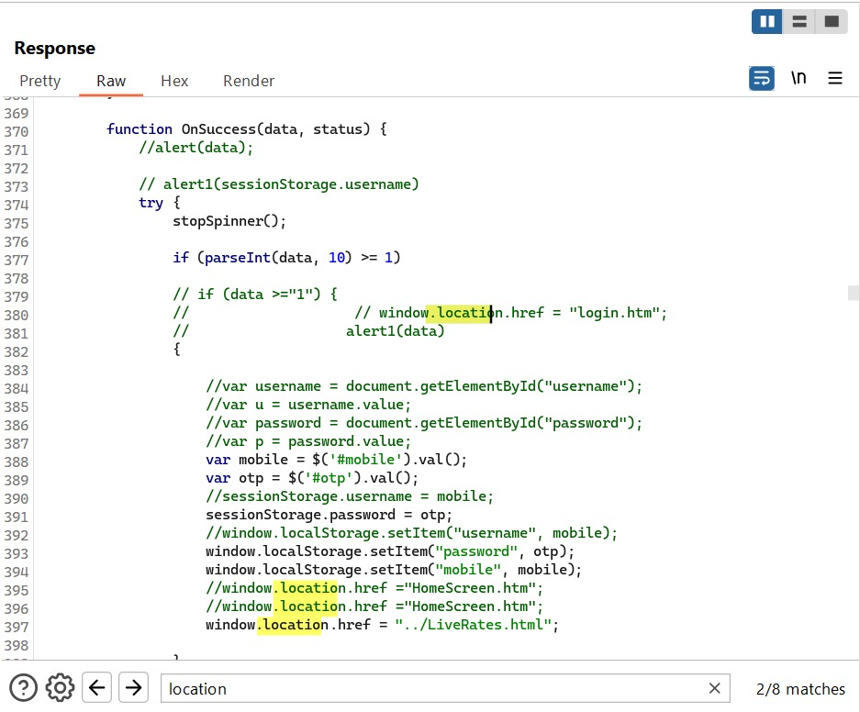

Impact

- Phishing Attacks: You might unknowingly log in to a fake website.

- Data Theft: Your sensitive information (like passwords) can be stolen.

- Financial Fraud: If attackers gain access to your account, they can misuse it.

3. Web Cache Poisoning

Medium
Ref Id | 1
CVE Score | 5.0
Category | Identification and Authentication Failures
Affected Item | https://admin.kundanrefinery.in/Telerik.Web.UI.WebResource.axd
Vulnerability Description | Web Cache Poisoning happens when an attacker tricks a caching system (like Cloudflare, Varnish, or a browser cache) into storing and serving malicious or incorrect content to other users.

PoC –

Step 1. Find a Vulnerable Endpoint
- Web caches store pages based on URLs and headers. If a website caches user-controllable input, it may be vulnerable.
- Check if the server responds with Cache-Control: public headers:

Step 2. Poisoning the Cache
- If the server does not validate input properly, an attacker can modify the URL or headers to inject malicious content.
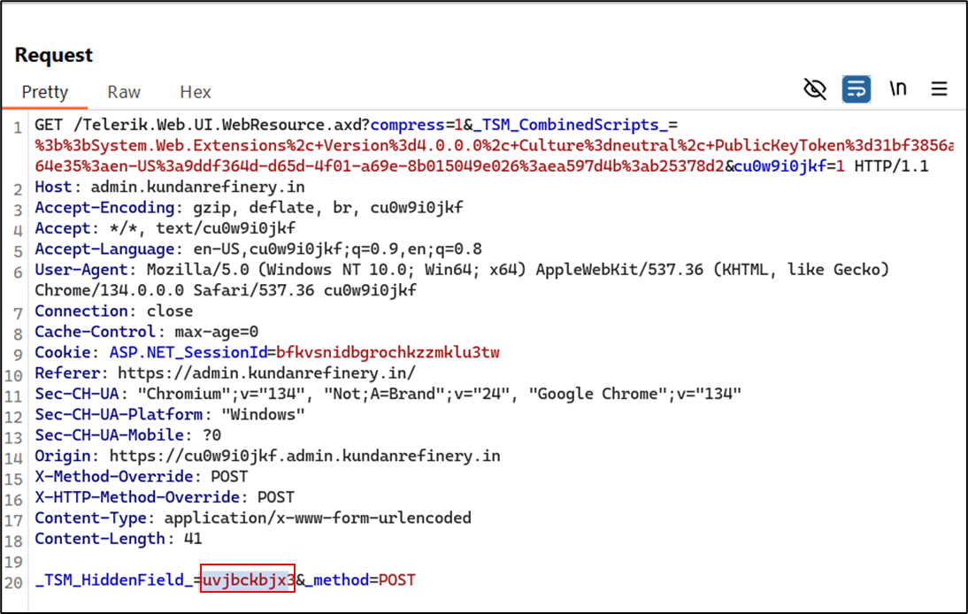

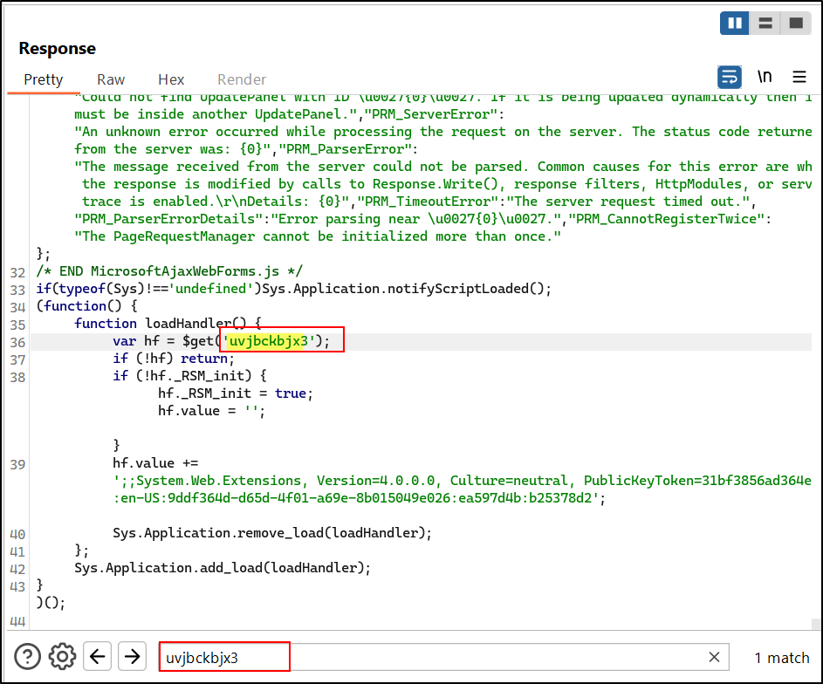

Second Request –

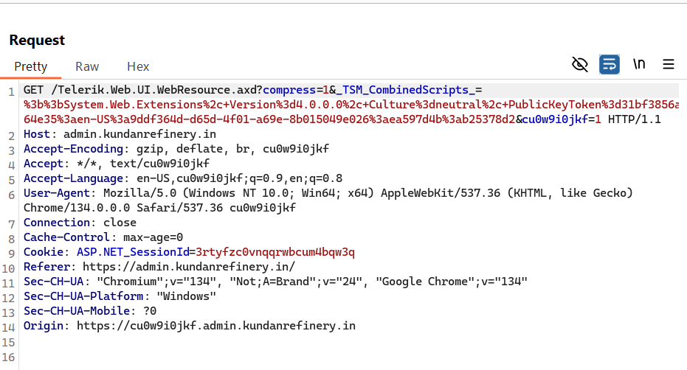

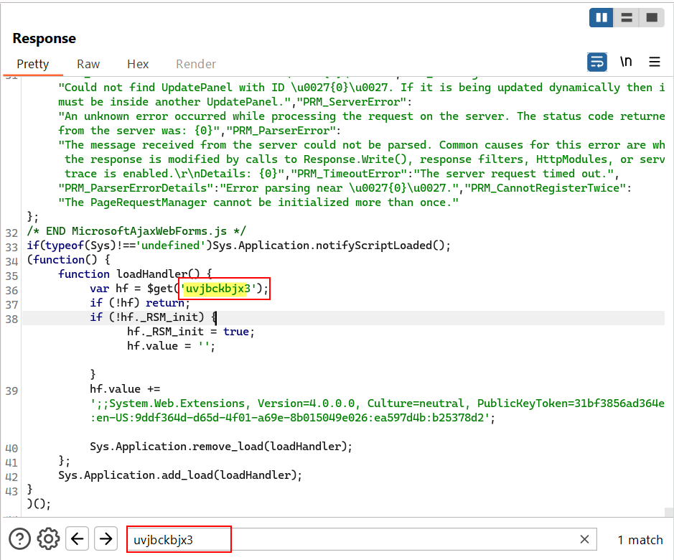

Impact:

- Defacing a website (showing fake or harmful content)
- Stealing user sessions (by caching sensitive data)
- Injecting malicious scripts (leading to XSS or phishing)

4. Client-Side Desync

High
Ref Id | 1
CVE Score | 7.0
Category | Insecure Design
Affected Item | https://admin.kundanrefinery.in/Telerik.Web.UI.WebResource.axd
Vulnerability Description | The server may be vulnerable to client-side desync attacks. A POST request was sent to the path '/LiveRates.html' with a second request inside the body. The server responded before the request body was sent and did not close the connection, which may have lead to the smuggled request being interpreted as the next request.  To verify this finding, review the response to 'Request 2' to identify whether it was influenced by the smuggled request.

PoC –

Step 1. The Attacker Manipulates HTTP Headers

- The attacker sends a malformed HTTP request that tricks an intermediary (like a CDN or proxy) into misinterpreting the request boundaries.

Step 2. The Proxy/CDN Mishandles Requests

- It stores or appends unintended data to another user’s request.

Step 3. Victim Receives a Poisoned Response

- The victim’s browser interprets the attacker’s injected content, leading to session hijacking, XSS, or data leakage.

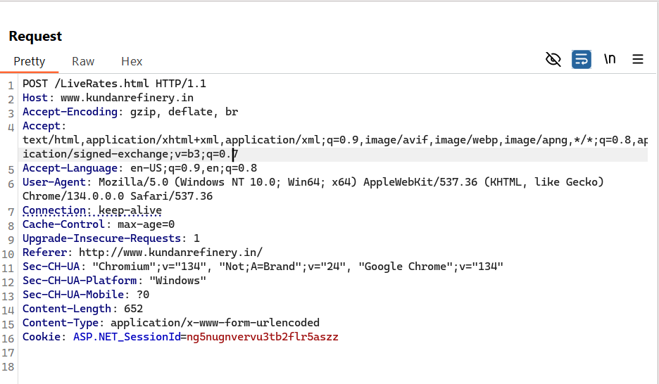

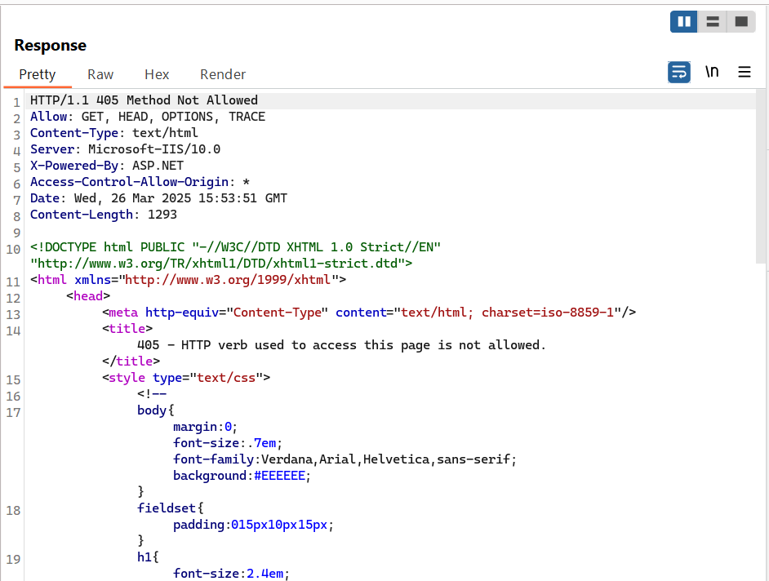

Second Request –

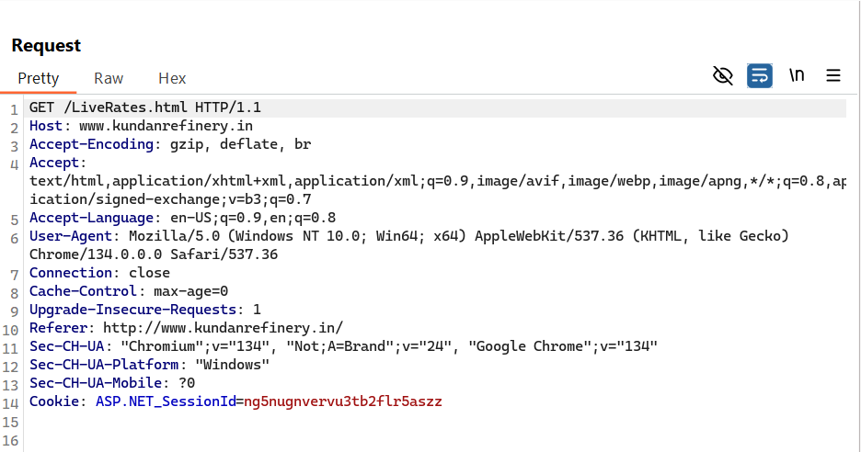

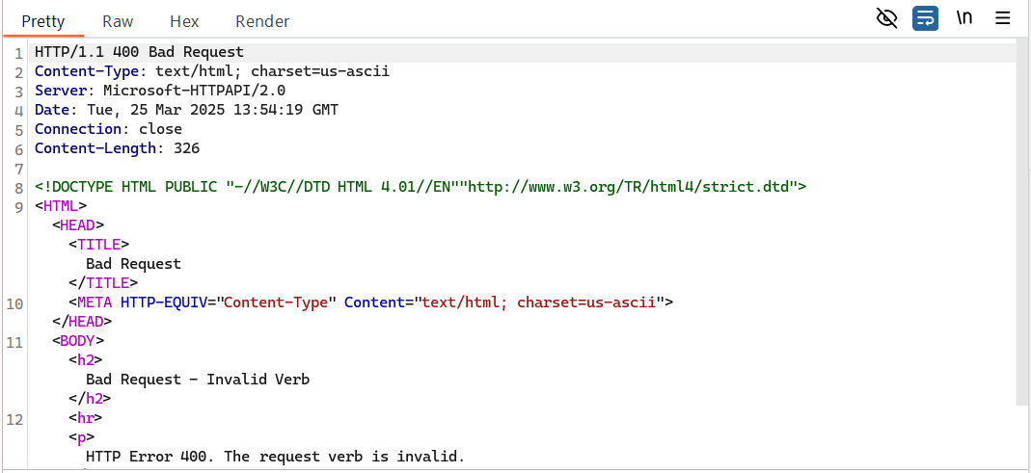

Impact:

- Session Hijacking – Attackers steal session tokens and gain unauthorized access.
- Cross-User Data Leakage – One user’s sensitive data is exposed to another.
- Web Cache Poisoning – Malicious content is stored and served to multiple users.
- Stored XSS – Injected scripts execute in users’ browsers, leading to credential theft.

*********************************************************
END OF THE REPORT

