# WEEK 3

**Explore Pandas module**

**Aggregation and Grouping**

Data aggregation and grouping allows us to create summaries for display or analysis, for example, when calculating average values or creating a table of counts or sums.

**Function Description**

* sum()         :Compute sum of column values
* min()          :Compute min of column values
* max()         :Compute max of column values
* mean()       :Compute mean of column
* size()          :Compute column sizes
* describe()  :Generates descriptive statistics
* first()          :Compute first of group values
* last()          :Compute last of group values
* count()       :Compute count of column values
* std()           :Standard deviation of column

**#simple example of using aggregation functions on a Dataframe**

Example:

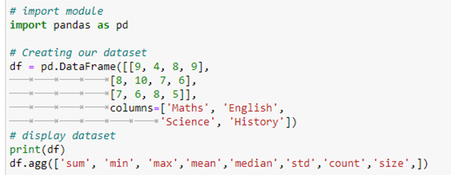

**Output**:

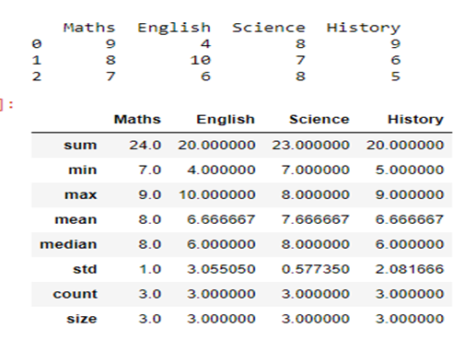

#using aggregation functions in dataframe

Ex1:



Output:

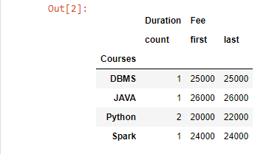

Ex2: Count



Output:

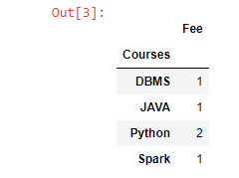

Grouping using Pandas

Grouping is used to group data using some criteria from our dataset. It is used as split –apply-combine strategy.

**Function Description:**

* sum()         :Compute sum of column values
* min()          :Compute min of column values
* max()         :Compute max of column values
* count()       :Compute count of column values

#creating data frame by grouping

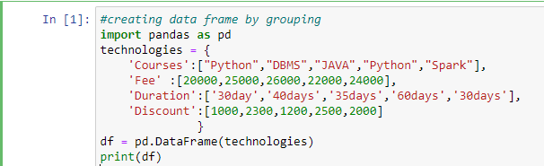

**Output**:

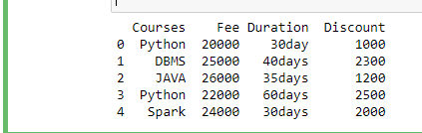

**Pivot and Melt function**

**Pivot**

Pivot () is used for pivoting the dataframe without applying aggregation. It doesn't contain same values or columns/index. While

**Melt**

The melt () function enables us to reshape and elongate the data frames in a user-defined manner. It organizes the data values in a long data frame format.

#creating data frame by Pivot and melt functions

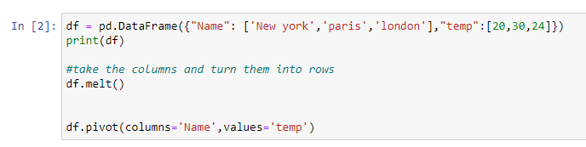

**Output:**

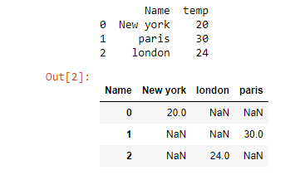

**Map, Filter and Reduce functions**

**Map**

**map()** function returns a map object (which is an iterator) of the results after applying the given function to each item of a given iterable (list, tuple etc.)

**Filter**

The filter() function returns an iterator were the items are filtered through a function to test if the item is accepted or not

**Reduce**

The **reduce (fun, seq)** function is used to**apply a particular function passed in its argument to all of the list elements** mentioned in the sequence passed along. This function is defined in “**functools**” module.

#creating data frame by Map, Filter and Reduce functions

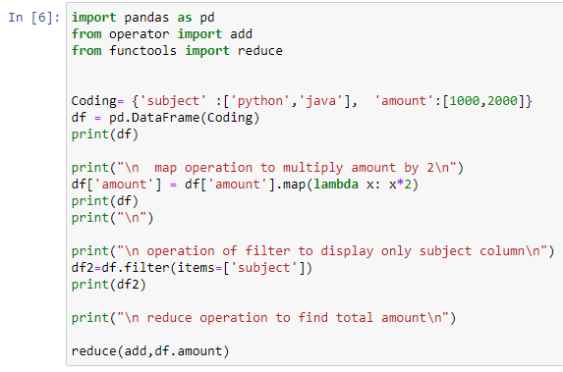

**Output:**

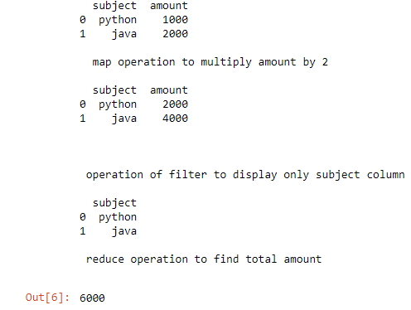

**Time series using Pandas**

#creating data frame using Pandas series

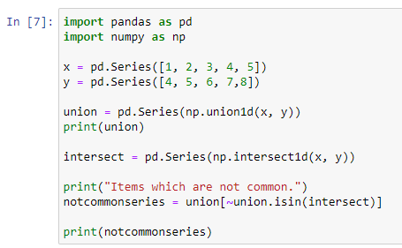

**Output:**

