**REPORTS WHEN L = 10, K = 10**

**DATASET 1:**

**STATS FOR TESTING DATASET BEFORE PRUNING FOR ENTROPY HEURISTIC**

Number of instances: 2000

Accuracy: 75.85%

**DISTINCT COMBINATIONS OF L AND K FOR ENTROPY HEURISTIC:**

L: 1, K: 2, Accuracy: 75.55

L: 2, K: 5, Accuracy: 75.95

L: 3, K: 4, Accuracy: 75.95

L: 4, K: 6, Accuracy: 75.95

L: 5, K: 7, Accuracy: 75.95

L: 6, K: 9, Accuracy: 75.95

L: 7, K: 6, Accuracy: 75.95

L: 8, K: 2, Accuracy: 76.0

L: 9, K: 7, Accuracy: 76.0

L: 10, K: 7, Accuracy: 76.0

**STATS FOR TESTING DATASET AFTER PRUNING FOR ENTROPY HEURISTIC**

Number of instances: 2000

Accuracy: 76.1%

**STATS FOR TESTING DATASET BEFORE PRUNING FOR VARIANCE HEURISTIC**

Number of instances: 2000

Accuracy: 75.35%

**DISTINCT COMBINATIONS OF L AND K FOR VARIANCE HEURISTIC:**

L: 1, K: 2, Accuracy: 75.75

L: 2, K: 5, Accuracy: 74.1

L: 3, K: 1, Accuracy: 75.8

L: 4, K: 6, Accuracy: 75.9

L: 5, K: 5, Accuracy: 75.65

L: 6, K: 4, Accuracy: 76.0

L: 7, K: 10, Accuracy: 76.0

L: 8, K: 4, Accuracy: 75.35

L: 9, K: 6, Accuracy: 76.0

L: 10, K: 7, Accuracy: 74.45

**STATS FOR TESTING DATASET AFTER PRUNING FOR VARIANCE HEURISTIC**

Number of instances: 2000

Accuracy: 76.05%

**DATASET 2**

**STATS FOR TESTING DATASET BEFORE PRUNING FOR ENTROPY HEURISTIC**

Number of instances: 600

Accuracy: 72.33%

**DISTINCT COMBINATIONS OF L AND K FOR ENTROPY HEURISTIC:**

L: 1, K: 3, Accuracy: 76.83

L: 2, K: 1, Accuracy: 77.17

L: 3, K: 7, Accuracy: 77.0

L: 4, K: 1, Accuracy: 77.17

L: 5, K: 9, Accuracy: 77.5

L: 6, K: 3, Accuracy: 77.5

L: 7, K: 4, Accuracy: 77.5

L: 8, K: 6, Accuracy: 77.5

L: 9, K: 5, Accuracy: 77.5

L: 10, K: 10, Accuracy: 78.0

**STATS FOR TESTING DATASET AFTER PRUNING FOR ENTROPY HEURISTIC**

Number of instances: 600

Accuracy: 73.83%

**STATS FOR TESTING DATASET BEFORE PRUNING FOR VARIANCE HEURISTIC**

Number of instances: 600

Accuracy: 72.5%

**DISTINCT COMBINATIONS OF L AND K FOR VARIANCE HEURISTIC:**

L: 1, K: 7, Accuracy: 76.83

L: 2, K: 9, Accuracy: 76.83

L: 3, K: 4, Accuracy: 76.83

L: 4, K: 2, Accuracy: 76.83

L: 5, K: 6, Accuracy: 76.83

L: 6, K: 7, Accuracy: 76.83

L: 7, K: 1, Accuracy: 76.33

L: 8, K: 4, Accuracy: 76.83

L: 9, K: 5, Accuracy: 76.83

L: 10, K: 9, Accuracy: 76.67

**STATS FOR TESTING DATASET AFTER PRUNING FOR VARIANCE HEURISTIC**

Number of instances: 600

Accuracy: 72.5%

**BELOW ARE 4 COMMAND LINE OUTPUTS:**

1. WHEN L = 10, K = 10, toPrint == "no" on dataset 1

2. WHEN L = 10, K = 10, toPrint == "yes" on dataset 1

3. WHEN L = 10, K = 10, toPrint == "no" on dataset 2

4. WHEN L = 10, K = 10, toPrint == "yes" on dataset 2

1. **COMMAND LINE OUTPUT OF WHEN L=10, K=10, toPrint == ”no” on dataset 1**

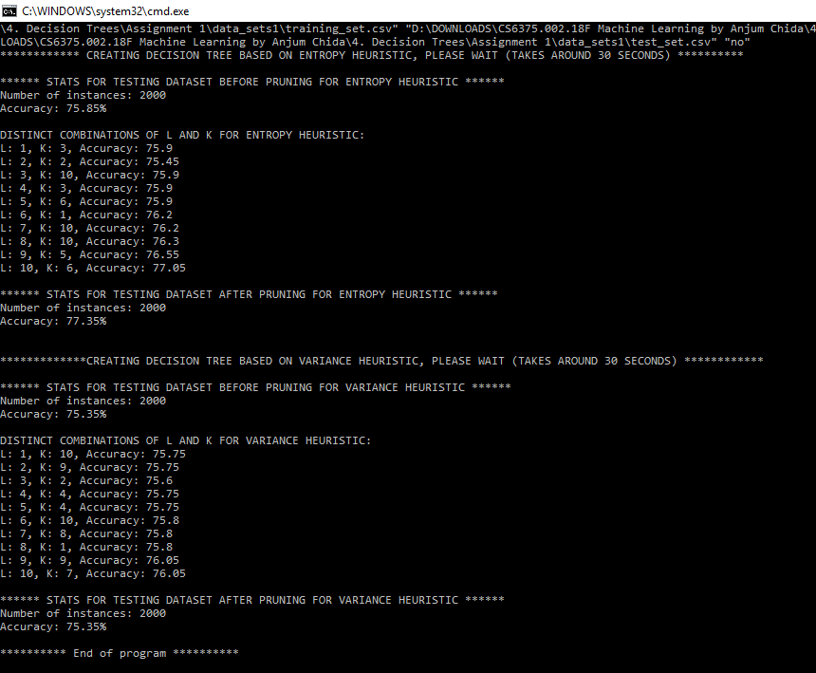

1. **COMMAND LINE OUTPUT WHEN L=10, K=10, toPrint == ”yes” on dataset 1**

Since the output is large, I redirected the output to this text file.



1. **COMMAND LINE OUTPUT OF WHEN L=10, K=10, toPrint == ”no” on dataset 2**

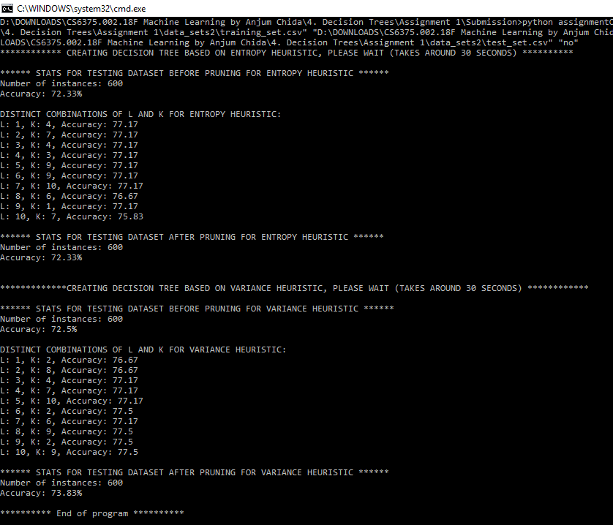

1. **COMMAND LINE OUTPUT WHEN L=10, K=10, toPrint == ”yes” on dataset 2**

Since the output is large, I redirected the output to this text file.

