EXECUTIVE SUBMISSION BRIEF / SEPTEMBER 2026

Compact model training for
insurance tariff ranking
Residential building-insurance tariff ranking with SFT, a measured GRPO continuation, and production economics

Assignment outcome — achieved
The goal was to exceed 80% Top-1 agreement while producing a deployable ranked Top-3. The selected 2B SFT adapter reached 84% Top-1, 86.7% Top-3 recall, and 100% strict JSON on the held-out Fable benchmark.
0.22 → 0.84  2B base → SFT Top-1 | 86.7%  Top-3 recall | 100%  strict JSON | $7.80  total billed spend
DECISION IN ONE PAGE

Task, approach, outcome
Stage | What we did | Why | Verified result
Data | Generated risks + 2,000 engine requests | Create task-specific panels | 1,490 usable panels / 9,632 tariff offers
Teacher | GPT-6 Sol silver labels | Scale ranked supervision | 1,490 Top-3 labels
Reward | 20k deterministic search | Align proxy to teacher | 49% → 94% calibration Top-1
SFT | 2B BF16 LoRA | Test smaller-model hypothesis | 22% → 84% golden Top-1
GRPO | 10-step continuation | Test reward optimization | 84% Top-1; no broad gain
Serving | RTX 4090 vLLM benchmark | Measure deployability | 63.66 rec/s at c64
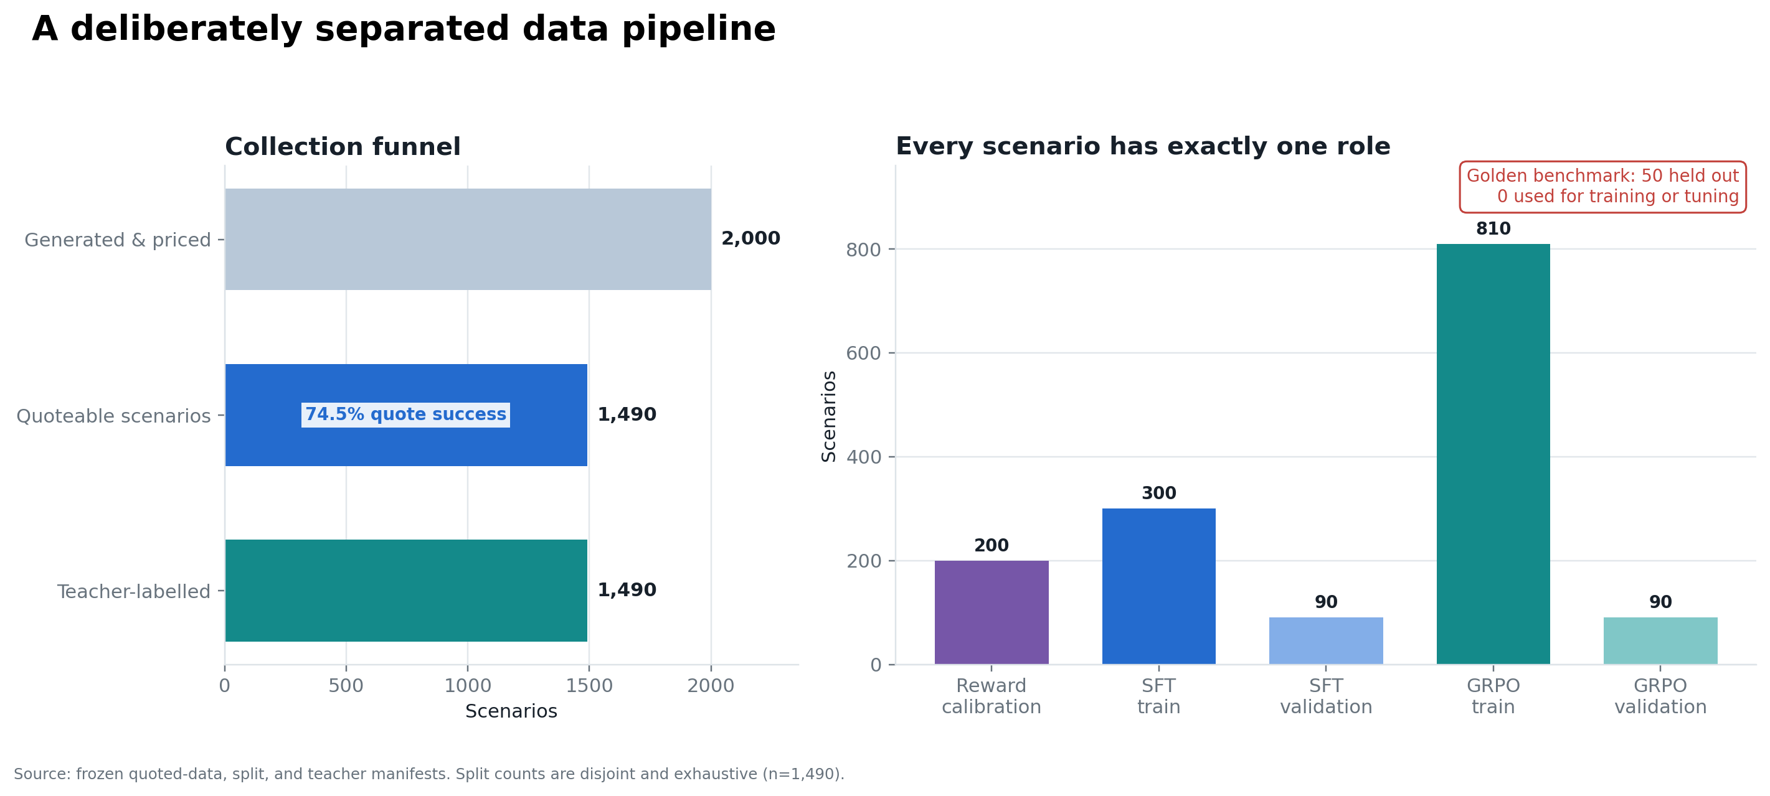
Leakage-safe path from generated risks to training and evaluation
Context: the supplied Qwen3.5-9B reference scored 42% Top-1. The trained-model improvement reported here is correctly measured from our unchanged 2B base (22%) to our 2B SFT model (84%).

02 / TASK / WHAT / WHY / RESULT

Data and reward: make the objective trustworthy

Task | What we did | Why this way | What we got
Build supervision | 2,000 quote-engine requests; GPT-6 Sol labelled the 1,490 usable panels | Real quote panels preserve product trade-offs; silver labels scale cheaply | 9,632 tariff offers returned; five insurers; nine tariffs; disjoint splits; zero golden-risk overlap
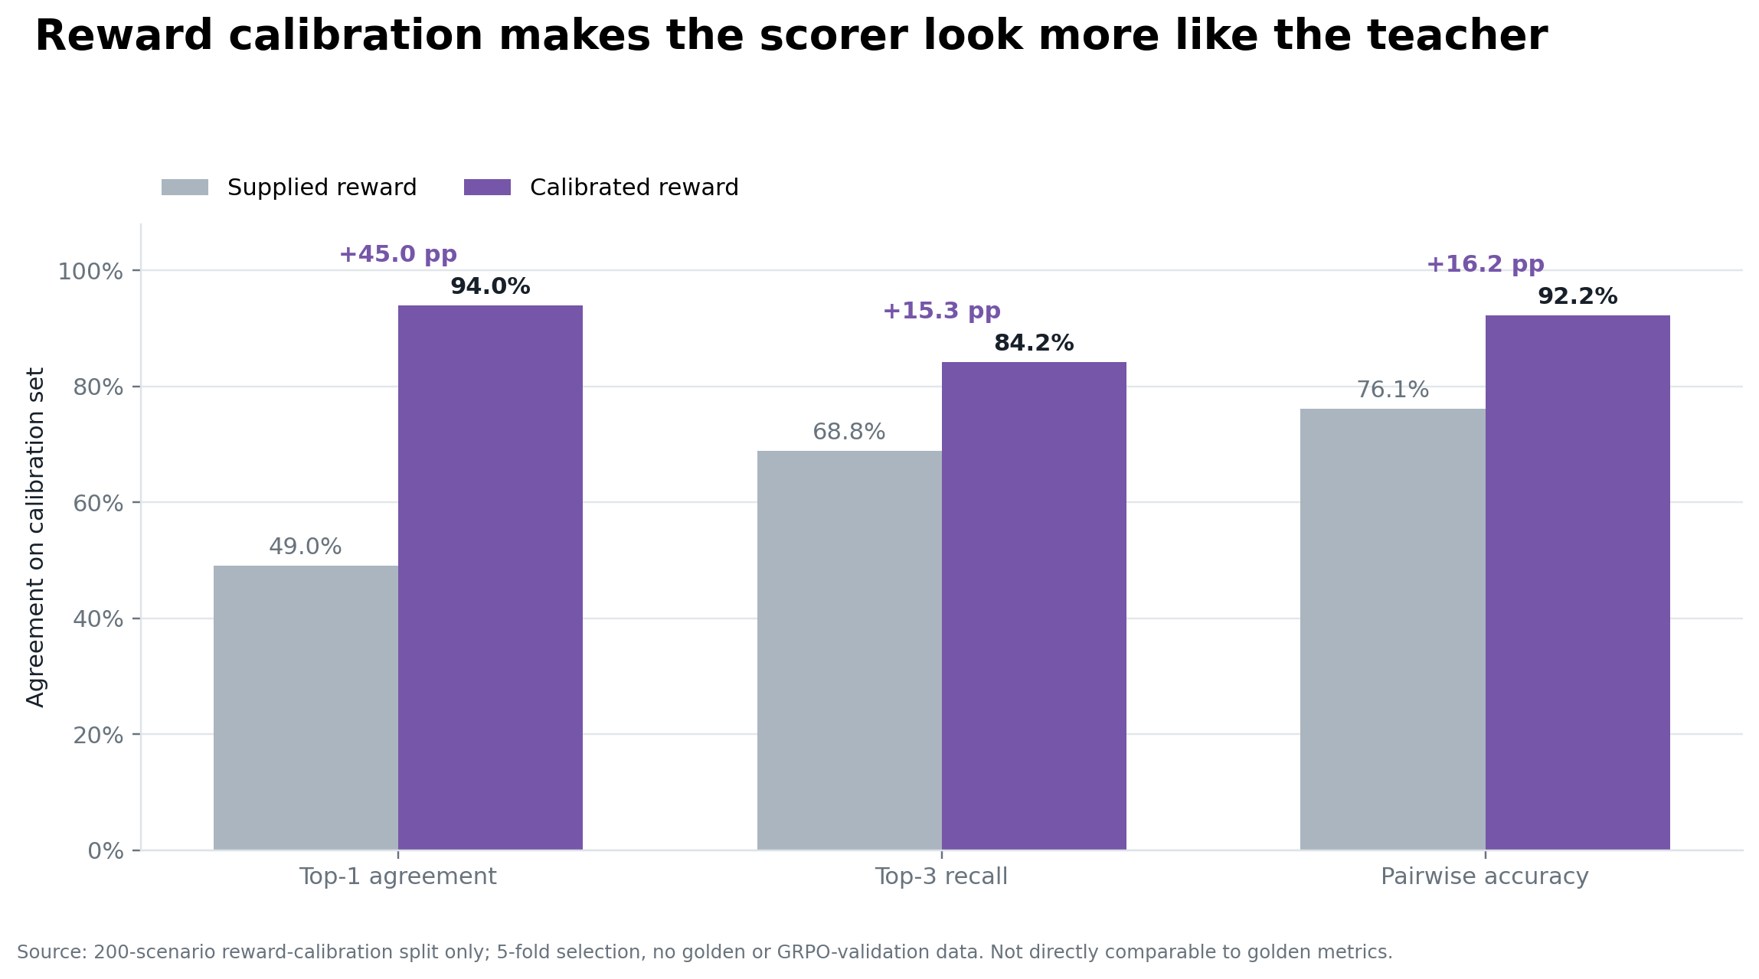
Reward search on the 200-scenario calibration split

What the reward audit changed
Within panels, coverage count and deductible did not vary; coverage score and annual price carried the consistent ranking signal. A deterministic 20,000-candidate search selected a quality–price curve without LLM calls or golden labels:
Frozen symbolic score
reward = (0.2863 + 0.4273 × normalized coverage score) / (1 + 1.7936 × normalized price)
Method on golden | Top-1 | Top-3 hits | Top-3 recall | Inference
Calibrated symbolic argmax | 42/50 (84%) | 119/150 | 79.3% | None
Selected 2B SFT | 42/50 (84%) | 130/150 | 86.7% | Required
Why not deploy only the zero-cost scorer?
For a Top-1-only product, it is a compelling simpler baseline. The assignment requires a ranked Top-3: SFT recovered 11 more of the 150 Fable-selected positions and offers a learned policy for interactions beyond the fixed score. The tie is evidence for a strong baseline—not proof that the scorer is ground truth.

03 / LEARNED POLICY

Model choice, SFT, and the GRPO stopping decision

Why 2B and why BF16 LoRA?
The proposal referenced a 9B model; our hypothesis was that structured tariff ranking should work with substantially less capacity. Qwen3.5-2B tests that claim directly. BF16 LoRA updated 10.9M parameters (0.49%): simple to run, easy to inspect, and sufficient for the available GPU. Keeping the experiment simple was also a reason not to add QLoRA complexity.
Golden evaluation | Top-1 | Top-3 recall | Strict JSON | Interpretation
2B base | 22% | 66.7% | 2% | Underpowered without task adaptation
2B + SFT | 84% | 86.7% | 100% | Selected model
2B + SFT + GRPO-10 | 84% | 86.0% | 100% | Stable continuation; no broad gain yet
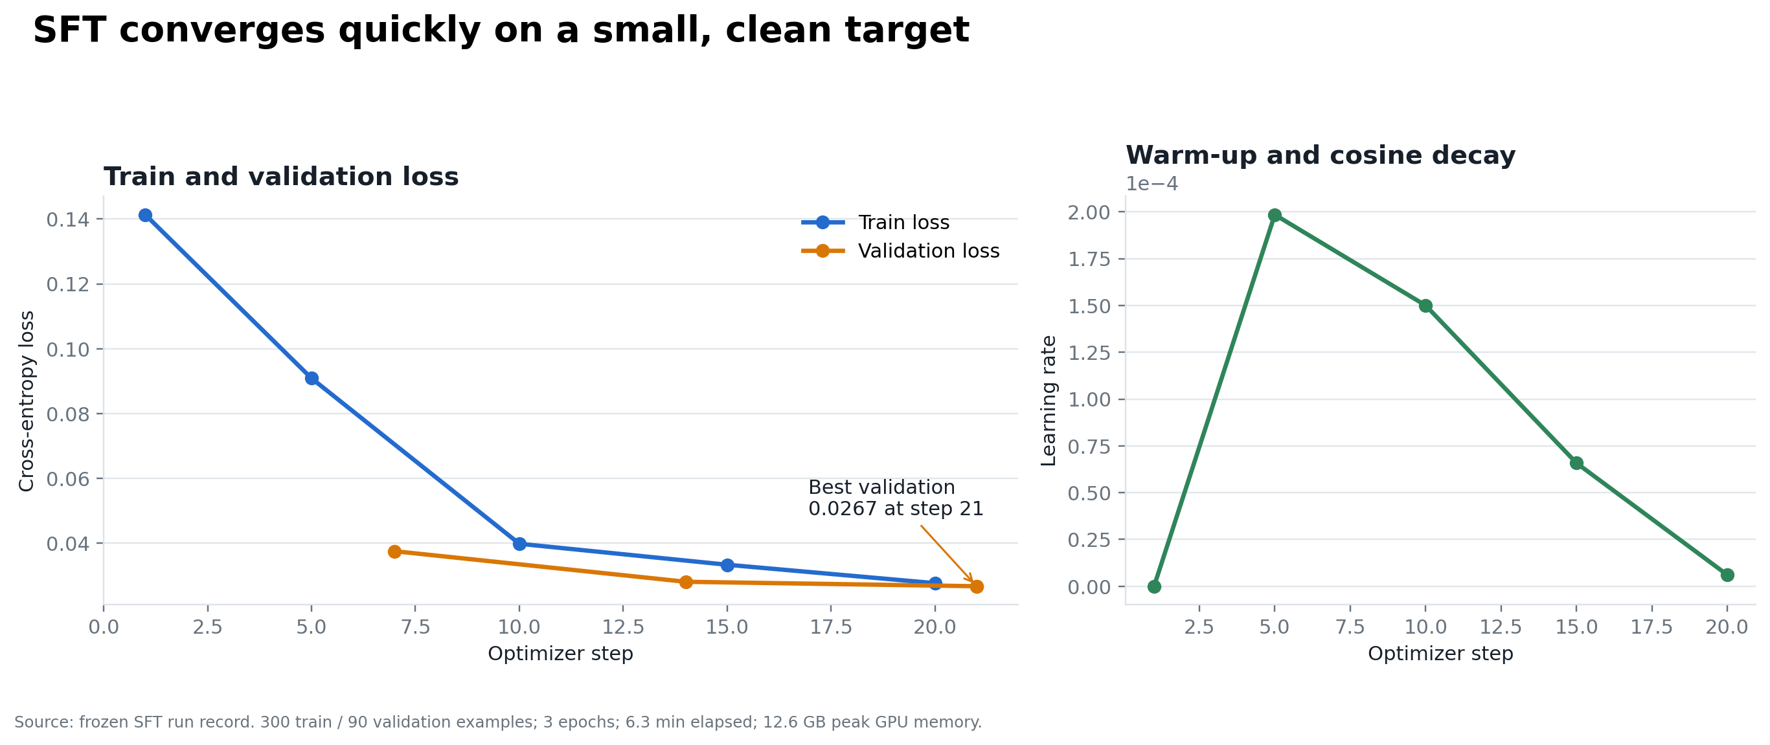
SFT produced the decisive quality and format-control improvement

Why stop GRPO at ten steps?
GRPO worked technically: it remained stable and corrected one SFT Top-1 error on the 90-scenario development set (83/90 → 84/90). Ten full Top-3 orderings changed, with a small net recall loss. On golden, SFT and GRPO both reached 42/50 Top-1; GRPO changed one list but not its first choice.
Practical ceiling, not a failed method
GPT-6 Sol—the silver teacher and reward-calibration target—also achieved 84% Top-1 against Fable, and SFT had already reached that observed level while clearing the assignment’s >80% target. More GRPO steps or samples might still improve the remaining predictions, but optimizing the same silver proxy more aggressively was not justified within the time budget. SFT therefore remains the evidence-backed selection.

04 / DECISION

Production case, delivery, and conclusion

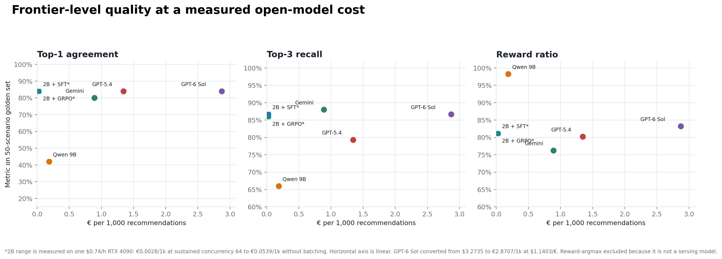
Held-out quality versus measured or supplied serving cost
Serving mode / comparator | Top-1 | Cost per 1k | What it means
2B SFT, RTX 4090 saturated | 84% | €0.0028 | Measured 63.66 rec/s at concurrency 64
2B SFT, 10% utilization | 84% | €0.0283 | Conservative utilization scenario
2B SFT, unbatched | 84% | €0.0539 | Measured lower-throughput bound
Supplied Qwen3.5-9B | 42% | €0.1869 | Reference
Gemini / GPT-5.4 | 80% / 84% | €0.8897 / €1.3445 | About 5–7× the 9B reference cost

Actual experiment spend
Teacher selection and batch labelling cost approximately $3.80; the complete RunPod bill for training, evaluation, and benchmarking was $4.00. Total billed cash spend: approximately $7.80.

Delivered and reproducible
Git repository: https://github.com/lakshaychhabra/reranking-optimisation
Hugging Face dataset: https://huggingface.co/datasets/lakshaychhabra/wg-recommendation-data
The package includes adapters, configs, logs, frozen results, hashes, portable reproduction instructions, and prepared non-golden data. Apple MPS reproduced all 50 selected SFT outputs exactly.
Final decision
Select the Qwen3.5-2B SFT LoRA. It met the assignment objective—84% Top-1 versus the >80% target—while improving Top-3 recall, enforcing the output contract, and supporting low-cost self-hosted serving. Keep the calibrated scorer as the zero-inference Top-1 fallback and GRPO as a credible next experiment once stronger labels or a new untouched benchmark are available.
Cost scope: GPU-only serving estimates exclude storage, networking, cold starts, redundancy, and operations. The 50-scenario benchmark is held out but small; results should be confirmed on a larger expert-labelled set before production policy decisions.

