TECHNICAL EXPERIMENT REPORT / SEPTEMBER 2026

Compact model training for
insurance tariff ranking
Reaching top-tier ranking quality with Qwen3.5-2B through supervised fine-tuning, a controlled GRPO continuation, and a verified quality–cost evaluation

84%  held-out Top-1 | 86.7%  Top-3 recall | 2B  base parameters | $7.80  total billed
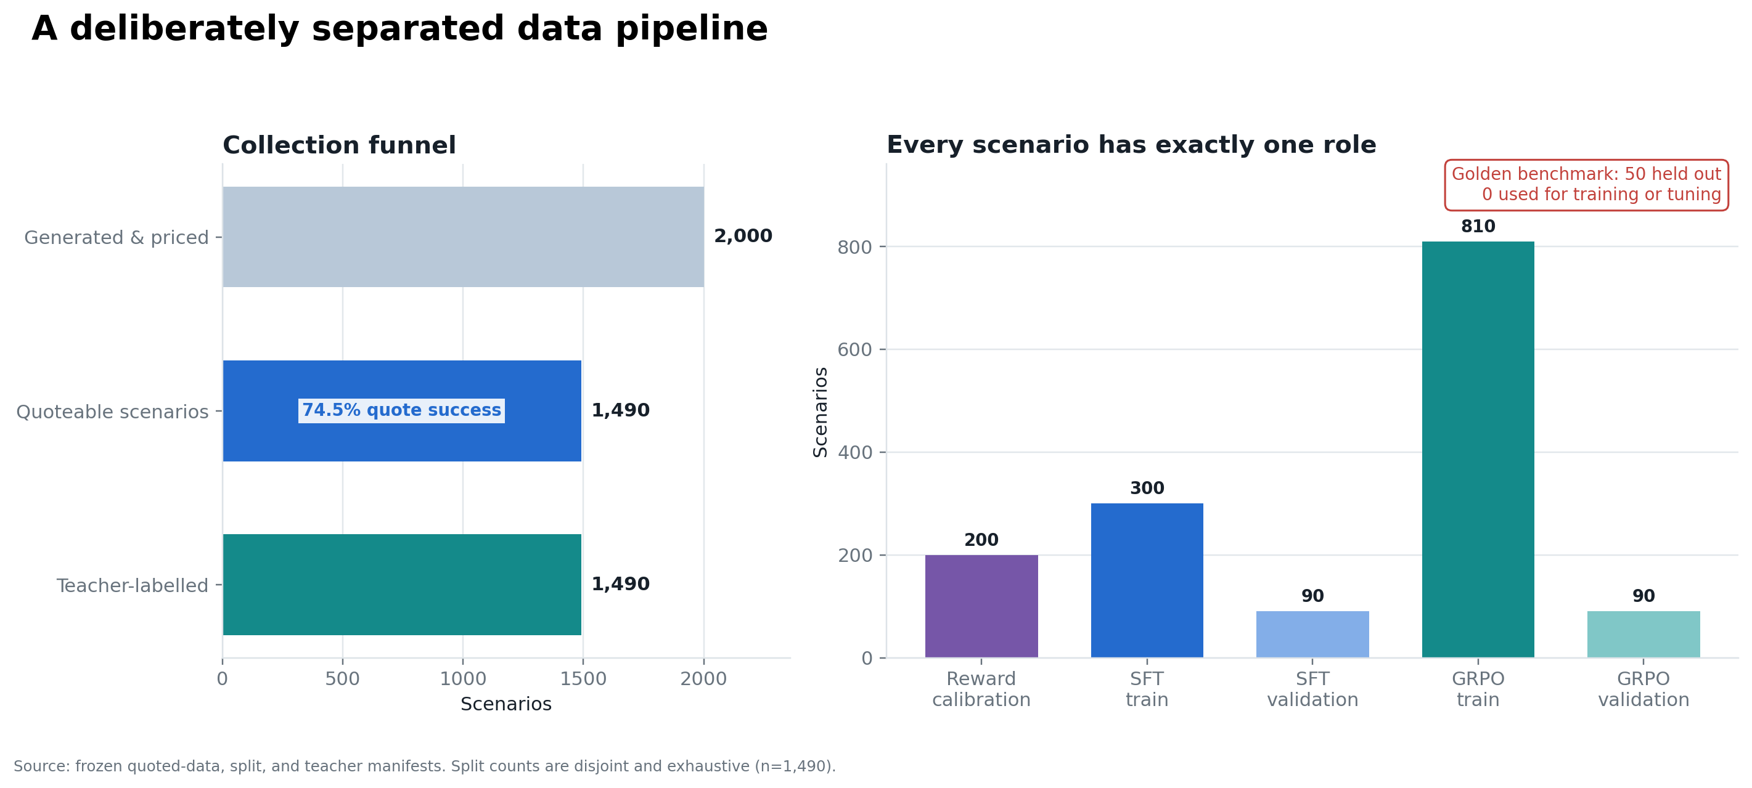
End-to-end experiment: independent data roles and a locked final benchmark
Executive conclusion
The selected SFT LoRA moved the unchanged 2B base from 22% to 84% held-out Top-1, matched the best observed frontier/teacher agreement, produced 100% strict JSON, and served at 63.66 recommendations/s in the sustained benchmark. GRPO was stable and promising on one development error, but SFT had already reached the observed supervision ceiling; ten steps did not establish a broader gain.
Report map: Task and success criteria → system and data → teacher and reward → model training → evaluation → economics → release and next experiments.

02 / WHAT WAS DECIDED

Executive decision dashboard

Bottom line
Select Qwen3.5-2B SFT LoRA; retain the symbolic scorer as a Top-1 fallback and GRPO as a future experiment, not the production checkpoint.
Stage | What we did | Why | Verified result
Data | Generated risks + live quotes | Create task-specific panels | 1,490 usable / 9,632 quotes
Teacher | GPT-6 Sol silver labels | Scale ranked supervision | 1,490 Top-3 labels
Reward | 20k deterministic search | Align proxy to teacher | 49% → 94% calibration Top-1
SFT | 2B BF16 LoRA | Test smaller-model hypothesis | 22% → 84% golden Top-1
GRPO | 10-step continuation | Test reward optimization | 84% Top-1; no broad gain
Serving | RTX 4090 vLLM benchmark | Measure deployability | 63.66 rec/s at c64

Decision matrix
Option | Top-1 | Top-3 | Runtime | Decision
Calibrated scorer | 84% | 79.3% | None | Fallback when only rank one matters
2B SFT | 84% | 86.7% | Low | Selected
2B GRPO-10 | 84% | 86.0% | Low | Ablation / future continuation
Frontier APIs | 80–84% | 79.3–88% | API | Teacher/comparator, not deployment

What made the result credible
• All experimental roles were disjoint; golden-risk overlap was zero.
• The canonical prompt builder controlled teacher, SFT, GRPO, and evaluation inputs.
• Reward weights were frozen before golden evaluation; the golden set was not used for tuning.
• Claims in this report are tied to machine-readable summaries, run records, and hashes.
Git repository: https://github.com/lakshaychhabra/reranking-optimisation
Hugging Face dataset: https://huggingface.co/datasets/lakshaychhabra/wg-recommendation-data

03 / PROBLEM CONTRACT

Task and success criteria

Bottom line
Given a building risk and its priced quote panel, return three distinct offered tariffs in ranked JSON; the primary target was held-out Top-1 agreement above 80%.
Metric | Definition | Why it matters
Top-1 agreement | First recommendation equals reference rank one | Primary assignment measure
Top-3 recall | Reference tariffs recovered across three slots | Measures shortlist usefulness
Strict JSON | Exact required schema | Operational reliability
Reward ratio | Supplied reward of model rank one / scenario maximum | Audits quality–price trade-off; not ground truth
Serving cost | Measured GPU cost per 1,000 | Deployment economics

Reference hierarchy
Fable rankings are the held-out evaluation reference. GPT-6 Sol is scalable silver supervision. The calibrated numeric reward is a deterministic approximation to that teacher. The objects are related, but none should be presented as objective truth.
Important correction
The supplied 9B model scored 42%. Our experiment did not fine-tune that model: our unchanged 2B base scored 22%, and our 2B SFT checkpoint scored 84%. Therefore the training gain is 0.22 → 0.84; 0.42 is a separate assignment reference.

Output contract
{"top_3":[{"rank":1,"tariff_id":"49"},{"rank":2,"tariff_id":"48"},{"rank":3,"tariff_id":"162"}]}

04 / HOW THE WORK FITS TOGETHER

System and experimental pipeline

Bottom line
One canonical prompt and explicit data roles connected scenario generation, real quote collection, teacher labels, reward calibration, SFT, GRPO, and evaluation.
Dataset funnel and experimental separation
Control | Implementation | Risk controlled
Scenario identity | Hash of normalized risk JSON | Duplicate leakage
Quote access | Cached client; ≥3 s live-call spacing | Cost and rate safety
Prompt construction | src/prompt.py only | Training/evaluation drift
Quote order | Seeded shuffle with stored mapping | Positional bias
Golden boundary | Final evaluation only | Selection leakage

Why this architecture
The design separates four questions: Can we create representative quote panels? Can a teacher provide consistent rankings? Can a deterministic reward capture the teacher’s preference? Can a small learned policy generalize beyond that formula? This makes failures attributable rather than mixing data, objective, and optimization effects.

05 / INPUTS

Dataset creation and coverage

Bottom line
The final corpus contains 1,490 usable scenarios and 9,632 live-engine quotes, then assigns every scenario exactly one experimental role.
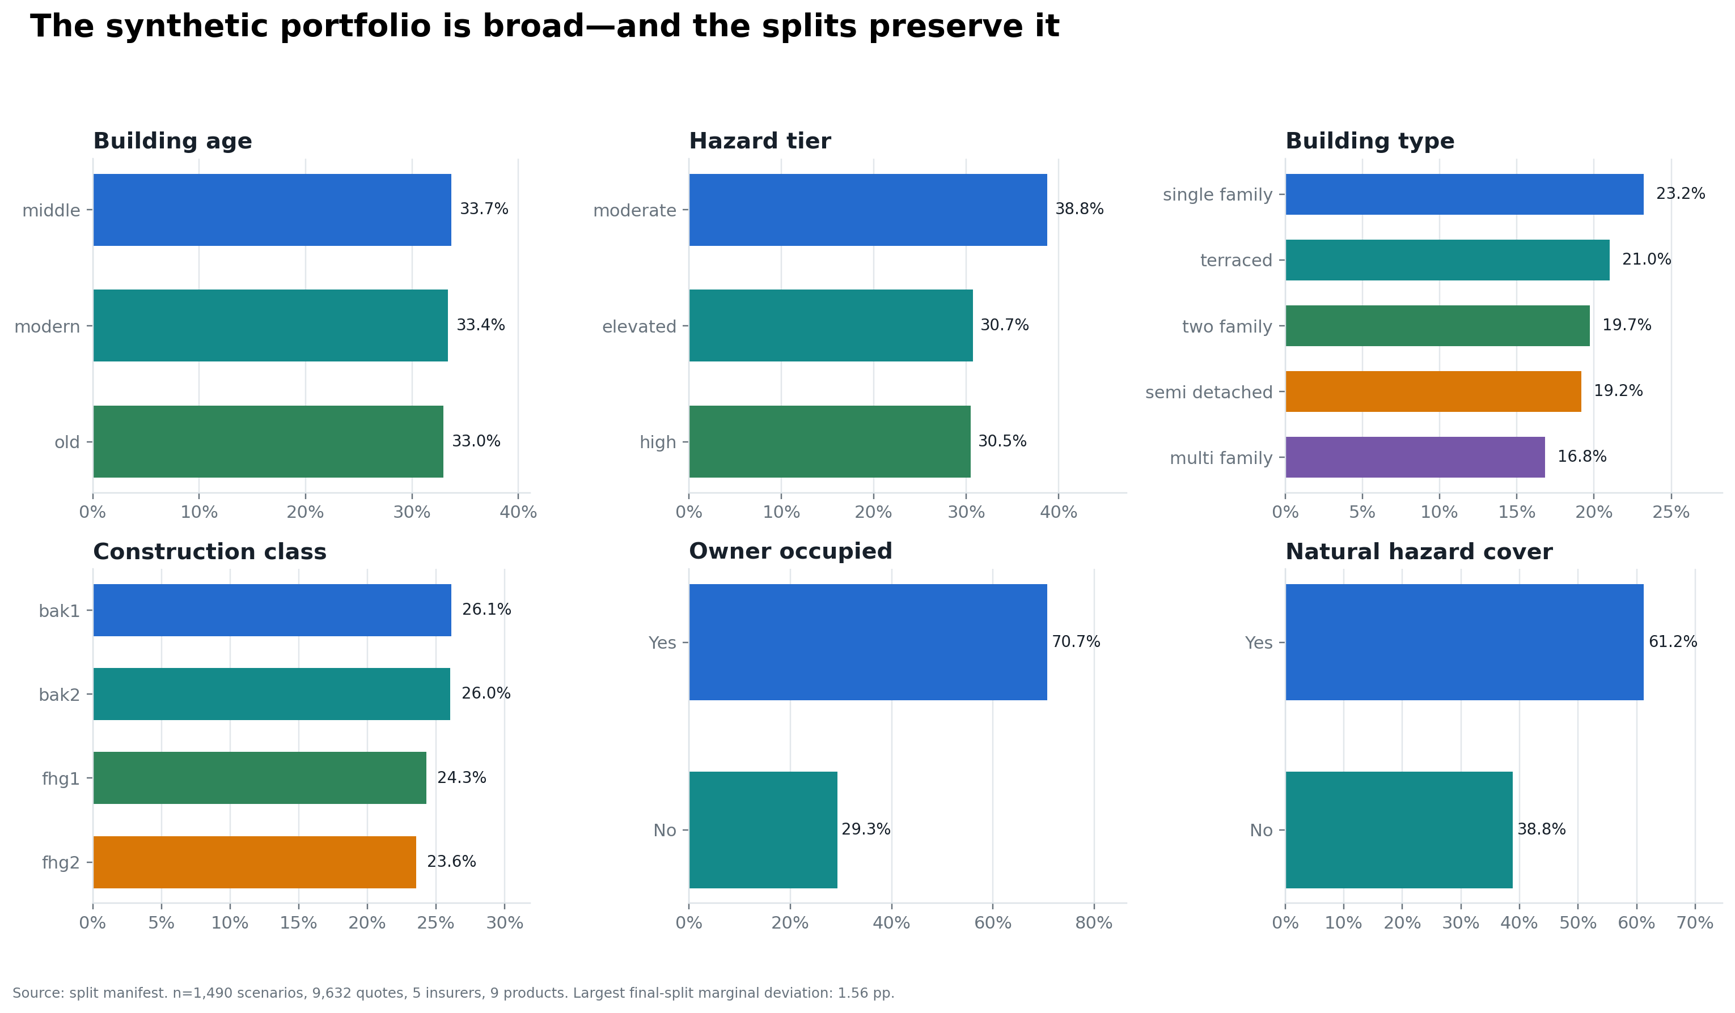
Scenario and quote-panel coverage in the generated corpus
Split | N | Labels | Purpose
Reward calibration | 200 | Teacher | Reward selection and validation
SFT train / validation | 300 / 90 | Teacher | Imitation and checkpoint selection
GRPO train / validation | 810 / 90 | Train labels omitted | Policy optimization and offline gate
Golden | 50 | Fable | Final reporting only

Checks
• 1,490 assignments were disjoint and exhaustive.
• No generated risk exactly overlapped a golden risk.
• Final panels span five insurers and nine tariff IDs.
• Only panels with at least three offered quotes entered training.
Scope note: generated risks and the finite product catalogue support a controlled experiment, not a claim of complete production-population coverage.

06 / SILVER LABELS

Teacher model and supervision

Bottom line
GPT-6 Sol produced 1,490 ranked Top-3 labels for $3.64 in the batch run; including teacher selection, the label programme cost approximately $3.80.
Item | Verified value
Teacher | GPT-6 Sol
Annotations | 1,490
Input / output tokens | 1,546,926 / 417,797
Batch annotation cost | $3.635911
Teacher selection + labels | ≈$3.80
Observed golden Top-1 | 84% (42/50)

Why use a teacher
Direct Fable labels were available only for the locked 50-scenario benchmark. A frontier teacher made task-specific supervision affordable at 1,490-scenario scale. The same canonical prompt and quote-ID mapping were used throughout, and the raw numeric reward was not exposed to the teacher.

What the 84% teacher result means
It is an observed ceiling for this supervision pipeline, not a theorem about all possible models. SFT matching 84% indicates that additional optimization against the same teacher/reward proxy had limited demonstrated headroom against Fable. Better expert labels could change that ceiling.
Economic motivation
A frontier/Fable-quality API route, represented by the evaluated Gemini and GPT-5.4 comparators, was materially more expensive than the supplied 9B reference: about 5× and 7× its per-recommendation cost. This is a comparator-based estimate, not a measured Fable tariff. Teacher-supervised fine-tuning aimed to retain that ranking quality in a self-hostable 2B model.

07 / OBJECTIVE DESIGN

Reward grid search and validation

Bottom line
Reward calibration showed that the effective task was a quality–price trade-off; a frozen deterministic scorer matched 84% Fable Top-1 but remained weaker on the full Top-3.
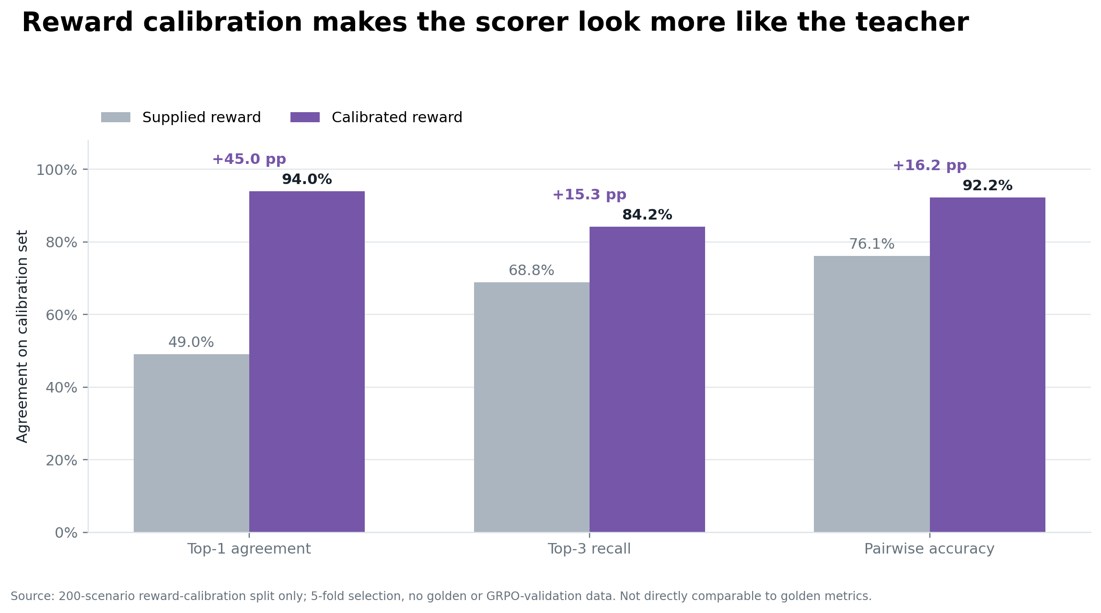
Twenty-thousand-candidate search and held-out controls
Evaluation | Default | Frozen calibrated
Calibration Top-1 | 49% | 94%
Calibration Top-3 recall | 68.8% | 84.2%
Golden Top-1 | 38% | 84%
Golden Top-3 recall | 65.3% | 79.3%
Golden pairwise | 66.0% | 90.4%
Frozen formula
reward = (0.2863 + 0.4273 × scoreₙ) / (1 + 1.7936 × priceₙ)
The selected weights were unchanged during validation; calibration used no golden labels and no LLM calls. A permutation negative control returned chance-level pairwise ranking, reducing the risk that the search merely manufactured agreement.

08 / WHY THIS MODEL

Model selection and training design

Bottom line
Qwen3.5-2B was chosen to challenge the assumption that a 9B model was necessary; BF16 LoRA kept the experiment transparent and operationally simple.
Choice | Selected | Reason
Base model | Qwen3.5-2B | Small enough to test the capacity hypothesis; modern instruction base
Adaptation | BF16 LoRA | Simple pipeline; no quantization confound; fits available GPU
LoRA | rank 16 / alpha 16 / dropout 0 | 10.9M trainable parameters (0.49%)
SFT data | 300 train / 90 validation | Independent teacher-labelled pool
SFT schedule | 3 epochs / 21 steps | Validation-loss checkpoint selection
Loss | Completion only | Learn output policy without fitting prompt tokens

Why not QLoRA
The full BF16 base plus LoRA fit the selected hardware, so quantization was not required. Avoiding QLoRA kept the experiment simpler and removed another variable from a short, decision-oriented comparison.

What would change the model choice
If time allowed, the next capacity experiment would test ≤1B models under the same split and evaluation contract. The 2B result supports—not exhausts—the hypothesis that this structured task needs far less than 9B parameters.

09 / MAIN MODEL GAIN

Supervised fine-tuning

Bottom line
SFT transformed both ranking quality and operational reliability: 22% → 84% Top-1 and 2% → 100% strict JSON.
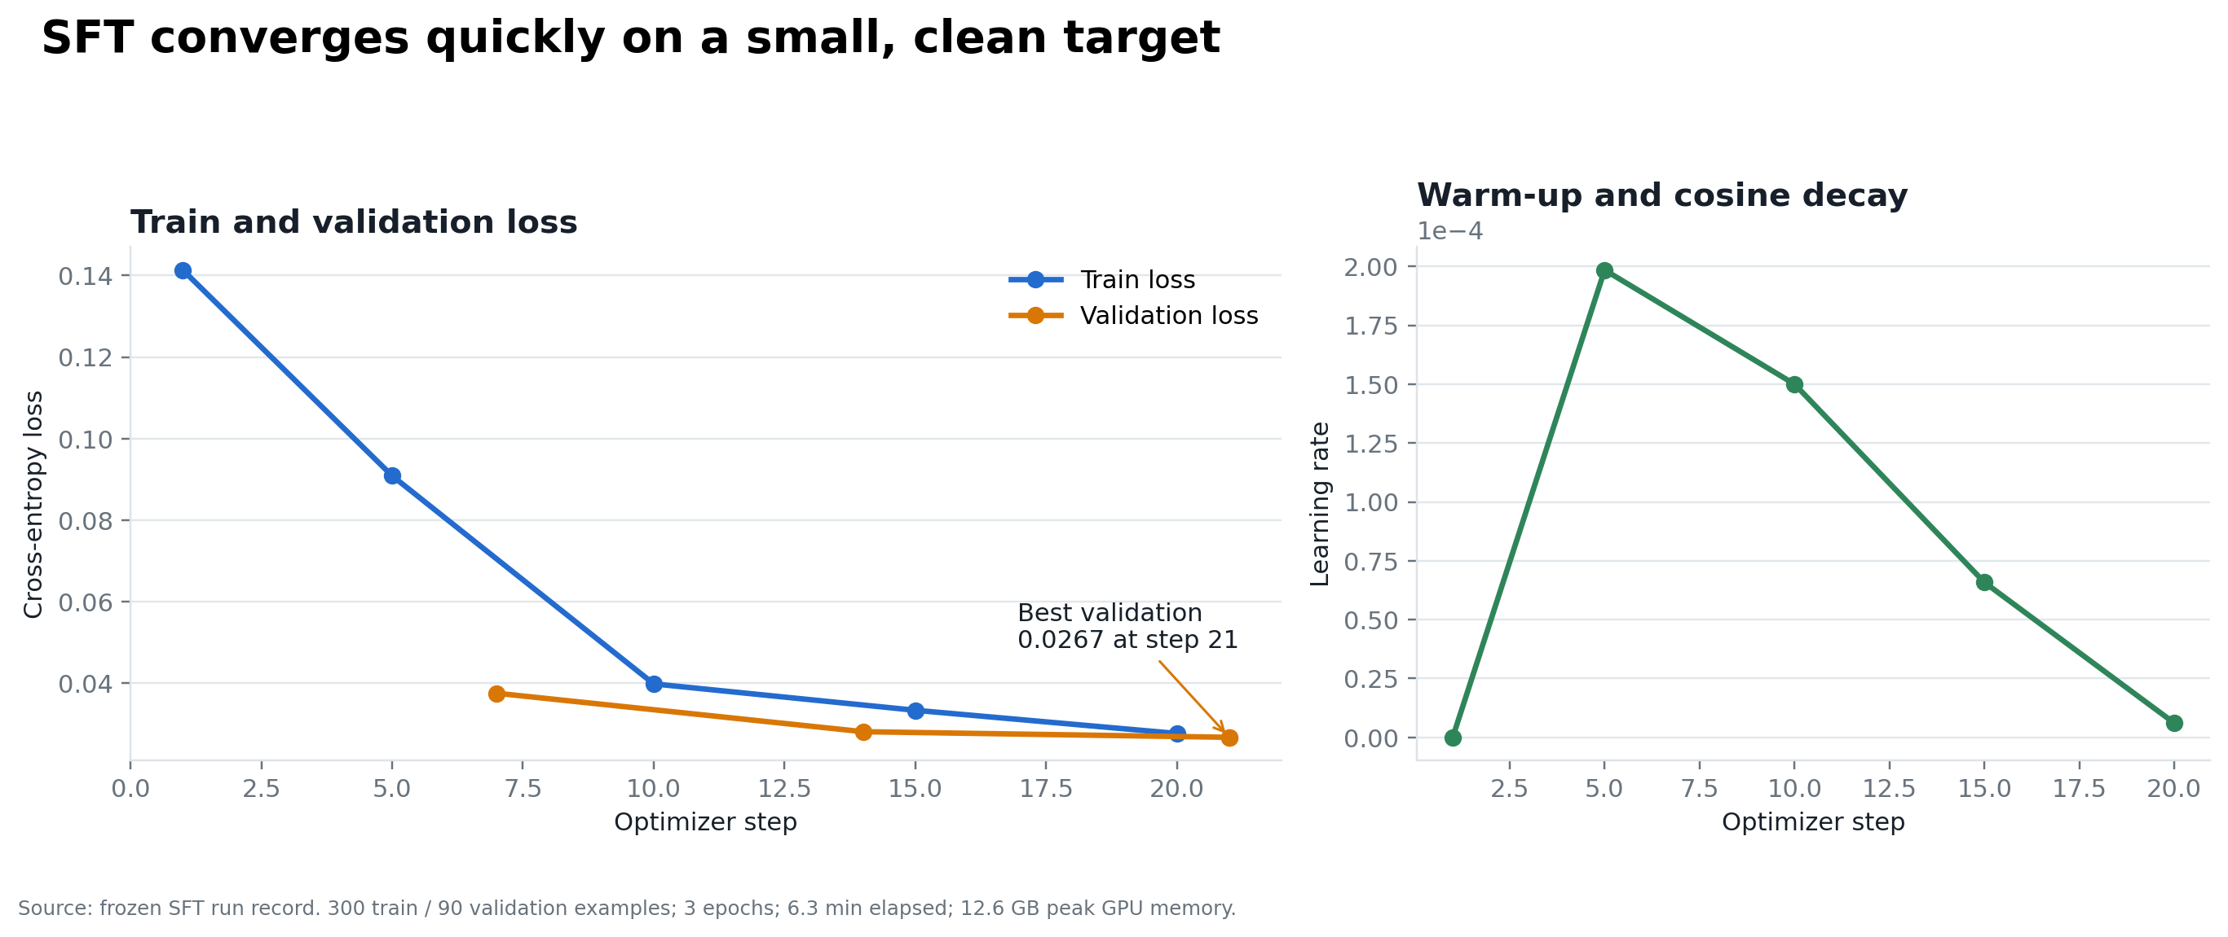
SFT learning curve and selected checkpoint
Golden metric | 2B base | 2B SFT | Change
Top-1 | 22% | 84% | +62 pp
Top-3 recall | 66.7% | 86.7% | +20 pp
Strict JSON | 2% | 100% | +98 pp
Valid three unique IDs | 100% | 100% | Maintained

Interpretation
The improvement is not merely format compliance: Top-1 and Top-3 both rose sharply. The selected model’s lower supplied-reward ratio than price-dominant baselines reflects a deliberate shift toward the teacher/Fable quality preference, not an internal contradiction.
Selection rule
The SFT checkpoint was selected from validation loss on its own 90-scenario split. Golden results were reported afterward and were not used to choose SFT steps or hyperparameters.

10 / POLICY OPTIMIZATION

GRPO continuation: useful signal, limited evidence

Bottom line
GRPO did not fail: it was stable and fixed one development Top-1 error. Ten steps were insufficient to demonstrate a broad improvement beyond an SFT model already at the teacher’s observed Fable agreement.
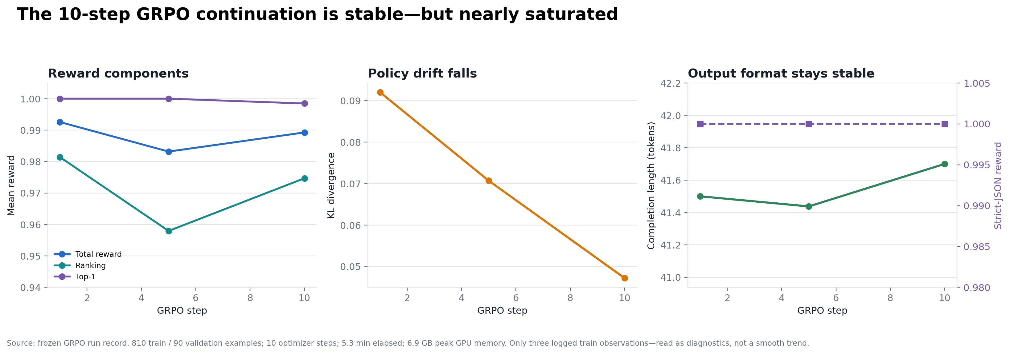
Ten-step GRPO training diagnostics
Evaluation | SFT | GRPO-10 | Observed change
Development Top-1 | 83/90 | 84/90 | +1 corrected scenario
Development Top-3 recall | 87.0% | 86.3% | Small net loss
Golden Top-1 | 42/50 | 42/50 | No change
Golden Top-3 recall | 86.7% | 86.0% | One fewer hit / 150
Strict JSON | 100% | 100% | No degradation

Why stop
• The assignment’s >80% objective was already exceeded by SFT.
• SFT matched the teacher’s observed 84% Fable Top-1.
• Additional optimization would still target a silver reward proxy, not independent truth.
• The time budget favored verifying reproducibility and serving economics over an open-ended RL sweep.
Longer training, more samples per prompt, or better supervision could still correct remaining cases. The defensible claim is that ten steps did not establish a broad gain—not that GRPO cannot work.

11 / WHAT WE GOT

Final evaluation and model selection

Bottom line
The selected 2B SFT model matched the best observed Top-1 result and produced the strongest balanced Top-3 among the compact deployable options.
System | Top-1 | Top-3 recall | Reward ratio | Cost / 1k
Supplied Qwen3.5-9B | 42% | 66.0% | 0.983 | €0.1869
Our Qwen3.5-2B base | 22% | 66.7% | 0.844 | —
Calibrated scorer | 84% | 79.3% | 0.812 | €0 inference
Our 2B SFT — selected | 84% | 86.7% | 0.812 | €0.0028–0.0539
Our 2B GRPO-10 | 84% | 86.0% | 0.812 | Same serving class
Gemini | 80% | 88.0% | 0.763 | €0.8897
GPT-5.4 | 84% | 79.3% | 0.802 | €1.3445
GPT-6 Sol | 84% | 86.7% | 0.832 | €2.8707

Selection rationale
SFT ties the strongest Top-1, matches GPT-6 Sol Top-3, exceeds the symbolic scorer by 11 recovered Top-3 positions, satisfies the output contract, and has a measured low-cost serving path. GRPO adds complexity without a demonstrated aggregate benefit at the tested budget.
The calibrated scorer remains valuable: if a product consumes only rank one, it offers the same measured Top-1 with no inference. It is not chosen for this deliverable because the required output is a useful ranked Top-3.

12 / PRODUCTION CASE

Serving benchmark and economics

Bottom line
A dedicated post-fix vLLM benchmark—not incidental training-run timing—provides the serving figures used for the cost claim.
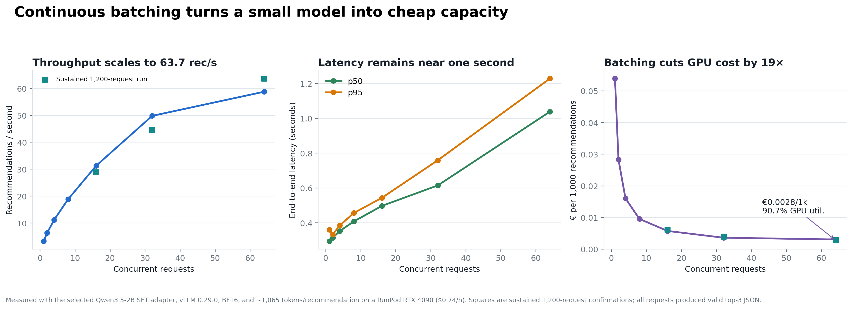
Measured throughput, latency, and utilization on an RTX 4090
Scenario | Cost / 1k | Status
Saturated, concurrency 64 | €0.002832 | Measured; 63.66 rec/s
50% utilization | €0.005663 | Scenario
25% utilization | €0.011327 | Scenario—not a recommendation
10% utilization | €0.028317 | Scenario
Unbatched / concurrency 1 | €0.053899 | Measured lower-throughput mode

Timing caveat
Early end-to-end runs took longer because FlashAttention was not functioning correctly; that environment issue was later fixed. For this reason, the report does not infer production latency from training or ad-hoc evaluation timestamps. It uses the separate serving benchmark: 1,200 requests, p50 1.003 s, p95 1.105 s, 90.7% mean GPU utilization, and 100% valid outputs.

Cost boundaries
Serving estimates use a $0.74/hour RTX 4090 and are GPU-only. Storage, networking, cold starts, redundancy, monitoring, and engineering operations are excluded.

13 / CAN IT BE RERUN

Spend, reproducibility, and delivery

Bottom line
The complete billed experiment cost approximately $7.80, and the release package preserves adapters, configs, logs, frozen outputs, hashes, and a portable reproduction flow.
Spend item | Amount | Evidence
Teacher pilot / selection | ≈$0.16 | Selection records
Teacher batch labels | $3.635911 | annotation_summary.json
RunPod total | $4.00 | Owner-confirmed total bill
Total | ≈$7.80 | Experiment + benchmarking

Release contents
• SFT and GRPO adapters with hashes and resolved configs.
• Frozen base, SFT, GRPO, comparator, and serving summaries.
• Prepared non-golden data and split manifests.
• HOW_TO_RUN.md and portable reproduction script.
• Apple MPS verification: all 50 SFT raw outputs matched CUDA exactly.
Git repository: https://github.com/lakshaychhabra/reranking-optimisation
Hugging Face dataset: https://huggingface.co/datasets/lakshaychhabra/wg-recommendation-data
Reproduction rule
Use development data for routine checks. The golden benchmark remains final-report evidence and must not become an iterative checkpoint-selection loop.

14 / WHAT REMAINS

Limits and next experiments

Bottom line
The current evidence supports the assignment decision; production confidence requires stronger independent labels, more scenarios, and a capacity study below 2B.
Limitation | Why it matters | Next experiment
50-scenario golden set | One case moves Top-1 by 2 pp | Larger untouched expert-labelled benchmark
Silver supervision | Teacher can reproduce its own preferences | Expert adjudication on disagreements
Synthetic risks / finite catalogue | May miss operational tail cases | Shadow evaluation on production-like traffic
Fixed reward formula | Can miss feature interactions | Compare learned reward or preference model
2B is smallest tested | Capacity floor remains unknown | Repeat SFT at ≤1B
GRPO only 10 steps | Longer run may improve remaining errors | Predeclare dev gate; increase steps/samples after better labels

Recommended sequence
• Deploy or shadow-test the selected SFT adapter with the symbolic scorer as a monitoring baseline.
• Collect expert labels specifically where SFT, scorer, and teacher disagree.
• Run the ≤1B capacity ablation under the identical prompt and split contract.
• Only then extend GRPO with a frozen development rule and a new untouched final benchmark.
Final conclusion
The assignment aim was achieved: a small self-hostable model exceeded 80% Top-1 and matched the observed top-tier result at a fraction of serving cost. The main lesson is not that one optimizer won; it is that disciplined data separation, reward interpretation, and simple SFT captured nearly all demonstrated value, while GRPO remains a credible path once the supervision ceiling is raised.

