Achievement Report
Smart India Hackathon (SIH) 2026 — Internal Hackathon Round
To: Vishal Shrivastava
From: Pari khatwani, 05117711725, BTech IIOT
Date: 24 September 2026
Subject: Selection in Top 10 Teams — SIH 2026 Internal Hackathon Round

Respected Sir/Madam,
I am writing to inform you, for inclusion in my mentor file, that our team "Cypher Luminaries" (Team ID: TeamId_59) has been selected among the Top 10 teams in the SIH 2026 Internal Hackathon Round, securing Rank 4 in the Hardware category. Details of the selection and our project are summarised below.
1. Selection Summary
Event | SIH 2026 — Internal Hackathon Round
Team Name | Cypher Luminaries
Team ID | TeamId_59
Rank Secured | 4th, among the Top 10 selected teams
Category | Hardware
Institution | VSET

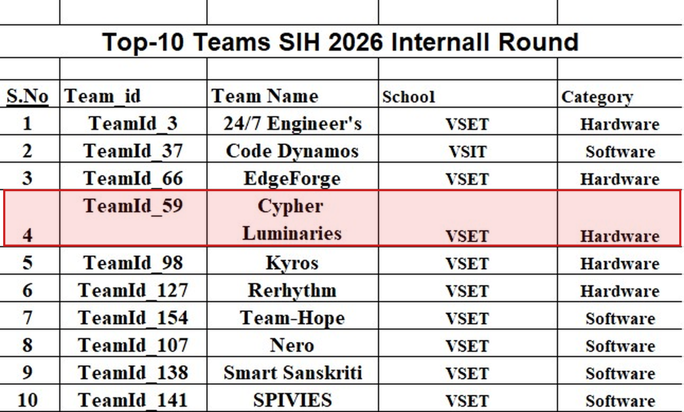
Official Top-10 team list, SIH 2026 Internal Round — our team, Cypher Luminaries, is highlighted at Rank 4.
2. About the Project — B.R.A.V.E.
B.R.A.V.E. (Belt Rupture Analysis & Vulnerability Estimation) is a real-time monitoring system built to prevent conveyor belt failures in mining and coal-handling plants. Conveyor belt rupture is a major cause of unplanned downtime and safety incidents in such plants, and existing inspection is largely manual and reactive. Our project instead uses low-cost embedded sensors and a live dashboard to continuously watch belt health and flag developing faults before they cause a failure.
3. What We Built
- A 7-screen real-time monitoring dashboard — Control Room, Live Sensor Monitoring, Belt Digital Twin, Anomaly Detection, Fault Localization, Predictive Maintenance, and Alerts & Actions — built in Python using Streamlit.
- Integration of physical sensors — an MPU6050 accelerometer for vibration, a DS18B20 probe for temperature, a Hall-effect sensor for roller speed and belt position, and an HC-SR04 ultrasonic sensor for belt profile — all read through an ESP32 microcontroller.
- A serial-to-dashboard gateway that reads live JSON sensor data from the ESP32 over USB, computes a fused health/risk score, and streams it to the web dashboard in real time.
- A fusion algorithm that combines vibration and temperature readings into a single Health Score and Risk Index, classifying belt condition as Normal, Warning, or Critical.
- Interactive visualizations, including a live telemetry chart, a joint-health "digital twin" map of the belt, an anomaly-score trend view, and a predictive maintenance forecast estimating Remaining Useful Life (RUL).
- An alerts & actions workflow allowing an operator to acknowledge alerts, raise work orders, and schedule inspections directly from the dashboard.
4. Learning Outcomes
- Hands-on experience integrating embedded hardware (ESP32 and multiple sensors) with a live software dashboard.
- Practical exposure to real-time data pipelines, serial communication protocols, and sensor fusion for condition monitoring.
- Dashboard design and full-stack development experience using Python and Streamlit.
- Teamwork and project management skills gained while building and presenting the solution as part of Team Cypher Luminaries.
5. Conclusion
Being selected among the Top 10 teams in the SIH 2026 Internal Round is an encouraging validation of our project idea and the effort put in by the team. I am submitting this report to keep my mentor file updated with this progress and look forward to guidance on refining the project for the next round.

Thanking you,
_____________________________
Pari khatwani
05117711725, BTech IIOT
Team Cypher Luminaries (TeamId_59)

