Integrative Capstone Project and Evaluation
End-to-End Data Science Pipeline: Titanic Passenger Survival Analysis
Python | pandas | scikit-learn | Matplotlib

1. Executive Summary
This capstone project integrates the major stages of a practical data science workflow using the Titanic dataset. The project combines data preparation, exploratory data analysis, supervised machine learning and unsupervised learning. A Random Forest classifier achieved 82.12% accuracy on the held-out test set and 83.73% mean five-fold cross-validation accuracy. K-Means clustering was also used to identify passenger segments, with a silhouette score of 0.485. The project demonstrates how descriptive, predictive and exploratory methods can be combined in one coherent Python-based pipeline.

2. Problem Statement and Objectives
The primary predictive problem is to determine whether a Titanic passenger survived based on demographic, socioeconomic and family-related characteristics. A secondary descriptive objective is to identify groups of passengers with similar characteristics using unsupervised clustering. The project therefore addresses both classification and segmentation.
- Predict passenger survival using supervised learning.
- Explore relationships between passenger characteristics and survival.
- Engineer meaningful features from raw data.
- Identify passenger segments using unsupervised learning.
- Evaluate methods and develop practical insights and recommendations.

3. Data Collection and Dataset Description
The project uses the publicly available Titanic passenger dataset supplied for this internship project. The dataset contains 891 observations and 10 original columns. Variables include passenger class, name, sex, age, family relationships, ticket information, fare and survival outcome. The target variable is Survived.
Initial loading code:
import pandas as pd
df = pd.read_csv("Titanic_cleaned.csv")
print(df.shape)
print(df.head())
print(df.info())

4. Data Cleaning and Preprocessing
The supplied dataset was inspected for missing values, data types and duplicate records. PassengerId was removed from modeling because it is an identifier. Name and Ticket were transformed or excluded to avoid directly learning high-cardinality identifiers. Numeric variables were median-imputed and standardized. Categorical variables were encoded using one-hot encoding inside a Scikit-learn pipeline, reducing the risk of data leakage.
Preprocessing code:
preprocessor = ColumnTransformer([
("num", Pipeline([
("imputer", SimpleImputer(strategy="median")),
("scaler", StandardScaler())
]), numerical_columns),
("cat", Pipeline([
("imputer", SimpleImputer(strategy="most_frequent")),
("encoder", OneHotEncoder(handle_unknown="ignore"))
]), categorical_columns)
])

5. Feature Engineering
Feature engineering was used to convert raw variables into signals that may better represent passenger circumstances.
- FamilySize = SibSp + Parch + 1.
- IsAlone identifies passengers travelling without family members.
- Title was extracted from Name and rare titles were grouped.
- FarePerPerson estimates economic resources per family member.
data["FamilySize"] = data["SibSp"] + data["Parch"] + 1
data["IsAlone"] = (data["FamilySize"] == 1).astype(int)
data["Title"] = data["Name"].str.extract(r",\s*([^.]*)\.")[0]
data["FarePerPerson"] = data["Fare"] / data["FamilySize"]

6. Exploratory Data Analysis
Exploratory analysis was performed to understand survival patterns and feature relationships. Sex and passenger class show strong associations with survival, while age provides additional demographic context.
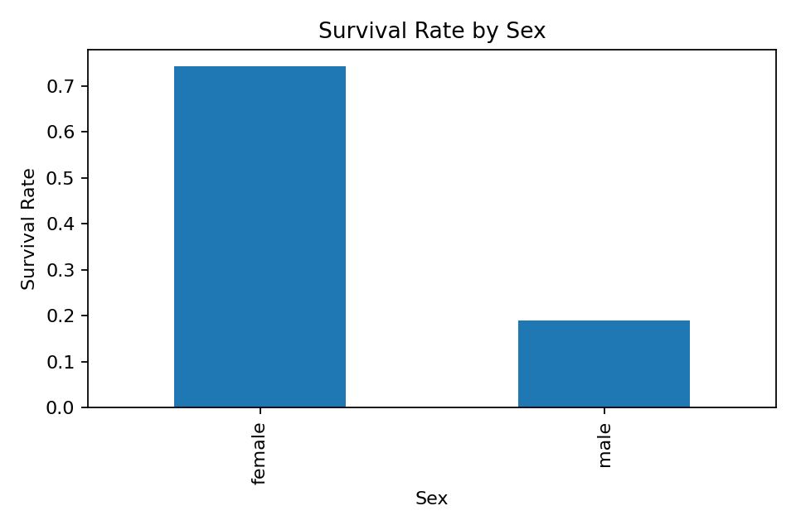
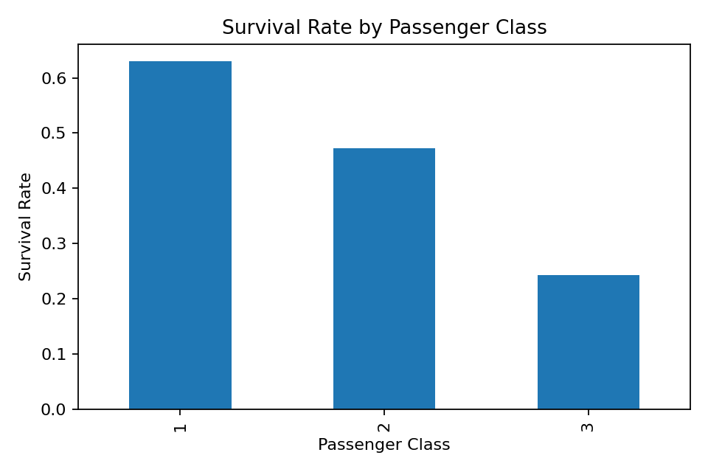
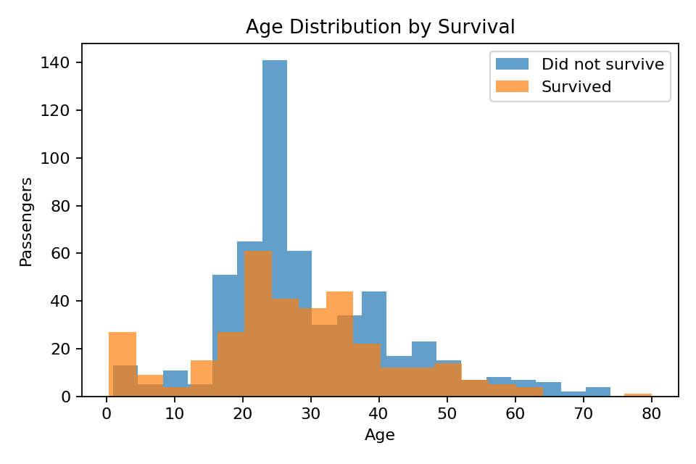
Key EDA insight: survival was not randomly distributed. Demographic and socioeconomic variables contain substantial predictive information, supporting the use of supervised learning.

7. Supervised Learning Methodology
Two classifiers were evaluated: Logistic Regression as an interpretable baseline and Random Forest as a nonlinear ensemble model. Data was divided into 80% training and 20% testing subsets using stratified sampling. Five-fold stratified cross-validation was used to obtain a more stable estimate of generalization performance.
X_train, X_test, y_train, y_test = train_test_split(
X, y, test_size=0.20, stratify=y, random_state=42)
model = Pipeline([
("preprocessor", preprocessor),
("classifier", RandomForestClassifier(
n_estimators=400,
min_samples_leaf=2,
class_weight="balanced",
random_state=42
))
])

8. Supervised Model Evaluation
Model | Accuracy | Precision | Recall | F1 | ROC-AUC
Logistic Regression | 0.844 | 0.825 | 0.754 | 0.788 | 0.875
Random Forest | 0.821 | 0.776 | 0.754 | 0.765 | 0.841
Random Forest mean 5-fold cross-validation accuracy: 0.837; standard deviation: 0.020. Multiple metrics were used because accuracy alone may hide differences in how effectively survivors and non-survivors are identified.

9. Unsupervised Learning: Passenger Segmentation
K-Means clustering was applied to Age, Fare, FamilySize and Pclass after imputation and standardization. Three clusters were selected to produce interpretable passenger segments. PCA reduced the clustering feature space to two dimensions for visualization.
features = ["Age", "Fare", "FamilySize", "Pclass"]
scaled = StandardScaler().fit_transform(cluster_features)
kmeans = KMeans(n_clusters=3, random_state=42, n_init=20)
clusters = kmeans.fit_predict(scaled)
score = silhouette_score(scaled, clusters)
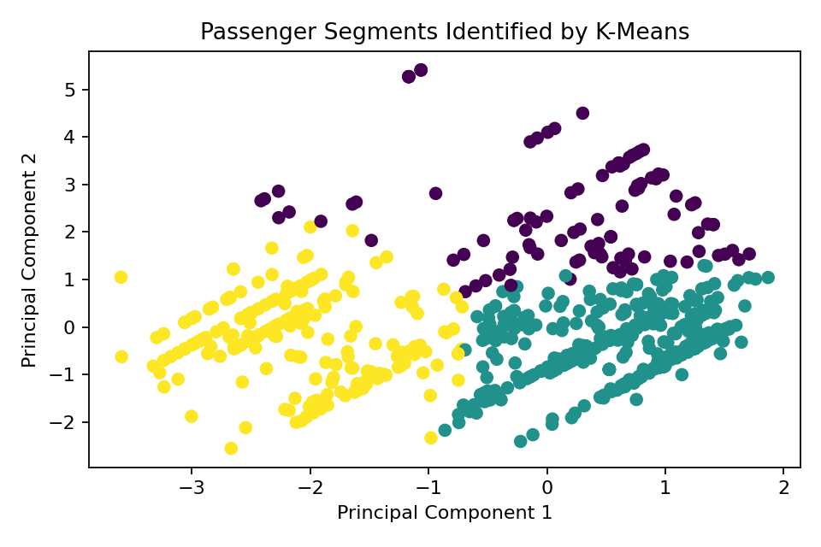
The clustering experiment produced a silhouette score of 0.485. This indicates that passenger segmentation contains some structure, although clusters are not perfectly separated. This is expected because human demographic data often forms overlapping groups rather than naturally isolated categories.

10. Integrated Findings and Insights
- Passenger survival can be predicted with useful accuracy using demographic and socioeconomic information.
- Feature engineering improves the representation of family and social characteristics.
- Nonlinear models can capture interactions that simpler linear approaches may miss.
- Passenger segmentation provides descriptive insight even when no survival label is used.
- Combining EDA, classification and clustering creates a richer understanding than using only one analytical technique.

11. Recommendations
- Use cross-validation rather than relying only on one train/test split.
- Select evaluation metrics according to the intended decision-making context.
- Retain interpretable baseline models when communicating predictive systems.
- Use clustering as an exploratory tool rather than treating clusters as absolute truths.
- For future work, compare Random Forest with gradient boosting and calibrated models.

12. Challenges and Solutions
- Small dataset size: addressed through compact feature engineering, stratification and cross-validation.
- Mixed variable types: addressed through a ColumnTransformer and separate numeric/categorical pipelines.
- Potential overfitting: reduced using conservative Random Forest settings and validation.
- High-cardinality text fields: transformed into Title or excluded rather than directly memorized.
- Interpreting unsupervised results: addressed using PCA visualization and silhouette evaluation.

13. Reflection and Successes
The major success of this capstone is the integration of the complete data science pipeline in one project. Instead of focusing only on model accuracy, the workflow begins with understanding the data, continues through feature engineering and exploration, and then applies both predictive and descriptive methods. A key lesson is that model performance depends strongly on data representation and validation design. Another important lesson is that sophisticated algorithms are most useful when supported by careful preprocessing, clear objectives and critical interpretation.

14. Future Analysis
- Conduct systematic hyperparameter tuning with RandomizedSearchCV.
- Compare K-Means with hierarchical or density-based clustering.
- Use permutation importance or SHAP for explainability.
- Explore additional ticket-group and surname-based features.
- Build a simple interactive dashboard to communicate findings.

15. Conclusion
This integrative capstone demonstrates an independent end-to-end data science workflow using Python. The Titanic problem was explored through data cleaning, feature engineering and visualization, modeled through supervised classification, and extended through unsupervised passenger segmentation. The results show that a carefully designed pipeline can generate both predictive performance and descriptive insight. The project also highlights the importance of reproducibility, validation and critical reflection when developing practical data science solutions.

16. Technologies and Reproducibility
Python libraries used: pandas, NumPy, Matplotlib and scikit-learn. Fixed random_state values were used where applicable to improve reproducibility. The main input dataset is Titanic_cleaned.csv.

