Exploratory Data Analysis and Visualization
Titanic Passenger Dataset (Cleaned)
Week 2 Task — EDA Report

1. Introduction and Objective
This report documents an exploratory data analysis (EDA) of the Titanic passenger dataset, performed using Python's data science stack — Pandas for data manipulation, and Matplotlib and Seaborn for visualization. The goal is to demonstrate a complete, disciplined EDA workflow: inspecting data quality, summarizing distributions, uncovering relationships between variables, detecting anomalies, and translating all of these observations into clear, well-supported insights.
The Titanic dataset is one of the most widely used public datasets in data science education. It records demographic and travel details for 891 passengers aboard the RMS Titanic, along with whether each passenger survived the sinking. It was used here — supplied as a pre-cleaned CSV file — because it combines a clear binary outcome (Survived) with a mix of numeric and categorical features, and because the underlying historical event (“women and children first,” class-based access to lifeboats) gives every statistical pattern a concrete, checkable real-world explanation.
Every code snippet shown below is the exact code used to produce the accompanying statistics and figures, so the analysis can be reproduced end to end.

2. Dataset Description
The supplied file, Titanic_cleaned.csv, contains 891 passenger records and 10 columns: PassengerId, Survived (0 = did not survive, 1 = survived), Pclass (ticket class: 1st, 2nd, 3rd), Name, Sex, Age, SibSp (number of siblings/spouses aboard), Parch (number of parents/children aboard), Ticket, and Fare. Unlike the raw Titanic dataset commonly distributed for teaching, this file has already had its missing values resolved and, as Section 4 shows, has evidence of additional preprocessing (outlier capping and imputation) applied before delivery.
import pandas as pd
df = pd.read_csv('Titanic_cleaned.csv')
print(df.shape) # (891, 10)
print(df.isnull().sum())
Code Snippet 1: Loading the dataset and confirming its shape and completeness.
A null-value audit confirmed there are zero missing values across all 10 columns — a notable contrast to the original Titanic dataset, which is famous for having roughly 20% of Age values and the large majority of Cabin values missing.

3. Methodology and Tools
The analysis was carried out in Python 3, using the following libraries:
- Pandas — data loading, cleaning, and aggregation
- NumPy — numerical operations
- Matplotlib — base plotting and figure composition
- Seaborn — statistical visualizations (distribution plots, heatmaps, grouped bar charts)

4. Data Cleaning and Preparation

4.1 Evidence of Prior Preprocessing
Although the file arrived with no missing values, closer inspection of the value distributions revealed clear fingerprints of upstream cleaning steps, which are documented here for transparency rather than treated as new problems to fix.
fare_cap = df['Fare'].max() # 65.6344
n_capped = (df['Fare'] == fare_cap).sum() # 116

age_spike_25 = (df['Age'] == 25.0).sum() # 117
age_spike_215 = (df['Age'] == 21.5).sum() # 42
df['Age'].nunique() # 89 unique values
Code Snippet 2: Detecting capping and imputation fingerprints.
- Fare capping: 116 of 891 passengers (13%) share the exact same maximum fare value, 65.6344. In the original Titanic data, fares range far higher (up to roughly 512). This strongly suggests fares above a certain threshold were capped/winsorized to that value to limit the influence of extreme outliers.
- Age imputation: 117 passengers share the exact age 25.0, and 42 share the exact age 21.5 — far more repetition than a naturally continuous variable like age would produce by chance. This is the classic signature of missing-value imputation, most likely filling gaps with a (possibly group-specific) median or mean age.
These observations do not require any corrective action — the data is already in a modeling-ready state — but they matter for interpretation: the fare distribution's right tail and any fare-related outlier count will be artificially truncated, and the specific values 25.0 and 21.5 in the age distribution reflect imputation choices rather than 117 people who were coincidentally the same age.

4.2 Feature Engineering
Three derived features were added to support deeper analysis:
df['Title'] = df['Name'].str.extract(r',\s*([^\.]+)\.')
df['Title'] = df['Title'].replace(
{'Mlle': 'Miss', 'Ms': 'Miss', 'Mme': 'Mrs'})
rare = df['Title'].value_counts()
df['Title'] = df['Title'].replace(
rare[rare < 10].index, 'Other')

df['FamilySize'] = df['SibSp'] + df['Parch'] + 1
df['IsAlone'] = (df['FamilySize'] == 1).astype(int)
Code Snippet 3: Extracting Title from Name; deriving FamilySize and IsAlone.
- Title — extracted from the Name field's honorific (e.g., “Mr”, “Mrs”, “Miss”, “Master”), with rare titles (Dr, Rev, Major, Col, and similar, each under 10 occurrences) grouped into “Other.” This converts a free-text field into a usable categorical signal.
- FamilySize — SibSp + Parch + 1, representing the total number of family members traveling together, including the passenger.
- IsAlone — a binary flag for passengers with FamilySize == 1, isolating solo travelers as their own group.

5. Summary Statistics
df[['Age','SibSp','Parch','Fare','FamilySize']].describe().T

Feature | Mean | Std Dev | Min | Max
Age | 29.11 | 13.30 | 0.42 | 80.00
SibSp (siblings/spouses aboard) | 0.52 | 1.10 | 0 | 8
Parch (parents/children aboard) | 0.38 | 0.81 | 0 | 6
Fare | 24.05 | 20.48 | 0.00 | 65.63
FamilySize (engineered) | 1.90 | 1.61 | 1 | 11
Table 1: Summary statistics for key numeric features (n = 891).
The overall survival rate is 38.4% (342 of 891 passengers) — already a strong hint that the disaster was not survivable for most aboard, and a class imbalance to keep in mind for any later modeling. Age ranges from 5 months (0.42 years) to 80 years, with a mean around 29. SibSp and Parch are both heavily right-skewed — most passengers (median 0) traveled with no siblings/spouses or parents/children aboard, but a minority traveled in larger family groups of up to 8 (SibSp) or 6 (Parch). Fare is also right-skewed even after capping, with a median of 14.45 well below the mean of 24.05, reflecting that most passengers held lower-priced 3rd class tickets while a smaller group paid substantially more.

6. Univariate Analysis

6.1 Survival Outcome
counts = df['Survived'].value_counts().sort_index()
ax.bar(['Did Not Survive', 'Survived'], counts.values)
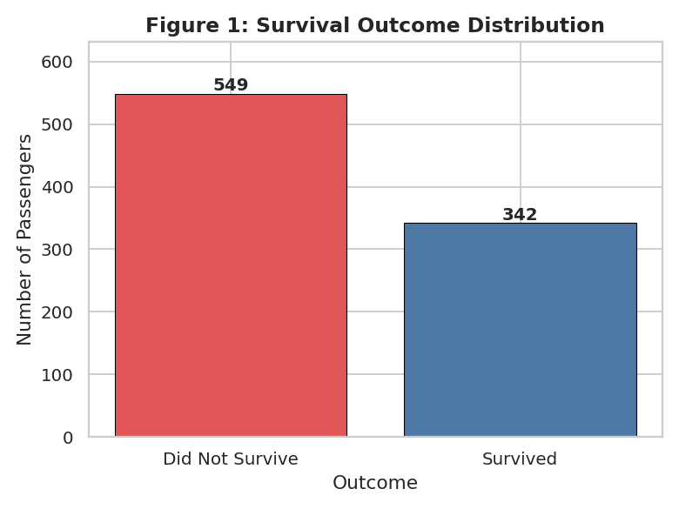
Figure 1: Survival outcome distribution (549 did not survive, 342 survived).
Only 38.4% of passengers in this dataset survived. This moderate imbalance (roughly 62/38) means that a model or heuristic that always predicts “did not survive” would already be correct 61.6% of the time — an important baseline for judging any classifier built on this data.

6.2 Age Distribution by Survival
sns.histplot(data=df, x='Age', hue='SurvivedLabel',
kde=True, element='step')
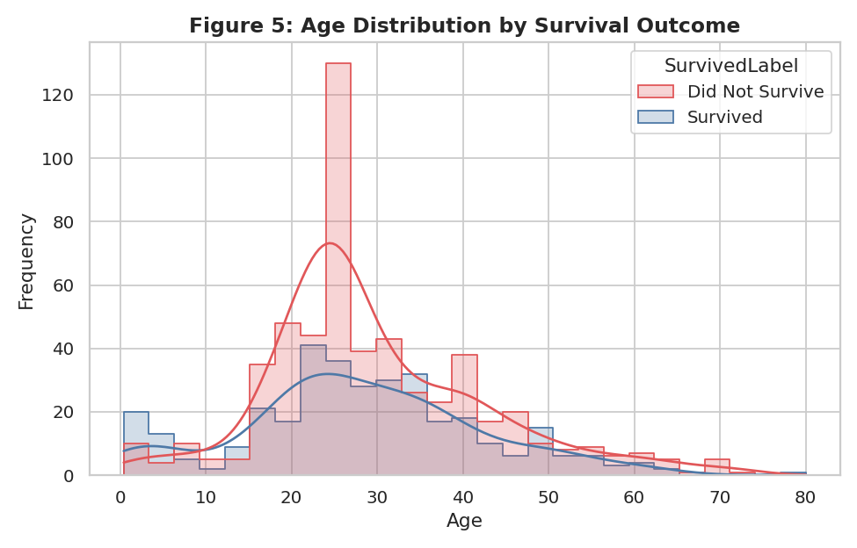
Figure 5: Age distribution, split by survival outcome.
The two age distributions largely overlap — mean age is 29.7 for those who did not survive versus 28.1 for those who did, a small difference. The clearest visible signal is at the youngest ages: there is a small but distinct bump of survivors under age 10, consistent with the historical “women and children first” evacuation priority. Beyond early childhood, age alone is a weak discriminator of survival, which is confirmed quantitatively in Section 8 (Age correlates with Survived at only r = -0.06).

7. Bivariate and Multivariate Analysis

7.1 Survival by Sex
rate = df.groupby('Sex')['Survived'].mean()
ax.bar(rate.index, rate.values * 100)
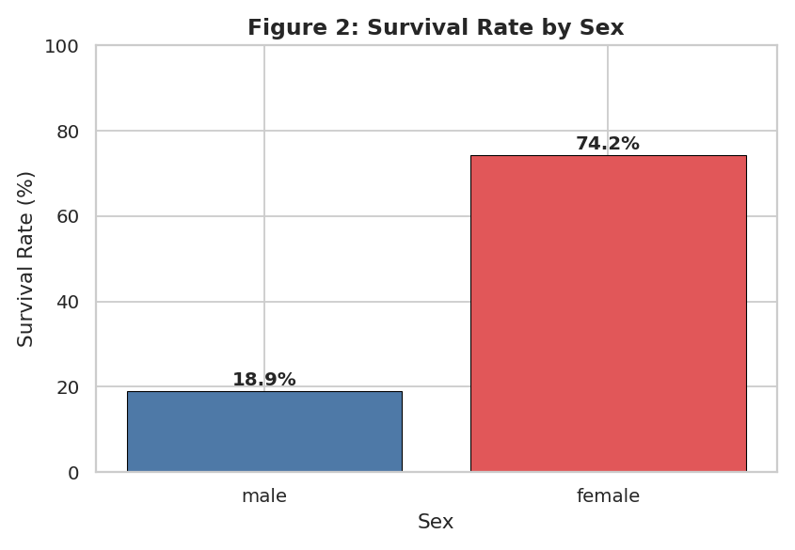
Figure 2: Survival rate by sex (female 74.2%, male 18.9%).
Sex is, by a wide margin, the single strongest predictor of survival in this dataset. 74.2% of female passengers survived compared to only 18.9% of male passengers — a 55-percentage-point gap. This is the clearest quantitative confirmation of the “women and children first” evacuation protocol that historical accounts of the disaster describe.

7.2 Survival by Passenger Class
rate = df.groupby('Pclass')['Survived'].mean()
ax.bar(['1st', '2nd', '3rd'], rate.values * 100)
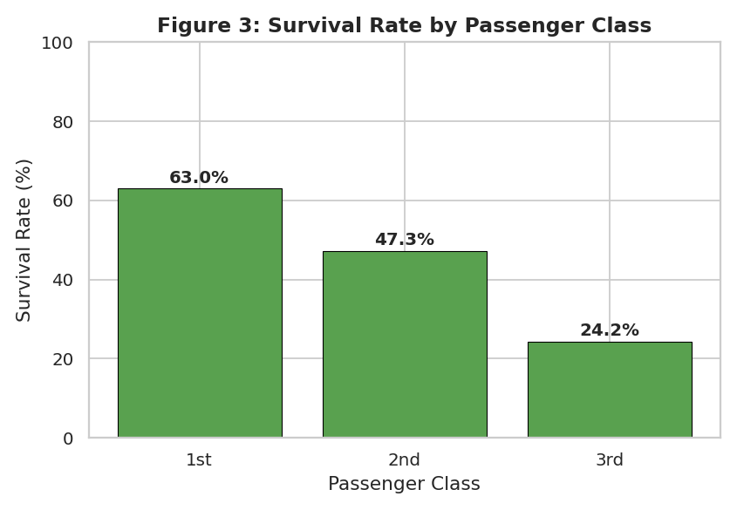
Figure 3: Survival rate by passenger class (1st 63.0%, 2nd 47.3%, 3rd 24.2%).
Ticket class shows a clean, monotonic relationship with survival: 1st class passengers survived at 63.0%, 2nd class at 47.3%, and 3rd class at only 24.2%. This mirrors the ship's physical layout and boarding procedures — 1st class cabins and access routes were closer to the boat deck, and evacuation was, by multiple historical accounts, prioritized by class as well as by sex.

7.3 Survival by Class and Sex Combined
grp = df.groupby(['Pclass','Sex'])['Survived']
.mean().unstack() * 100
grp.plot(kind='bar')
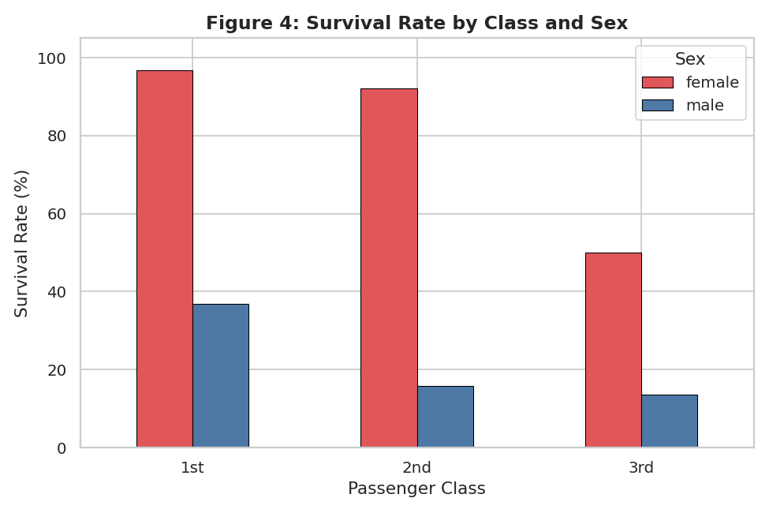
Figure 4: Survival rate by class and sex, combined.
Class | Sex | Survival Rate | Passengers
1st | Female | 96.8% | 94
1st | Male | 36.9% | 122
2nd | Female | 92.1% | 76
2nd | Male | 15.7% | 108
3rd | Female | 50.0% | 144
3rd | Male | 13.5% | 347
Table 2: Detailed survival rates by class and sex.
Layering sex on top of class reveals that the two factors compound rather than substitute for one another. Nearly all 1st and 2nd class women survived (96.8% and 92.1%), and even 3rd class women survived at a 50/50 rate — matching or exceeding the survival rate of 1st class men (36.9%). Men fared poorly across every class, but especially in 2nd and 3rd class (15.7% and 13.5%). The single most at-risk group was 3rd class men, and the safest group by a wide margin was 1st and 2nd class women.

7.4 Age and Fare by Outcome
sns.boxplot(data=df, x='SurvivedLabel', y='Age')
sns.boxplot(data=df, x='SurvivedLabel', y='Fare')
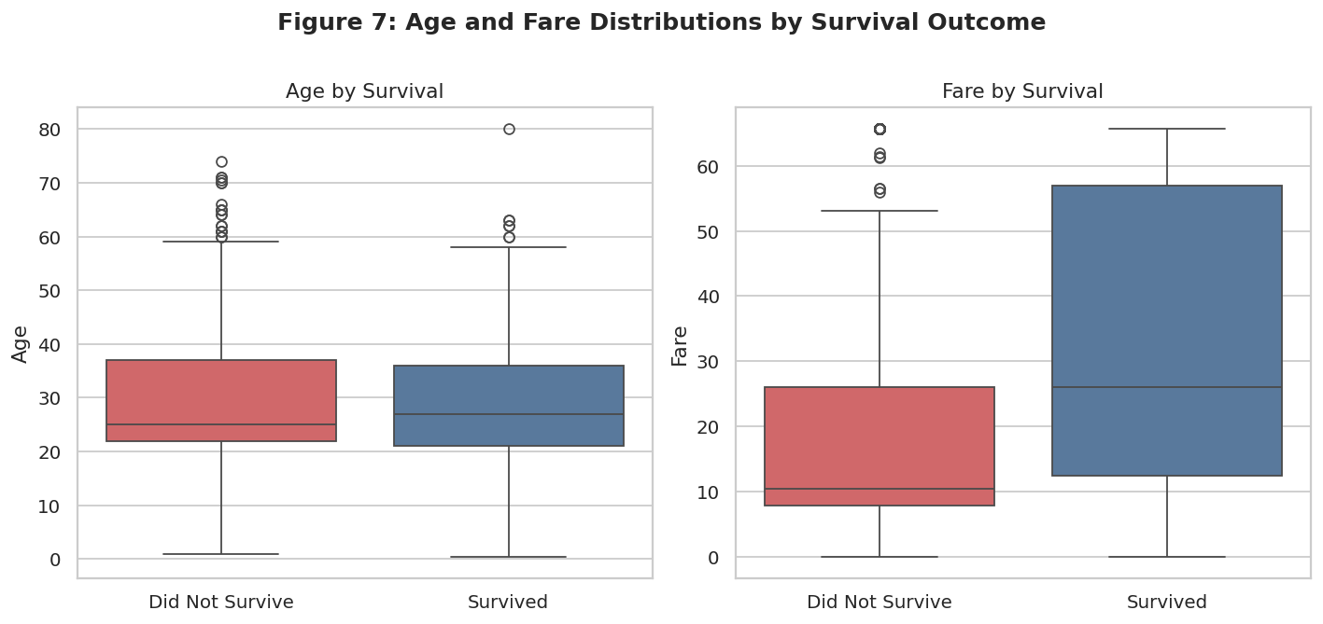
Figure 7: Age and Fare distributions compared across survival outcome.
Feature | Did Not Survive (mean ± std) | Survived (mean ± std)
Age (years) | 29.74 ± 12.82 (median 25) | 28.11 ± 14.01 (median 27)
Fare | 18.92 ± 17.12 (median 10.50) | 32.28 ± 22.66 (median 26.00)
Table 3: Group-level statistics for Age and Fare by survival outcome.
The Age boxplot confirms the near-identical medians and spreads seen in Figure 5 — age has limited discriminative value on its own. Fare tells a very different story: survivors paid a median fare of 26.00 versus 10.50 for non-survivors, and the entire survivor box sits visibly higher. Since fare is closely tied to class (higher fares bought 1st and 2nd class tickets), this is best read as the fare distribution carrying much of the same signal as ticket class — passengers who paid more tended to be berthed and evacuated under more favorable conditions.

7.5 Fare Distribution by Outcome
sns.histplot(data=df, x='Fare', hue='SurvivedLabel',
kde=True, element='step')
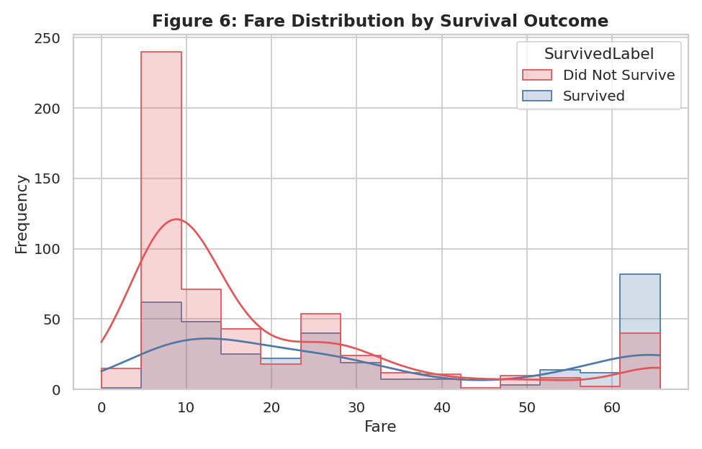
Figure 6: Fare distribution, split by survival outcome (note the cap at 65.63).
Both groups show the sharp right-hand cutoff at 65.63 described in Section 4.1 — the capping affects survivors and non-survivors alike, so it does not distort the comparison between groups, though it does compress what would otherwise be an even more strongly right-skewed distribution for the (mostly 1st class) high-fare survivors.

7.6 Age vs. Fare, by Outcome and Class
sns.scatterplot(data=df, x='Age', y='Fare',
hue='SurvivedLabel', style='Pclass')
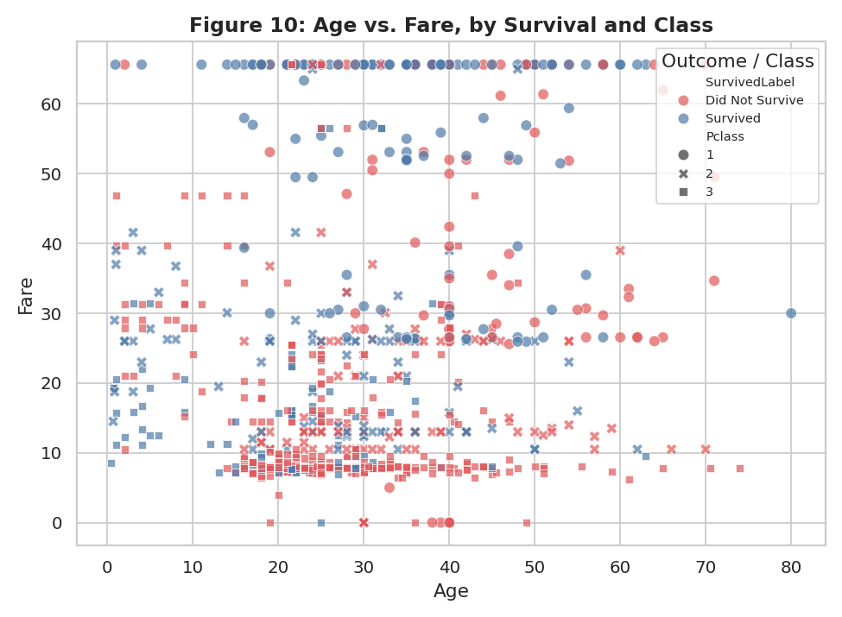
Figure 10: Age vs. Fare, colored by survival outcome and styled by class.
This combined view shows that survivors (blue) are concentrated in the upper portion of the fare axis across most ages, while non-survivors (red) dominate the low-fare band. The class markers confirm that the low-fare band is overwhelmingly 3rd class, and the higher-fare band is a mix of 1st and 2nd class — visually reinforcing that fare, class, and survival move together rather than independently.

7.7 Family Size and Survival
fam_rate = df.groupby('FamilySize')['Survived'].mean() * 100
ax.bar(fam_rate.index.astype(str), fam_rate.values)
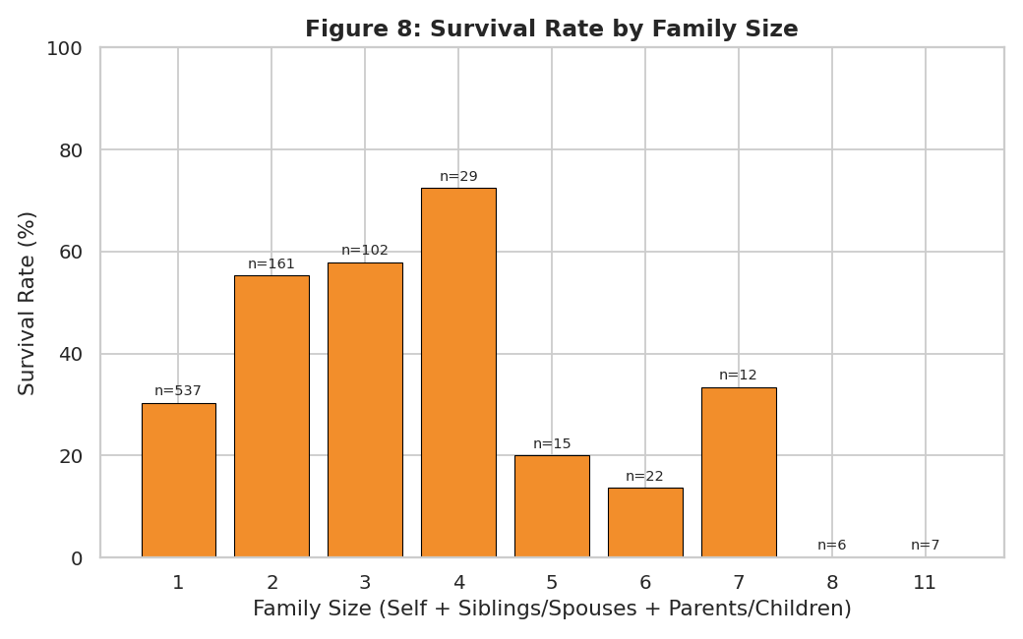
Figure 8: Survival rate by family size (including the passenger).
Traveling completely alone (FamilySize = 1, n = 537) corresponds to a survival rate of just 30.4%, while small families of 2–4 members survived at notably higher rates — peaking at 72.4% for families of 4 (n = 29). Survival rates drop off sharply again for larger families of 5 or more, several of which show 0–20% survival. A plausible explanation is that solo travelers were disproportionately 3rd class young men, small families could coordinate and access lifeboats together, and very large families struggled to stay together and board as a group during a chaotic evacuation — though the largest-family groups also have small sample sizes (n = 6–15), so those specific rates should be read cautiously.

7.8 Survival by Title
title_rate = df.groupby('Title')['Survived'].mean()
.sort_values(ascending=False) * 100
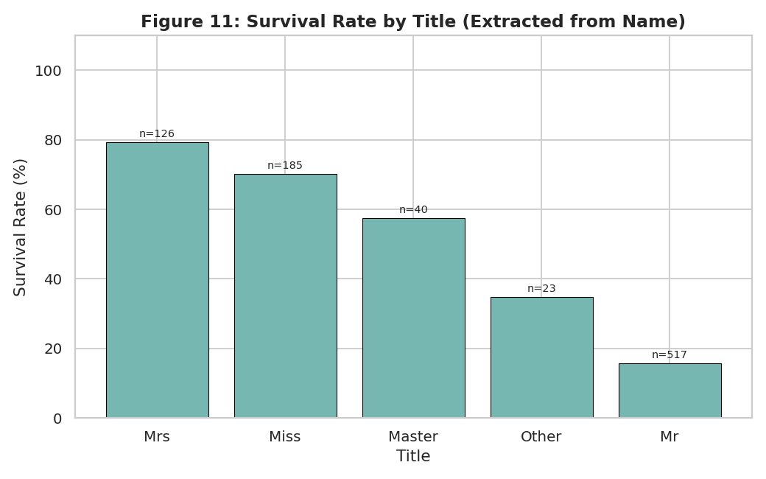
Figure 11: Survival rate by title extracted from passenger name.
The engineered Title feature sharpens the sex and age signals into one variable. “Mrs” and “Miss” (adult and young women) show the highest survival rates, “Master” (boys) shows a markedly higher rate than “Mr” (adult men), and “Mr” shows the lowest survival rate of any group. This single categorical feature captures much of the combined effect of sex and age-based evacuation priority in a form that could be directly useful for classification modeling.

8. Correlation Analysis
cols = ['Survived','Pclass','Age','SibSp',
'Parch','Fare','FamilySize']
sns.heatmap(df[cols].corr(), annot=True,
cmap='coolwarm', center=0)
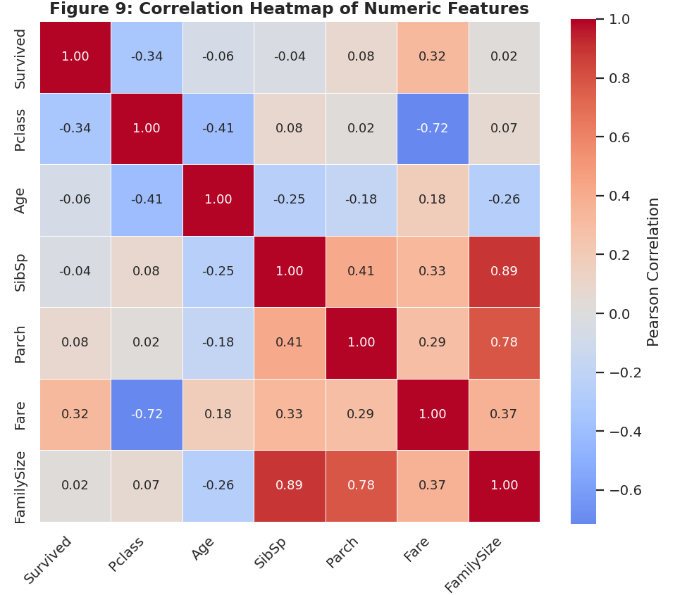
Figure 9: Correlation heatmap of numeric features, including Survived.
Among the numeric features, Pclass shows the strongest linear relationship with Survived (r = -0.34; recall lower Pclass numbers mean higher class, so this negative correlation means higher class → higher survival), followed by Fare (r = 0.32, positive, consistent with Section 7.4). Age (r = -0.06), Parch (r = 0.08), and FamilySize (r = 0.02) show only weak linear association individually — not because these variables are irrelevant (Section 7.7 showed FamilySize has a clear non-linear relationship with survival), but because Pearson correlation only captures straight-line relationships, and family size's effect on survival is better described as “moderate is better than either extreme” rather than a simple increasing or decreasing trend.
The heatmap also reveals a strong negative correlation between Pclass and Fare (r = -0.72, expected, since higher class tickets cost more) and, unsurprisingly, a strong positive correlation between SibSp, Parch, and FamilySize (r = 0.89 and 0.78 respectively, since FamilySize is derived directly from the other two). Any predictive model built on this data should avoid including SibSp, Parch, and FamilySize all together without addressing this redundancy.

9. Outlier Detection
q1, q3 = df[col].quantile(0.25), df[col].quantile(0.75)
iqr = q3 - q1
lower, upper = q1 - 1.5*iqr, q3 + 1.5*iqr
outliers = ((df[col] < lower) | (df[col] > upper)).sum()
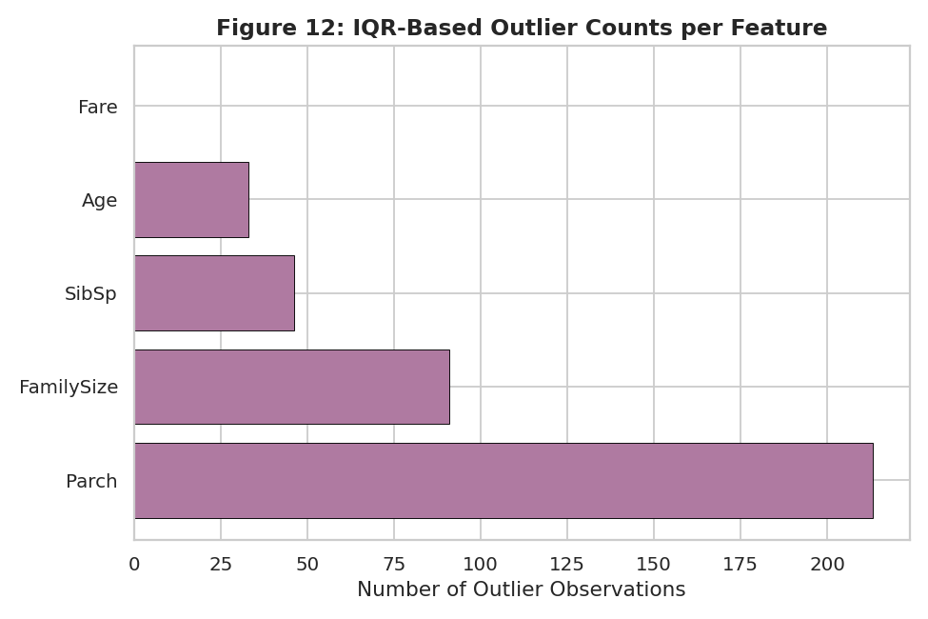
Figure 12: Count of IQR-based outliers for each numeric feature.
Parch shows by far the most statistical outliers (213 of 891 rows, roughly 24%) — a direct consequence of its heavily skewed, mostly-zero distribution, where any nonzero value falls outside a tight interquartile range built almost entirely from zeros. FamilySize (91) and SibSp (46) show a similar pattern for the same reason. Age has a moderate 33 outliers, mostly very young children and passengers in their 60s–80s. Fare shows zero IQR-flagged outliers — not because fares are naturally uniform, but because the capping identified in Section 4.1 already removed the extreme high values that would otherwise dominate this count. This is a good illustration of why outlier statistics should always be interpreted alongside a data-cleaning history rather than taken at face value.

10. Data Transformations and Aggregations Summary
The following transformations were applied during this analysis, and are listed here for transparency:
- Fingerprint detection: value-frequency checks on Fare and Age were used to detect prior capping and imputation, without altering the underlying data.
- Title extraction: a regular expression pulled the honorific out of each passenger's Name field, with rare titles consolidated into an “Other” category.
- Feature construction: FamilySize (SibSp + Parch + 1) and IsAlone (FamilySize == 1) were derived to test family-related survival patterns directly.
- Grouped aggregation: df.groupby() was used extensively — by Sex, Pclass, Pclass and Sex together, FamilySize, and Title — to compute the survival rates summarized in Sections 6–7.
- IQR outlier flagging: quartiles and the interquartile range were computed per numeric feature to identify and count statistical outliers, without removing any records from the working dataset.

11. Key Insights
- Sex is the single strongest predictor of survival in this dataset: women survived at 74.2% versus 18.9% for men, a 55-point gap consistent with a “women and children first” evacuation policy.
- Passenger class shows a clean, monotonic relationship with survival (63.0% / 47.3% / 24.2% for 1st / 2nd / 3rd class), and compounds with sex rather than replacing it — 3rd class women (50.0%) still outsurvived 1st class men (36.9%).
- Fare and class carry overlapping signal (r = -0.72 between them); fare correlates with survival (r = 0.32) largely because it is a proxy for class and cabin location, not an independent cause.
- Family size has a non-linear relationship with survival: solo travelers (30.4%) and very large families (often under 20%) fared worse than small family groups of 2–4 (55–72%), suggesting a coordination advantage for small groups that neither extreme shared.
- Age alone is a weak predictor overall (r = -0.06) apart from a modest survival advantage for young children, but becomes much more informative when combined with sex through the engineered Title feature.
- The supplied dataset shows clear evidence of prior cleaning — fare capping at 65.6344 (116 records) and age imputation spikes at 25.0 and 21.5 (159 records combined) — which affects how outlier counts and tail behavior should be interpreted, particularly for Fare.

12. Conclusion
This EDA shows that survival aboard the Titanic was shaped overwhelmingly by two structural factors — sex and passenger class — with fare acting largely as a proxy for class, and family size and age contributing smaller, more nuanced effects. The analysis also surfaced practical data-quality considerations for any follow-on modeling: strong collinearity between Fare and Pclass, between SibSp/Parch and the engineered FamilySize, a moderate class imbalance in the target variable, and pre-existing outlier capping that already suppresses the extreme tail of the Fare distribution. Together, the univariate, bivariate, multivariate, correlation, and outlier analyses in this report provide a solid, evidence-based foundation for any subsequent predictive modeling or further historical investigation.

13. Tools and Reproducibility
All statistics and figures in this report were generated with a single Python script using pandas, NumPy, Matplotlib, and Seaborn, reading directly from the supplied Titanic_cleaned.csv file. This makes the entire analysis fully reproducible: running the script regenerates every table and figure exactly as shown above.

