WEEK 1 TASK REPORT
Data Acquisition, Cleaning, and Preprocessing
Dataset: Titanic Passenger Dataset
Prepared using Python, Pandas, NumPy and Matplotlib
Dataset file analyzed: Titanic-Dataset-selected-columns.csv

Objective: To demonstrate the acquisition, exploration, cleaning and preprocessing of a public dataset, with special attention to missing values, inconsistent entries and outliers.

1. Introduction
Data preprocessing is an important stage of a data analytics or machine-learning workflow. Raw datasets may contain missing values, duplicate records, inconsistent text, incorrect data types, or extreme observations. If these issues are ignored, later analysis can produce misleading results. This report documents the complete Week 1 data acquisition, cleaning and preprocessing process performed on a selected-column version of the Titanic passenger dataset.
The supplied CSV contains 891 passenger records and 10 columns. The analysis focuses on understanding the structure of the data, measuring its quality, treating missing Age values, investigating potential outliers, validating numerical ranges, standardizing text fields, and preparing a model-ready version.

2. Objectives
- Acquire and inspect a publicly available Titanic dataset.
- Understand the dataset structure, variables, data types and distributions.
- Identify missing values and choose an appropriate imputation strategy.
- Check for duplicate, invalid and inconsistent records.
- Detect numerical outliers using the Interquartile Range (IQR) method.
- Distinguish genuine extreme observations from possible errors instead of deleting values blindly.
- Prepare a clean dataset and a model-ready dataset.
- Discuss how preprocessing decisions can affect later analysis.

3. Dataset and Data Collection Method
The dataset used in this report is the classic Titanic training dataset. The supplied CSV contains the same 891 training passengers used in the Kaggle Titanic competition, but only 10 selected columns are included. Kaggle describes the training data as containing 891 passengers with survival outcomes.
Public source: Kaggle – Titanic: Machine Learning from Disaster
Source: https://www.kaggle.com/competitions/titanic/overview
Data collection method: The dataset was obtained as a CSV file and supplied for analysis. The CSV was imported into Python using Pandas.
import pandas as pd
df = pd.read_csv("Titanic-Dataset-selected-columns.csv")
print(df.shape)
print(df.head())
The resulting shape is 891 rows × 10 columns. The columns are PassengerId, Survived, Pclass, Name, Sex, Age, SibSp, Parch, Ticket and Fare.

4. Tools and Technologies
Tool/Library | Purpose
Python | Programming and data-processing environment
Pandas | Reading, inspecting and transforming tabular data
NumPy | Numerical calculations and array operations
Matplotlib | Charts and visual inspection of data quality
python-docx | Generating the final DOCX report
Pandas was the main library used for data loading, missing-value handling, duplicate checking and data transformation. NumPy supported numerical operations, while Matplotlib was used to create visual evidence for the report.

5. Initial Data Exploration

5.1 First Five Records
print(df.head())
PassengerId | Survived | Pclass | Name | Sex | Age | SibSp | Parch | Ticket | Fare
1 | 0 | 3 | Braund, Mr. Owen Harris | male | 22.0 | 1 | 0 | A/5 21171 | 7.25
2 | 1 | 1 | Cumings, Mrs. John Bradley (Florence Briggs Thayer) | female | 38.0 | 1 | 0 | PC 17599 | 71.2833
3 | 1 | 3 | Heikkinen, Miss. Laina | female | 26.0 | 0 | 0 | STON/O2. 3101282 | 7.925
4 | 1 | 1 | Futrelle, Mrs. Jacques Heath (Lily May Peel) | female | 35.0 | 1 | 0 | 113803 | 53.1
5 | 0 | 3 | Allen, Mr. William Henry | male | 35.0 | 0 | 0 | 373450 | 8.05

5.2 Dataset Shape
print(df.shape)
Output: (891, 10). This means the dataset contains 891 rows and 10 columns.

5.3 Data Types and Non-Null Counts
print(df.info())
The dataset contains integer, floating-point and object/string columns. Age is the only column with missing values in the supplied file.

5.4 Statistical Summary
print(df.describe())
Column | count | mean | std | min | 25% | 50% | 75% | max
PassengerId | 891.0 | 446.0 | 257.35 | 1.0 | 223.5 | 446.0 | 668.5 | 891.0
Survived | 891.0 | 0.38 | 0.49 | 0.0 | 0.0 | 0.0 | 1.0 | 1.0
Pclass | 891.0 | 2.31 | 0.84 | 1.0 | 2.0 | 3.0 | 3.0 | 3.0
Age | 714.0 | 29.7 | 14.53 | 0.42 | 20.12 | 28.0 | 38.0 | 80.0
SibSp | 891.0 | 0.52 | 1.1 | 0.0 | 0.0 | 0.0 | 1.0 | 8.0
Parch | 891.0 | 0.38 | 0.81 | 0.0 | 0.0 | 0.0 | 0.0 | 6.0
Fare | 891.0 | 32.2 | 49.69 | 0.0 | 7.91 | 14.45 | 31.0 | 512.33

5.5 Initial Data Quality Summary
Column | Data Type | Missing | Unique Values
PassengerId | int64 | 0 | 891
Survived | int64 | 0 | 2
Pclass | int64 | 0 | 3
Name | object | 0 | 891
Sex | object | 0 | 2
Age | float64 | 177 | 88
SibSp | int64 | 0 | 7
Parch | int64 | 0 | 7
Ticket | object | 0 | 681
Fare | float64 | 0 | 248

6. Missing Value Analysis and Treatment
The initial inspection found 177 missing values in Age. This represents 19.87% of the dataset. No other column contains missing values.
missing = df.isnull().sum()
print(missing)
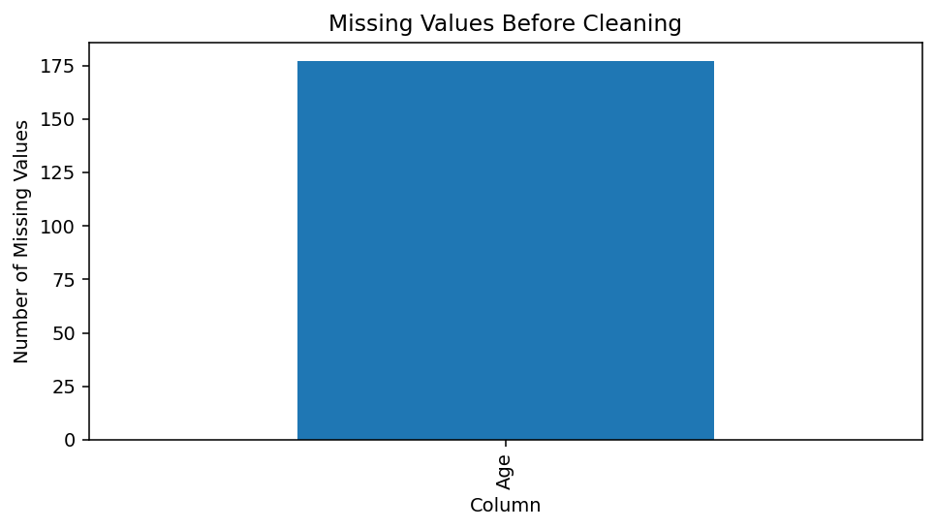
Figure 1. Missing values in the original dataset.

6.1 Why Age Was Imputed
Deleting all 177 rows would reduce the dataset and could remove useful passenger information. Age is also an important demographic variable. Therefore, the missing values were imputed rather than dropping the affected records.
A grouped median strategy was selected: the median Age was calculated within each combination of Sex and Pclass. This is more informative than using one overall median because passenger age patterns can differ across passenger classes and sexes. A global median was retained as a fallback.
group_medians = df.groupby(["Sex", "Pclass"])["Age"].transform("median")
df["Age"] = df["Age"].fillna(group_medians)
df["Age"] = df["Age"].fillna(df["Age"].median())
After imputation, missing Age values reduced from 177 to 0.
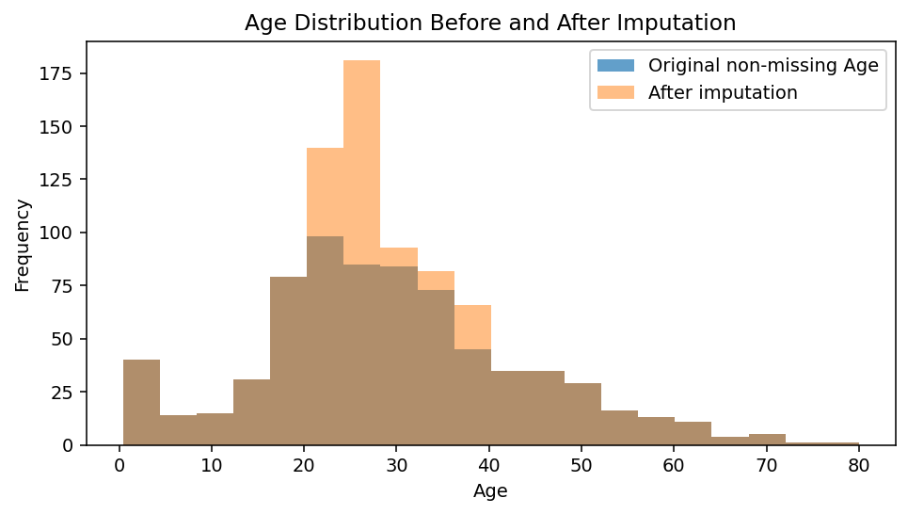
Figure 2. Age distribution before and after imputation.

7. Duplicate and Erroneous Entry Checks

7.1 Duplicate Rows
print(df.duplicated().sum())
The check identified 0 exact duplicate rows. Therefore, no rows had to be removed for duplication.

7.2 Numerical Range Validation
print((df["Age"] < 0).sum())
print((df["Fare"] < 0).sum())
print((df["SibSp"] < 0).sum())
print((df["Parch"] < 0).sum())
Age values ranged from 0.42 to 80.00, with no negative or impossible age values detected. Fare had no negative values. SibSp and Parch also had no negative values.
The maximum Age of 80 is unusual but plausible. Likewise, higher family counts in SibSp and Parch are possible passenger circumstances and are not automatically data-entry errors. These values were therefore not deleted simply because they were statistically unusual.

7.3 Text Consistency
df["Sex"] = df["Sex"].astype(str).str.strip().str.lower()
df["Name"] = df["Name"].astype(str).str.strip()
df["Ticket"] = df["Ticket"].astype(str).str.strip()
Whitespace was removed and the Sex field was normalized to lowercase. This prevents simple formatting differences from creating multiple categories during later analysis.

8. Outlier Detection and Treatment
Outliers were investigated using the Interquartile Range (IQR) method. The IQR is calculated as Q3 − Q1. Values below Q1 − 1.5×IQR or above Q3 + 1.5×IQR are flagged as statistical outliers.
Q1 = df["Fare"].quantile(0.25)
Q3 = df["Fare"].quantile(0.75)
IQR = Q3 - Q1
lower = Q1 - 1.5 * IQR
upper = Q3 + 1.5 * IQR
outliers = df[(df["Fare"] < lower) | (df["Fare"] > upper)]
print(len(outliers))
For Fare, the IQR method identified 116 observations above the upper IQR boundary (the lower boundary was below zero and therefore was not meaningful for a non-negative fare variable).
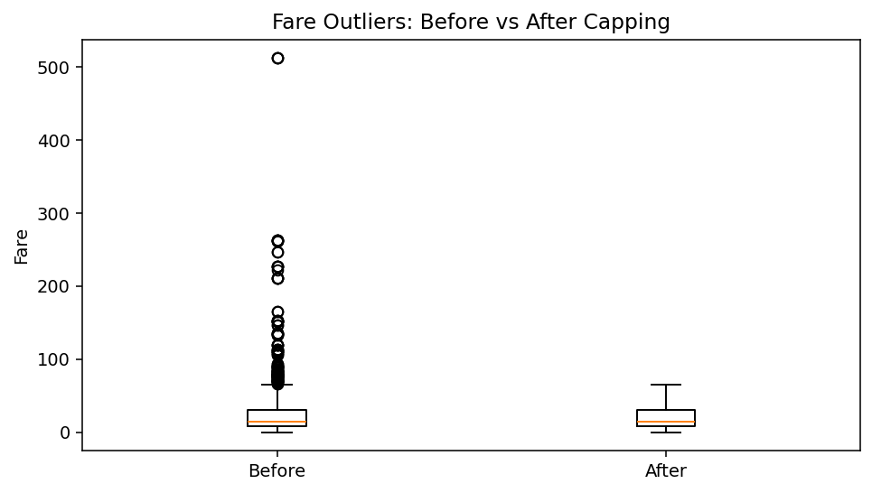
Figure 3. Fare outliers before and after IQR capping.

8.1 Outlier Treatment Decision
Instead of deleting the high-fare observations, the Fare values were capped at the IQR upper boundary of approximately 65.63. This preserves the passenger records while reducing the influence of extreme fares in analyses that are sensitive to large numerical values.
fare_upper = Q3 + 1.5 * IQR
df["Fare"] = df["Fare"].clip(lower=0, upper=fare_upper)
Important: IQR flags statistical unusualness, not necessarily an error. For this reason, the high values in SibSp and Parch were reviewed and retained because large family groups can be legitimate.

9. Data Preprocessing

9.1 Removing Unnecessary Identifiers
PassengerId is a unique identifier. It is useful for tracking records but should generally not be treated as a predictive numerical feature because its magnitude has no meaningful relationship with survival.
Name and Ticket are retained in the cleaned dataset for traceability, although they would normally require feature engineering or exclusion before a simple machine-learning model.

9.2 Encoding Categorical Data
model_ready["Sex"] = model_ready["Sex"].map({
"male": 0,
"female": 1
}).astype("int64")
The Sex variable was converted into binary numerical form: male = 0 and female = 1. This makes the field usable by algorithms that require numerical input.

9.3 Feature Scaling
for col in ["Age", "Fare", "SibSp", "Parch"]:
model_ready[col] = (
model_ready[col] - model_ready[col].mean()
) / model_ready[col].std(ddof=0)
Standardization converts selected numerical features to a common scale with approximately zero mean and unit standard deviation. Scaling can be useful for distance-based or gradient-based algorithms.

10. Before vs After Cleaning
Metric | Before | After
Rows | 891 | 891
Columns | 10 | 10
Missing Age | 177 | 0
Duplicate Rows | 0 | 0
Fare IQR Outliers | 116 | 0
Missing Values After Cleaning | 177 | 0
The main improvement is that the missing Age values were eliminated while retaining all 891 passenger records. Duplicate rows were already absent. Fare extremes were capped rather than deleted. The resulting cleaned dataset is therefore complete for the selected variables and preserves the original passenger population.

11. Basic Data Understanding After Cleaning
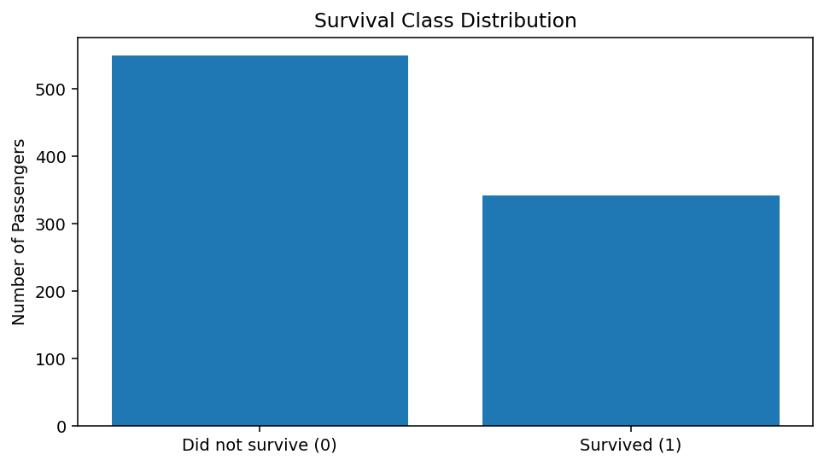
Figure 4. Distribution of the target variable Survived.
The dataset contains 549 passengers who did not survive and 342 passengers who survived. The survival rate is 38.38%.

12. Consolidated Python Code
import pandas as pd
import numpy as np
# Load data
df = pd.read_csv("Titanic-Dataset-selected-columns.csv")
# Initial exploration
print(df.head())
print(df.shape)
print(df.info())
print(df.describe())
print(df.isnull().sum())
# Duplicate check
df = df.drop_duplicates()
# Validate values
print("Invalid age:", ((df["Age"] < 0) | (df["Age"] > 100)).sum())
print("Invalid fare:", (df["Fare"] < 0).sum())
# Impute missing Age using Sex + Pclass median
group_medians = df.groupby(["Sex", "Pclass"])["Age"].transform("median")
df["Age"] = df["Age"].fillna(group_medians)
df["Age"] = df["Age"].fillna(df["Age"].median())
# Standardize text
df["Sex"] = df["Sex"].astype(str).str.strip().str.lower()
df["Name"] = df["Name"].astype(str).str.strip()
df["Ticket"] = df["Ticket"].astype(str).str.strip()
# IQR outlier treatment for Fare
Q1 = df["Fare"].quantile(0.25)
Q3 = df["Fare"].quantile(0.75)
IQR = Q3 - Q1
upper = Q3 + 1.5 * IQR
df["Fare"] = df["Fare"].clip(lower=0, upper=upper)
# Save cleaned dataset
df.to_csv("Titanic_cleaned.csv", index=False)
# Model-ready data
model_ready = df.copy()
model_ready["Sex"] = model_ready["Sex"].map({"male": 0, "female": 1})
for col in ["Age", "Fare", "SibSp", "Parch"]:
model_ready[col] = (
model_ready[col] - model_ready[col].mean()
) / model_ready[col].std(ddof=0)
model_ready.to_csv("Titanic_model_ready.csv", index=False)

13. Challenges Faced and Solutions
Challenge | Solution
Missing Age values | Used median imputation grouped by Sex and Pclass.
Statistical outliers in Fare | Used IQR analysis and capped extreme Fare values instead of deleting records.
Unusual but valid family-size values | Reviewed values semantically and retained them because they can represent real families.
Categorical Sex field | Normalized text and encoded Sex as 0/1 in the model-ready dataset.
Identifier columns | Kept identifiers for traceability but avoided treating PassengerId as a predictive measurement.

14. Potential Impact of Preprocessing on Subsequent Analysis
- Imputing Age prevents the loss of 177 passenger records and allows Age-based analysis to continue.
- Median imputation is less sensitive to extreme values than mean imputation, although it can reduce natural variability.
- Fare capping reduces the influence of extremely expensive tickets and can make some statistical or machine-learning methods more stable.
- Keeping legitimate extreme family-size values avoids introducing artificial information loss.
- Encoding Sex allows numerical algorithms to use the variable, but the chosen encoding should be interpreted as a category rather than a continuous quantity.
- Feature scaling prevents variables with larger numeric ranges from dominating distance-based methods.
- Preprocessing can change distributions, so a researcher should always document the original and transformed versions.

15. Reflective Commentary
The most important lesson from this task is that data cleaning is not simply a process of deleting unusual values. Every change should have a reason. For example, the IQR method flags high SibSp and Parch values, but those values can be genuine family relationships. Automatically deleting them would remove valid information. Similarly, missing Age values were imputed rather than removing records because preserving the sample size was useful.
The preprocessing strategy therefore balances statistical rules with domain understanding. The final data is more consistent and complete, but the report keeps a clear record of what was changed so that later analysts can understand the assumptions.

16. Conclusion
The Week 1 task was completed using the supplied Titanic passenger dataset. The dataset was inspected using Pandas, and its dimensions, data types, statistical summaries and missing values were documented. The main data quality issue was missing Age data, which was handled using grouped median imputation. Duplicate and invalid-value checks found no duplicate records or negative numerical values. Outliers were examined using the IQR method, and extreme Fare values were capped while legitimate family-size observations were retained. Text fields were standardized, Sex was encoded, and selected numerical features were standardized in a model-ready copy.
The resulting cleaned files are suitable for further exploratory analysis and can also serve as a starting point for machine-learning experiments, provided that future modeling work applies train/test separation and fits preprocessing parameters only on the training data.

17. References
1. Kaggle, “Titanic – Machine Learning from Disaster,” Titanic competition dataset.
https://www.kaggle.com/competitions/titanic/overview
2. Pandas documentation – Python Data Analysis Library.
https://pandas.pydata.org/docs/
3. NumPy documentation – Numerical Python.
https://numpy.org/doc/
4. Matplotlib documentation – Visualization with Python.
https://matplotlib.org/stable/

18. Appendix: Dataset Snapshot
PassengerId | Survived | Pclass | Name | Sex | Age | SibSp | Parch | Ticket | Fare
1 | 0 | 3 | Braund, Mr. Owen Harris | male | 22.0 | 1 | 0 | A/5 21171 | 7.25
2 | 1 | 1 | Cumings, Mrs. John Bradley (Florence Briggs Thayer) | female | 38.0 | 1 | 0 | PC 17599 | 65.6344
3 | 1 | 3 | Heikkinen, Miss. Laina | female | 26.0 | 0 | 0 | STON/O2. 3101282 | 7.925
4 | 1 | 1 | Futrelle, Mrs. Jacques Heath (Lily May Peel) | female | 35.0 | 1 | 0 | 113803 | 53.1
5 | 0 | 3 | Allen, Mr. William Henry | male | 35.0 | 0 | 0 | 373450 | 8.05
6 | 0 | 3 | Moran, Mr. James | male | 25.0 | 0 | 0 | 330877 | 8.4583
7 | 0 | 1 | McCarthy, Mr. Timothy J | male | 54.0 | 0 | 0 | 17463 | 51.8625
8 | 0 | 3 | Palsson, Master. Gosta Leonard | male | 2.0 | 3 | 1 | 349909 | 21.075
9 | 1 | 3 | Johnson, Mrs. Oscar W (Elisabeth Vilhelmina Berg) | female | 27.0 | 0 | 2 | 347742 | 11.1333
10 | 1 | 2 | Nasser, Mrs. Nicholas (Adele Achem) | female | 14.0 | 1 | 0 | 237736 | 30.0708
The table above is a sample of the cleaned dataset. The complete cleaned dataset is provided separately as Titanic_cleaned.csv, along with Titanic_model_ready.csv for numerical preprocessing.

