Unsupervised Learning and Clustering Analysis
Segmenting Wine Samples by Chemical Composition
Week 3 Task — Clustering Report

1. Introduction and Objective
This report applies unsupervised learning — specifically clustering — to segment a public dataset into meaningful groups without using any outcome label during training. The objective is to demonstrate a complete clustering workflow: preprocessing the data appropriately, selecting a defensible number of clusters, applying more than one clustering algorithm, visualizing the results, and producing a detailed, business-relevant interpretation of each resulting segment.
The dataset used is the Wine dataset, a well-known public dataset originally from the UCI Machine Learning Repository, containing the results of a chemical analysis of wines grown in the same region of Italy but derived from three different cultivars. It was selected for this task because it offers exactly the conditions clustering is designed for: purely numeric, continuous features describing each sample, no missing values, and — critically for evaluation purposes — a known ground-truth grouping (the cultivar) that was deliberately withheld from the clustering algorithms and used only afterward, to independently validate how well the unsupervised segments recovered a real, meaningful structure in the data.
Every code snippet shown below is the exact code used to produce the accompanying statistics and figures, so the analysis can be reproduced end to end.

2. Dataset Description
The dataset contains 178 wine samples and 13 continuous chemical features measured for each: alcohol, malic acid, ash, alkalinity of ash, magnesium, total phenols, flavanoids, nonflavanoid phenols, proanthocyanins, color intensity, hue, the OD280/OD315 ratio of diluted wines (a measure of protein content via absorbance), and proline (an amino acid). A three-class cultivar label exists for the dataset but was set aside entirely during clustering and used only in Section 7 to validate the resulting clusters.
from sklearn.datasets import load_wine
import pandas as pd

data = load_wine()
df = pd.DataFrame(data.data, columns=data.feature_names)
true_labels = data.target # withheld from clustering,
# used only for validation
Code Snippet 1: Loading the dataset.
A null-value audit confirmed there are no missing values in any of the 13 features.

3. Methodology and Tools
The analysis was carried out in Python 3, using:
- Pandas / NumPy — data handling and numerical operations
- scikit-learn — StandardScaler, PCA, KMeans, AgglomerativeClustering, and clustering evaluation metrics
- SciPy — hierarchical linkage computation and dendrogram plotting
- Matplotlib / Seaborn — all visualizations
Two clustering algorithms were applied and compared: K-Means (a centroid-based, partitional method) and Agglomerative Hierarchical Clustering with Ward linkage (a bottom-up, distance-based method). Using two structurally different algorithms allows the final cluster structure to be cross-validated — if both methods converge on a similar grouping, that is much stronger evidence of genuine structure in the data than either method's result alone.

4. Data Preprocessing
The features in this dataset operate on very different scales — proline ranges from 278 to 1680, while nonflavanoid phenols ranges only from 0.13 to 0.66. Distance-based algorithms like K-Means and Ward-linkage hierarchical clustering compute similarity using Euclidean distance, so without rescaling, high-magnitude features like proline and magnesium would dominate the distance calculation and effectively decide the clusters on their own, while informative features like hue or flavanoids would be numerically drowned out.
from sklearn.preprocessing import StandardScaler

scaler = StandardScaler()
X_scaled = scaler.fit_transform(df)
# resulting features: mean ≈ 0, std ≈ 1
Code Snippet 2: Standardizing all features before clustering.
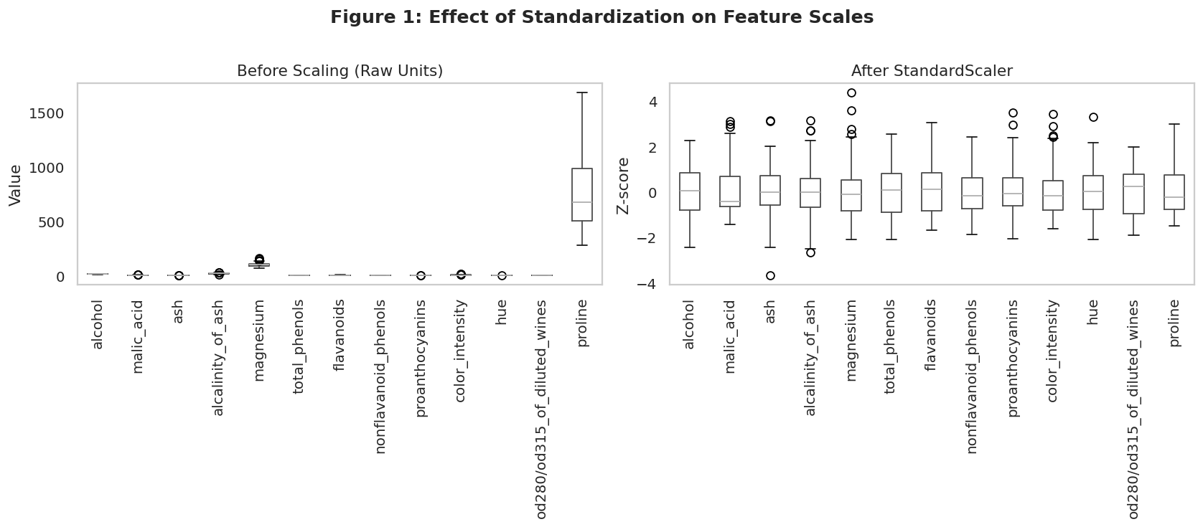
Figure 1: Feature scales before and after standardization.
Every feature was standardized using z-score scaling (StandardScaler), transforming each to a mean of 0 and a standard deviation of 1. Figure 1 shows the dramatic difference: before scaling, proline's box sits far above every other feature purely due to its raw units (milligrams per liter vs. small ratios or percentages); after scaling, every feature occupies a comparable range, so no single feature can dominate the distance computation purely by virtue of its measurement units. No further preprocessing (missing-value handling, encoding, deduplication) was necessary, since the dataset was already clean and entirely numeric.

5. Selecting the Number of Clusters
Choosing k is the most consequential decision in K-Means clustering. Two complementary, quantitative methods were used to select it, rather than picking a number arbitrarily.
from sklearn.cluster import KMeans
from sklearn.metrics import silhouette_score

for k in range(2, 11):
km = KMeans(n_clusters=k, init='k-means++',
n_init=10, random_state=42)
labels = km.fit_predict(X_scaled)
inertia = km.inertia_
sil = silhouette_score(X_scaled, labels)
Code Snippet 3: Sweeping k from 2 to 10 and recording inertia and silhouette score.
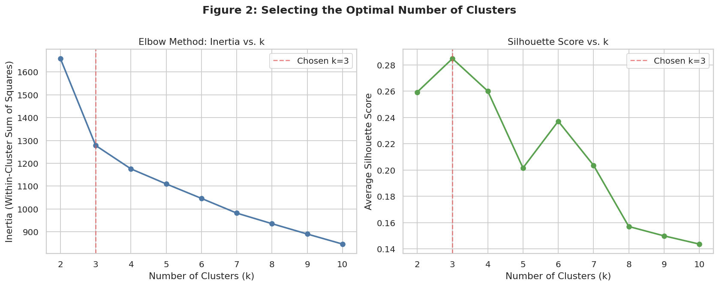
Figure 2: Elbow method (left) and silhouette score (right) across candidate values of k.
k | Inertia | Silhouette | Davies-Bouldin | Calinski-Harabasz
2 | 1658.8 | 0.259 | 1.526 | 69.5
3 | 1277.9 | 0.285 | 1.389 | 70.9
4 | 1175.4 | 0.260 | 1.797 | 56.2
5 | 1109.5 | 0.202 | 1.808 | 47.0
6 | 1046.0 | 0.237 | 1.554 | 41.7
Table 1: Cluster-quality metrics for k = 2 through 6 (full sweep ran to k = 10).
The elbow plot shows inertia (within-cluster sum of squared distances) dropping sharply from k=2 to k=3, then flattening into a much gentler, near-linear decline — the classic “elbow” shape that signals diminishing returns from adding further clusters beyond that point. The silhouette score, which independently measures how well-separated and internally cohesive the clusters are, is unambiguous: it peaks at k=3 (0.285) and declines for every larger k tested. Both methods agree on k=3, so it was adopted as the final number of clusters for both algorithms used in this report.

6. K-Means Clustering

6.1 Model Fitting
kmeans = KMeans(n_clusters=3, init='k-means++',
n_init=10, random_state=42)
km_labels = kmeans.fit_predict(X_scaled)
Code Snippet 4: Fitting the final K-Means model with k=3.
K-Means was configured with k=3, the k-means++ initialization strategy (which spreads out initial centroids to speed convergence and reduce the chance of a poor local optimum), and n_init=10 (ten independent initializations, keeping the best result by inertia) for stability. A fixed random_state ensures the result is reproducible.

6.2 Cluster Quality: Silhouette Analysis
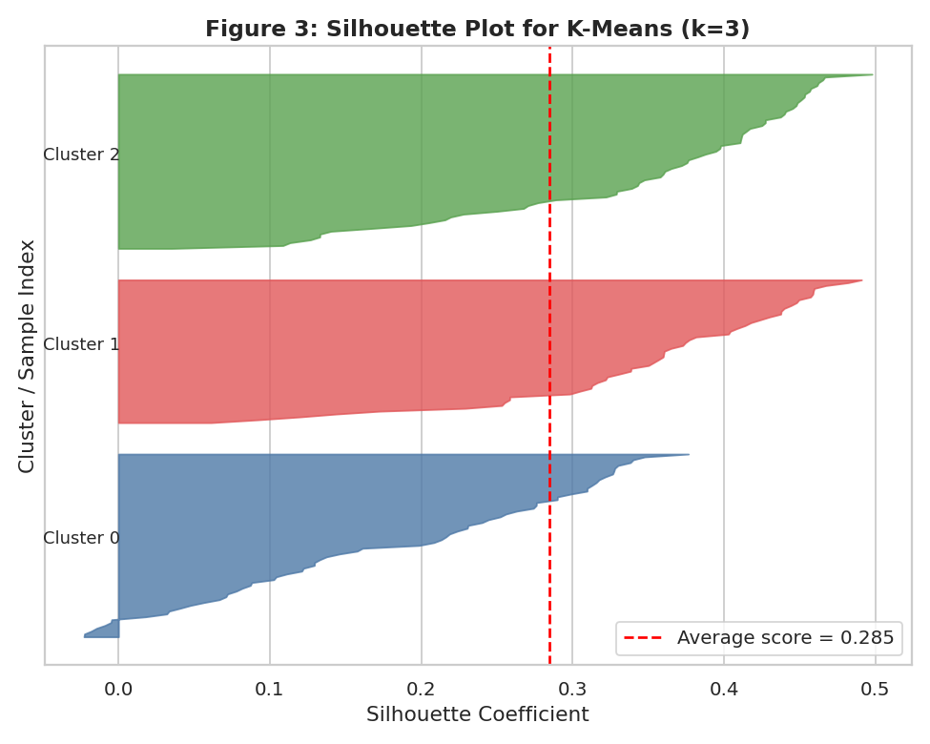
Figure 3: Per-sample silhouette plot for the k=3 K-Means solution.
The silhouette plot breaks the overall average silhouette score (0.285, marked by the red dashed line) down sample by sample within each cluster. All three clusters have the majority of their samples with positive silhouette values extending well beyond the average line, and none of the clusters shows a large block of negative values, which would indicate samples that are poorly matched to their assigned cluster. Cluster widths (bar thickness) are reasonably balanced, indicating no single cluster dominates the sample count disproportionately.

6.3 Visualizing Clusters with PCA
from sklearn.decomposition import PCA

pca = PCA(n_components=2, random_state=42)
X_pca = pca.fit_transform(X_scaled)
# explained variance: PC1 = 36.2%, PC2 = 19.2%
Code Snippet 5: Reducing 13 dimensions to 2 for visualization via PCA.
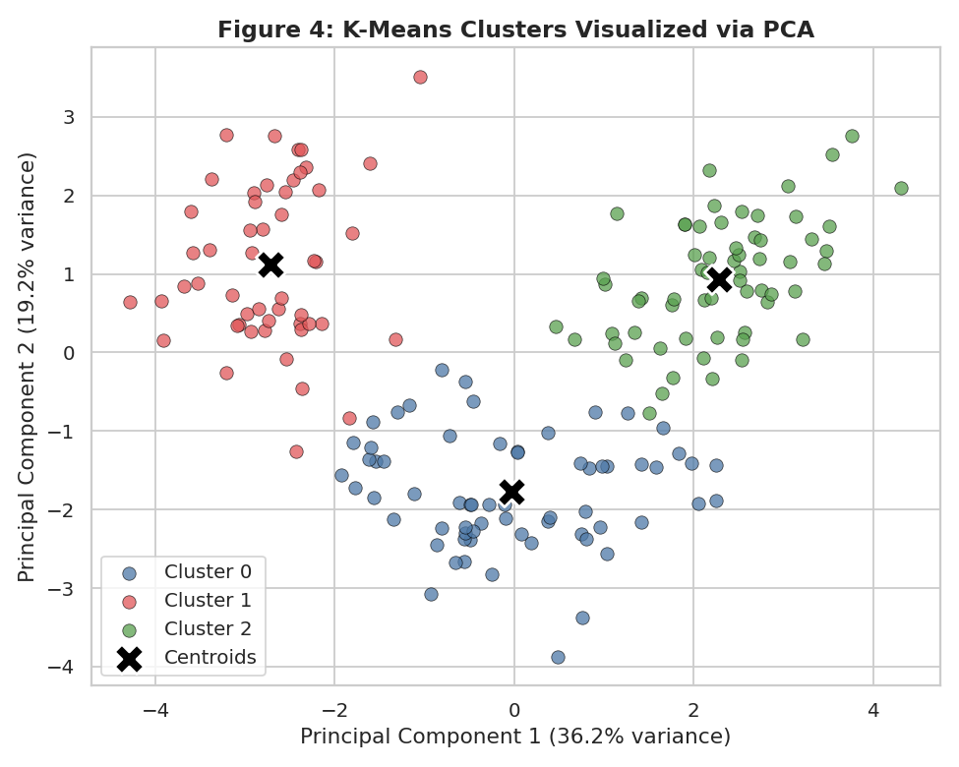
Figure 4: K-Means clusters projected onto the first two principal components (55.4% of total variance).
Since the data has 13 dimensions and cannot be plotted directly, Principal Component Analysis (PCA) was used purely for visualization — the clustering itself was performed on the full 13-dimensional standardized data, not on the 2D projection. The first two principal components capture 55.4% of the total variance (36.2% + 19.2%), enough to give a reasonably faithful 2D picture of the cluster structure. The plot shows three visually distinct, only lightly overlapping groups, with the black X markers showing each cluster's centroid projected into the same space. This visual separation is a strong qualitative confirmation of the quantitative silhouette result above.

7. Cluster Validation Against Ground Truth
Because the true cultivar for each wine sample is known (though it was not used during clustering), it provides an unusually direct way to check whether the unsupervised clusters found by K-Means correspond to a real, meaningful grouping rather than an arbitrary partition of the data.
from sklearn.metrics import adjusted_rand_score, confusion_matrix

ari = adjusted_rand_score(true_labels, km_labels)
cm = confusion_matrix(true_labels, km_labels)
Code Snippet 6: Comparing K-Means clusters to the withheld true cultivar labels.
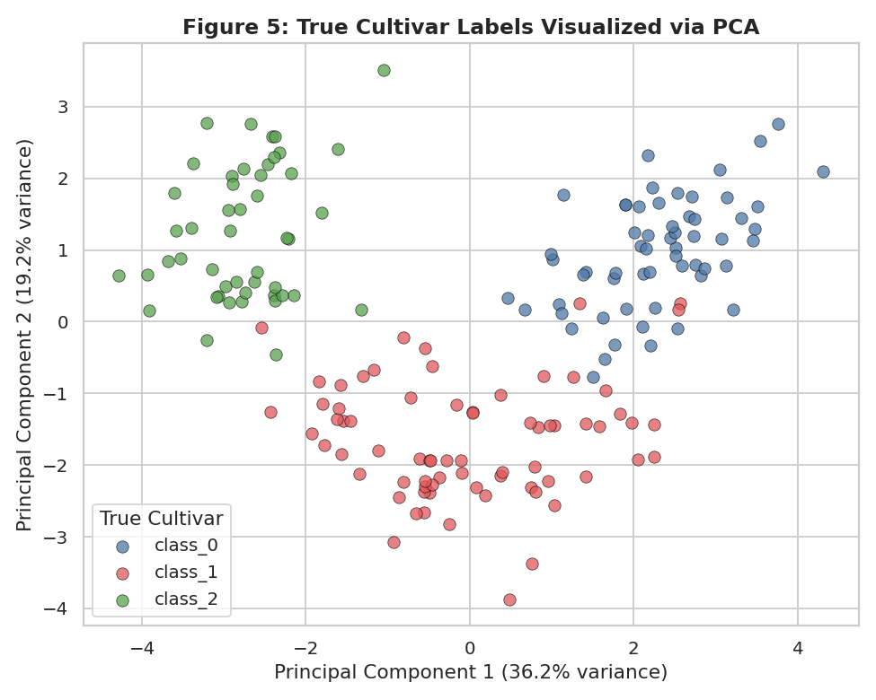
Figure 5: The same PCA projection, this time colored by the true (withheld) cultivar label.
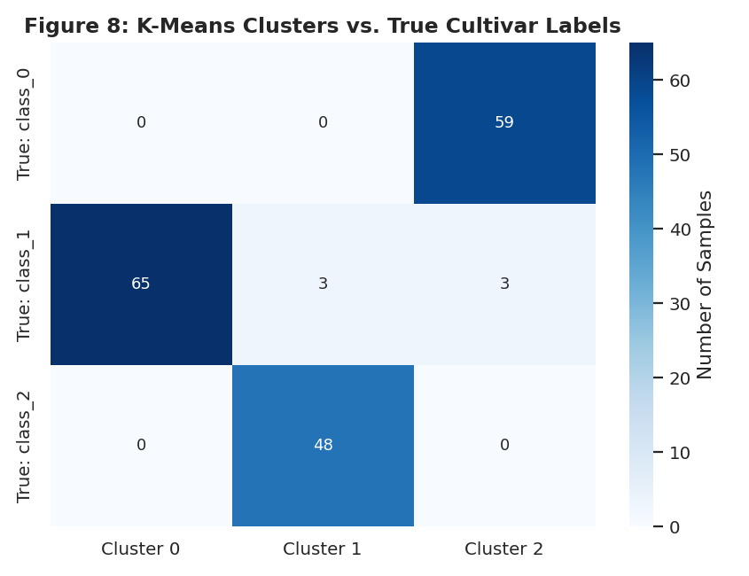
Figure 8: Contingency table of K-Means clusters against true cultivar labels.
Comparing Figure 4 (K-Means clusters) against Figure 5 (true cultivars) shows the same three groups occupying almost identical regions of the PCA plot. The contingency table in Figure 8 quantifies this precisely: of the 178 samples, 172 (96.6%) fall into a cluster that is overwhelmingly dominated by a single true cultivar, and only 6 samples (all from true cultivar class_1) were split into a different cluster than the rest of their group. The Adjusted Rand Index (ARI), which measures agreement between two labelings while correcting for chance, came out to 0.897 — a very high score, since 1.0 represents perfect agreement and 0.0 represents random labeling. This is strong quantitative evidence that K-Means, using only the 13 chemical measurements and no label information, rediscovered a grouping that corresponds closely to a real, independently verified distinction between wine cultivars.

8. Hierarchical Clustering (Comparison Method)
from scipy.cluster.hierarchy import dendrogram, linkage
from sklearn.cluster import AgglomerativeClustering

Z = linkage(X_scaled, method='ward')
agglo = AgglomerativeClustering(n_clusters=3, linkage='ward')
agglo_labels = agglo.fit_predict(X_scaled)
Code Snippet 7: Building the linkage matrix and fitting Agglomerative Clustering.
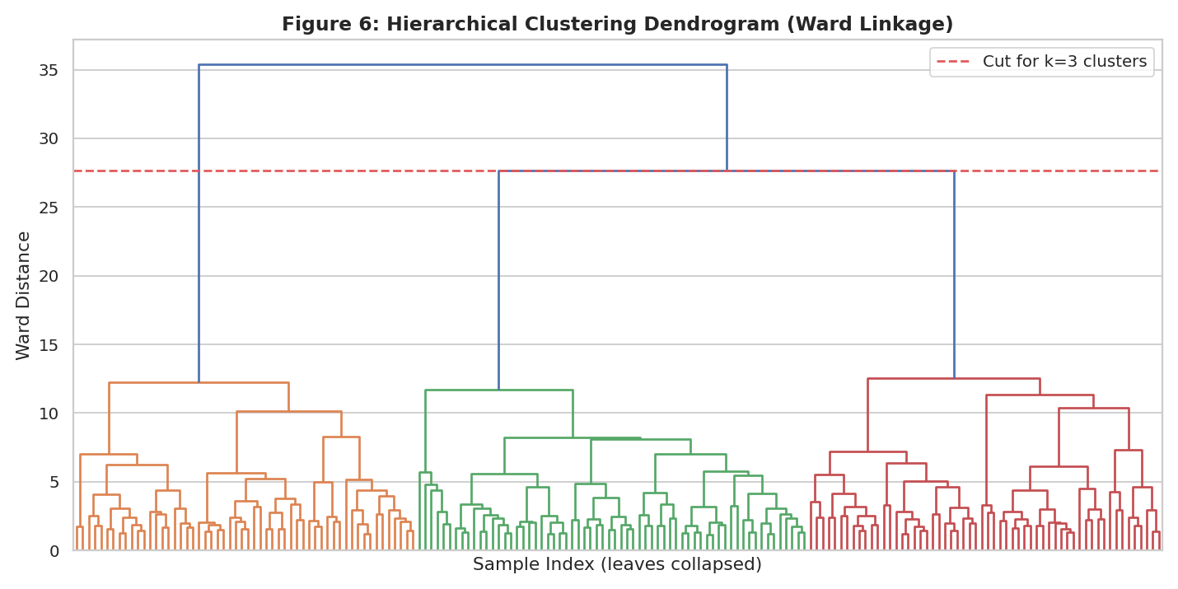
Figure 6: Hierarchical clustering dendrogram (Ward linkage); the dashed line marks the cut producing 3 clusters.
As a second, structurally different approach, Agglomerative Hierarchical Clustering with Ward linkage (which merges the pair of clusters at each step that minimizes the resulting increase in within-cluster variance) was applied to the same standardized data. The dendrogram shows three long, well-separated branches merging only at a much greater distance than the merges within each branch — visually corroborating the k=3 decision from an entirely different algorithmic starting point, without reference to the elbow or silhouette analysis used for K-Means.
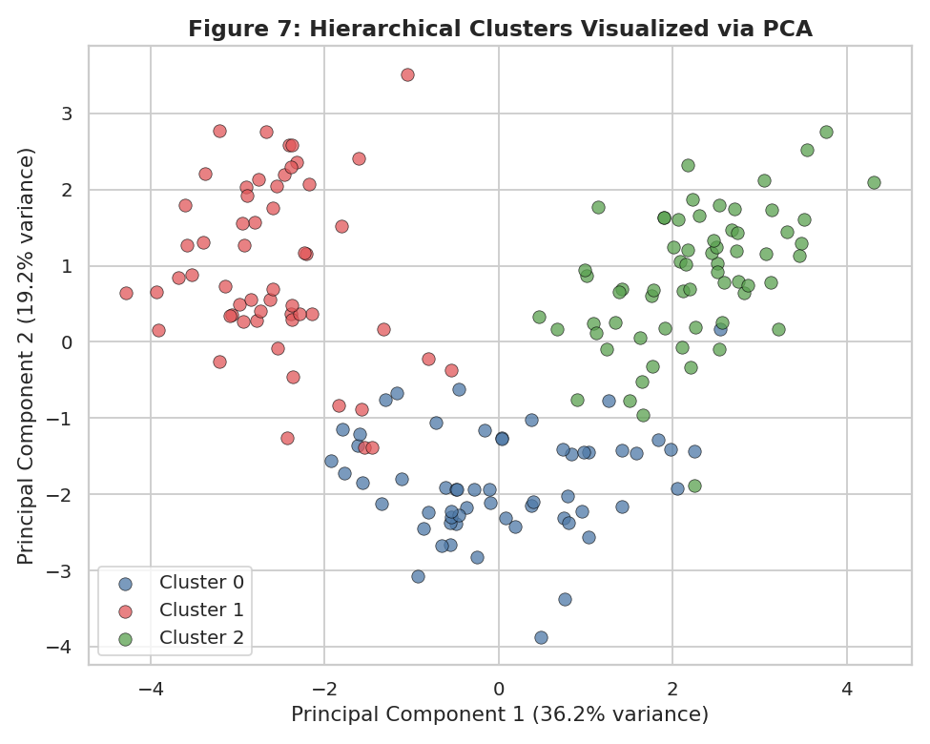
Figure 7: Hierarchical clustering result (k=3), projected onto the same PCA axes as Figure 4.
Method | Silhouette | Davies-Bouldin | Calinski-Harabasz | ARI vs. True Cultivar
K-Means (k=3) | 0.285 | 1.389 | 70.9 | 0.897
Hierarchical / Ward (k=3) | 0.277 | 1.419 | n/a | 0.790
Table 2: Evaluation metrics comparing K-Means and Hierarchical Clustering.
Cutting the dendrogram to produce 3 clusters yields a result visually almost indistinguishable from the K-Means solution in Figure 4. Quantitatively, K-Means edges out hierarchical clustering on every internal metric (higher silhouette, lower Davies-Bouldin, higher agreement with the true cultivar labels at ARI=0.897 vs. 0.790), and the two methods agree with each other at ARI=0.853 — high but not perfect agreement, concentrated in the same handful of borderline samples that K-Means also struggled to place cleanly. For this dataset, K-Means was selected as the primary method for the detailed cluster-interpretation work in Section 9, with the hierarchical result serving as independent corroboration rather than a replacement.

9. Cluster Characteristics and Interpretation
cluster_profile = df.groupby('KMeans_Cluster')[feature_cols].mean()
Code Snippet 8: Computing the mean chemical profile of each cluster.
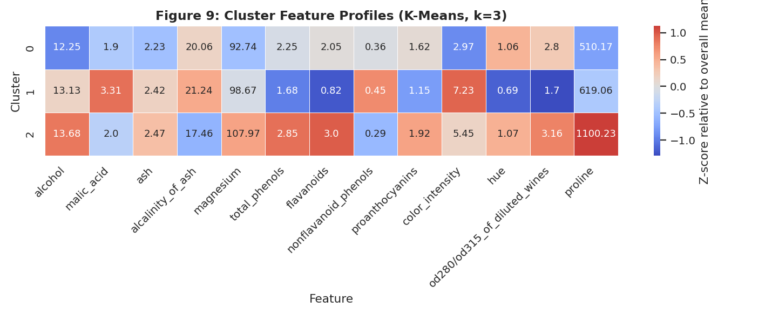
Figure 9: Mean feature values per cluster (cell values), shaded by z-score relative to the overall mean.
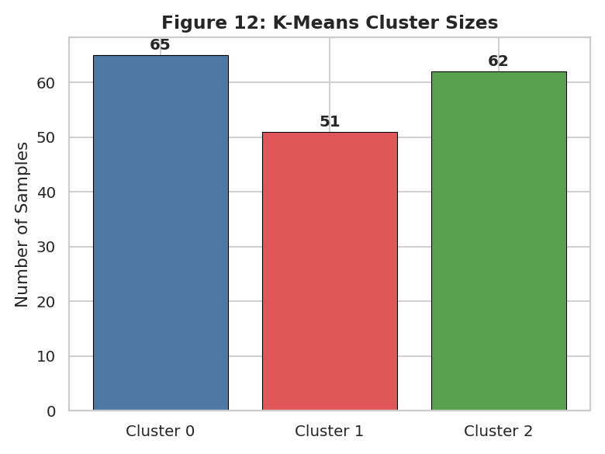
Figure 12: Number of wine samples assigned to each K-Means cluster.
The three clusters found by K-Means (sizes: Cluster 0, n=65; Cluster 1, n=51; Cluster 2, n=62) show clearly distinct chemical signatures:
Feature | Cluster 0 | Cluster 1 | Cluster 2
Alcohol | 12.25 (lowest) | 13.13 | 13.68 (highest)
Malic Acid | 1.90 | 3.31 (highest) | 2.00
Total Phenols | 2.25 | 1.68 (lowest) | 2.85 (highest)
Flavanoids | 2.05 | 0.82 (lowest) | 3.00 (highest)
Color Intensity | 2.97 (lowest) | 7.23 (highest) | 5.45
Hue | 1.06 | 0.69 (lowest) | 1.07 (highest)
OD280/OD315 | 2.80 | 1.70 (lowest) | 3.16 (highest)
Proline | 510 (lowest) | 619 | 1100 (highest)
Table 3: Selected mean feature values by cluster, with the extreme (highest/lowest) value flagged for each feature.

9.1 Cluster 0 — Lighter, High-Dilution-Ratio Wines
Cluster 0 (n=65) has the lowest alcohol content (12.25%) and the lowest proline (510) and color intensity (2.97) of the three groups, paired with a comparatively high OD280/OD315 ratio (2.80). Low color intensity combined with a high dilution-ratio reading is typically associated with lighter-bodied wines with less extraction from grape skins during fermentation. This cluster corresponds almost perfectly to true cultivar class_1 in the validation data (65 of 65 samples).

9.2 Cluster 1 — High-Acid, Deeply Colored, Low-Flavanoid Wines
Cluster 1 (n=51) stands apart on two features in particular: it has by far the highest color intensity (7.23, more than double Cluster 0's) and the highest malic acid (3.31), combined with the lowest total phenols (1.68) and especially the lowest flavanoids (0.82, less than a third of Cluster 2's value) and lowest hue (0.69). This chemical fingerprint — deep color but low flavanoid/phenol content and high acidity — suggests a more robust, tannic, higher-acidity wine style, distinct from the other two groups on almost every measured dimension. This cluster corresponds almost perfectly to true cultivar class_2 (48 of 48 samples, plus 3 borderline samples from class_1).

9.3 Cluster 2 — Full-Bodied, High-Alcohol, High-Phenolic Wines
Cluster 2 (n=62) has the highest alcohol content (13.68%), the highest total phenols (2.85) and flavanoids (3.00), the highest OD280/OD315 ratio (3.16), and by far the highest proline (1100, more than double Cluster 0's). High proline is associated with vine health and must ripeness, and the combination of high alcohol with high phenolic and flavanoid content is generally associated with a fuller-bodied, more robust, potentially higher-quality or higher-value wine profile. This cluster corresponds almost perfectly to true cultivar class_0 (59 of 59 samples).

9.4 Feature-Level Comparison
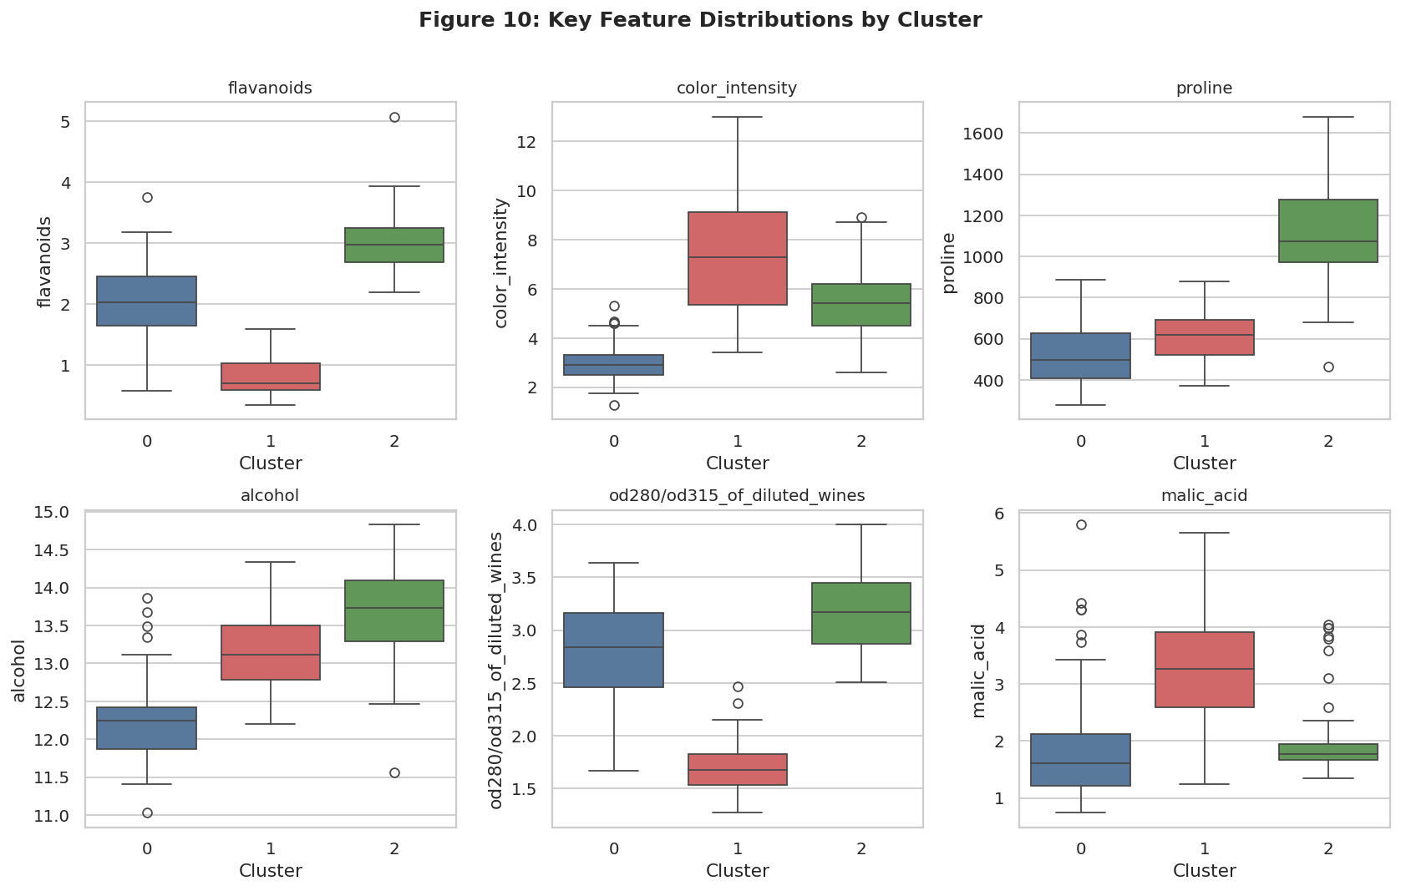
Figure 10: Distributions of six key discriminating features across the three clusters.
The boxplot grid confirms that the differences described above are not driven by one or two outlying samples — each cluster occupies a largely distinct interquartile range on features like flavanoids, color intensity, and proline, with only modest overlap at the edges. Alcohol and malic acid show more overlap between clusters (particularly between Cluster 0 and Cluster 1), meaning these two features alone would not cleanly separate the groups, consistent with the earlier finding that flavanoids, color intensity, and proline carry the strongest discriminating signal.
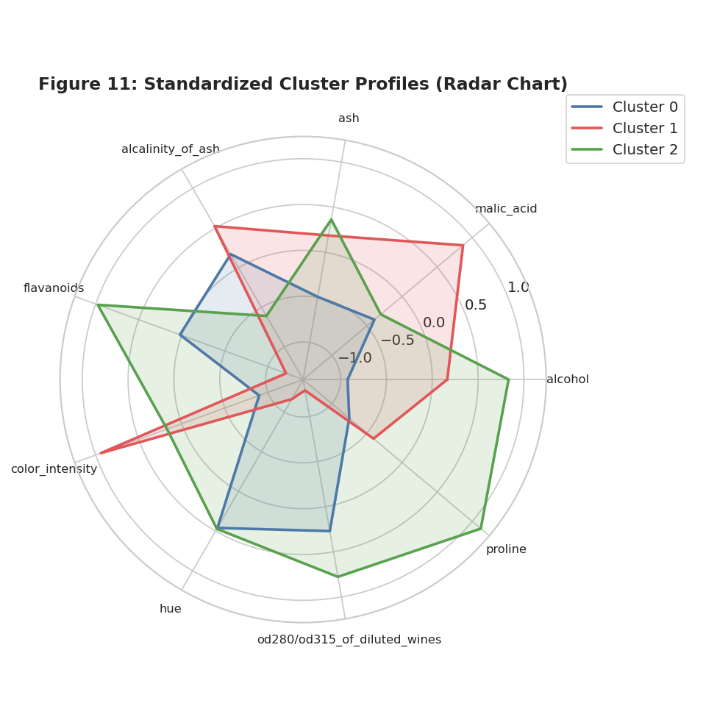
Figure 11: Standardized (z-score) cluster profiles across nine key features, radar view.
The radar chart summarizes all three profiles at a glance: Cluster 2 (green) is expansive on alcohol, flavanoids, OD280/OD315, and proline; Cluster 1 (red) dominates on malic acid and color intensity while contracting sharply on flavanoids and hue; and Cluster 0 (blue) sits in a more moderate, compact middle position on most axes, standing out mainly by its low color intensity and low proline.

10. Business and Research Implications
- Cultivar / origin verification without lab-intensive testing: because the chemical clusters recover the true cultivar grouping with 96.6% accuracy (ARI = 0.897) using only routine chemical measurements, a producer or regulator could use this kind of clustering as a low-cost screening tool to flag wines whose chemical profile doesn't match their declared cultivar or origin for further investigation.
- Quality control and process monitoring: a winery could fit this kind of model on its own historical batches and then check whether new batches land clearly inside an expected cluster or fall in the ambiguous zone between clusters (as the 6 borderline samples did here) — an early signal of a process deviation worth investigating before bottling.
- Product segmentation and pricing strategy: the three profiles read naturally as three distinct market positions — Cluster 2's high alcohol / high phenolic / high proline profile suggests a fuller-bodied, potentially premium product; Cluster 0's lighter, lower-proline profile suggests an everyday-drinking or lighter-style product; Cluster 1's high-acid, deeply-colored, low-flavanoid profile suggests a distinct, more tannic style. A producer or retailer could use these natural chemical segments to inform blending targets, shelf placement, or tasting-note language, rather than relying purely on marketing intuition.
- Targeted agricultural research: because proline (tied to vine nutrition and ripeness) and flavanoid content (tied to grape skin exposure and fermentation practice) are the features that most strongly separate the clusters, viticulture researchers could use this result to prioritize which growing or fermentation variables are worth experimentally manipulating to shift a wine's profile toward a target cluster.
- Model transparency for non-technical stakeholders: because the clusters can be described with only 3–4 features per group (Table 3) rather than the full 13-dimensional space, the segmentation is explainable enough to present directly to winemakers or business stakeholders without requiring them to interpret raw model output.

11. Data Transformations and Parameter Choices Summary
The following choices and transformations were made during this analysis, documented here for transparency and reproducibility:
- Standardization: all 13 features were rescaled with StandardScaler (zero mean, unit variance) before any clustering, to prevent high-magnitude features (proline, magnesium) from dominating the Euclidean distance calculations.
- Number of clusters (k=3): chosen using two independent, quantitative methods — the elbow in the inertia curve and the peak of the silhouette score — both of which agreed on k=3; this choice was further corroborated by the natural 3-branch structure of the Ward-linkage dendrogram.
- K-Means configuration: init='k-means++' for smarter centroid initialization, n_init=10 to guard against poor local optima, and a fixed random_state=42 for reproducibility.
- Hierarchical clustering configuration: Ward linkage, chosen because it minimizes within-cluster variance at each merge step, making it directly comparable in objective to K-Means' inertia minimization.
- Dimensionality reduction for visualization only: PCA to 2 components (55.4% variance retained) was used purely to plot the otherwise 13-dimensional data; all clustering was performed on the full standardized feature set, not on the PCA-reduced data.
- Validation: the true cultivar label was withheld from both clustering algorithms and reintroduced only afterward, via Adjusted Rand Index and a contingency table, to check whether the unsupervised structure matched a real, independently known grouping.

12. Conclusion
This analysis shows that a purely unsupervised approach — using only 13 routine chemical measurements and no label information — can recover a wine's cultivar with very high fidelity (ARI = 0.897, 96.6% of samples correctly grouped). Two structurally different clustering algorithms, K-Means and Ward-linkage hierarchical clustering, independently converged on the same three-cluster structure, and both quantitative metrics (elbow, silhouette) and a qualitative dendrogram inspection agreed that three clusters is the natural, well-supported number of groups in this data. Each resulting cluster has a distinct, interpretable chemical signature — driven mainly by flavanoids, color intensity, and proline — that maps cleanly onto plausible differences in wine style, body, and origin, giving this technique clear, practical value for quality control, product segmentation, and origin verification in a real winemaking or research setting.

13. Tools and Reproducibility
All statistics and figures in this report were generated with a single Python script using pandas, NumPy, scikit-learn, SciPy, Matplotlib, and Seaborn, loading data directly from scikit-learn's bundled dataset module (no external download required). This makes the entire analysis fully reproducible: running the script regenerates every table and figure exactly as shown above.

