- Relative EMA 9 short sell strategy by Lakshay
//@version=5
strategy("Short Sell Strategy - EMA9 + Percent TP/SL", overlay=true, default_qty_type=strategy.fixed, default_qty_value=1, process_orders_on_close=true)

// ─── Inputs ───────────────────────────────────────────────────────────────────
ema_len = input.int(9, title="EMA Length")
target_pct = input.float(0.2, title="Target %", step=0.1) / 100
sl_pct = input.float(0.4, title="Stop Loss %", step=0.1) / 100

// ─── EMA ──────────────────────────────────────────────────────────────────────
ema9 = ta.ema(close, ema_len)
plot(ema9, title="EMA 9", color=color.orange, linewidth=2)

// ─── Candle helpers ───────────────────────────────────────────────────────────
c1_open = open
c1_close = close
c1_high = high
c1_low = low

c2_open = open[1]
c2_close = close[1]
c2_high = high[1]
c2_low = low[1]

// ─── Condition 1: Both candles are red ───────────────────────────────────────
c1_red = c1_close < c1_open
c2_red = c2_close < c2_open

// ─── Condition 2: EMA9 is inside C2's body ───────────────────────────────────
c2_body_high = math.max(c2_open, c2_close)
c2_body_low = math.min(c2_open, c2_close)
ema_in_c2 = ema9[1] <= c2_body_high and ema9[1] >= c2_body_low

// ─── Condition 3: C1 fully below EMA9 ────────────────────────────────────────
c1_below_ema = c1_open < ema9 and c1_close < ema9

// ─── Condition 4: Wick filter on both candles ─────────────────────────────────
c1_body = c1_open - c1_close
c1_wick_top = c1_high - c1_open
c1_wick_bot = c1_close - c1_low
c1_wick_ok = (c1_wick_top < c1_body) and (c1_wick_bot < c1_body)

c2_body = c2_open - c2_close
c2_wick_top = c2_high - c2_open
c2_wick_bot = c2_close - c2_low
c2_wick_ok = (c2_wick_top < c2_body) and (c2_wick_bot < c2_body)

// ─── Final Entry Signal ───────────────────────────────────────────────────────
short_signal = c1_red and c2_red and ema_in_c2 and c1_below_ema and c1_wick_ok and c2_wick_ok

// ─── Entry + Exit ─────────────────────────────────────────────────────────────
if short_signal and strategy.position_size == 0
entry_price = close
tp_price = entry_price * (1 - target_pct)
sl_price = entry_price * (1 + sl_pct)
strategy.entry("Short", strategy.short, comment="SHORT")
strategy.exit("Exit", from_entry="Short", limit=tp_price, stop=sl_price, comment="TP/SL")

// ─── Visual Markers ───────────────────────────────────────────────────────────
plotshape(short_signal, title="Short Signal", location=location.abovebar,
style=shape.triangledown, color=color.red, size=size.small, text="SHORT")

// ─── Info Table ───────────────────────────────────────────────────────────────
var table info = table.new(position.top_right, 2, 4, border_width=1)
if barstate.islast
table.cell(info, 0, 0, "EMA", text_color=color.white, bgcolor=color.gray)
table.cell(info, 1, 0, str.tostring(math.round(ema9, 2)), text_color=color.white, bgcolor=color.gray)
table.cell(info, 0, 1, "Target", text_color=color.white, bgcolor=color.teal)
table.cell(info, 1, 1, str.tostring(target_pct * 100) + "%", text_color=color.white, bgcolor=color.teal)
table.cell(info, 0, 2, "Stop Loss", text_color=color.white, bgcolor=color.red)
table.cell(info, 1, 2, str.tostring(sl_pct * 100) + "%", text_color=color.white, bgcolor=color.red)
table.cell(info, 0, 3, "Position", text_color=color.white, bgcolor=color.navy)
table.cell(info, 1, 3, strategy.position_size == 0 ? "Flat" : "Short", text_color=color.white, bgcolor=color.navy)
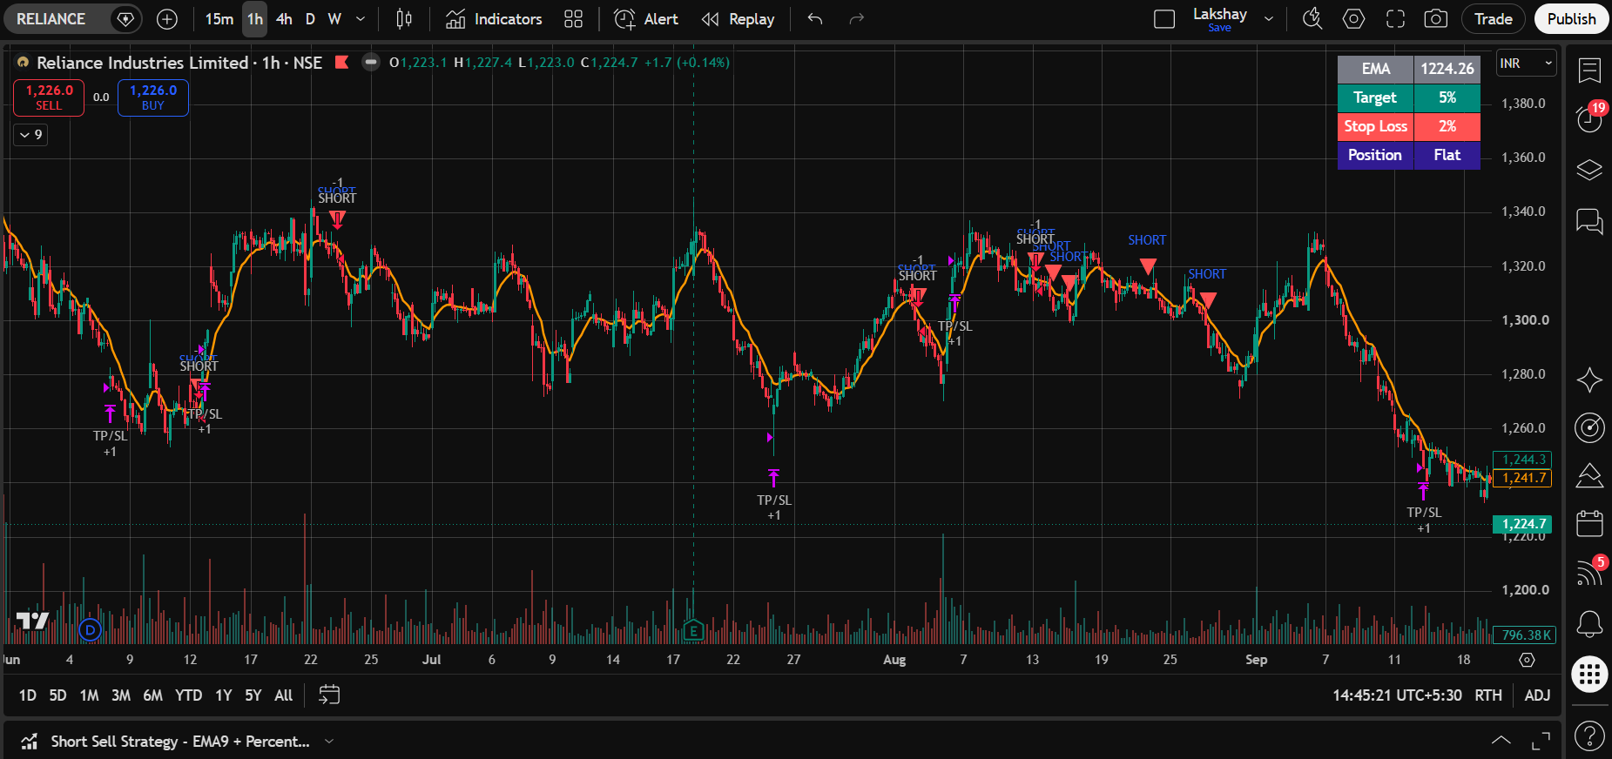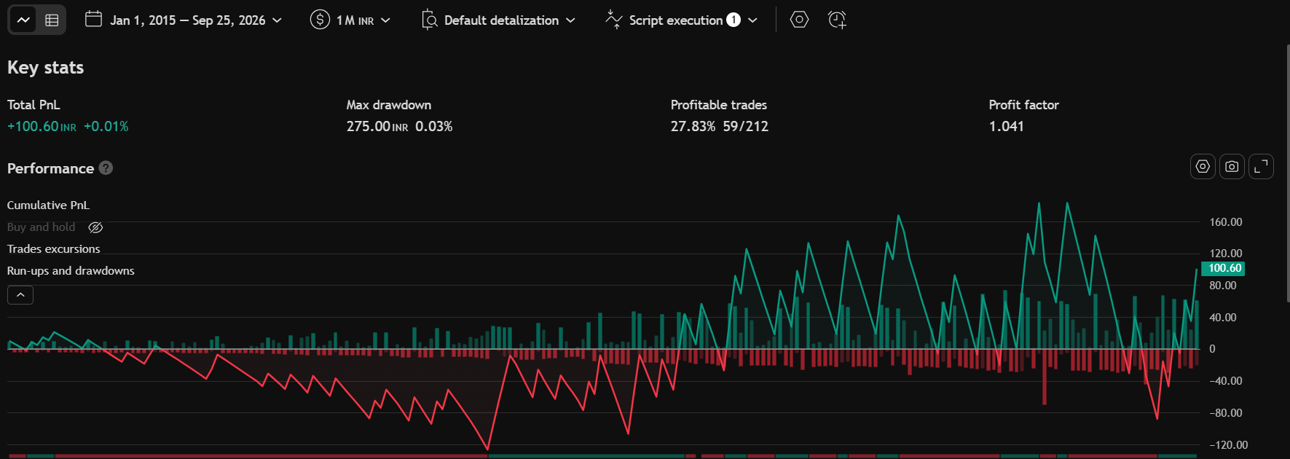
- MA Crossover + Movement Filter

//@version=6
indicator("MA Crossover + Movement Filter", overlay=true)

//====================================================
// INPUTS
//====================================================

// Moving Average Type
maType = input.string(
"EMA",
"MA Type",
options=["EMA", "WMA", "VWMA"]
)

// MA Lengths
fastLength = input.int(
9,
"Fast MA Length",
minval=1
)

slowLength = input.int(
21,
"Slow MA Length",
minval=1
)

// No crossover lookback
noCrossLookback = input.int(
12,
"No Crossover of MA in Last Candles",
minval=1
)

// Movement parameters
movementMultiplier = input.float(
2.0,
"Multiplier of Average Movement",
minval=0.0,
step=0.1
)

movementCandles = input.int(
9,
"Consider Candles for Movement",
minval=1
)

//====================================================
// MOVING AVERAGE FUNCTION
//====================================================

getMA(source, length) =>
switch maType
"EMA" => ta.ema(source, length)
"WMA" => ta.wma(source, length)
"VWMA" => ta.vwma(source, length)

//====================================================
// MOVING AVERAGES
//====================================================

fastMA = getMA(close, fastLength)
slowMA = getMA(close, slowLength)

//====================================================
// MA CROSSOVER CONDITIONS
//====================================================

bullishCross = ta.crossover(fastMA, slowMA)
bearishCross = ta.crossunder(fastMA, slowMA)

//====================================================
// PREVIOUS MA CROSSOVER FILTER
//====================================================

// We only examine candles BEFORE the current candle.
// This prevents the current crossover from being
// counted as a previous crossover.
//
// [1] shifts the check one candle backward.

previousBullCross = ta.barssince(ta.crossover(fastMA, slowMA)[1])
previousBearCross = ta.barssince(ta.crossunder(fastMA, slowMA)[1])

previousAnyCross = math.min(
nz(previousBullCross, 100000),
nz(previousBearCross, 100000)
)

noPreviousCrossover = previousAnyCross > noCrossLookback

//====================================================
// CANDLE MOVEMENT
//====================================================

// Movement % = Abs(High - Low) * 100 / High

candleMovement = high != 0
? math.abs(high - low) * 100.0 / high
: 0.0

//====================================================
// MOVEMENT STATISTICS
//====================================================

// Average movement over the defined number of candles
averageMovement = ta.sma(
candleMovement,
movementCandles
)

// Highest movement over the defined number of candles
highestMovement = ta.highest(
candleMovement,
movementCandles
)

//====================================================
// MOVEMENT CONDITION
//====================================================

// Required condition:
//
// Average Movement × Multiplier > Highest Movement
//
// Example:
// Average = 1.5%
// Multiplier = 2
// Threshold = 3.0%
//
// If Highest Movement = 2.8%
// 3.0% > 2.8% = PASS

movementThreshold = averageMovement * movementMultiplier

movementPass = movementThreshold > highestMovement

//====================================================
// FINAL BUY / SELL CONDITIONS
//====================================================

buySignal =
bullishCross and
noPreviousCrossover and
movementPass

sellSignal =
bearishCross and
noPreviousCrossover and
movementPass

//====================================================
// PLOT MOVING AVERAGES
//====================================================

plot(
fastMA,
title="Fast MA",
color=color.blue,
linewidth=2
)

plot(
slowMA,
title="Slow MA",
color=color.orange,
linewidth=2
)

//====================================================
// BUY / SELL SIGNALS
//====================================================

plotshape(
buySignal,
title="BUY",
style=shape.labelup,
location=location.belowbar,
color=color.green,
text="BUY",
textcolor=color.white,
size=size.small
)

plotshape(
sellSignal,
title="SELL",
style=shape.labeldown,
location=location.abovebar,
color=color.red,
text="SELL",
textcolor=color.white,
size=size.small
)

//====================================================
// ALERT CONDITIONS
//====================================================

alertcondition(
buySignal,
title="BUY Alert",
message="BUY Signal - MA Crossover + Movement Filter"
)

alertcondition(
sellSignal,
title="SELL Alert",
message="SELL Signal - MA Crossover + Movement Filter"
)

//====================================================
// OPTIONAL DATA WINDOW VALUES
//====================================================

plot(
averageMovement,
title="Average Movement %",
display=display.data_window
)

plot(
highestMovement,
title="Highest Movement %",
display=display.data_window
)

plot(
movementThreshold,
title="Average × Multiplier %",
display=display.data_window
)

