Understanding GenoPred V2
A plain language guide through Stage 6
18 September 2026
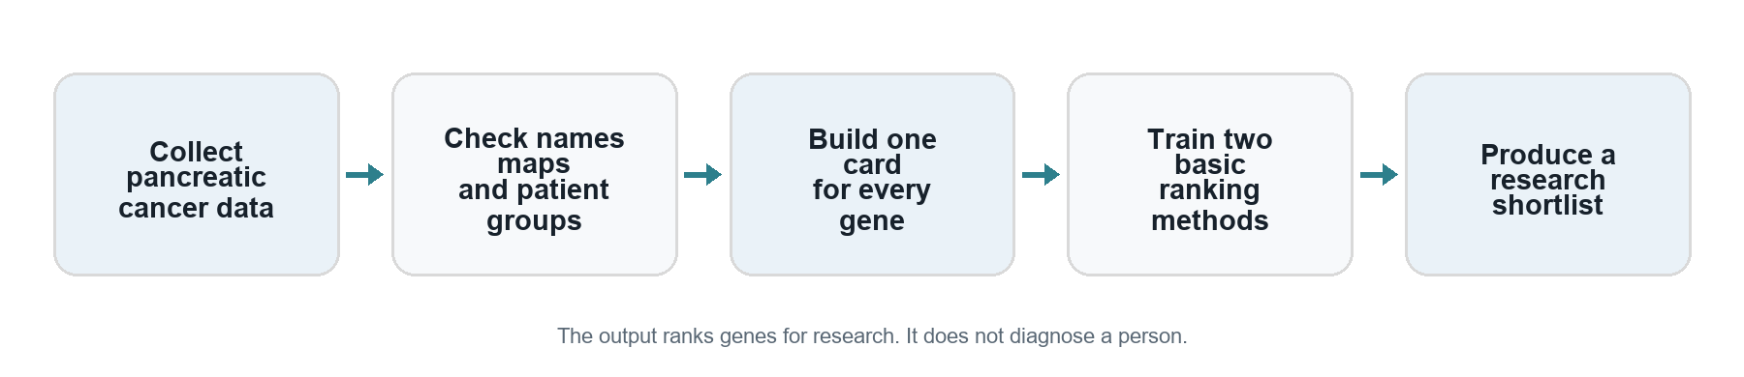
Visual overview of the GenoPred V2 workflow

What this project is trying to do
GenoPred V2 is a research project that puts genes into an order of interest for pancreatic cancer research. It combines several kinds of biological evidence, then uses a computer model to produce a ranked list. Researchers could use that list to decide which genes deserve closer study.
The main question is this: which genes might help pancreatic cancer develop or continue growing?
The project has reached the point where it can collect data, prepare a gene information table, build a network of biological connections, and run two basic ranking methods. Errors found in an audit have been corrected. This guide describes those corrected versions, called Stage 5 v2 and Stage 6 v2.
The output is a research shortlist. It does not tell a person whether they have cancer, choose a treatment, or predict their survival. A gene placed high on the list still needs independent evidence and, where appropriate, laboratory investigation.

How to read this guide
The next two sections introduce the small amount of biology needed to understand the project. The following sections explain Stages 1 to 6, with examples. Later sections explain the results, the corrections, and what remains unfinished. A short glossary is at the end.
You do not need to know biology, programming, or statistics before starting. When a technical name appears, the explanation comes with it. The actual dataset names are included so you can recognise them in the project folder or discuss them with a mentor.

The most useful distinction
The project learns about genes using measurements from patient samples. Its final list contains genes, not patients. This distinction explains many of the design choices that follow.

The biology needed to follow the project
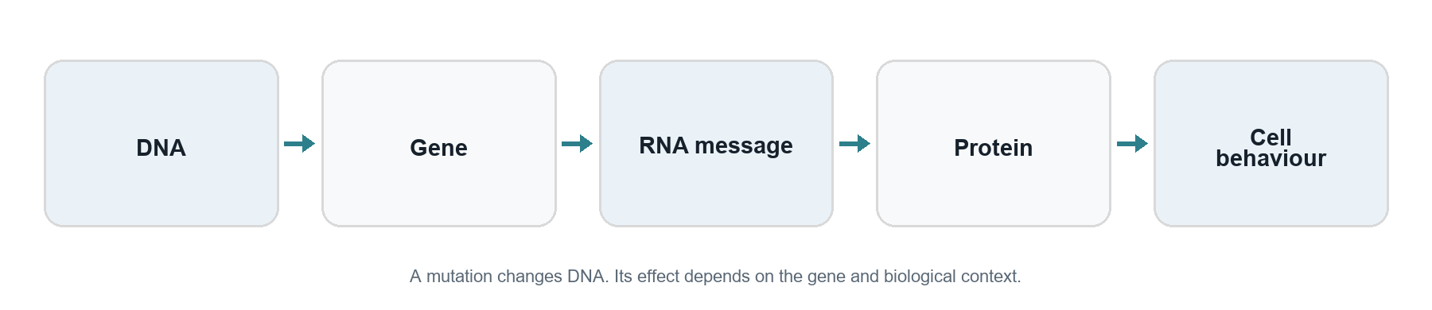
Visual guide to genes and cell behaviour

Cells and their instructions
Our bodies are made of cells. DNA is a molecule that stores instructions used by cells. DNA is organised into packages called chromosomes. A gene is a region of DNA with a biological role. This project focuses on protein coding genes: genes whose instructions can be used to make proteins.
Proteins do much of a cell's work. They help send messages, copy DNA, repair damage, and control growth. Think of DNA as an instruction collection and proteins as some of the working machinery built from it. This is an analogy; a cell is much more complicated than a factory.

What changes in cancer
Cancer can develop when cells acquire changes that allow uncontrolled growth and other harmful behaviour. A mutation is a change in the DNA sequence. Some mutations matter a great deal; many others do not help a tumour grow.
A driver change contributes to cancer development or growth. A passenger change is present but does not provide that advantage in the context being studied. A driver gene is a gene in which relevant changes can contribute to cancer. Finding a change in a gene does not, by itself, prove that the gene is a driver.
There are different ways a gene can matter. Too much growth-promoting activity may be harmful. Losing a protective function may also be harmful. The model therefore collects different types of evidence instead of looking only for one kind of change.

Why pancreatic cancer needs its own evidence
The pancreas is an organ involved in digestion and blood sugar regulation. The project focuses on pancreatic ductal adenocarcinoma, often shortened to PDAC. PAAD is the label used by the main cancer data collection in this project. Those labels are useful for locating data; they should not be read as covering every pancreatic tumour type.
Different cancers can share important genes, but their biology is not identical. Through Stage 6, the current models are built using pancreatic evidence and a general human interaction network. They have not been trained using a breast cancer model.

Different kinds of evidence about a gene
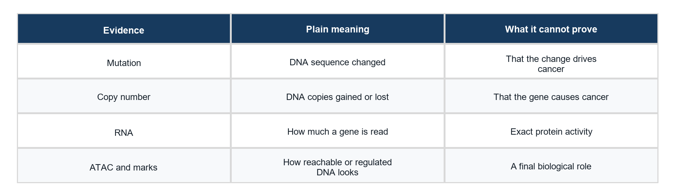
What each kind of biological evidence contributes

Changes to the instructions
Mutation data record DNA sequence changes found in tumour samples. The project counts how many of its selected patients have a qualifying change in each gene. If the same patient has several changes in one gene, that patient is counted once for this feature.
Copy number describes how many copies of a DNA region are present. Tumours can gain or lose copies. A gene with more copies may behave differently from one with fewer copies, but copy count alone does not prove a cancer-driving role.

How much the instructions are used
RNA is an intermediate message made when a gene's information is read. RNA measurements give an indication of gene activity. In this project, expression means the measured amount of RNA associated with a gene. It is a clue about activity, not a direct measurement of every protein's activity.
DNA is packaged inside cells. Some regions are easier for the cell's machinery to reach than others. ATAC-seq is an experiment that measures this accessibility. An accessible region is more like an open page than a closed page; it is not proof that the gene is active or harmful.
A promoter is a region near where the reading of a gene begins. The project measures several signals around this starting area. Histone marks are chemical marks on proteins around which DNA is packaged. H3K4me3 and H3K27ac are the names of two marks used here. You only need to remember that they offer additional clues about regulation.
CTCF is a protein involved in organising DNA and its regulatory environment. Its measured binding signal supplies another clue. No single mark, signal, or protein establishes the final answer.

Combining clues
The word multi-omic means using several kinds of biological measurements together. GenoPred combines mutation, copy number, RNA, and DNA regulation measurements. The measurements come from different studies, so they must be checked and made compatible before the model can use them.

Stages 1 and 2 establish the project and collect data
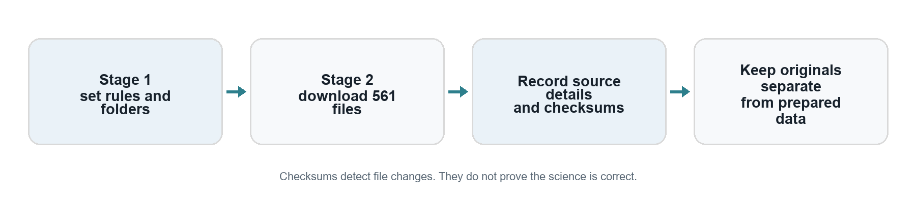
How Stages 1 and 2 prepare trustworthy inputs

Stage 1 sets the rules
Stage 1 created the structure of the new project. It separates original downloads, prepared data, reusable code, tests, and written explanations. The README acts as the project's progress record.
Before data are combined, the project records what each source contains and where it came from. It also defines the planned features. A feature is simply one numerical piece of information that the model can use about a gene.
This is similar to preparing a careful survey. The questions, record formats, and checking rules need to be clear before interpreting the answers. In a computer project, unclear rules can let a mistake spread through every later calculation.
Stage 1 also added automatic tests. These check specific behaviours, such as rejecting duplicate gene identifiers or inconsistent tables. Tests are useful, but they only catch the situations they cover. The later audit showed why passing tests is not the same as proving scientific correctness.

Stage 2 downloads the original evidence
The core downloads came from three sources. TCGA-PAAD contains tumour measurements for RNA, mutations, and copy number. GSE124229 contains accessibility measurements from pancreatic tumour material. GSE149103 contains experiments using PANC-1 and HPNE cell models.
PANC-1 is a pancreatic cancer cell line: cells maintained and studied in a laboratory. HPNE is an immortalised pancreatic comparison cell model. HPNE is not a perfect representation of all healthy pancreas tissue. A laboratory comparison and a patient study answer related but different questions.
The project acquired 561 core files. During the audit, every one matched its recorded checksum. A checksum is a digital fingerprint: it can reveal whether a file has changed or been damaged. It cannot establish that the experiment or interpretation is correct.
Original downloads are kept separate from processed results. This makes it possible to redo a calculation after an error is found without downloading everything again or losing the source evidence.

Stage 3 makes the sources compatible
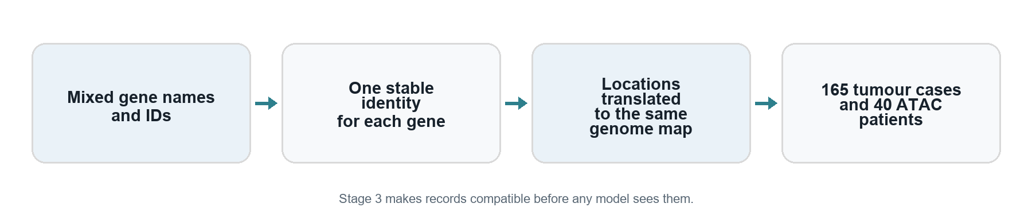
How Stage 3 turns mixed records into compatible data

Giving each gene a reliable identity
A gene may have a short name and several database identifiers. Names can change, and similar names can cause confusion. Stage 3 builds a reference table linking gene names to stable identifiers and locations.
Imagine merging school records from several offices. A student's name alone may be ambiguous, but a unique student number helps join the correct records. Gene identifiers play a similar role. The reference table contains 60,660 gene records. The later prediction table uses 19,962 protein coding genes from it.

Using the same map
Researchers describe locations in DNA using a reference genome, which acts like a map. Different releases can assign different coordinates to the same biological region. The project uses GRCh38 as its main map. Some downloaded experiments use an older map called hg19.
Liftover is the process of translating locations between maps. It resembles updating an old street address to a newer map. A translation can be ambiguous or fail, so the project must not assume that every location transfers correctly.
For cell-line promoter measurements, it translates the target region back to the map used by the original signal files. The corrected code rejects mappings that become too large, shrink too much, reverse unexpectedly, or behave inconsistently within the interval. Rejected regions are marked as unavailable.

Choosing compatible patient measurements
The TCGA files do not all represent the same set of cases. Stage 3 selects 165 cases with the required tumour RNA, mutation, and copy-number files. This common group is called the cohort.
The ATAC table has 80 experimental libraries representing 40 patient identifiers, with two selected libraries per patient. These are repeated measurements, not 80 separate patients. The corrected Stage 5 combines the repeats before describing differences across patients.
At the end of Stage 3, records can be matched by gene, measurements have a declared coordinate system, and the main patient group is defined. That gives later calculations a consistent starting point.

Stage 4 decides which genes have strong existing evidence
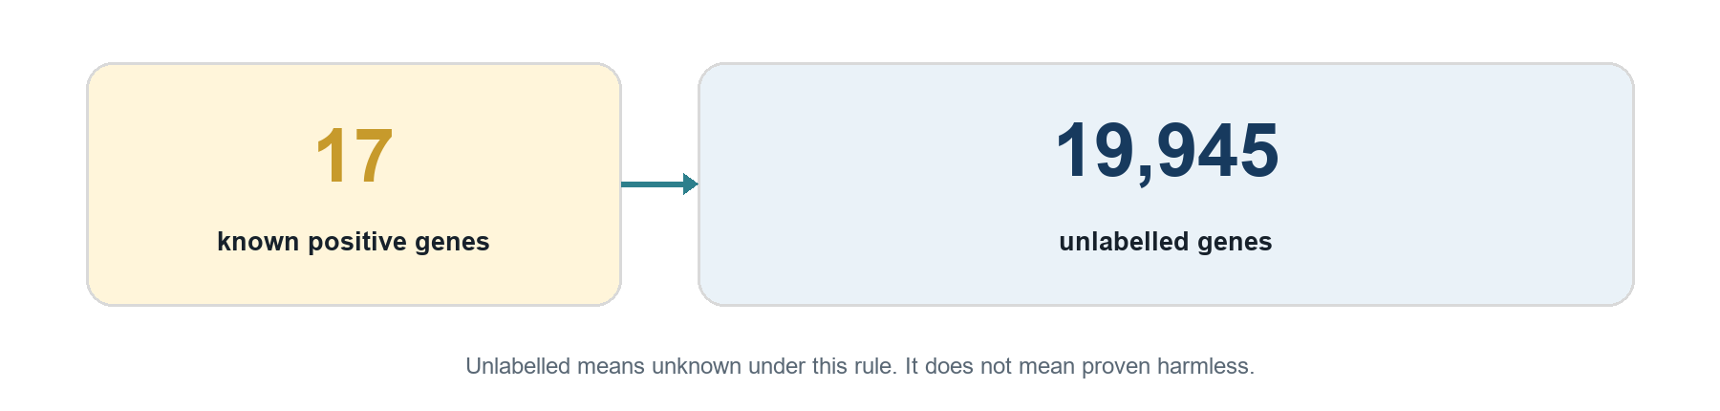
How Stage 4 treats known and unknown genes

The model needs examples
A learning system needs examples of what it is trying to find. Stage 4 assigns labels to genes using an external collection called IntOGen. That collection brings together analyses of cancer-driving genes from different studies.
In this project, positive means that a gene meets a particular evidence rule. It does not mean a patient tested positive for cancer. A gene must have qualifying pancreatic evidence from at least two external study families to receive this label.
The qualifying families are CPTAC, ICGC PACA-AU, and ICGC PACA-CA. Different analyses from the same family are not automatically counted as independent confirmations. Evidence from an overlapping collection is kept as supporting information rather than being counted again.

Why most genes remain unknown
The rule produces 17 positive genes and 19,945 unlabelled genes. Unlabelled means that the gene did not meet this evidence rule. It does not mean that researchers have proved the gene irrelevant to cancer.
Imagine finding 17 books that are definitely useful for a topic. The other books in the library are not automatically useless; many have not been assessed well enough. The distinction matters when teaching a model from incomplete scientific knowledge.
The project has no separately verified negative gene set. A negative would require credible evidence for the opposite class, not merely an absence from a list.

Keeping the answer separate from the clues
The project uses TCGA mutation measurements as an input feature. It therefore excludes TCGA evidence from the rule that creates positive labels. Otherwise, it could partly teach the model an answer derived from the same data it uses as a clue.
This is one form of leakage: information enters the process in a way that makes evaluation appear stronger than it is. The label design reduces that circularity. However, the studies used to create labels are then no longer untouched sources for a later independent evaluation.

Stage 5 creates one information card for every gene
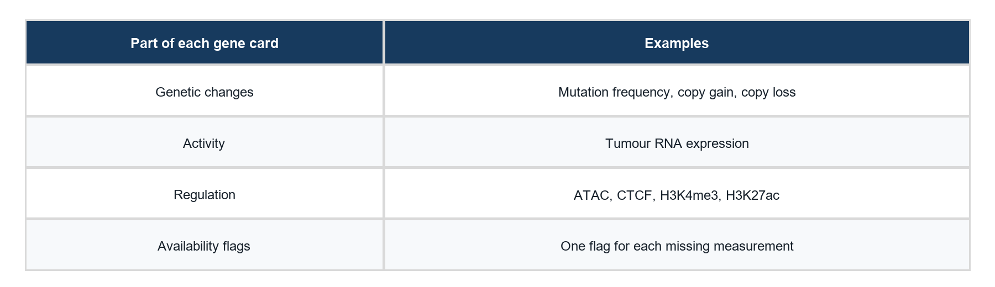
The four parts of a Stage 5 gene information card

Turning experiments into a usable table
Stage 5 creates a table with one row per gene. Think of each row as an information card. Each card contains ten biological measurements and ten additional indicators showing whether any measurement was unavailable.
The table therefore has 19,962 rows and 20 columns used by the model. The positive or unlabelled label is stored separately from these input features. A gene name or label is not secretly added as another biological clue.

The ten biological measurements
Four measurements compare PANC-1 with HPNE: accessibility, CTCF, H3K4me3, and H3K27ac near the gene's starting region. A difference indicates that the laboratory models have different measured signals there. It does not establish the same difference in every patient.
Two measurements describe patient accessibility: the typical accessibility level and how much it differs between patients. The two libraries for each patient are combined first, leaving 40 patient profiles. The summary reduces the influence of unusually large or small values.
The remaining four measurements describe mutation frequency, copy-number gain, copy-number loss, and tumour RNA expression in the 165-case cohort.
For copy number, the expected background is estimated separately for each tumour using its most common observed copy count across the non-sex chromosomes. This matters because different tumours can have different background copy counts. Sex-chromosome copy-number values are currently unavailable until an appropriate sex-aware calculation is supported.

Handling missing measurements
Missing does not mean zero. A region that cannot be mapped is different from a region that was measured and showed no signal. A missingness indicator records this distinction.
Stage 5 uses temporary middle-value replacements so the stored table contains usable numbers. During Stage 6, those replacements are recalculated using only the permitted training group. This prevents the model's preparation steps from learning from the reserved test group.

A concrete example of a gene information card
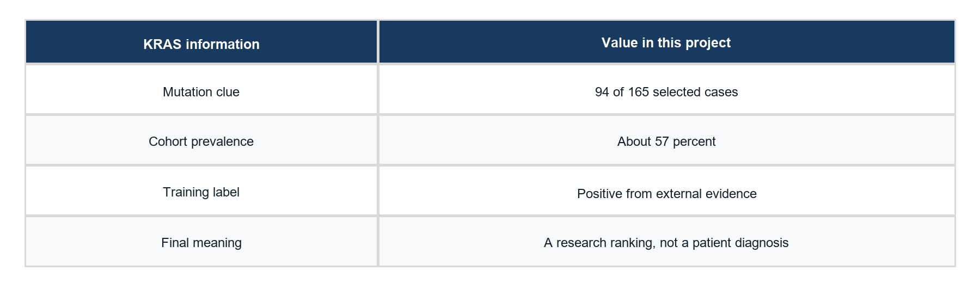
KRAS followed through the project

Following KRAS through the project
KRAS is one of the genes in the table. Its name is an identifier, not a score. In the corrected mutation calculation, 94 of the 165 selected cases have at least one KRAS mutation in the project's selected consequence categories.
That gives a mutation prevalence of about 57 percent for this selected cohort and definition. It does not mean that 57 percent of all people, or even all pancreatic cancer patients, have this change. The number belongs to the particular data and rules used here.
If one of those patients has two qualifying KRAS entries, the patient still contributes only one to the gene's case count. This prevents duplicate entries or multiple changes in one patient from inflating the number of affected patients.
KRAS also receives expression, copy-number, and regulatory measurements where available. The data are joined using the gene's identifier so a measurement from another gene is not accidentally added to its card.

Where its label comes from
KRAS receives a positive label because it meets the external evidence rule from Stage 4. The TCGA mutation count is an input clue, while the qualifying external studies supply the label.
This separation is deliberate. A model that is told a gene is important only because its input mutation count is high could appear to learn something new when it is simply reproducing the same rule.

What a final ranking means
After training, the model assigns a score to each gene. Sorting these scores produces a ranked list. A higher score means the model considers that gene more similar to the positive examples under its chosen rules and measurements.
The score is not a proven probability that the gene causes cancer. It is also not the probability that a particular patient has cancer. A high-ranking unlabelled gene is a candidate for further research. A low rank does not prove that a gene is harmless or unimportant.

Stage 6 teaches a basic ranking model
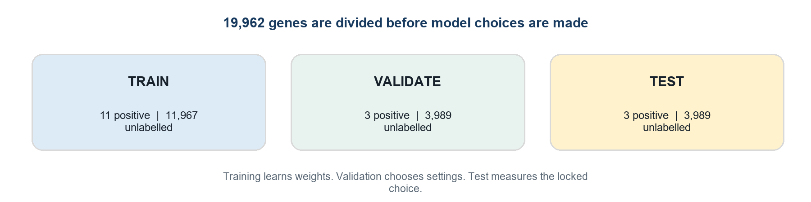
How Stage 6 separates learning from assessment

Learning how to combine the clues
The first model uses the gene information cards without using the interaction network. It learns how much weight to give each measurement when forming a score. A weight describes how strongly that measurement influences this particular model.
The method is called non-negative positive-unlabelled learning, abbreviated nnPU. The name is technical, but its purpose is simple: learn from known positives while recognising that the unlabelled group can contain real positives too.
The method needs assumptions about how common real positive genes might be. Several candidate settings are compared. These assumptions are not established biological facts, and the resulting scores should not be treated as calibrated medical probabilities.

Separating practice from assessment
The gene table is split into three groups. The training group helps the model learn. The validation group helps choose settings. The test group is used to describe performance after the settings have been chosen.
Group | Known positive genes | Unlabelled genes
Training | 11 | 11967
Validation | 3 | 3989
Test | 3 | 3989

These are groups of genes. They are not three groups of patients. The biological measurements were already summarised across the selected patient cohort. This experiment evaluates gene ranking, not prediction for a new patient.

Fair preparation before learning
Measurements can use very different numerical scales. Stage 6 puts them on comparable scales using statistics calculated from the training group. It also fits missing-value replacements within that group.
Once settings are selected, the final model is fitted using training and validation genes together. Test labels do not enter that fitting step. However, the test results had already been examined before the audit corrections. The corrected run therefore uses a previously seen test set and is described as exploratory.

Stage 6 also tries a biological network
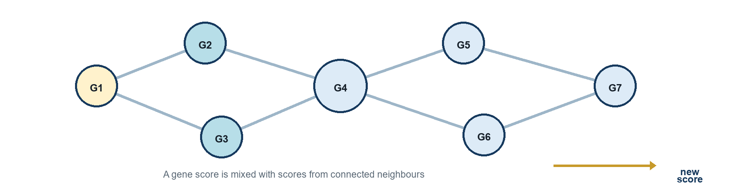
How network diffusion shares scores between connected genes

What the network represents
A network contains items and connections between them. In GenoPred, genes are the items. Connections come from evidence about physical interactions involving their protein products, obtained from the STRING database.
Imagine a map of collaborators. If two people work together, that connection may help interpret what they do. In a cell, a protein's connections can provide context about its role. The analogy does not mean that every connected gene has the same function or the same importance in cancer.
The selected network contains 85,171 distinct pairs. The computer stores each pair in both directions, producing 170,342 directed entries. These are two storage directions for the same pair, not twice as many independently discovered interactions.

How the graph method uses the scores
The second method starts with scores from the first model. It repeatedly mixes each gene's score with information from its neighbours, while retaining part of the starting score. This is called diffusion, or a random walk with restart.
This Stage 6 graph method is a score-smoothing procedure. It is not a trained graph neural network. A graph neural network would be a different modelling approach requiring its own implementation and evaluation.
The experiment uses the network and features for the whole gene list while keeping test labels out of training. This is called a transductive setting. It measures performance with the network already available, rather than testing a completely new and unseen network.

A connection is helpful only if the evidence supports it
At the selected confidence threshold, 9,363 genes have no retained connection. Such genes keep a prediction based on their own features. One known positive, LRP1B, is in this group.
A network can spread useful information, but it can also spread misleading similarities. Well-studied proteins may have more recorded connections. The project therefore compares the network method with the simpler feature method instead of assuming that adding a network must improve the answer.

Reading the corrected results without overclaiming
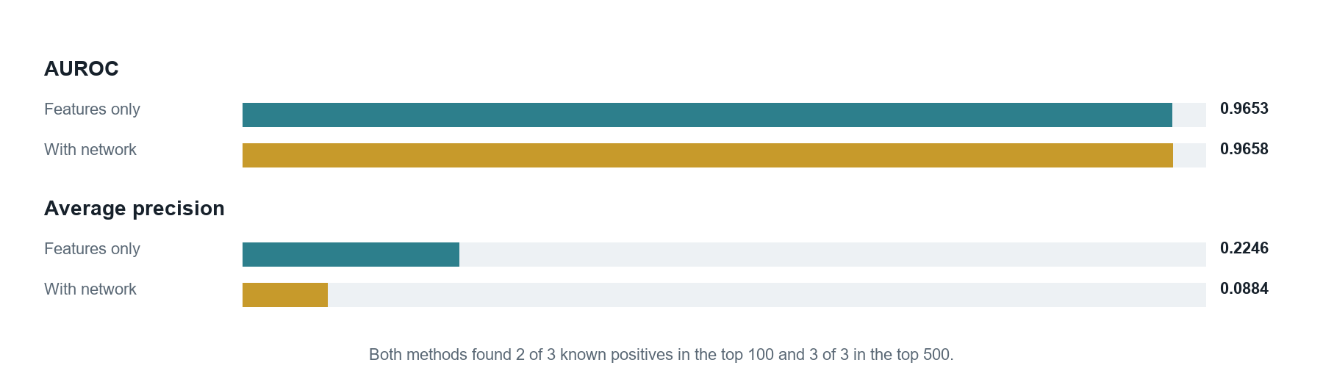
Corrected Stage 6 results on two ranking measures

What the numbers say
Both methods were assessed on the same test subset of 3,992 genes: three known positives and 3,989 unlabelled genes. The following figures describe the corrected v2 experiment.
Measure | Features only | With network diffusion
AUROC | 0.9653 | 0.9658
Average precision | 0.2246 | 0.0884
Known positives in top 100 | 2 of 3 | 2 of 3
Known positives in top 500 | 3 of 3 | 3 of 3

The top 100 and top 500 refer to this test subset, not the full list of 19,962 genes.

Two ways to look at a ranked list
AUROC broadly measures whether known positives tend to appear above unlabelled genes. Here, a value near 0.965 indicates strong separation for the observed labels in this small test. It does not mean 96.5 percent diagnostic accuracy.
Average precision pays attention to how well known positives are concentrated near the top of the ranking. It is useful when positives are rare. The feature-only model has higher average precision, even though the network method has a slightly higher AUROC. Different measures can describe different aspects of the same ranked list.
Average precision of 0.2246 does not mean that exactly 22.46 percent of the top 100 genes are true drivers. The measure summarises precision at changing cutoffs, and many unlabelled genes have unknown biological status.

Why the result remains preliminary
Only three known positives are in the test group. Moving one gene can noticeably change a result. Also, the test was examined during earlier work and reused after correcting errors. The corrected scores are useful for development, but they do not establish performance on independent new evidence.
The change from the earlier results is partly explained by repairing a completely missing mutation feature. It should not be presented as proof that a new scientific discovery or a clinical tool has been validated.

What the audit changed
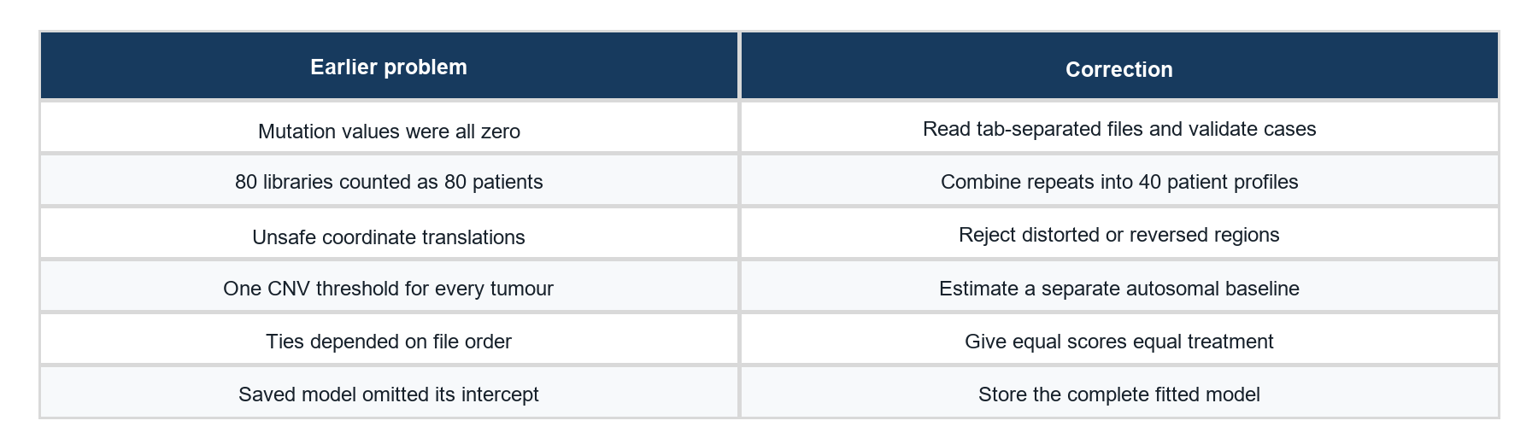
The six audited errors and their corrections

Repairing the biological inputs
The mutation reader originally used the wrong separator for its input files. It quietly made mutation frequency zero for every gene. The corrected reader recognises the tab-separated columns, checks required fields, and verifies which case a record belongs to. It now finds nonzero mutation prevalence in 3,525 genes.
Some promoter translations turned a region about 4,000 DNA letters long into a span exceeding a million letters. Averaging that huge area no longer described the intended promoter. The corrected checks reject such translations and record the measurement as missing.
The patient accessibility calculation originally treated 80 libraries as separate patient profiles. The corrected version first combines the two libraries for each of 40 patient identifiers.
Copy-number thresholds originally ignored differences in the tumour background. The new calculation uses a separate autosomal baseline for each case and leaves sex-chromosome CNV unavailable. The proportion of chromosome-X genes in the feature model's top 100 fell from 68 to 5. This is a useful diagnostic, not proof that every source of bias has disappeared.

Repairing evaluation and saved models
Equal scores could previously receive different metric treatment depending on the order of genes in a file. The corrected evaluation treats ties together, so rearranging equal-scoring genes does not arbitrarily change the result.
The saved model originally omitted its intercept, a number that shifts the model's scores. The complete saved bundle now includes this value, the weights, the preparation rules, and the network settings. Loading it reproduces the stored predictions exactly in the verification run.

What the checks establish
The current suite passes 41 automatic tests, including tests for these errors. Output files also match their recorded fingerprints. These checks support correct execution of the specified calculations. Biological usefulness still requires independent evidence. Earlier files are retained in an audit archive so the correction history can be followed.

What exists now and what remains to be done
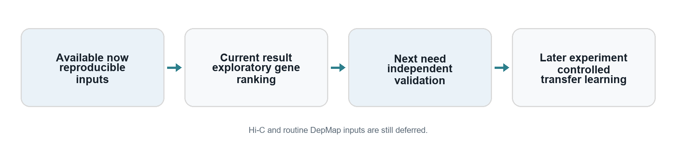
What exists now and what the project needs next

The current deliverable
By the end of corrected Stage 6, GenoPred V2 has original datasets with source records, compatible gene identifiers, a 165-case tumour cohort, an external positive-label rule, a gene feature table, a biological network, two basic models, and saved gene rankings.
It also has written methods, automatic checks, reports of model settings and results, and an archive of the superseded version. This makes the work easier to inspect and explain than a collection of results with no clear route back to the original data.
The important folders are data for measurements and outputs, configs for calculation rules, src for reusable code, tests for automatic checks, manifests for recorded checks and results, and docs for explanations. The README gives the project-level overview.

Work that has not been completed
Hi-C measurements, which describe contacts between distant DNA regions, were planned as additional inputs but are still deferred. The current twenty model columns do not contain those planned contact features.
DepMap contains experiments that test how cell models respond when genes are disrupted. It is reserved as a possible source of additional functional evidence. It has not been used as a routine training input in the current model.
Transfer learning means using knowledge learned on one task or dataset to help another. Breast-to-pancreas or broader cancer transfer has not been carried out in the current Stages 1 to 6. If attempted later, it must be compared fairly with the pancreatic model built from scratch. Transfer can help or make performance worse.

The evidence needed next
The project needs a stronger assessment using genuinely held-out or suitably independent evidence. The studies already used to build labels cannot simply be called new validation. Rearranging the same already examined genes also does not create fresh evidence.
The project can now propose a research ordering of genes. Establishing which candidates matter biologically, and whether the method generalises, is the next scientific task.

A short glossary and reading record
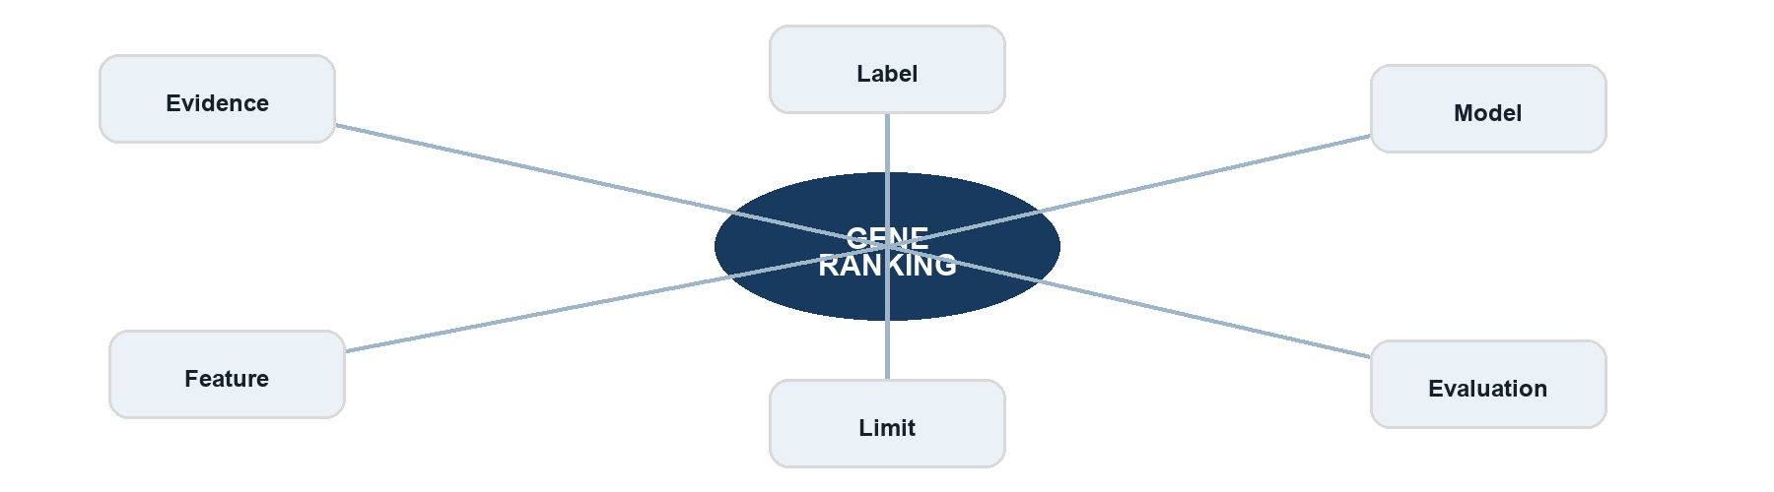
A map of the main terms used in the project

Words you will see in the project
Gene: a region of DNA with a biological role. This project focuses on protein coding genes.
Mutation: a change in the DNA sequence. Its importance depends on the change and its context.
Driver gene: a gene in which relevant changes can contribute to cancer development or growth.
Feature: one numerical clue about a gene, such as mutation frequency or RNA expression.
Label: the evidence category used for learning. Here the categories are positive and unlabelled.
Cohort: the defined group of patient cases used for a calculation. The main shared TCGA cohort has 165 cases.
Replicate: a repeated experimental measurement. Two libraries from one patient do not make two independent patients.
Genome build: a version of the reference map used to locate DNA regions. Liftover translates between such maps.
Baseline model: an initial method used as a reference for later comparisons. A more complicated model must demonstrate improvement.
Leakage: information entering preparation, training, or selection in a way that makes assessment misleading.
Unlabelled: not assigned a positive label under the chosen rule. It does not mean proven negative.

Where the project facts can be checked
This guide describes the corrected project state recorded on 18 September 2026. The versions are stage5-core-v2 and stage6-baselines-v2. The project lives in the GenoPred V2 folder inside Desktop\PythonProjects.
README.md records stages and milestones. docs/STAGE4_LABELS.md explains the labels. docs/STAGE5_DATASET.md explains the features. docs/STAGE6_BASELINES.md explains the models. docs/AUDIT_CORRECTIONS.md records the six repairs.
manifests/stage5_dataset_report.json and manifests/stage6_baseline_report.json contain the detailed counts, settings, and results. The model bundle is data/processed/stage6/model.npz. These files provide the detailed record behind the numbers in this guide.

