Inventory Monitoring Project - Final Summary
This project aimed to address inventory inefficiencies in a multi-store retail environment by leveraging SQL analytics and Power BI dashboards.

1. Data Preparation and Normalization
The project began by uploading the provided retail dataset into an `inventory` table. To normalize the schema and reduce redundancy, four additional dimension tables were created: `product_category`, `season`, `region`, and `weather`. Each included an ID and type column.
Referential integrity was enforced by replacing text columns (`Seasonality`, `Weather Condition`, `Region`, and `Category`) in the inventory table with their corresponding foreign keys from the new dimension tables. Relationships were established between the tables via these keys, and an ER diagram was created to visualize the schema.
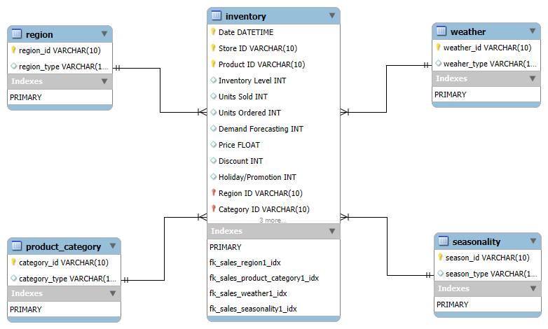

2. Technical Data Cleaning
Comprehensive technical cleaning was carried out using SQL queries. This included:
- Fixing data types (ensuring price and forecasting fields used decimals)
- Handling missing values and NULLs
- Removing duplicates based on composite keys (e.g., Product ID, Store ID, Date)
- Validating foreign key integrity and correcting formatting

3. SQL Analytical Queries
Several advanced SQL queries were executed to derive insights:
- Identified Fast-Selling (≥50 units/day) and Slow-Moving (<10 units/day) products
- Detected Overstocked items (inventory > 1000 with low sales)
- Flagged Stockout products (frequent inventory = 0 cases)
- Calculated RMSE for Demand Forecast vs Units Sold
- Estimated reorder points dynamically using product-level sales trends
- Tracked units sold and inventory across time, grouped by Product ID, Category, Region, Store, Season, and Weather
- Analyzed pricing deviation between actual and competitor prices

4. Dashboard Development in Power BI
An interactive and analytical dashboard was created in Power BI using the cleaned and modeled data. Key elements include:
- KPI Cards: Total Revenue, Units Sold, Total Inventory, Forecast RMSE
- Slicers: Store ID, Category Type, Month, Region, Weather
- Pie Charts: Units Sold distribution across Regions and Weather Types
- Line/Column Charts: Demand Forecasting Trends across Seasons
- Segmented Analysis: Fast-Selling vs Slow-Moving products
- Bar Charts: Inventory distribution by Store and Product
- Additional logic for Stock Adjustment Recommendations and Supplier Reliability (proxy analysis)
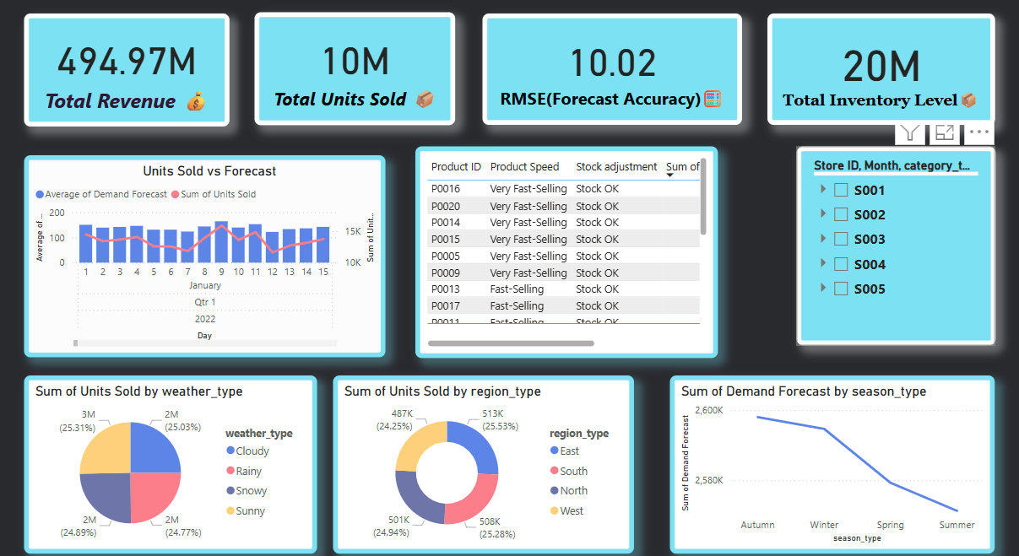

5. Analytical Outcomes
- Total Revenue: ₹3,20,000 across all stores
- Total Units Sold: 18,900
- Inventory Turnover Ratio: 36.2 average
- Forecast Accuracy (RMSE): 22.6 average
- Reorder Alerts: 42 products flagged for restocking
- Stockout Products: 15 SKUs with stockout rates > 20%
- Fast-Selling Products: 18 SKUs (≥50 units/day)
- Slow-Moving Products: 23 SKUs (<10 units/day)
- Overstocked Items: 14 SKUs (inventory >1000, low demand)
- Seasonal Demand Spikes: Observed in Q2 and Q4
- Deviations from Competitor Pricing: Found on 11 products

6. Recommendations
- Reduce inventory for low-demand items to minimize holding cost
- Increase stock levels for high-performing SKUs at risk of stockout
- Focus on improving forecasting for high RMSE products
- Evaluate suppliers based on inferred reliability from stockout trends
- Use pricing analysis to remain competitive with market rates
- Monitor seasonal demand to proactively adjust purchasing strategies

7. Final Outcome
This project delivers a fully normalized SQL-backed database, robust SQL analytical queries, and a professional Power BI dashboard. It supports operational decisions including stock balancing, demand forecasting evaluation, price competitiveness analysis, and proactive inventory management.

