HEAD – pointing to most recent commit
Note : we can also checkout to commit to detach HEAD from a branch and attaching it to commit.
Command : git checkout C3
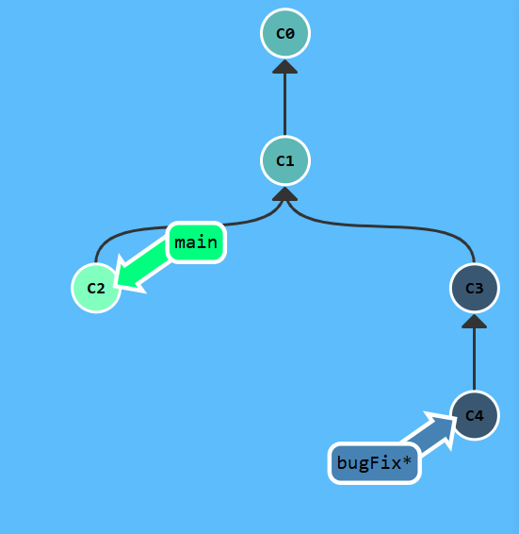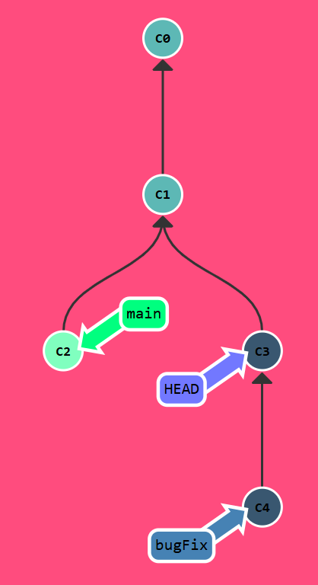

The "~" operator

