📌 1.1 Introduction to APIs

🔹 1️⃣ What is an API?
📖 Definition
API = Application Programming Interface
An API is a bridge that allows two software systems to communicate with each other.
👉 It defines:
- How requests should be made
- What data should be sent
- What format response will come in
- What operations are allowed

🧠 Real-Life Analogy
Imagine you're in a restaurant:
- 🧑 You = Client
- 👨‍🍳 Kitchen = Server
- 🧾 Waiter = API
You don’t go into the kitchen directly.
You tell the waiter (API) what you want.
The waiter takes your request to the kitchen and brings back your food.
✔ That waiter is exactly what an API does.

🖥 Technical Example
When you open Instagram:
- App requests: GET /user/profile
- Server responds with:
{
"name": "Lakshay",
"followers": 1200
}
The app and server talk via an API.

🎯 Key Points
- APIs allow system-to-system communication
- APIs expose only required functionality
- APIs improve modularity & scalability

🔹 2️⃣ What is a Web Service?
📖 Definition
A Web Service is a type of API that works over the internet using HTTP protocol.
👉 All Web Services are APIs
❌ But not all APIs are Web Services

🌐 Why “Web”?
Because it:
- Uses HTTP/HTTPS
- Communicates over a network
- Uses standard formats like:
  - JSON
  - XML

📌 Example of Web Services
- Payment gateway APIs
- Weather APIs
- Google Maps APIs
- Banking APIs
These are web-based APIs accessible over the internet.

🔹 3️⃣ API vs Web Service
Feature | API | Web Service
Definition | Communication interface between systems | API over the web
Protocol | Any (HTTP, TCP, etc.) | Only HTTP/HTTPS
Network required | Not always | Yes
Example | Java library API | REST API

🎯 Important Interview Line
Every Web Service is an API, but not every API is a Web Service.

🔹 4️⃣ Client–Server Architecture
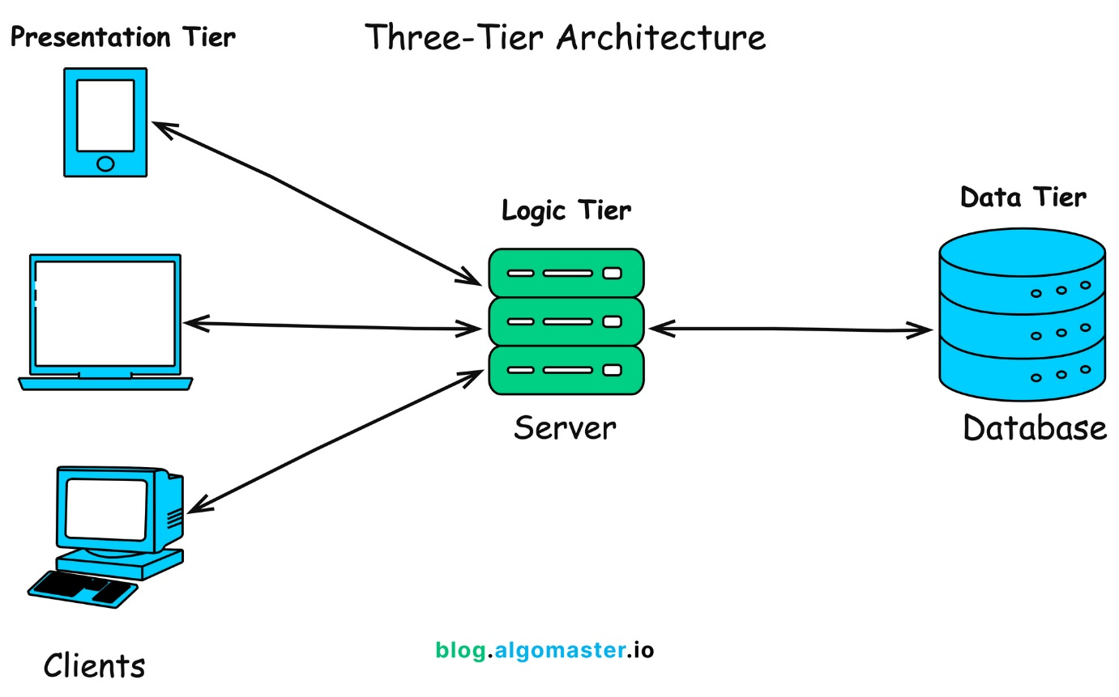
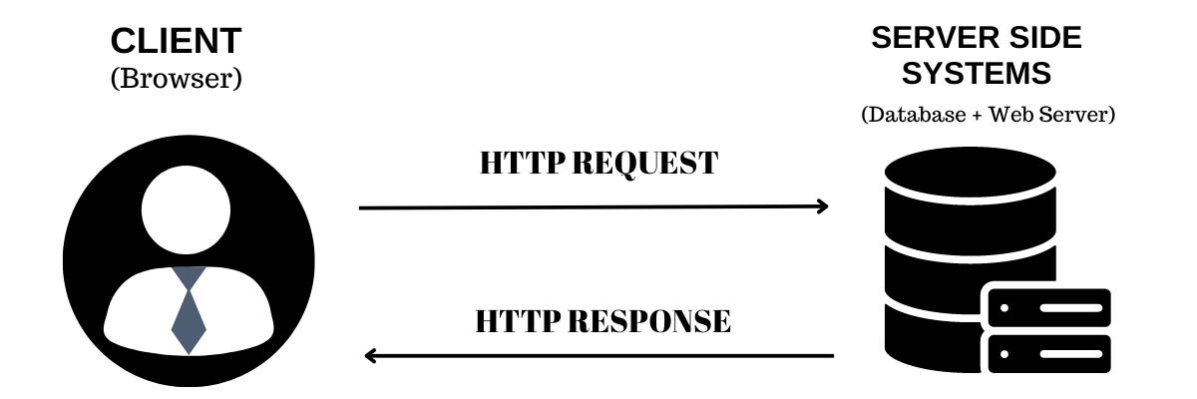

📖 What is Client-Server Architecture?
It is a distributed system where:
- 🖥 Client → Sends request
- 🗄 Server → Processes and sends response

🔁 How It Works (Step-by-Step)
- Client sends HTTP request
- Server processes request
- Server returns HTTP response
- Client displays result

📦 Example (Login API)
Client sends:
POST /login
{
"username": "lakshay",
"password": "123"
}
Server responds:
200 OK
{
"token": "abc123xyz"
}

🎯 Why This Model is Powerful?
- Separation of concerns
- Scalable
- Easy to maintain
- Secure (server controls data)

🔹 5️⃣ Role of APIs in Microservices
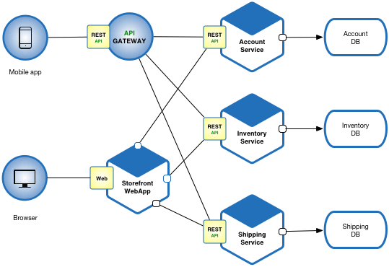
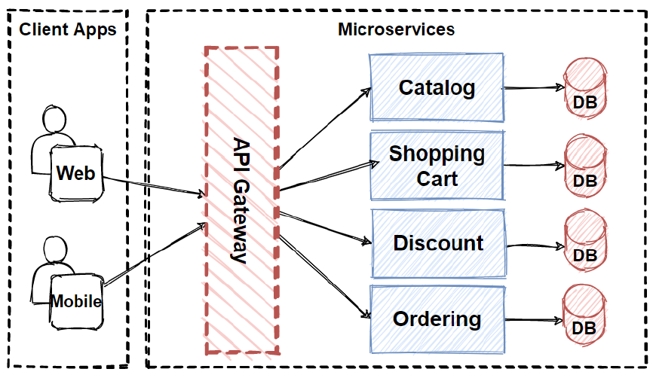
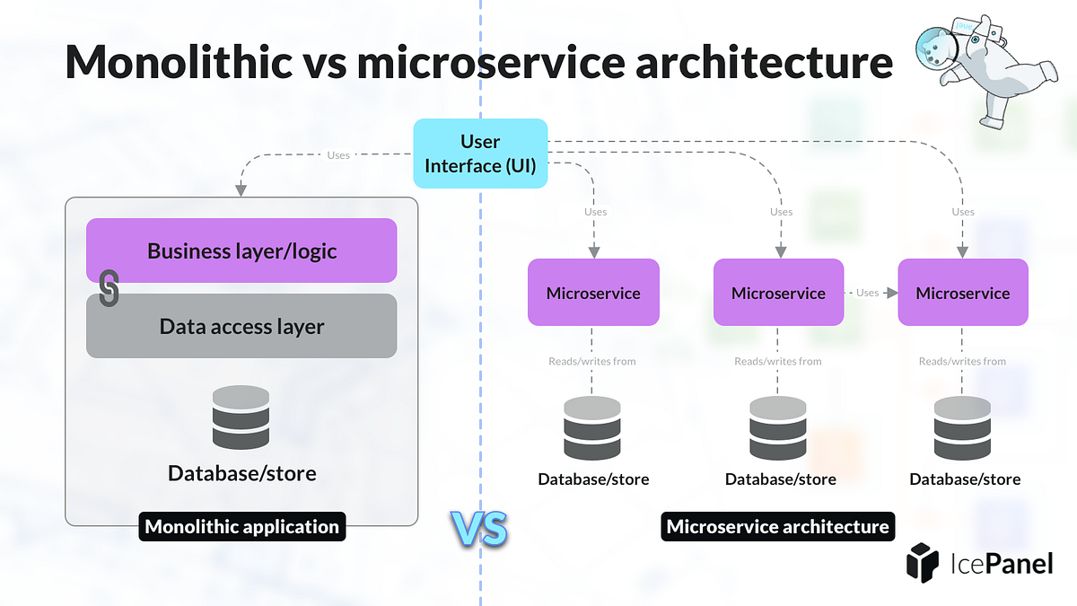
4

📖 First: What are Microservices?
Microservices architecture means:
Instead of one big application (monolith),
we break it into small independent services.
Example in E-commerce:
- User Service
- Order Service
- Payment Service
- Inventory Service
Each service:
- Runs independently
- Has its own database
- Communicates via APIs

🔁 How APIs Help in Microservices
APIs allow:
- Service-to-service communication
- Independent deployment
- Scalability of individual modules
- Loose coupling

🏢 Example Flow
User places order:
- Order Service calls:
  - Inventory API
  - Payment API
- All communicate via REST APIs
Without APIs → Microservices cannot talk.

🧠 Important Concept for You (As API Tester)
When testing APIs in microservices:
You are testing:
- Communication between services
- Data consistency
- Authentication between services
- Contract validation

🧾 Summary of 1.1
Concept | Key Idea
API | Bridge between systems
Web Service | API over HTTP
Client-Server | Request-Response model
Microservices | APIs connect independent services

🧪 Quick Knowledge Check
Answer these:
- Is every API a Web Service? Why?
- Why are APIs critical in microservices?
- What happens if API fails in microservice architecture?
- Can an API exist without internet?

