SQL & MySQL Assignment: Lab-1

1. What is SQL and Its Use?
SQL, or Structured Query Language, is the standard language used to communicate with relational database systems. It allows users to store, manipulate, and retrieve data efficiently. The primary purpose of SQL is to provide a consistent way to manage large sets of structured information.
Its uses include:
- Data Retrieval: Extracting specific information from large datasets using queries.
- Data Manipulation: Adding new records, updating existing ones, or deleting unnecessary data.
- Database Definition: Creating and modifying tables, schemas, and other structures.
- Access Control: Granting or revoking permissions to ensure data security.
- Transaction Management: Ensuring data consistency and reliability when multiple operations are performed.

2.Describe all the different commands of SQL, mention use of it and syntax.
SQL commands are broadly divided into categories based on their purpose:
- Data Definition Language (DDL): These commands define and modify the structure of the database.
CREATE is used to create new tables or databases. Example:
sql
CREATE TABLE Students (ID INT, Name VARCHAR(50));
    - ALTER modifies the structure of an existing table, such as adding a new column.
sql
ALTER TABLE Students ADD Age INT;
    - DROP deletes a table or database permanently.
sql
DROP TABLE Students;
- Data Manipulation Language (DML): These commands handle the actual data inside tables.
INSERT adds new records.
sql
INSERT INTO Students VALUES (1, 'Lakshay', 20);
    - UPDATE modifies existing records.
sql
UPDATE Students SET Age = 21 WHERE ID = 1;
    - DELETE removes records.
sql
DELETE FROM Students WHERE ID = 1;
- Data Query Language (DQL):
SELECT retrieves data from tables.
sql
SELECT Name, Age FROM Students WHERE Age > 18;

- Transaction Control Language (TCL): These commands manage transactions to ensure data integrity.
  - COMMIT saves changes permanently.
  - ROLLBACK undoes changes made in the current transaction.
  - SAVEPOINT sets a checkpoint within a transaction.
- Data Control Language (DCL): These commands manage user privileges.
  - GRANT provides access rights.
  - REVOKE removes access rights.

3.Write step by step procedure to install MYSQL.
Step 1: Go to the official MySQL Community Downloads page and select the latest MySQL Installer version for Windows.
Step 2: Choose the installer type. You can either download the smaller web installer (which fetches components during setup) or the full installer (which contains all components).
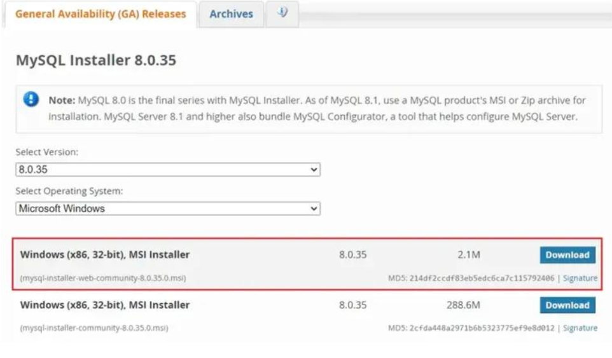
Step 3: When prompted, you may log in or sign up for an Oracle account. If you prefer, click on “No thanks, just start my download” to continue without an account
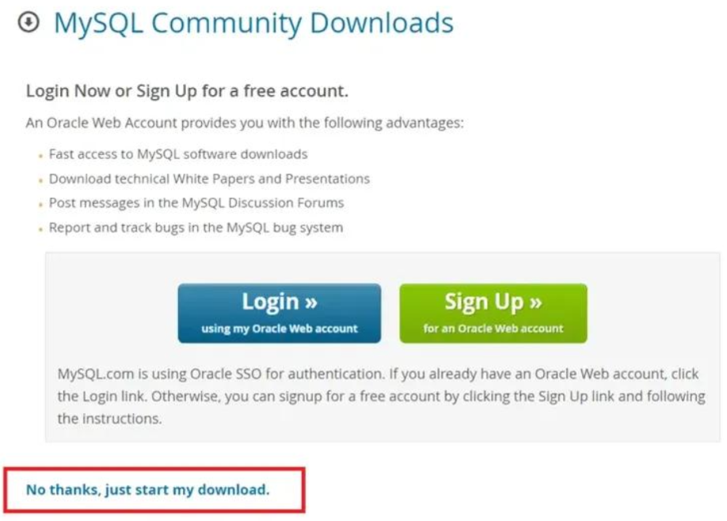.
Step 4: Once downloaded, run the .msi installer file to launch the MySQL Installer wizard.
Step 5: Select the setup type. Options include Developer Default, Server Only, Client Only, or Custom. Choose the one that suits your requirement.
Step 6: The installer will check system requirements. If any prerequisites are missing (such as Visual Studio for MySQL for Visual Studio integration), resolve them before proceeding.
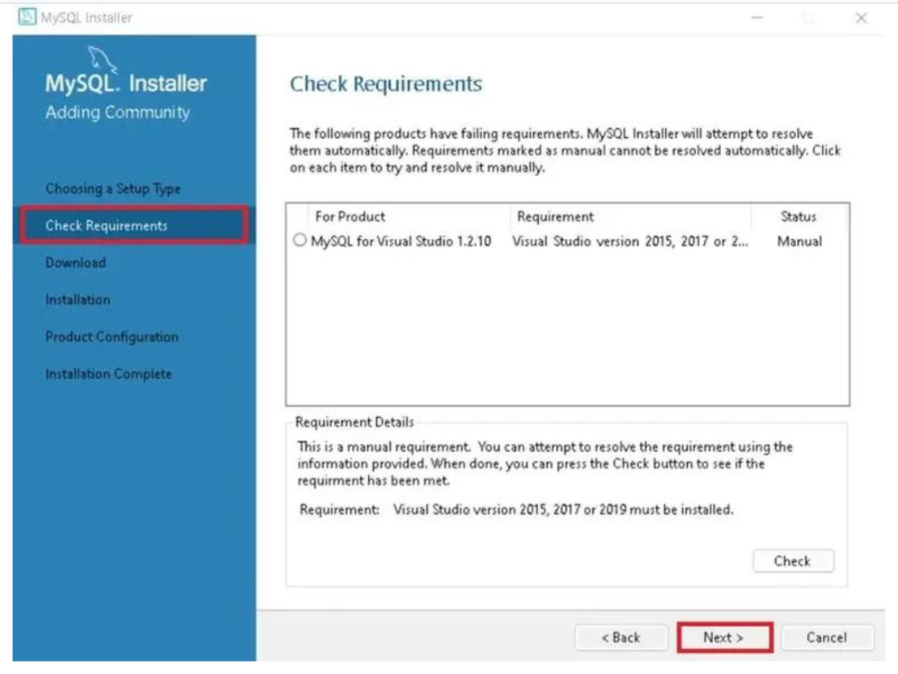

Step 7: The installer will now download and install the selected MySQL products such as MySQL Server, Workbench, Shell, Router, Connectors, Documentation, and Samples.
Step 8: Configure the MySQL Server type and networking. Select whether the server will run as a standalone or clustered server, and confirm the default port (3306).
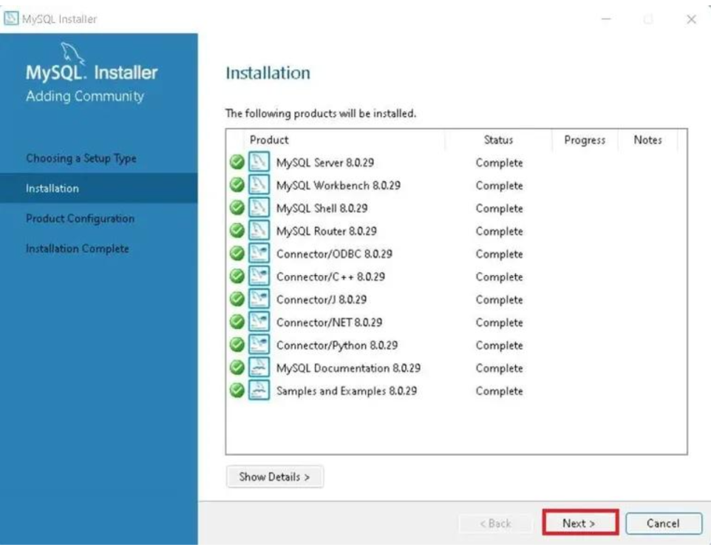
Step 9: Choose the authentication method. Strong password encryption is recommended for better security.
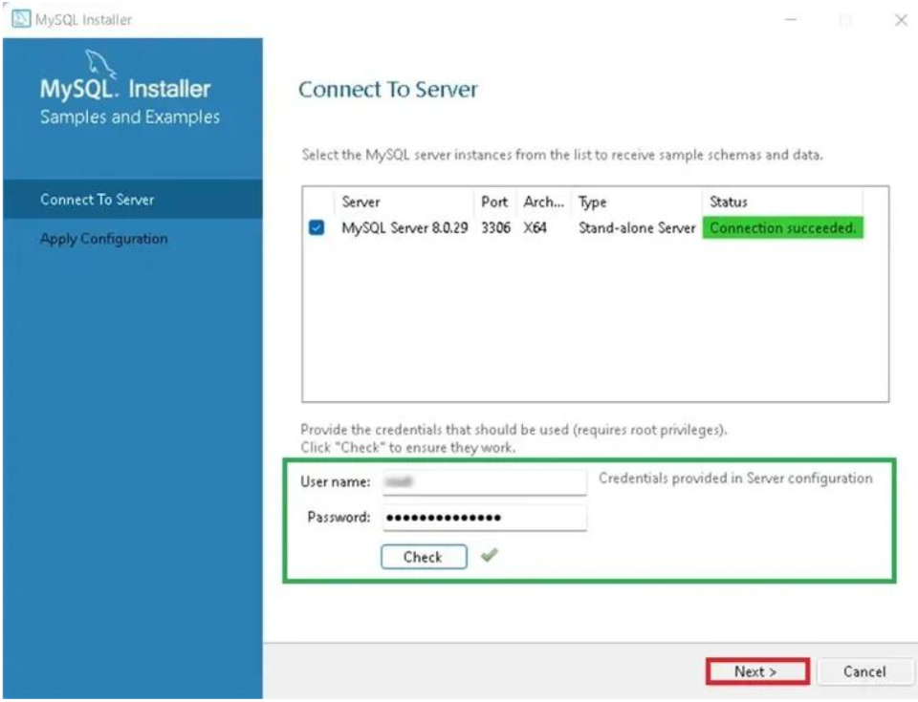
Step 10: Set up the root account by creating a strong password. You may also add additional user accounts and assign roles to them.
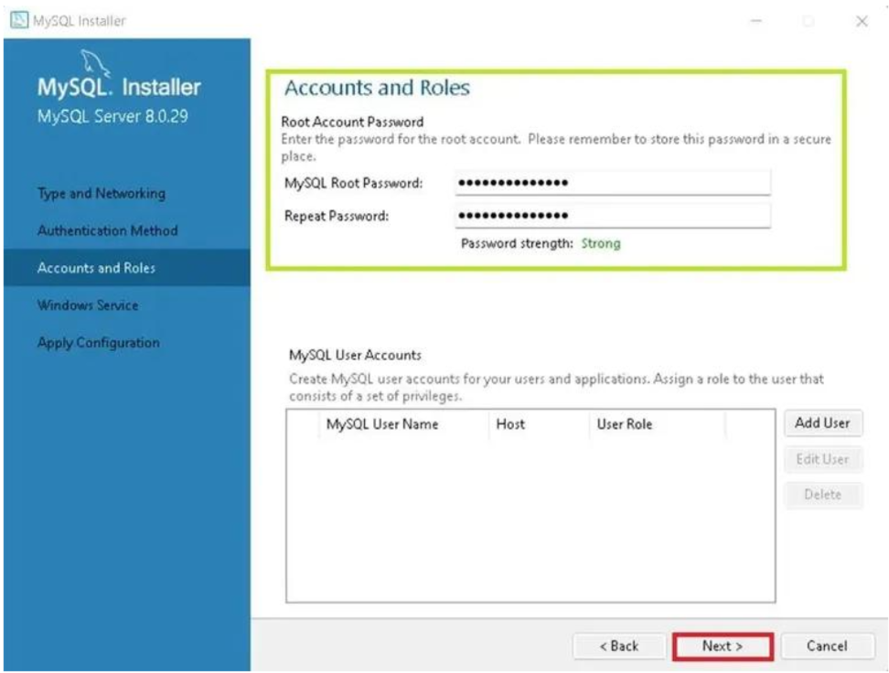
Step 11: Configure MySQL as a Windows Service so that it starts automatically whenever the system boots.
Step 12: Apply the configuration. The installer will test the server connection, finalize the setup, and display a completion screen. You can then launch MySQL Workbench or MySQL Shell to begin using MySQL.
